Search 4: Precision Nutrition & Microbiome
PubMed Query: "Precision Nutrition" AND ("Microbiome" AND "Nutrition")
Covers gut microbiota-diet relationships, microbiome-guided dietary interventions, and host-microbiome interactions in precision health.
464 | 2016–2026 | 190 | 203
Total Articles | Year Range | Unique Journals | Review Papers

Publication Overview
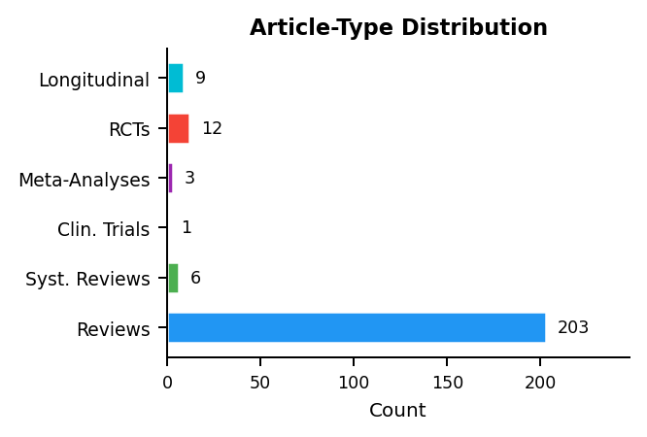 | 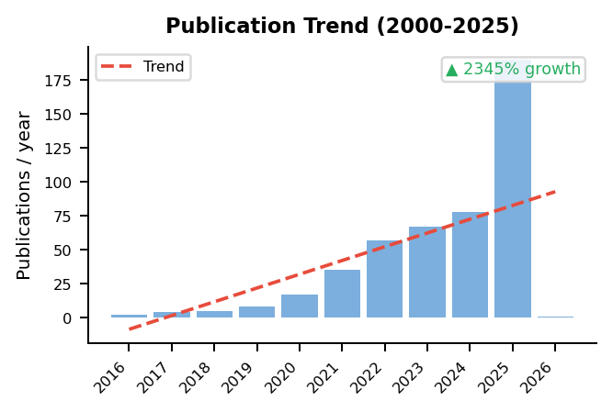

Research Cluster Analysis
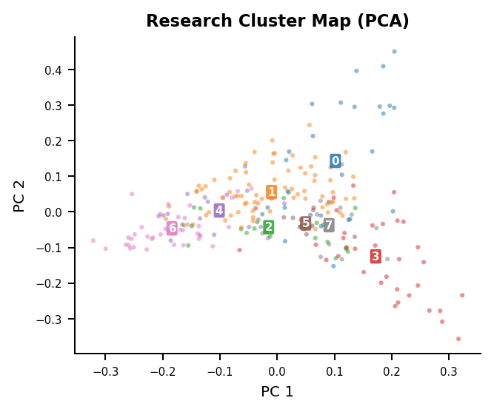 | Identified Research Themes  Cluster 1 (n=75)  gut, microbiota, diet, study, obesity, group  Cluster 6 (n=42)  nutrition, microbiome, gut, precision, dietary, health  Cluster 3 (n=35)  intestinal, gut, inflammatory, microbiota, colitis, induced  Cluster 0 (n=27)  group, significantly, intestinal, groups, growth, 05  Cluster 2 (n=21)  gut, microbiota, mice, brain, microbiome, ckd  Cluster 4 (n=17)  gut, study, microbiome, microbiota, dietary, diet  Cluster 5 (n=13)  acid, genome, probiotic, bgi, vitro, genes  Cluster 7 (n=12)  exposure, skin, intestinal, pathway, microbiota, uvb

Gap Analysis: Review Coverage of Research Topics
3 of 8 research clusters (38%) have cosine similarity < 0.30 to any review cluster:
- Cluster 0 (n=27): group, significantly, intestinal, groups, growth
- Cluster 5 (n=13): acid, genome, probiotic, bgi, vitro
- Cluster 7 (n=12): exposure, skin, intestinal, pathway, microbiota
MedScrape | AI-Assisted Systematic Literature Review | USMA Department of Mathematical Sciences | Generated: 2026-02-20

