Search 5: Dietary Supplements & Diabetes
PubMed Query: "Dietary Supplements" AND "Diabetes"
Surveys supplementation strategies for glycemic control, insulin sensitivity, and diabetes prevention including vitamins, minerals, and botanical compounds.
5,977 | 2000–2026 | 1,301 | 1,410
Total Articles | Year Range | Unique Journals | Review Papers

Publication Overview
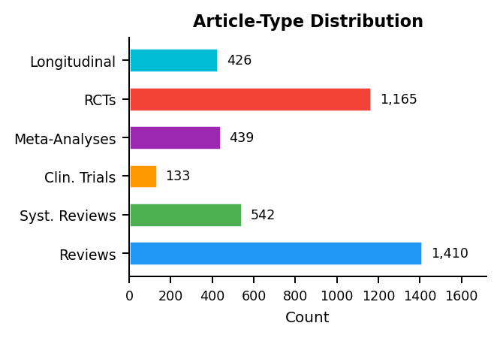 | 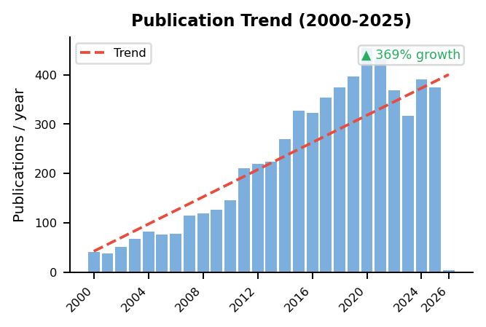

Research Cluster Analysis
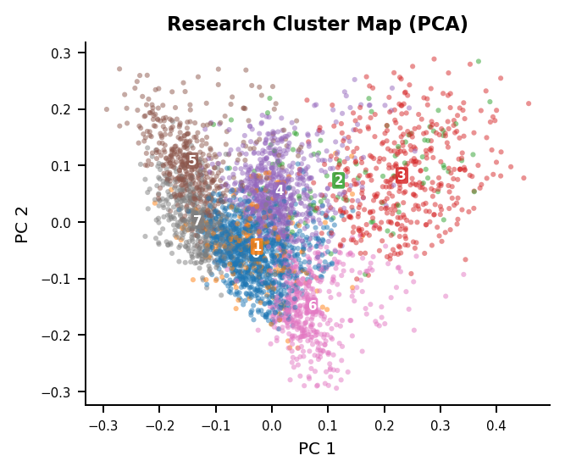 | Identified Research Themes  Cluster 0 (n=993)  diabetes, patients, supplementation, study, dietary, effects  Cluster 4 (n=690)  group, placebo, supplementation, patients, insulin, glucose  Cluster 6 (n=439)  women, risk, diabetes, 95, intake, ci  Cluster 7 (n=433)  mice, diet, insulin, glucose, supplementation, fat  Cluster 5 (n=425)  diabetic, rats, diabetes, group, supplementation, levels  Cluster 3 (n=422)  vitamin, 25, supplementation, oh, levels, group  Cluster 1 (n=189)  oil, fish, fatty, acid, supplementation, omega  Cluster 2 (n=110)  sub, vitamin, sup, supplementation, 25, placebo

Gap Analysis: Review Coverage of Research Topics
No significant gaps detected — existing reviews broadly cover all research clusters.
MedScrape | AI-Assisted Systematic Literature Review | USMA Department of Mathematical Sciences | Generated: 2026-02-20

