Audio Analysis Report

# Analysis of sin_60Hz.wav

## FFT Size: 256

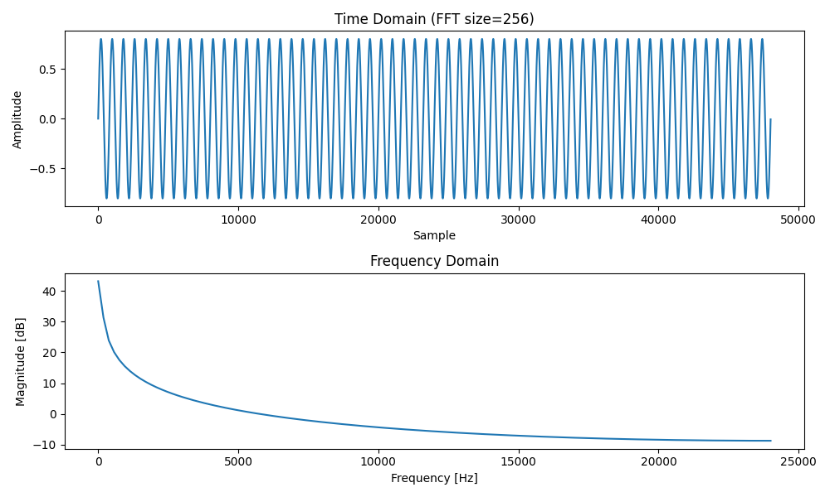

Highest peak at: 0.00 Hz  
Amplitude: 144.87 dB

## FFT Size: 4096

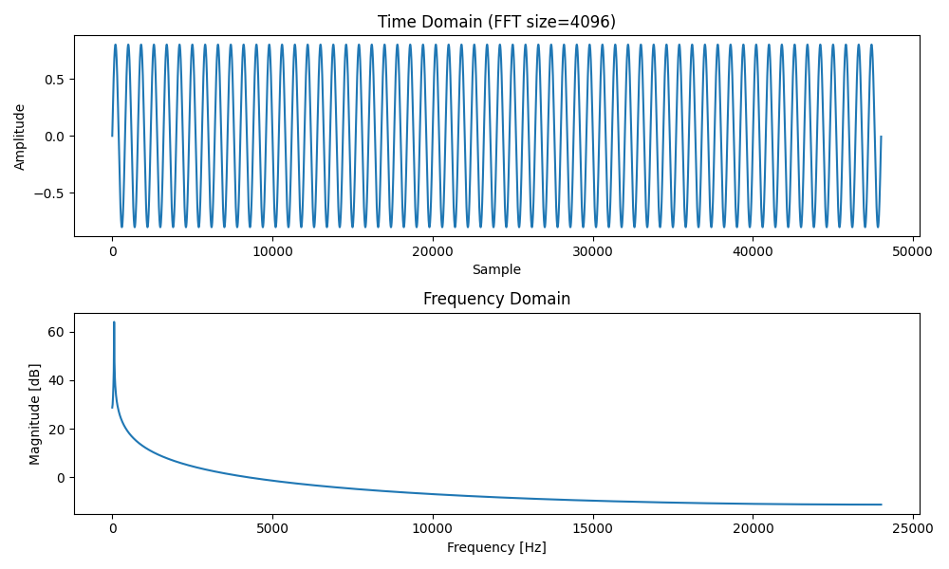

Highest peak at: 58.62 Hz  
Amplitude: 1585.99 dB

## FFT Size: 65536

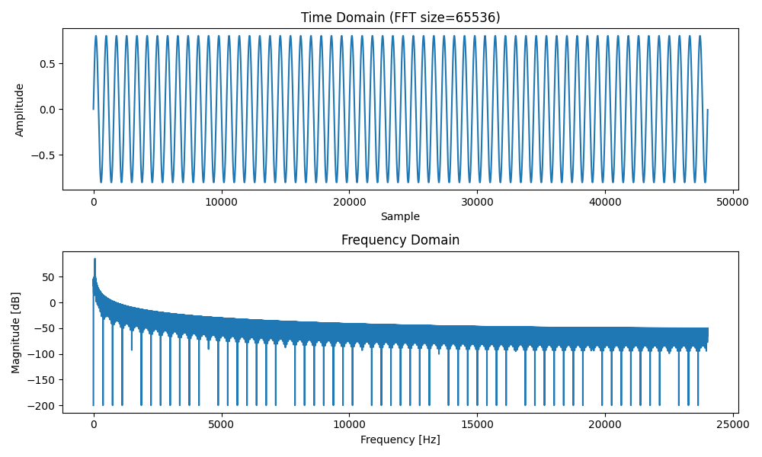

Highest peak at: 60.06 Hz  
Amplitude: 19082.44 dB

# Analysis of sin_440Hz.wav

## FFT Size: 256

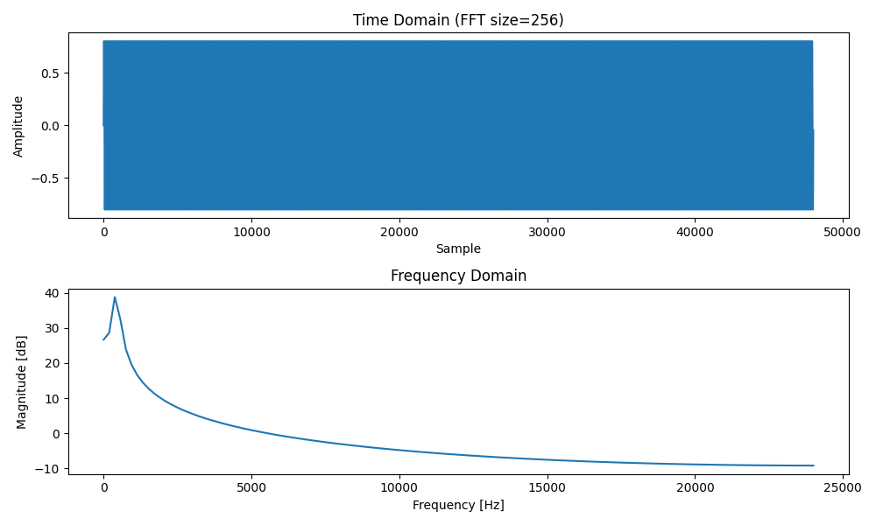

Highest peak at: 377.95 Hz  
Amplitude: 86.98 dB

## FFT Size: 4096

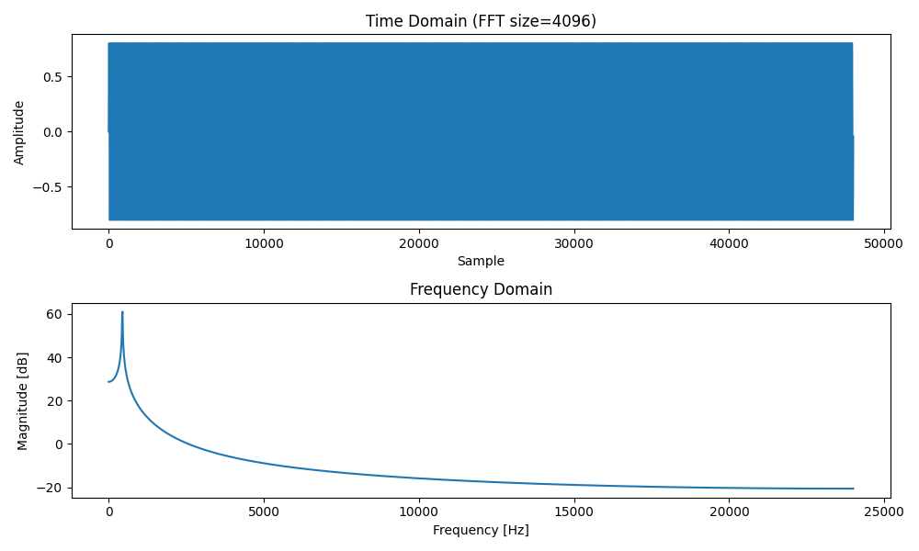

Highest peak at: 445.53 Hz  
Amplitude: 1131.43 dB

## FFT Size: 65536

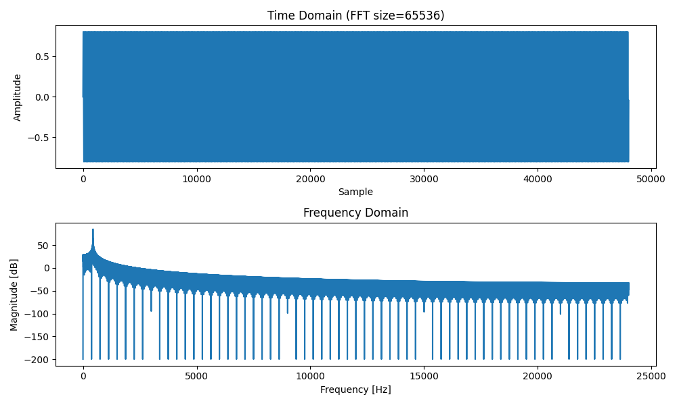

Highest peak at: 440.20 Hz  
Amplitude: 18127.19 dB

# Analysis of sin_8000Hz.wav

## FFT Size: 256

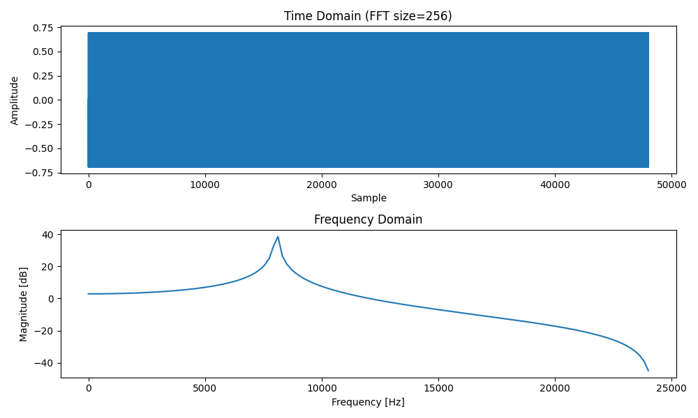

Highest peak at: 8125.98 Hz  
Amplitude: 84.29 dB

## FFT Size: 4096

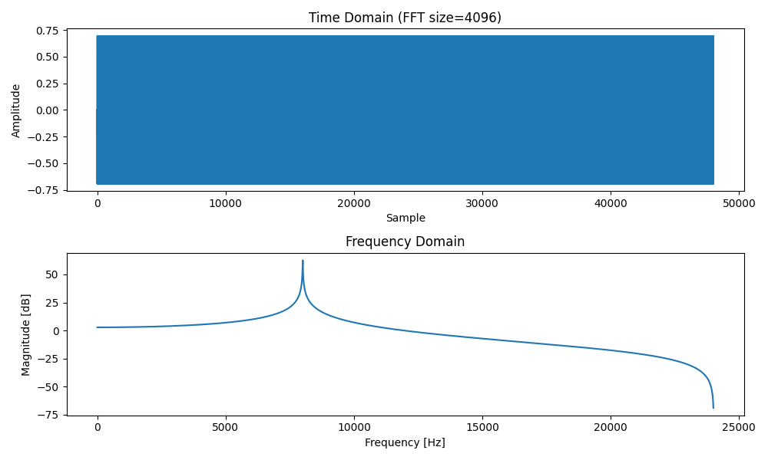

Highest peak at: 8007.82 Hz  
Amplitude: 1354.55 dB

## FFT Size: 65536

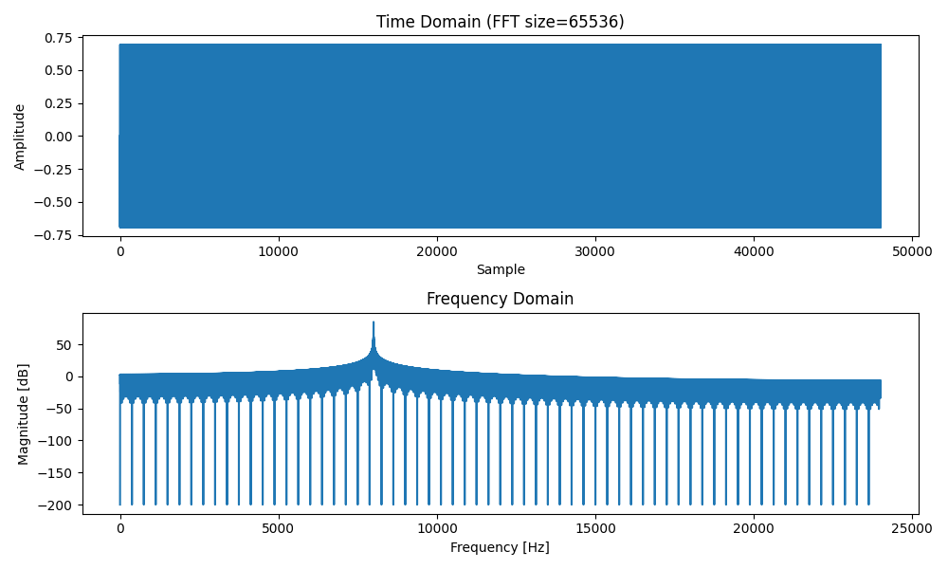

Highest peak at: 8000.49 Hz  
Amplitude: 17371.96 dB