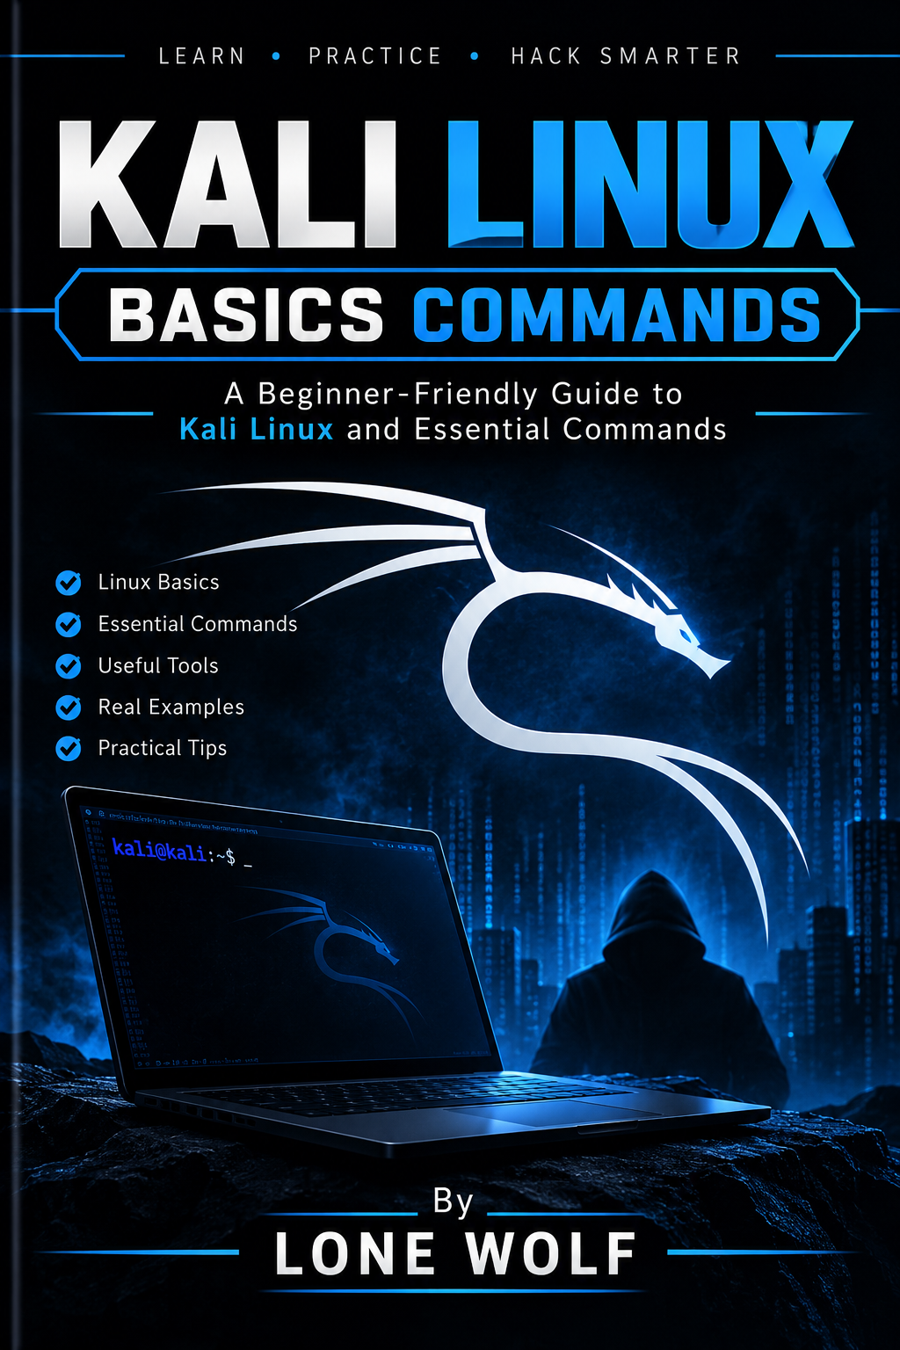

Hi there, Am Lone Wolf ( A Pakistani Certified Ethical Hacker). I designed this book for beginners who want to learn Kali Linux commands from scratch. Every command is explained in very simple language with easy examples so anyone can understand, learn, and practice without difficulty.

Part 1 — Basic Linux Commands
Command | Easy Explanation
pwd | Shows your current folder.
ls | Shows files and folders.
ls -l | Shows files with more details.
ls -la | Shows hidden files too.
cd folder | Moves into a folder.
cd .. | Goes one folder back.
cd ~ | Goes to your home folder.
clear | Clears the terminal screen.
whoami | Shows your current username.
id | Shows your user ID and groups.
hostname | Shows the computer name.
date | Shows date and time.
history | Shows commands you used before.
man command | Shows the manual for a command.
command --help | Shows basic help for a command.

Part 2 — Files & Folders
Command | Easy Explanation
mkdir test | Creates a new folder.
touch file.txt | Creates an empty file.
cp file.txt backup.txt | Copies a file.
cp -r folder backup | Copies a folder.
mv file.txt /tmp/ | Moves a file.
mv old.txt new.txt | Renames a file.
rm file.txt | Deletes a file.
rm -r folder | Deletes a folder and its files.
rmdir folder | Removes an empty folder.
file test.txt | Tells you what type of file it is.
stat file.txt | Shows file information.

Part 3 — Read & Search Files
Command | Easy Explanation
cat file.txt | Shows the whole file.
less file.txt | Opens a file page by page.
head file.txt | Shows the first lines.
tail file.txt | Shows the last lines.
tail -f log.txt | Watches new lines added to a log.
grep "admin" file.txt | Finds admin inside a file.
grep -i "admin" file.txt | Finds it without caring about capital letters.
grep -r "admin" folder/ | Searches inside a folder and its files.
find / -name "test.txt" | Searches for a file by name.
which nmap | Shows where a command is installed.
whereis nmap | Shows locations related to a command.
locate test.txt | Quickly searches for a file name.

Part 4 — Permissions
Command | Easy Explanation
ls -l | Shows file permissions.
chmod +x script.sh | Makes a script executable.
chmod 644 file.txt | Sets common file permissions.
chmod 755 script.sh | Gives the owner full access and others read/run access.
chown user file.txt | Changes the file owner.
sudo command | Runs a command with admin rights.
sudo -i | Opens an admin shell.

Part 5 — Processes
Command | Easy Explanation
ps | Shows running processes.
ps aux | Shows many running processes.
top | Shows processes live.
htop | Easier process viewer.
pgrep firefox | Finds Firefox's process ID.
kill PID | Stops a process.
kill -9 PID | Force-stops a process.
jobs | Shows background jobs.
bg | Sends a stopped job to background.
fg | Brings a background job back.

Part 6 — Networking
Command | Easy Explanation
ip addr | Shows network interfaces and IPs.
ip link | Shows network interfaces.
ip route | Shows the routing table.
ping 8.8.8.8 | Checks if a host responds.
ss -tuln | Shows listening network ports.
ss -tulpn | Shows listening ports with process information.
ip neigh | Shows nearby devices known to your system.
hostname -I | Shows your local IP address.
curl example.com | Gets data from a website.
wget example.com/file | Downloads a file.
dig example.com | Gets DNS information.
nslookup example.com | Looks up DNS information.
traceroute example.com | Shows the path toward a host.

Part 7 — Disk & System Information
Command | Easy Explanation
df -h | Shows free disk space.
du -sh folder | Shows folder size.
free -h | Shows RAM usage.
uname -a | Shows system information.
lsblk | Shows disks and partitions.
mount | Shows mounted storage.
uptime | Shows how long the system has been running.
lscpu | Shows CPU information.
lsusb | Shows USB devices.
lspci | Shows PCI devices.

Part 8 — Package Management
Command | Easy Explanation
sudo apt update | Updates the package list.
sudo apt upgrade | Updates installed packages.
sudo apt install nmap | Installs Nmap.
sudo apt remove nmap | Removes Nmap.
apt search nmap | Searches for a package.
apt show nmap | Shows package information.
sudo apt autoremove | Removes unused packages.

Part 9 — Archives
Command | Easy Explanation
tar -cf file.tar folder/ | Creates a TAR archive.
tar -xf file.tar | Extracts a TAR file.
tar -czf file.tar.gz folder/ | Creates a compressed archive.
tar -xzf file.tar.gz | Extracts a .tar.gz file.
unzip file.zip | Extracts a ZIP file.
zip -r backup.zip folder/ | Creates a ZIP archive.

Part 10 — Useful Kali/Security Commands
Command | Easy Explanation
nmap TARGET | Scans a host for open ports.
nmap -sV TARGET | Tries to find service versions.
nmap -O TARGET | Tries to identify the OS.
nmap -p 80,443 TARGET | Scans specific ports.
nmap -A TARGET | Enables several Nmap detection features.
whois example.com | Shows domain registration information.
dig example.com | Checks DNS records.
curl -I https://example.com | Shows HTTP response headers.
wget URL | Downloads content.
openssl version | Shows OpenSSL version.
sha256sum file | Creates a SHA-256 hash of a file.
md5sum file | Creates an MD5 hash of a file.

Part 11 — Shell & Environment
Command | Easy Explanation
echo "Hello" | Prints text.
echo $PATH | Shows command search paths.
env | Shows environment settings.
export NAME=value | Creates an environment value.
alias ll='ls -la' | Creates a shortcut for a command.
history | Shows previous commands.
source file.sh | Runs settings from a shell file.
bash script.sh | Runs a Bash script.
chmod +x script.sh | Allows the script to run directly.
./script.sh | Runs the script from the current folder.

