**MRBS EMULATOR SYSTEM SETUP GUIDELINE**

1. **Clone source code**

* Clone the source code from Github repository <https://github.com/ftdichipsg/MRBS>

|  |
| --- |
| $ git clone <https://github.com/ftdichipsg/MRBS>_PanL70  $ git pull  $ git checkout panl70-dev |

1. **PanL70 software compilation and running**

* Open MSVC++ in folder *MRBS\panl70\MRBS_PanL_Display\MRBS_PanL_Emulator*
* Before compile the Emulator software, select the **Solution Platform** is **x86** and then select **Build/Build Solution** in menu bar

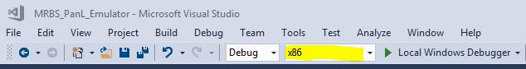  
  
If build has no error the ***MRBS_PanL_Emulator.exe***file will be compiled in *MRBS\panl70\MRBS_PanL_Display\MRBS_PanL_Emulator\Debug* folder

* The application can directly run by double click with default configuration (server port: 9999, server IP 127.0.0.1, PanL70 MAC: 16 and UUID: 10:20:30:40:50:60:70:80). However it can be run via ***window’s command prompt (cmd.exe)*** to configure the configurations. The option list is listed as bellow:

**-m <addr>**

Setting BACnet MAC address,

eg. ./MRBS_PanL_Emulator.exe -m 255

**-u <seg0:seg1:seg2:seg3:seg4:seg5:seg6:seg7>**

Setting BACnet UUID,

eg. ./MRBS_PanL_Emulator.exe -u 10:20:30:40:50:60:70:80

**-p <addr>**

Setting port address for MRBS Agent,

ex. ./MRBS_PanL_Emulator.exe -p 8080

**-i <seg0.seg1.seg2.seg3>**

Setting IP address for MRBS Agent,

ex. ./MRBS_PanL_Emulator.exe -i 192 168 1 1

NOTE : all arguments above can be combined to pass to the application

Eg. ./MRBS_PanL_Emulator.exe -m 255 -u 10:20:30:40:50:60:70:80 –p 8080

* To run PanL70 Emulator app in command prompt it need to open cmd.exe at *MRBS\panl70\MRBS_PanL_Display\MRBS_PanL_Emulator\Debug* folder or folder that contain ***MRBS_PanL_Emulator.exe*** app

Run commands in command prompt

|  |
| --- |
| $ cd MRBS\panl70\MRBS_PanL_Display\MRBS_PanL_Emulator\Debug  $ MRBS_PanL_Emulator.exe [configuration] |

1. **PanL Controller compilation and running**

* Open Cygwin and go to directory *MRBS\agent* and do steps will be mentioned bellow to compile Agent and Hub test:

|  |
| --- |
| $ cd <Your_Driver>  $ cd MRBS_PanL70/agent  $ make clean  $ make |

If everything done with no error, two applications named ***mrbsagent.exe*** and ***mrbshub_test.exe*** will appear in this folder.

To run these apps, Open Cygwin at *MRBS\agent* directory and run command:

$ ./mrbsagent.exe  
$ ./mrbshub_test.exe

Each app must be run in one Cygwin Terminal

**Note:** The computer needs to be installed Cygwin and GCC packets before. To install Cygwin, go to <https://www.cygwin.com/> to download a version accordingly with your operating system.

1. **Running Emulator system**



Figure 1: Emulator system block diagram

* **Step 1:** Run the mrbsagent.exe application. Open the Cygwin terminal and run this application via command line with command listed as bellow:

|  |
| --- |
| $ ./mrbsagent.exe |

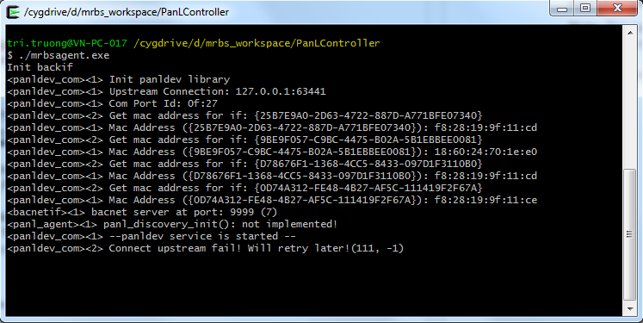

Image 1: Open the mrbsagent.exe by Cygwin terminal

* **Step 2:** Run the mrbshub_test.exe application. The way to run his application is same with mrbsagent.exe app mentioned above.

|  |
| --- |
| $ ./mrbshub_test.exe |

* **Step 3:** Run the PanL70 Emulator application as mentioned at section 1

1. **Run Emulator system by script**

* Step 1: Clone MRBS_PanL70 repository by do steps mentioned in sections 1
* Step 2: Compile MRBS Emulator by steps mentioned in section 2
* Step 3: Compile Agent and Hub test (run on Windows OS)
  + Open Cygwin and go to directory *MRBS\agent* and do steps will be mentioned bellow to compile Agent and Hub test:

|  |
| --- |
| $ cd <Your_Driver>  $ cd MRBS_PanL70/agent  $ make clean  $ make |

* + If everything done with no error, two applications named ***mrbsagent.exe*** and ***mrbshub_test.exe*** will appear in this folder.
* Step 4: Open *MRBS_PanL70\tools\RunEmulator* folder and edit **configurations.jon** file if necessary.

"panl70_emulator_app_dir":"D:\\MRBS_PanL70\\panl70\\MRBS_PanL_Display\\MRBS_PanL_Emulator\\Debug\\MRBS_PanL_Emulator.exe",

"agent_app_dir":"D:\\MRBS_PanL70\\agent\\mrbsagent.exe",

"mrbs_hub_dir":"D:\\MRBS_PanL70\\agent\\mrbshub_test.exe",

Three fields above point to location which contains the MRBS_PanL_Emulator.exe, mrbsagent.exe, mrbshub_test.exe applications.

The fields mentioned bellow are information of Agent and 8 PanL70 Emulator applications will be started

"agent":

[

{

"agent_info": { "hub_port": "633441", "bacnet_port":"9999", "hub_ip":"127.0.0.1", "mac": "10" },

"panl70_info":

[

{ "uuid": "01:02:03:04:05:06:07:01", "mac": "01" },

{ "uuid": "01:02:03:04:05:06:07:02", "mac": "02" },

{ "uuid": "01:02:03:04:05:06:07:03", "mac": "03" },

{ "uuid": "01:02:03:04:05:06:07:04", "mac": "04" },

{ "uuid": "01:02:03:04:05:06:07:05", "mac": "05" },

{ "uuid": "01:02:03:04:05:06:07:06", "mac": "06" },

{ "uuid": "01:02:03:04:05:06:07:07", "mac": "07" },

{ "uuid": "01:02:03:04:05:06:07:08", "mac": "08" }

]

}

]

If user want to run more than one Agent, just copy the content into the bracket “{ }” like bellow:

"agent":

[

{

"agent_info": { "hub_port": "633441", "bacnet_port":"9999", "hub_ip":"127.0.0.1", "mac": "10" },

"panl70_info":

[

{ "uuid": "01:02:03:04:05:06:07:01", "mac": "01" },

{ "uuid": "01:02:03:04:05:06:07:02", "mac": "02" },

{ "uuid": "01:02:03:04:05:06:07:03", "mac": "03" },

{ "uuid": "01:02:03:04:05:06:07:04", "mac": "04" },

{ "uuid": "01:02:03:04:05:06:07:05", "mac": "05" },

{ "uuid": "01:02:03:04:05:06:07:06", "mac": "06" },

{ "uuid": "01:02:03:04:05:06:07:07", "mac": "07" },

{ "uuid": "01:02:03:04:05:06:07:08", "mac": "08" }

]

},

{

"agent_info": { "hub_port": "633441", "bacnet_port":"9999", "hub_ip":"127.0.0.1", "mac": "11" },

"panl70_info":

[

{ "uuid": "01:02:03:04:05:06:07:01", "mac": "01" },

{ "uuid": "01:02:03:04:05:06:07:02", "mac": "02" },

{ "uuid": "01:02:03:04:05:06:07:03", "mac": "03" },

{ "uuid": "01:02:03:04:05:06:07:04", "mac": "04" },

{ "uuid": "01:02:03:04:05:06:07:05", "mac": "05" },

{ "uuid": "01:02:03:04:05:06:07:06", "mac": "06" },

{ "uuid": "01:02:03:04:05:06:07:07", "mac": "07" },

{ "uuid": "01:02:03:04:05:06:07:08", "mac": "08" }

]

}

]

NOTE: user must to change the **“mac”:”<value>”** in **“agent_info”** field

* Step 4 :after ensure that all configurations are correct, execute script by run command in Cygwin:

|  |
| --- |
| $ python Run_emulator.py |

Script will start Hub test, Agent and PanL70s with configurations in json file