**Trang Hone tạo mới :**

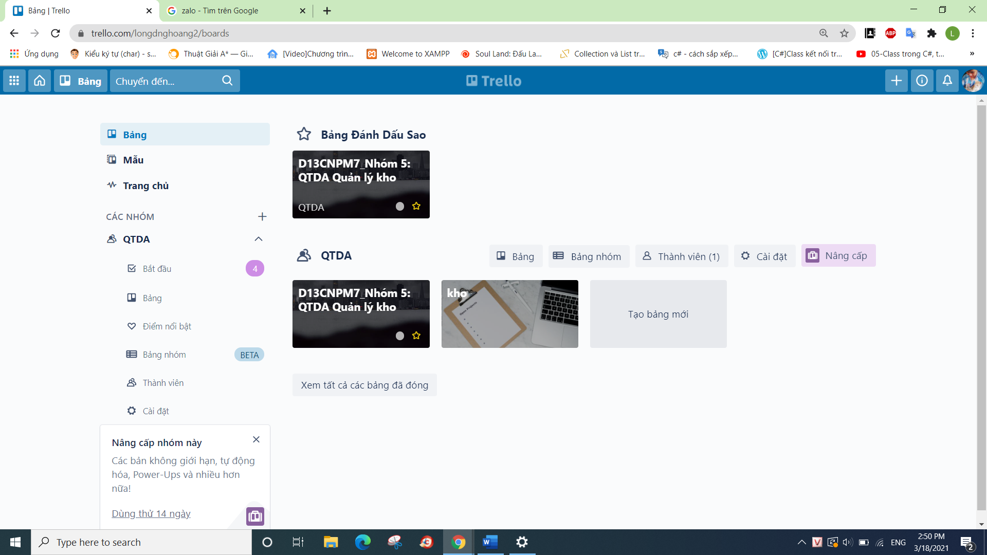

**Tạo nhóm mới**

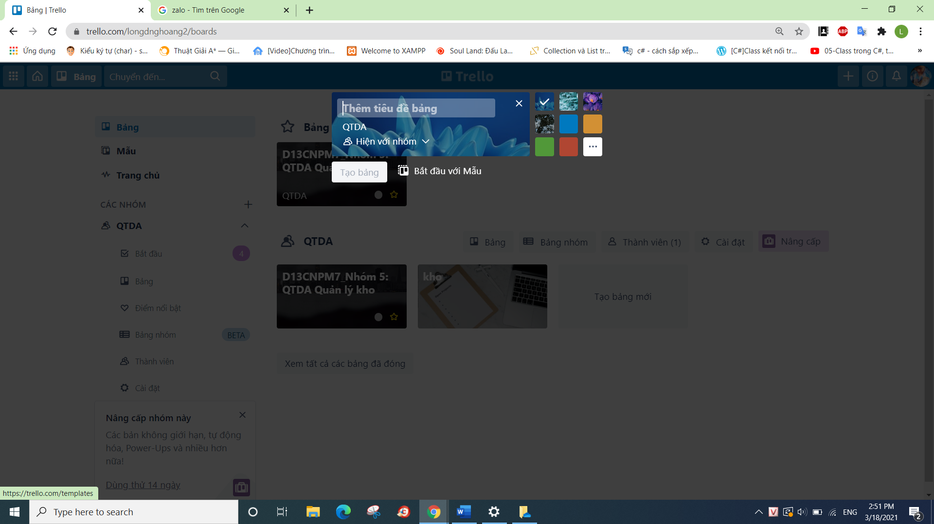

**Tạo nhóm thành công :**

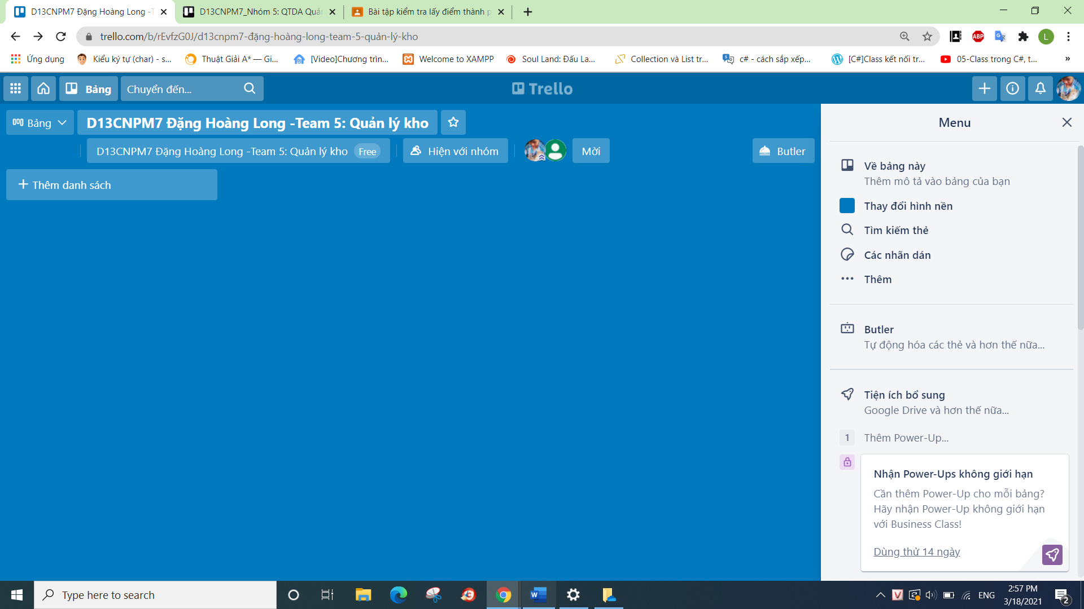

**MỜi thầy vào :**

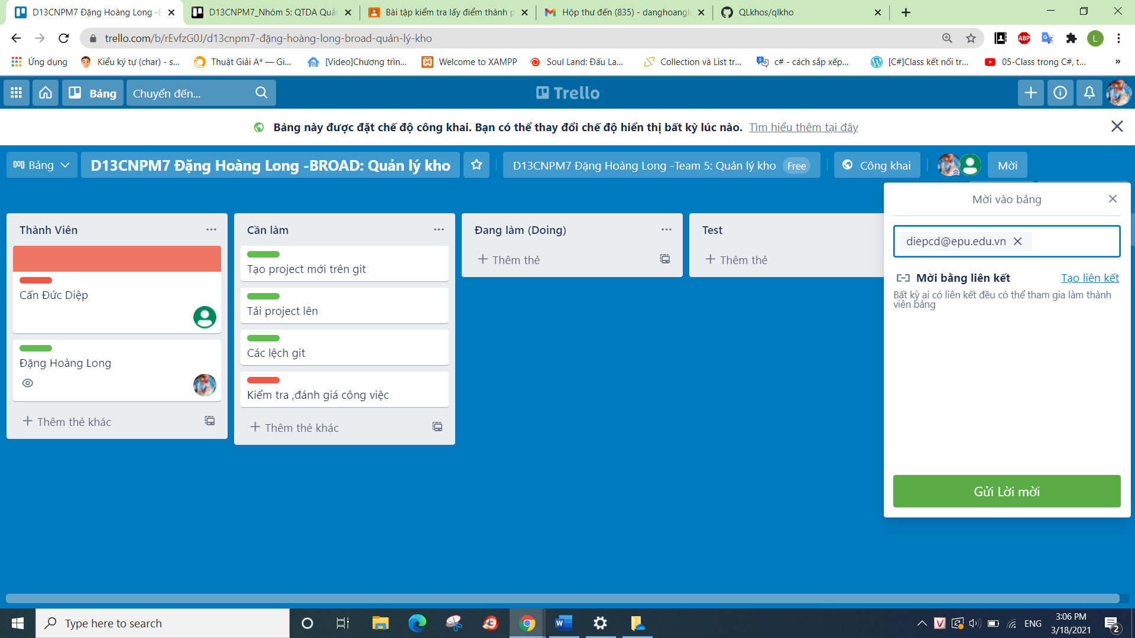

**Tạo các thẻ công việc**

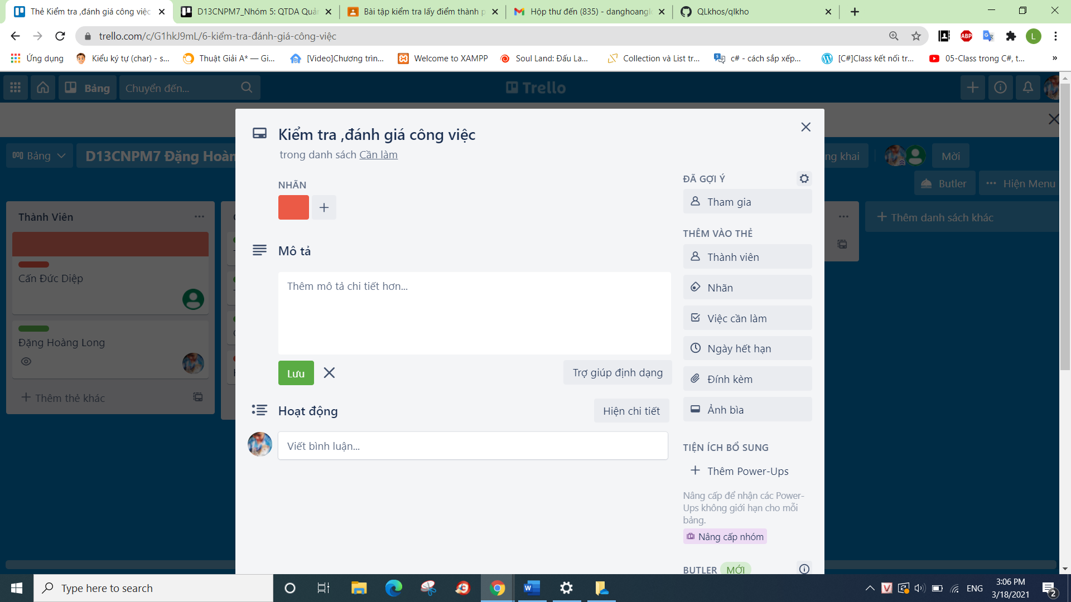

**Tạo công việc kéo xang bảng đang làm**

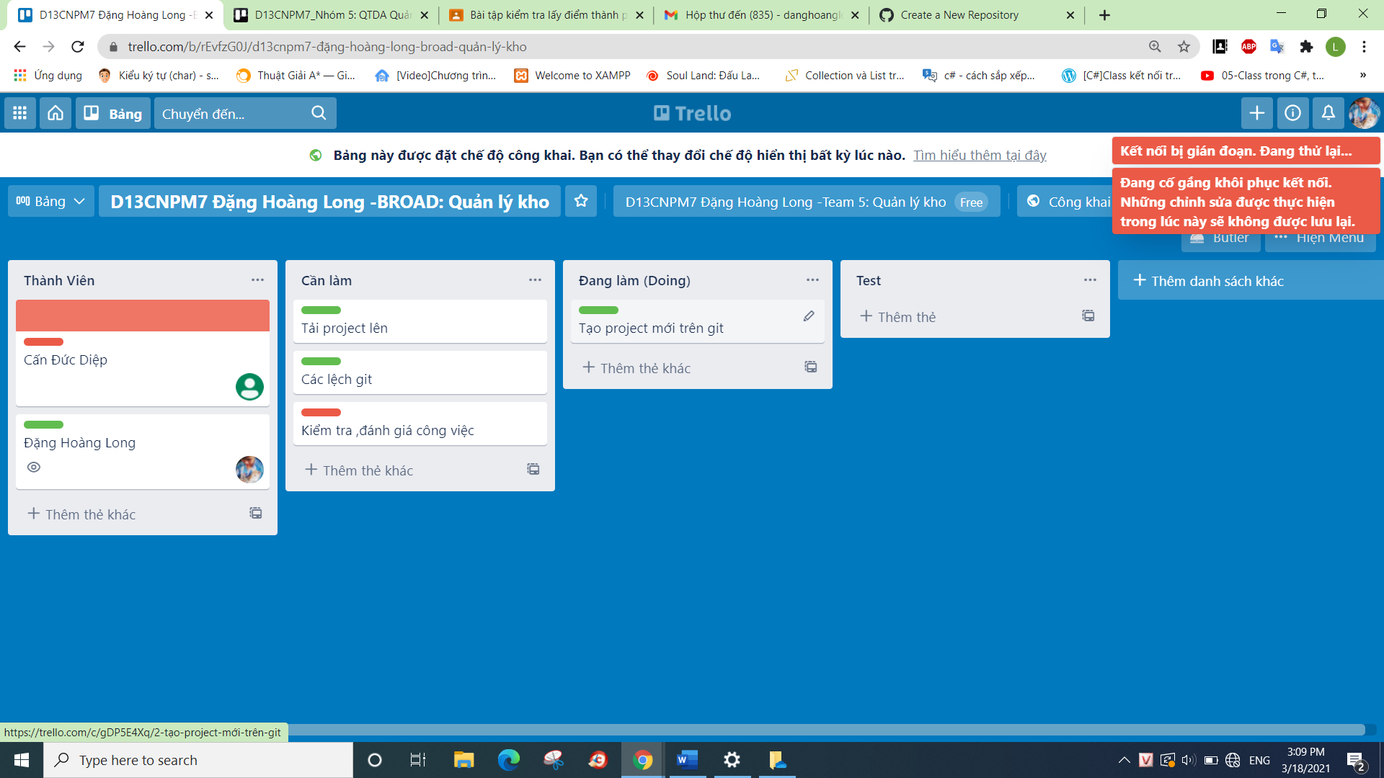

**Tạo git thành công**

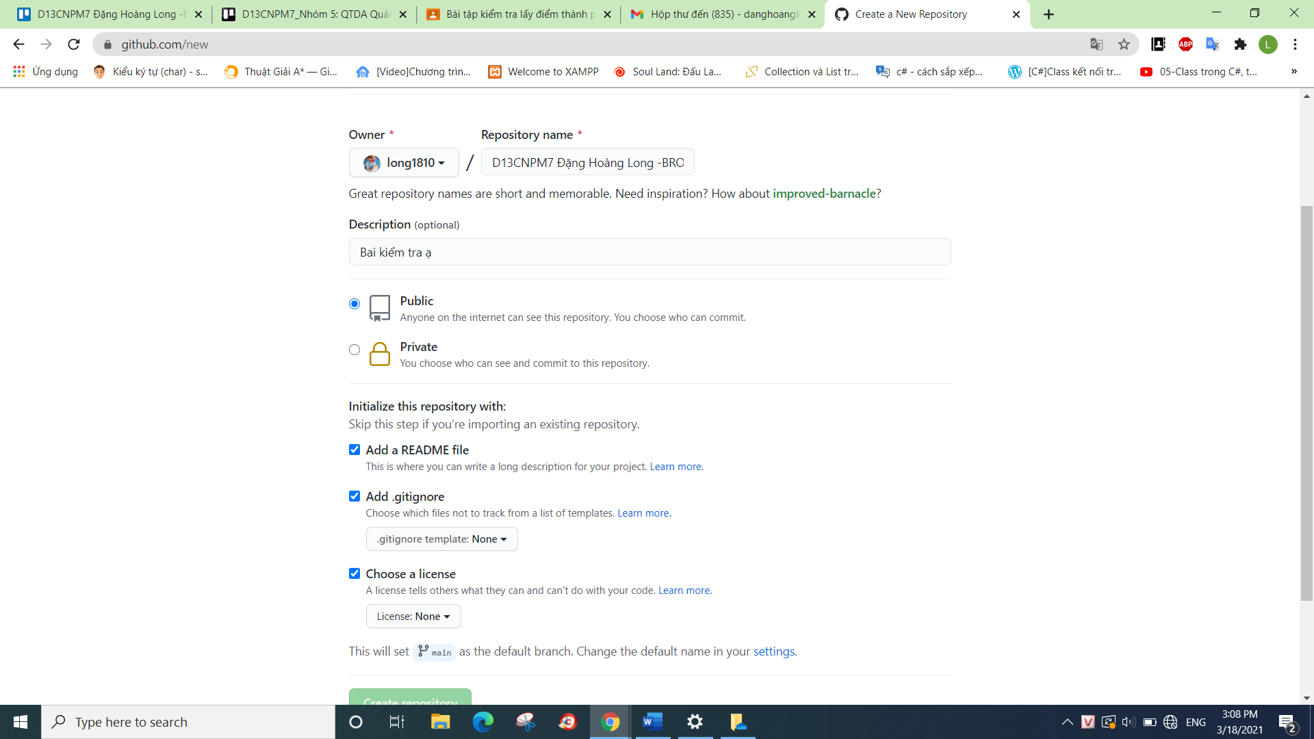

**ĐÃ tạo thành công Git :**

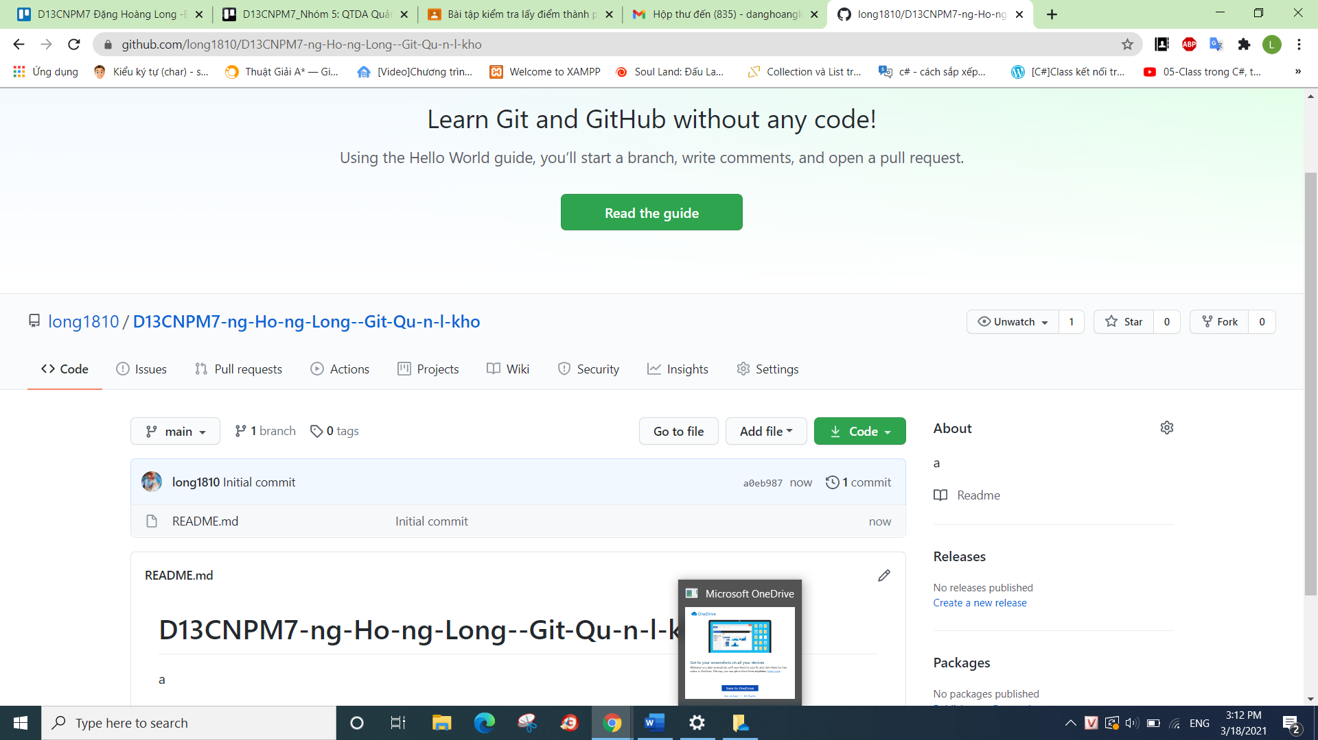

**Code git :**

**Code git :**

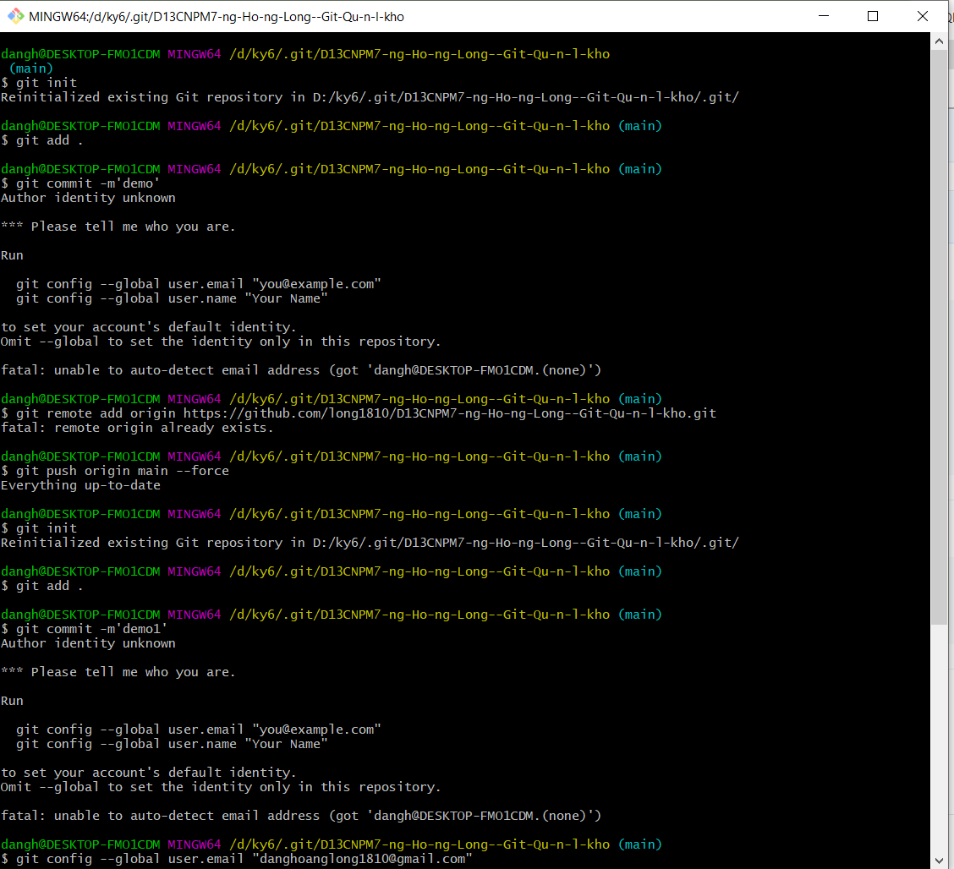

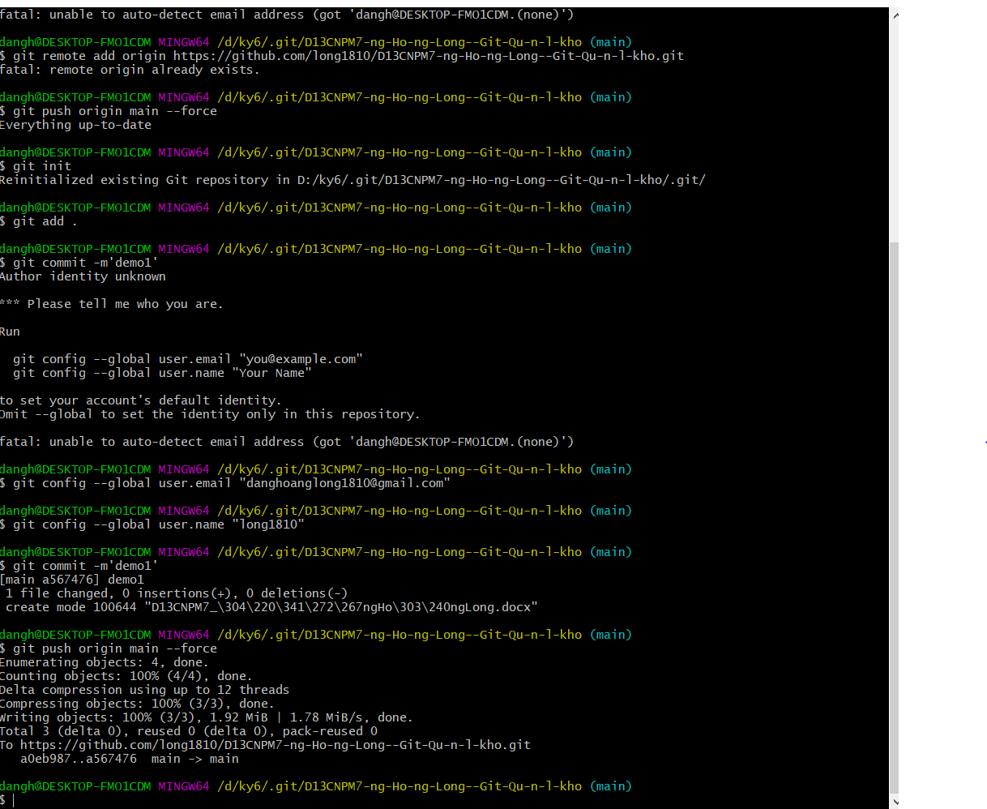

**Đã tai lên thành công**

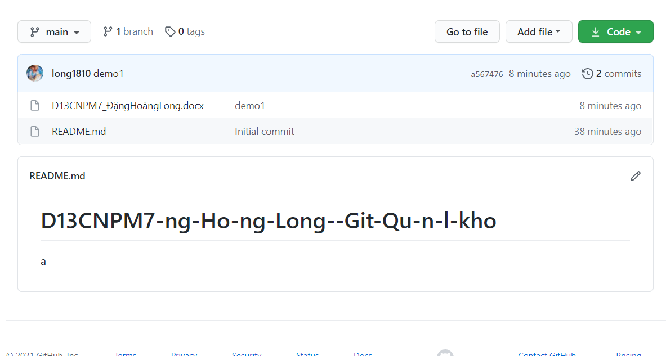

dangh@DESKTOP-FMO1CDM MINGW64 /d/ky6/.git/D13CNPM7-ng-Ho-ng-Long--Git-Qu-n-l-kho (main)

$ git init

Reinitialized existing Git repository in D:/ky6/.git/D13CNPM7-ng-Ho-ng-Long--Git-Qu-n-l-kho/.git/

dangh@DESKTOP-FMO1CDM MINGW64 /d/ky6/.git/D13CNPM7-ng-Ho-ng-Long--Git-Qu-n-l-kho (main)

$ git add .

dangh@DESKTOP-FMO1CDM MINGW64 /d/ky6/.git/D13CNPM7-ng-Ho-ng-Long--Git-Qu-n-l-kho (main)

$ git commit -m'demo'

Author identity unknown

*** Please tell me who you are.

Run

git config --global user.email "you@example.com"

git config --global user.name "Your Name"

to set your account's default identity.

Omit --global to set the identity only in this repository.

fatal: unable to auto-detect email address (got 'dangh@DESKTOP-FMO1CDM.(none)')

dangh@DESKTOP-FMO1CDM MINGW64 /d/ky6/.git/D13CNPM7-ng-Ho-ng-Long--Git-Qu-n-l-kho (main)

$ git remote add origin https://github.com/long1810/D13CNPM7-ng-Ho-ng-Long--Git-Qu-n-l-kho.git

fatal: remote origin already exists.

dangh@DESKTOP-FMO1CDM MINGW64 /d/ky6/.git/D13CNPM7-ng-Ho-ng-Long--Git-Qu-n-l-kho (main)

$ git push origin main --force

Everything up-to-date

dangh@DESKTOP-FMO1CDM MINGW64 /d/ky6/.git/D13CNPM7-ng-Ho-ng-Long--Git-Qu-n-l-kho (main)

$ git init

Reinitialized existing Git repository in D:/ky6/.git/D13CNPM7-ng-Ho-ng-Long--Git-Qu-n-l-kho/.git/

dangh@DESKTOP-FMO1CDM MINGW64 /d/ky6/.git/D13CNPM7-ng-Ho-ng-Long--Git-Qu-n-l-kho (main)

$ git add .

dangh@DESKTOP-FMO1CDM MINGW64 /d/ky6/.git/D13CNPM7-ng-Ho-ng-Long--Git-Qu-n-l-kho (main)

$ git commit -m'demo1'

Author identity unknown

*** Please tell me who you are.

Run

git config --global user.email "you@example.com"

git config --global user.name "Your Name"

to set your account's default identity.

Omit --global to set the identity only in this repository.

fatal: unable to auto-detect email address (got 'dangh@DESKTOP-FMO1CDM.(none)')

dangh@DESKTOP-FMO1CDM MINGW64 /d/ky6/.git/D13CNPM7-ng-Ho-ng-Long--Git-Qu-n-l-kho (main)

$ git config --global user.email "danghoanglong1810@gmail.com"

dangh@DESKTOP-FMO1CDM MINGW64 /d/ky6/.git/D13CNPM7-ng-Ho-ng-Long--Git-Qu-n-l-kho (main)

$ git config --global user.name "long1810"

dangh@DESKTOP-FMO1CDM MINGW64 /d/ky6/.git/D13CNPM7-ng-Ho-ng-Long--Git-Qu-n-l-kho (main)

$ git commit -m'demo1'

[main a567476] demo1

1 file changed, 0 insertions(+), 0 deletions(-)

create mode 100644 "D13CNPM7_\304\220\341\272\267ngHo\303\240ngLong.docx"

dangh@DESKTOP-FMO1CDM MINGW64 /d/ky6/.git/D13CNPM7-ng-Ho-ng-Long--Git-Qu-n-l-kho (main)

$ git push origin main --force

Enumerating objects: 4, done.

Counting objects: 100% (4/4), done.

Delta compression using up to 12 threads

Compressing objects: 100% (3/3), done.

Writing objects: 100% (3/3), 1.92 MiB | 1.78 MiB/s, done.

Total 3 (delta 0), reused 0 (delta 0), pack-reused 0

To https://github.com/long1810/D13CNPM7-ng-Ho-ng-Long--Git-Qu-n-l-kho.git

a0eb987..a567476 main -> main

dangh@DESKTOP-FMO1CDM MINGW64 /d/ky6/.git/D13CNPM7-ng-Ho-ng-Long--Git-Qu-n-l-kho (main)

$ git init

Reinitialized existing Git repository in D:/ky6/.git/D13CNPM7-ng-Ho-ng-Long--Git-Qu-n-l-kho/.git/

dangh@DESKTOP-FMO1CDM MINGW64 /d/ky6/.git/D13CNPM7-ng-Ho-ng-Long--Git-Qu-n-l-kho (main)

$ git add .

dangh@DESKTOP-FMO1CDM MINGW64 /d/ky6/.git/D13CNPM7-ng-Ho-ng-Long--Git-Qu-n-l-kho (main)

$ git commit -m'up file '

[main 878be0e] up file

1 file changed, 0 insertions(+), 0 deletions(-)

dangh@DESKTOP-FMO1CDM MINGW64 /d/ky6/.git/D13CNPM7-ng-Ho-ng-Long--Git-Qu-n-l-kho (main)

$ git push origin main --force

Enumerating objects: 5, done.

Counting objects: 100% (5/5), done.

Delta compression using up to 12 threads

Compressing objects: 100% (3/3), done.

Writing objects: 100% (3/3), 244.09 KiB | 2.42 MiB/s, done.

Total 3 (delta 1), reused 0 (delta 0), pack-reused 0

remote: Resolving deltas: 100% (1/1), completed with 1 local object.

To https://github.com/long1810/D13CNPM7-ng-Ho-ng-Long--Git-Qu-n-l-kho.git

a567476..878be0e main -> main

dangh@DESKTOP-FMO1CDM MINGW64 /d/ky6/.git/D13CNPM7-ng-Ho-ng-Long--Git-Qu-n-l-kho (main)

$ ^C

dangh@DESKTOP-FMO1CDM MINGW64 /d/ky6/.git/D13CNPM7-ng-Ho-ng-Long--Git-Qu-n-l-kho (main)

$