BÁO CÁO BÀI TẬP 3
KIỂM THỬ · ĐÓNG GÓI · TÀI LIỆU KỸ THUẬT
Nguyễn Ngô Ngọc Long · MSSV: 2374802010281
Track SE · Luồng L4: Phân công kỹ thuật viên và lịch hẹn
Repository: https://github.com/long191105/smartcrm-2374802010281-phan_cong_ky_thuat_vien
Tag v1.0 is published and publicly accessible. A fresh clone from the remote tag passed Docker startup, health, 78/78 container tests, and repeated migration/seed checks; terminal screenshots remain missing.
Cập nhật: 13/11/2026

1. Test Plan

1. Scope and scenarios
Verify the L4 login/session flow, ticket and appointment CRUD, assignment decisions, technician
workload boundaries, status history, input validation, sanitized errors, migration/seed repeatability,
Scope: verify login/session, ticket and appointment CRUD, assignment decisions, input validation, error handling, migration/seed behavior, and Docker runtime. L2-to-L4 integration and session-bound owner authorization are outside the current implementation.
deployment are outside the evidence available in this run.

2. Test data and methods
- Run the complete automated suite with the single command npm test.
- Use fixture technicians KT002 and KT999, ticket BH-900001/2025, and the repeatable seed.
- Cover valid operations, invalid input, unauthorized requests, actor mismatch (403), not found (404),
appointment overlap (409), workload values 14/15, malformed/oversized JSON (400/413), and repeat
migration/seed behavior.
- The suite uses Node's test runner, HTTP test servers, fake repositories, and test-double database
runners. The migration/seed repeatability tests are not a substitute for a fresh PostgreSQL run.

3. Environment and acceptance criteria
- Required runtime: Node.js 20 or newer. The latest local verification used Node.js 24.21.0 on Windows.
- npm test must exit 0 with every test passing; npm run build must exit 0.
- Invalid business data follows the current API contract and returns 422. The assignment checklist's
requested 400 is recorded as a rubric discrepancy, not silently reported as compliant.
- The database health endpoint must return {"status":"ok","db":"up"} only when PostgreSQL answers.
- Docker Compose must show db and app healthy, with no database host port published.

4. Results and evidence
Latest test run: 78/78 PASS and build PASS. A real PostgreSQL outage now returns sanitized HTTP 503; recovery returns healthy. Evidence and remaining screenshot/tag gaps are detailed below.
The live Docker health screenshot is included in the validation addendum. A fresh clone from the public v1.0 tag passed startup, health, container tests, and repeated migration/seed checks. Terminal screenshots for docker compose ps and npm test are not saved; genuine command output is recorded in docs/evidence/16-docker-validation.txt.
docs/api-reference-bt3.md documents the current Express route inventory. The original BT3 brief for
items S2–S4 was not included, so those items are not inferred.

2. Test Report
Live verification dated 13/11/2026: a fresh clone from the public v1.0 tag used .env.example; Docker Compose build and startup passed, both services became healthy, /health returned HTTP 200 on port 3000, and the container suite passed 78/78. Repeated migrations and seeds left PostgreSQL row counts unchanged. The earlier detailed table is a historical BT3 snapshot dated 12/11/2026. After BUG-04 was fixed, a real DB outage returned sanitized HTTP 503 without terminating the app. No terminal screenshots are claimed.

Historical BT3 evidence snapshot - 12/11/2026 (before Docker runtime verification)
This dated snapshot records the test and dependency results available on 12/11/2026 only. The current Docker and 78-test results are in the live retest addendum below.
changes, the current Windows/Node.js 24.21.0 run completed npm test with 77 PASS, 0 FAIL, 0 SKIP;
npm run build, npm ci, npm audit, and npm audit --omit=dev also passed. Docker/PostgreSQL live
integration was not run because Docker and psql are unavailable here. The following 12 representative
cases are selected from the 77-test run; they cover functional, validation, authorization, error-handling,
boundary, and database-runner behavior.
Mã | Tiền điều kiện | Các bước | Dữ liệu thử | Kết quả mong đợi | Ưu tiên | Kết quả thực tế | PASS/FAIL
BT3-01 | Functional: auth test server and manager fixture | Login, inspect response and cookie | Valid manager fixture | 200; user returned; HttpOnly session cookie | High | HTTP test verified user response and cookie attributes | PASS
BT3-02 | Authorization: no session cookie | Request GET /api/tickets | No cookie | 401; ticket service is not called | High | HTTP test returned 401; service call count remained zero | PASS
BT3-03 | Functional: waiting ticket and overloaded technician | Confirm assignment | BH-900001/2025, KT002, confirm_overload=true | 201; assignment and status/history are atomic | High | Repository test-double verified assignment transaction | PASS
BT3-04 | Validation: technician skill below minimum | Attempt assignment | KT002, proficiency 2 | 409 SKILL_MISMATCH; no assignment insert | High | Repository test verified conflict and no insert | PASS
BT3-05 | Functional/error: existing technician time slot | Create overlapping appointment | 60-minute overlapping slot | 409; rollback; no duplicate reservation | High | Appointment repository test verified rollback using test doubles | PASS
BT3-06 | Authorization: assigned technician is KT002 | Update status as another actor | changed_by=KT999 | 403; no status/history change | High | HTTP test returned 403 with no side effects; actor is client-supplied, so this is not identity-bound ownership proof | PASS*
BT3-07 | Validation: API session established | Create ticket with missing required fields | {} | 422 VALIDATION_ERROR; repository not called | High | API returned 422 and identified invalid fields; rubric's 400 expectation remains a discrepancy | PASS
BT3-08 | Error handling: authenticated API; valid but absent ticket code | Read ticket | BH-900099/2025 | 404; sanitized JSON without stack | Medium | HTTP test returned 404 with the common error envelope | PASS
BT3-09 | Error handling: JSON endpoint | Send malformed JSON | {"ticket_code": | 400 INVALID_JSON; no parser stack in response | Medium | HTTP regression test passed with sanitized response | PASS
BT3-10 | Boundary: 1 MiB JSON parser limit | Send body larger than limit | JSON body 1 MiB + 11 bytes | 413 PAYLOAD_TOO_LARGE; no parser details | Medium | HTTP regression returned 413; regression was 500 before BUG-02 fix | PASS
BT3-11 | Database behavior: migration runner with test database double | Apply migrations twice | Migration files 001–004 | Second run skips unchanged checksums | Medium | Runner test passed; not a live PostgreSQL run | PASS*
BT3-12 | Database behavior: seed runner with test database double | Run seed twice | Demo fixtures | Second run does not duplicate records | Medium | Runner and SQL guard tests passed; not a live PostgreSQL count | PASS*

* A different client-supplied changed_by is rejected, but the actor is not bound to the session.
PASS is against the implemented 422 contract; it does not satisfy the rubric's requested 400.
* Test-double result only; fresh Docker/PostgreSQL evidence remains outstanding.
Per-test-case screenshots are still pending. The live browser health image is included; the remote v1.0 clean clone passed, but terminal screenshots have not been saved.
terminal test evidence. To rerun an individual case, for example:
node --test --test-name-pattern="oversized JSON requests" tests/app.test.js
Historical status in the 12/11/2026 snapshot: Docker had not yet been run. The 13/11/2026 live run is documented in the addendum; the health screenshot is saved, while terminal screenshots are unavailable.
Live results: both services healthy and 78/78 container tests passed. The command outputs are recorded in docs/evidence/16-docker-validation.txt; no terminal image is claimed.

3. Nhật ký lỗi (Bug Log)

BUG-01 — Lệnh kiểm thử đầy đủ thất bại vì test còn trỏ tới mô-đun L2 đã bị loại khỏi repo
- Thời điểm: 30/10/2026, khi chạy npm test trước khi tích hợp CRUD Buổi 12.
- Tái lập: chạy npm test ở thư mục gốc với dependencies đã cài.
- Mức độ/Hiện tượng: Major — 44 test hiện hành PASS nhưng tests/ticket.service.test.js và tests/ticket.validator.test.js dừng với MODULE_NOT_FOUND.

- Mong đợi: một lệnh trong README chạy toàn bộ test của sản phẩm và trả mã thoát 0.
- Khoanh vùng/nguyên nhân: hai test nhập src/services/ticket.service và
src/validators/ticket.validator, là API tiếp nhận L2 cũ; kiến trúc hiện tại dùng
src/services/ticket-l4.service.js và Zod qua src/validation.js.
- Sửa nguyên nhân: chuyển hai bộ test sang xác nhận hợp đồng CRUD L4 và dữ liệu sai; giữ các
test trong lệnh chạy đầy đủ, không bỏ qua hoặc lọc lỗi.
- Xác nhận: lần chạy ban đầu npm test PASS 63/63; ngày 31/10/2026 chạy lại npm test
PASS 67/67 (0 fail, 0 skipped) và npm run build PASS, cả hai lệnh có mã thoát 0.
Migration/seed và CRUD được xác minh trên một PostgreSQL database riêng
smartcrm_l4_bt2_c5_20261031, không chạy lặp trên database workshop. Phần cập nhật test nằm trong
commit 408b196 (https://github.com/long191105/smartcrm-2374802010281-phan_cong_ky_thuat_vien/commit/408b196), commit này cũng thay đổi nhiều file chức năng/tài liệu nên không phải commit riêng
cho BUG-01.

Cập nhật kiểm chứng C5 và CRUD — 31/10/2026
- Tạo database PostgreSQL cô lập smartcrm_l4_bt2_c5_20261031.
- Chạy npm run migrate, npm run seed, rồi chạy lại cả hai lệnh. Lượt migrate thứ hai bỏ qua
đủ bốn migration theo checksum; số dòng sau seed lần 1 và lần 2 không đổi:
technician 2, technician_skill 7, ticket 18, ticket_assignment 17,
ticket_status_log 18, appointment 0; hai bảng xác thực vẫn rỗng trước bootstrap.
- Qua API HTTP có xác thực, thực hiện create/read/update/soft-delete cho ticket và appointment.
Ticket được lưu với trạng thái DA_DONG; appointment được lưu với trạng thái KHACH_HUY.
Đọc lại từ PostgreSQL xác nhận các bản ghi vẫn tồn tại theo đúng trạng thái mềm.
- Xóa database cô lập sau xác minh. Log kết quả và mã thoát 0 nằm tại
docs/evidence/09-c5-crud-validation.txt.

BUG-02 — JSON vượt giới hạn bị báo nhầm là lỗi hệ thống
- Thời điểm: 11/11/2026, khi bổ sung kiểm thử giới hạn request HTTP.
- Tái lập: gửi POST /api/auth/login với Content-Type: application/json và JSON body lớn hơn
1 MiB; có thể tái lập bằng node --test --test-name-pattern="oversized JSON requests" tests/app.test.js.
- Mức độ/Hiện tượng trước sửa: Major — body-parser báo entity.too.large, nhưng middleware trả HTTP 500 INTERNAL_ERROR thay vì 413.

- Mong đợi: HTTP 413 với lỗi JSON chung, không trả stack/chi tiết parser.
- Nguyên nhân: error middleware chỉ ánh xạ JSON sai cú pháp và AppError; lỗi kích thước từ
express.json({ limit: '1mb' }) rơi vào nhánh lỗi hệ thống mặc định.
- Sửa nguyên nhân: ánh xạ rõ type === 'entity.too.large' và status 413 thành
PAYLOAD_TOO_LARGE; thêm assertion HTTP kiểm status/body.
- Xác nhận: test hồi quy trước sửa tái hiện 500 (1 FAIL); sau sửa test riêng và npm test
PASS, response là 413. Sửa code/test nằm riêng trong commit
3b52a0e (https://github.com/long191105/smartcrm-2374802010281-phan_cong_ky_thuat_vien/commit/3b52a0e).

BUG-03 — PostgreSQL được publish trực tiếp ra host
- Thời điểm: 12/11/2026, khi rà soát yêu cầu đóng gói BT3.
- Tái lập: kiểm tra cấu hình Compose trước sửa; dịch vụ db có mapping
${DB_PORT:-5432}:5432.
- Mức độ/Hiện tượng: Major — PostgreSQL nhận kết nối từ host qua cổng 5432, trái với yêu cầu chỉ truy cập trong
mạng nội bộ của Compose.
- Mong đợi: không khai báo ports cho db; chỉ ứng dụng app được publish.
- Nguyên nhân: cấu hình Compose phục vụ thử nghiệm local trước đây mở cổng database ra host.
- Sửa nguyên nhân: bỏ mapping cổng DB, đổi dịch vụ API thành app, và thêm healthcheck dịch vụ
ứng dụng qua /health.
- Xác nhận: docker-compose.yml không khai báo ports cho db; lần chạy Docker ngày 13/11/2026 xác nhận db chỉ hiện 5432/tcp trong mạng Compose và cả db, app đều healthy. Phần thay đổi được ghi trong commit 8722b8a (https://github.com/long191105/smartcrm-2374802010281-phan_cong_ky_thuat_vien/commit/8722b8a).

4. Deployment Guide

1. Requirements
- Windows 10/11, macOS, or a 64-bit Linux distribution.
- Docker Engine or Docker Desktop 24 or newer.
- Docker Compose v2 (docker compose, not the legacy docker-compose binary).
- Git 2.30 or newer.
- At least 2 GB free disk space for the application/database images and sample volume.
- Host TCP port 3000 available. PostgreSQL port 5432 is internal to the Compose network and is not published.
Check the installed tools:
docker --version
docker compose version
git --version

2. Setup steps
Run each command from the directory in which you want the repository:
- Clone the repository:
git clone https://github.com/long191105/smartcrm-2374802010281-phan_cong_ky_thuat_vien.git
- Enter the project directory:
cd smartcrm-2374802010281-phan_cong_ky_thuat_vien
- Create the local environment file:
cp .env.example .env
- Start and build both services:
docker compose up -d --build
The application waits for PostgreSQL to become healthy. On a new volume, the database init scripts
apply the schema and sample data. The application then runs the checksum-based migrations, repeats
the idempotent seed, and creates or updates the demo login before listening. Re-running the startup
does not add duplicate sample rows. Do not commit .env.

3. Environment variables
Copy the safe sample values from .env.example. Replace the sample database and account passwords
before exposing the service beyond a local development machine.
Variable | Meaning | Example | Required
DATABASE_URL | Optional PostgreSQL connection URI; when set, it takes precedence over DB_*. | Leave blank | No
DB_HOST | Database hostname; Compose service name inside Docker. | db | Yes, unless DATABASE_URL is set
DB_PORT | PostgreSQL port inside the container network. | 5432 | No
DB_NAME | Database created by PostgreSQL. | smartcrm_l4_workshop | Yes, unless DATABASE_URL is set
DB_USER | PostgreSQL login. | postgres | Yes, unless DATABASE_URL is set
DB_PASSWORD | PostgreSQL password; use a unique value for a real deployment. | change_me_locally | Yes, unless DATABASE_URL is set
APP_PORT | Host port mapped to the API's container port 3000. | 3000 | No
PORT | Optional platform-provided port override. | Leave blank | No
AUTH_BOOTSTRAP_USERNAME | Initial login name; normalized to lowercase. | manager | Yes
AUTH_BOOTSTRAP_PASSWORD | Initial login password; 12–128 characters. | change_me_to_a_unique_12_char_password | Yes
AUTH_BOOTSTRAP_DISPLAY_NAME | Name shown for the initial account. | Demo Manager | Yes
AUTH_COOKIE_SECURE | Set to true when the service is behind HTTPS. | false for local HTTP | No
VITE_API_BASE_URL | Frontend API base path for local Vite development. | /api | No
VITE_API_PROXY_TARGET | Backend URL used by the local Vite proxy. | http://localhost:3000 | No

Compose sets DB_HOST=db for the application; do not change it to localhost in the container.
The database has no host ports mapping.

4. Sample data
The flat files db/init/001_create_tables.sql and db/init/002_seed_demo.sql invoke the checked-in
migration and seed SQL. The normal application startup also runs those idempotent scripts, including
when an existing volume skips PostgreSQL's one-time init directory.
The demo seed has 2 technicians, 7 technician-skill rows, 18 tickets (one unassigned and 17 assigned
open tickets), 17 assignments, and 18 initial status-history rows. Counts are verified by the seed
and schema tests. Live Docker counts captured on 13/11/2026 were 2 technicians, 7 skills, 18 tickets, 17 assignments, 18 status rows, 0 appointments, 1 auth user, and 4 migrations; restart counts were unchanged.
Demo sign-in:
- Username: manager
- Password: the current AUTH_BOOTSTRAP_PASSWORD value in .env (the sample value is shown above).

5. Verify it works
Check that both services report healthy:
docker compose ps
Expected: db and app show Up and (healthy).
Check API and database readiness:
curl -s http://localhost:3000/health
Expected JSON:
{"status":"ok","db":"up"}
Run all tests inside the application container:
docker compose exec app npm test
Expected: all tests pass, exit code 0.

Troubleshooting
- If port 3000 is already in use, set APP_PORT=3001 in .env, then run docker compose up -d --build
again and use http://localhost:3001/health.
- To inspect startup output, run docker compose logs app db.
- docker compose down stops services and keeps database data.
- docker compose down -v deletes the database volume and all data in it. Use it only when a full
local reset is intended, then run docker compose up -d --build again.

5. Checklist bảo mật
Statuses are evidence-based. Live retests now support checklist items 5 and 6 as complete; session-bound owner authorization remains incomplete.
# | Status | Evidence
1. No repository secrets | ĐÃ LÀM | git log --all --oneline -- .env and git ls-files .env return no entries; git check-ignore -v .env confirms .env is ignored.
2. Input validation and parameterized SQL | ĐÃ LÀM | Test case BT3-07 returned HTTP 422 VALIDATION_ERROR for an empty ticket body; repository queries use PostgreSQL placeholders such as $1. The rubric's example asks for 400, so this contract discrepancy remains explicit.
3. Owner-based access control | CHƯA LÀM | The status test returns 403 when changed_by differs from the assigned technician, but the client supplies that value and it is not bound to the authenticated session; this is not proof of owner authorization.
4. Password hashing | ĐÃ LÀM | Live query SELECT left(password_hash, 12) || '[REDACTED]' FROM auth_user LIMIT 1 returned scrypt$9adf0[REDACTED]; the stored value is a Node scrypt hash, not bcrypt $2b$10$.
5. Sanitized errors | ĐÃ LÀM | Live Docker outage test: after docker compose stop db, GET /health returned HTTP 503 {"status":"error","db":"down"}; app stayed up. Malformed JSON returned HTTP 400 INVALID_JSON. Neither response exposed a stack. See docs/evidence/16-docker-validation.txt.
6. Logs exclude secrets and personal data | ĐÃ LÀM | PowerShell scan for password, token, and 0[0-9]{9} returned LOG_SCAN=empty after the outage test and recovery. The pool emits only a generic error message, not the PostgreSQL error object.
7. Pinned dependencies and vulnerability scan | ĐÃ LÀM | Direct dependencies are exact-version pinned; npm audit and npm audit --omit=dev report 0 vulnerabilities after the upgrades recorded in the BT3 report.

No item is marked not applicable. Checklist items 5 and 6 passed the live retest; owner-based access control remains CHƯA LÀM because the actor identifier is client-supplied. Never include a real .env value, session cookie, or full password hash in a screenshot.

6. Tài liệu kỹ thuật — API Reference
This reference inventories every Express route in src/app.js and the route modules: 21 routes
(18 under /api, plus /, /health, and /health/ready). The API contract remains the detailed
source for request and response examples. No role-based authorization is implemented: business API
routes require an authenticated session, but the prototype has no technician/manager role enforcement.

Common rules
- JSON request bodies are limited to 1 MiB. Invalid JSON returns 400 INVALID_JSON; oversized
JSON returns 413 PAYLOAD_TOO_LARGE.
- Validation failures return 422 VALIDATION_ERROR; conflicts use 409; missing records use 404.
- Business endpoints use the smartcrm_session cookie. Login is the only way to create a session;
logout revokes a presented session and returns 204.
- Responses on API errors have { "error": "...", "message": "...", "fields": {} }.
- URL-encode ticket codes containing /, for example BH-900001%2F2025.

Routes
Method and path | Description | Authentication | Parameters | Success response | Error codes | Limits
GET / | Serve the built frontend; if no build is present, return service status JSON. | Not required. | Not applicable; route has no input. | 200 HTML when dist/ exists; otherwise JSON with service and status. | None beyond generic 500. | No request body.
GET /health | Check API and PostgreSQL connectivity. | Not required. | Not applicable; route has no input. | 200 {"status":"ok","db":"up"}. | 503 with {"status":"error","db":"down"}. | No body.
GET /health/ready | Compatibility readiness probe for PostgreSQL. | Not required. | Not applicable; route has no input. | 200 {"status":"ok","database":"connected"}. | 503 DATABASE_UNAVAILABLE. | No body.
POST /api/auth/login | Verify credentials and issue an HttpOnly session cookie. | Not required. | JSON username, password. | 200 {"user":{"username":"…","displayName":"…"}}; cookie expires after 8 hours. | 400 INVALID_JSON, 401 INVALID_CREDENTIALS, 413, 422, 500. | Body ≤1 MiB; username 1–64 chars, password 1–128 chars.
GET /api/auth/me | Return the authenticated user. | Valid session cookie required. | Cookie smartcrm_session; no query/body. | 200 {"user":{…}}. | 401 UNAUTHORIZED, 500. | Session lifetime 8 hours.
POST /api/auth/logout | Revoke the supplied session and clear its cookie. | No active session required; a cookie is optional. | Optional session cookie; no query/body. | 204 empty response. | 500. | One cookie; no body.
GET /api/tickets | List and filter tickets. | Valid session cookie required. | Query: ticket_code, status, center_code, category_name, limit, offset. | 200 {"items":[…],"total":n}. | 401, 422, 500. | limit 1–100, default 100; offset ≥0.
POST /api/tickets | Create a new MOI ticket. | Valid session cookie required. | Ticket fields documented in api_contract.md E9. | 201 with created ticket. | 400, 401, 409 TICKET_CODE_EXISTS, 413, 422, 500. | Body ≤1 MiB; issue description ≤2,000 chars.
GET /api/tickets/{ticketCode} | Read a ticket by code. | Valid session cookie required. | Path ticketCode; no query/body. | 200 with ticket. | 401, 404, 422, 500. | Code format BH-######/YYYY; URL-encode /.
PATCH /api/tickets/{ticketCode} | Update editable fields on an unassigned MOI ticket. | Valid session cookie required. | Path code; at least one editable ticket field in JSON. | 200 with updated ticket. | 400, 401, 404, 409, 413, 422, 500. | Body ≤1 MiB; fields are restricted by the service schema.
DELETE /api/tickets/{ticketCode} | Soft-close an eligible new ticket; preserves history. | Valid session cookie required. | Path code; JSON closed_by, optional note. | 200 with status:"DA_DONG". | 400, 401, 404, 409, 413, 422, 500. | Body ≤1 MiB; note ≤255 chars.
POST /api/tickets/{ticketCode}/assignment | Assign a waiting ticket to a technician. | Valid session cookie required; no role check. | Path code; JSON technician_code, assigned_by, optional confirm_overload. | 201 assignment and ticket status. | 400, 401, 404, 409, 413, 422, 500. | Body ≤1 MiB; overload confirmation required at 15 open tickets.
GET /api/tickets/{ticketCode}/history | Read assignment/status history. | Valid session cookie required. | Path code; no query/body. | 200 history list. | 401, 404, 422, 500. | No request body.
PATCH /api/tickets/{ticketCode}/status | Change status and write history atomically. | Valid session cookie required; technician identity is not session-bound. | Path code; JSON status, changed_by, optional note. | 200 with updated ticket. | 400, 401, 403, 404, 409, 413, 422, 500. | Body ≤1 MiB; note ≤255 chars; only documented next states.
GET /api/technicians | List/filter technicians and workload. | Valid session cookie required. | Query category_name, center_code, status, limit. | 200 {"items":[…],"total":n}. | 401, 422, 500. | limit 1–100, default 100.
GET /api/technicians/{technicianCode}/tickets | List assigned work for a technician. | Valid session cookie required; no role check. | Path technicianCode; optional query status. | 200 assigned-work list (empty when no rows match). | 401, 422, 500. | Technician code KT plus 3 digits.
GET /api/appointments | List appointments by technician/date. | Valid session cookie required. | Optional query technician_code, date (YYYY-MM-DD). | 200 appointment list. | 401, 422, 500. | Maximum 100 appointments.
POST /api/appointments | Create a reservation for an assigned ticket. | Valid session cookie required. | JSON fields documented in api_contract.md E4. | 201 with appointment. | 400, 401, 404, 409, 413, 422, 500. | Body ≤1 MiB; duration 15–240 minutes; overlaps rejected.
GET /api/appointments/{appointmentId} | Read an appointment. | Valid session cookie required. | Positive integer path appointmentId; no body. | 200 with appointment. | 401, 404, 422, 500. | Positive integer identifier.
PATCH /api/appointments/{appointmentId} | Change an active appointment. | Valid session cookie required. | Path ID; at least one editable appointment field in JSON. | 200 with updated appointment. | 400, 401, 404, 409, 413, 422, 500. | Body ≤1 MiB; duration 15–240 minutes; overlaps rejected.
DELETE /api/appointments/{appointmentId} | Soft-cancel an active appointment. | Valid session cookie required. | Positive integer path ID; no query/body. | 200 with status KHACH_HUY. | 401, 404, 409, 422, 500. | No request body; row is retained.

Actual database-backed API request and response examples are included in the live API section and `docs/api-reference-bt3.md`.
Fresh database-backed examples for login, ticket creation, assignment, and 403/409/422 responses are included in this report and docs/api-reference-bt3.md.

7. Ảnh chụp minh chứng
The UI images below are genuine screenshots from earlier application flows, not terminal test evidence. A genuine browser screenshot of the live health endpoint is included in the Docker addendum. The docker compose ps and container npm test results are recorded as text in docs/evidence/16-docker-validation.txt; no terminal screenshot is saved.
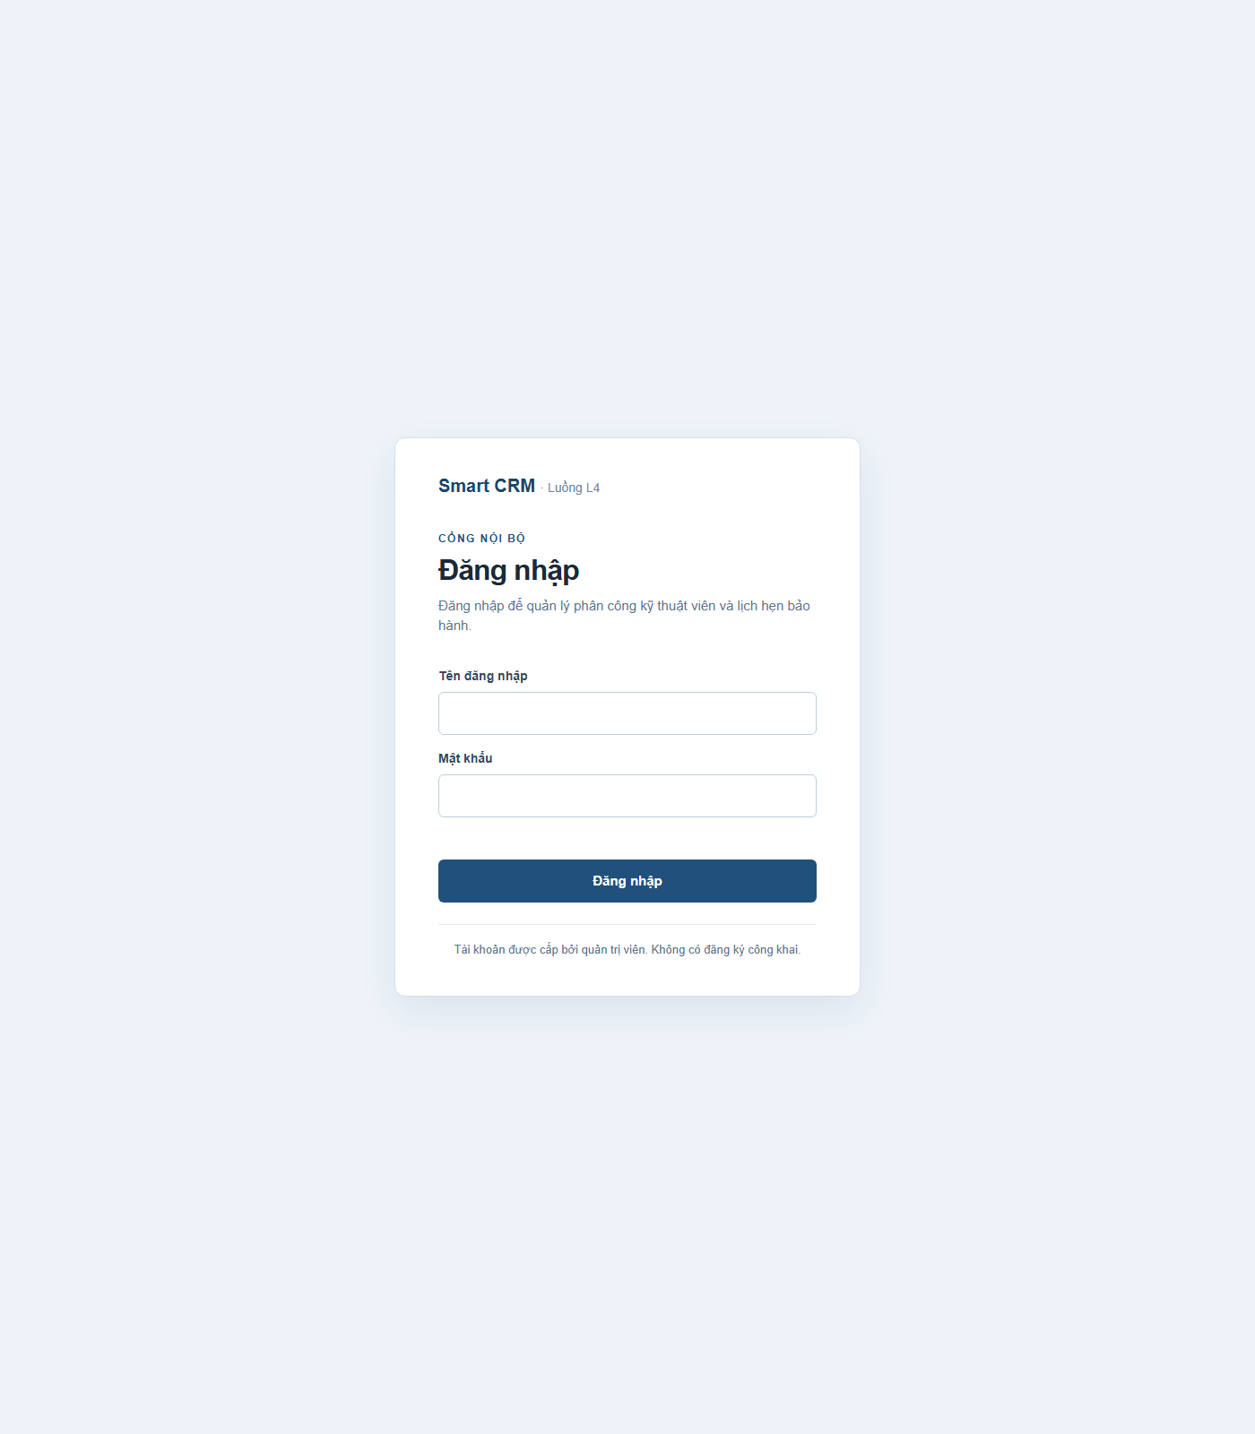
Màn hình đăng nhập Smart CRM.
File: docs/screenshots/ui-01-login.png

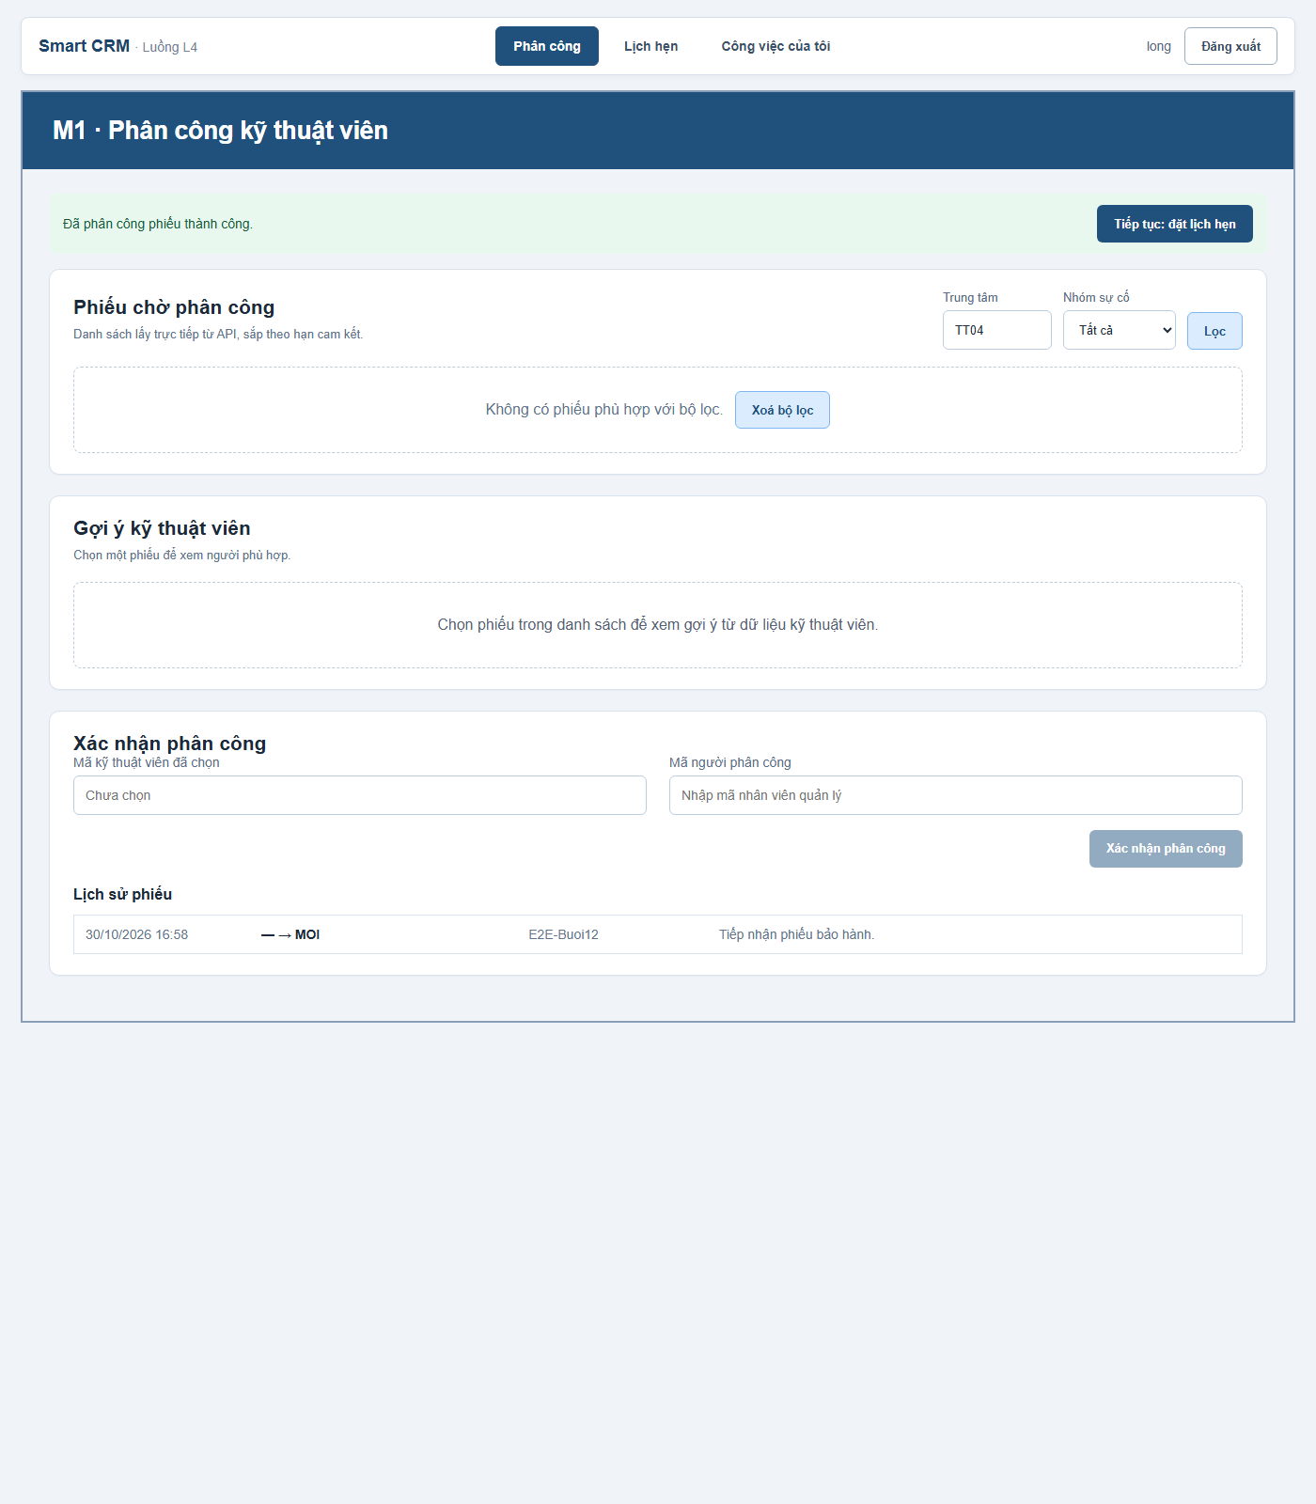
Giao diện phân công kỹ thuật viên.
File: docs/screenshots/ui-02-assignment-success.png

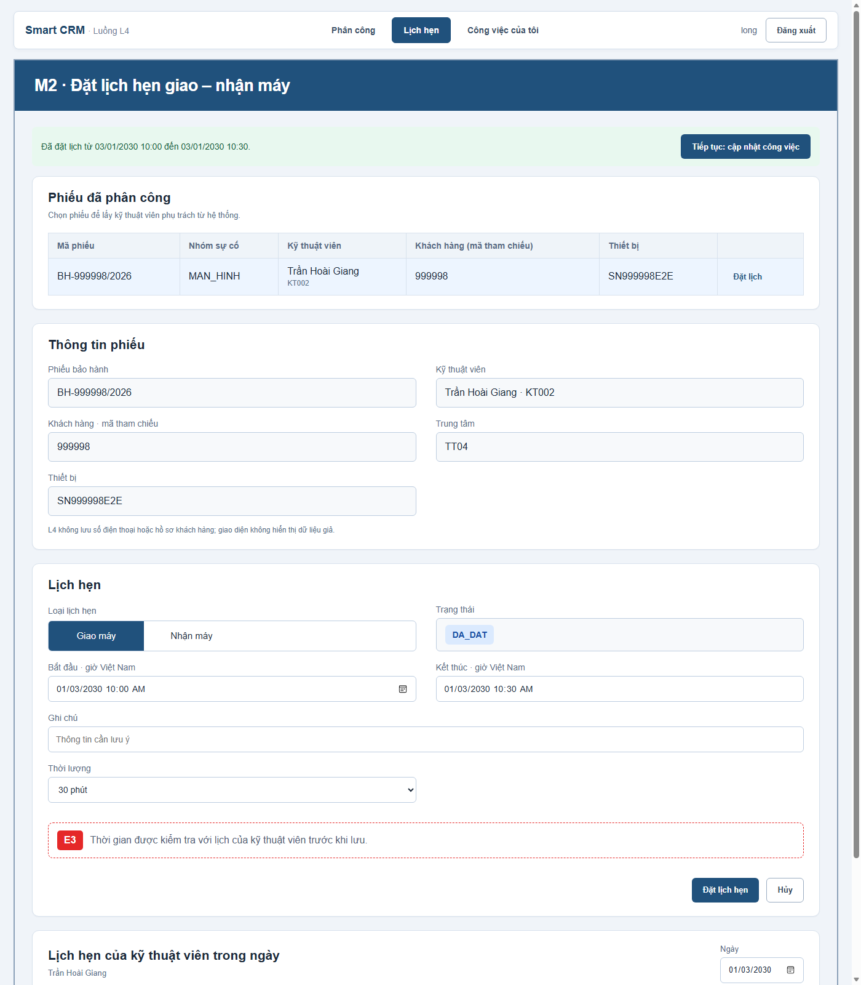
Giao diện đặt lịch hẹn.
File: docs/screenshots/ui-03-appointment.png

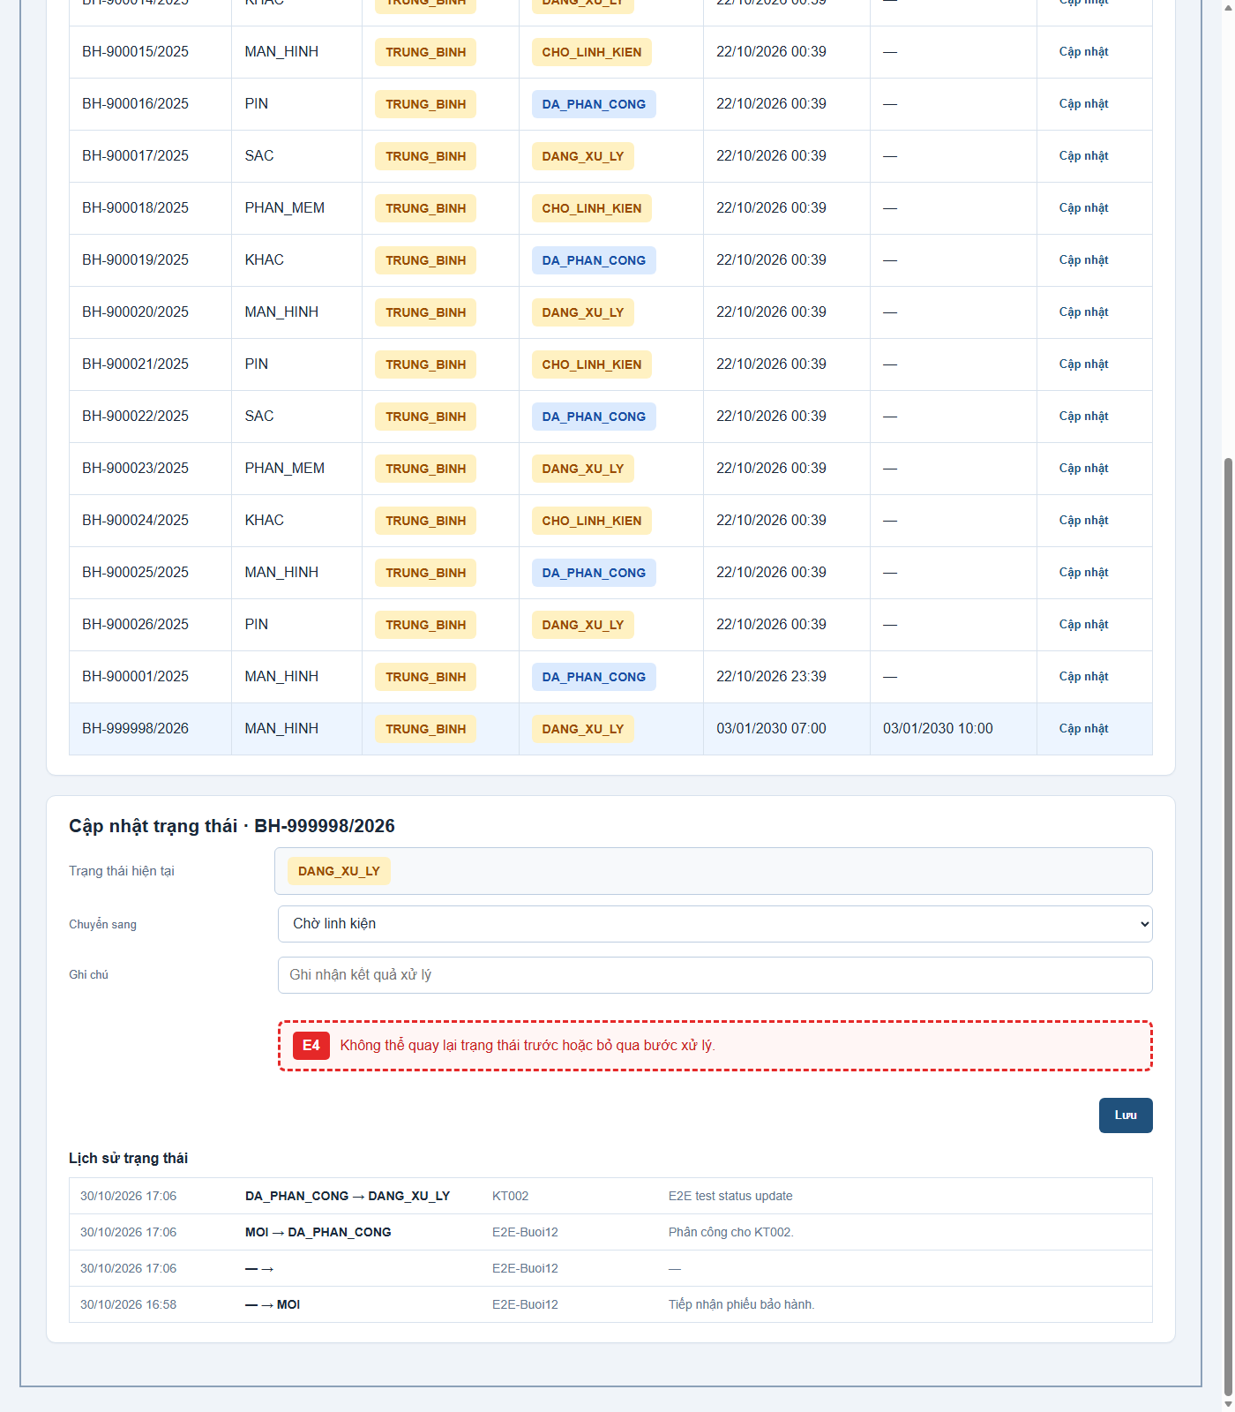
Giao diện cập nhật công việc.
File: docs/screenshots/ui-04-work-update.png

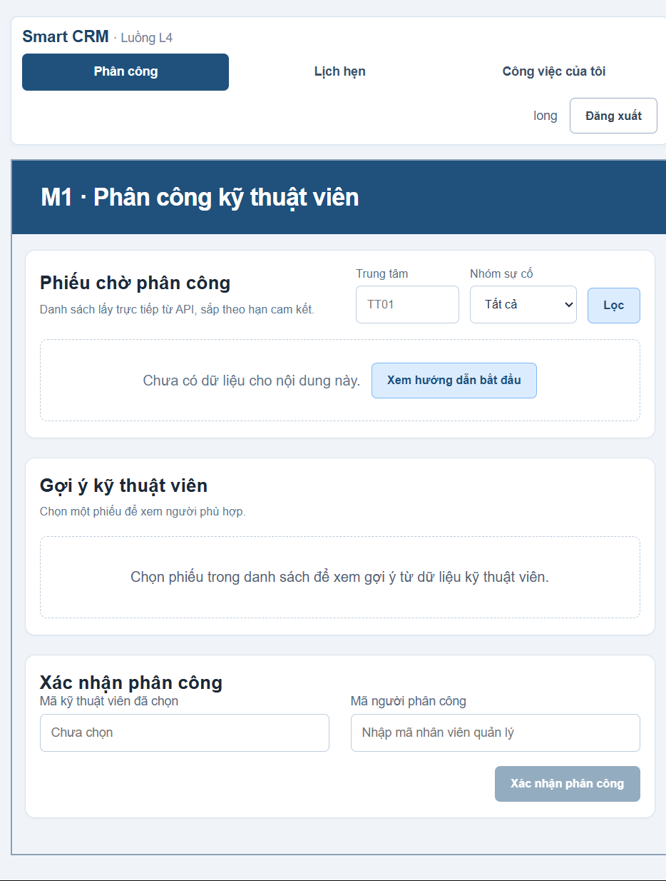
Giao diện trạng thái chưa có dữ liệu.
File: docs/screenshots/ui-05-empty-state.png

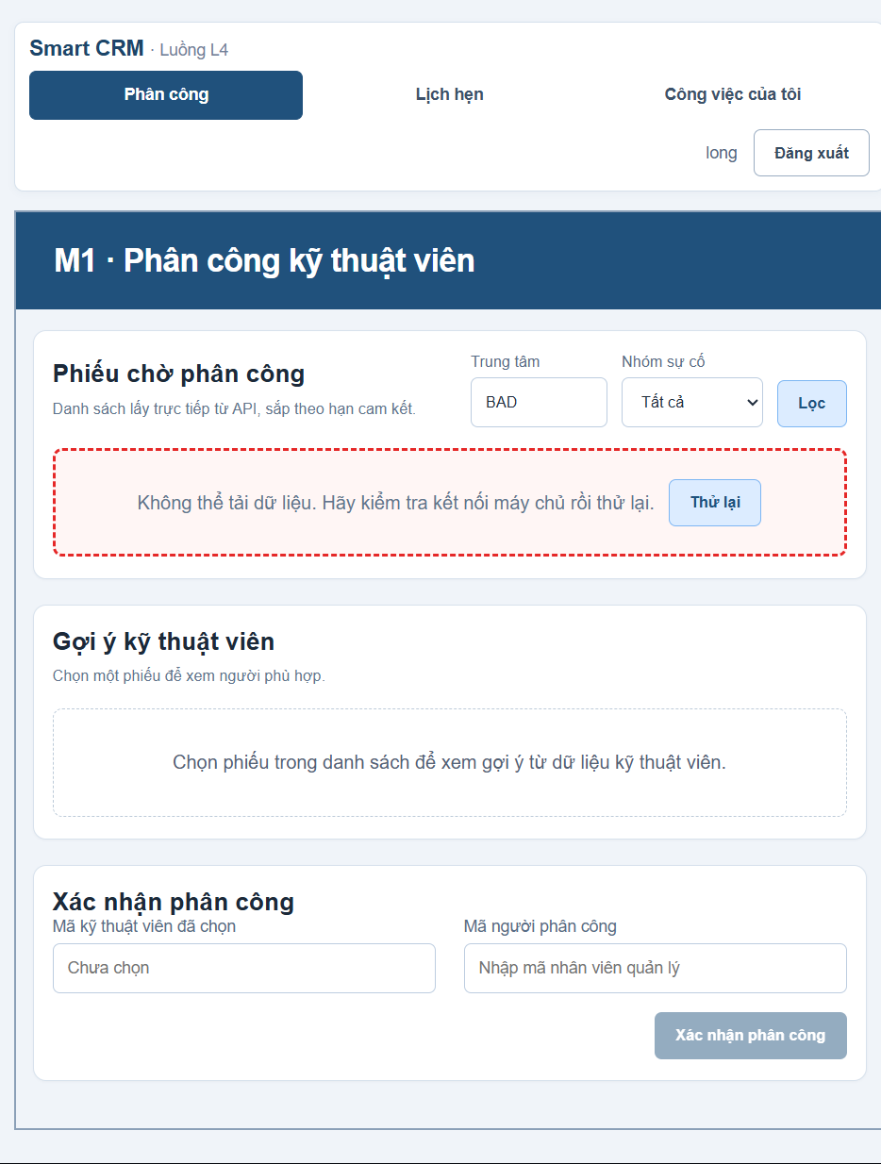
Giao diện lỗi lọc dữ liệu.
File: docs/screenshots/ui-06-invalid-filter.png

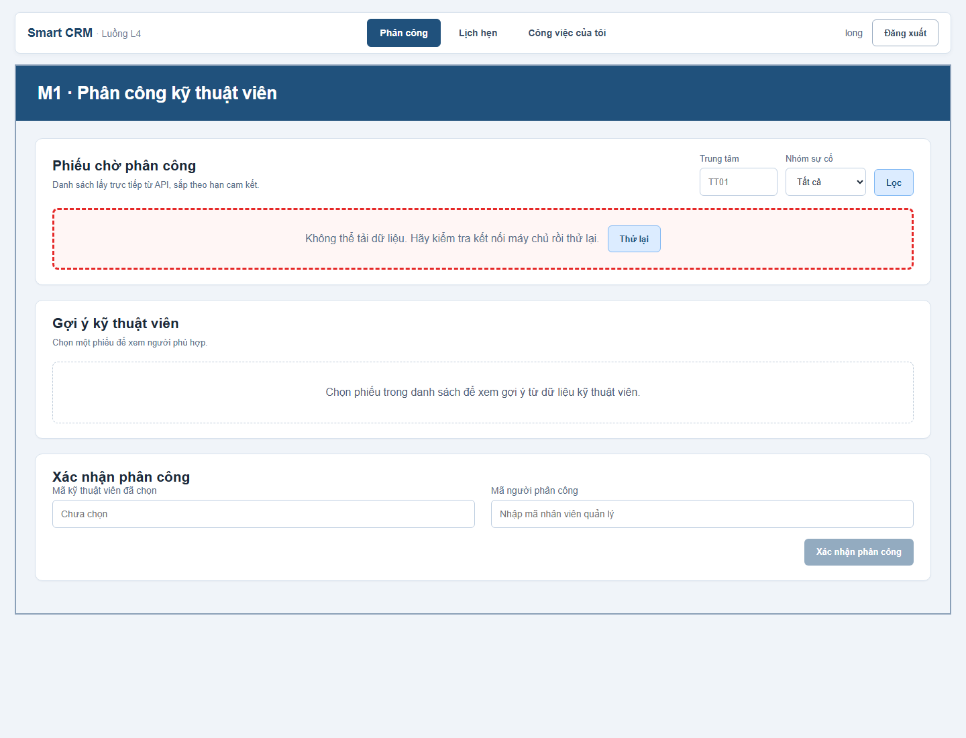
Giao diện khi backend không kết nối được.
File: docs/screenshots/ui-07-backend-unavailable.png

Phụ lục A. Khai báo sử dụng công cụ AI
Bốn cột: công cụ · dùng vào việc gì · áp dụng ở tệp / hàm nào · em đã kiểm chứng thế nào. Student confirms that only GitHub Copilot was used for BT3.
Công cụ | Dùng vào việc gì | Áp dụng ở tệp / hàm nào | Em đã kiểm chứng thế nào
GitHub Copilot (Copilot SDK trong VS Code) | Rà soát checklist BT3; cập nhật cấu hình Docker/startup; sửa xử lý sự kiện lỗi PostgreSQL pool; chuẩn bị tài liệu, API evidence và báo cáo Word | src/db/pool.js, tests/db.pool.test.js, Dockerfile, docker-compose.yml, src/config.js, src/db/initialize.js, src/app.js, tests/, docs/ | npm test 78/78, npm run build PASS; Docker test chạy thật, DB outage trả HTTP 503, recovery healthy, log scan rỗng; API examples được chụp từ một Compose DB tạm, rồi stack và volume thử nghiệm được xóa.

Cam kết: Tôi xác nhận đã đọc, hiểu và chịu trách nhiệm về toàn bộ nội dung nộp.
Họ tên: Nguyễn Ngô Ngọc Long · MSSV: 2374802010281 · Ngày cập nhật: 12/11/2026

Phụ trang — Xác minh Docker trực tiếp (13/11/2026)
Docker Engine 29.9.3 và Docker Compose v5.7.0 đã chạy được. Lệnh build/start thành công trong repository hiện tại. Tệp .env đã có sẵn nên không bị ghi đè; APP_PORT trong .env hiện đặt host port là 8000.
Kiểm tra | Kết quả thực tế | Trạng thái
docker compose up -d --build | Build image và khởi động db/app thành công. | PASS
docker compose ps | db và app đều Up (healthy); DB chỉ hiện 5432/tcp nội bộ; app publish 8000->3000. | PASS
GET http://localhost:8000/health | HTTP 200; {"status":"ok","db":"up"}. Ảnh browser thật ở docs/screenshots/health-endpoint.png. | PASS
docker compose exec -T app npm test | 78 tests, 78 passed, 0 failed, 0 skipped; exit code 0. | PASS
Restart app / kiểm tra seed | Counts trước/sau giống nhau: technician 2, skill 7, ticket 18, assignment 17, history 18, appointment 0, auth_user 1, migrations 4. | PASS
Gửi JSON hỏng | HTTP 400 INVALID_JSON; response chung, không có stack trong body. | PASS
Tắt PostgreSQL trong lúc app chạy | Before BUG-04 fix: app exited and /health returned HTTP 000. After fix: app stayed Up; /health returned HTTP 503 with {"status":"error","db":"down"}; recovery returned HTTP 200. No error object or stack was logged. | PASS after fix
Clean clone of public v1.0 tag | Fresh remote clone; copied .env.example to .env; docker compose up -d --build PASS; db/app healthy; GET :3000/health HTTP 200; container npm test 78/78; repeated migrate/seed counts unchanged (0 appointment, 1 auth user, 4 migrations, 2 technicians, 7 skills, 18 tickets, 17 assignments, 18 status rows). | PASS; tag page publicly accessible. Terminal screenshot not saved.
Kết luận bảo mật: mục 5 (sanitized error khi DB tắt) và mục 6 (quét log không có chuỗi khớp) vẫn CHƯA LÀM. Lệnh quét log có match các tên hàm pg authenticationCleartextPassword/authenticationMD5Password; không quan sát thấy giá trị mật khẩu, nhưng kết quả không rỗng. Kiểm tra DB outage thực tế thất bại và cần xử lý.
Initial run limitation: this run used the existing working directory and volume, not a clean clone of tag v1.0. A later fresh clone from the public v1.0 tag passed; the tag page is publicly accessible. The genuine health image is saved. docker compose ps and test output are recorded as text in docs/evidence/16-docker-validation.txt; no terminal images are saved.
Ảnh xác minh health endpoint
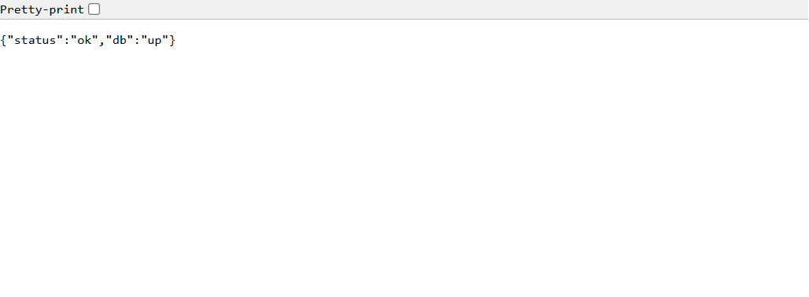

BUG-04 — PostgreSQL mất kết nối làm tiến trình API thoát
- Thời điểm: 13/11/2026, khi kiểm thử tắt dịch vụ db trong lúc app đang chạy.
- Tái lập: chạy docker compose stop db, sau đó gọi GET /health. Trước khi sửa, app thoát với mã 1; client nhận HTTP 000 và log có đối tượng lỗi pg.
- Mức độ/Hiện tượng: Major — sự cố DB làm API ngừng phục vụ thay vì trả trạng thái lỗi có kiểm soát.
- Mong đợi: tiến trình app tiếp tục chạy, /health trả HTTP 503 với {"status":"error","db":"down"}; không ghi chi tiết lỗi nội bộ; khôi phục DB thì app healthy lại.
- Nguyên nhân: sự kiện error của pg.Pool cho client đang idle không có listener; EventEmitter phát sự kiện error không được xử lý và kết thúc tiến trình Node.
- Sửa nguyên nhân: gắn listener error cho pool và chỉ ghi thông báo chung, không in đối tượng lỗi; health handler hiện có ánh xạ truy vấn DB thất bại thành 503 JSON.
- Xác nhận: npm test PASS 78/78; chạy Docker thật ngày 13/11: tắt DB trả HTTP 503 đúng JSON, app vẫn chạy; bật DB lại thì /health trả 200 và hai dịch vụ healthy. Sửa code/test trong commit b80b682 (https://github.com/long191105/smartcrm-2374802010281-phan_cong_ky_thuat_vien/commit/b80b682).

Live API request/response examples
Captured on 13/11/2026 against a disposable PostgreSQL Compose project on port 8001. The project and
its test volume were removed after capture. Login credentials and the session cookie are omitted.
ticket_id and timestamps below are from that isolated run.

Login
Request:
POST /api/auth/login
Content-Type: application/json
{"username":"[configured demo user]","password":"[REDACTED]"}
Actual response: 200 OK
{"user":{"username":"long","displayName":"long"}}

Create a ticket
Request:
POST /api/tickets
Content-Type: application/json
Cookie: smartcrm_session=[REDACTED]
{"ticket_code":"BH-990101/2026","customer_id":14159,"product_id":21,"serial_no":"BT3PROOF20261113","center_code":"TT04","category_name":"MAN_HINH","priority":"CAO","issue_desc":"BT3 isolated API evidence record","received_at":"2026-11-13T10:00:00+07:00","due_date":"2026-11-14T10:00:00+07:00","created_by":"BT3 demo"}
Actual response: 201 Created
{"ticket_id":"900027","ticket_code":"BH-990101/2026","customer_id":"14159","product_id":21,"serial_no":"BT3PROOF20261113","center_code":"TT04","category_name":"MAN_HINH","priority":"CAO","status":"MOI","issue_desc":"BT3 isolated API evidence record","received_at":"2026-11-13T03:00:00.000Z","due_date":"2026-11-14T03:00:00.000Z","is_warranty":true}

Assign the ticket
Request:
POST /api/tickets/BH-990101%2F2026/assignment
Content-Type: application/json
Cookie: smartcrm_session=[REDACTED]
{"technician_code":"KT002","assigned_by":"8","confirm_overload":true}
Actual response: 201 Created
{"ticket_code":"BH-990101/2026","status":"DA_PHAN_CONG","technician_code":"KT002","assigned_by":"8","assigned_at":"2026-11-13T11:29:16.058Z"}

Error responses
The following actual responses came from the same run:
Actual error responses from the disposable PostgreSQL run:

Wrong assigned technician: HTTP 403 - {"error":"FORBIDDEN","message":"Chỉ kỹ thuật viên đang phụ trách mới được cập nhật phiếu.","fields":{}}
Repeat assignment: HTTP 409 - {"error":"TICKET_NOT_ASSIGNABLE","message":"Phiếu không còn ở trạng thái chờ phân công.","fields":{}}
Empty ticket body: HTTP 422 - {"error":"VALIDATION_ERROR","message":"Dữ liệu không hợp lệ.","fields":{"ticket_code":"Invalid input: expected string, received undefined", "...":"additional required fields omitted"}}
These are real database-backed examples, not just fixture contracts. Owner identity is still supplied
by the client for status updates; the 403 example does not prove session-bound ownership control.

