INF II - Exercise I
dynamic web pages for calculating building materials
Group 06
Käte Zierhut 2411985
Eslemhan Boynuuzun 2758075
Doan Nam Long Vu 2788184
Xiaotian Liu
Yuan Tian
Institut für Numerische Methoden und Informatik im Bauwesen


Table of contents

Table of contents i
Table of figures ii
List of tables iii
List of abbreviations iv
1 Introduction 1
2 Application 2
2.1 Programming 2
2.2 User Guide 2
2.3 Error book 9

Table of figures
Figure 1: First Page 2
Figure 2: Input of project information 3
Figure 3: Overview of all projects 3
Figure 4: Pressing the button „Show“ 4
Figure 5: Going back to „Manage Projects“ to add new projects, delete or edit existing projects. 4
Figure 6: Changes in the project ID after editing the project. 5
Figure 7: Page for adding the structure 5
Figure 8: Step 1 for adding structures of a building to a project. 6
Figure 9: Step 3 for adding structures of a building to a project. (Pressing „Capture“) 6
Figure 10: Step 4 for adding structures of a building to a project. (Pressing „Add structures“) 7
Figure 11: Page after pressing the button „Pick Selected“ (Part 1) 7
Figure 12: Page after pressing the button „Pick Selected“ (Part 2) 8
Figure 13: Exported PDF (extract) 8
Figure 14: Locked access after adding structure to a project 9
Figure 15: TreeView 10

List of tables
Tabelle 1: Error book 9

List of abbreviations

JSON – JavaScript Object Notation
IOT – Internet of Things

Introduction

In this year´s exercise of the course Engineering Informatics II we were supposed to create a web application to calculate the amount of building material used in construction as those are important information when it comes to renovations necessary due to the “Energy Performance of Buildings Directive”.

Application

Programming
For a better understanding of how the code works, please see the comments in the code. Here is some basic information about how the construction of the code works:

The MongoDB hosts the details of the material needed for further computation.
In the code we chose xoekit as the toolkit for viewing the IFC model.

For scraping the elements from the model, we use two methods to access the web elements:
- Scraping without jQuery: We scrape all data, we need one click
- Scraping with jQuery: We select the data we want to scape and scrape only the selected

Functionalities such as scraping and PDF export only happens on the client side, while other iterations require the use of MongoDB happen on the server side before being send for rendering in the web browser. To send the scraped data from the client to the server we open an XML HTTP request and format it as JSON (JavaScript Object Notation) before sending it to the server, as JSON offers several benefits like web-friendliness, simplicity and flexibility among others.
For a first understanding the function of the whole code is described first:

User Guide
This is the documentation of how to use the dynamic webpage for calculating building materials. The programming can be found in the submission folder, including the description of the code with comments.
When starting the program, the first page can be seen in Figure 1. Here new projects can be added, and existing ones can be deleted or edited.

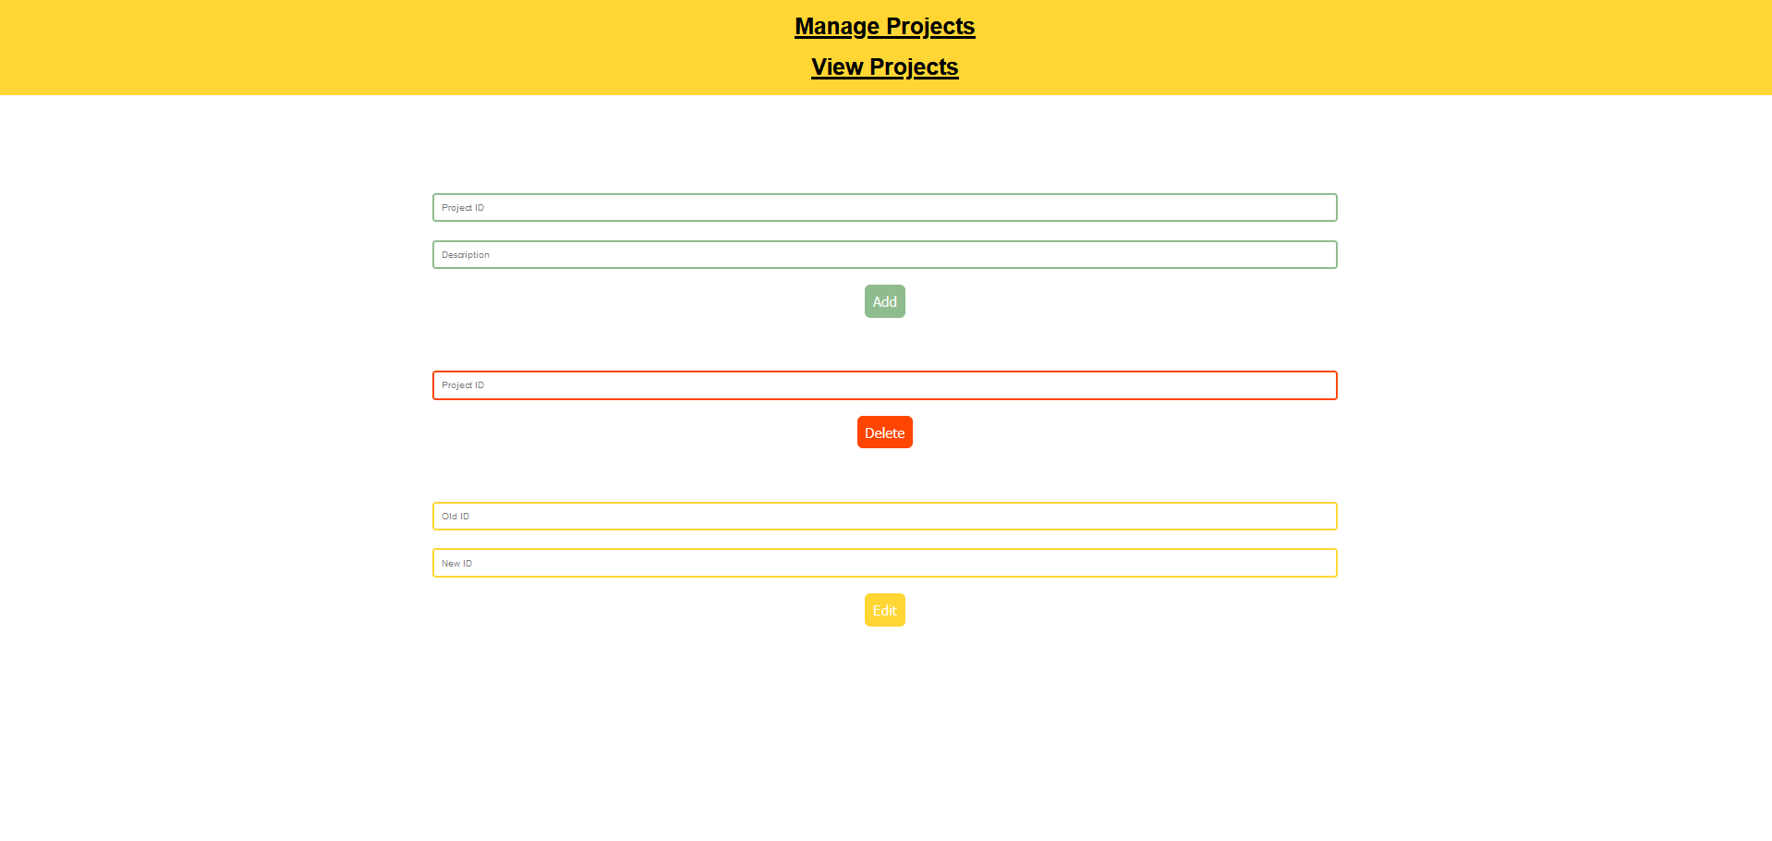
Figure 1: First Page
In Figure 2 a new project (here: “Project 1”) is added to the database and with pressing the button “Add” the user is directed to the next page where all existing projects can be seen (Figure 3).
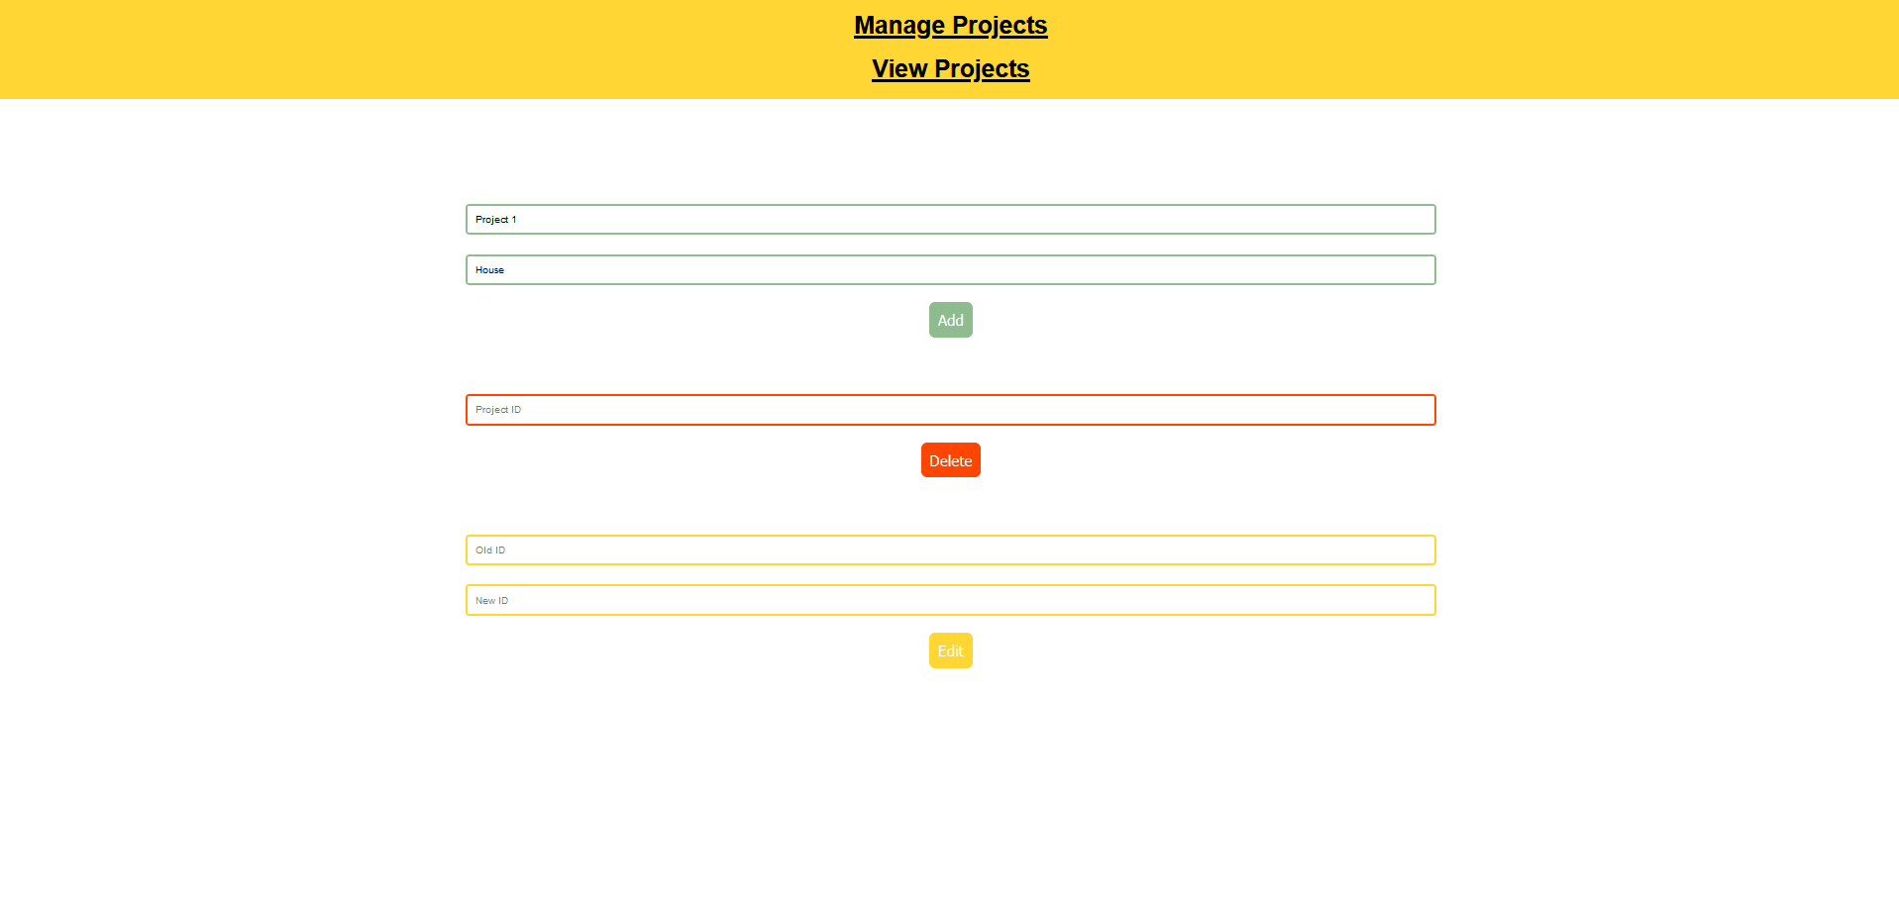
Figure 2: Input of project information
: 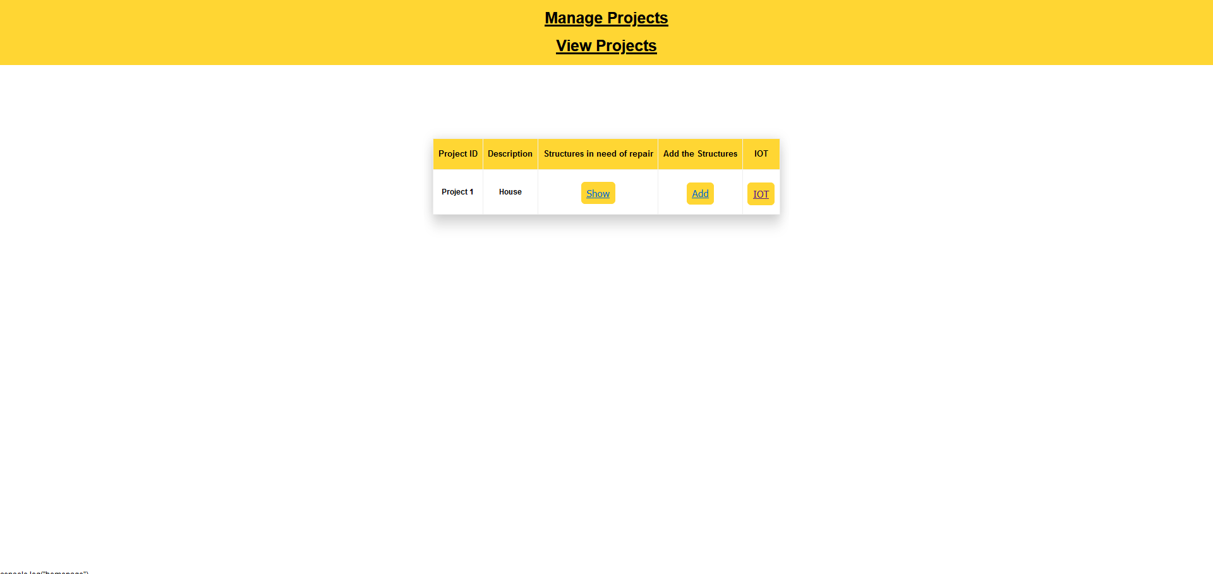
Figure 3: Overview of all projects
In this page the extracted information of the existing projects can be seen (via the button „Show“), structure can be added (via the button „Add“) and the connection to the Internet of Things (IOT) can be seen (via the button “IOT”). In Figure 4 the information of the added project can be seen. In this example the user can see that there is no structure added yet, so the tables and the pie chart are empty.

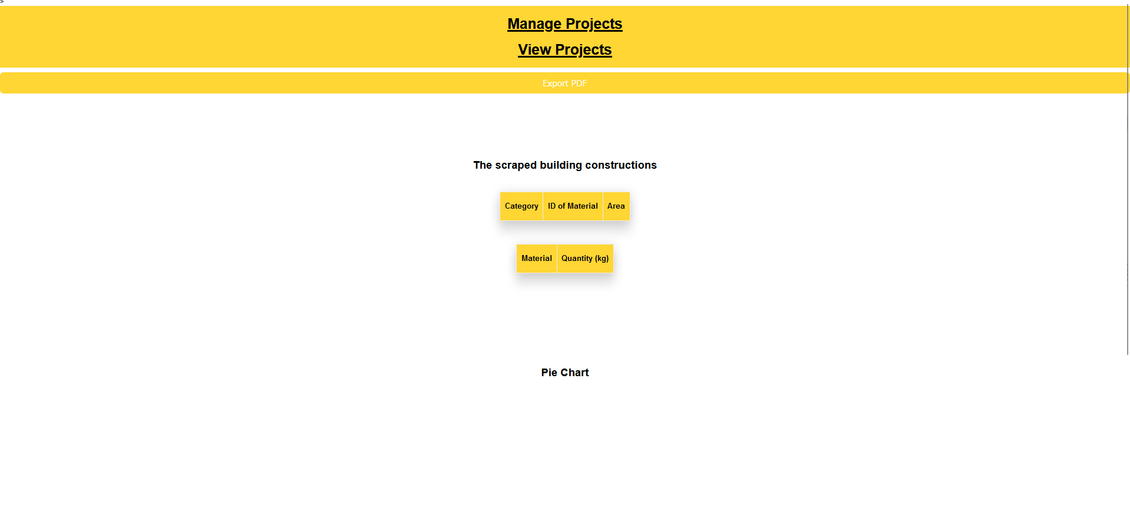
Figure 4: Pressing the button „Show“
If the user decides to change the information of the Project ID, the user can go back to „Manage Projects“ and edit the Project ID. In Figure 5 the ID is edited and in Figure 6 the changed Project ID appears in the „View Projects“ page.
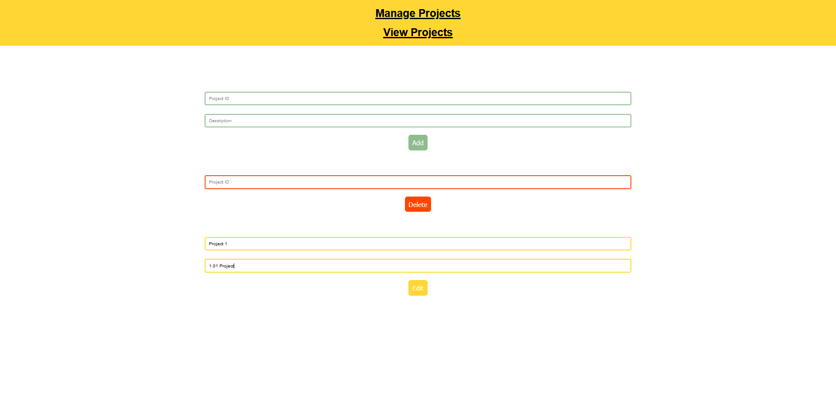
Figure 5: Going back to „Manage Projects“ to add new projects, delete or edit existing projects.
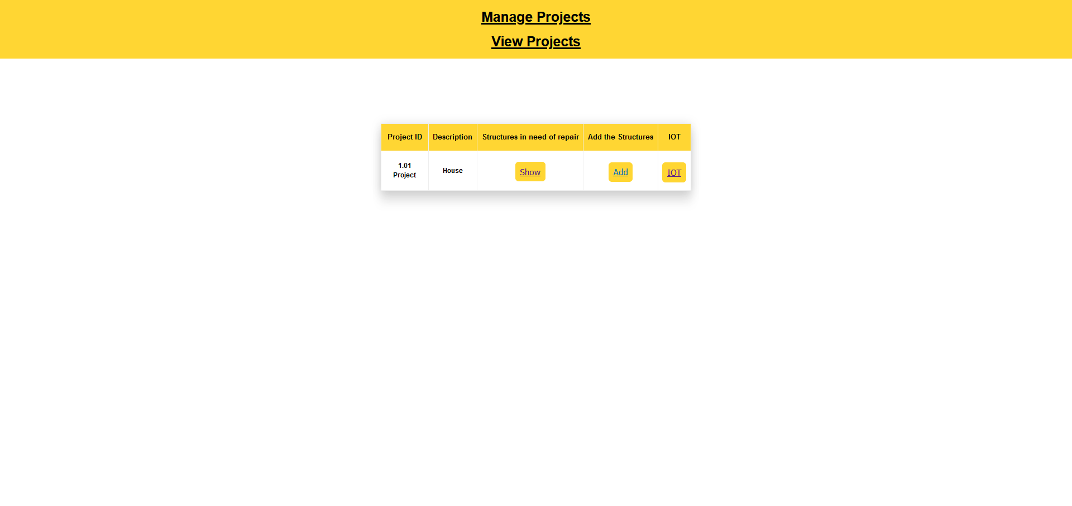
Figure 6: Changes in the project ID after editing the project.
The most important purpose of this application is to add structure of a building to the project. The page for adding the structure can be opened with pressing the button „Add“ in the „View Projects“ page (Figure 7).
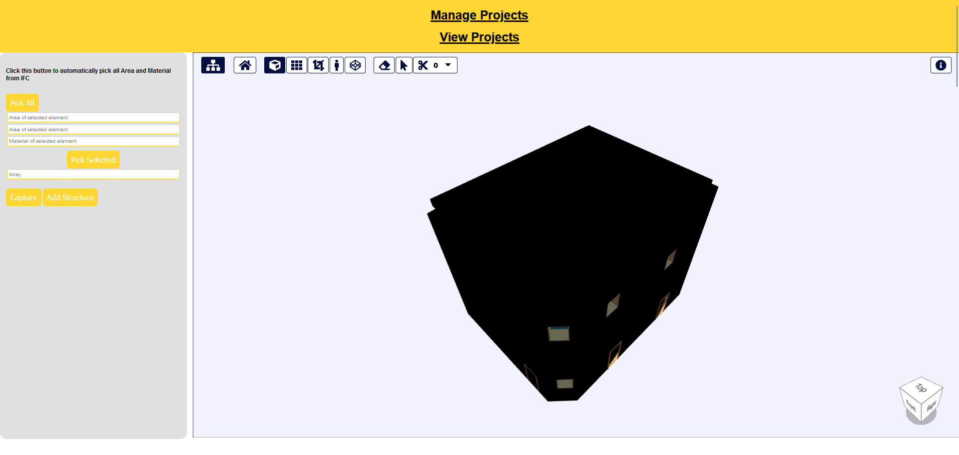
Figure 7: Page for adding the structure
With using the select objects tool in this page, selecting an element in the IFC model and right-clicking on it, a context menu appears as it is possible to see in Figure 8.
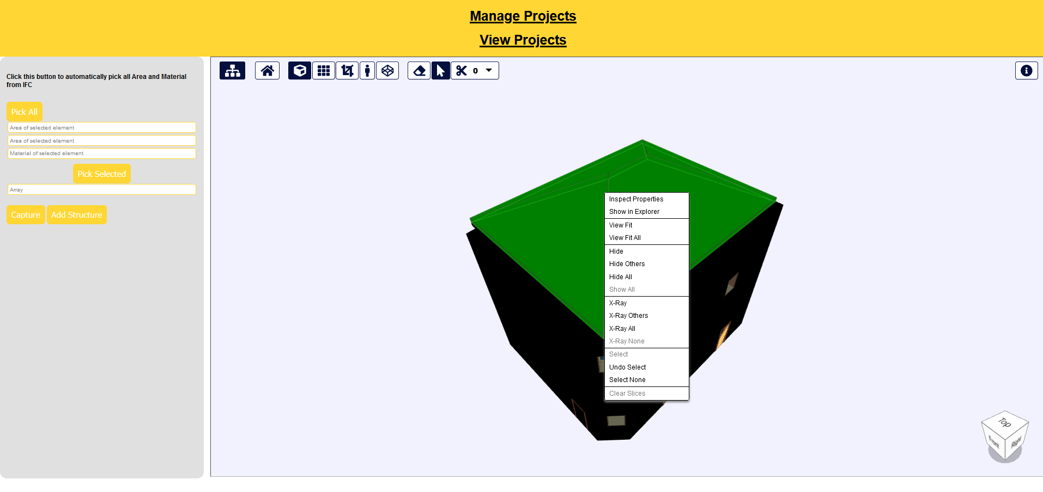
Figure 8: Step 1 for adding structures of a building to a project.
In the context menu the first entry „Inspect Properties“must be selected. The properties appear on the right side of the page (Figure 9).

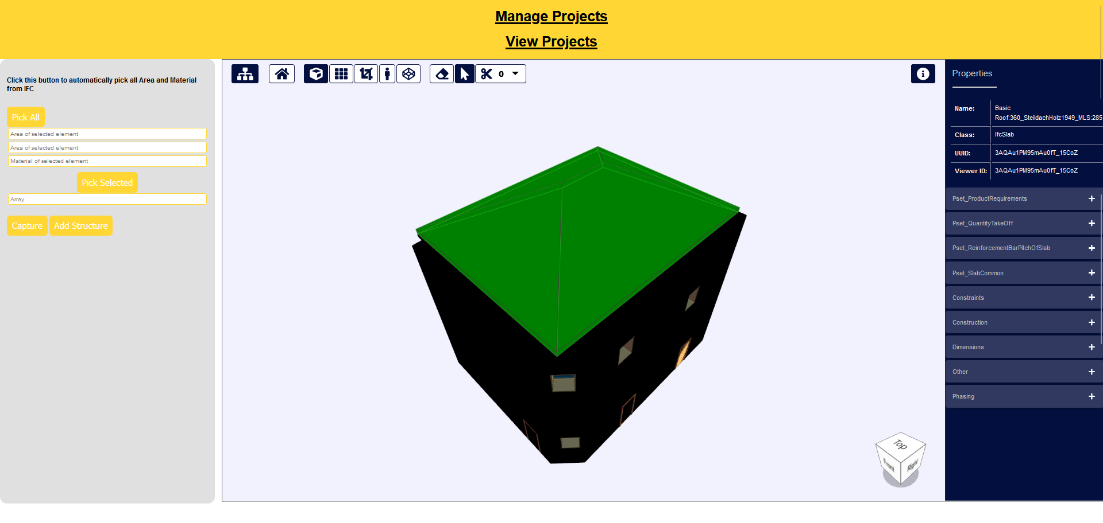
Figure 9: Step 3 for adding structures of a building to a project. (Pressing „Capture“)
Now the button „Capture“ on the left side can be pressed and in the three input boxes on the left top the information of the selected and inspected element appear (Figure 10).

If the user decides to add this element to the structure the „Add Structure“ button need to be pressed. With this button an array with the captured information is saved and further elements can be selected by repeating the procedure (selecting an element in the IFC model, inspecting the element, pressing „Capture“ and „Add Structures“). The added element can be seen in the furth input box (Figure 10).
If the user wants to automatically select all elements in the IFC model, the “Pick All” button can be pressed, and the user will be directed to the new page immediately (Figure 11).
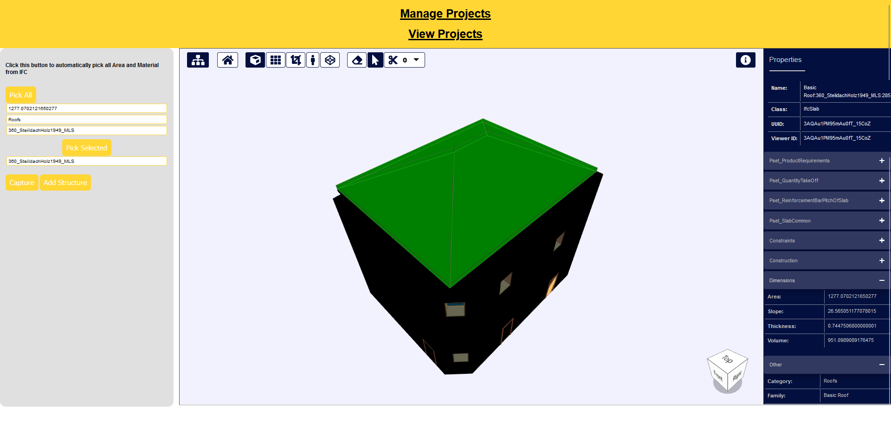
Figure 10: Step 4 for adding structures of a building to a project. (Pressing „Add structures“)
If the user does not want to select any further structures, the “Pick Selected” button can be pressed and the summary of the structure appears with the next page (Figure 11 and Figure 12).
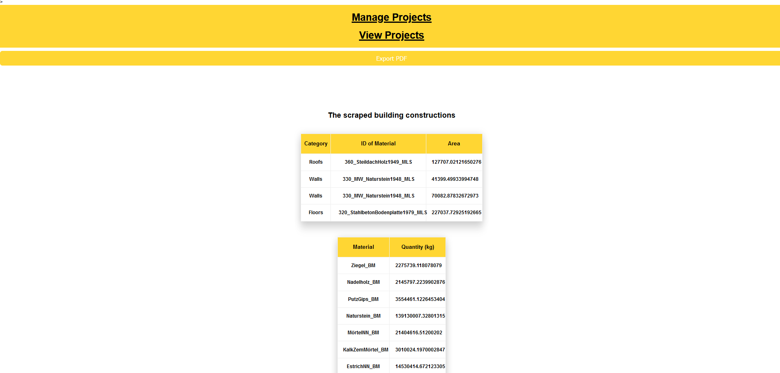
Figure 11: Page after pressing the button „Pick Selected“ (Part 1)
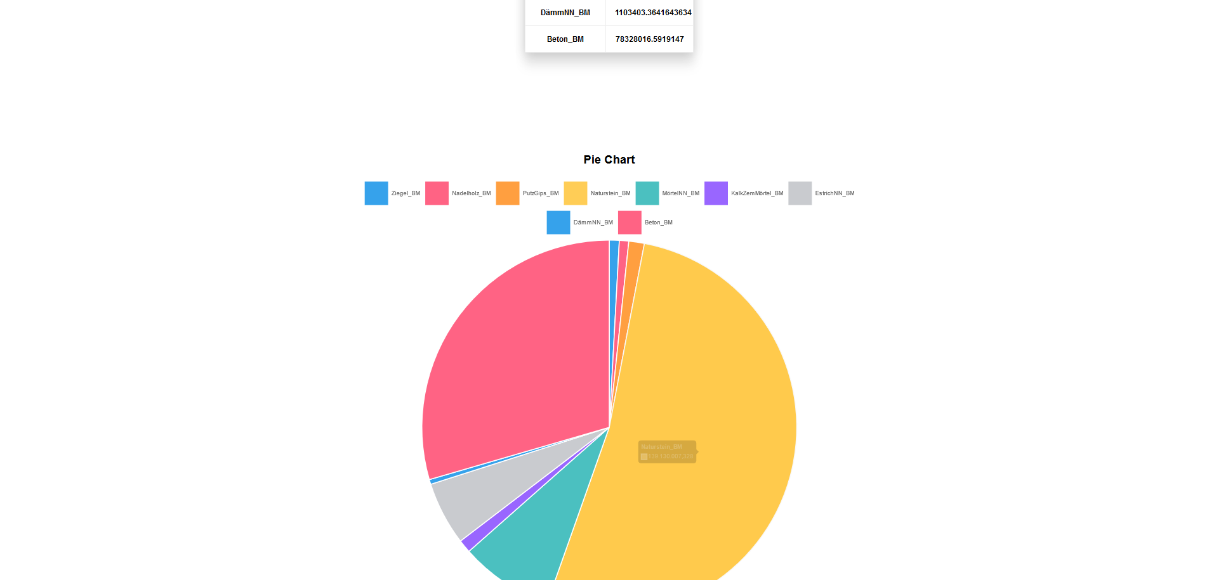
Figure 12: Page after pressing the button „Pick Selected“ (Part 2)
The scraped information can also be exported as an PDF. An extract of such an PDF can be seen in Figure 13.
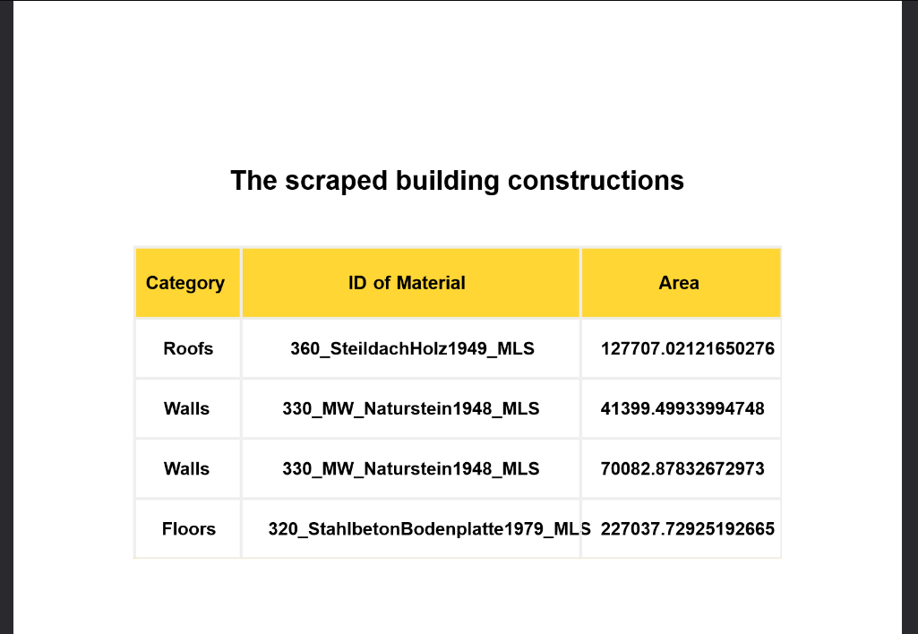
Figure 13: Exported PDF (extract)
After having added structure to a project, no more structure can be added to the project. The access from the „View Projects“ page will be denied (Figure 14). Only from MongoDB the Admin can change the status from „1“ to „0“ and unlock the page for adding structures to a project.
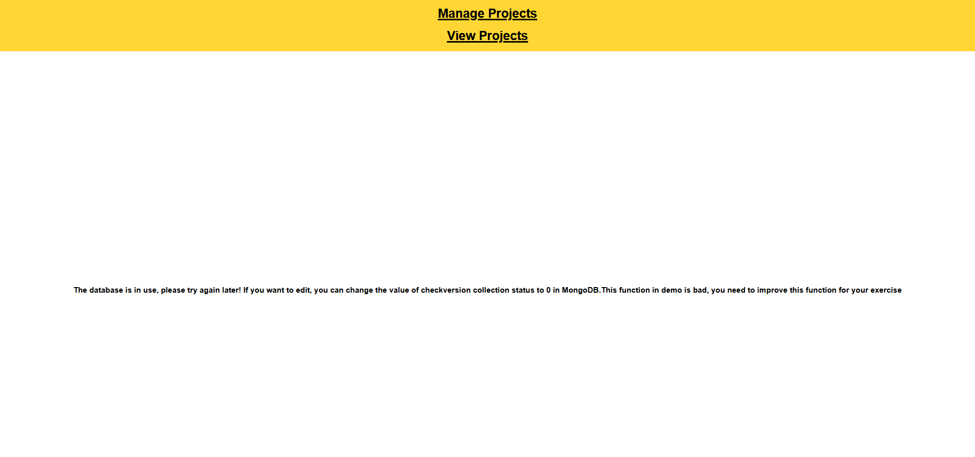
Figure 14: Locked access after adding structure to a project
The projects can also have a connection to IOT. In the “View Projects” page the button “IOT” can be pressed. In the appearing page the humidity of the project send from a sensor to the page can be viewed.
SCREENSHOT

Error book

In this part the problems appeared during the working process are listed, as well as solution, all listed in Tabelle 1.

Tabelle 1: Error book
Error name | Error description | Error solution
Pick Selected | In the first version of the code, we only automatically selected all elements existing in the IFC model by iterating over all nodes of the third layer in the TreeView in connection with the properties of the page where the user adds the structure (Figure 15). This is the functionality of the “Pick All” button in this version. | First, we tried to iterate over only the selected check boxes in the TreeView to make an easy selection possible. But as the HTML elements (checkbox and description of the element) are not connected, the iteration over the TreeView is quite difficult. That is why we looked for an easier solution and instead of getting the information from the TreeView and the inspected properties, we only went over the properties by selecting the item as described in the User Guide.
Select many elements | As the first error was solved, we realized that with the existing code it is only possible to select one element and add only one element to the structure. We decided that this is not practical and user friendly. | To solve this problem, we decided to change the button structure. In the first draft we had only two buttons – “Capture” and “Add Structure”. The “Add Structure” would send the captured information to the next page. We changed the definition of this button. With “Add Structure” now the captured information in the input boxes is saved in an array which gets longer if another element is captured and added to the structure. The elements in the array are saved with the different needed Information (Area, Type and Category) with KeyValue Pairs. With the third and new button “Pick Selected” the array from “Add Structure” is send via the MongoDB to the next page.
Size of Pie Chart
Connection of IOT to Wifi

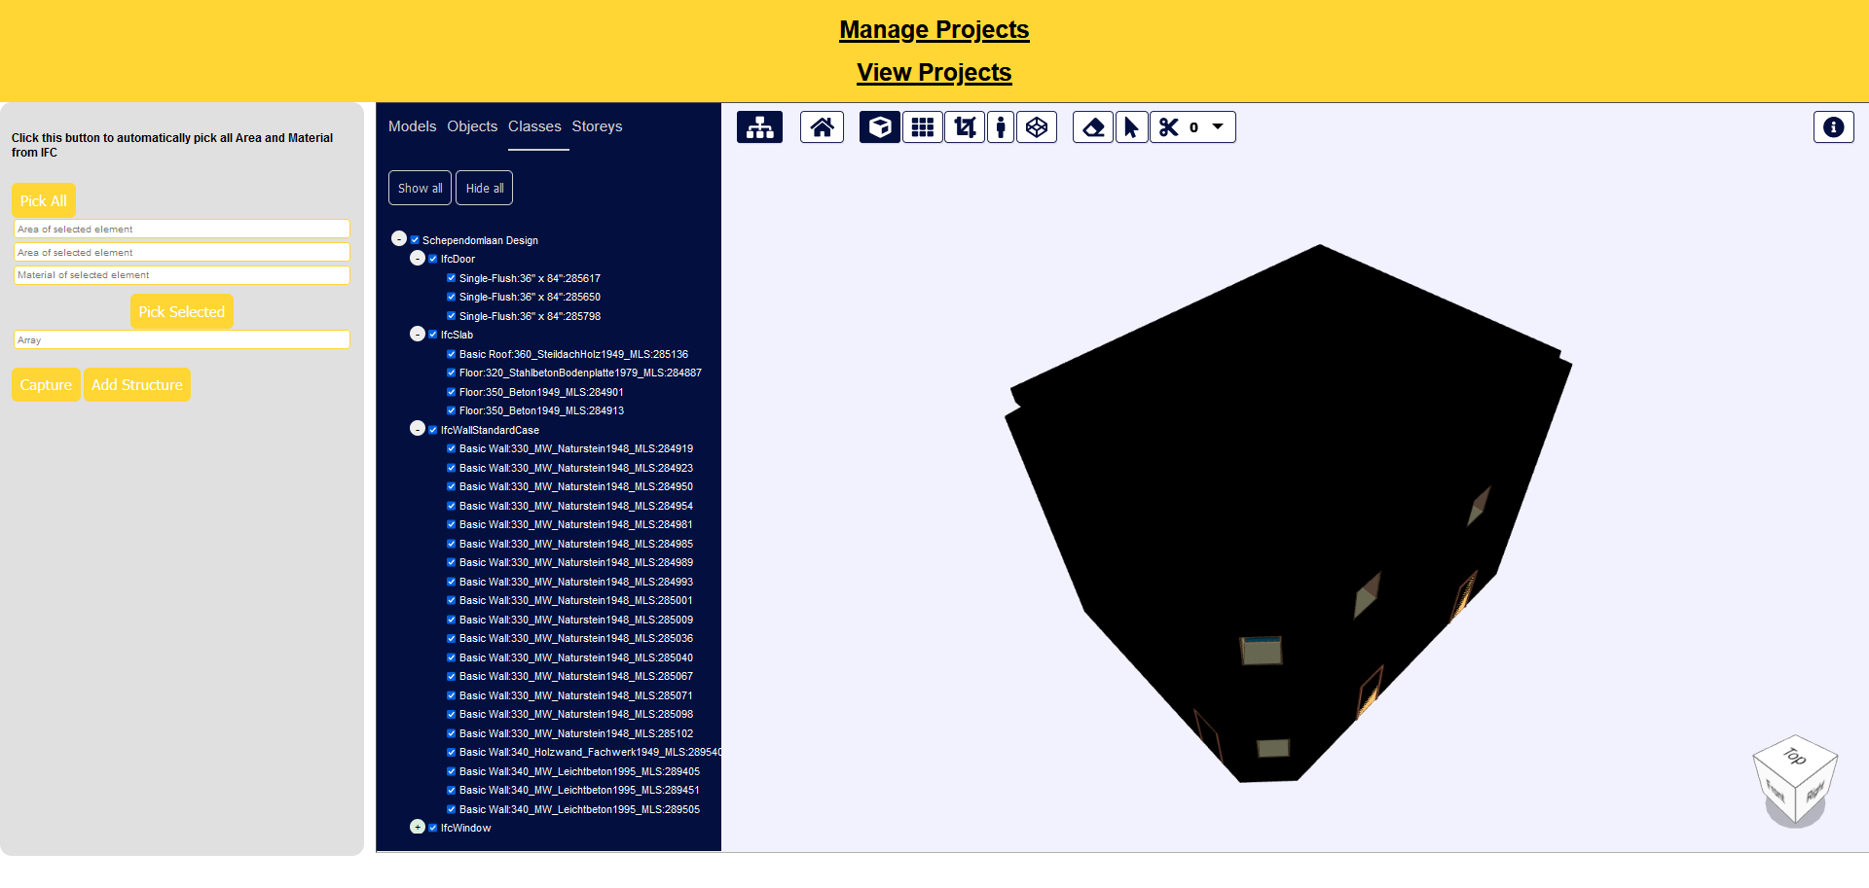
Figure 15: TreeView

