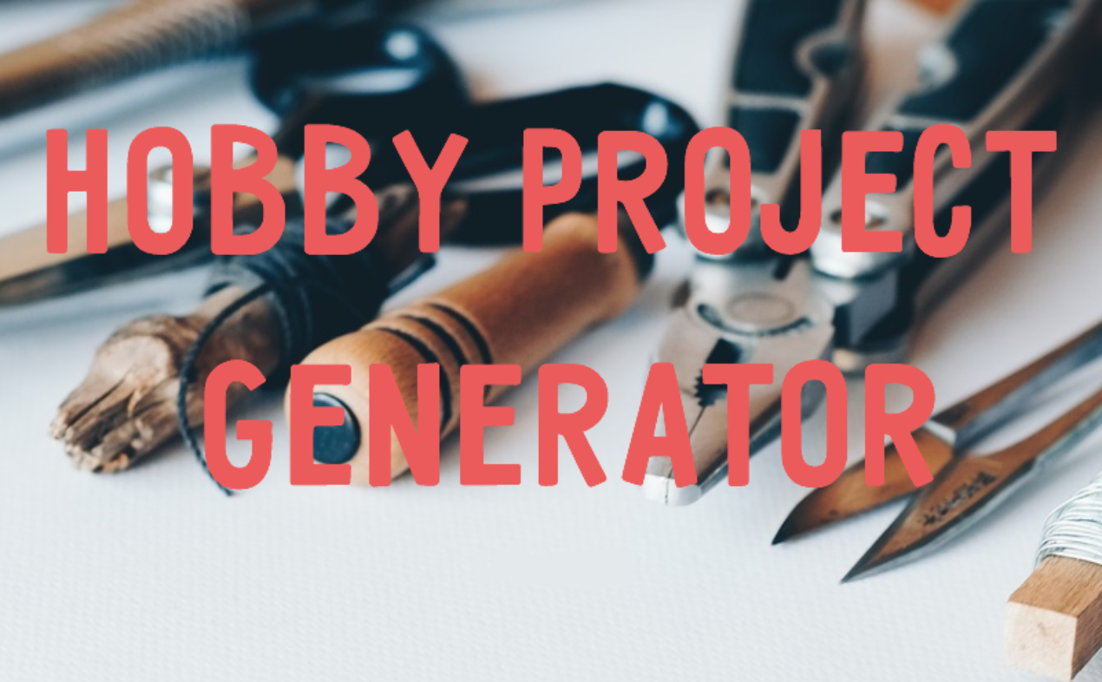**Business Requirements Document**

Date Submitted: 10/6/2021

Team Hobby:

Colin Creasman

Daniel Bribiesca

Team Lead: Jacob Delgado

Long Nguyen

Rifat Hasan

**Document History**

| **Date** | **Version** | **Changes** |
| --- | --- | --- |
| 9/11/2021 | 0.1 | Develop Outline of Doc |
| 9/20/2021 | 0.2 | Add Descriptions to Headings |
| 9/28/2021 | 0.3 | Start on Requirements |
| 10/1/2021 | 0.4 | Fill in Feature Requirements |
| 10/4/2021 | 0.5 | Formatting and Final Touches |
|  |  |  |

**Introduction**

**Purpose**

The purpose of our website is to give users an immersive experience when looking for a hands-on activity to work on. Rather than recommending users projects that are arbitrary in practice and/or based on popularity, our website is geared towards personalizing the user interface through a simple questionnaire. Our customized algorithm will provide an intuitive environment where the user can develop, progress, and mature their current skill sets, or look to acquire new skills based on their personality.

**Audience**

The leading audience of this website would be beginner to professional hobbyists with tools at their disposal that seek to progress their physical crafting skills through personalized project recommendations. Age-wise, the target audience would be adults who are 18 and older to decrease liability issues within the website application.

**Project Summary**

**Project Scope**

The website will be region locked to the United States of America and will be supporting American English only. The website will only support the latest Chrome version as of 05/20/22 and will not support beta versions. Our website is based on the tools a user has, so the website will display all measurements in metric units, but will also offer imperial conversions.

Our website will:

* Discovery/Featured page for looking for new project ideas
* Have a login/logout function
* Give logged in users the ability to post projects, receive notifications, receive recommended projects, comment, and rate other user projects
* Personalized portfolio for users to post their projects
* Capability of commenting on others’ posts
* Notifications option for comments, ratings, and recommended items
* Rating system to accompany comments
* Allow users to save their projects as draft or publish to their portfolio
* Personalize user content through a mutable questionnaire
* Clean UI/UX that immerses user into a friendly and academic environment

**Personalization Formula**

Go over how the website will find projects specifically for each user

Our personalization formula is based off of the mandatory questionnaire that every user must complete when creating an account. The user inputs the tools available to them and then they enter in their skills along with the skill sets that they are interested in. We gave the most weight to tools, with a weight of 2, while both the user interest and the skillset are given an equal weight value of 1. Skills will have levels based on what the user inputs so we can recommend them projects that are feasible. Skill interests will then have a secondary scaling of 1 to 3 based on how interest there is from the user.

**Order of Filtering**

1. Project recommendations will first filter out any required tools the user doesn’t have.
2. It will then filter out the projects based on the skills and skill level the user has on that specific expertise.
3. Lastly, it will filter in projects that the user is interested in, but will be of low skill level if the user states that they do not have the skill set.

**Out of Scope**

Our website will not:

* Have any monetization or product recommendations.
* Support Software/coding related projects or skill sets.
* Support languages other than American English.
* Support the ASCII-Extended table, only the original 127 characters.
* Support professional level projects that require licensing to complete.
* Have an email system to recommend projects or give notifications to our users.
* Be supporting direct messaging between users.
* Responsive to other devices such as mobile

**Website Requirements**

**Features *\*Requirements/features are ordered from highest to lowest\****

**Project Collection**

* Functional:
  + Projects must be displayed with a title, thumbnail, and brief summary.
    - Title cannot be more than 20 characters (excluding spaces)
    - Thumbnail must be a PNG, BMP, or JPEG to show the user what the project could be about.
    - Thumbnail can be up to 8MB
    - Brief summary will be up to 300 characters to let the user glance at project contents.
  + Projects will be pooled from WikiHow and Instructables.
  + Will pull a maximum of 70 new projects per week at 12am PST Monday.
  + Projects that are not in accordance with U.S. safety laws will be removed.
  + Existing projects that have pending changes will be updated weekly.
* Non-Functional:
  + Projects will accurately mirror the title, thumbnail, and description of the project from WikiHow and Instructables
    - Titles will be the same as where it was taken from
    - Thumbnail will be compressed if needed but the same image will be used from the website it was taken from
    - Description will be shortened to a maximum of 10,000 characters if it’s over the limit
  + A project file will take no more than 30 seconds to accurately upload all contents of the user’s project

**User Questionnaire**

* Functional:
  + Questionnaire is mandatory for users who wish to create an account.
  + Questionnaire will be 4 pages, one for each data category:
    - Skill sets
      * 20 available to be selected by the user.
    - Skill level
      * Limited to beginner, intermediate, advanced.
    - Interests
      * 20 available to be selected by the user.
    - Available tools to the user
      * Total list of tools available to be selected is 181.
  + Questionnaire pages require at least one answer from the user.
    - Answers can be updated after it has been completed.
* Non-Functional:
  + The questionnaire can be expected to have a 1 to 2 second delay from when the user selects an option or unselects it.
  + Questionnaire page selections will accurately describe the available skill set(s) and skill level(s) based on their definition in the real world.
  + Questionnaire page will accurately display the name of the available tools for selection based on its formal definition.
  + Each page of the questionnaire must load within 3 seconds to ensure a smooth experience.
  + The questionnaire must close and redirect to the account page within 10 seconds of the user finishing it.

**Customized Recommendations for Projects and Tools**

* Functional:
  + This functionality is only available to logged in users.
  + Users are given project recommendations based on the answers given in the questionnaire.
    - Recommended projects will be displayed for one week until it is refreshed.
    - Recommended projects can be saved for later.
  + Users are given tool recommendations that would allow them to take on new projects.
    - The tool(s) must allow the user to take on at least 5 new projects in order to be recommended.
    - Tool sizes will be shown in metric units, but a conversion to imperial units will be available.
* Non-Functional:
  + Recommended projects will be displayed in the standard format of left to right, so that U.S. residents can understand.
  + Recommended tool(s) will accurately display the way they look in real life.
  + Recommended tool(s) will be chosen and loaded within 30 seconds.

**Uploading/Removing Projects from Personalized Profile**

* Functional:
  + This functionality is only available to logged in users.
  + Users are able to upload their own projects to the website.
    - Users can upload an infinite amount of projects.
      * Only one project at a time can be uploaded
    - Users can save as draft before publishing.
    - Users can delete published projects.
    - Projects consist of the title, body, and images.
    - The project title is limited to 30 characters.
    - The body is limited to 10,000 characters.
    - Users will be able to upload media file(s) for their project posts or comments.
      * Users can edit their uploaded file(s) at any point.
      * Other users cannot remove a different user’s uploaded file(s).
      * Users will have the option to upload a PDF version of their project.
        + 15 MB limit per file.
      * Uploaded images will be limited to BMP, PNG, and JPEG.
        + 5 MB limit per image
        + Unrestricted resolution
* Non-Functional:
  + Uploading a project will take a maximum of 20 seconds.
  + Deleting a project will take less than 5 seconds.

**Rating for Projects**

* Functional:
  + This functionality is only available to logged in users.
  + Users will be able to rate a project from 1 to 5 stars.
    - Users can update their rating at any time.
      * Users cannot undo a rating.
    - The average star rating and the number of ratings will be displayed.
    - User ratings will only count once per user to ensure credibility.
* Non-Functional:
  + Ratings should be updated in under 1 second of rating a project.
  + Star rating will be easily identifiable for all viewers of the project.

**Search and Discovery Page**

* Functional:
  + This functionality does not require an account.
  + User searches are limited to 30 characters.
    - Search is not case sensitive.
  + Discovery page shows 20 random projects.
    - When logged in, the page will contain the 20 random projects, but also a recommended section catered to them.
    - Recommended section will display 10 catered projects.
    - Recommended section is updated daily.
* Non-Functional:
  + Users can expect search results to load within 10 seconds.
  + Search will display 10 results per page.
  + Discovery page will load within 10 seconds.
  + Each discovery project will accurately summarize the full contents of the project.

**Comment Section**

* Functional:
  + Users must be logged in to post comments.
  + Users are able to comment on projects.
    - Comments will be limited to 500 characters (excluding spaces).
    - Comments containing racial slurs will be rejected when attempting to post.
    - The original poster of the project will immediately be notified when a comment is posted.
    - A rating option is available to users for comments.
      * Users can give a up or downvote on the comment.
    - Users are able to post images with their comments.
      * There is a 5 MB limit per image.
      * Image formats accepted are BMP, PNG, and JPEG.
  + Users can filter comments by:
    - Highest to lowest rated.
    - Lowest to highest rated.
    - Most number of ratings.
    - Newest posted first.
    - Oldest posted first.
* Non-Functional:
  + Users ratings will update/load within 3 seconds.
  + Comments will be posted and displayed within 10 seconds.
  + 15 comments will be displayed per page.
  + Users will be notified within 3 seconds of a rejected comment.
  + Media file(s) will take up to 5 seconds to upload per file.
  + Images will take up to 3 seconds to load when viewed.

**Notifications**

* Functional:
  + This functionality is only available to logged in users.
  + Users will be notified of the 5 most recent activity notifications.
  + Users can disable notifications.
  + A notification page will be available for users to view all notifications.
    - Users will be notified when events occur:
      * Users are recommended projects and tools on the first login of the day.
        + Recommended projects will be limited to 5.
        + Recommended tools will be limited to 2.
        + Recommended notifications will be removed after 7 days regardless of being viewed.
      * A user has posted a comment on their project.
        + Will be stored for 30 days once viewed.
      * A user has replied to their comment.
        + Will be stored for 30 days once viewed.
      * The first upvote their project has received.
        + Will be stored for 30 days once viewed.
    - Comment and upvote notifications will be stored for 30 days once the user has viewed them.
* Non-Functional:
  + The total (unread) notification available for view is on display to users
  + Notifications will take up to 3 seconds to load.
  + Notification(s) will be organized.
    - Notification body limited to 3 lines of text unless fully viewed.
  + Notification(s) will accurately display its contents and what they’re referring to.
    - Project name
    - Commenter’s username and contents

**Policies and Guidelines**

**System Requirements**

**Software:**

* Operating System: Windows 10 64-bits, any Linux distribution 64-bits
* Web Browsers: Chrome, FireFox, Microsoft Edge

Minimum hardware requirements:

* CPU: Intel 3th Generation or AMD FX series
* 3GB RAM
* Graphics: Intel HD graphics

**Operating Systems:**

* What we used to build the project:
  + Windows 10:
    - Version 21H1 build 19043.1237+
    - Version 20H2 build 19042.1237+
  + Windows 11:
    - Version 21H2 build 22000.194+
* One of the most popular operating system with intuitive graphical user interface
* High compatibility with desktop applications and web browsers such as Chrome version **94.0.4606.61+**

**Web browsers:**

“Hobby Project Generators” require Chrome browser version **94.0.4606.61** and latest version of Chrome as of **05/20/22**

**Hardware:**

Minimum hardware requirements:

* CPU: Intel Pentium or AMD FX Series
* 3GB Ram
* Graphics: Intel HD graphic

Recommend hardware requirement:

* CPU: Intel 7th generation or AMD Zen 2 architecture
* RAM: 8GB
* Graphics: Intel HD graphic

**Browser Compatibility:**

We will support the current version of Chrome **94.0.4606.61** and will target support for the latest Chrome version as of **05/20/22**.

**Data Storage**

Project information that will be stored from pooled feature:

* We will store the title, thumbnail, and small summary of the project.
* Project links to route to the correct website will also be stored.

Hobby Project Generator will store certain user information in the database:

* Username and password.
* Registered users security question answers.
* Registered users preferences from questionnaire.
* Registered user projects.
* Project ratings and comments.

Hobby Project Generator will use the information for:

* Username and password that is used for login functionality.
* Security question answers will be for when the user forgets their password.
* User preferences from questionnaire that is used for recommendations.
* Registered user projects will be used for recommendations.
* Project ratings and comments for community interaction.

**Security**

* Upload
  + Secure connection for uploading
  + Upload cannot be interrupted
* Account
  + Login
    - Credentials
    - Username must match password
    - At least 1 special character
    - At least one uppercase letter
    - At least one 1 number
    - Character length of 8-16
  + Username/Password recovery
    - During generation of account, security questions will be asked to have another sense of authorization for the user in case another user attempts to sign in their account
    - User will be required to pick 2 questions to answer as a backup
    - User will need to answer either questions correctly in order to receive the forgotten information
    - Password can be changed into anything as long as it confines to password requirements (old password can be re-entered)
    - Account username cannot be changed
  + Logout
    - Once logged out, user must sign in with username and password that they signed up with
    - User will be shown the same information an unregistered user sees until they sign in again
    - Upon signing in, they will be able to see notifications they missed and receive recommended projects in the background
    - Logging out will be easy and seamless
* Functional:
  + Verify user’s username and password
  + Registered users must be able to log in
  + Errors will be handled without revealing user data to other users
  + Ask security questions when username or password is forgotten
  + Password will be able to be guessed 7 times before account will be denied to the user for 30 seconds
  + Archive any login attempts for backlogging and prevent accounts to be taken.
  + Verify username and password through logged information in database
  + Logout must successfully and fully log user out of their account
  + When user logs out, all information of that user must be hidden and they will be treated as a user without an account
  + Authentication of the user will be received and checked
  + Open SSL used for HTTPS to encrypt and safeguard the website
  + Unregistered users will only have “view” permissions
  + Filtering will occur when the system detects inappropriate for comments and/or descriptions
* Non-Functional:
  + Security features will not bother user experience in any way
  + Logging in will not deteriorate system

**Error Handling**

We will not stop users from inputting what they like into our search box, but it will try to find the closest match. If illegal characters are found, then we will not initiate the search at all. If a user tries to post a project with illegal characters, then it will not go through and will be saved as a draft instead with the reason displayed. If a user tries to upload an image larger than the 5MB limit, then it will be converted to jpg if it is not already one. If it is a jpg file and is over the size limit, then it will be rejected and inform the user. If a user doesn’t select anything from the questionnaire then they will not be allowed to proceed to the next question until they select at least one item.

* Functional:
  + Website will stay responsive
  + Both registered and non-registered users will be informed of any errors
  + Errors will be archived for error handling in the future
  + Errors will be handled quickly in an organized fashion
  + Features within website must not disrupt the website’s functionality
* Non-Functional:
  + Errors shouldn’t affect other parts of the website
  + Error description must accurately show user what went wrong
  + Handling errors should not be heavy computationally

**Error Handling Examples:**

* Empty search box or illegal character
* Illegal characters will trigger error
* Oversize images will be convert to JPG, otherwise decline
* Empty or incorrect user name or pass upon logging in
  + Not proceed and inform user
* Empty project Title or body
  + Will not post, will inform user to type in the correct fields (at least 1 character)
* Empty comment or illegal characters in the comment
  + Will not post, will then inform the user
* If post body or title or comment is over the character limit
  + When the user tries to publish, they will be informed by how many characters they’re over
* If our database goes down and the user is trying to post or search:
  + Display an error message with the “nyan cat” gif
  + Save option, if not saved, good luck
* If our website goes down or is unresponsive
  + 404 error will be displayed
* If system fails to update a project from Instructables or wikiHow
  + Display error message for both the image and description
  + Archive the error for later

**User Navigation**

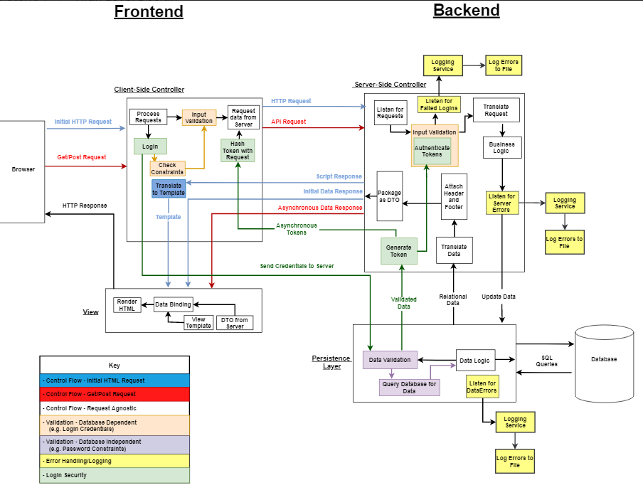

**Logging/Registration**

How and what will be shown during registration:

* A form with details asking the user to input their desired username and password twice.
* Usernames must be unique.
  + Must align with guidelines and be appropriate
  + Must be 4-16 characters in length
    - Characters from the ASCII non-extended table only.
* Passwords will have restrictions for special characters, numbers, and uppercase letters.
  + Users must add a minimum of 1 special character, 1 number, and 1 uppercase letter.
  + User’s password character length must be at least 8 characters.
  + Security questions will be asked during sign up process for users that forgot their password and will be case-sensitive to add a layer of protection

**Login/Logout**

* Functional:
  + User can successfully login if they have an account created with correct credentials
  + Note any sign-ins/sign-outs attempts
  + Log any failed login attempts
  + User can successfully log out after they have signed in
* Non-Functional:
  + Users will login within 5 seconds.
  + Users will logout within 5 seconds.
  + Failed attempts will be logged within 3 seconds.
  + Users will be automatically logged out when they exit their browser.

**User Experience Requirements**

* Simple user interface where user does not have to guess what they are doing
* Consistent scaling throughout entire website while being smooth and responsive
* Links in the search bar, will be treated as plaintext
* Signing up will be seamless and easy process
* Words are easy to read and does not hurt the eyes
* Inputting reviews and/or comments will be easy to do
* Desirable projects will be presented to user based on questionnaire when signing up for an account
* Project will be given based on tool accessibility and usability
* Information pooled from other sites will be professional and credible
* Content will be simple and easy to navigate around
* Only questionnaire, username, and password data will be logged
  + No private information will be gathered
* User interface will be a friendly and safe environment for learning opportunities

**References**

Boogaard, Kat. “Business Requirements Document (BRD) Guide & Template.” *Wrike*, https://www.wrike.com/blog/how-write-business-requirements-document/#What-is-a-business-requirements-document-BRD.

ReQtest. “Functional vs Non-Functional Requirements - Understand the Difference.” *ReQtest*, 28 July 2020, https://reqtest.com/requirements-blog/functional-vs-non-functional-requirements/.