MINISTRY OF EDUCATION AND TRAINING

UNIVERSITY OF ECONOMICS HO CHI MINH CITY


INVESTMENT PROPOSAL REPORT
Next-generation e-wallet Fincore: Implementing Alternative Data Risk Scoring and AI-Powered Portfolio Matching

Presentation Group 5:
Nguyễn Huỳnh Phi Long - 31231022148
Đặng Thị Mai Phương - 31231021017
Lê Đoàn Khánh Chi - 31231025306
Bùi Đức Huy - 31231026578

Ho Chi Minh City - 05/06/2026

TABLE OF CONTENTS
EXECUTIVE SUMMARY 3
PART 1: PROPRIETARY AI METHODOLOGIES 4
1.1 Alternative Data Sources 4
1.2 Feature Engineering 4
1.3 Hybrid Machine Learning Pipeline (K-Means & XGBoost) 5
1.4 Portfolio Matching & Gemini ReAct Agent 6
PART 2: CUSTOM INFRASTRUCTURE ARCHITECTURE 7
2.1 The Limitations of Global Fintech Infrastructure in Vietnam 7
2.2 Endpoint Classification and VND Localization 7
2.3 System Architecture and Uptime Security 8
PART 3: COMMERCIAL SCALING ROADMAP 9
3.1 Market Opportunity (TAM) and Competitive Moat 9
3.2 Business Model and Revenue Streams 9
3.3 Product Roadmap and Allocation of Funds 9

EXECUTIVE SUMMARY
Fincore Wallet is an innovative smart e-wallet designed specifically for the Vietnamese digital generation. It addresses two critical bottlenecks of the domestic financial ecosystem: first, the lack of credit history for over 70% of young adults under 30 (who are excluded from traditional credit scoring); second, the incompatibility of global payment frameworks like Plaid, Stripe, or Dwolla with Vietnamese Dong (VND) transactions and local KYC regulations under the State Bank of Vietnam (SBV).
Our solution consists of a custom-built, VND-native OpenAPI Server paired with a proprietary AI risk scoring engine. By analyzing alternative behavioral data (social media sentiment and utility bill histories) under explicit user consent, Fincore extracts 15 core financial discipline features. We deploy a hybrid machine learning pipeline (K-Means auto-labeling and real-time XGBoost) to classify risk appetites and dynamically match users with open-ended funds, explained interactively by a Gemini AI agent.

PART 1: PROPRIETARY AI METHODOLOGIES

1.1 Alternative Data Sources
Traditional financial institutions in Vietnam assess risk using static, self-reported surveys, which suffer from user bias. Fincore establishes a defensible data moat by collecting objective, real-time alternative data from three core channels to construct a high-fidelity behavior model:
Source 1 - Social Media: With explicit user consent via OAuth 2.0, Fincore integrates with Facebook Graph API v19.0 to pull public posts. Our NLP models analyze text sentiment and categorize interests across 7 dimensions (Technology, Entertainment, Discipline, Health, Education, Entrepreneurship, Family). This provides an understanding of user interests and lifestyle orientations.
Source 2 - Utility Bills: Integrating simulated endpoints representing Vietnam's national utility network (EVN/SAWACO) via the NGSP Gateway, Fincore tracks payment histories. On-time or late bill payments serve as the single most objective proxy for a user's real-world financial discipline and debt obligation reliability.
Source 3 - Internal Wallet Transactions: Stored securely in a self-hosted Appwrite DB, we track transaction timestamps (late-night vs. business hours), cash-out velocity post-deposit, and balance volatility. This provides granular insight into spending behaviors without relying on external credit bureaus.

1.2 Feature Engineering
Raw transactional and social data are engineered into 15 distinct behavioral features. These variables are calculated dynamically using mathematical formulations (ratios, volatility, and counts) to construct a comprehensive financial discipline index:

Feature Group | Technical Variable Names | Behavioral Definition & Financial Significance
Financial Discipline | bill_on_time_ratio  spend_discipline  save_after_payday_ratio  auto_save_completion_rate | Measures the ratio of utility bills paid on time, essential spending vs total spending, savings initiated within 48 hours of payday, and the completion rate of scheduled autopilot transactions.
Impulse Spending | impulse_purchase_index  late_night_spend_ratio  immediate_cash_out_rate | Tracks purchase frequency outside business hours (late-night e-commerce sales), transactions occurring between 11 PM and 5 AM, and the speed of withdrawing money after deposit.
Financial Capacity | income_regularity_index  liquidity_buffer_ratio  balance_volatility | Evaluates the consistency of income sources, the liquidity buffer ratio (days of survival based on wallet balance), and standard deviation of weekly balance changes.
Digital Footprint | social_sentiment  onboarding_attention_score  balance_check_frequency  p2p_network_density  low_battery_transaction | Analyzes positive sentiment on social media, time spent reading risk terms, balance checking frequency, unique P2P transaction partners, and checkout behavior when device battery is under 20%.

1.3 Hybrid Machine Learning Pipeline (K-Means & XGBoost)
To solve the cold-start problem of unlabeled user data, Fincore employs a hybrid machine learning pipeline. In the offline phase, historical behavioral features are normalized using MinMaxScaler, then clustered using K-Means (K=3). Clusters are auto-labeled as Conservative, Balanced, or Aggressive based on a custom Safety Score (Discipline - Impulse). In the online phase, a real-time XGBoost Classifier uses these labels to predict the risk group of new users, outputting probability distributions to calculate an Expected Risk Score:
E(Risk) = P(Conservative)*0.1 + P(Balanced)*0.5 + P(Aggressive)*0.9

1.4 Portfolio Matching & Gemini ReAct Agent
Using E(Risk) and the 7-dimensional interest vector, a Double-Matching Algorithm evaluates open-ended funds and equities in Vietnam. It computes Cosine Similarity between user interests and product DNA, multiplying it by the risk rating (final_score = interest_score * risk_score) to dynamically allocate top 5 assets. This allocation is passed to Gemini 2.5 Flash, which operates in a ReAct loop with 13 custom API tools (e.g., check balance, transfer, manage autopilot). The agent explains the investment logic in natural language, requiring user confirmation via interactive cards for all transaction executions.

PART 2: CUSTOM INFRASTRUCTURE ARCHITECTURE

2.1 The Limitations of Global Fintech Infrastructure in Vietnam
Standard financial infrastructure templates (Plaid, Stripe, Dwolla) are unusable for the Vietnamese market due to three main issues:
- Incompatibility with VND: Plaid and Dwolla rely on ACH and USD networks, meaning they cannot connect natively to NAPAS or local bank accounts in Vietnam. Currency conversion fees and settlement delays make them impractical for daily use.
- Incompatible KYC/eKYC Standards: Global platforms require Social Security Numbers (SSN) or credit bureau checks. Vietnam requires Citizen Identity Cards (CCCD 12-digit format) and matching mobile subscriber databases.
- Data Sovereignty Compliance: Transferring Vietnamese citizen transaction logs to foreign cloud servers violates Vietnam's Cyber Security Law and State Bank regulations on data storage.
Fincore resolves this by building a custom-designed, VND-native OpenAPI 3.0.3 Server. It serves as a local ledger, handling secure wallet-to-wallet and wallet-to-bank transactions instantly with zero fees, documented interactively at /api-docs.

2.2 Endpoint Classification and VND Localization
Our custom API architecture groups endpoints into structured categories that align with the user journey. All transactions utilize the vi-VN locale, displaying currency as VND (e.g., 50,000,000 ₫).
Method & Path | Function Group | Description & Parameters
POST /api/v1/auth/signup  POST /api/v1/auth/signin | Authentication | Registers new users with CCCD/SĐT, initializes starting balance, and establishes login sessions.
GET /api/v1/banks  POST /api/v1/banks | Local Bank Integration | Retrieves linked Vietnamese bank accounts and processes new direct local bank linkages.
POST /api/v1/transfers | VND Transactions | Executes wallet-to-wallet or wallet-to-bank fund transfers. Formats currency via vi-VN locale (₫).
GET /api/v1/automations | Autopilot Investment | Manages automated, scheduled saving rules for periodic mutual fund acquisitions.
GET /api/v1/alternative-data/risk-appetite | AI Engine Pipeline | Evaluates alternative behavioral features and predicts risk appetite category.
GET /api/v1/external/utility-bills  GET /api/v1/external/social-posts | External Connectors | Retrieves utility invoices (EVN/SAWACO) and syncs Facebook Graph API posts.

2.3 System Architecture and Uptime Security
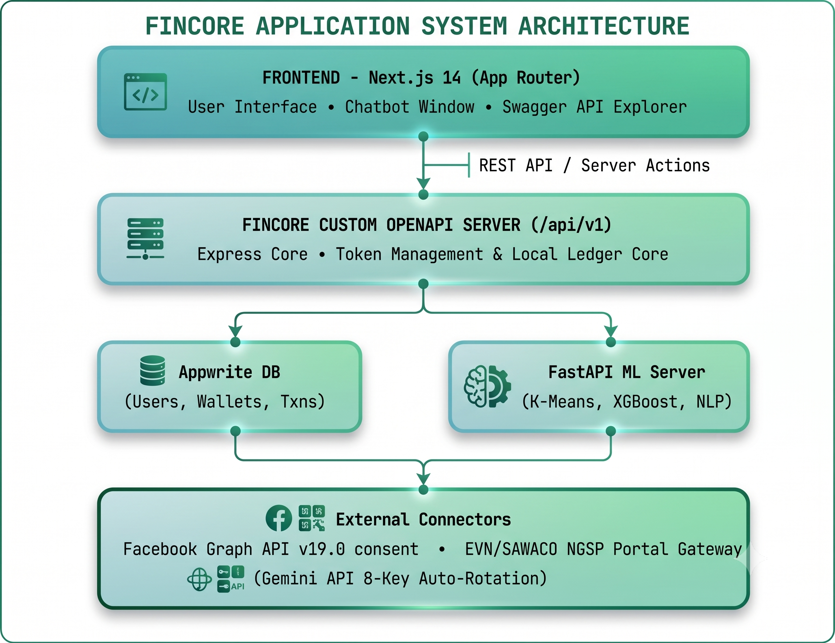
Fincore is designed as a decoupled microservices architecture, separating frontend rendering from ML computing. The complete system layout and data routing flows are detailed in the diagram below:

To ensure maximum uptime, we implement an API Key Rotation mechanism for the Gemini API. The server automatically rotates through 8 active API keys, switching keys in under 50ms upon hitting rate limits, guaranteeing 99.9% chatbot uptime. Additionally, our self-hosted Appwrite instance stores all sensitive ledger logs locally, assuring compliance with Vietnam's national data residency requirements.

PART 3: COMMERCIAL SCALING ROADMAP

3.1 Market Opportunity (TAM) and Competitive Moat
According to the e-Conomy SEA 2025 report by Google, Temasek, and Bain & Company, Vietnam's digital economy Gross Merchandise Value (GMV) will reach $39B in 2025, growing at 17% annually. Digital payment transactions in Vietnam are projected to hit $178B in 2025. Over 87% of adults have bank accounts, and smartphone penetration exceeds 84% as of 2025. Fincore targets the underserved Gen Z wealth management market. Our competitive moat relies on proprietary alternative data scoring, ReAct chatbot agents, and automated autopilot investments:
Feature Comparison | Fincore Wallet | MoMo | VNPay
AI Alternative Scoring | Proprietary K-Means & XGBoost | No (Traditional scores only) | No alternative scoring
Personalized Portfolios | Cosine Similarity & Gemini Agent | Static fund packages suggested | No portfolio services
Autopilot Saving Rules | Cron-based automated investments | Auto-debit bills only | No investment automation
Custom OpenAPI Ledger | OpenAPI Spec 3.0.3 Native | Third-party bank APIs | NAPAS-integrated API only

3.2 Business Model and Revenue Streams
Our business model relies on four main streams: Merchant payment processing fees (1.2% - 1.5%), mutual fund distribution commissions (0.5% - 1% AUM), B2B alternative credit scoring API licensing, and Premium subscription tiers (advanced AI insights). Year 1 Projection: 10,000 active monthly users (MAU) spending 2,000,000 ₫/month via merchant channels yields 250,000,000 ₫/month at an average 1.25% fee rate.

3.3 Product Roadmap and Allocation of Funds
- Months 1-3: Finalize UII Incubator MVP, onboard 500 college beta testers, sign MOUs with 2 open-ended fund partners.
- Months 3-6: Integrate live mutual fund APIs, launch Autopilot regular savings feature with smart alerts.
- Months 6-12: Pilot B2B risk-scoring API licensing with 1 commercial bank. Target 5,000 MAU.
- Months 12+: Raise seed funding, scale platform infrastructure, apply for SBV fintech sandbox.
Use of Funds: 40% on Engineering and AI R&D, 25% on User Acquisition (referral networks), 20% on Legal & SBV Sandbox compliance, and 15% on Cloud Operations.

