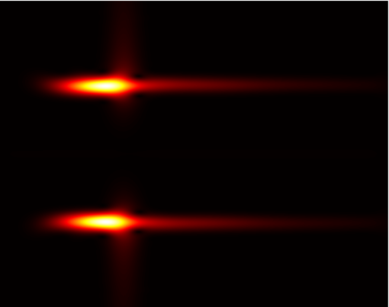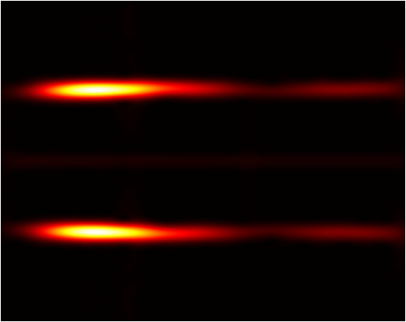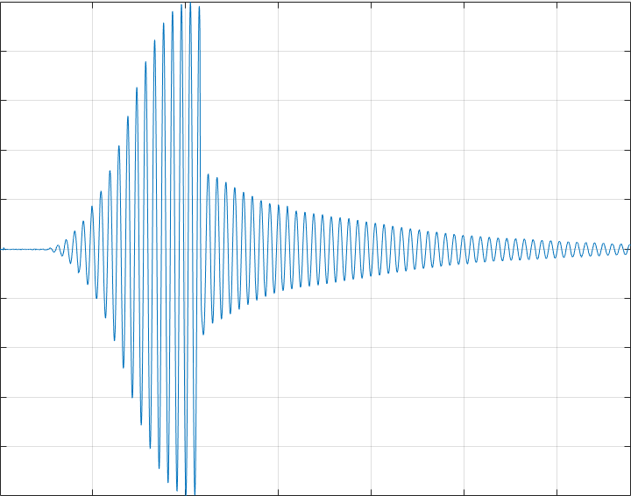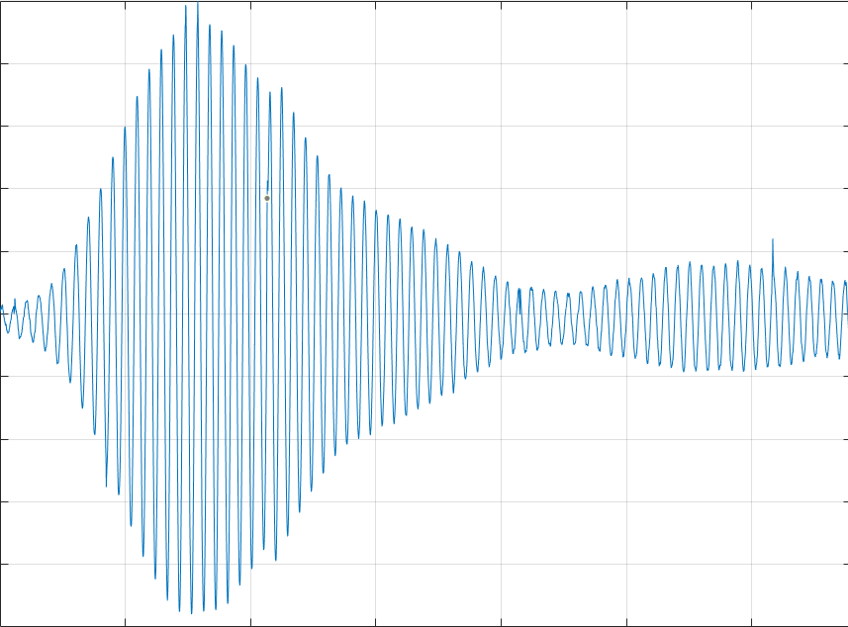

Gabor transformation

MATLAB code

Object B #1 respective spectrogram (TFR)

Object A #1 respective spectrogram (TFR)

Reflected data from Object B #1

Reflected data from Object A #1