How to Have Multiple Chrome Versions on a Laptop
Prerequisites
Before proceeding, ensure you have 7-Zip installed on your laptop. This tool allows us to extract files from .exe installers, which is essential for this process.
Downloading an Older Version of Chrome
To install multiple versions of Chrome, we need to download an older version. You can find previous versions of Google Chrome at the following link:
Google Chrome Old Versions - Uptodown (link)
Selecting and Downloading a Version
Choose any version you need. For example, in this guide, we are downloading version 127.0.6533.120. This will be in the form of .exe file.
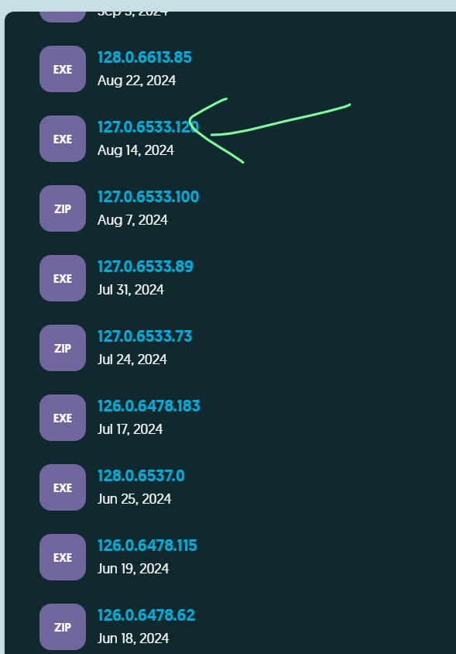
Extracting the .exe File
Once the .exe file is downloaded, use 7-Zip to extract its contents. After extraction, you will have a set of files and folders required for running the selected Chrome version.

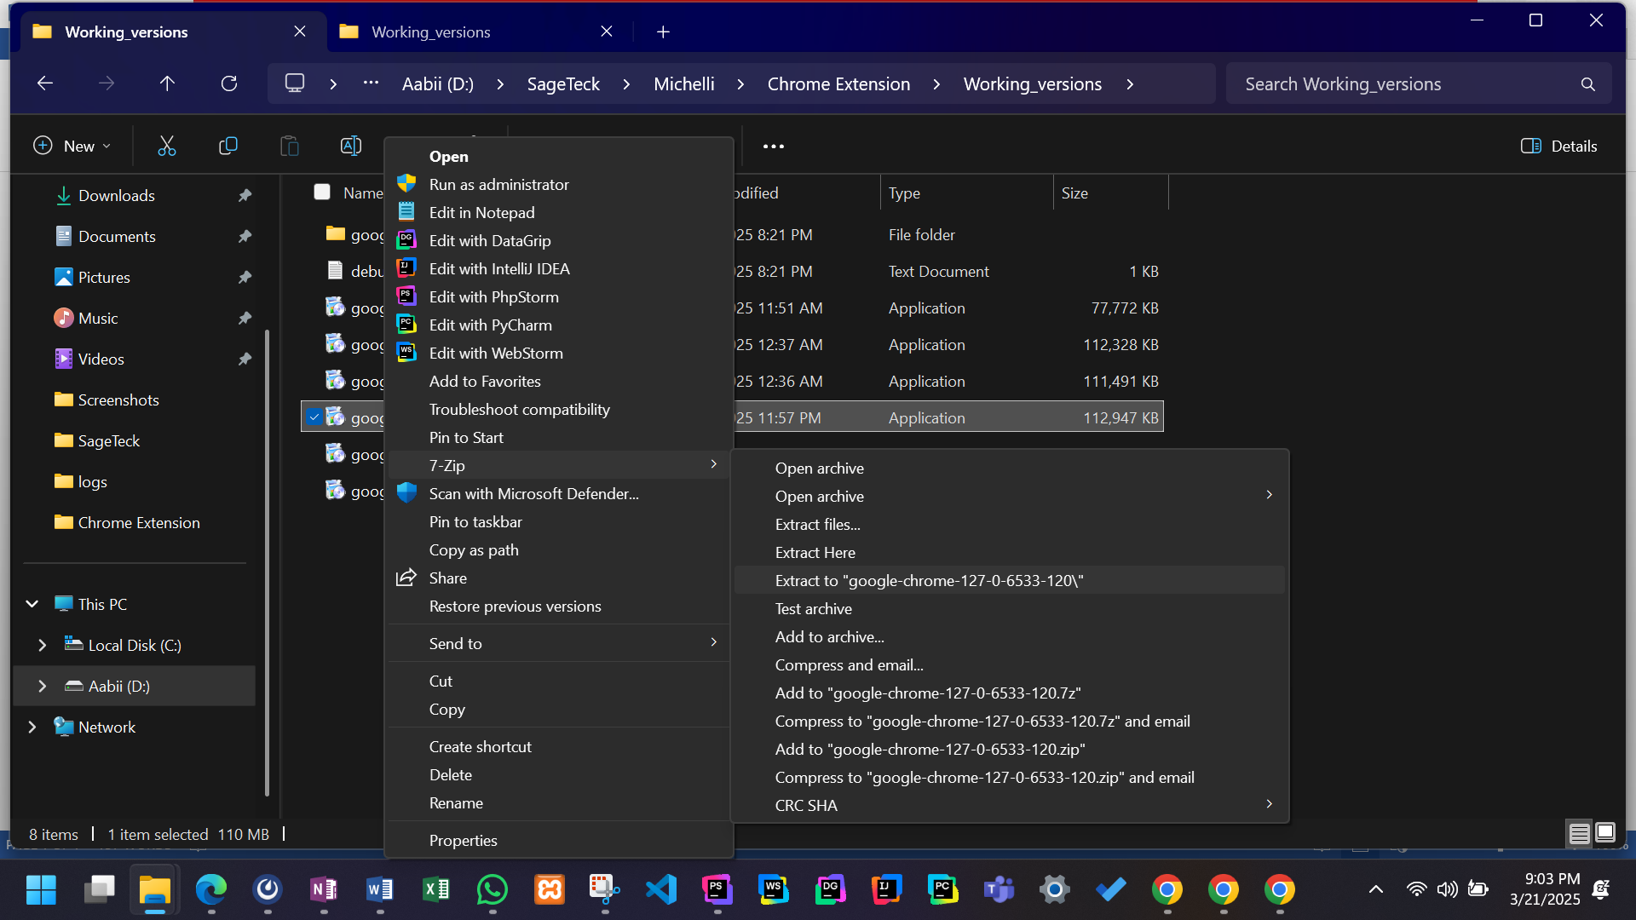
After extraction, you’ll find updater.zip file, extract that to proceed further.
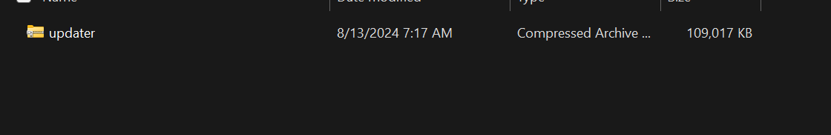
Exploring the Extracted Files
After extracting updater.zip, you will find a bin folder inside the updater directory. Within the bin folder, you will have the following files:
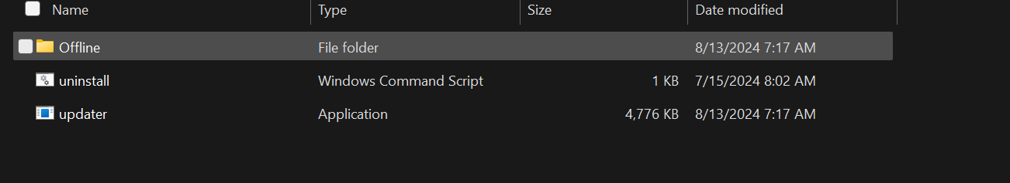
Locating the Chrome Installer
Navigate to the Offline folder and move two steps forward in the directory structure. You will find the 127.0.6533.120_chrome_installer application, which is the installer for the selected Chrome version.
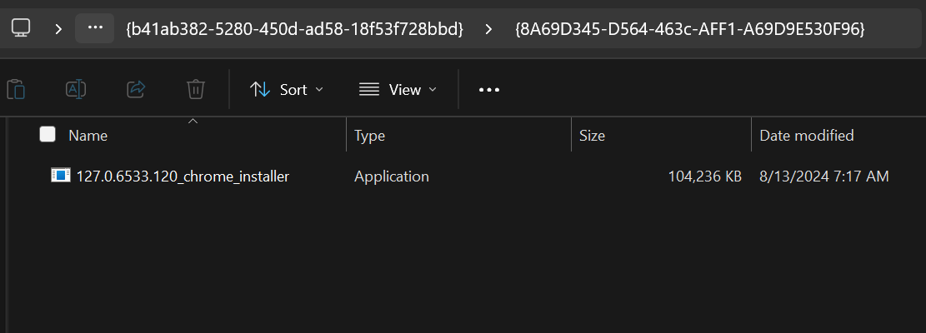
Extracting the Chrome Installer
Use 7-Zip to extract the 127.0.6533.120_chrome_installer application.
Finding and Extracting the Chrome Zip File
After extracting the Chrome installer, you will find another zip file named chrome.zip. Extract that too.
Inside the Extracted Chrome Zip
After extracting chrome.zip, you will find a folder named Chrome-bin. This folder contains the core Chrome files required to run the browser independently.
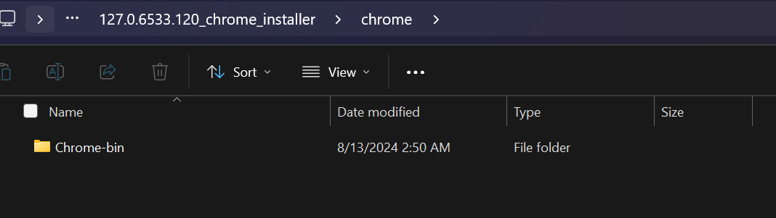
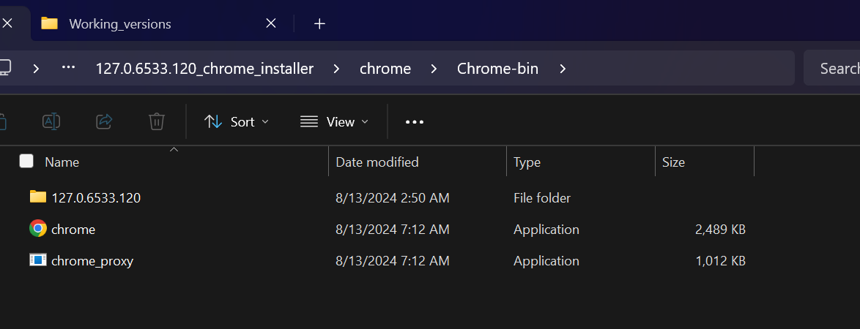
Creating a Folder for the Chrome Version
Before pasting the extracted files, you need to create a dedicated folder for this Chrome version:
- Navigate to C:\Program Files\Google\.
- Create a new folder and name it based on the Chrome version you are installing.
  - In this case, the folder is named Chrome127.
- Inside Chrome127, create another folder named Application.
Copying the Extracted Files
Now, copy all the files from the Chrome-bin folder and paste them into:
C:\Program Files\Google\Chrome127\Application
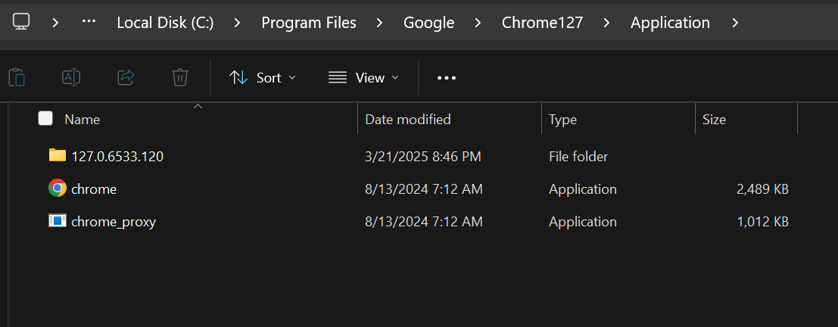
Creating a Shortcut and Modifying Its Target
- Navigate to C:\Program Files\Google\Chrome127\Application.
- Right-click on chrome.exe and select Create Shortcut.
- Move the shortcut to your desired location (e.g., Desktop).
- Right-click on the shortcut and select Properties.
- In the Target field, modify it by adding the following argument at the end:
"C:\Program Files\Google\Chrome127\Application\chrome.exe" --user-data-dir="C:\ChromeTestProfile"
Instead of ChromeTestProfile, you can specify any folder.
Now when you’ll open that shortcut it will open your desired version.

