C:\data|modular_61_0\revision_notes\Rev_61_0_final.docx
REVISION 61.0
- NEW_INPUT_FILES
Contains a list of new input files that are being tested.
- NEW_OUTPUT_FILES
Contains a list of new output files being review.
- Existing output files
List of changes in output files
- Existing input files
List of changes in input files
- Other

- NEW INPUT FILES
SED_NUT.CHA file added (this file is hard coded and not currently included in file.cio;

- NEW OUTPUT_FILES
New carbon output files here and are written when NB_HRU timestep == ‘y’ in print.prt file:
UNIT #
HRU_SOILCARB_*.TXT (4520-4527)
HRU_RESCARB_*.TXT (4530-4537)
HRU_PLCARB_*.TXT (4540-4547)
HRU_SCF_*.TXT (4550-4557)

HRU_PLC_STAT.TXT (4560,4563)
HRU_RESC_STAT.TXT (4561,4564)
HRU_SOLC_ STAT.TXT (4562,4565)
BASIN_CARBON_ALL.TXT 4566

- Output files written for the SWIFT program are being written to a SWIFT directory to keep them separate from other files;

- EXISTING OUTPUT FILES

      - *_PW output files have a new variable added to the file named STRSS (This was added by Ryan Bailey and is the stress on salts);

      - ALL WB output files have the following changes:
-Header for ‘GWTRANQ’ changed to ‘GWSOILQ’
-added new outputs at the end:
WET_EVAP
WET_OFLO
WET_STOR
      - Added new outputs named UPTAKE and IN_PLANT to the following pesticide output files: (currently do not have any sample files);
hru_pest_*.txt
basin_aqu_pest_*.txt and aquifier_pest_*.txt
basin_ch_pest_*.txt and channel_pest_*.txt
basin_res_pest_*.txt and eservoir_pest_*.txt
basin_aqu_pest_*.txt and aquifer_pest_*.txt
basin_ls_pest_*.txt

      - All NB output files; header ‘GWTRANN’ changed to’ GWSOILN’;
and header ‘GWTRANP’ changed to ‘GWSOILP’;

      - All water_allo_*.txt output files:
-Added columns RCV_TYP and RCV_NUM to the files;

      - All WB output files added columns (includes hru-lte_wb*.txt output files)
Added new inputs to the end of this file:
wet_evap (water_evaporation mm)
wet_oflo (outflow from wetland mm)
wet_stor (volume stored in wetland mm)
Example file in: \database_files\example_release_version_files

      - channel_sdmorph_*.txt output files added columns
Added new outputs at the end of this file:
N_TOT – total nitrogen leaving the reach
P_TOT – total phosphorus leaving the reach
DEP_BF – depth of water when reach is at bankful depth
VELAV_BF – average velocity when reach is at bankful depth

Example file in: \database_files\example_release_version_files

- EXISTING INPUT FILES

PARAMETERS.BSN: The inputs for LIN_SED/EXP_SED (mod spreadsheet) named SPCON and SPEXP in the code and cal_parms.cal file have been removed. In the parameters.bsn file, put “NULL” for both for place holders;

CODES.BSN:
GWFLOW added to the end of this line (after I_FPWET) where:
- == gwflow module not active:
- == gwflow module active;

NOTE: The inputs and default for the I_FPWET variable in the codes.bsn file have changed.

1 == original channel routing code using QUAL-2E for nutrient transport;
2 == channel routing with updated for moving overbank flooding into flood plain
wetlands. Using QUAL-2E for nutrient transport;
3 == New sediment budgets and simplified nutrient transport (not using QUAL-2E);
Still under development.

The default for I_FPWET == 2;

PRINT.PRT:
- SOILOUT changed to CROP_YLD
where:
a == prints average annual (default);
y == prints yearly;
b== prints both average annual and yearly;
n== no print

Example:
crop_yld mgtout hydcon fdcout
b n n n

- New output options added for SALT and Constituents added at the end of the file:
basin_salt n n n y
hru_salt n n n y
ru_salt n n n y
aqu_salt n n n y
channel_salt n n n y
res_salt n n n y
wetland_salt n n n y
basin_cs n n n y
hru_cs n n n y
ru_cs n n n y
aqu_cs n n n y
channel_cs n n n y
res_cs n n n y
wetland_cs n n n y

- OBJECT.CNT: ‘MFL’ column header is ‘GWFL’
- HYD-SED-LTE.CHA file: old BEDLDCOEF renamed to BANKFULL_FLO;

- CAL_PARMS.CAL:
Added to the file:
- NPERCO_LCHTILE

Removed the following from the file:
- SPCON
- SPEXP

REPLACED:
- CHSEQ with FLOOD_SEDFRAC
- BEDLDCOEF with BANKFULL_FLO

- Changed the MIN value for REVAP_CO from 0.02 to 0.00

Edit the following existing parms:
petco hru abs_min/abs_max changed from 0.7/1.3 to 0.8/1.2;
revap_co aqu min/max changed from 0.00/0.2000 to 0.02/0.200

bankfull_flo rte min/max changed from 0.2/3.0 to 0.5/1.5

rs2 swq max changed from 0.100/0.500
rs3 swq max changed from 0.100/2.000

pperco bsn min/max changed from 10.0/17.5 to 5.0/20.0
phoskd bsn max changed from 200.0/400.0

Renamed existing parm named: withdrawal_rate to withdraw_rate

added these new parms to the file:
lab_p sol 0.00000 30.00000 mg/kg
hum_c_n sol 0.00000 20.00000 mg/kg
hum_c_p sol 0.00000 160.00000 mg/kg

ch_n_conc rte 0.00000 500.00000 mg/kg
ch_p_conc rte 0.00000 50.90000 mg/kg
ch_p_bio rte 0.00000 1.00000 frac

sed_stlr res 0.10000 2.00000 none
velsetlr res 1.00000 15.0000 m/day

pk_rto rte 1.00000 3.00000 null
fp_inun_days rte 0.05000 30.00000 days
n_setl rte 0.05000 0.90000 frac
p_setl rte 0.05000 0.90000 frac
n_sol_part rte 0.00100 0.10000 null
p_sol_part rte 0.00100 0.10000 null
n_dep_enr rte 0.20000 1.00000 frac
p_dep_enr rte 0.20000 1.00000 frac
arc_len_fr rte 0.50000 2.00000 frac
part_size rte 0.00100 0.01000 mm
wash_bed_fr rte 0.00000 0.80000 frac

Example file in: \database_files\example_release_version_files

Added the following GWFLOW parameters to the file:
aquifer_K gwf 0.0001 40.0 m/day
aquifer_Sy gwf 0.001 0.60 m3/m3
aquifer_delay hru 0 1000 days
aquifer_exdp gwf 0 4.0 m
stream_K gwf_riv 0.0000001 0.01 m/day
stream_thk gwf_riv 0.01 2.0 m
stream_bed gwf_sgl 0 20.0 m

- OBJECT.PRT file – new option added for printing floodplain water balance data; HYD_TYP == ch_fp;

- PLANTS.PLT
For RICE plants, the following variables were updated:
DAYS_MAT
BM_E
LAI_MAX1
FRAC_HU
DLAI_RATE

- The BM_DIEOFF for all the grasses in the table below were changed to 1.0 to cutdown the erosion and organics.
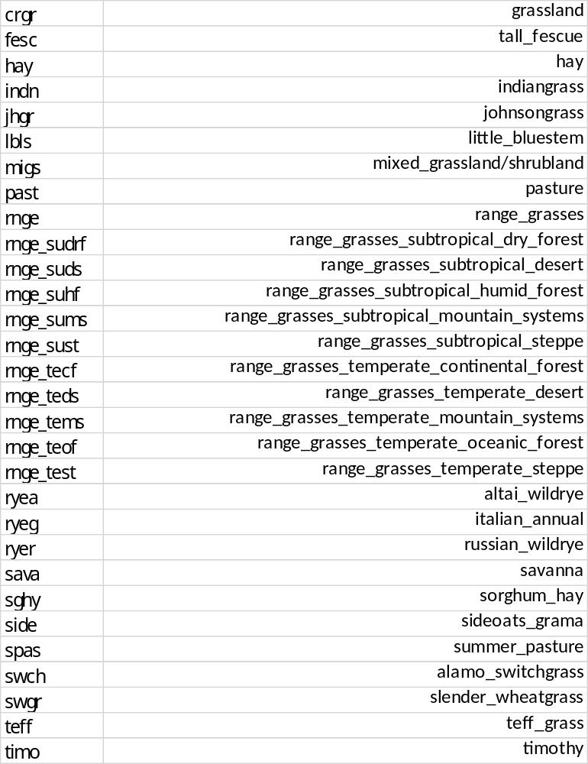
The EXT_CO values were too high in several of the plants:
name incorrect corrected
BSVG 80 0.80
CRDY 85.5 0.85
CRGR 85.5 0.85
CRIR 85.5 0.85
CRWO 83 0.83
FODB 83 0.83
FODN 83 0.83
FOEB 77 0.77
FOEN 77 0.77
FOMI 79 0.79
GRAS 84 0.84
MIGS 82 0.82
MIXC 87 0.87
SAVA 82 0.82
SHRB 80 0.80
TUBG 79.5 0.79
TUHB 79 0.79
TUMI 79.5 0.79
TUWO 79.5 0.79
WEWO 83 0.83

NOTE: The source code for the variable named ‘DAYS_MAT’ column in this file has been edited. If the amount is input as a negative number the input is considered to be heat units to maturity; If it is positive, the input is days to maturity. All entries are currently days to maturity.
Example file in: \database_files\example_release_version_files

- CONSTITUENTS.CS:
A line added to the end of the file for “Other constituents”

- Decision table:
- Conditions added:
(swatplus_decision_table_rules_61_0_Jaclyn.xlsx)
days_irr
res_inflo
- Actions added:
(swatplus_decision_table_rules_61_0_Jaclyn.xlsx)
Case DIVERT action added flo_cms

      - The model now has the capability of reading daily pet values for each HRU. There will be changes in:
- FILE.CIO where PET.CLI is entered in the place of WIND-DIR.
- WEATHER-STA.CLI - The column originally used for WNDIR is now for PET filenames.
- PET.CLI was added with a list of all files
- Measured PET files are similar to the other daily climate files and are free format (see STA1.PET example)

      - LUM.DTL added GRAIN for harvest or harvest_kill actions in standard file;

      - pesticide.pes file: added ‘pl_uptake’ column at the end of each line with a value of 0.01 for all;

      - new formatted files for pesticide and pathogens
PEST_HRU.INI
PEST_WATER.INI
PATH_HRU.INI
PATH_WATER.INI

Example file in: \database_files\example_release_version_files

- OTHER
      - NOTE: There are new SWAT DEG channel budget output files included in this code, but they haven’t been tested yet. There are no example output files with this release and will be described in the next release.

basin_sd_chanbud_*.txt
sd_chanbud_*.txt

      - Fixed the SWIFT message on the screen at simulation time;

      - There were many new additions/changes in Ryan Bailey’s groundwater routines as well as constituents and salts.

ROUTINES DELETED:
ch_rthsed.f90
ch_rtsed.f90
cli_tair.f90
expo.f90 – This routine was deleted by the advice of Steve Lionel, the “Fortran Doctor”. This routine was causing the DEBUG and RELEASE versions to be different. Removal of EXPO function and substituting with EXP function from advice of Doctor Fortran. In addition, replaced all ‘AMAX1’ occurrences with ‘MAX’ in all subroutines.
gwflow_riv.f90
NCsed_leach.f90
salt_cha_res_read.f90
scen_read_filterstrip.f90
soil_nutcarb_output.f90

ROUTINES ADDED:
cli_petmeas.f90
carbon_read.f90
ch_temp1.f90
hru_carbon_output.f90
mgt_harvresidue.f90
organswat2.f90
pest_pl_up.f90
channel_control3.f90
sd_channel_sediment.f90
basin_chanbud_output.f90
sd_chanbud_output.f90
manure_parm_read.f90 (not currently active)

GWFLOW ROUTINES ADDED;
aqu_cs_output.f90
aqu_read_init_cs.f90
aqu_salt_output.f90
carbon_read.f90
ch_cs_module.f90
ch_cs_output.f90
ch_read_init_cs.f90
ch_salt_module.f90
ch_salt_output.f90
ch_temp.f90
cli_read_atmodep_cs.f90
cli_read_atmodep_salt.f90
cs_aqu_read.f90
cs_aquifer.f90
cs_balance.f90
cs_cha_read.f90
cs_data_module.f90
cs_divert.f90
cs_fert.f90
cs_fert_read.f90
cs_fert_wet.f90
cs_hru_init.f90
cs_hru_read.f90
cs_irr_read.f90
cs_irrig.f90
cs_lch.f90
cs_module.f90
cs_plant_read.f90
cs_rain.f90
cs_rctn_aqu.f90
cs_rctn_hru.f90
cs_reactions_read.f90
cs_sed.f90
cs_sorb_aqu.f90
cs_sorb_hru.f90
cs_str_output.f90
cs_uptake.f90
cs_uptake_read.f90
cs_urban_read.f90
gwflow_canl.f90
gwflow_canl_out.f90
gwflow_chan_read.f90
gwflow_chem.f90
gwflow_fpln.f90
gwflow_gwet.f90
gwflow_gwsw.f90
gwflow_ppag.f90
gwflow_ppex.f90
gwflow_rech.f90
gwflow_resv.f90
gwflow_satx.f90
gwflow_soil.f90
gwflow_tile.f90
gwflow_wetl.f90
header_const.f90
header_salt.f90
hru_carbon_output.f90
hru_cs_output.f90
hru_salt_output.f90
mgt_harvresidue.f90
orgncswat2.f90
recall_cs.f90
recall_nut.f90
recall_read_cs.f90
recall_read_salt.f90
recall_salt.f90
res_cs.f90
res_cs_module.f90
res_cs_output.f90
res_read_cs.f90
res_read_csdb.f90
res_read_salt.f90
res_read_salt_cs.f90
res_read_saltdb.f90
res_salt.f90
res_salt_module.f90
res_salt_output.f90
ru_cs_output.f90
ru_salt_output.f90
salt_aqu_read.f90
salt_aquifer.f90
salt_balance.f90
salt_cha_read.f90
salt_chem_aqu.f90
salt_chem_hru.f90
salt_chem_soil_single.f90
salt_fert.f90
salt_fert_read.f90
salt_fert_wet.f90
salt_hru_read.f90
salt_irr_read.f90
salt_irrig.f90
salt_lch.f90
salt_module.f90
salt_plant_read.f90
salt_rain.f90
salt_roadsalt.f90
salt_roadsalt_read.f90
salt_uptake.f90
salt_uptake_read.f90
salt_urban_read.f90
soil_nutcarb_module.f90
soil_plant_init_cs.f90
wet_cs.f90
wet_cs_output.f90
wet_read_salt_cs.f90
wet_salt.f90
wet_salt_output.f90

