C:\data|modular_61_0\revision_notes\Rev_61_0_5_28_24
REVISION 61.0 – dated 5-28-24
- NEW_INPUT_FILES
Contains a list of new input files that are being tested.
- NEW_OUTPUT_FILES
Contains a list of new output files being review.
- Existing output files
List of changes in output files
- Existing input files
List of changes in input files
- Other

- NEW INPUT FILES
SED_NUT.CHA file added (this file is hard coded and not currently included in file.cio;
- NEW OUTPUT_FILES
- EXISTING OUTPUT FILES

      - All WB output files added columns (includes hru-lte_wb*.txt output files)
Added new inputs to the end of this file:
wet_evap (water_evaporation mm)
wet_oflo (outflow from wetland mm)
wet_stor (volume stored in wetland mm)
Example file in: \database_files\example_release_version_files

      - channel_sdmorph_*.txt output files added columns
Added new outputs at the end of this file:
N_TOT – total nitrogen leaving the reach
P_TOT – total phosphorus leaving the reach
DEP_BF – depth of water when reach is at bankful depth
VELAV_BF – average velocity when reach is at bankful depth

Example file in: \database_files\example_release_version_files

- EXISTING INPUT FILES
      - CAL_PARMS.CAL file:
Edit the following existing parms:
petco hru abs_min/abs_max changed from 0.7/1.3 to 0.8/1.2;
revap_co aqu min/max changed from 0.00/0.2000 to 0.02/0.200

bankfull_flo rte min/max changed from 0.2/3.0 to 0.5/1.5

rs2 swq max changed from 0.100/0.500
rs3 swq max changed from 0.100/2.000

pperco bsn min/max changed from 10.0/17.5 to 5.0/20.0
phoskd bsn max changed from 200.0/400.0

Renamed existing parm named: withdrawal_rate to withdraw_rate

added these new parms to the file:
lab_p sol 0.00000 30.00000 mg/kg
hum_c_n sol 0.00000 20.00000 mg/kg
hum_c_p sol 0.00000 160.00000 mg/kg

ch_n_conc rte 0.00000 500.00000 mg/kg
ch_p_conc rte 0.00000 50.90000 mg/kg
ch_p_bio rte 0.00000 1.00000 frac

sed_stlr res 0.10000 2.00000 none
velsetlr res 1.00000 15.0000 m/day

pk_rto rte 1.00000 3.00000 null
fp_inun_days rte 0.05000 30.00000 days
n_setl rte 0.05000 0.90000 frac
p_setl rte 0.05000 0.90000 frac
n_sol_part rte 0.00100 0.10000 null
p_sol_part rte 0.00100 0.10000 null
n_dep_enr rte 0.20000 1.00000 frac
p_dep_enr rte 0.20000 1.00000 frac
arc_len_fr rte 0.50000 2.00000 frac
part_size rte 0.00100 0.01000 mm
wash_bed_fr rte 0.00000 0.80000 frac

Example file in: \database_files\example_release_version_files

- PLANTS.PLT The BM_DIEOFF for all the grasses in the table below were changed to 1.0 to cutdown the erosion and organics.
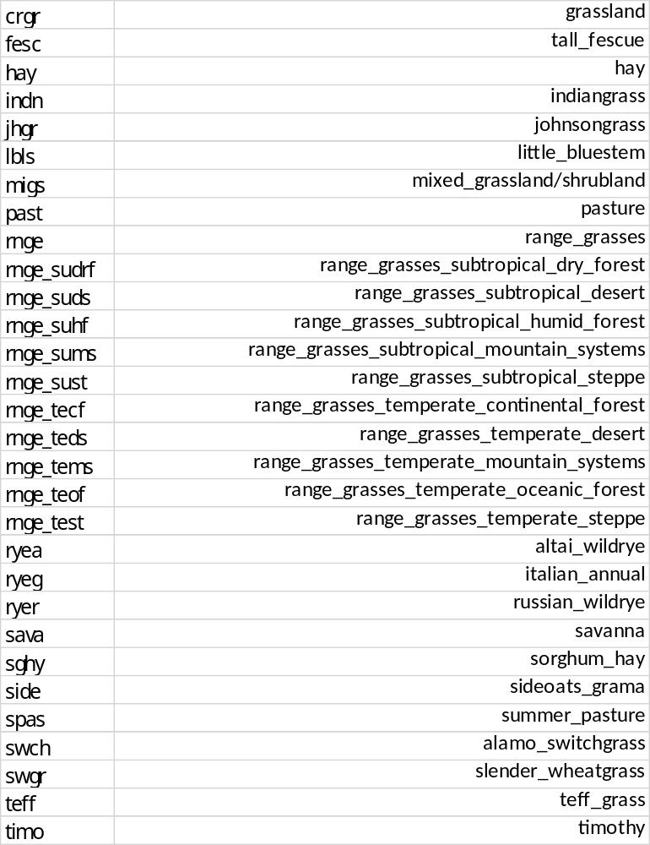

PLANTS.PLT (continued)
These changes were reported in previous release, but all of them had not been changed in the file;
The EXT_CO values were too high in several of the plants:
name incorrect corrected
BSVG 80 0.80
CRDY 85.5 0.85
CRGR 85.5 0.85
CRIR 85.5 0.85
CRWO 83 0.83
FODB 83 0.83
FODN 83 0.83
FOEB 77 0.77
FOEN 77 0.77
FOMI 79 0.79
GRAS 84 0.84
MIGS 82 0.82
MIXC 87 0.87
SAVA 82 0.82
SHRB 80 0.80
TUBG 79.5 0.79
TUHB 79 0.79
TUMI 79.5 0.79
TUWO 79.5 0.79
WEWO 83 0.83

NOTE: The source code for the variable named ‘DAYS_MAT’ column in this file has been edited. If the amount is input as a negative number the input is considered to be heat units to maturity; If it is positive, the input is days to maturity. All entries are currently days to maturity.
Example file in: \database_files\example_release_version_files

- CODES.BSN FILE
input variable I_FPWET routing code definitions have changed to the following:

i_fpwet 0 = new sediment and nutrient routing (no QUAL2E – simplified nutrients)
1 = daily routing with QUAL2E
2 = subdaily routing – with QUAL2E

Default == 0;

- OTHER

      - Added subroutines:
- channel_control3.f90
- sd_channel_sediment.f90
- basin_chanbud_output.f90
- sd_chanbud_output.f90

      - Renamed subroutine ‘ch_temp’ to ‘ch_temp’1

      - Made changes in Ryan’s GW code for compiling in Linux

      - In this version Jeff was in the process of merging the sd_channel_control and sd_channel_control2 subroutines into a new routine named sd_channel_control3.f90.

      - NOTE: There are new SWAT DEG channel budget output files included in this code, but they haven’t been tested yet. There are no example output files with this release and will be described in the next release.

basin_sd_chanbud_*.txt
sd_chanbud_*.txt

      - These files are currently not in FILE.CIO:
scen_dtl.upd
basin_carbon.tes
element.ccu
co2_yr.dat
manure_allo.mnu
puddle.ops
pest_metabolite.pes
transplant.plt
pest.com
res_conds.dat
sed_nut.cha
treatment.trt

