日期及时间: 2023/3/22 - 17:26:56

源代码
VarConstant q=[50000,100000,200000,300000];
Parameter a>0,n>0,m=[-1,0];
Variable t,ea;
function ea=a/(m+1)*q^n*t^(m+1);
Data;//50000
0,0
0.002777778,0.000895781
0.011111111,0.001029296
0.022222222,0.001103341
0.041666667,0.001175087
0.077777778,0.00125094
0.138888889,0.001325785
0.263888889,0.001413871
0.538888889,0.001518749
1.113888889,0.00163339
2.055555556,0.001736829
3.013888889,0.001804736
4.627777778,0.001883993
6.113888889,0.001937315
7.597222222,0.001979953
9.283333333,0.002020128
10.73611111,0.00204978
11.99722222,0.002072723
13.19166667,0.002092532
14.34166667,0.002110135
15.475,0.00212628
16.575,0.002140964
17.64722222,0.002154456
18.70277778,0.002167037
19.74444444,0.00217884
20.76944444,0.002189919
21.78055556,0.002200377
22.78333333,0.002210326
23.76666667,0.002219706
Data;//100000
0,0
0.927777770000002,0.00159623508997851
0.93333333,0.00222946248320418
0.94722222,0.00231679300884164
0.988888890000002,0.00241225596638554
1.1,0.00252236496403069
1.35277777,0.00263587519876425
1.77222222,0.00275149211384202
2.325,0.00285584226650204
2.98888889,0.00294658612599374
3.75,0.00302110121172435
4.59722222,0.00309416929955168
5.49166666,0.00315344688369893
6.86111111,0.00323025171804335
7.78055555,0.00327426880856292
8.85555555,0.00331885769873772
10.02777777,0.00336245924171699
11.45,0.00340935781620536
12.45277777,0.00343920808752429
13.55555555,0.00346953339337641
14.65,0.00349742869979401
15.77777777,0.00352421217067698
16.88888889,0.00354891883767097
18.00555555,0.00357227832322267
19.11944444,0.00359428764624861
20.23055555,0.00361509904769316
21.33888889,0.00363484239944518
22.43888889,0.00365353086038041
23.51111111,0.00367095852816346
24.56944444,0.00368773998281869
25.62777777,0.00370425752644724
data; //200000
0,0
0.0611111199999996,0.000109829236134417
0.0666666699999965,0.00116763992925888
0.0805555600000005,0.00133177823154751
0.108333340000001,0.00149012402370202
0.163888890000003,0.00169105733947257
0.274999999999999,0.00198935796854997
0.466666670000002,0.00241938559850484
0.777777780000001,0.00304957219819192
1.26388889,0.00439869305337439
1.91111112,0.00466028065931935
2.65,0.00484779093871349
3.43611112,0.00499090253450873
4.33055556,0.00512006856671746
5.35555556,0.00523879186965084
6.48055556,0.0053450209855927
7.49722223,0.00542936488413092
8.55277778,0.00550488811703987
9.62222223,0.00557316587216185
10.71666667,0.00563621273849143
11.83611112,0.005695503445251
12.95277778,0.00574932407801604
14.06944445,0.00579916466502674
15.18611112,0.00584553818777303
16.31111112,0.00588927804988258
17.43611112,0.00593038750813234
18.55833334,0.00596910556296673
19.66111112,0.00600517603137226
20.76666667,0.00603957997297007
21.86944445,0.00607232196399213
22.99444445,0.00610425726610442
24.11111112,0.00613477759996889
25.21388889,0.00616408451376984
data;//300000
0,0
1.03055556000001,0.00376972790264993
1.03611111000001,0.0046943107621986
1.05000000000001,0.0048545130116997
1.08333334000001,0.00505559876616049
1.15555556000001,0.00535904585240299
1.29444445,0.00576899305669659
1.53055556000001,0.00595356364391861
1.88888889,0.00617872248660905
2.375,0.00637596463424291
2.97500000000001,0.0065658164051971
3.67222223,0.00673664066714646
4.44722223000001,0.00689125164626634
5.28055556000001,0.00702818224064906
6.17500000000001,0.00715073170475012
7.10833334,0.00726444966504358
8.06944445000001,0.00736730860265537
9.03888889000001,0.00745964470130694
10.02777778,0.00754492284942724
11.03055556,0.00762411955254478
12.06111111,0.00769931997910226
13.11388889,0.00777005313161092
14.19166667,0.00783742928608742
15.27777778,0.00790086958068964
16.375,0.00796107500564653
17.46666667,0.00801757379331211
18.54166667,0.00807027789325155
19.61111111,0.00812012160726379
20.775,0.00817184263438043
21.75,0.00821320674544164

结果图
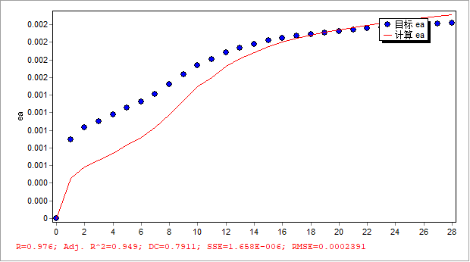
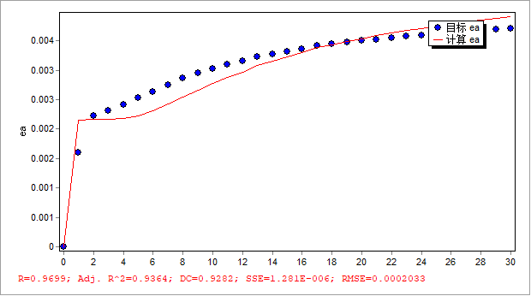
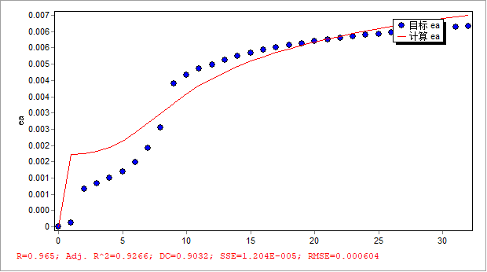
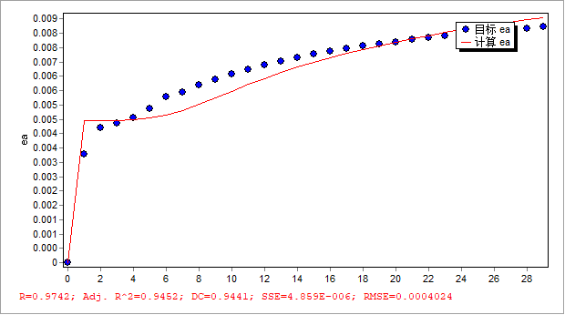

结果
时间硬化蠕变模型人造 分别加载

模型公式: ea = a/(m+1)*q^n*t^(m+1)
ea = 7.97131940028862e-8/(-0.82095907016458+1)*q^0.738264814619947*t^(-0.82095907016458+1)

迭代数: 49
计算用时(时:分:秒:微秒): 00:00:20:306
优化算法: 通用全局优化算法(UGO3)
计算结束原因: 达到收敛判断标准
残差平方和(SSE): 1.98369823969296E-5
均方差(RMSE): 0.000401592180762816
相关系数(R): 0.971056811042817
相关系数之平方(R^2): 0.942951330272644
修正R平方(Adj. R^2): 0.938889805043219
确定系数(DC): 0.893063225139339
F统计(F-Statistic): 251.031936204859

参数 最佳估算 标准差 置信区间[95%]
---- -------- ------ -------------
a 7.97131940028862E-8 1.74932963107354E-8 [4.50776847521447E-8, 1.14348703253628E-7]
n 0.738264814619947 0.0173369098365948 [0.7039389397043, 0.772590689535594]
m -0.82095907016458 0.00715513255866273 [-0.835125734669872, -0.806792405659289]

====== 结果输出 ======

文件: 数据文件-1
No 目标 ea 计算 ea
1 0 0
2 0.000895781 0.000457040061136619
3 0.001029296 0.00058580175978846
4 0.001103341 0.000663206657131706
5 0.001175087 0.000742213165192705
6 0.00125094 0.000829969367781208
7 0.001325785 0.00092076325699371
8 0.001413871 0.00103289859544426
9 0.001518749 0.00117375085794964
10 0.00163339 0.00133670862183494
11 0.001736829 0.0014916901229824
12 0.001804736 0.00159748098744237
13 0.001883993 0.0017249724350471
14 0.001937315 0.00181316313887396
15 0.001979953 0.00188507047711235
16 0.002020128 0.00195394972094184
17 0.00204978 0.00200548257465977
18 0.002072723 0.0020457612260109
19 0.002092532 0.00208082248614519
20 0.002110135 0.00211219686056073
21 0.00212628 0.00214115676754218
22 0.002140964 0.00216764486856587
23 0.002154456 0.00219210961773193
24 0.002167037 0.00221502970106609
25 0.00217884 0.00223662967076523
26 0.002189919 0.00225698932624969
27 0.002200377 0.00227628031762879
28 0.002210326 0.00229469933246309
29 0.002219706 0.00231212582068735

文件: 数据文件-2
No 目标 ea 计算 ea
1 0 0
2 0.00159623508997851 0.00215804615164897
3 0.00222946248320418 0.00216035419638716
4 0.00231679300884164 0.00216607534434286
5 0.00241225596638554 0.00218283512856019
6 0.00252236496403069 0.00222485108758034
7 0.00263587519876425 0.00230879473056151
8 0.00275149211384202 0.00242318142479282
9 0.00285584226650204 0.0025438781544546
10 0.00294658612599374 0.00266089574598828
11 0.00302110121172435 0.00277119913858067
12 0.00309416929955168 0.00287413324592407
13 0.00315344688369893 0.00296709054077461
14 0.00323025171804335 0.00308775478872136
15 0.00327426880856292 0.00315806893722052
16 0.00331885769873772 0.00323210097859677
17 0.00336245924171699 0.00330484741789722
18 0.00340935781620536 0.00338426686112492
19 0.00343920808752429 0.00343552213923956
20 0.00346953339337641 0.00348811495500319
21 0.00349742869979401 0.00353694472994758
22 0.00352421217067698 0.00358422300753781
23 0.00354891883767097 0.00362816283500349
24 0.00357227832322267 0.00366999289405118
25 0.00359428764624861 0.00370964820607624
26 0.00361509904769316 0.00374735794656721
27 0.00363484239944518 0.00378331583509384
28 0.00365353086038041 0.00381751797121307
29 0.00367095852816346 0.00384955629614411
30 0.00368773998281869 0.00388002411401737
31 0.00370425752644724 0.00390943287991442

文件: 数据文件-3
No 目标 ea 计算 ea
1 0 0
2 0.000109829236134417 0.00221202148739136
3 0.00116763992925888 0.0022467524458249
4 0.00133177823154751 0.00232418358889643
5 0.00149012402370202 0.00245079884789522
6 0.00169105733947257 0.00263935538923509
7 0.00198935796854997 0.00289563883423502
8 0.00241938559850484 0.00318321967672827
9 0.00304957219819192 0.00348809040853457
10 0.00439869305337439 0.00380487309573793
11 0.00466028065931935 0.00409725242171276
12 0.00484779093871349 0.00434420262328699
13 0.00499090253450873 0.00455103605625166
14 0.00512006856671746 0.00474351384564562
15 0.00523879186965084 0.00492741472080017
16 0.0053450209855927 0.00509853614543523
17 0.00542936488413092 0.00523331636373115
18 0.00550488811703987 0.00535820884144599
19 0.00557316587216185 0.0054724410913151
20 0.00563621273849143 0.00557901645493022
21 0.005695503445251 0.00567915016498451
22 0.00574932407801604 0.00577156640040915
23 0.00579916466502674 0.00585765729209842
24 0.00584553818777303 0.00593830974060915
25 0.00588927804988258 0.00601478199752052
26 0.00593038750813234 0.00608703993667937
27 0.00596910556296673 0.00615540153643999
28 0.00600517603137226 0.00621934870341693
29 0.00603957997297007 0.0062805664182686
30 0.00607232196399213 0.00633902036690118
31 0.00610425726610442 0.00639620970412275
32 0.00613477759996889 0.00645074717337039
33 0.00616408451376984 0.0065026078001406

文件: 数据文件-4
No 目标 ea 计算 ea
1 0 0
2 0.00376972790264993 0.00494848175324137
3 0.0046943107621986 0.00495324752473044
4 0.0048545130116997 0.00496507082955368
5 0.00505559876616049 0.00499293146875729
6 0.00535904585240299 0.00505096122671669
7 0.00576899305669659 0.00515465582886786
8 0.00595356364391861 0.00531163317329256
9 0.00617872248660905 0.00551550436306901
10 0.00637596463424291 0.00574635751805915
11 0.0065658164051971 0.00598284180455016
12 0.00673664066714646 0.00621269220220036
13 0.00689125164626634 0.00642938270691331
14 0.00702818224064906 0.00663016683170301
15 0.00715073170475012 0.00681854866898491
16 0.00726444966504358 0.00699257562199872
17 0.00736730860265537 0.00715316561803276
18 0.00745964470130694 0.00729995407096947
19 0.00754492284942724 0.00743692236762446
20 0.00762411955254478 0.00756492176730623
21 0.00769931997910226 0.00768687151140147
22 0.00777005313161092 0.00780291544256208
23 0.00783742928608742 0.00791404504264891
24 0.00790086958068964 0.0080192321208585
25 0.00796107500564653 0.00811943574736695
26 0.00801757379331211 0.00821380293675883
27 0.00807027789325155 0.00830211041946698
28 0.00812012160726379 0.00838588473574574
29 0.00817184263438043 0.00847289823919526
30 0.00821320674544164 0.00854276124792682

