# Name: Long Bui

Group: 7

Class: ECON298

Professor: Jiang Ye

# ***Are Emily and Greg More Employable Than Lakisha and Jamal? Further Research On Bertrand and Mullainathan’s Paper***

# **I) Introduction**

1. *Statements of Interest*

The study “Are Emily and Greg More Employable Than Lakisha and Jamal ? A Field Experiment on Labor Market Discrimination” by Marianne Betrand and Sendhil Mullainahthan explored racial discrimination in the job market by conducting a field experiment to investigate whether job applicants with African-American sounding names receive fewer callbacks for interviews compared to applicants with stereotypically white-sounding names, even when the qualifications on their resumes are the same. By continuing the legacies of the previous researches on differential treatments occuring in the labor market, Bertrand and Mullainathan envisioned to delve into a socially ongoing debate about there are evidence exists on racial disparities in employment opportunities since, as the authors stated, “some argue yes, citing either employer prejudice or employer perception that race signals lower productivity” while some others argued racial disparities “is a relic of the past” and “stringent enforcement of affirmative action programs” may even “produce an environment of reverse discrimination”.[1]

1. *Experiment Summary*

The original authors conducted a field experiment to study labor market discrimination by sending fictitious resumes in response to real job advertisements in Boston and Chicago newspapers. The resumes were created from fictitious resumes that were identical in terms of qualifications, skills, and experience and then would be randomly assigned either African-American or White-sounding names to manipulate the perceived race of applicants. Then, the researchers responded to real job advertisements with fictitious resumes. This involved actively engaging with the job market by submitting these resumes to various employers who had posted job oppenings. The primary outcome measure was the callback rate and by tracking the responses to the resumes with different names, the researchers could assess whether there were significant differences in callback rates based on the perceived race associated with the applicants’ names. Finally, the research tested p-value to examine the null hypothesis and check whether the data they found were subjected to randomness or not.

The study employs a field experiment, a method that involves real-world scenarios, to collect data. This approach adds a level of realism and allows researchers to observe actual behaviors in hiring practices, providing valuable insights into potential biases that might not be evident in traditional surveys or observational research. Nevertheless, the research question is structured in a way that allows for concrete and measurable outcomes since the callback rates for resumes with different names provide clear evidence of any disparities in employer responses, making the study’s findings more actionable and understandable.

The collected data on callback rates were subjected to statistical analysis to determine whether any observed differences were statistically significant. For instance, the researchers examine whether the employment from a certain employer demonstrated equal treatment, white favored, or African-American favored or not. Nevertheless, the authors also conducted analysis to establish correlations between all the factors with the callback rate to examine whether the callback rates were likely due to chance or if they were indicative of systematic biases. To enhance the internal validity of the study, the researchers compared the amount of attributes between black and white resumes, and higher and lower quality resumes. Finally, the researchers also assign zipcode as an attribute to examine whether neighborhoods affect call-back rate. This means that the allocation of names to resumes was done randomly, helping to control for potential confounding variables and ensuring a more accurate assessment of the impact of the manipulated variable.

1. *Research’s Results*

Bertrand and Mullainathan concluded that “for two identical individuals engaging in an identical job search, the one with an African-American name would receive fewer interviews” [2], indicating that evidence of racial disparities in the labor market does exist. In fact, resumes with White-sounding names received 50% more callbacks compared to those with African-American names. Although the study also witnessed any effect of neighborhood of residence on the likelihood of callback, it found consistent patterns of discrimination across various industries, including even federal contractors, indicating that the observed biases were not limited to specific sectors. This suggested a pervasive and systematic issue in the labor market. While the study provided valuable insights, the authors acknowledged the need for further research to explore other dimensions of discrimination and to assess the effectiveness of proposed interventions. The study served as a starting point for a more comprehensive understanding of biases in the labor market which Bertrand and Mullainathan strongly believed in the need for robust anti-discrimination laws and equal opportunity policies in the workplace.

1. *Main Empirical Result*

Our team is committed to reproducing the primary empirical table by employing linear regression and p-value analysis. This will enable a thorough investigation into the diverse factors influencing callback rates in the job market. Utilizing these statistical methods proves valuable in identifying subtle effects of different attributes beyond race, establishing a strong foundation to authenticate the initial study's result and propelling discussions on fair hiring practices forward.

***II) Experimental Design***

1. *General Summary*



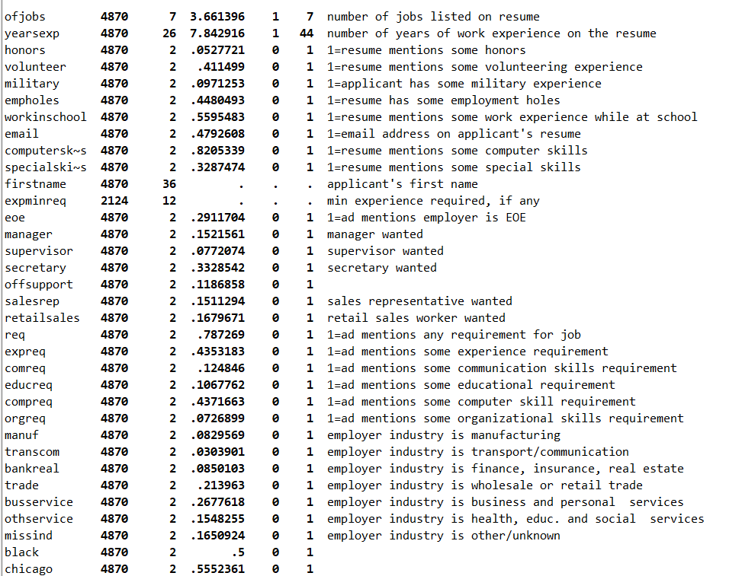



*Table1: Summary statistics for each variable in the dataset.*

We will utilize a subset of the initial dataset, comprising 4,870 observations and 38 variables, to replicate and findings outlined in the paper. Each observation encompasses details about a resume's attributes, such as background information and skill sets, along with the job's requirements, including recruited positions and specific skill demands. However, we mainly focus on dominant attributes that are being used in the original research’s primary table: black (race), chicago (location), high (resume’s quality), female (gender), college(college degree), and call_back (call back acceptance). These variables summarize most of the other attributes in the dataset. The callback result is also included in each entry. However, the data lacks specific information about applicants' zip codes and detailed employer information, preventing us from exploring the impact of zip codes on resumes or the distribution of callbacks by employer.

In total, there are 34 dummy variables, with only the "expminreq" attribute containing null values, indicating that the employer did not specify a minimum experience requirement. Consequently, we will replace all null values in this attribute with 0 for our analysis.

1. *Important Factors*
2. **Race variables**

The data demonstrated that there are the same amount of black and non-black resumes (around 2435 each). Additionally, every attribute that belongs to black and non-black groups demonstrates similiar quality except callback rate: while black has 6.4% callback rate, non-black has 9.7% call-back rate. However, as we examined, all other factors demonstrated high-degree of similarities between two groups of ethnicities, being demonstrated by below graphs and tables. Therefore, the data collected could be perceived as unbiased.

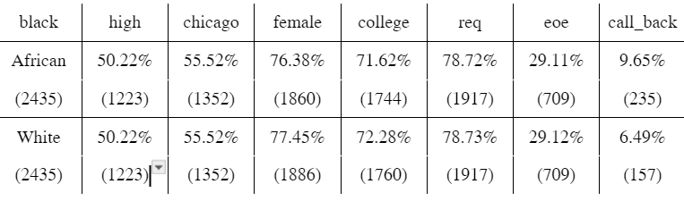

*Table2: Table 2 demonstrates a number of observations having a certain characteristic (column) dividing by African or white sounding names. These columns represent: high: high quality resume, chicago: resume from Chicago, female: applicant is female, req: does the job required any skill, ,eoe: the employer claims to be equal opportunity employer, call_back: the amount of call back*

1. **Gender**

As the paper clearly indicated: “We use male and female names for administrative and clerical jobs to increase callback rate”[3]. The number of female applications (3746) is substantially higher than male applications (1124), and female resumes also demonstrate higher call-back rates ( 8.2% > 7.38%). Therefore, it is true that the authors stated that adding more female resumes will increase the chance of getting a call back.

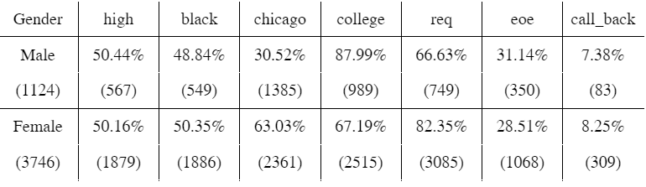

*Table3: Table3 demonstrates number having a certain characteristic (column) dividing by gender. These columns represent: high: high quality resume, chicago: resume from Chicago, black: race, req: does the job required any skill, ,eoe: the employer claims to be equal opportunity employer, call_back: the amount of call back*

1. **Resume’s Quality**

There are a similar number of high quality (2446) and low quality (2424) resumes. The total callback rate in the data set is 8% as well as there is a similar rate between high and low quality resumes. The high-quality resumes have a higher chance (8.7%) to receive call-back rate than the low-quality resumes (7.34%) with all other factors being held equal for high and low quality resumes. Therefore, we can assure that the high and low quality is designed unbiased.

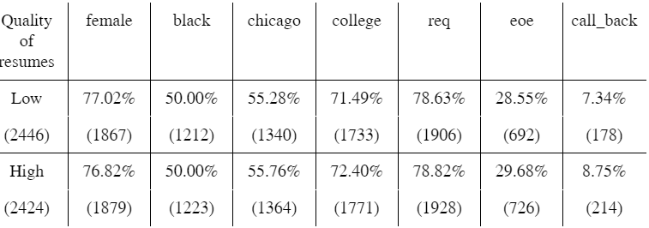

*Table4: Table4 demonstrates the number of observations having a certain characteristic (column) divided by quality of resumes. These columns represent: female: gender, chicago: resume from Chicago, black: race, req: does the job required any skill, ,eoe: the employer claims to be equal opportunity employer, call_back: the amount of call back*

1. *Replication methods*

We will try to replicate the primary table which demonstrates how different factors affected the call back rate between resumes that have white-sounding names and those of African-American sounding names. By conducting this replication, we can examine racial gaps when adjusting other attributes and inspect statistical confidence of the result through interpreting the p-value. Furthermore, we will also investigate other factors besides factors mentioned in the primary table to explore do racial gaps exist in different levels of structures. Finally, we believe conducting regression analysis between call back rate, race, and different factors can help us to envision correlations between these factors.

***III) Replication Results***

1. *Statement of Interest*

From Figure1, we can observe that although resumes that have African-American sounding names have lower number of call back acceptance than those of White-sounding names, the number of call backs from both columns compared to the total observations is relatively low, indicating that the connection between *race* factor and call back is very weak

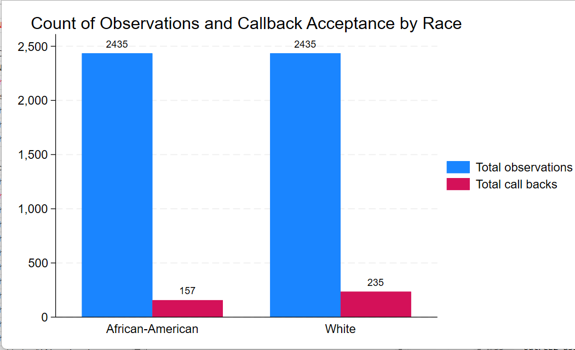

*Figure1: Bar Graph for Count of total Observations and Call-back Acceptance by Race*

Likewise, after running a quick linear regression between call_back (dependent variable) and black (independent variable), a very low R-square (0.0035) appeared, suggesting that the *race* factor may not be a conclusive and important factor in the process of receiving call back after applying to job posts. Thereby, it is interesting to further investigate how the authors establish their conclusion, especially when taking into consideration other factors excluding race.

## *Replication process*

The table replicated all the vital factors’, separating by race factor, influence on call back rate.

Although both female in administrative and female in sales columns did not accurately have the exact same value as the original research, we still received a relatively similar percentage difference between these two. Therefore, similar to the 1st table in the original research, overall, we can witness in every aspect, White-sounding name resumes always have a higher chance of getting a call back than African-American sounding name resumes. This further strengthens the original thesis that race does affect whether an individual will have a job or not, demonstrating from the data above that white-sounding name has an average of 50% chance of getting a call-back rate.

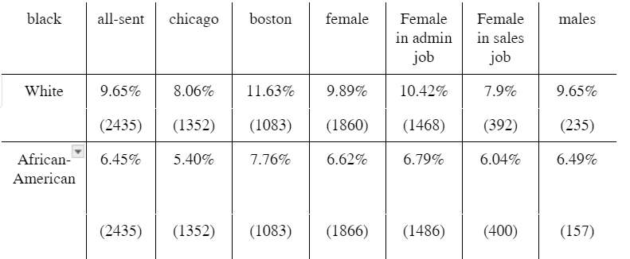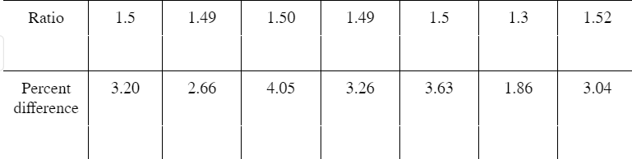*Table5: The table 5 is replicated in stata using bysort: black sum call_back if [condition]*. *The table demonstrates how the call back rate changed between white names and black names if we adjust one of these important factors including location (chicago, boston), gender (female, male), or types of job being applied for only female since female has higher call back rates (administrative jobs, sales jobs). The first two columns, the percentage indicates the call back rate if conditions were suited while the number in the bracket demonstrates the quantity of resumes that met the conditions regardless of call back.*

Now, let’s consider whether if getting higher in our social hierarchy, race would be a detrimental factor to job application or not.

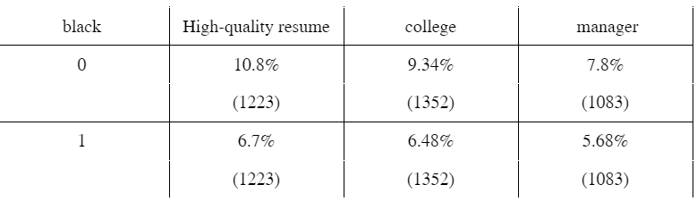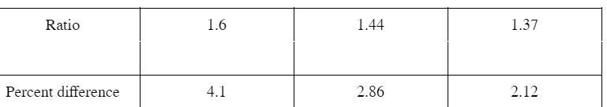*Table6: An examination of racial difference considering factors that may be confounding to the result. The row “0” represents resumes that have white-sounding names while the row “1” represents resumes that have African-American names. The first two columns, the percentage indicates the call back rate if conditions were suited while the number in the bracket demonstrates the quantity of resumes that met the conditions regardless of call back. The manager column is a column that has employees applied to manager jobs.*

College (1.44) and Manager (1.37) have a lower level of racial disparity than average (1.5) since it is common to believe that the more complex that the job is, the more important skill sets rather than race. However, it is also interesting that high-quality resumes (1.6) have a significantly higher level of racial disparity proportion than normal (1.5), illustrating that higher skill credibility cannot reduce the effect of racial injustice on social employment.

We will also replicate the p-value in this section to examine the test of proportion testing the null hypothesis that the callback rates are equal across racial groups. Hence, from table 2, that the p-value for all-sent, chicago, boston, female, and female in administrative jobs suggested that there is strong evidence against the null hypothesis, demonstrating that there is statistically significant difference in call back rates between these resumes across different aspects. However, although the original table did have the high p-value in females in sales jobs and males, the research did not mention much about it. In other words, we acquired some borderline evidence against a null hypothesis in these 2 cases. Practically interpreting, the replication demonstrated a reality that females-gender, although being stated to have higher chance of receiving call back rate, witnessed a higher level of racial disparities to the males groups. Not only that, while sales jobs are perceived as jobs that directly communicate with customers, they have a much higher chance of enjoying equality than administrative jobs.

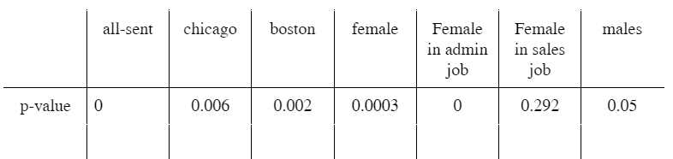*Table7: Table7 demonstrates the p-value of separating white and African-American names with different factors, being replicated using reg call_back black if [condition].*

Hence, it is interesting to see how the racial disparity differs across different industries.

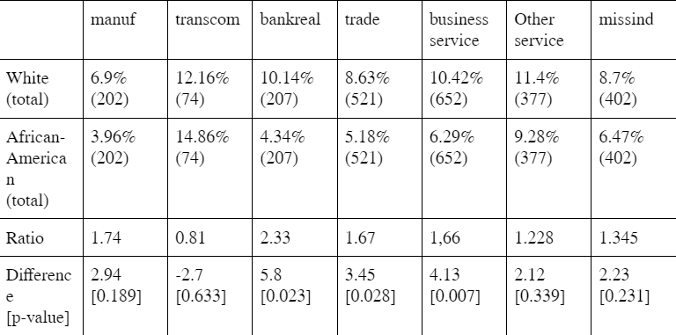

*Table 8: Table 8 demonstrates call back rate across different industries, including in order from left to right: manufacturing, transport-communication, finance-insurance-real estates, sales, business and personal service, health-educational-social services, and other unknown services. The first two rows depict the call back rate and observations that satisfied the conditions in the bracket. The third row illustrates how large the call back rate from white compared to African-American. The last row shows the difference between the two call-back rates and p-value.*

We can witness high racial disparities across all types of industries, indicating that inequalities of opportunities between races exist as a common phenomenom in the labor market. Banking/ real-estates demonstates the highest level of racial inequalities, targeting against the African-American resumes. It also has a low p-value which we can reject the null hypothesis. In other words, it is statistically evident that an White person has a more 130% chance of getting a call-back rate in this industry than an African-American person. In contrast, the transportation-commerce sector is the only industry that prefers African-American names to White names but the p-value is so high that we cannot reject the null hypothesis.

1. *Conclusion*

From the replication above, we could clearly agree with the original conclusion of the paper that racial disparities did exist in the labor market. However, it is interesting that we found out several other statistics and insights from the data we replicated. First, racial disparities do not become less significant between high-quality laborers but instead, becoming more detrimental and biased. Secondly, although females have an advantage over male’s resumes, African-American female employees suffered a higher level of racial discrimination than African-American men in the labor market. Not only that, system racism does have an influential impact on the labor market and even more heavily than social racial differences. As we explored from the p-value, recruiters are very biased in administrative jobs, preferring white-sounding names than African-American names. In conclusion, throughout the replication, we could conclude that racial differences do exist in the labor market and detrimentally impact on many aspects. Furthermore, we do find racial disparities exist across different industries.

# **IV) *Potential Extension***

The influential research conducted by Bertrand and Mullainathan in 2004 laid a crucial groundwork for exploring racial discrimination in job markets by examining callback rates for job applicants. Our replication initiative not only affirms the initial discoveries but also opens avenues for various insightful details about racial discrimination on the labor market.

However, there is one confounding factor that should be deeply investigated. The observed low correlation between skills demanded by employers and the skills presented in job applications raises intriguing questions about whether skill sets in resumes had been appropriately applied to the correct works. For instance, in table 9, a low correlation level of computer skills in resume and computer skills demanded by the recruiters. Hence, further research should be conducted to rearrange all the matching resumes with the matching jobs to see whether race plays a crucial factor on the recruiting process or not.

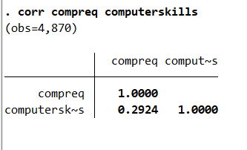

*Table8: Correlation between resumes that has computer skills and jobs that required computer skills.*

Additionally, a contemporary extension could assess how advancements in technology and changes in recruitment practices influence racial disparities in hiring. Analyzing the role of artificial intelligence in the hiring process and potential biases embedded in algorithms may offer critical perspectives on emerging challenges. Furthermore, in-depth interviews with employers and job seekers could uncover the underlying mechanisms driving discriminatory practices and provide a nuanced understanding of the socio-cultural factors influencing hiring decisions. Finally, expanding upon this study could entail the examination of additional variables, employing contemporary methodologies, and applying the insights to current datasets to assess whether patterns of discrimination have persisted or evolved.

1. Bertrand and Mullainathan, pg.991
2. Bertrand and Mullainathan, pg.1006
3. Bertrand and Mullainathan, pg.1005