1.

Station is a place where a user can interact with the network.

Node is a place where station can address the physical network and is a transfer point to pass information through a network.

2.

Distance

Bandwidth

Closeness

3.

3

1 + 1+ 1+ 1+ 1 + 1 + 1

4 + 4 and 4 and 4 +4 and

30 in total 3 + 7 + 20

4.

Destination node

A B C D F G

Origination B A - C C C C

Origination C F B - F F G

5.

Centralised routing

The whole routing table can located in one centralised in one node

Advantages:

-Every decision is made in one node

Disadvatages:

- Every time a node need to change to another it need to consult

-Big traffic

-If the central node fail there will be problem

Distribute routing

Disadvantage

If a node have a problem then it will very to pull up every routing and compare it and to fix it

LAB

First part

3.125KB in one sec

3125 \* 8 = 25000 bit/sec

Ack window size 40\*8 = 320 bytes \* 8 = 2560 bits

Packet sent window size 100 \*10 = 1000 \* 8 = 8000 bits

Window size is 10 packet + 1Kb each window

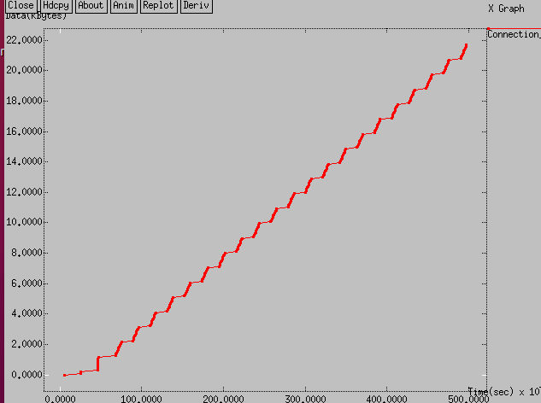

Second part

Packet window size 15 packets

Same packet size 100 bytes each

100 \* 15 \* 8 = 12000 bits

4.600Kb one sec

4600 \* 8 = 36800 bits

Ack window

15 \* 40 \* 8 = 4800 bits

Was able to transmit more data per sec

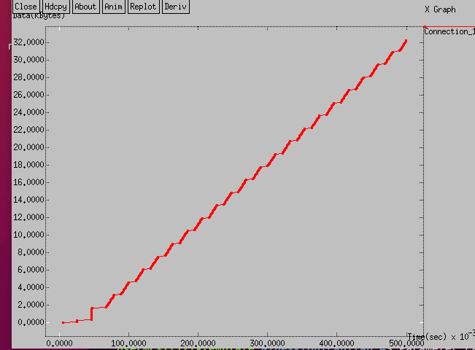

Part three

27

51