This report show the work allocated for each team member at the fist stage of the project.

|  |  |  |  |
| --- | --- | --- | --- |
| **Name** | **Start** | **Finish** | **Remaining Work** |
| Long | Wed 11/03/20 | Thu 18/06/20 | 496 hrs |
| Yash | Mon 16/03/20 | Thu 18/06/20 | 568 hrs |
| Blake | Wed 11/03/20 | Thu 18/06/20 | 416 hrs |
| Lam | Mon 16/03/20 | Thu 18/06/20 | 568 hrs |
| Hoa | Wed 11/03/20 | Thu 18/06/20 | 328 hrs |

This table show a more detailed work with actual hours times. It also show where work date start for each members.

This chart show a more complex

Work status for overallocated resources.

Work Status

**Overallocated Resources**

OVERALLOCATION

Team Planner View

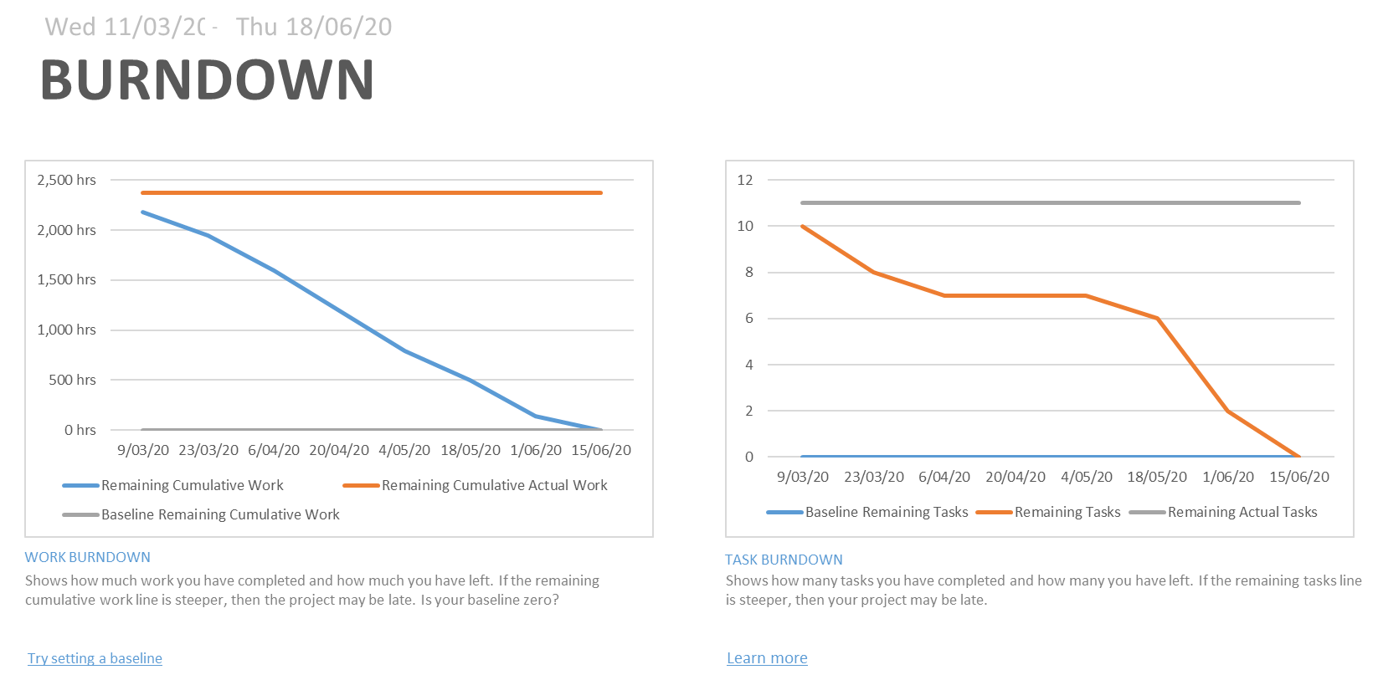

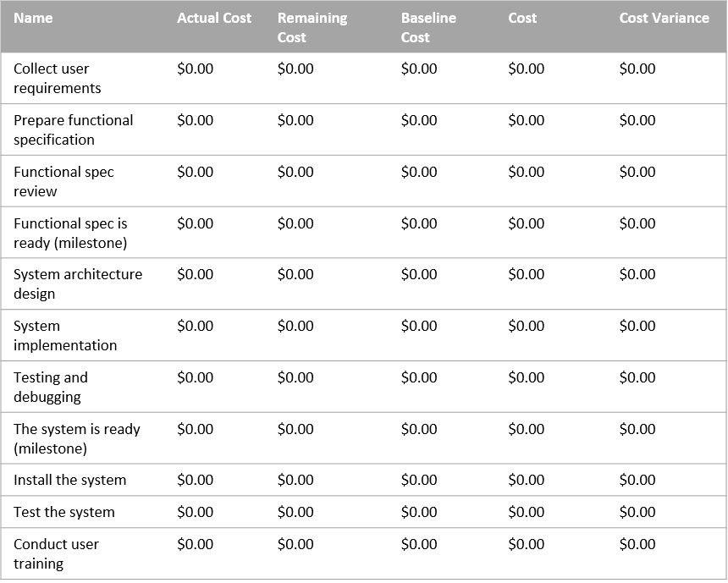

PROGRESS VERSUS COST

Progress made versus the cost spent over time. If % Complete line below the cumulative cost line,your project may be over budget.

COST STATUS

-

COST STATUS

Try setting as baseline

**COST OVERVIEW**

Cost status for top level tasks.

Cost status for all top-level tasks. Is your baseline zero?

