Report

Lab Exercise/Assignment week : Lab 8

Lab Group (CL/01, CL/02,…) : Lab CL/01

Family name : Le

First name : Quang Long

Student number : 6482132

Email address : qll998@uowmail.edu.au

Project Manager: Le Quang Long

Contents

Part 1 2

Figure 1.1 Using baseline to show the project progress 3

Figure 1.2 Using Network Diagram to show the project progress 4

Figure 1.3 Using Cost view to show the project progress 6

Part 2 6

Figure 2.1 Using critical path view to show the project progress 7

Figure 2.2 Using crashing on task 7 to shorten the critical path 8

Figure 2.3 Error crashing shown when moving another task outside of the critical path 9

Part 1

In order to study the progress tracking technique. I have experimented with baseline views (Figure 1.1). Cost views (Figure 1.2) and network diagram (Figure 1.3). In order to complete the tasks also, human resources has been added in the resources sheet and assigned tasks accordingly. Waterfall model for tasks is still the same until part 2.

Using the baseline (referring to figure 1.1). I have found that the baseline takes in the data of the project copying it’s current tasks length, ordering and predecessor. So that when back to a in progress chart it overlaps and showed under the current progress line. The baseline in here is used like a snapshot of the tasks of the estimates that you have made and then to be used for comparison when changing tasks length. For part of tasks that has not been changed at all the baseline should phase completely in the and is shown right under the blue progress line(figure 1.1). For the changed tasks the baseline will somewhat phase out a bit or completely phased out depending on how much has changed. Using the baseline you can see how radical the changes happens to the calculate the cost for the change.

Network diagram is also a very useful way to show the progress of the project (refer to figure 1.2). But with a downside that is very lengthy and can’t be fitted on one page easily. However, it is more informative compared to baseline. It shows explicitly the start date, end date, duration and completion percentage. It explicitly shows which tasks is done by having an ‘X’ cross over the task and even color coding (red vs blue) and relation clearly drawn out. This network diagram shows a more simplistic view but easy to understand. This can come in handy when showing progress to sponsors and stakeholders.

The Cost view is a more detailed technical view and mostly focused on what progress has been done(figure 1.3). Compared against the normal task view, this view can be mainly used to see planned cost and date progress rather than tasks relationships and connection. Of course, by using the update project function we can also see the progress at the desired stage if we want to. Combined with the baseline we can have an exact of the cost and the time the change made.

In conclusion, baseline, view and diagrams are mostly used to see hypothetical changes and how it would potentially impact the project. Not only that looking the project from a different perspective like cost, labor work intensity, hours worked are valuable information.

#### 

### Figure 1.1 Using baseline to show the project progress

### Figure 1.2 Using Network Diagram to show the project progress

#### 

### Figure 1.3 Using Cost view to show the project progress

# Part 2

To complete part 2 there were changes that needed to be made. Since Lab5 was a waterfall model only without any kind of simultaneous tasks. Change to tasks’ predecessors and dependent tasks needs to be made. I have made a few tasks to be able to start simultaneously, some part start earlier than other but still is overlaps with other tasks.

To study the progress tracking technique. I have experimented with critical path (figure 2.1), used crashing technique (figure 2.2) and intentionally moving a task to see how it changes the critical path(figure 2.3) to understand how it works.

Using critical path view (figure 2.1). The view shows us the critical tasks. By critical tasks, it means tasks that will delay the entire projects if not completed as planned. By seeing and understanding what critical path does, a good project manager can organize other tasks and focus on critical tasks to keep the project within it’s own time constraint. At the same time if a project is foreseeably and inevitably delayed a good project manager will be able to think ahead and plan around the delay.

By crashing task 7 (figure 2.2) We have reduced the time it takes to complete the project critical path to 4.88. In return we have allocated all of our staff members of the team to work on the task. But this does not change that task 7 is still a critical task since the time it takes to go from task 7 to task 10 is still relative more compared to task 8 and 9. Since task 7 is still very short and does not delay the summary task to go to the next critical task.

To understand what free slack do. I moved task 8 out of it’s free slack (figure 2.3) further out and even later out of task 9 and 10. From my understanding free slack shows the allocated time that the task can be completed within before it starts delaying successor tasks, the next critical task. Even though task 8 is not a predecessor of any tasks it will lengthen the parent task, task 6 (refer to figure 2.3). Now, since task 8 will delay the next critical task. It will become the critical task. This will tell us if we need to apply methods like crashing in order to reduce it’s time, and again to be able to plan ahead around the delay.

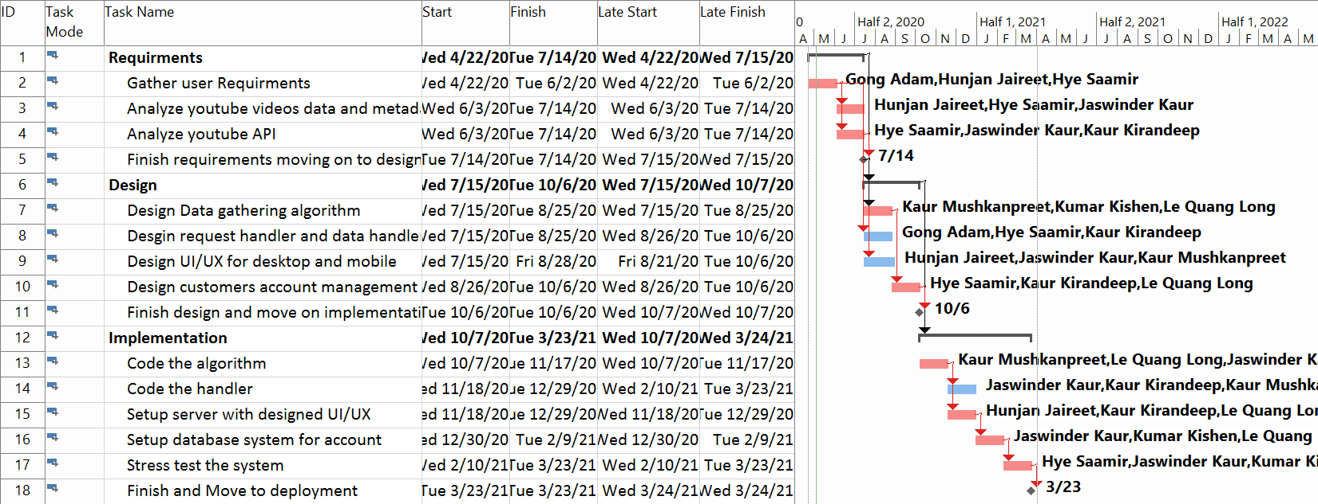

#### 

### Figure 2.1 Using critical path view to show the project progress

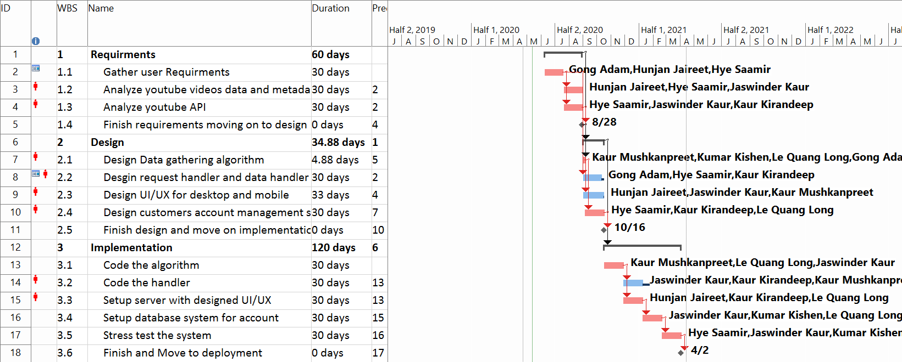

#### 

### Figure 2.2 Using crashing on task 7 to shorten the critical path

# 

### Figure 2.3 Moving task 8 out of the free slack

# 