Report

Lab Exercise/Assignment week : Week 3
Lab Group (CL/01, CL/02,…) : CL 1
Family name : Le
First name : Quang Long
Student number : 6482132
Email address : qll998@uowmail.edu.au

Summary:
The work that has been done by the project manager that have been assigned to this project are. Allocation of personnel that work on the project to their appropriate tasks that they can excel at. Allocating tasks and requirements into bite sizes that can be clearly timed and managed. Organizing tasks in specific order and in an efficiency way that minimize the length of the project. Overseer the project so that it is completed successfully

Stakeholders that are interested in the project:
Project manager (you)
Project team
IT department
R&D department manager

Stakeholders that are potentially interest in the project:
The Customer
The Executives of the company
The Surveyed Users

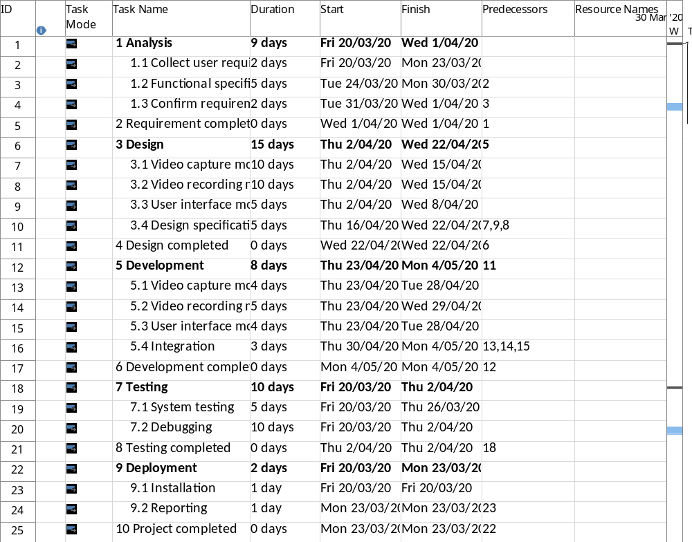

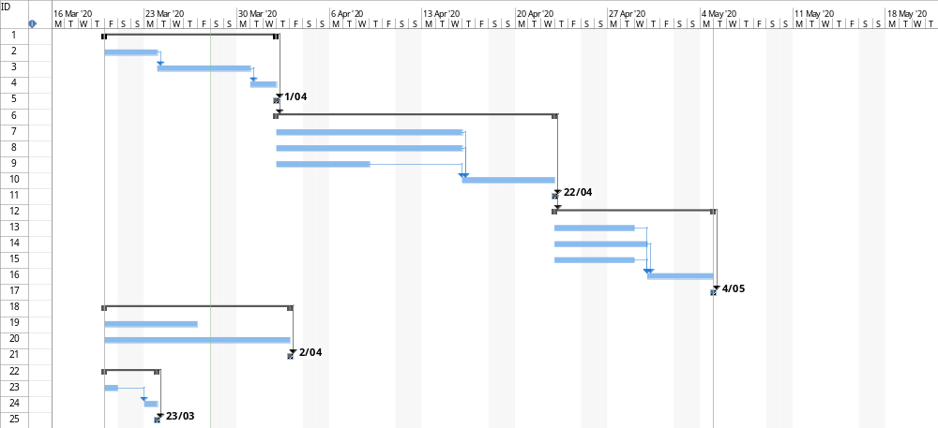

As the project timeline shows there are 25 tasks in total with 5 generalised tasks and 19 subtasks. With that we have the design and Development with the most subtask(4) and Deployment with least (2) subtasks. We can also that because of the two subtasks Video capture module and video recording module that are independent of each other that takes up most of the project time with each being 10 days long.

As the gantt chart show the project takes 45 days to complete with the longest task being Design takes around 15 days and the shortest task is deployment that only takes 2 days. One particular detail is that Testing and deployment can be started with the same time at start of the project and does not depends on any tasks at all.

