Report

Lab Exercise/Assignment week : Lab 4
Lab Group (CL/01, CL/02,…) : CL/01
Family name : Le
First name : Quang Long
Student number : 6482132
Email address : qll998@uowmail.edu.au

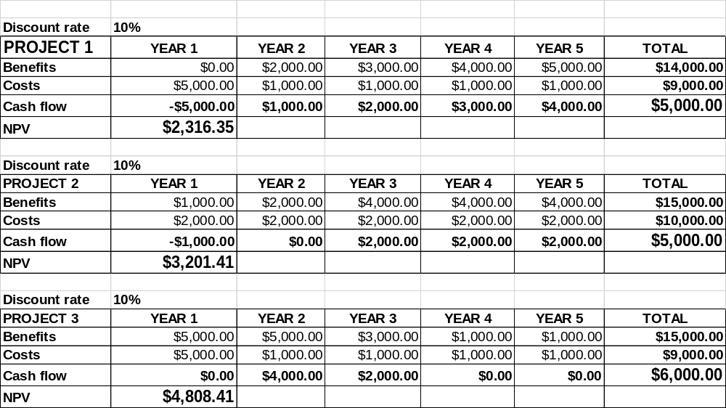
Explanation:
The project that is favourable for the IT company would be project 1. A project that is not expected to immediately return the benefit have more relaxed time to be developed which helps it to produce the expected result. If a project can be pushed towards the client and accepted the company have more opportunities to use the funding towards other infrastructure or aspect that could improve the company

The client would definitely prefers project 3 because profit in early stage. The longer it takes for the benefit to rise the longer it takes to pay back the original cost.

Question 2.

Discount rate an inverse relationship with ROI %

The higher the discount rate the lower the ROI % and reversed

Since the value of the cash flow keep reducing years after years then at one point doesn’t matter how much profit a company make. If it’s in the later year it won’t amount much to the original Cost.

If a year 1 project cost have grown 20% then it will affect the ROI heavily.

Example using project 1

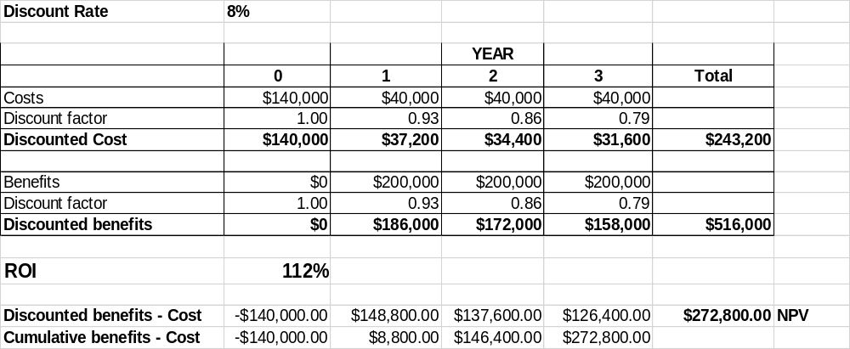
By just increasing 20% in the year 1 cost it have reduced ROI from 112% to 90% taking away 22%. Depending on how initial cost scale with the entire project cost and benefit. But with very close/similar number and only 8% of discount rate. It has heavily affected the project ROI.

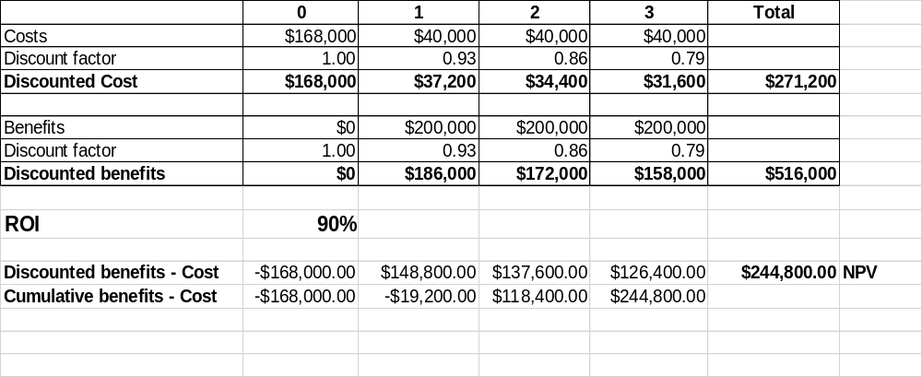

Question 3
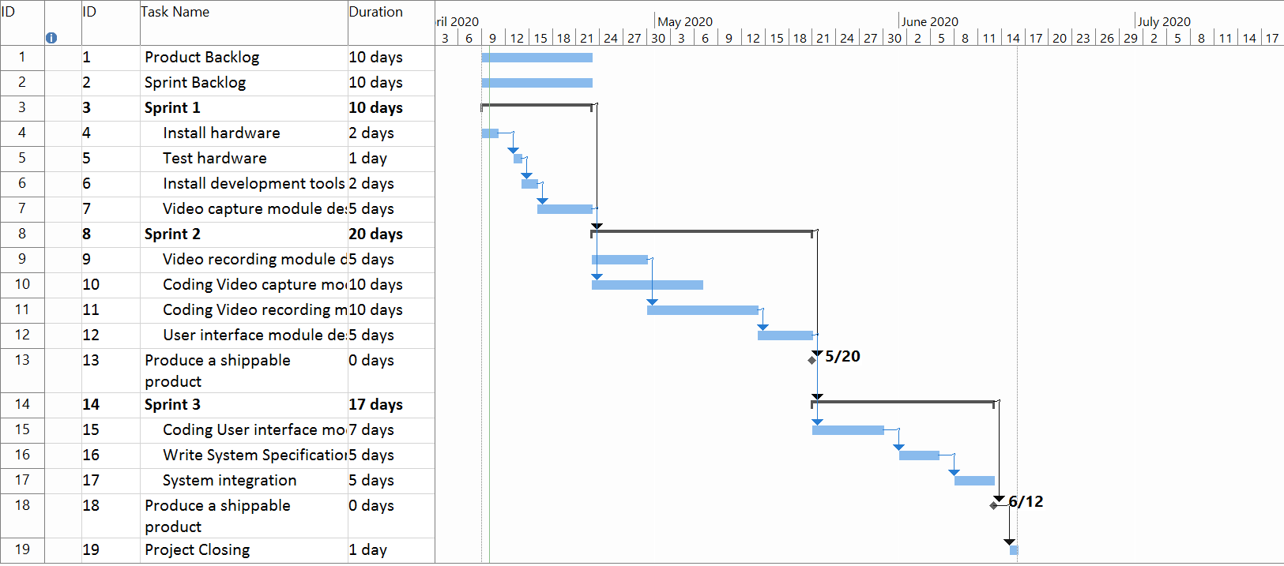

There are a total of 11 task in project backlog that takes total of 57 days. By putting them into each sprints we reduced it down to 47 days of work to complete the project.

With the following

Sprint 1
- Install hardware
- Test hardware
- Install dev tools
- Video capture module design
There are 4 tasks with every single task completed in order. To make sure that the initial preparation for the project to go well and reduce risks of hardware failure. Takes total of 10 days
Sprint 2
- Video recording module design
- Coding Video capture module
- Coding video recording module
- User interface module design

There are 4 bigger tasks with Video recording module design and Coding video capture module start at the same time Since in this section Video recording and Video capture is closely related we want to make sure there is a back and forth progress between the two so that we can make sure of standards and consistency matches between them. When the design has finished the last half of Coding video capture module will be spent working with the Coding video recording module, again since they are closely related. User interface module design is done last and separated on it’s own. Since user interface could be decided to be the touch up. Takes total of 20 days

The last sprint
Sprint 3
- Coding user interface module
- Write system specification
- System integration

There are 3 small tasks. Sprint 3 is mostly used to touch up and finalize the project before closing it. Tasks are completed in order.

So far it seem that this is the most efficient way to organize the project since the project can’t be started without installing hardware and development tool. Sprint 1 has to resort to be preparation sprint. Sprint 2 is the sprint that have the most work. Sprint 3 is then used to touch up.

Limitation and risks of Scrum model

Product Backlog is given by the Product owner. Who sometime does not necessary understand the exact time it takes to complete a specific task. Product owner does not necessary have a close contact with the project team. Which sometime can be hard for the scrum master to explain certain limitations and strong points of the team.

At some point the project can’t nothing to do but wait for certain tasks to be completed without doing anything else. Ex: install hardware, test hardware. At the same time creating extra task to fill the time can be unnecessary and could either raise of lower the morale of the team.

Scrum tasks duration does not reflect how efficient the team can work. It just requirements set out by the Product owner. Which means that the project can also potentially fail because the timing requirement set out by the product owner.

Scrum master can have a hard time to decide which tasks can be worked parallel with each other. Or which tasks crucial that It has to be worked on it’s own separately. This requires a lot of knowledge about the team and experience.

