

**TRAINING SUPPORT SYSTEM PROJECT**

**Software Design Specification**

– Hanoi, September 2022 –

**Record of changeS**

| **Date** | **A* M, D** | **In charge** | **Change Description** |
| --- | --- | --- | --- |
| 10/09/2022 | A | DongNG | Create new SDS |
| 13/09/2022 | M | AnhNT | Spelling corrections and layout corrections |
| 13/09/2022 | M | HoangNM | Color correction for class diagrams |
| 13/09/2022 | M | LongCH | Color correction for admin/setting list |
| 13/09/2022 | M | NghiaLM | Correcting some points in web contact detail, web contact list |
| 15/09/2022 | M | LongCH | Change color code common login, register,admin/setting list  admin/setting details |
| 15/09/2022 | M | HoangNM | Update template home page |
| 13/10/2022 | A | AnhNT | Add design for Subject Setting Details, Assignment Details, Class Details |
| 23/10/20222022 | A | LongCh | Add Issue ListList |
| 23/10/20222022 | A | LongCh | Add Issue Detail |
| 23/10/20222022 | A | LongCh | Add Team List |
|  |  |  |  |
|  |  |  |  |

*A - Added M - Modified D - Deleted

**Table of Contents**

I. Overview **8**

1. Code Packages 8

2. Database Design 9

a. Database Schema 9

b. Table Description 9

II. Code Designs **13**

1. Common/Login 13

a. Class Diagram 13

b. Class Specifications 13

c. Sequence Diagram 14

d. Database Queries 14

2. Common/Register 15

a. Class Diagram 15

b. Class Specification 15

c. Sequence Diagram 16

d. Database queries 17

3. Admin/Setting List 18

a. Class Diagram 18

b. Class Specification 19

c. Sequence Diagram 19

d. Database queries 20

4. Admin/Setting Details 20

a. Class Diagram 20

b. Class Specification 20

c. Sequence Diagram 20

d. Database queries 21

5. Admin/User List 22

a. Class Diagram 22

b. Class Specification 22

c. Sequence Diagram 23

d. Database queries 23

6. Admin/User Detail 24

a. Class Diagram 24

b. Class Specification 24

c. Sequence Diagram 24

d. Database queries 26

7. Common/Forgot Password 26

a. Class Diagram 26

b. Class Specification 27

c. Sequence Diagram 27

d. Database queries 28

10. Common/Change Password 28

a. Class Diagram 28

b. Class Specification 28

c. Sequence Diagram 29

d. Database queries 29

11. Common/User profile 29

a. Class diagram 29

b. Class Specification 29

c. Sequence diagram 30

d. Database queries 30

12. Change password 31

a. Class diagram 31

b. Class Specification 31

c. Sequence Diagram 32

d. Database queries 32

13. Support/ Web contact list 32

a. Class diagram 32

b. Class Specification 33

c. Sequence Diagram 33

14. Support/ Web contact detail 33

a. Class diagram 33

b. Class Specification 34

c. Sequence Diagram 35

c. Sequence Diagram 35

15. Eval criteria list 36

a. Class diagram 36

b. Class Specification 36

c. Sequence Diagram 37

d. Database queries 37

16. Subject Setting List 38

a. Class diagram 38

b. Class Specification 38

c. Sequence Diagram 38

d. Database queries 39

17.Subject Setting Details 39

a. Class diagram 39

b. Class Specification 39

c. Sequence Diagram 39

d. Database queries 39

18.Eval criteria detail 40

a. Class diagram 40

b. Class Specification 40

c. Sequence Diagram 41

d. Database queries 41

19. Admin/System Permissions 42

a. Class diagram 42

b. Class Specification 42

c. Sequence Diagram 43

d. Database queries 43

20. Assignment List 44

a. Class diagram 44

b. Class Specification 44

c. Sequence Diagram 45

d. Database queries 45

21. Assignment Details 45

a. Class diagram 45

b. Class Specification 45

c. Sequence Diagram 46

d. Database queries 46

22. Milestone list 46

a. Class diagram 46

b. Class Specification 46

c. Sequence Diagram 47

d. Database queries 47

23. Class List 47

a. Class diagram 48

b. Class Specification 48

24. Class Details 49

a. Class diagram 49

b. Class Specification 49

b. Class Specification 50

c. Sequence Diagram 50

d. Database queries 51

b. Class Specification 52

c. Sequence Diagram 52

26. Class eval criteria list 53

a. Class diagram 53

b. Class Specification 54

c. Sequence Diagram 55

d. Database queries 55

27. Class eval criteria details 56

a. Class diagram 56

b. Class Specification 56

c. Sequence Diagram 57

d. Database queries 57

28. Milestone details 58

a. Class diagram 58

b. Class Specification 58

c. Sequence Diagram 59

d. Database queries 59

29.Team List 60

a. Class diagram 60

b. Class Specification 60

c. Sequence Diagram 61

d. Database queries 62

30.Schedule List 62

a. Class diagram 62

b. Class Specification 62

c. Sequence Diagram 63

d. Database queries 63

31. Schedule Detail 63

a. Class diagram 63

b. Class Specification 63

c. Sequence Diagram 64

d. Database queries 64

# I. Overview

## 1. Code Packages

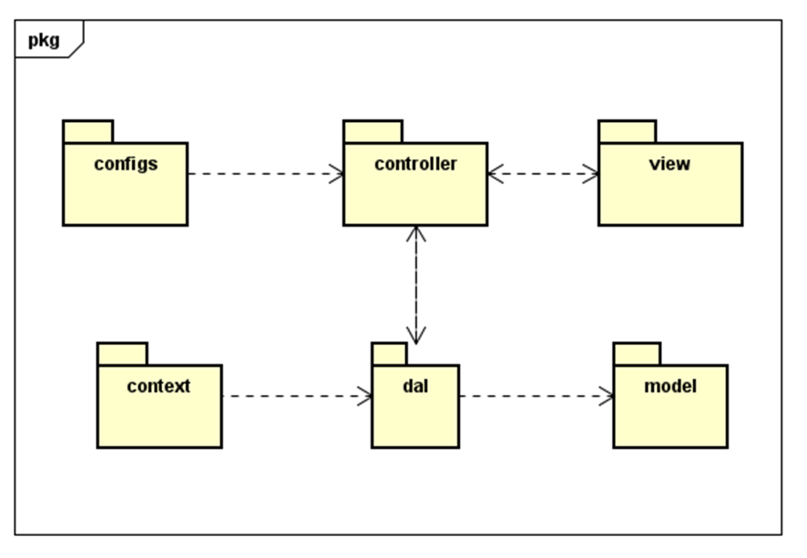

***Package descriptions***

| **No** | **Package** | **Description** |
| --- | --- | --- |
| *01* | *controller* | *Acts as a go-between for the service layer and the Front-end, passing on different input requests* |
| *02* | *dal* | *This component is used to get data directly FROM the database* |
| *03* | *configs* | *This component helps define configuration* |
| *04* | *context* | *This component helps connect database* |
| *05* | *model* | *This component includes interfaces used to receive data retrieved FROM the database and classes used to receive data* |
| *06* | *view* | *This component display front-end.* |

## 2. Database Design

### a. Database Schema

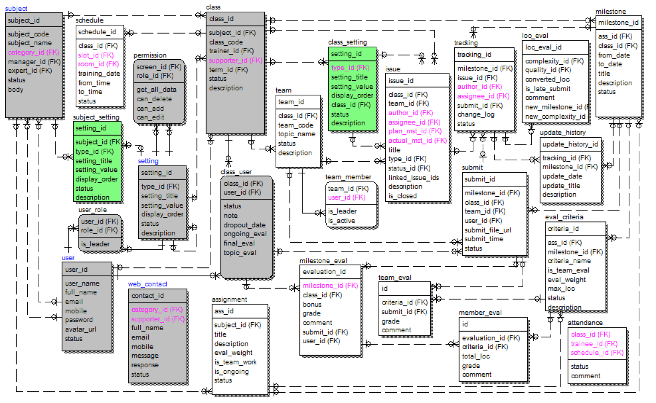

### b. Table Description

| **No** | **Table** | **Description** |
| --- | --- | --- |
| 1 | class | have information about class is stored |
| 2 | class_lesson | Store information about a specific lesson including (lessons, subjects, classes, slot) |
| 3 | class_setting | allow change about title , value ,status and description |
| 4 | class_user | Archive study groups of a class once assigned by the teacher |
| 5 | client | have the list of all client is stored |
| 6 | lesson | Store subjects, instructors teaching that subject, lectures in the form of videos, files containing learning materials |
| 7 | package | General information for the subject |
| 8 | permission | have information about screen and function about delete, add, edit. |
| 9 | setting | Allow or restrict user to have different permissions |
| 10 | subject | Have the list of all subject is stored |
| 11 | subject_setting | allow change about title , value ,status and description of the subject |
| 12 | team | have the list of all team is stored |
| 13 | user | have the list of all user is stored |
| 14 | user_role | have user access rights |
| 15 | web_contact | Information for user to contact |
| 16 | System Permissions | Configure the page-access permissions for each of the system roles |
| 17 | User Authorization | Link Check, Sider Menu, Header & Footer |
| 18 | Subject Setting List | Configure the subject: complexity levels, quality levels |
| 19 | Subject Setting Details |  |
| 20 | Assignment List | List of subject assignments; filter by subject , status; search by title |
| 21 | Assignment Details |  |
| 22 | Eval Criteria List | List of assignment evaluation criteria; filter by subject , assignment , status; search by criteria_name |
| 23 | Eval Criteria Details | View details of a criterion, edit or delete it |
| 24 | Class List | Filters: Subject, Term, Trainer, Supporter, Status  Columns: Id, Code, Term, Trainer, Supporter, Status  Row Actions: View/Edit, Activate/Deactivate/Close  Global Actions: Filter, Search (by Code), Sort (columns), Paginate  Status: Active, Inactive, Closed |
| 25 | Class Details | Subject (L), Code, Term (L), Trainer (L), Supporter (L), Status, Description  Trainer can edit the GitLab API connection configuration for the class he/she is in charge of |
| 26 | Class Setting List | Filters: Type, Status  Column: Id, Type, Title, Value, Display Order, Status  Row Actions: View/Edit, Activate/Deactivate  Global Actions: Filter, Search (by Title, Value), Sort (columns), Paginate  Roles: trainer ~ full access, student ~ read only  Status: Active, Inactive |
| 27 | Class Setting Details | Fields: Type (L), Title, Value, Display Order, Status, Description |
| 28 | Milestone List | List of milestones and content of class assignments |
| 29 | New Milestone | Create a new milestone, select based assignment from the list of related subject assignments enter start date, end date  Once created, the subject's selected assignment information and related evaluation criteria are copied into the milestone information. |
| 30 | Milestone Details | View and edit class milestone information |

# II. Code Designs

## 1. Common/Login

### a. Class Diagram

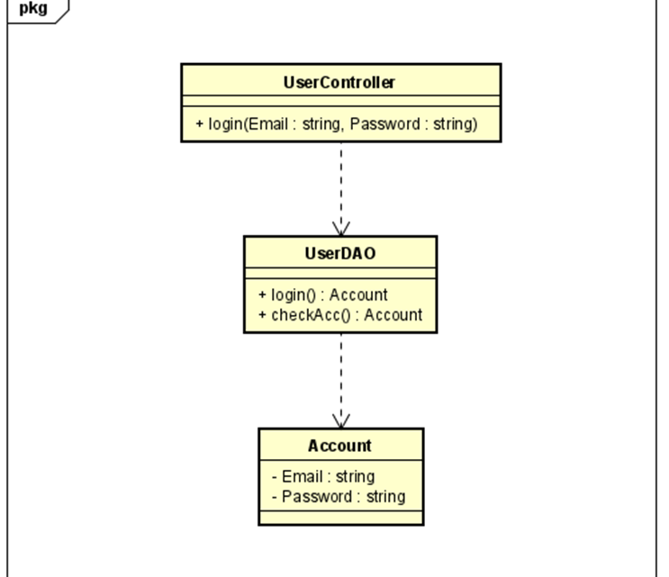

### b. Class Specifications

| **No** | **Method** | **Description** |
| --- | --- | --- |
| *01* | *login* | *Using to login into the system* |
|  | *checkAcc* | *Using to check account in database* |

#### 

### c. Sequence Diagram

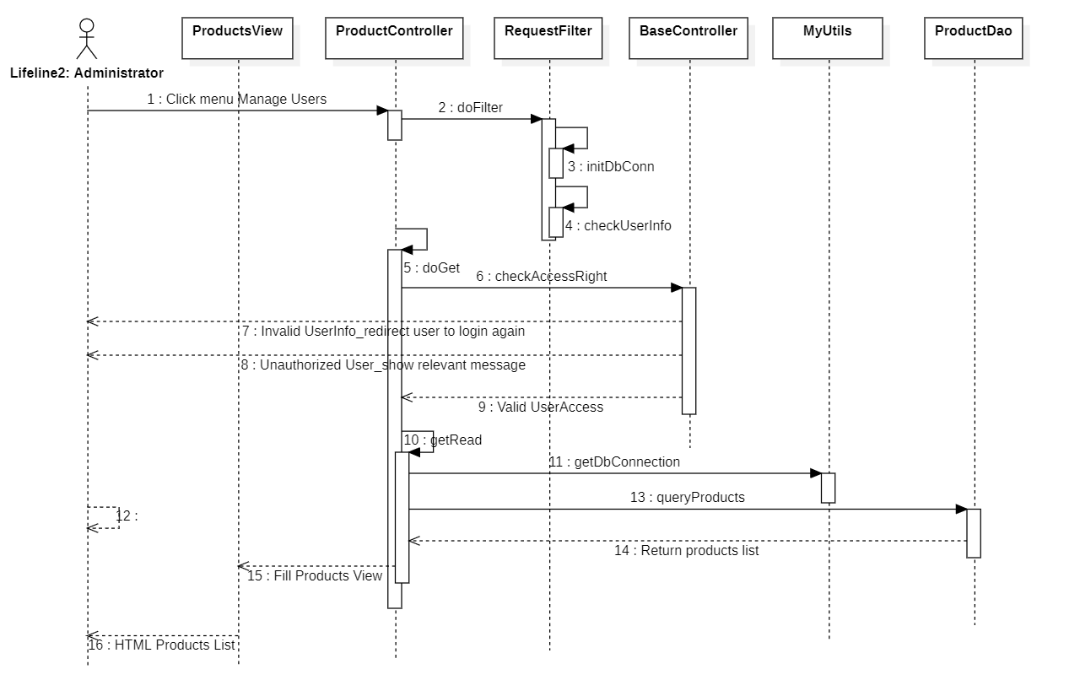

### d. Database Queries

String sql = “Select * from user where email = ? or full_name = ?”

## 2. Common/Register

### a. Class Diagram

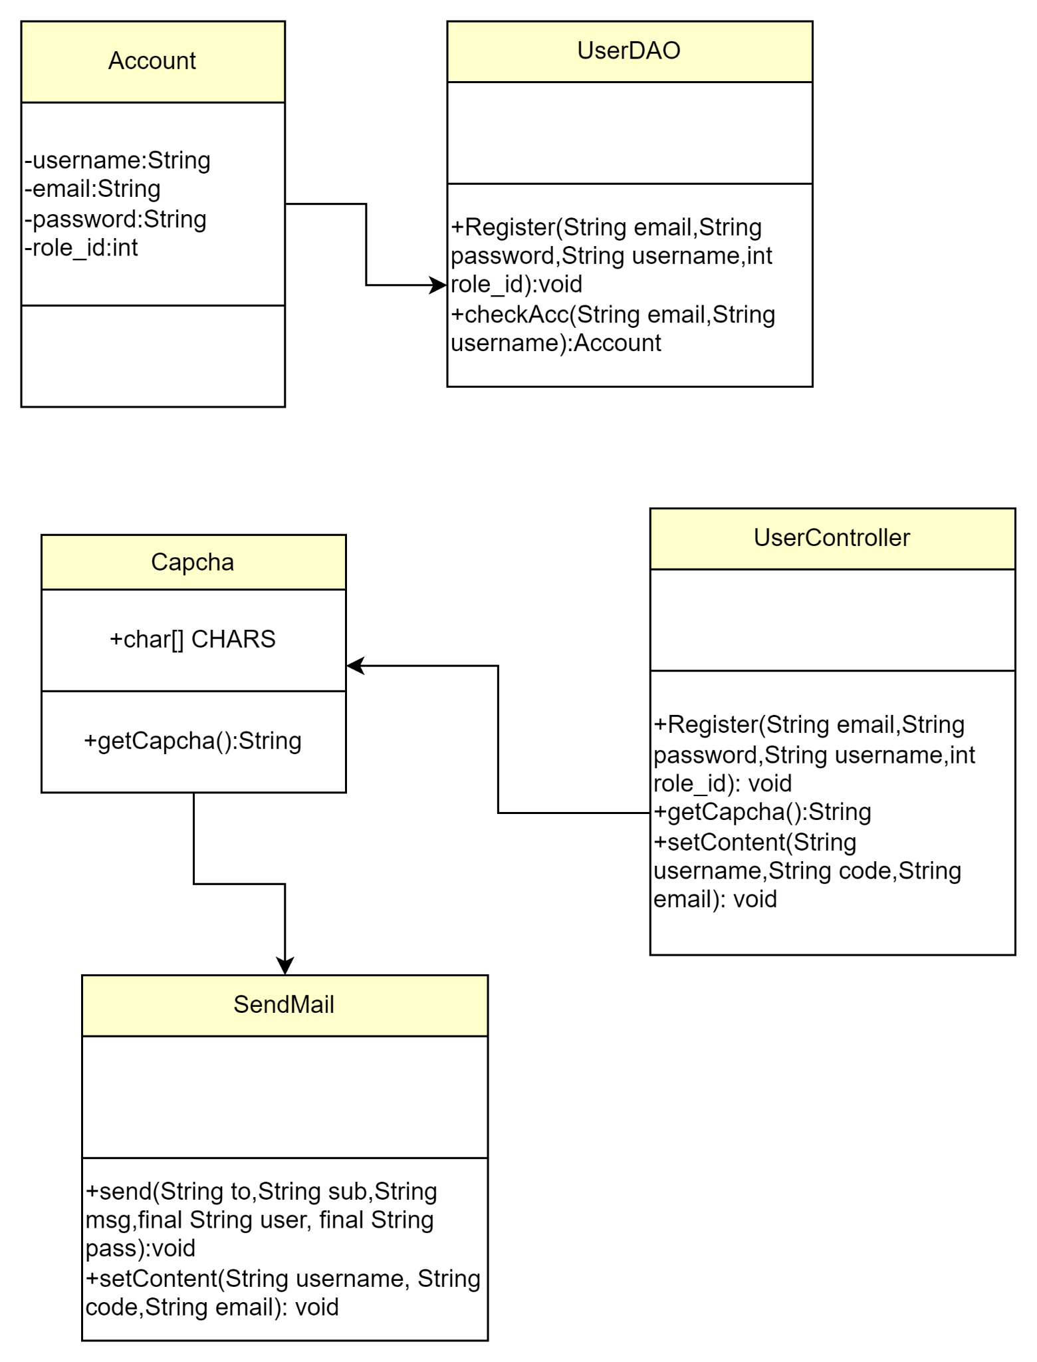

### b. Class Specification

| No | Method | Description |
| --- | --- | --- |
| 1 | register | use to create new user |
| 2 | checkAcc | use to check username or email exist |
| 3 | getCaptcha | get a random string |
| 4 | send | send mail to user |
| 5 | setContent | set email and username that user use to register to send |

### c. Sequence Diagram

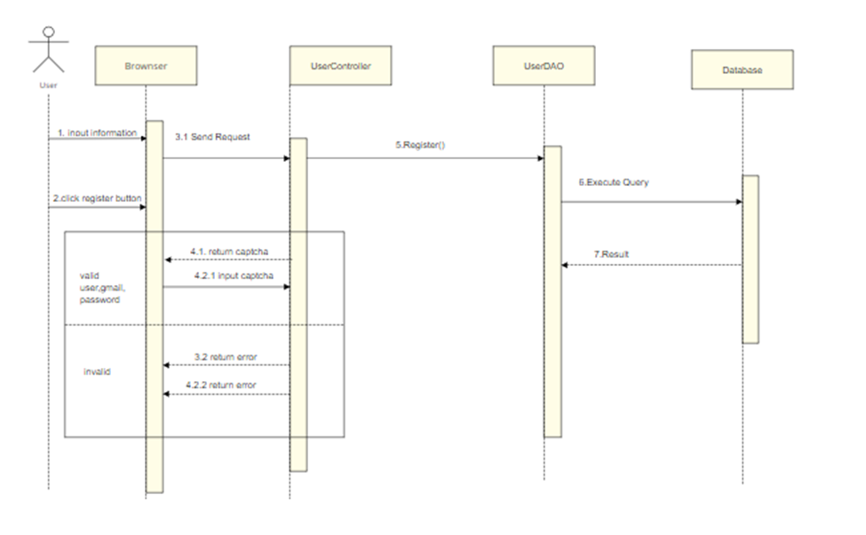

### d. Database queries

* Select * from user where email = ? or full_name=?
* Insert into user (‘full_name’ , ‘email’ , ‘password’ ) values (?,?,?)

## 3. Admin/Setting List

### a. Class Diagram

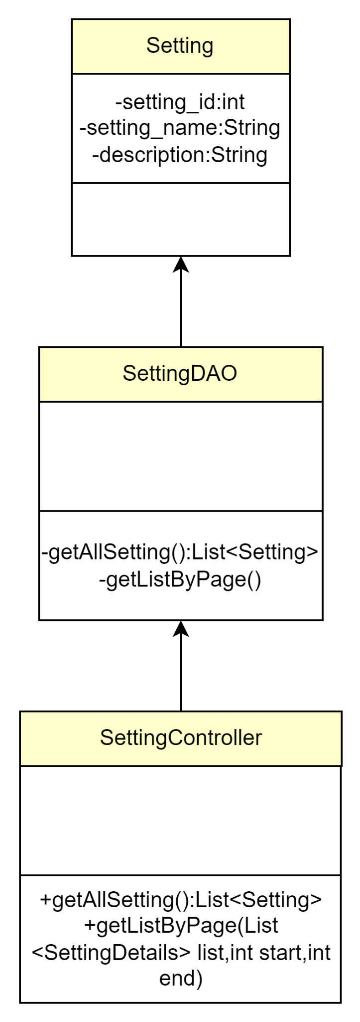

### b. Class Specification

| No | Method | Description |
| --- | --- | --- |
| 1 | getAllSetting | use to list setting |
| 2 | getListByPage | use to pagination |

### c. Sequence Diagram

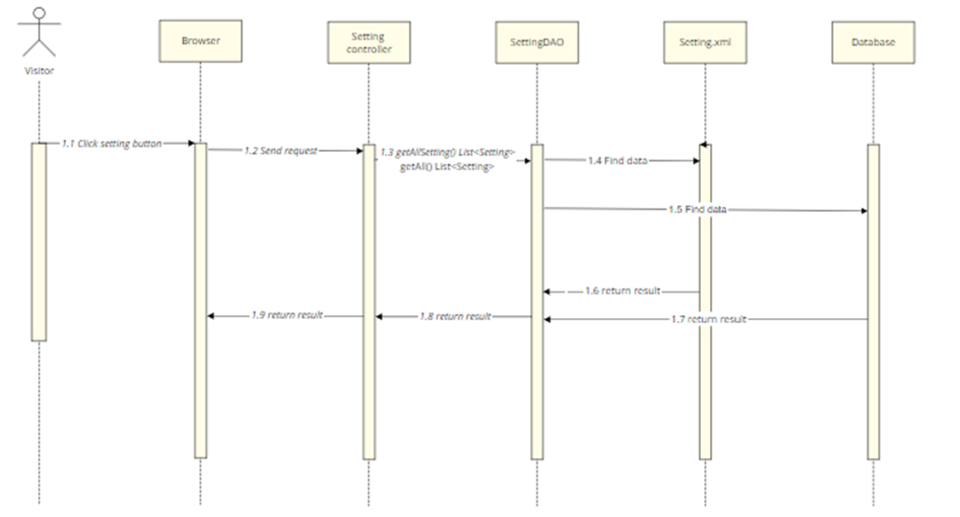

### d. Database queries

## 4. Admin/Setting Details

### Class Diagram

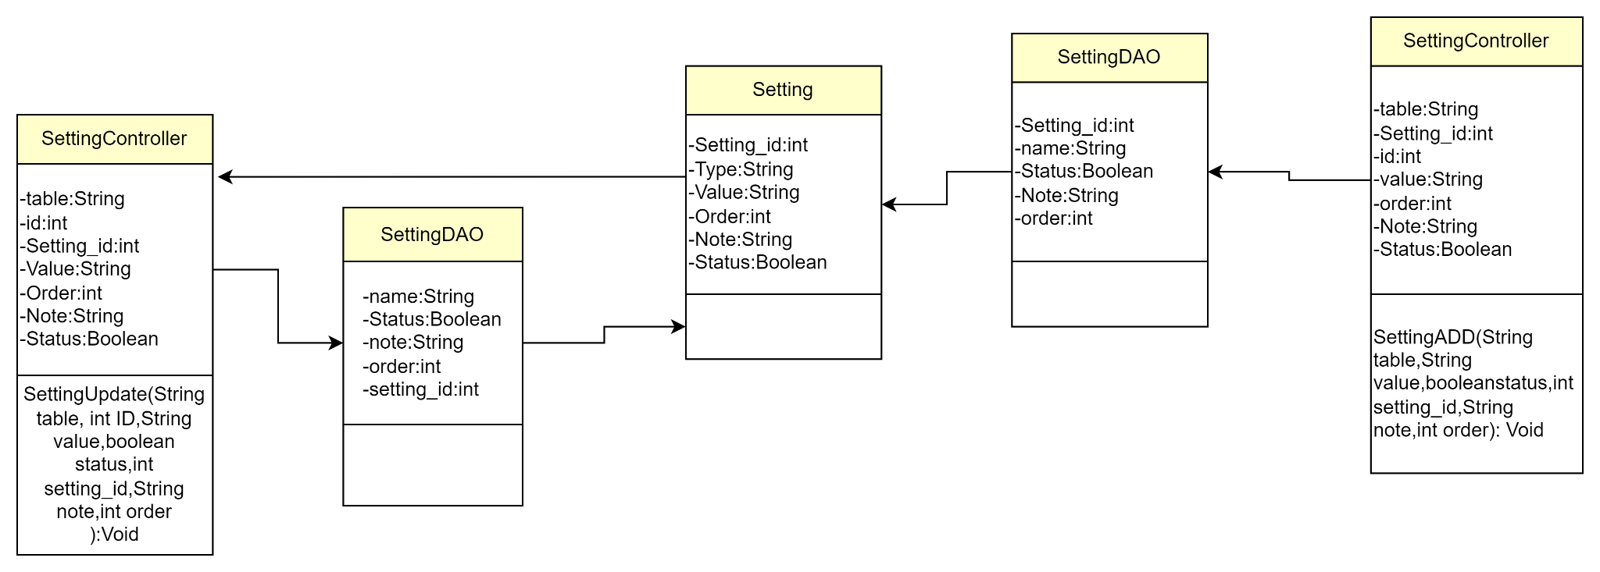

### Class Specification

| No | Method | Description |
| --- | --- | --- |
| 1 | SettingADD | use to create new setting |
| 2 | SettingUpdate | use to update setting |

### Sequence Diagram

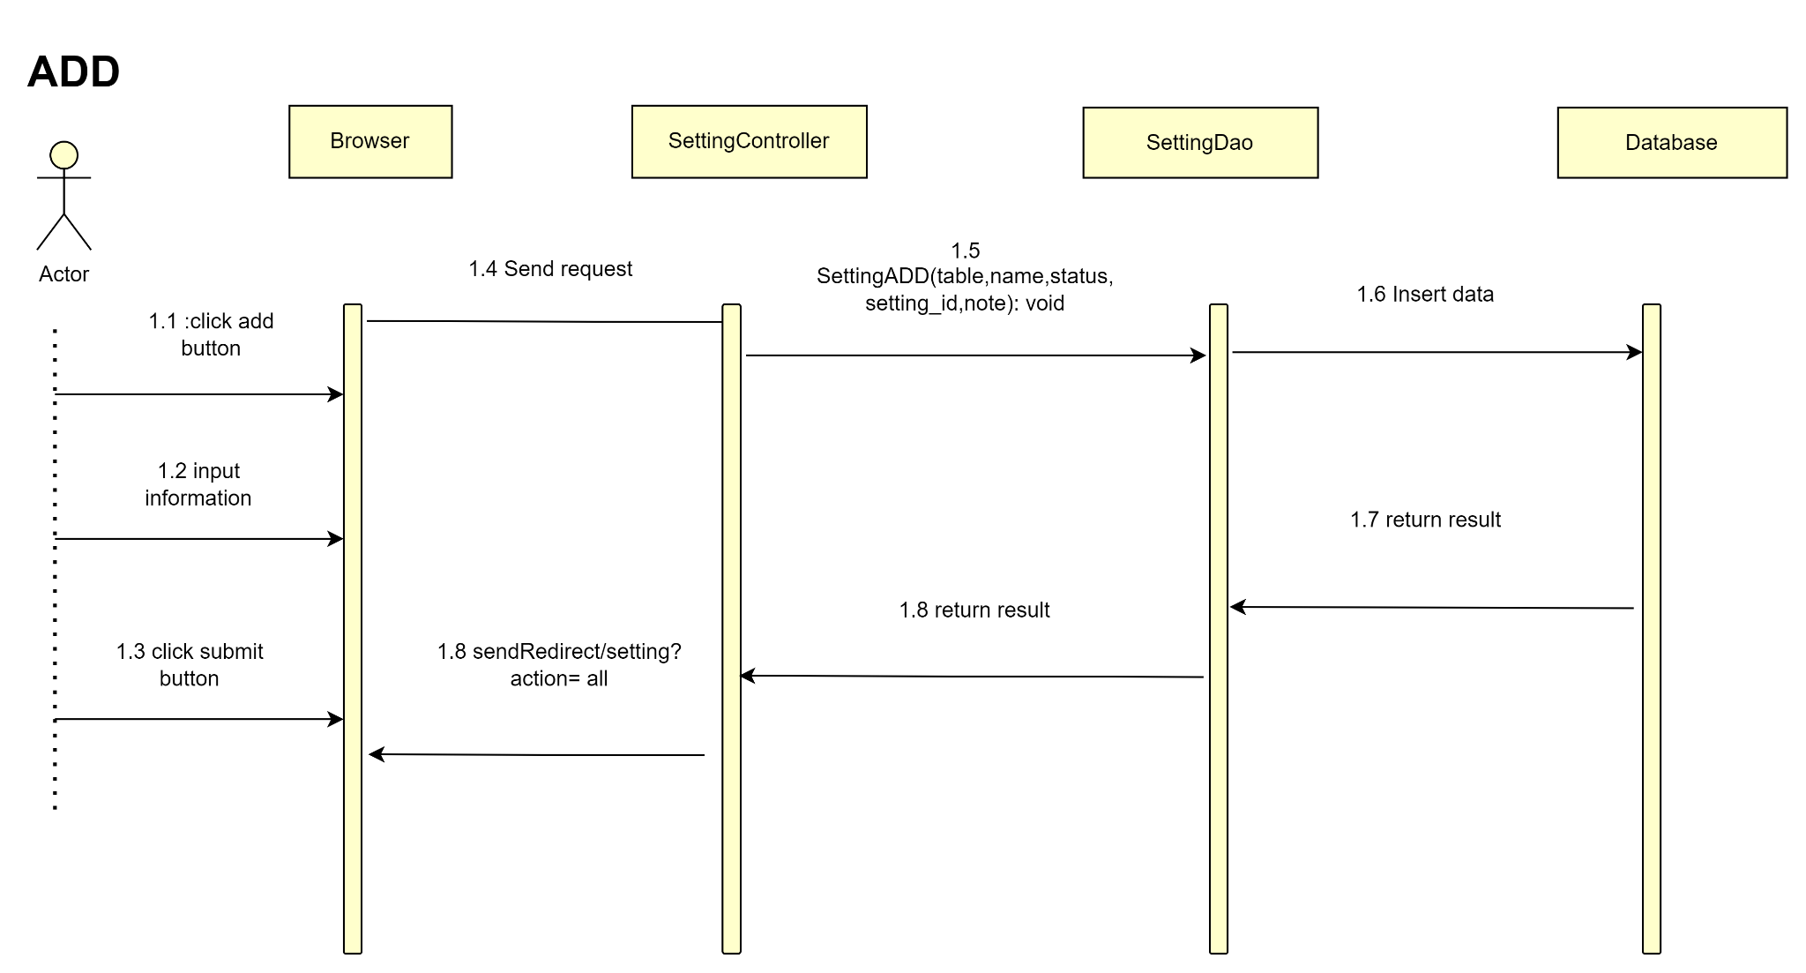

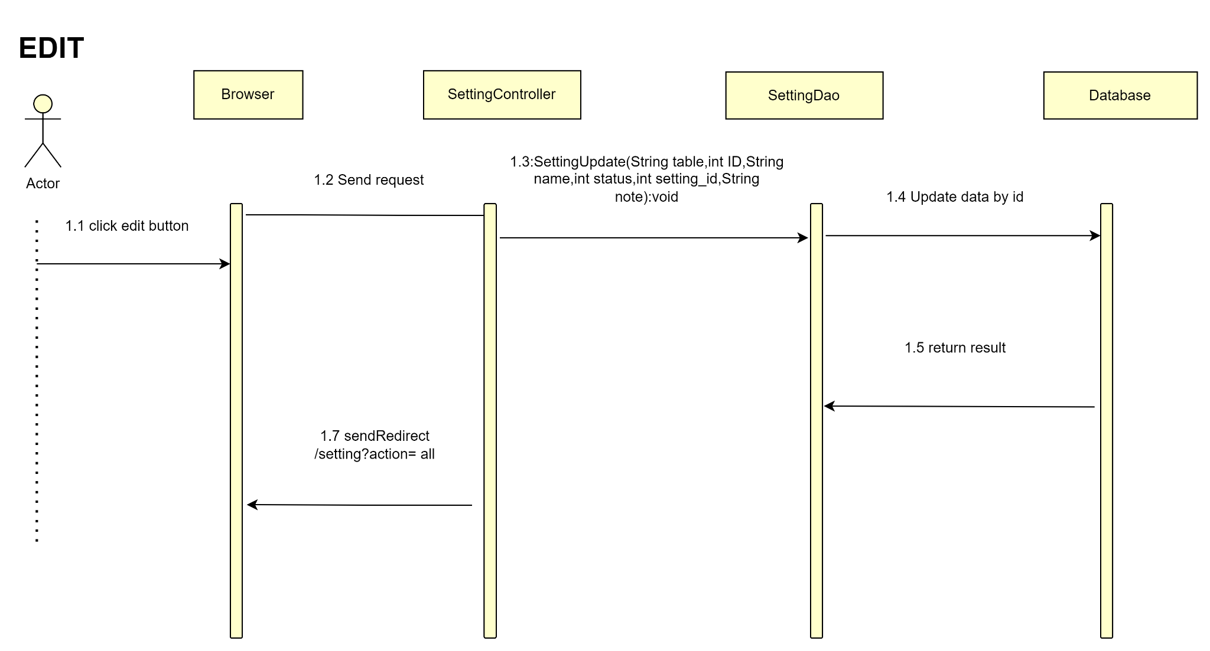

### Database queries

## 5. Admin/User List

### a. Class Diagram

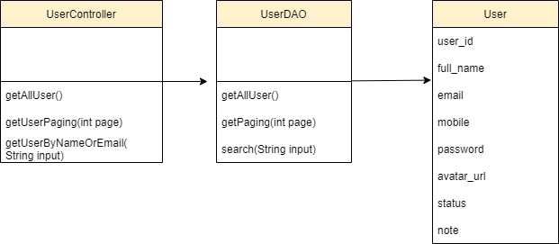

### 

### 

### 

### b. Class Specification

| No | Method | Description |
| --- | --- | --- |
| 1 | getAccountPaging | Display 10 account in a page |
| 2 | getAccountByUserNameOrEmail | Search account by username or email |

### c. Sequence Diagram

Show all accounts in User list paging function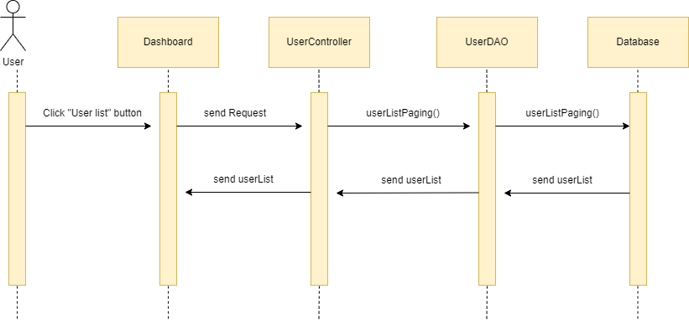

Search user by name or email function

### d. Database queries

SELECT * FROM user ORDER BY user_id LIMIT ? OFFSET 10

SELECT * FROM user WHERE email = ? or full_name=? ORDER BY user_id LIMIT ? OFFSET 10

## 6. Admin/User Detail

### a. Class Diagram

### 

### b. Class Specification

| No | Method | Description |
| --- | --- | --- |
| 1 | getAccountByUseName | Search account by username |
| 2 | editName | Edit user name |
| 3 | editEmail | Edit user email |

### 

### c. Sequence Diagram

Show detail profile of user on “User detail ” function

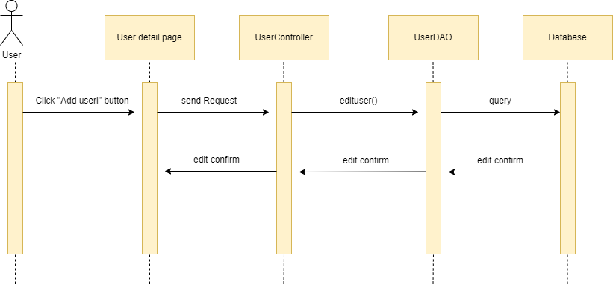

Perform edit user

Perform add user

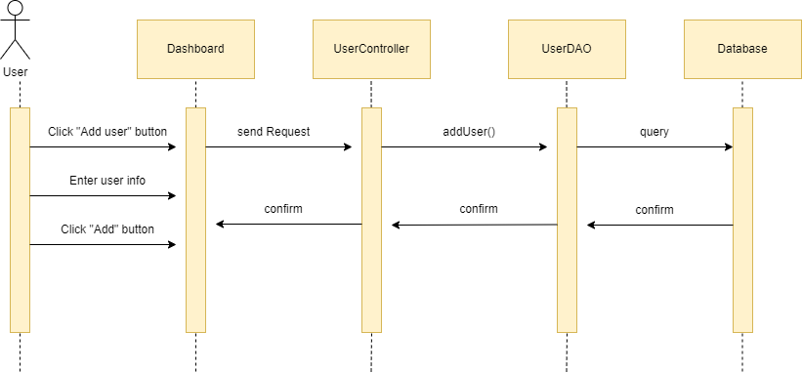

### d. Database queries

SELECT * FROM user WHERE user_id = ?

UPDATE user

SET full_name=?, email=?, mobile = ?, password=?

WHERE user_id = ?;

INSERT INTO user (full_name, email, mobile , password)

VALUES( ?, ?, ?, ?)

## 7. Common/Forgot Password

### a. Class Diagram

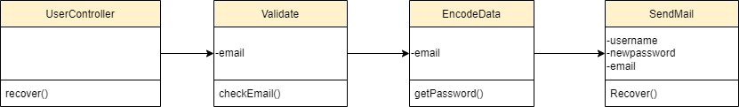

### b. Class Specification

| No | Method | Description |
| --- | --- | --- |
| 1 | recover | using to forgot password |
| 2 | checkEmail | using to check validate email |
| 3 | checkAccByEmail | using to check exist email |
| 4 | getPassword | using to create password randomrandom |
| 5 | setContentRecover | using to send newpassword |

### c. Sequence Diagram

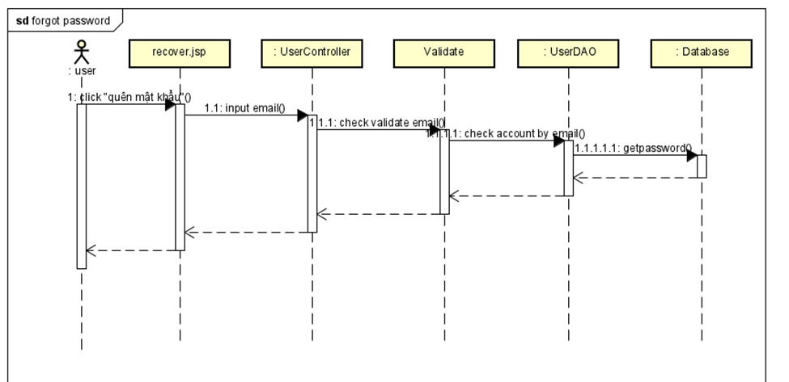

### d. Database queries

## 10. Common/Change Password

### a. Class Diagram

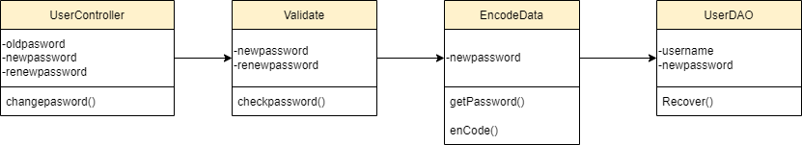

### b. Class Specification

| No | Method | Description |
| --- | --- | --- |
| 1 | changePassword | using to change password |
| 2 | checkPassword | using to check validate password |
| 3 | enCode | using to encode password |
| 4 | getPassword | using to update password |
| 5 | Recover | using to save password |

### c. Sequence Diagram

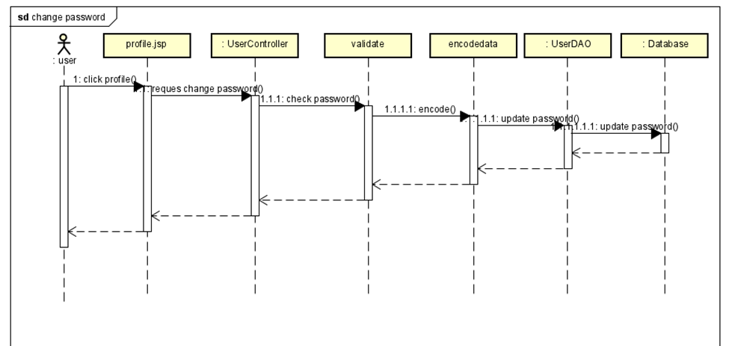

### d. Database queries

## 11. Common/User profile

### a. Class diagram

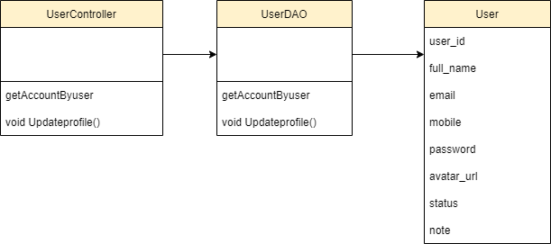

### b. Class Specification

| No | Method | Description |
| --- | --- | --- |
| 1 | getAccountByUsername | use to find account profile by it’s username |
| 2 | UpdateProfile | use to update user’s profile |

### c. Sequence diagram

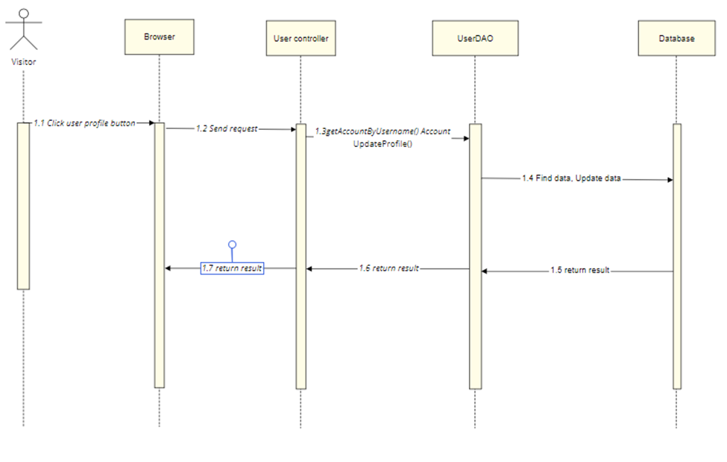

### d. Database queries

## 12. Change password

### a. Class diagram

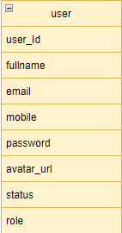

### b. Class Specification

| No | Method | Description |
| --- | --- | --- |
| 1 | checkOldPassword | If you want to change your password, you must enter the correct old password |
| 2 | changePassword | After the user enters the correct old password, the new password and re-enters the new password, proceed to change the password |

### c. Sequence Diagram

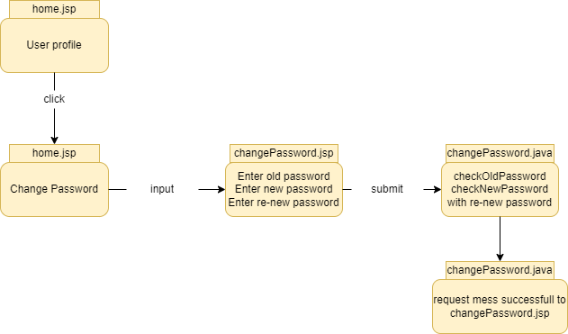

### d. Database queries

+) select * from user where email = ? and password = ?

+)Update user set password = ? where email = ?

### 

## 13. Support/ Web contact list

### a. Class diagram

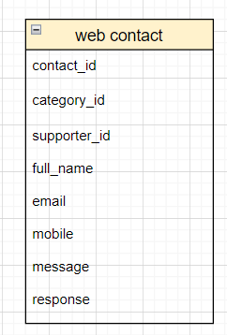

### b. Class Specification

| No | Method | Description |
| --- | --- | --- |
| 1 | getAllSupporter | show all information of supporter |

### c. Sequence Diagram

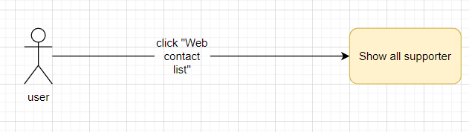

## 14. Support/ Web contact detail

### a. Class diagram



### b. Class Specification

| No | Method | Description |
| --- | --- | --- |
| 1 | getAllCategory | using to select contact’s category |
| 2 | getSupporterByCategory | show all information of supporter with each category |
| 3 | getResponseByContactID | using to send response to user |

### c. Sequence Diagram

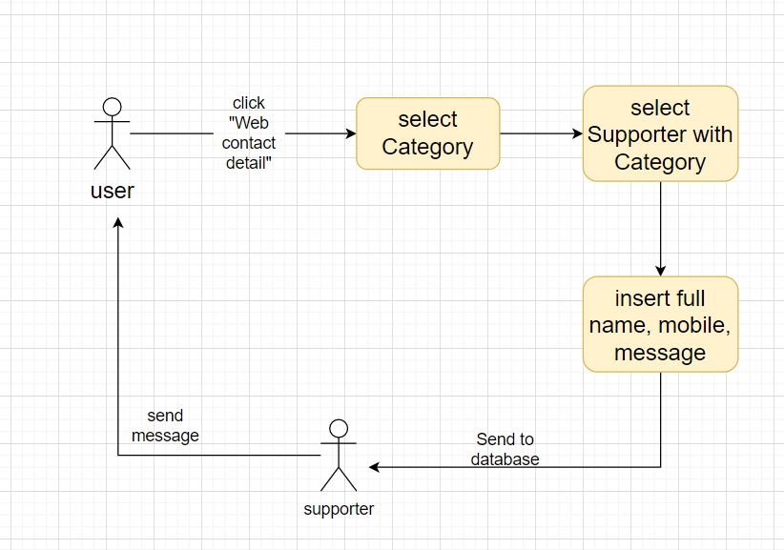

### c. Sequence Diagram

## 15. Eval criteria list

### a. Class diagram

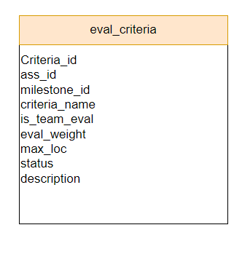

### b. Class Specification

| No | Method | Description |
| --- | --- | --- |
| 1 | getAllCriteria | Show list eval criteria |
| 2 | getCriteriaByID | get a criteria by id to view and update |
| 3 | countPage | count element in database |

### c. Sequence Diagram

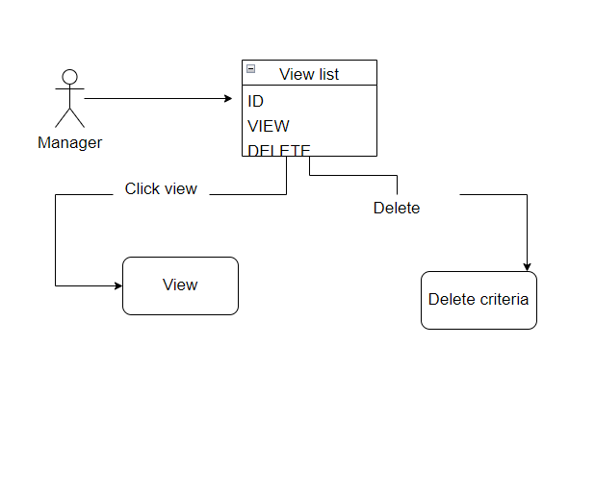

### d. Database queries

* select * from eval_criteria;
* select * from eval_criteria where criteria_id=?;

## 16. Subject Setting List

### a. Class diagram

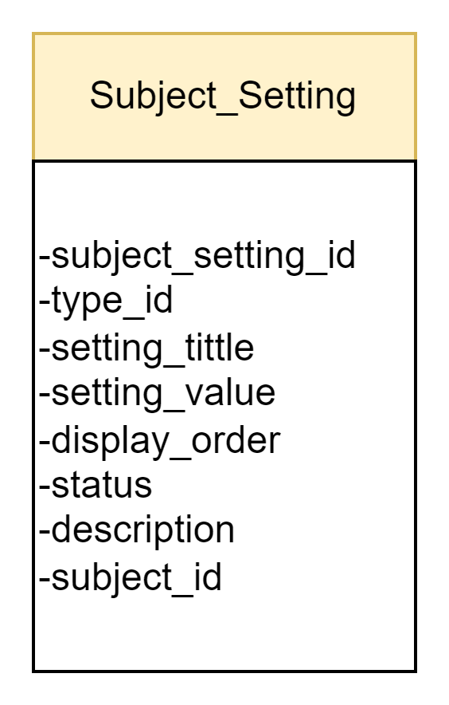

### b. Class Specification

| No | Method | Description |
| --- | --- | --- |
| 1 | getListSubject_Setting_List() | Show list subject setting |

### c. Sequence Diagram

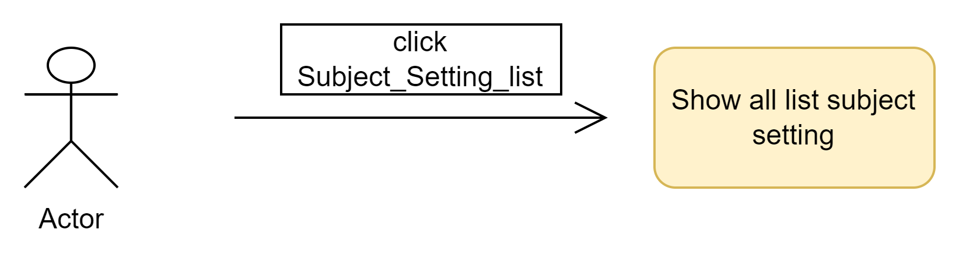

### d. Database queries

+) Select subject_name, setting_title, setting_value, display_order,status, description, from dbo.subject_setting as set , dbo.subject as sub where set.subject_id = sub.subject_id.

## 

## 17.Subject Setting Details

### a. Class diagram

### b. Class Specification

| No | Method | Description |
| --- | --- | --- |
| 1 |  |  |

### c. Sequence Diagram

### d. Database queries

## 

## 18.Eval criteria detail

### a. Class diagram



### b. Class Specification

| No | Method | Description |
| --- | --- | --- |
| 1 | getCriteriaByID | get a criteria by id to view and update |
| 2 | updateCriteria | update criteria |
| 3 | getAllAssignment | Show combo box of assignment |

### c. Sequence Diagram

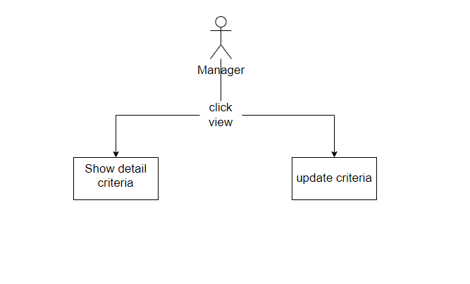

### **d.** Database queries

-select * from eval_criteria where id = ?

-UPDATE `project_swp_391`.`eval_criteria`

SET

`criteria_id` = <{criteria_id: }>,

`ass_id` = <{ass_id: }>,

`milestone_id` = <{milestone_id: }>,

`criteria_name` = <{criteria_name: }>,

`is_team_eval` = <{is_team_eval: }>,

`eval_weight` = <{eval_weight: }>,

`max_loc` = <{max_loc: }>,

`status` = <{status: }>,

`description` = <{description: }>

WHERE `criteria_id` = <{expr}>;

-select * from assignment ;

## 19. Admin/System Permissions

### a. Class diagram

### 

### b. Class Specification

| No | Method | Description |
| --- | --- | --- |
| 1 | getPermissionPaging | get a permission to view |
| 2 | updatePermission | update permission |

### 

### c. Sequence Diagram

### d. Database queries

select perm.screen_id, st.setting_value, perm.setting_id, perm.get_all_data, perm.can_add, perm.can_delete, perm.can_edit from

permission as perm

inner join setting as st

on st.setting_id = perm.screen_id

and st.type_id = 12 order by perm.screen_id

UPDATE `permission`

SET

`get_all_data` = ?

+ "`can_delete` = ?,\n"

`can_edit` = ?,

`can_add` = ?

WHERE `screen_id` = ?

and `setting_id` = ?;

## 20. Assignment List

### a. Class diagram

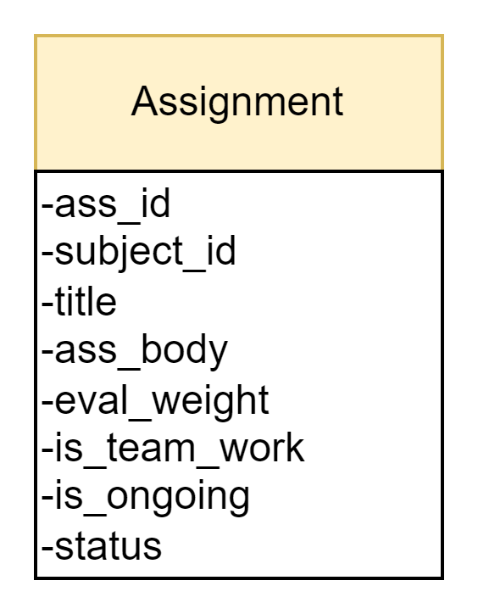

### b. Class Specification

| No | Method | Description |
| --- | --- | --- |
| 1 | getAllAssignmentList() | Show information about Assignment |
| 2 | getAllAssignmentList(subject,status,tittle) | Show information about Assignment follow fitler |

### 

### c. Sequence Diagram

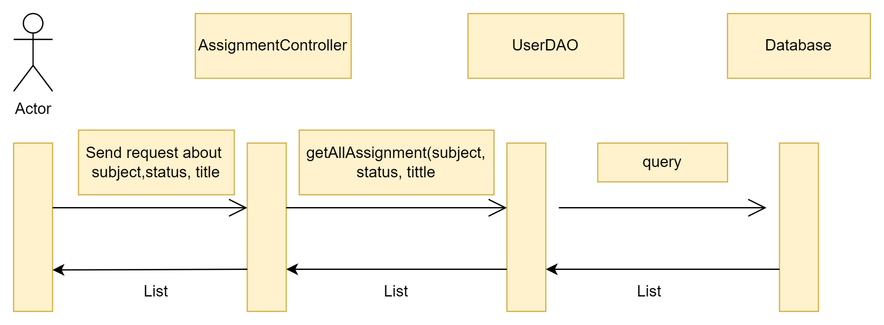

### d. Database queries

+)select ass_id , subject_name , tittle , ass_body, eval_weight, is_team_work, is_ongoing, status from dbo.Assignment as assign, dbo.Subject as sub where assign.subject_id = sub. subject_id .

+) select ass_id , subject_name , tittle , ass_body, eval_weight, is_team_work, is_ongoing, status from dbo.Assignment as assign, dbo.Subject as sub where assign.subject_id = sub. subject_id and sub.subject_name=? and sub.status = ? and assign.title=? .

## 21. Assignment Details

### a. Class diagram

### b. Class Specification

| No | Method | Description |
| --- | --- | --- |
| 1 |  |  |

### 

### c. Sequence Diagram

### d. Database queries

## 22. Milestone list

### a. Class diagram

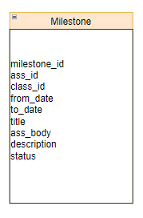

### b. Class Specification

| No | Method | Description |
| --- | --- | --- |
| 1 | getallMilestone | show list milestone |
| 2 | getMilestoneByID | show a milestone by id |
| 3 | countPage | count total page |

### 

### c. Sequence Diagram

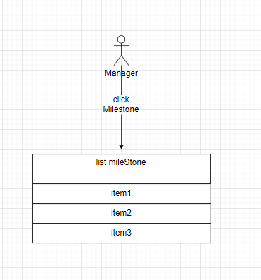

### d. Database queries

-select * from milestone;

-select * from milestone where id =?;

## 23. Class List

### a. Class diagram

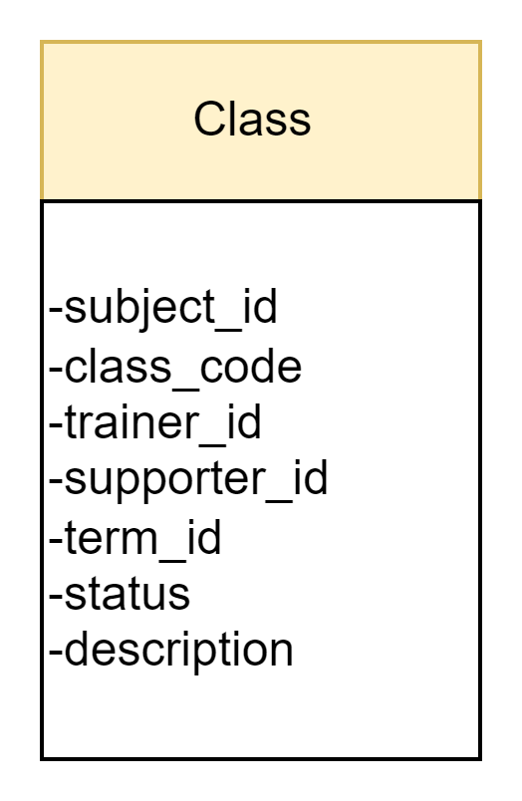

### b. Class Specification

| No | Method | Description |
| --- | --- | --- |
| 1 | getAllClassList() | show information about class list |
| 2 | getAllClassList(subject, Term , Trainer , Supporter , Status ) | show information list of class follow filter |
| 3 | getClassById(int id) | Show information class follow id |
| 4 | updateClassById(int id) | Update information about class |
|  |  |  |

### 

## 24. Class Details

### a. Class diagram

### b. Class Specification

| No | Method | Description |
| --- | --- | --- |
| 1 |  |  |

### 

**24. Issue List**

**a.Class Diagram**

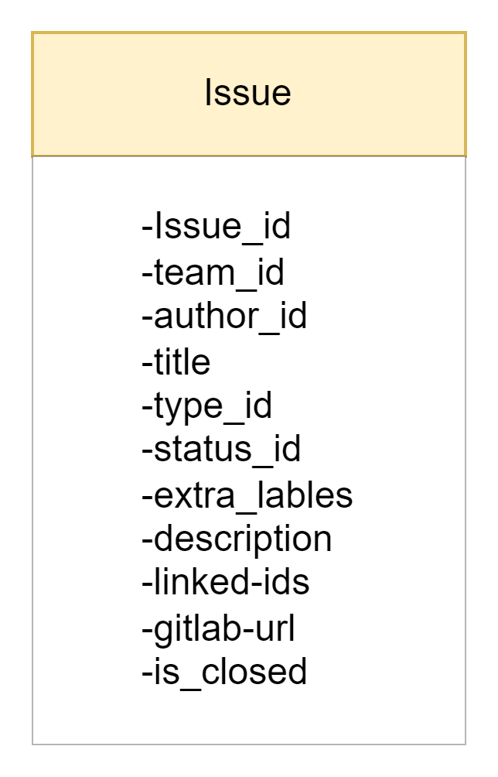

### b. Class Specification

| No | Method | Description |
| --- | --- | --- |
| 1 | getAllIssue() | show information about list of issue |
| 2 | getAllIssue(String status, String Milestone, String author,String assignee, String Issue_type,String issue_status) | show all information about list of issue follow by filter |
| 3 | sortAllIssue() | Sort list of issue following Id,Name,... |
| 4 | countPage() | Count page of list issue |

### 

### c. Sequence Diagram

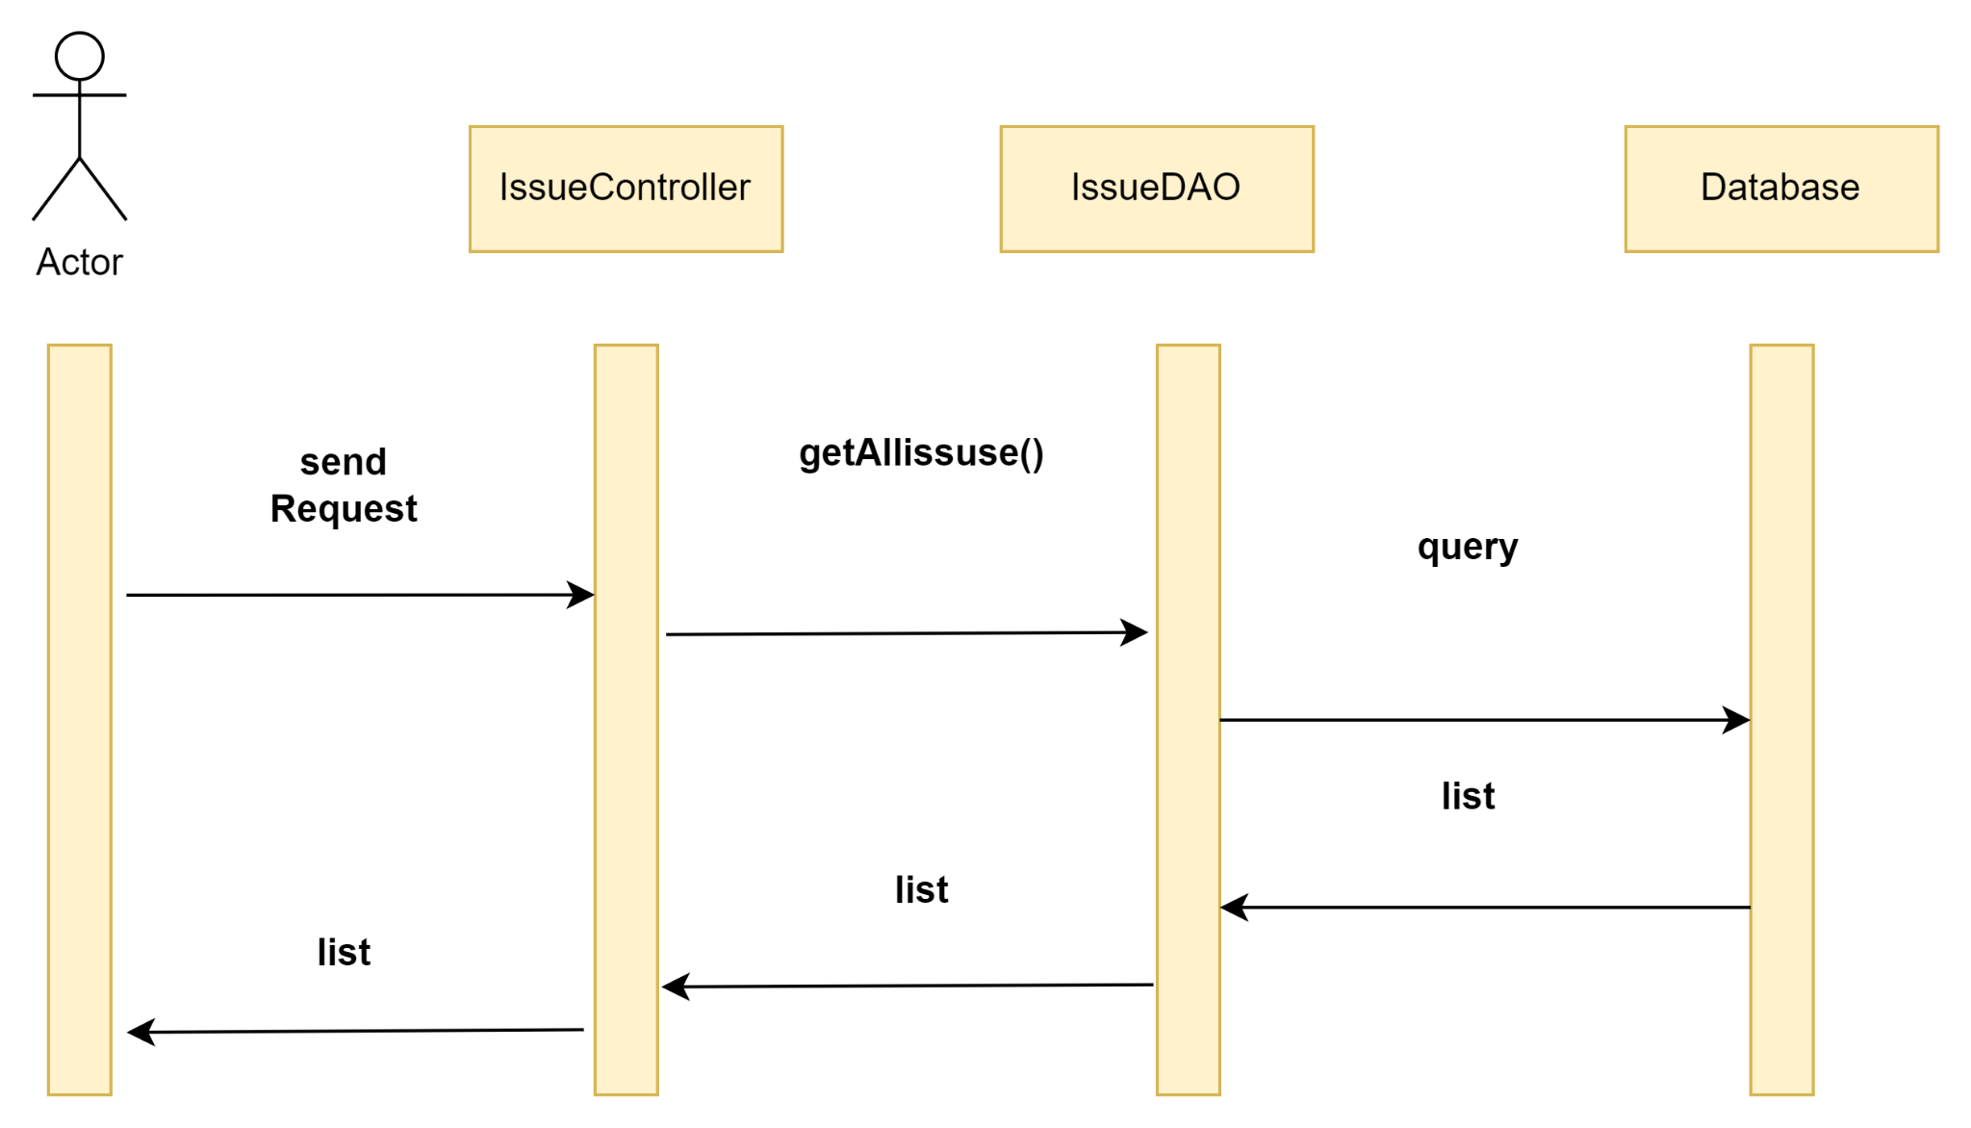

### d. Database queries

+) select class,misletone, Author, Assignee,Type, Status from dbo.issue as issue , dbo.team as team , dbo.class_setting as set ,dbo.class as class where issue.team_id = team.team_id and set.type_id = issue.type_id and class.class_id = team.class_id

+) select class,misletone, Author, Assignee,Type, Status from dbo.issue as issue , dbo.team as team , dbo.class_setting as set ,dbo.class as class where issue.team_id = team.team_id and set.type_id = issue.type_id and class.class_id = team.class_id and issue.title = ?

+) with t as(select class,misletone, Author, Assignee,Type, Status from dbo.issue as issue , dbo.team as team , dbo.class_setting as set ,dbo.class as class where issue.team_id = team.team_id and set.type_id = issue.type_id and class.class_id = team.class_id and issue.title = ?)

select count(*) from t.

**25. Issue Details**

**a.Class Diagram**



### b. Class Specification

| No | Method | Description |
| --- | --- | --- |
| 1 | getAllIssue() | show information about list of issue |
| 2 | UpdateIssue() | Update information of issues |

### 

### c. Sequence Diagram

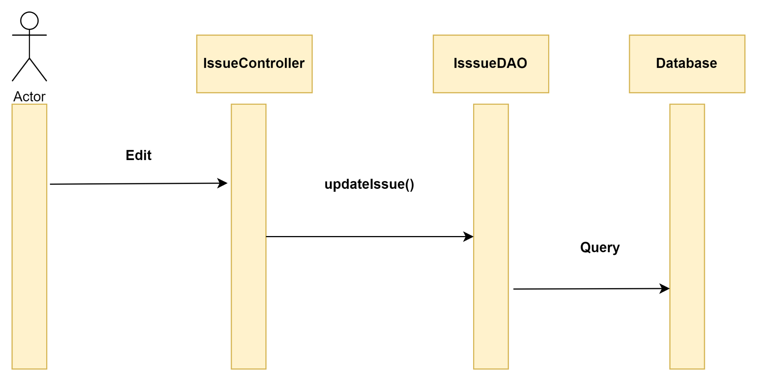

**d, Database queries**

+) Select * from dbo.issue as issue, dbo.class_setting as set, dbo.team as team where issue.team_id = team.team_id and set.type_id = issue.type_id

+) Update Issue set tittle = ? , extra_label = ?,description =? ,is_closed =? where team_id =? and author_id = ? and assignee_id =?

### 

## 26. Class eval criteria list

### a. Class diagram



### b. Class Specification

| No | Method | Description |
| --- | --- | --- |
| 1 | getAllCriteria | Show list eval criteria |
| 2 | getCriteriaByID | get a criteria by id to view and update |
| 3 | countPage | count element in database |
| 4 | changeStatus | change status |

### c. Sequence Diagram



### d. Database queries

* select * from eval_criteria;
* select * from eval_criteria where criteria_id=?;
* select * from evalcriteria order by criteria_id limit ? , ?;
* SELECT * FROM eval_criteria ORDER BY eval_weight asc ;
* SELECT * FROM eval_criteria ORDER BY eval_weight desc ;

## 27. Class eval criteria details

### a. Class diagram



### b. Class Specification

| No | Method | Description |
| --- | --- | --- |
| 1 | getAllClass | Show list class |
| 2 | getCriteriaByID | get a criteria by id to view and update |
| 3 | updateCriteria | update criteria by id |

### c. Sequence Diagram



### d. Database queries

* select * from class;
* UPDATE `project_swp_391`.`eval_criteria`

SET

`ass_id` = ?,

`milestone_id` = ?,

`criteria_name` = ?,

`is_team_eval` =?,

`eval_weight` = ?,

`max_loc` = ?,

`status` = ?,

`description` = ?

WHERE `criteria_id` = ?;

## 28. Milestone details

### a. Class diagram



### b. Class Specification

| No | Method | Description |
| --- | --- | --- |
| 1 | getMilestoneByID | get a milestoneby id to view and update |
| 2 | updateMilestone | update milestoneby id |

### c. Sequence Diagram

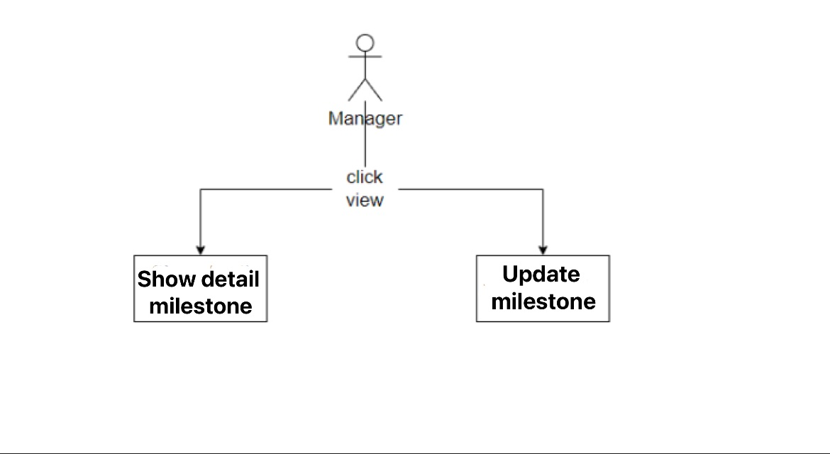

### d. Database queries

* select * from milestone where milestone_id = ?;
* UPDATE `project_swp_391`.`milestone`

SET

`ass_id` = ?,

`class_id` = ?,

`from_date` = ?,

`to_date` = ?,

`title` = ?,

`ass_body` = ?,

`description` = ?,

`status` = ?

WHERE `milestone_id` = ?;

## 29.Team List

### a. Class diagram

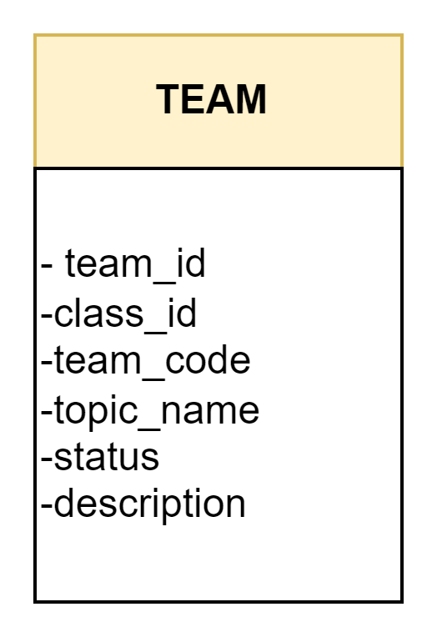

### b. Class Specification

| No | Method | Description |
| --- | --- | --- |
| 1 | ddeleteTeam() | Remove team |
| 2 | changeTeam() | change team |
| 3 |  |  |

### c. Sequence Diagram

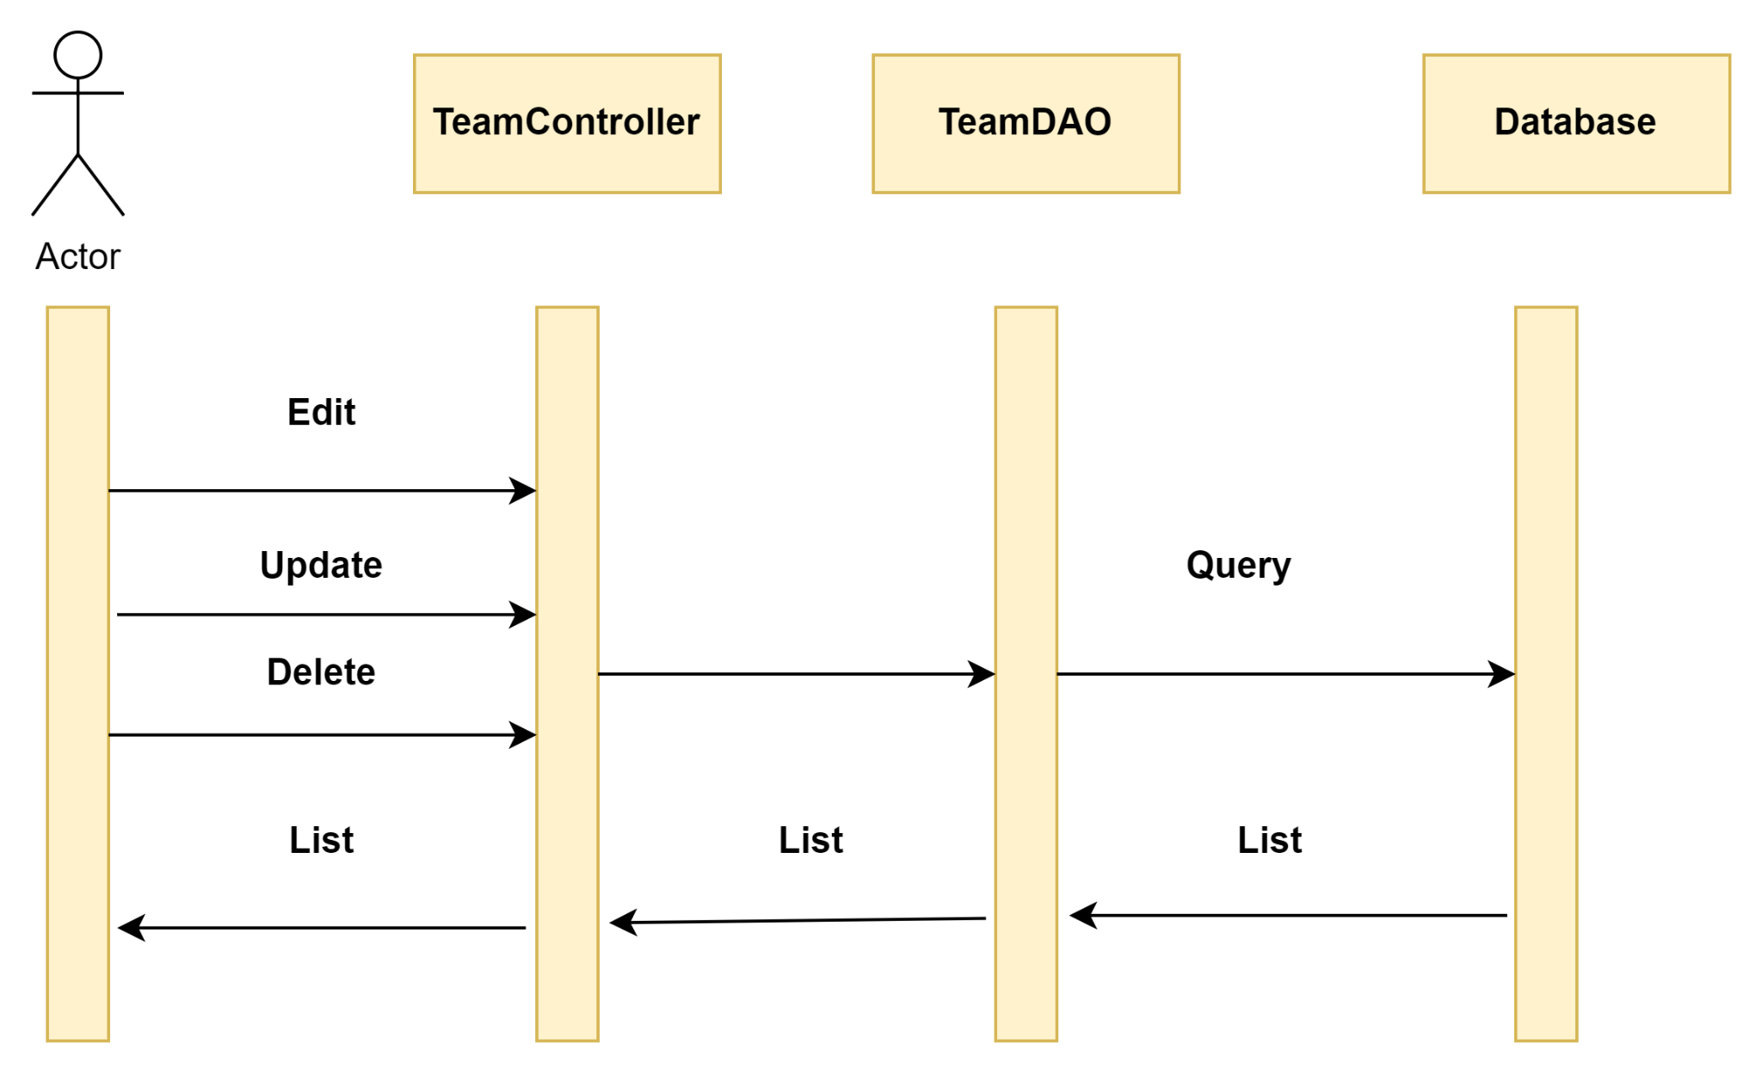

### d. Database queries

## 30.Schedule List

### a. Class diagram

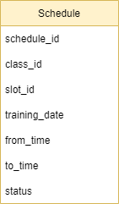

### b. Class Specification

| No | Method | Description |
| --- | --- | --- |
| 1 | getScheduleList() | Get list of schedule for the class |

### c. Sequence Diagram

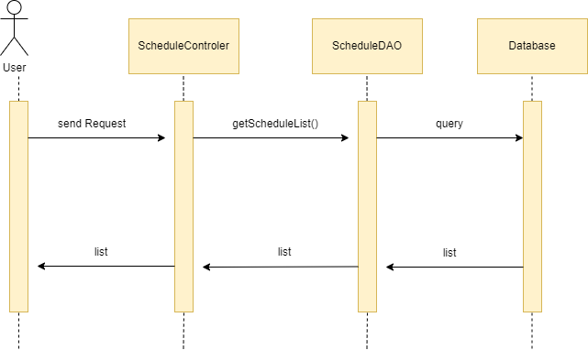

### d. Database queries

## 31. Schedule Detail

### a. Class diagram



### b. Class Specification

| No | Method | Description |
| --- | --- | --- |
| 1 | getSchedule() | Get detail schedule |
| 2 | updateSchedule() | Update schedule |
| 3 | deleteSchedule | Delete schedule |

### c. Sequence Diagram

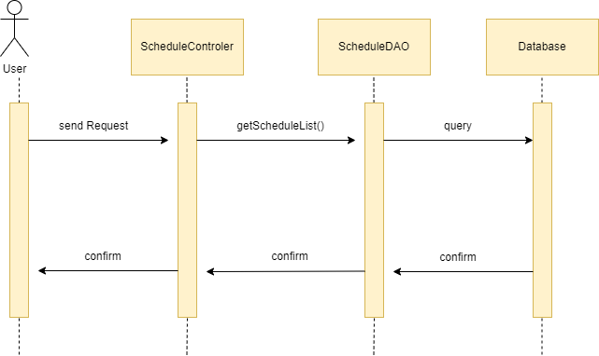

### d. Database queries

## 32.Home page

### a. Class diagram

### b. Class Specification

| No | Method | Description |
| --- | --- | --- |
| 1 | getSubjectListHome | Get 6 subject to interface home page |

### 

### c. Sequence Diagram

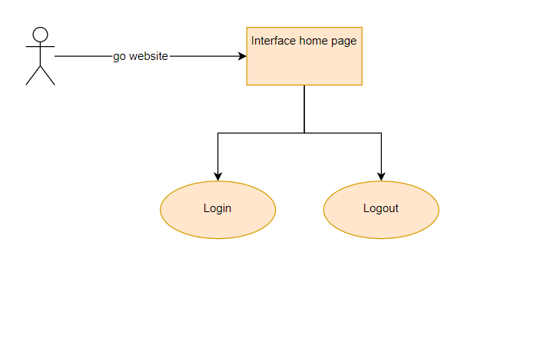

### d. Database queries

-SELECT * FROM project_swp_391.subject limit 6;