

**TRAINING SUPPORT SYSTEM PROJECT**

**Software Requirement Specification**

– Hanoi, August 2022 –

**Record of changeS**

| **Date** | **A* M, D** | **In charge** | **Change Description** |
| --- | --- | --- | --- |
| 10/09/2022 | A | DongNG | Create new SRS |
| 13/09/2022 | M | AnhNT | Fixing some spelling errors |
| 18/9/2022 | M | DongNG | Change website layout |
| 9/9/2022 | A | Longch | Add function Subject Setting List |
| 9/9/2022 | A | Longch | Add function Assignment List |
| 9/9/2022 | A | Longch | Add function Class List |
| 10/8/2022 | A | DongNG | Add System Permission |
| 10/8/2022 | A | DongNG | Add New Milestone |
| 23/10/2022 | A | LongCH | Add Issue List |
| 23/10/2022 | A | LongCh | Add Issue Detail |
| 23/10/20222022 | AA | LongCh | Add Team List |
|  |  |  |  |

*A - Added M - Modified D - Deleted

**Table of Contents**

**I. Overview** **6**

1. Introduction 6

2. System Functions 7

a. Screen Flow 7

b. Screen Details 7

c. User Authorization 8

d. Non-Screen Functions 10

**II. Functional Requirements** **11**

1. Common Features 11

a. Home page 11

b. Login 12

c. Register 12

d. Change Password 13

e. Password reset 13

f. User profile 14

g. Dashboard 15

2. Admin Features 16

a. Setting list 16

b. Setting details 17

c. User list 18

d. User details 18

e. System Permission 19

3. Manager Features 20

a. Subject List 20

b. Subject Details 21

c. Eval criteria list 21

d. Eval criteria details 22

e. Class Details 23

f. Class List 23

g. Assignment List 24

h. Assignment Details 24

i. Subject Setting List 25

j. Subject Setting Details 25

k. Milestone List 25

l. Class eval criteria list 26

m. Class eval criteria details 27

n. Milestone details 27

4. Supporter Features 28

a. Web Contact List 28

b. Web Contact Details 29

c. Trainee List 29

d. Trainee Details 29

e. Schedule List 30

f. Schedule Details 30

g. Schedule Attendance 31

5. Trainer Features 32

a. New Milestone 32

# I. Overview

## 1. Introduction

The Training Support System is a new software system that replaces the need for students to take extra lessons and also creates additional income for teachers who can earn money outside of class time. Allows students to access and buy courses that they feel are suitable. After successfully purchasing the course, the student will receive the corresponding schedule (study online via website). The system administrator will pay an amount after that. When agreeing with the lecturer, the lecturer will have the task of teaching online and returning to the entire content of the lessons for students to review if they do not fully understand. Up to high school seniors and university students to support Support students outside of classroom hours to learn more advanced knowledge.

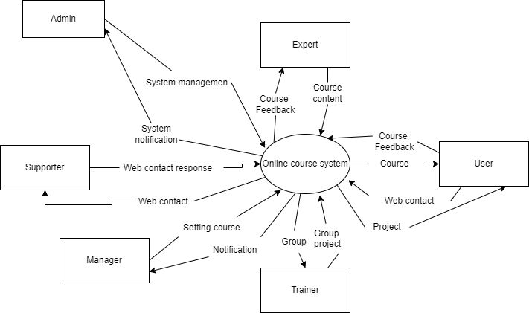

## 2. System Functions

### a. Screen Flow

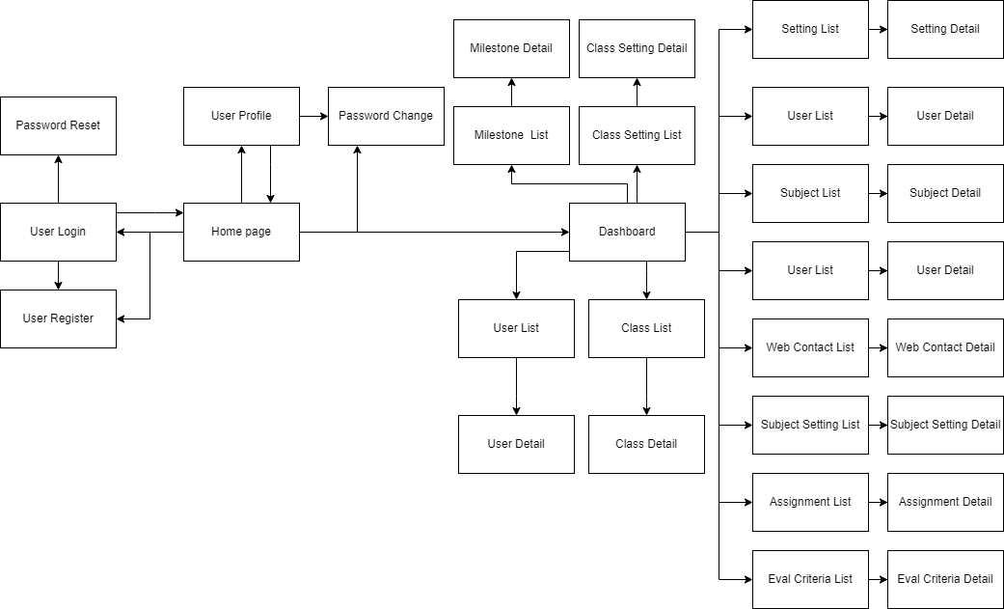

### b. Screen Details

| **No** | **Feature** | **Screen** | **Description** |
| --- | --- | --- | --- |
| 1 | Common | Home page | Display the main interface of the page |
| 2 | Common | Dashboard | Admin dashboard screen |
| 3 | Common | User Login | Allow user enter email and password to login |
| 4 | Common | Password Reset | Let user change password when their  forgot password |
| 5 | Common | User Register | Let user create a new account |
| 6 | Common | User Profile | User's personal information display, password change function |
| 7 | Common | Password Change | Let user change password |
| 8 | Admin | Setting List | Show the list of setting for admin |
| 9 | Admin | Setting Details | Allow admin can change about delete,edit or add. |
| 10 | Admin | User List | Show the list of user |
| 11 | Admin | User Details | Show detail information of the user  selected and allowed editing information. |
| 12 | Manager | Subject List | Display courses for users to choose to buy |
| 13 | Manager | Subject Details | Show detail information of the subject  selected and allow editing information. |
| 14 | Supporter | Web Contact List | Show the list of web contact |
| 15 | Supporter | Web Contact Details | Show detailed information of the web contact selected and allow editing information. |
| 16 | System | System Permissions | Configure the page-access permissions for each of the system roles |
| 17 | Manager | Subject Setting Details |  |
| 18 | Manager | Assignment List | List assignment of subjects |
| 19 | Manager | Assignment Details |  |
| 20 | Manager | Eval Criteria List | Show list eval criteria. |
| 21 | Manager | Eval Criteria Details | Show detailed eval criteria , update , delete eval criteria. |
| 22 | Manager | Class List | List of class |
| 23 | Manager | Class Details |  |
| 24 | Trainer | Class Setting List |  |
| 25 | Trainer | Class Setting Details |  |
| 26 | Trainer | Milestone List |  |
| 27 | Trainer | New Milestone |  |
| 28 | Trainer | Milestone Details |  |
| 29 | Manager | Subject Setting List | Displays a list of subjects |

### c. User Authorization

| **Screen** | **Guest** | **Client** | **Expert** | **Supporter** | **Trainer** | **Manager** | **Admin** |
| --- | --- | --- | --- | --- | --- | --- | --- |
| Home Page | x | x | x | x | x | x | x |
| Dashboard |  |  |  |  |  | x | x |
| User Login | x |  |  |  |  |  |  |
| Password Reset |  | x | x | x | x | x | x |
| User Register | x | x | x | x | x | x | x |
| User Profile |  | x | x | x | x | x | x |
| Password Change |  | x | x | x | x | x | x |
| Setting List |  |  |  |  |  |  | x |
| Setting Details |  |  |  |  |  |  | x |
| User List |  |  |  |  |  |  | X |
| User Details |  |  |  |  |  |  | x |
| Subject List |  |  | x |  | x | x | x |
| Subject Details |  |  | x |  | x | x | x |
| Web Contact List |  |  |  | x |  |  | x |
| Web Contact Details |  |  |  | x |  |  | x |
| Eval criteria list |  |  | x |  |  | x | x |
| Eval criteria details |  |  |  |  |  | x | x |
| System Permissions |  |  |  |  |  |  | x |
| Subject Setting List |  |  |  |  |  | x | x |
| Subject Setting Details |  |  |  |  |  | x | x |
| Assignment List |  |  |  |  |  | x | x |
| Assignment Details |  |  |  |  |  | x | x |
| Eval Criteria List |  |  |  |  |  | x | x |
| Eval Criteria Details |  |  |  |  |  | x | x |
| Class List |  |  |  |  |  | x | x |
| Class Details |  |  |  |  |  | x | x |
| Class Setting List |  |  |  |  | x | x | x |
| Class Setting Details |  |  |  |  | x | x | x |
| Milestone List |  |  |  |  | x | x | x |
| New Milestone |  |  |  |  | x | x | x |
| Milestone Details |  |  |  |  | x | x | x |

In which:

* Role Admin : Can control everything to maintain and troubleshoot websites.
* Role Manager: Supervising, setting their course, having role like Expert/Trainer.
* Role Trainer : Manage students of the course and give students assignment projects.
* Role Supporter : Write article, answer question and feedback of user, tracking web contact.
* Role Expert :Creating content for the course and having role like trainer.
* Role Client : Login user study course.
* Role Guest : Unlogin user.

|  |
| --- |
|  |
|  |
|  |
|  |
|  |
|  |

### 

### 

### d. Non-Screen Functions

| **No** | **Feature** | **System Function** | **Description** |
| --- | --- | --- | --- |
| 1 | Common | Sign out | Users sign out of the system |
| 2 | Common | User Authorization | This is the authorization mechanism in the system |

## 

# II. Functional Requirements

## 1. Common Features

### a. Home page

* Function trigger: This function is triggered when user visits the website or the system homepage
* Function description: Show the static contents and include the web header and footer as in the mockups
* Screen layout: mockup prototype of the screen, sample below is for Manage Products screen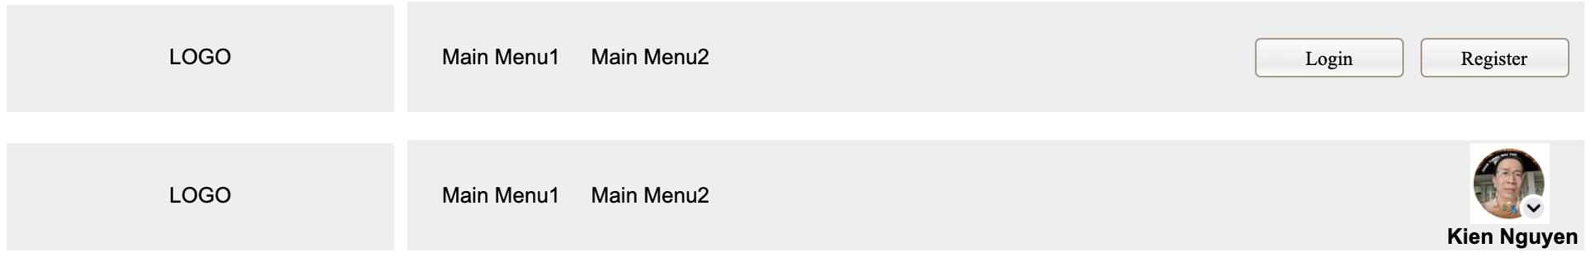

**Header before and after login**

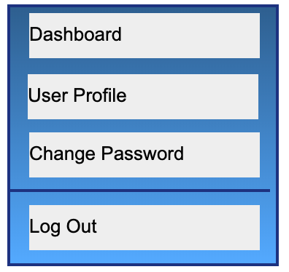

**Context Menu**

* Function Details: When users access the system, the homepage will appear and show information about the system.

### b. Login

* Function trigger: This function is trigger when the user clicks “Login” from Homepage
* Function description: User sign in into the system
* Screen layout: Mockup prototype of the screen, sample below is for the “Sign in” screen
* Function Details: When the user is in the state not logged in, at the home page there will be a “Sign in” button after signing in into the system, the Sign in button will become “Sign out”

### c. Register

* Function trigger: This function is triggered when the guest goes to login and choose to do the register
* Function description: The guest can create an account
* Screen layout: Mockup prototype of the screen, sample below is for the “Register”

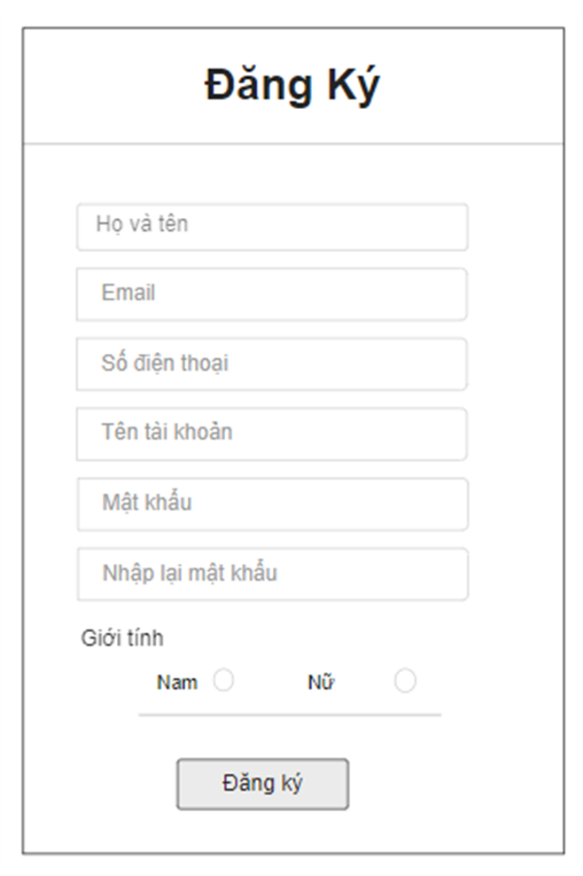

* Function Details: After going to the login, the guest can create an account

### d. Change Password

* Function trigger: This function is triggered when the user clicks “Tài khoản của tôi” from their avatar in Homepage
* Function description: Show profile of the user
* Screen layout: simulated prototype of screen, below sample is for Change Password screen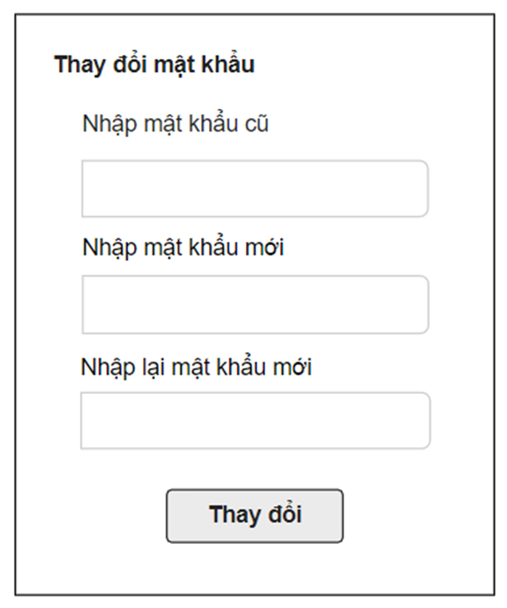
* Function Details: Allows the user to change his/her password by inputting his current password as well as new password (twice)

### e. Password reset

* Function trigger: when user click on “Quên mật khẩu” at login page
* Function description: The user can Reset Password to an account.
* Screen layout: simulated prototype of screen, below sample is for ForgotPassword screen
* Function Details: Allows the user to change his/her password if the user forgot their password.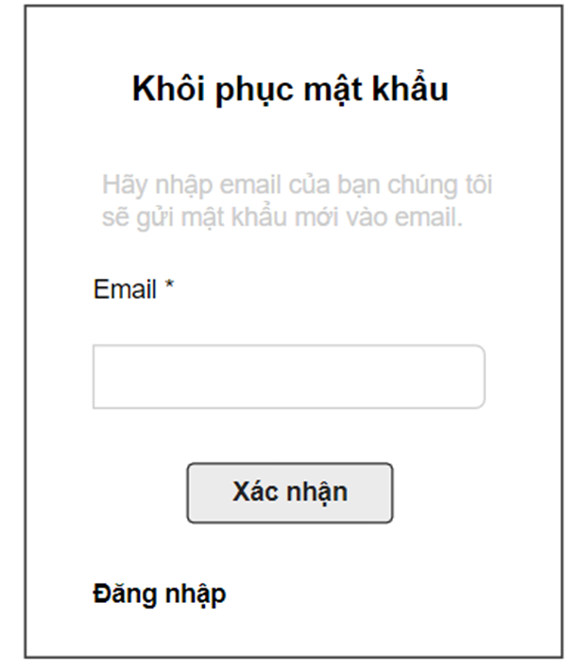

### f. User profile

* Function trigger: This function is triggered when the user clicks “Tài khoản của tôi” from Home
* Function description: The user can edit his/her profile information, including the registered user information and the avatar image.
* Screen layout: simulated prototype of screen, below sample is for User profile screen

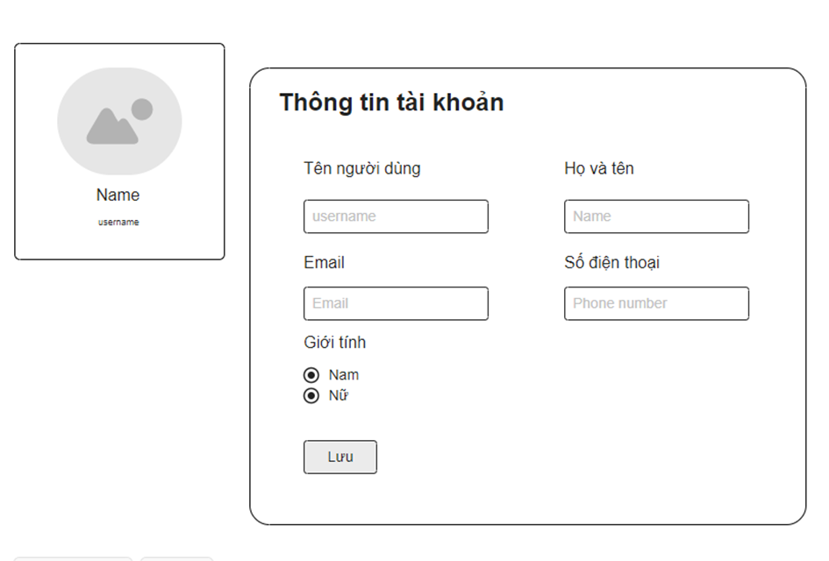

* Function Details:The user can edit his/her profile information.

### g. Dashboard

* Function trigger: When login with organisation account.
* Function description: Show dashboard
* Screen layout: 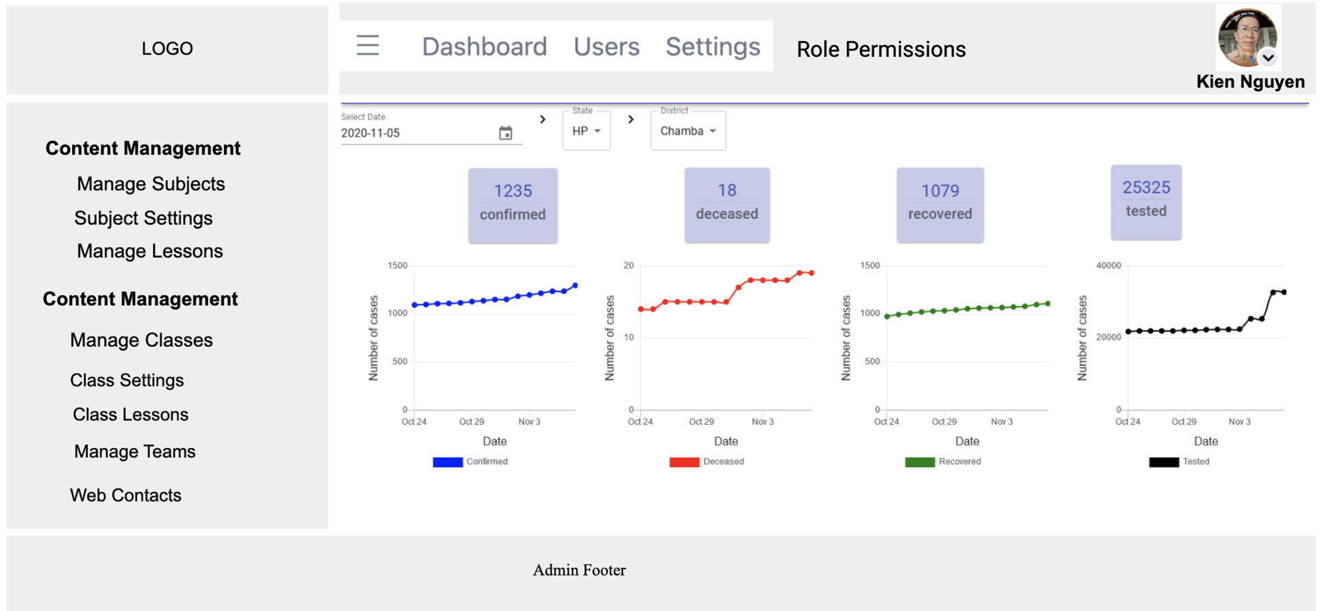
* Function Details: Get information from API in the organisation to have information about the website.

## 2. Admin Features

### a. Setting list

* Function trigger: Click at setting list at dashboard when user are admin.
* Function description: Show website setting list
* Screen layout: 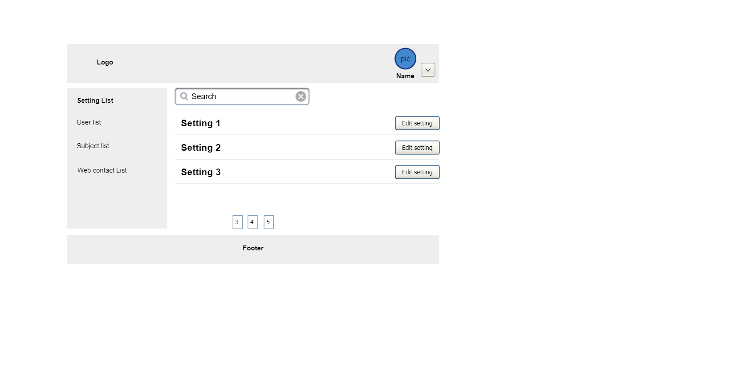

* Function Details: Allows admin to search, view and edit settings.

### 

### 

### 

### 

### 

### b. Setting details

* Function trigger: When click at “Edit setting” at the “Setting list” page.
* Function description: Show setting detail
* Screen layout:

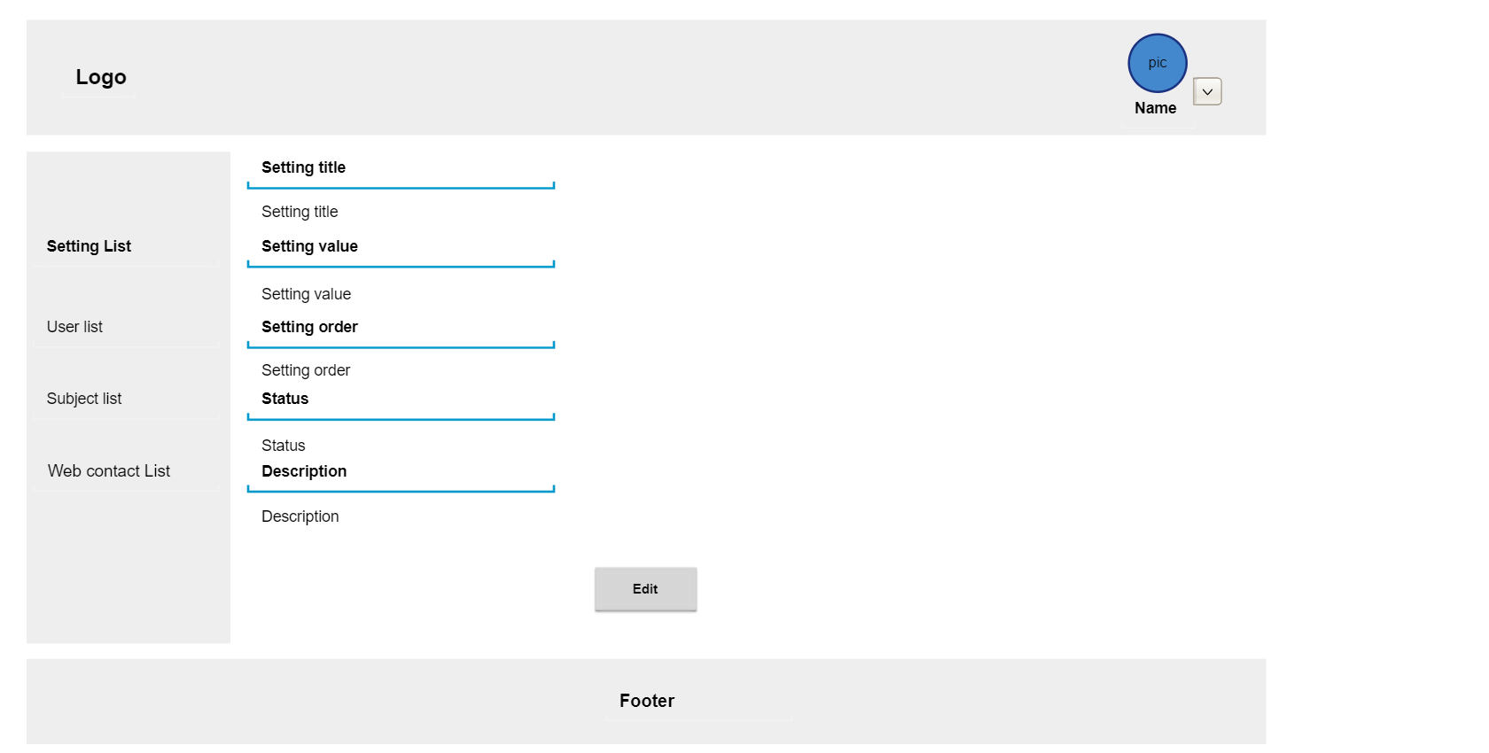

Setting detail

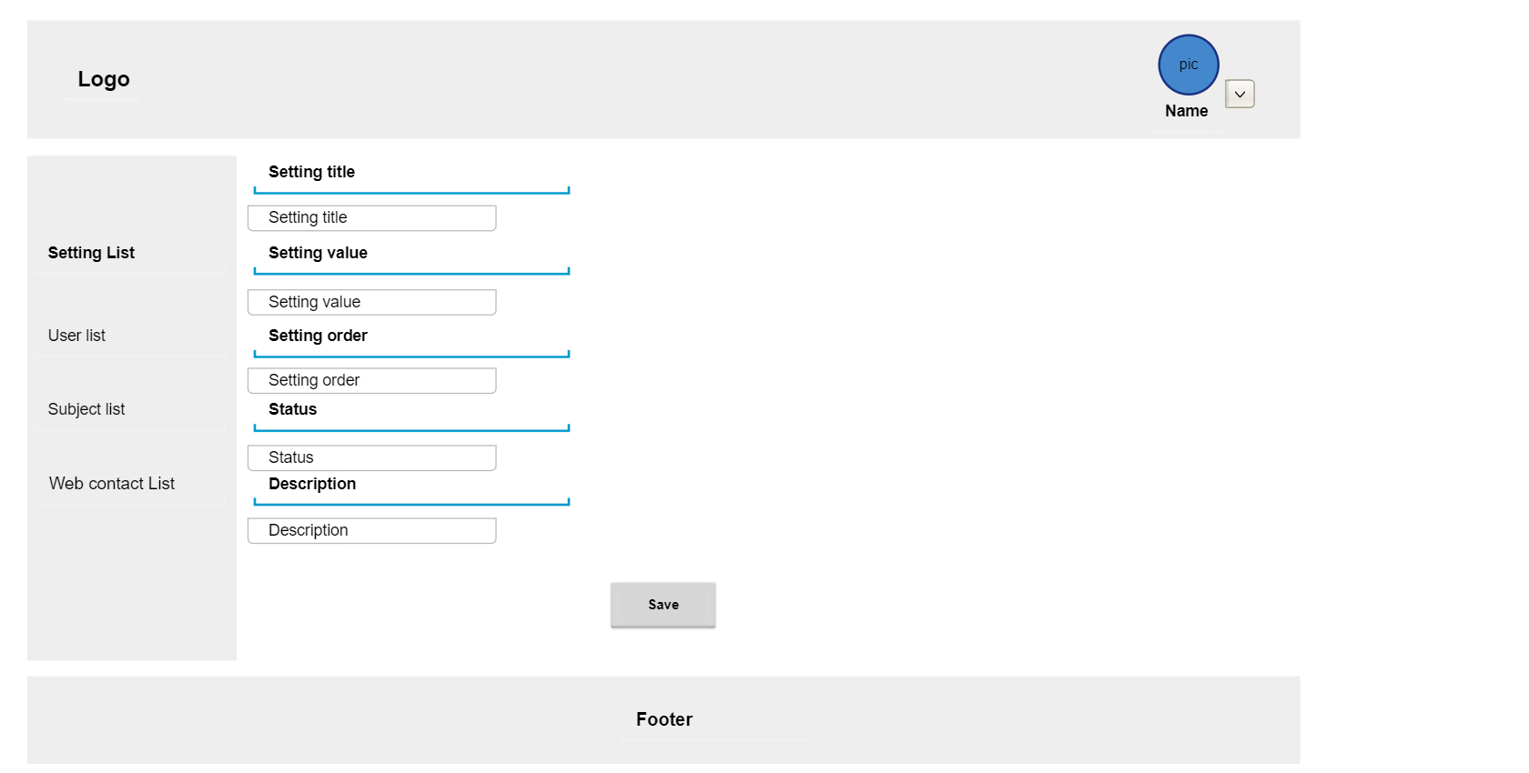

Edit setting

* Function Details: Allows see setting information and edit setting

### c. User list

* Function trigger: Click at “User list” at dashboard.
* Function description: List all users with accounts created on the website.
* Screen layout:

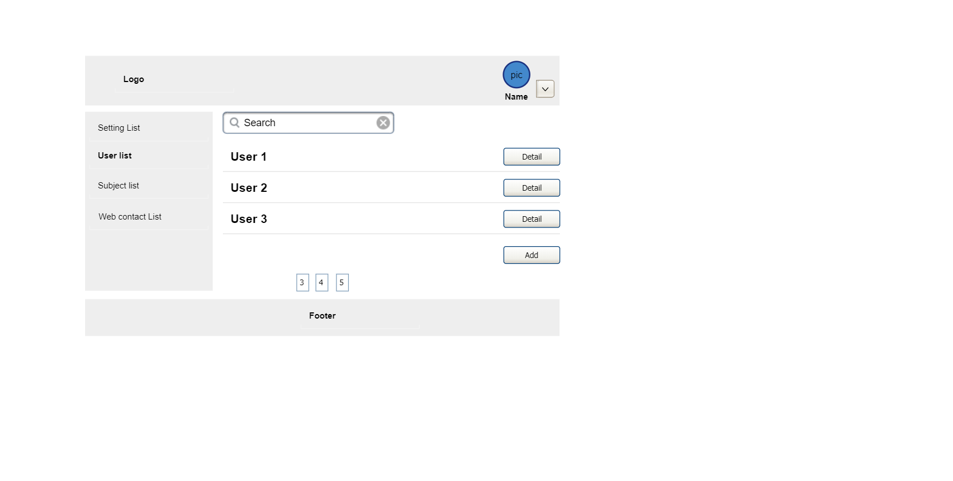

* Function Details: Allows admin to search account and see account detail.

### d. User details

* Function trigger: When admin clicks on “User detail” at account list.
* Function description: User account information.
* Screen layout:

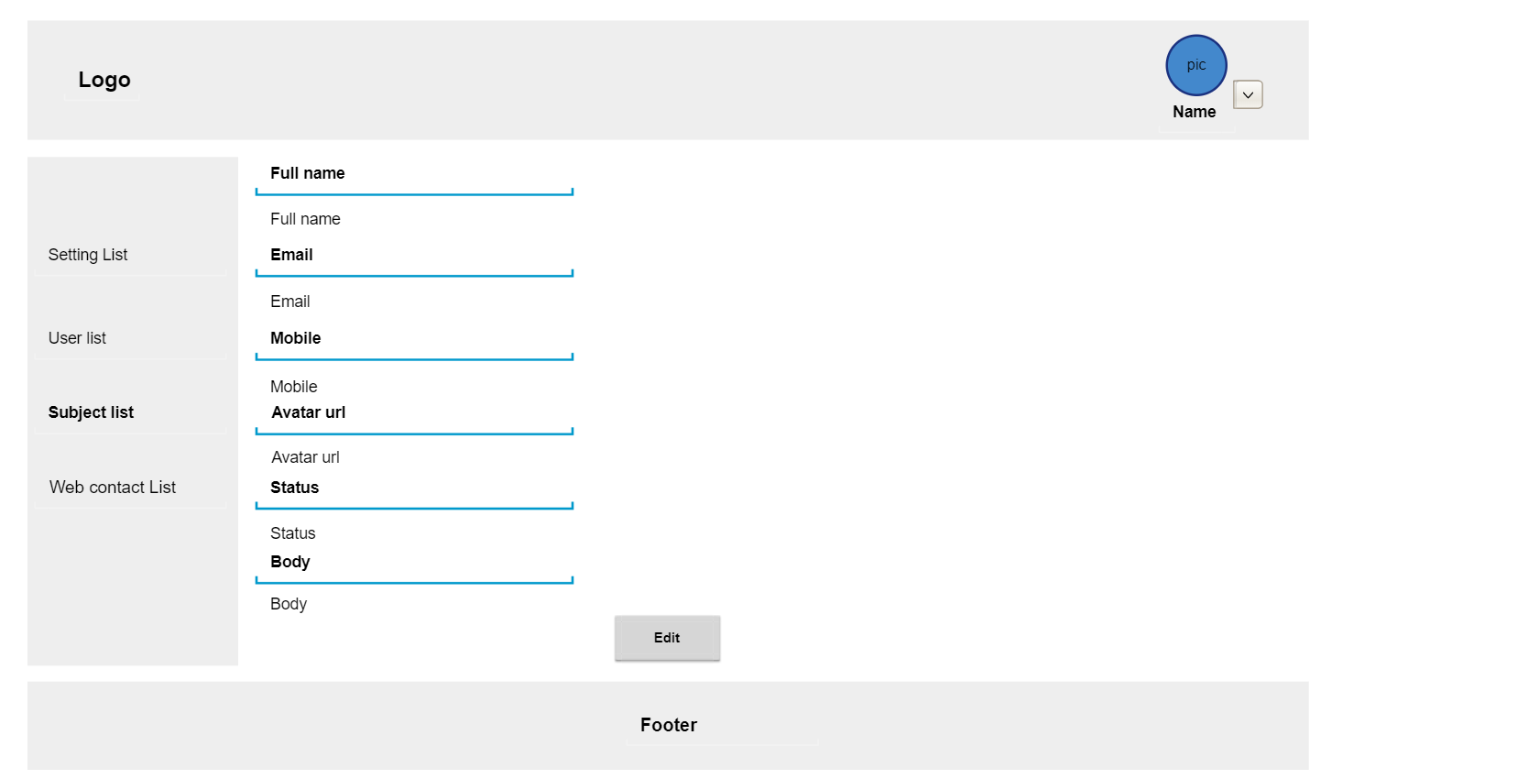

User detail

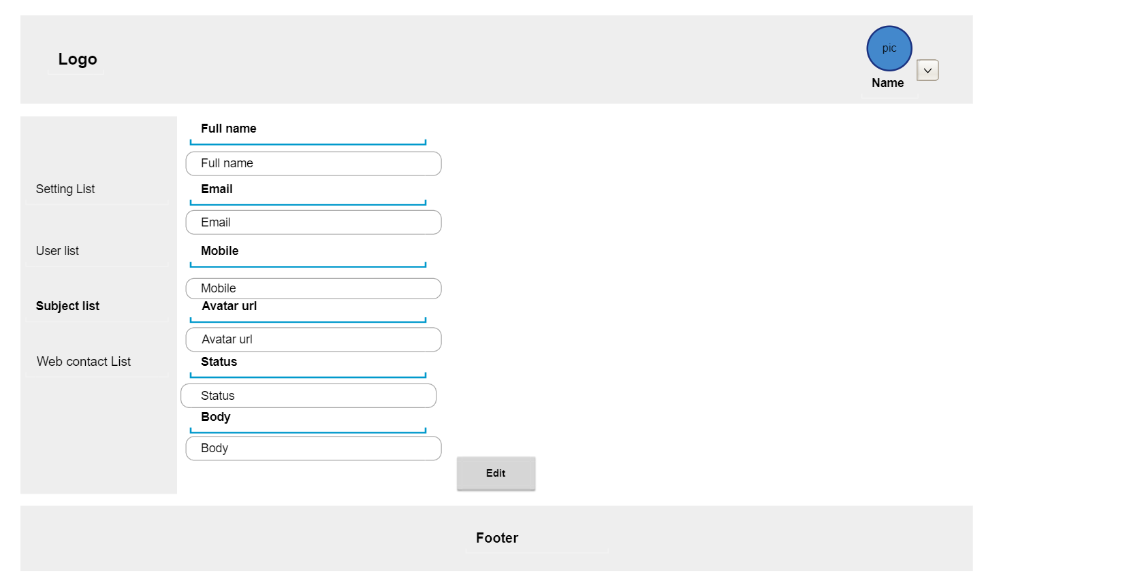

Edit user

* Function Details: Allows admin to view and edit account details.

### e. System Permission

* Function trigger: Click at “System Permission” at dashboard.
* Function description: Show and edit permission for each role for page and edit permission.
* Screen layout:
* Function Details: Allows admin to view and edit role permission.

## 

## 3. Manager Features

### a. Subject List

* Function trigger: Click at “Subject List” at dashboard.
* Function description: Show subjects list.
* Screen layout: 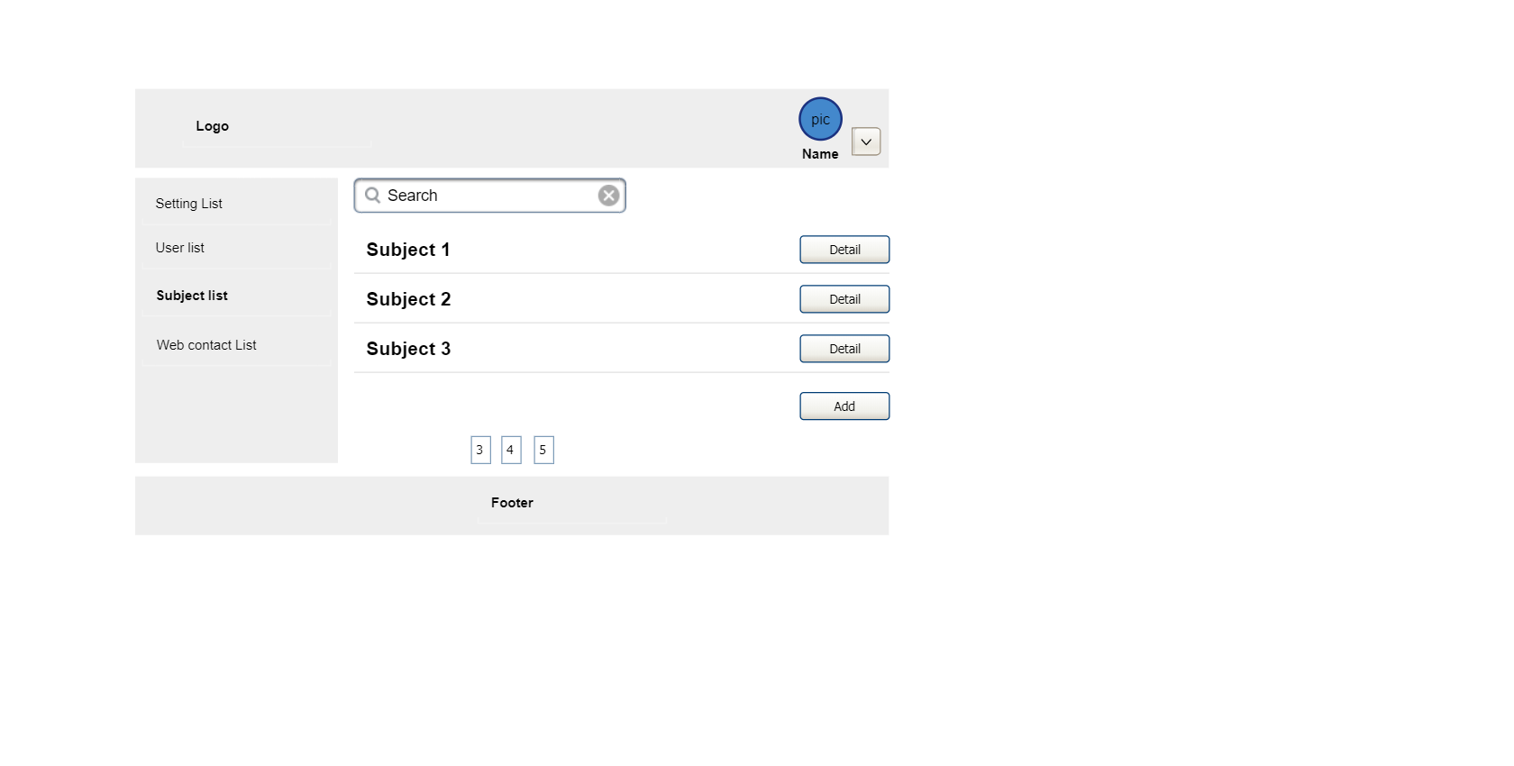
* Function Details: Allows managers to search Subject and see Subject detail.

### b. Subject Details

* Screen layout: 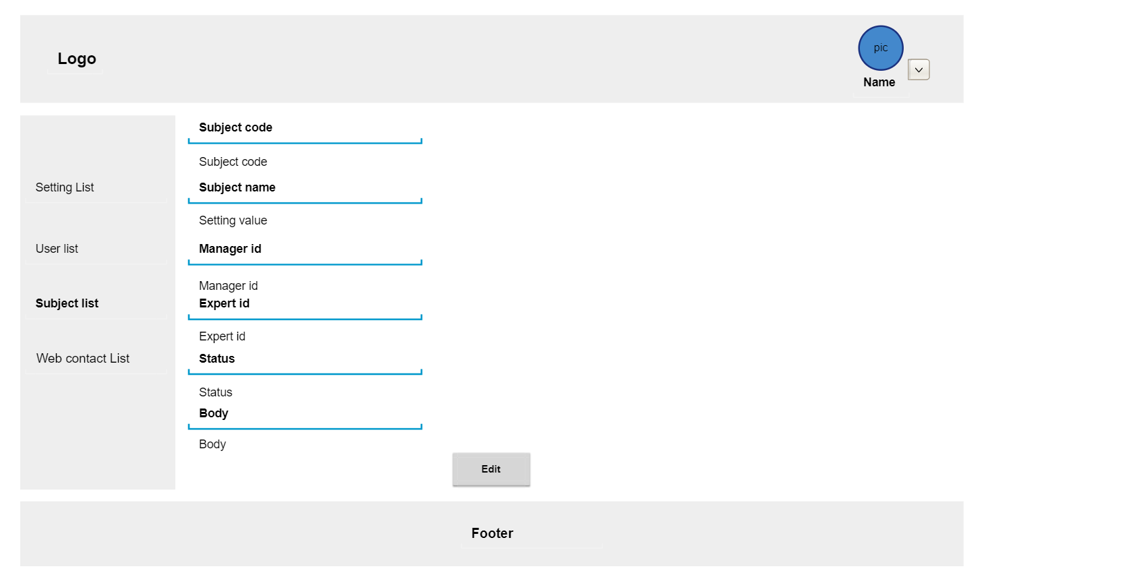

Subject detail

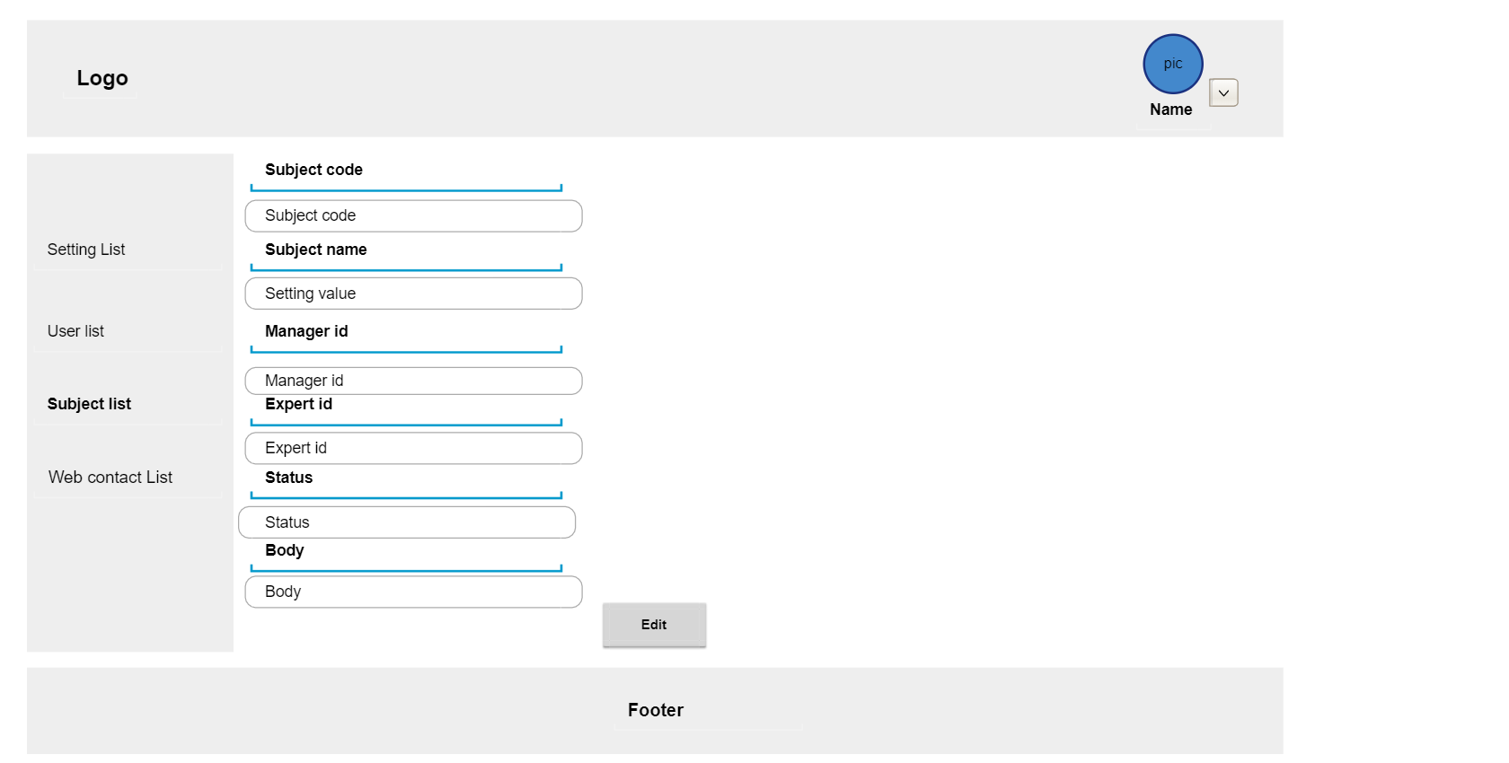

Edit subject

* Function Details: Allows managers to view and edit account details.

### 

### c. Eval criteria list

* Allows manager and expert view or search eval criteria.

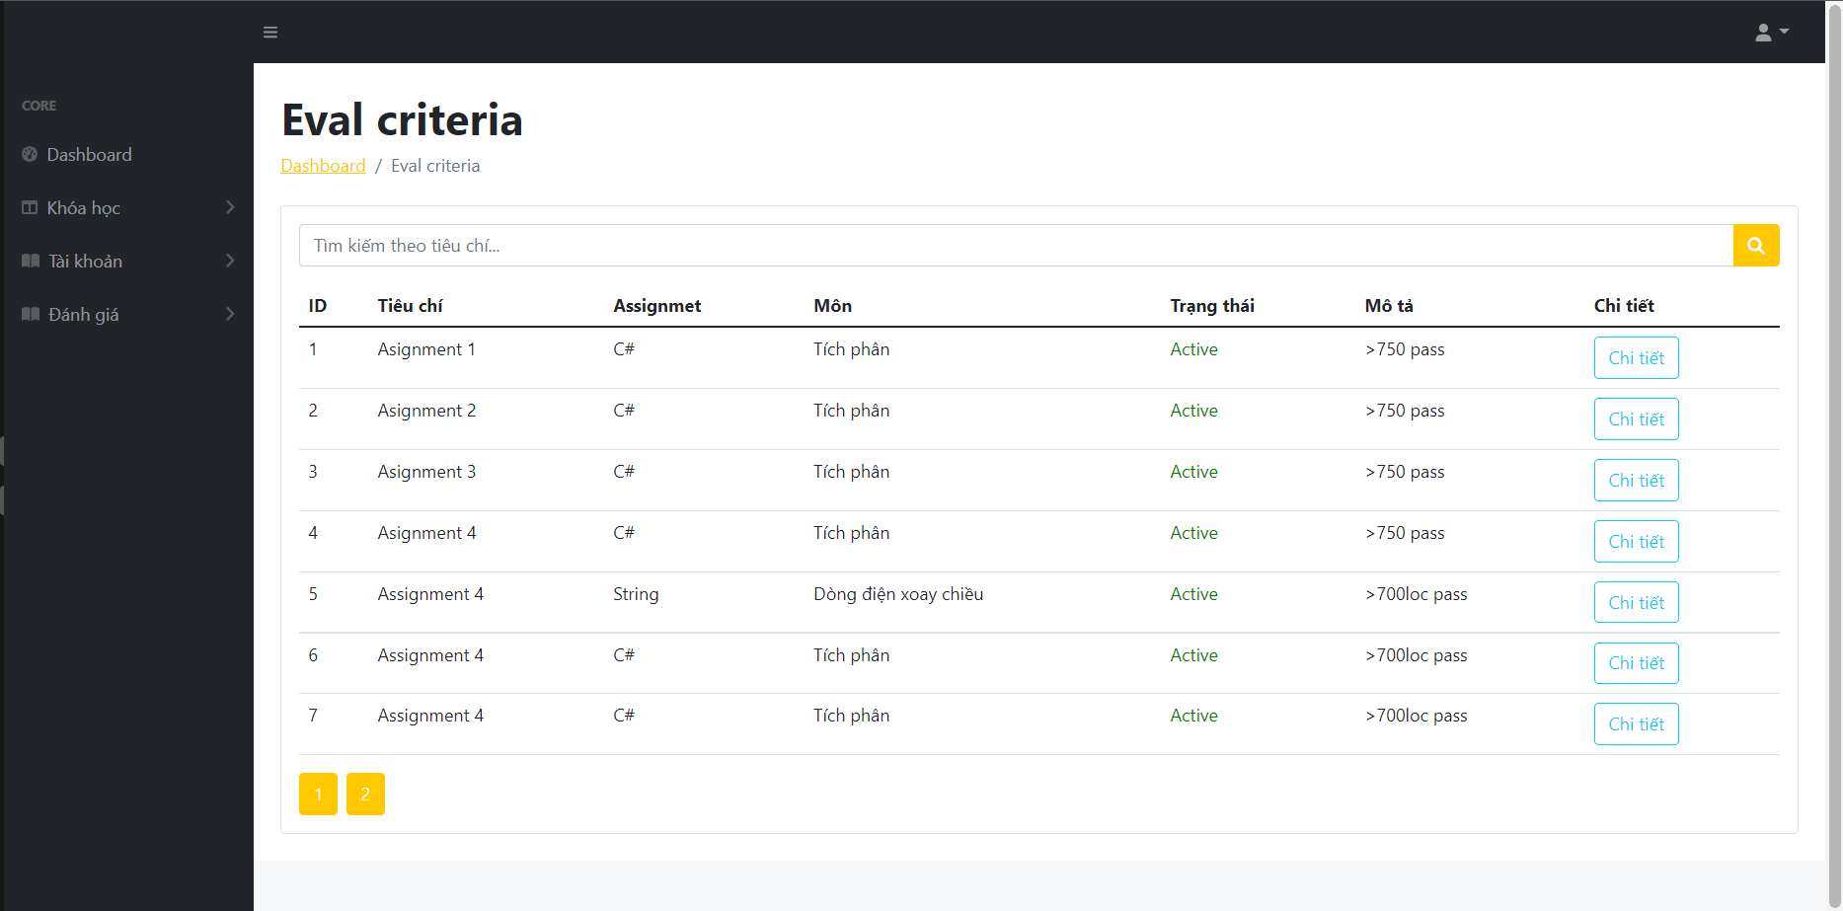

### 

### d. Eval criteria details

* Allows Manager or Admin view details or update.

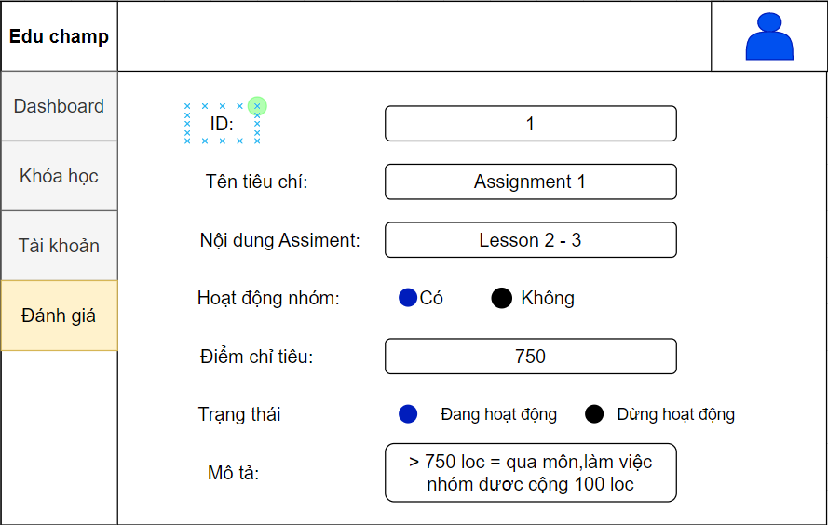

### 

### e. Class Details

Function description: Show the list of the Class data fields for viewing, updating or newly adding

Screen layout:

Function details:

- The Manager user can update the Class information (except for the Subject)

- The Supporter & Trainer user can view the Class information; The Supporter user can change some class information (trainer, status, description)

### f. Class List

Function trigger: Click at “Class List” at dashboard

Function description: Show information list of class

Screen layout:

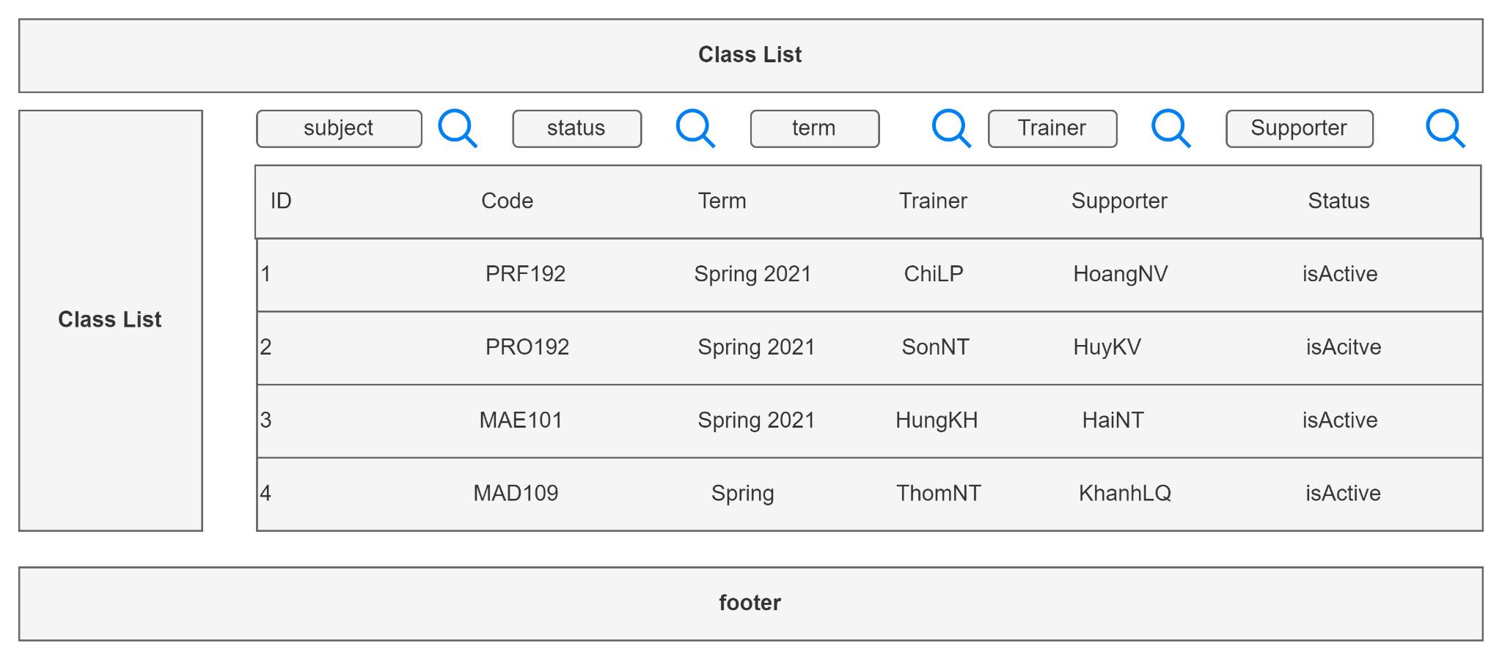

Function details: Show information about class, subject, user, user_role, setting

### g. Assignment List

Function trigger: Click at “Assignment List” at dashboard

Function description: Show list of assignment

Screen layout:

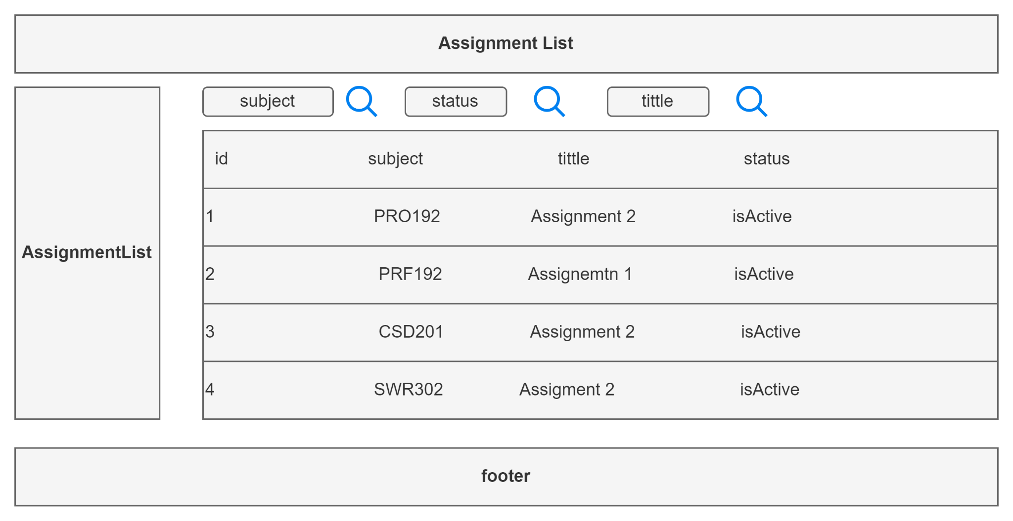

Function details: List of subject assignments; filter by subject , status; search by title

### h. Assignment Details

Function description: Allow the user to input Assignment information for adding or updating

Screen layout:

Function details:

### i. Subject Setting List

Function trigger: Click at “Setting List” at dashboard

Function description: Display list of subject setting list

Screen layout:

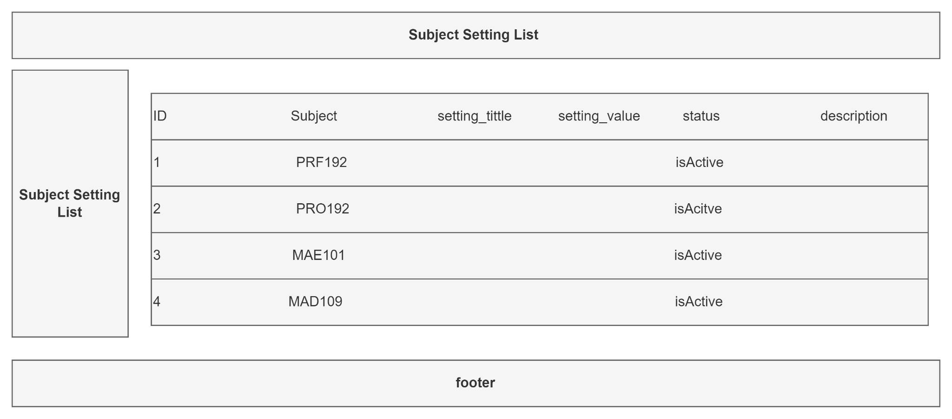

Function details: Configure the subject: complexity levels, quality levels

### j. Subject Setting Details

Function description: Allow the user to input Subject Setting information for adding or updating

Screen layout:

Function details:

### k. Milestone List

* Show list milestone

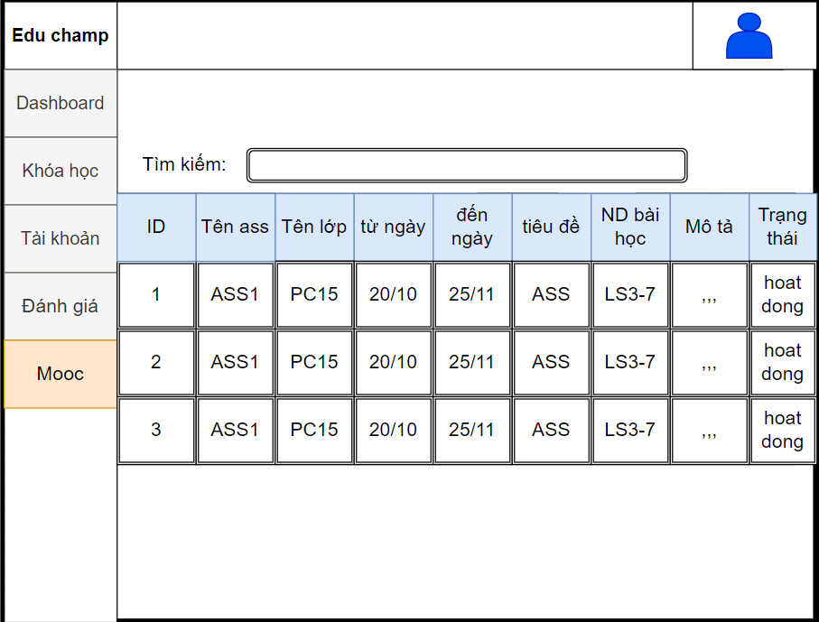

Screen layout

### l. Class eval criteria list

* Function trigger: Click at “Đánh giá lớp” at dashboard.
* Function description: Show class eval criteria list.
* Screen layout:

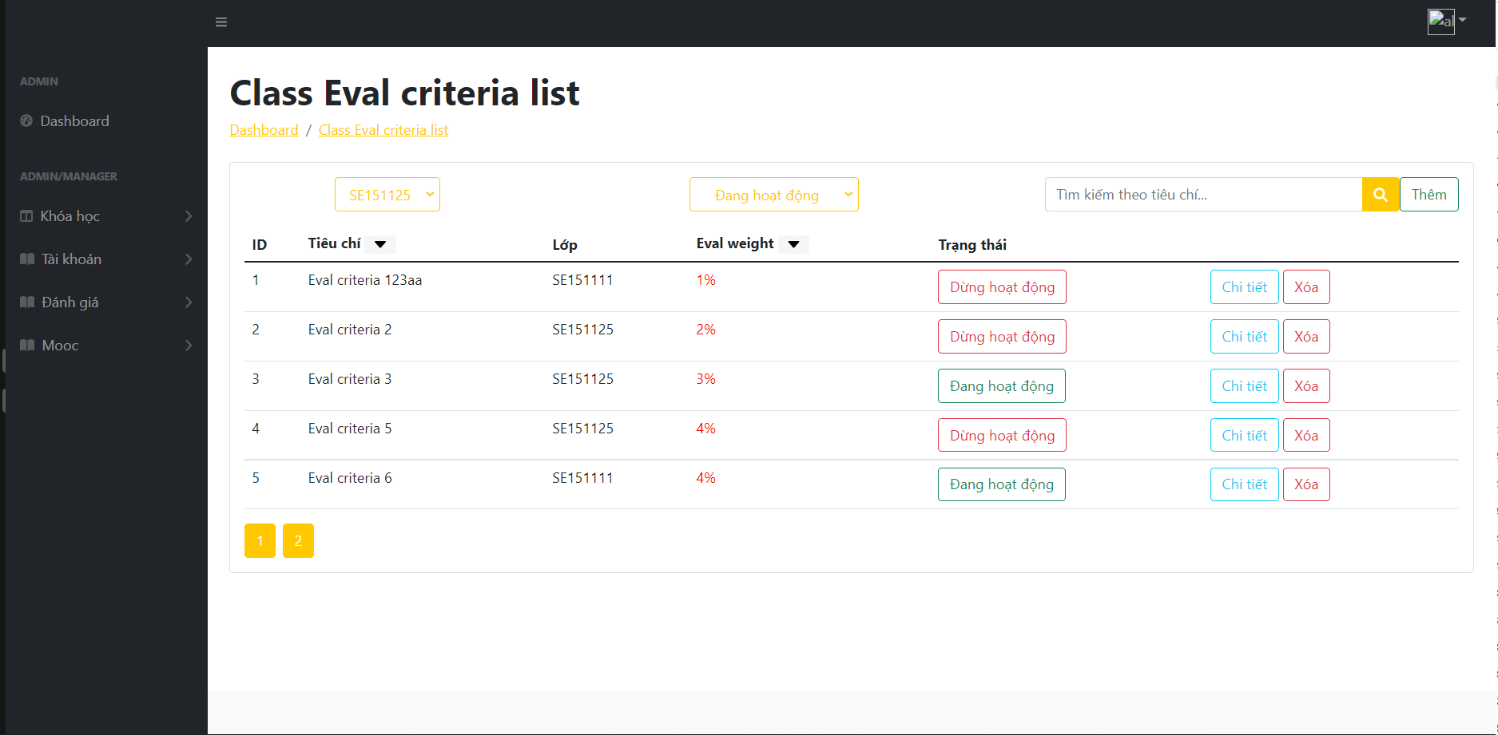

### m. Class eval criteria details

* Function trigger: Click at “Chi tiết” at action in list.
* Function description: Show details class eval criteria.
* Screen layout:

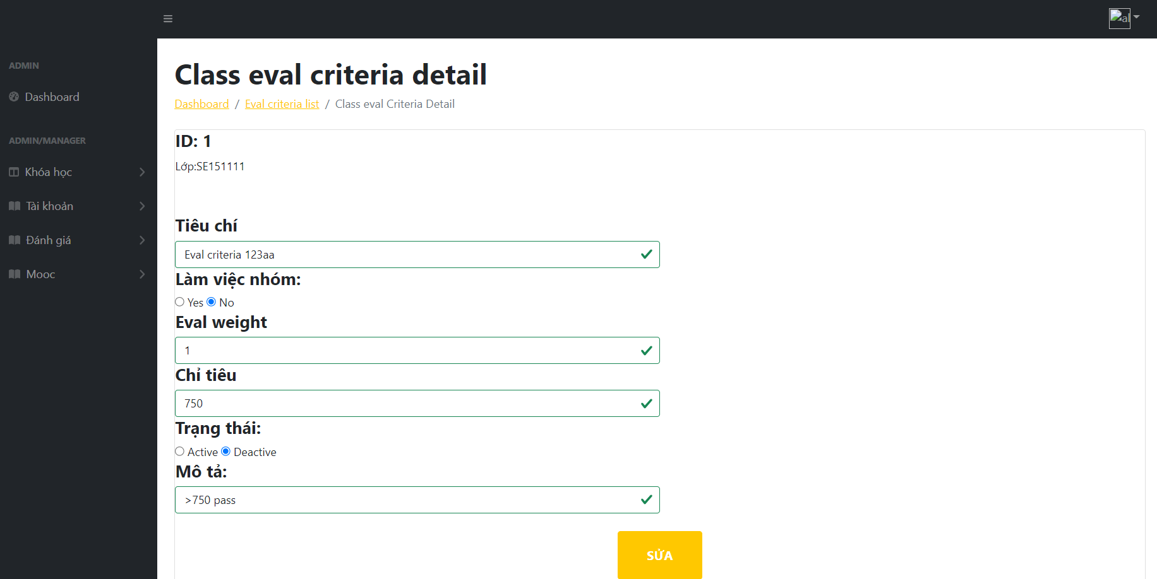

### n. Milestone details

* Function trigger: Click at “Chi tiết” at list Milestone.
* Function description: Show list milestone
* Screen layout:
* 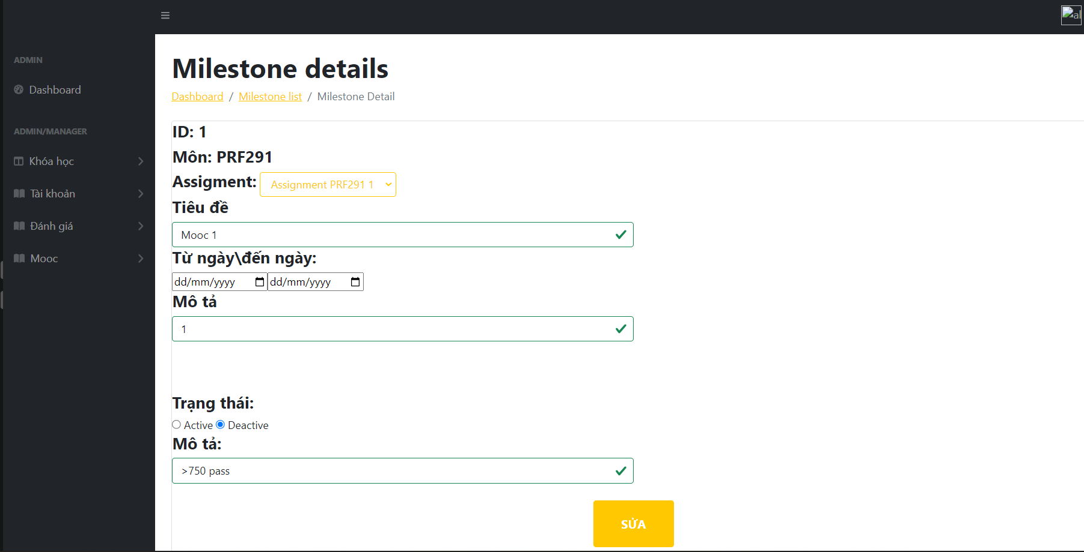

## 4. Supporter F**eatures**

### a. Web Contact List

* Function trigger: Click at “Web Contact List” at dashboard.
* Function description: Show Web Contact List
* Screen layout:

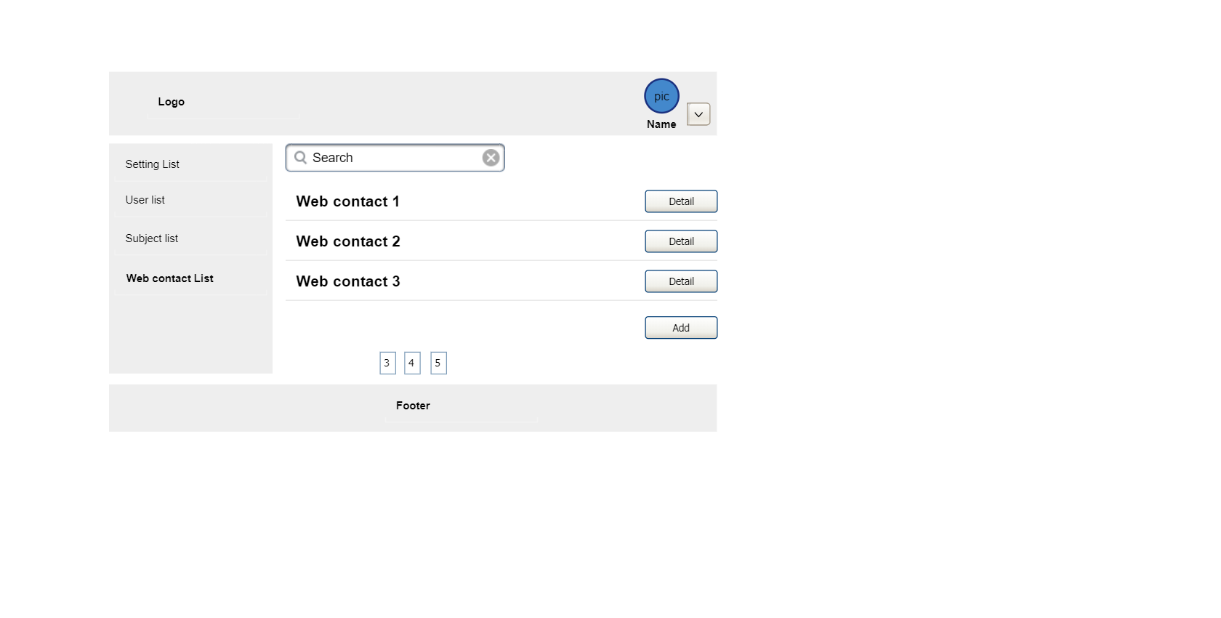

* Function Details: Allow users to see all information about the contact.

### 

### b. Web Contact Details

* Function trigger: Click at “Web Contact Details” at dashboard
* Function description: Show Web Contact Details information
* Screen layout: 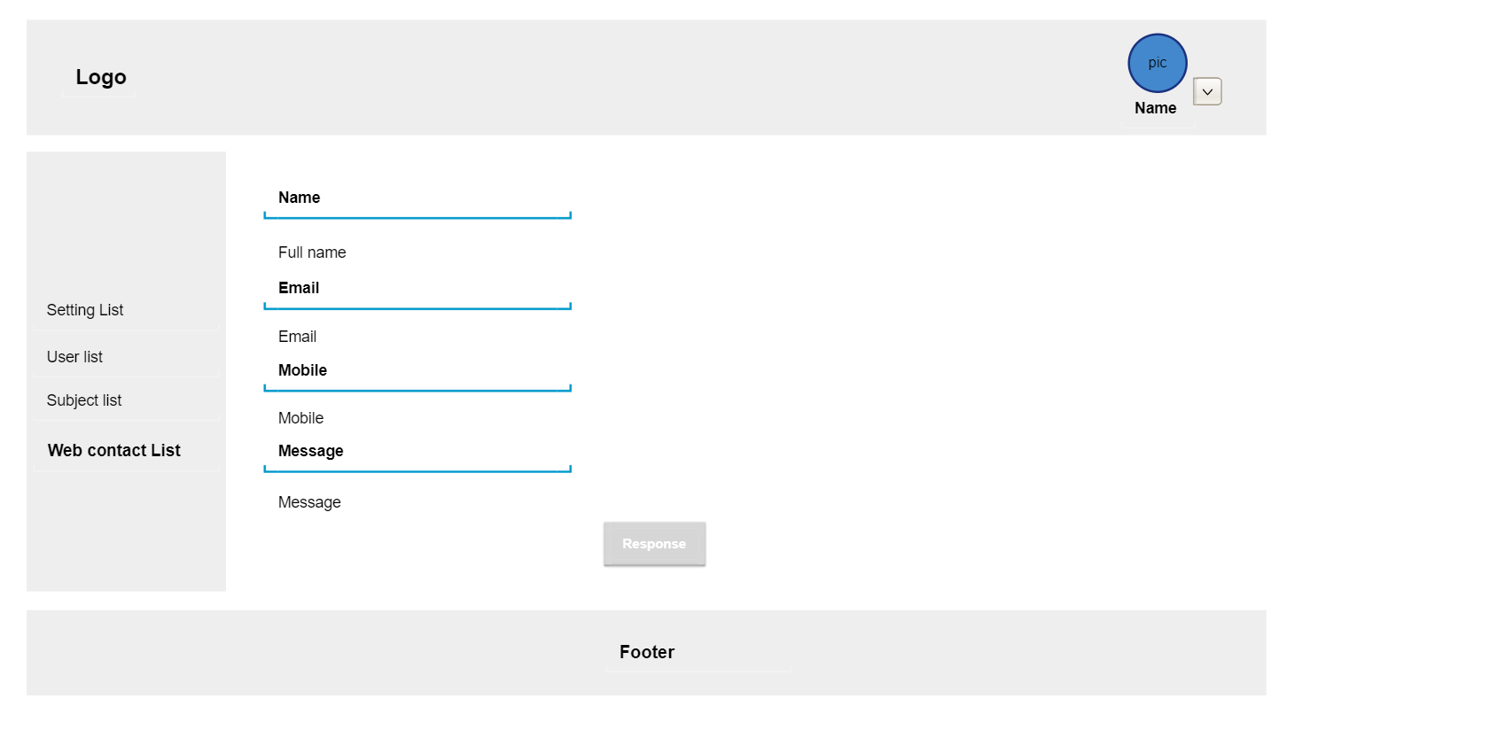
* Function Details: Allows supporters to view and answer web contact

### c. Trainee List

* Function trigger:
* Function description:
* Screen layout:
* Function Details:

### d. Trainee Details

* Function trigger:
* Function description:
* Screen layout:
* Function Details:

### e. Schedule List

* Function trigger: When clicking the ”Schedule” button from a class in class list or selecting a corespont class in the class drop down.
* Function description: Show schedule of a class.
* Screen layout: 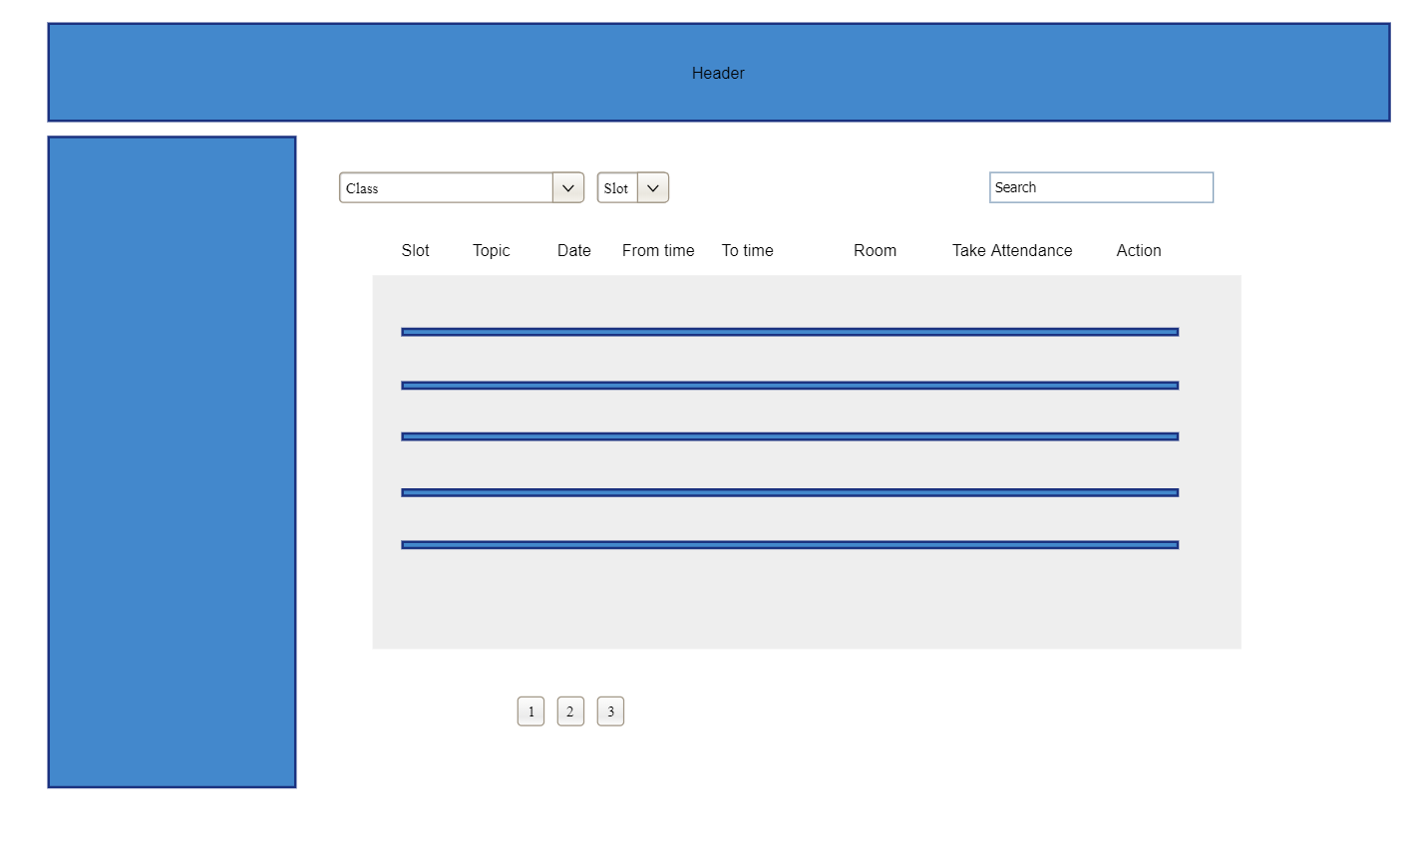
* Function Details: Allow trainer, supporter and trainee to see the schedule for their class

### f. Schedule Details

* Function trigger: Click the “Schedule Details” button at Schedule List.
* Function description: Show detail of schedule.
* Screen layout: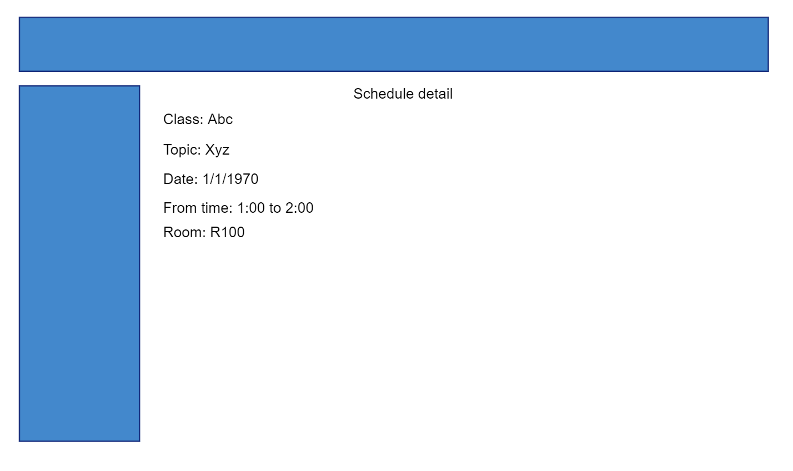
* Function Details: Allow trainee to see details of the schedule and trainer, supporter to edit, add new schedule.

### g. Schedule Attendance

* Function trigger: Click “Take Attendance” button at Schedule list.
* Function description: Take attendance for schedule slot.
* Screen layout: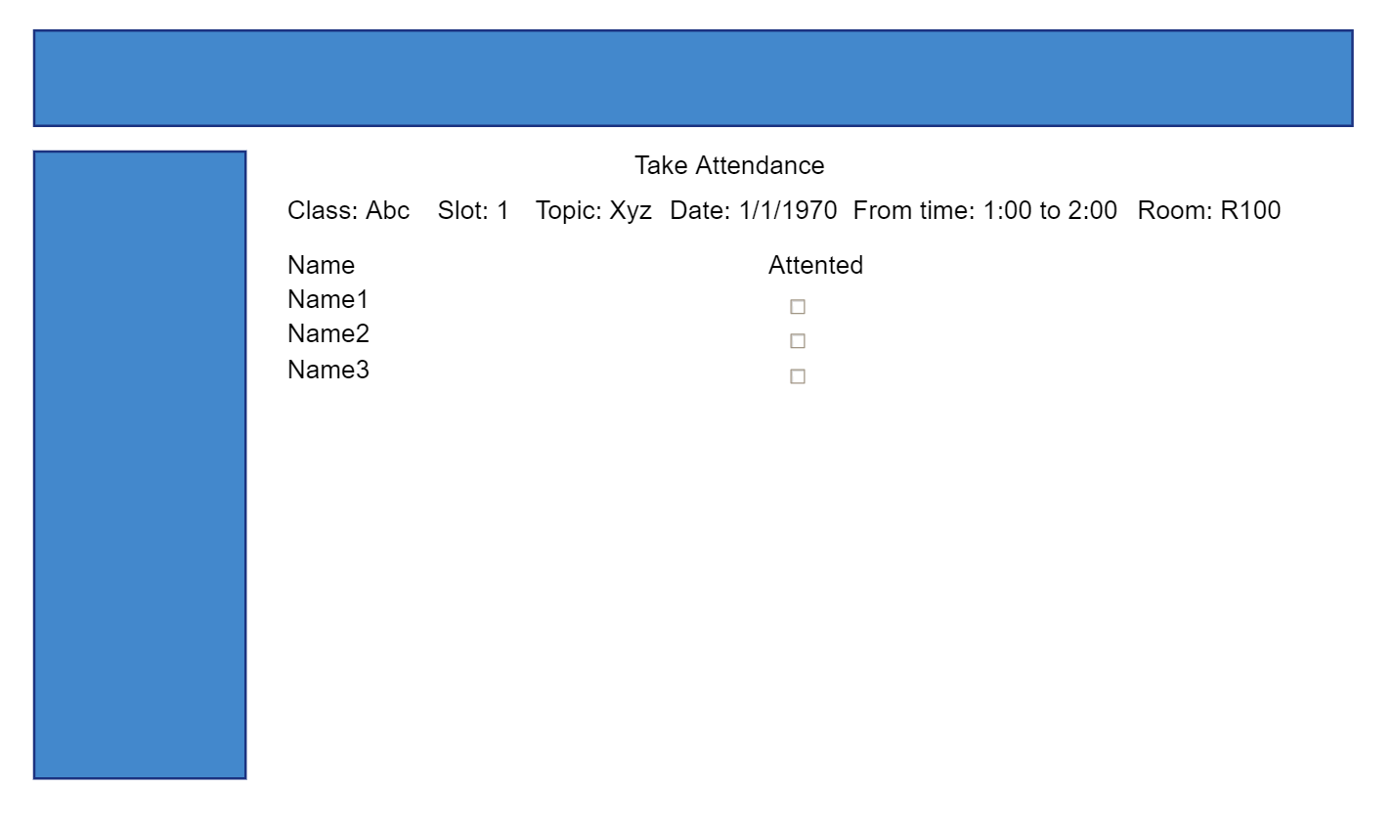
* Function Details: Allow trainer to take attendance.

## 5. Trainer **Features**

### a. New Milestone

* Function trigger: Click at “Add milestone” at “Milestone List”
* Function description: Add new milestone
* Screen layout:
* Function Details: Allows Trainer to add new milestone

b. Issue Details

* Function trigger: Click at “Issue Details” at Issue List
* Function description: View detailed information with change history
* Screen layout:

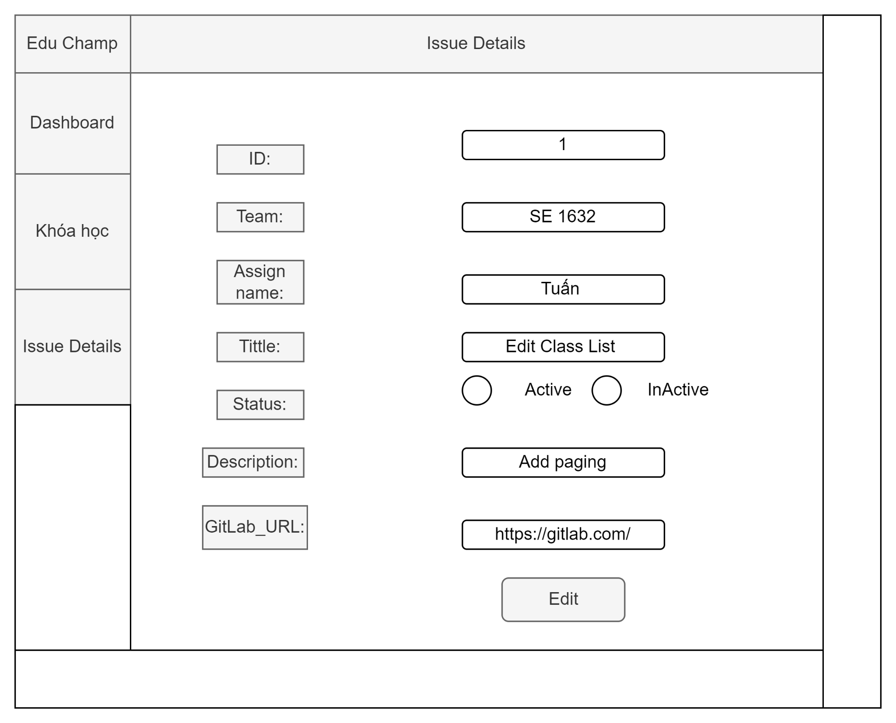

* Function Details:

View detailed issue information + issue change history; For issues where the trainee is playing the role of author or assignee, the trainee can link/update the issue link information to specific requirement issues & after updating, the mapping information will be automatically synced to GitLab (refer to the mechanism of this issue). link issue in GitLab)

c. Issue List

* Function trigger: Click at “Issue List”
* Function description: List of all issue
* Screen layout:

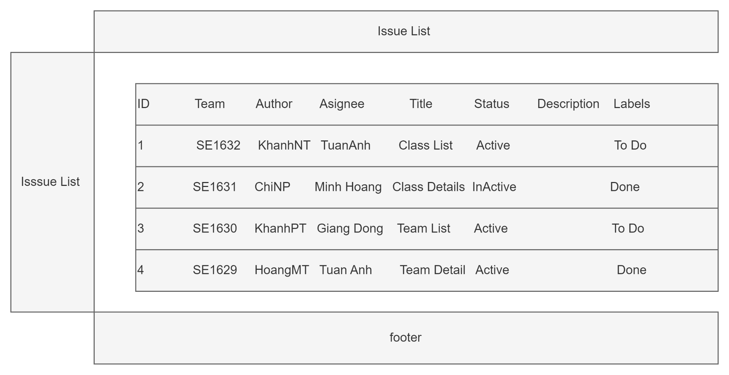

* Function Details: DS issues, filter by [Class, Milestone, Author, Assignee, Issue Type(s), Issue Status] + search by issue title + choose to sort ascending/descending by specific column => refer to filter mechanism/ GitLab's search/sort. Trainee can click Sync GitLab button to get the latest issue information from GitLab

d.Team List

* Function trigger: Click at “Team List ”
* Function description: List of all team list
* Screen layout:
* Function Details:

+) The Supporter & Trainee can view the team list & team details

+)Member Actions: Change Team, Remove Member, Set As Team Leader

+)Global Actions: Group or Regroup - link to New Teams page to create/re-create new team set

+) Team Actions:

* Add New Trainee: add trainee(s) from weighting list into the selected team
* Add New: link to Team Details to add new team to the milestone team set
* Team Details: link to Team Details to view and/or edit the team
* Activate/Deactivate: activate or deactiavate the team
* - The above actions are not allowed for the team sets which are "attached" to the in-progress or closed milestones