 | MINISTRY OF EDUCATION AND TRAINING

FPT UNIVERSITY
Capstone Project Document
Student Club Management System
Group 19
Group Members | Vo Phuong Viet Khoi – Team leader - 60011  Doan Gia Huy – Team member - 60009  Nguyen Huu Thuan – Team member - 60107  Pham Anh Tu – Team member - 60105
Supervisor | Mr. Nguyen Trong Tai
Ext Supervisor
Capstone Project code | SCMS

- Ho Chi Minh City, 09/2012 -

Table of Contents
Table of Contents 2
1 Report No.1: Introduction 1
1.1 Background 1E
1.2 Project Objective 1
1.3 Scope Definition 2
1.4 Main Project Success Criteria 2
1.5 Approach 2
1.6 Group Function 2
1.7 Project Program and Management 3
2 Report No.2: Software Project Management Plan (SPMP) 3
2.1 Problem definition 3
2.1.1 Name of This Capstone Project 3
2.1.2 Problem Abstract 3
2.1.3 Project Overview 4
2.2 Project Organization 6
2.2.1 Software Process Model 6
2.2.2 Roles and Responsibility 8
2.2.3 Tools and Techniques 8
2.3 Project Management Plan 9
2.3.1 Tasks 9
2.3.2 Task Sheet: Assignments and Timetables 13
2.4 Coding Convention 13
3 Report No.3: Software Requirements Specifications (SRS) 14
3.1 User Requirement Specification 14
3.2 System Requirement Specification 14
3.2.1 External Interface Requirement 14
3.2.2 System Features 16
3.3 Software System Attributes 79
3.3.1 Reliability 79
3.3.2 Availability 80
3.3.3 Security 80
3.3.4 Maintainability 80
3.3.5 Protability 80
3.3.6 Performace 80
3.4 Entity Relationship Diargram 80
3.4.1 Entity Relationship Model 80
3.4.2 Data Dictionary 81
4 Report No.4: Software Design Description (SDD) 84
4.1 Design Overview 84
4.2 System Architechure Design 85
4.2.1 Choice of System Architechure 85
4.2.2 Discussion of Aternative Designs 86
4.2.3 Description of System Interface 87
4.3 Component Diagram 88
4.4 Detail Description of Components 90
4.4.1 User Management 90
4.4.2 Activity Management 99
4.4.3 Finance Management 103
4.4.4 Supporting Tool for User 108
4.5 Sequence Diagram 116
4.5.1 User Management 116
4.5.2 Activity Management 140
4.5.3 Finance Management 150
4.5.4 Supporting Tool for User 158
4.6 User Interface Design 160
4.7 Database Design 161
5 Report No.5: Software Test Documentation (STD) 162
5.1 Introduction 162
5.1.1 System Overview 162
5.1.2 Test Approach 162
5.2 Test Plan 162
5.2.1 Features to be test 162
5.2.2 Features not to be test 164
5.2.3 Test Tool and Environment 165
5.3 Test Cases 165
5.3.1 User Management 165
5.3.2 Activity Management 167
5.3.3 Finance Management 171
5.4 Checklists 176
5.4.1 User Management 176
5.4.2 Activity Management 178
5.4.3 Finance Management 182
6 Report No.6: Software User’s Manual 186
6.1 Installation Guide 186
6.1.1 Server Side 186
6.1.2 Client Side 186
6.2 User Guide 186
6.2.1 Minimum System Requirements 186
6.2.2 Introduction of Student Club Management System 186
6.2.3 Features and How to Use 187
6.2.4 Others 205

Figure 1 - Waterfall model 7
Figure 2 – Member of Project 8
Figure 3 – Main Tasks of Project 13
Figure 4 – Task Sheet 13
Figure 5 – User Interfaces 15
Figure 6 – Actor Description 16
Figure 7 – Entity Relationship Model 81
Figure 8 – Description of Entities 82
Figure 9 – Description of Relationship 82
Figure 10 – Description of Attributes 84
Figure 11 – MVC Architecture 85
Figure 12 – MVP Model 86
Figure 13 – MVVM Model 87
Figure 14 – Component Diagram 89
Figure 15 – User Management Class Diagram 90
Figure 16 – Activity Management Class Diagram 99
Figure 17 –Finance Management Class Diagram 103
Figure 18 – Search Function Class Diagram 108
Figure 19 – Report Function Class Diagram 111
Figure 20 – Register Sequence Diagram 117
Figure 21 – Login Sequence Diagram 118
Figure 22 – Forget Password Sequence Diagram 119
Figure 23 – Edit Profile Sequence Diagram 120
Figure 24 – Send Request Join Club Sequence Diagram 121
Figure 25 – Delete Request Join Club Sequence Diagram 123
Figure 26 – Approve Member Sequence Diagram 123
Figure 27 – Reject Member Sequence Diagram 124
Figure 28 – Dismiss CM Sequence Diagram 125
Figure 29 – Change CC Sequence Diagram 126
Figure 30 – Send Request Create Club Sequence Diagram 127
Figure 31 – Delete Request Create Club Sequence Diagram 128
Figure 32 – Approve Club Sequence Diagram 129
Figure 33 – Reject Club Sequence Diagram 130
Figure 34 – Create MMB Sequence Diagram 131
Figure 35 – Delete MMB Sequence Diagram 132
Figure 36 – Edit Club Sequence Diagram 133
Figure 37 – Delete Club Sequence Diagram 134
Figure 38 – Create President Sequence Diagram 135
Figure 39 – Delete President Sequence Diagram 137
Figure 40 – Delete Account Sequence Diagram 138
Figure 41 – Edit Account Sequence Diagram 139
Figure 42 – Create Event Sequence Diagram 140
Figure 43 – Edit Event Sequence Diagram 141
Figure 44 – Delete Event Sequence Diagram 142
Figure 45 – Create Article Sequence Diagram 143
Figure 46 – Edit Article Sequence Diagram 144
Figure 47 – Delete Article Sequence Diagram 145
Figure 48 – Approve Article Sequence Diagram 146
Figure 49 – Create Comment Sequence Diagram 147
Figure 50 – Edit Comment Sequence Diagram 148
Figure 51 – Delete Comment Sequence Diagram 149
Figure 52 – Create Income Sequence Diagram 150
Figure 53 – Edit Income Sequence Diagram 151
Figure 54 – Create Fee Sequence Diagram 152
Figure 55 – Edit Fee Sequence Diagram 153
Figure 56 – Create Actual Sequence Diagram 154
Figure 57 – Edit Acual Sequence Diagram 155
Figure 58 – Create Estimated Sequence Diagram 156
Figure 59 – Edit Estimated Sequence Diagram 157
Figure 60 – Total Income & Expend Report Sequence Diagram 158
Figure 61 – View Report about Event Sequence Diagram 158
Figure 62 – View Report about Member Sequence Diagram 159
Figure 63 – View Income in Club Sequence Diagram 159
Figure 64 – Search All Sequence Diagram 160
Figure 65 – Site Map 160
Figure 66 – Database Diagram 161
Figure 67 – GUI_”Đăng Kí” 187
Figure 68 – GUI_”Đăng Nhập” 188
Figure 69 – GUI_”Quên Mật Khẩu” 189
Figure 70 – GUI_”Gửi – Xóa Yêu Cầu Gia Nhập CLB” 189
Figure 71 – GUI_”Quản Lý Yêu Cầu Gia Nhập CLB” 190
Figure 72 – GUI_”Quản Lý Thành Viên CLB” 191
Figure 73 – GUI_”Quản Lý Chủ Nhiệm CLB” 191
Figure 74 – GUI_”Gửi Yêu Cầu Tạo CLB” 192
Figure 75 – GUI_”Quản Lý Yêu Cầu Tạo CLB” 193
Figure 76 – GUI_”Tạo Thành Viên Ban Quản Trị” 193
Figure 77 – GUI_”Sửa Thông Tin CLB” 194
Figure 78 – GUI_”Quản Lý Chủ Tịch” 195
Figure 79 – GUI_”Quản Lý Tài Khoản” 195
Figure 80 – GUI_”Tạo Sự Kiện” 196
Figure 81 – GUI_”Tạo Bài Báo” 197
Figure 82 – GUI_”Tạo Khoản Thu” 199
Figure 83 – GUI_”Tạo Phí Tháng” 200
Figure 84 – GUI_”Tạo Thực Chi” 201
Figure 85 – GUI_”Tạo Dự Chi” 202
Figure 86 – GUI_”Báo Cáo Tài Chính” 203
Figure 87 – GUI_”Báo Cáo Về Sự Kiện” 204
Figure 88 – GUI_”Báo Cáo Về Thành Viên” 204
Figure 89 – GUI_”Tìm Kiếm” 205

Report No.1: Introduction

Background
Today, education is increasingly enhanced. Specifically, in Vietnam, the majority of students after high school can continue their studies at university. University environment gives students a lot of new things, from the self-study to communication and teamwork skills. In particular, the richness and diversity of clubs at the university environment gives students a lot of interesting.
Number of clubs at each university at Vietnam is so much. However, the club management has many limitations, such as decentralized management structure is not reasonable, the management is completely done by hand-made, based on a lot of paperwork, applications, and so on that lead to errors in the statistics. The most limitations in management student club in Vietnam is do not have a formal channel of communication for the management of student clubs, most of which have to share the university’s official website for the notification of new events. Each club itself is also limited to the introduction of its good points, their clubs’ attractiveness to all students in order to attract more number of participants.
From those reasons, we want to develop a Student Club Management System that may help student clubs organize, manage, and improve their current management to become more effectively, quickly and professionally. In terms of the club members, they may feel more excited and enthusiastic when joining into clubs at their university.

Project Objective
The purpose of Student Club Management project is to create a new system that improves the current student club’s activities process of the university by automating some functions of the current process.
Student Club Management system allows the users to login with their authorization to manage basically activities of a student club such as user management, activity management and financial management.
It also provides some functions to allow users to query data from the database and generate some defined reports which support for the management is become more easily, quickly and accurately.
Moreover, Student Club Management system is also a “channel” for introducing activities and interesting things of each club to all the students of their university, even students of other one.

Scope Definition
The main scope of the Student Club Management System is to provide an efficiently and easy-to-use software that facilitate manually process of the university.
It manages users, allocates suitable roles for each kind of users. It also has functions for managing activities and financial situation such as income and expenditure in club. Beside that it also provides some convenient functions for user in searching and statistic.
Student Club Management system does not take responsibility for managing activity process of a student in club such as attendance and contribution.
It is not designed for specific university, but for general structure management of all university.

Main Project Success Criteria
The system must meet all written specifications, be thoroughly tested and be completed on time. Also, Student Club Management system must be compatible with almost student club management model in Vietnam currently.

Approach
Have many discussions with management board and chairman of all clubs at FPT University; also make survey from other university at HCMC and other provinces via face to face discussions, phone calls and emails to determine their current structural management process, the existing problems, and their expectation on the new system.
Develop the new distributed system based on web technologies to improve the performance of traditional managing – manually.
Do research on software and techniques to manage and validate features in system.
Review internal and external templates that are used in managing student clubs currently.

Group Function
There are four main groups function in the system. There are:
- User Management
- Activity Management
- Finance Management
- Facility Tools For User
With user management group function, user can manipulate the system with their account type. Each type of account is allocated some roles that suitable for their job. There are seven types of account in the system. Those are Admin, President, Member of the management board, Club’s Chairman, Club’s Member, User, and Guest.
With activity management group function, chairman of each club can create a new event. All members in each club can post many article about that event for all user in the system read and comment.
With finance management group function, chairman of club can manage the current financial situation of his or her group by calculate income and expenditure for each activity in group.
Finally, system gives some facility tools for user. Those are searching function and statistical function based on viewing and exporting some reports into many format.

Project Program and Management
The Student Club Management System (SCMS) Project is one of 20 Capstone projects of FPT University in 2012, and be divided in to 3 main phrases, takes place from September 2012 to December 2012.
The sponsor of the project is one of the university professors: Mr. Nguyễn Trọng Tài.
SCMS will be performed as a formal software engineering project from the start of the project. Every document will be created as of the need of the project and request from users and sponsors following the templates of FPT Software.

Report No.2: Software Project Management Plan (SPMP)

Problem definition

Name of This Capstone Project
- Project full name: Student Club Management System.
- Vietnamese name: Hệ thống quản lý câu lạc bộ sinh viên.
- Project code: SCMS (Student Club Management System).

Problem Abstract
- Nowadays the level of living and education is increasingly enhanced. Specially, in Vietnam, the majority of students after high school can continue their studies at university. At university environment, Vietnamese students not only study but they also participate in student clubs for making friends, gathering experience in living and working in team; helping community, or simply relaxing after study and so on.
- However, the current management completely done by hand-made. A lot of efforts have to be spending for management. When the chairman of club need to notice some news to club, he or she has to make phone calls orally transmitted or send emails to each member in club. Those things lead to lessen performance of the chairman and be late and missing important news of club members. Financial management and statistical work also make the chairman exhausted. Moreover, the president also has to face many difficult things when manage and supervise all clubs of a university.
- By the above reasons, there is a demand of a software system that may help student clubs organize, manage, and improve their current management to become more effectively, quickly and professionally. So we intend to develop software which may satisfy those necessary functions and provide plus functions to help club members fell more excited and enthusiastic when joining into clubs at their university.

Project Overview

The Current System
- There is not any current system. The traditional club management at Vietnam has some limitations like:
  - Number of clubs at each university is so much but the decentralized management structure is not reasonable.
  - The management completely done by hand-made based on a lot of paperwork, applications, and so on that lead to errors in the statistics and searching.
  - Noticing important news to each member in club by traditional way make the chairman tired and make the club members be missing, misunderstood, and late in receiving information.
  - The most limitations in management student club in Vietnam that is clubs have to share the university’s official website for the notification of new event. Therefore, each club itself is also limited to the introduction of its good points, their clubs’ attractiveness to all students in other to attract more number of participants.

The Proposed System
- With Student Club Management system, we give users a new system that improves the current student clubs’ activities process of the university by automating some functions of the traditional process.
- There are four main groups function in the system. There are:
  - User Management
  - Activity Management
  - Finance Management
  - Facility Tools For User
- With user management group function, user can manipulate the system with their account type. Each type of account is allocated some roles that suitable for their job. There are seven types of actors in the system. Those are Admin, President, Member of the management board, Chairman of the club, Club member, User and Guest. Some main functions of this group is listed below (each actor is authorized to manipulate some of below functions, not all):
  - Login and Logout into the system.
  - Get new password via resisted email.
  - Edit profile: User can edit their profile.
  - Manipulate on request for join into club: allow User to send request to the Chairman of the club for asking to join into his or her club.
    - Chairman of this club can become Member of other club and vice versa.
    - Member of the Management Board can become Member of clubs that do not belong to his or her management. However, Member of the Management Board never can become Chairman of any club and vice versa.
  - Approve or reject request for join into club: this function allow Chairman of club can decide if he or she accepts the request or not.
  - Manipulate on account: Each type of actor can have authorization to create or dismiss or delete other actors.
    - Admin can edit or delete an account out of the system.
    - Admin can create and dismiss President.
    - President can create or dismiss Member of the Management Board.
    - Member of the Management Board can change (create and dismiss) Chairman of clubs that belong to his or her management.
    - Chairman of each club can dismiss member of his or her club.
  - Manipulate on request for create new club: Member of the Management board can send request for create new club. He or she also can delete this request before it is approved or rejected.
  - Approve or reject request for create new club: the President has authorization to approve or reject request for create new club.
  - Edit and Delete club: President can edit or delete existing club.
- With activity management group function, Chairman of each club can create, edit or delete an event. All members in each club can post many article about that event for all user in the system read and comment.
- With finance management group function, Chairman of club can manage the current financial situation of this or her group by calculate income and expenditure (include estimated and actual expenditure) for each activity in group.
- With facility tools for user, the system gives some searching functions and statistical function based on viewing and exporting some reports into many format.

Boundaries of the System
- The main scope of the Student Club Management System is to provide an efficiently and easy-to-use software that facilitate manually process of the university.
- It manages users, allocates suitable roles for each kind of users. It also has functions for managing activities and financial situation such as income and expenditure in club. Beside that it also provides some convenient functions for user in searching and statistic.
- Student Club Management system does not take responsibility for managing activity process of a student in club such as attendance and contribution.
- It is not designed for specific university, but for general structure management of all university.
- The software supports only language, which is Vietnamese.

Project Organization

Software Process Model
- With the schedule of weekly reports for every stage, the software will be developed by using waterfall model which is very simple and require minimal resource for implementation. In the waterfall approach, the whole process of software development is divided into separate phases. These phases in the model are:
  - Requirement specifications phase
  - Software design
  - Implementation
  - Testing and maintenance

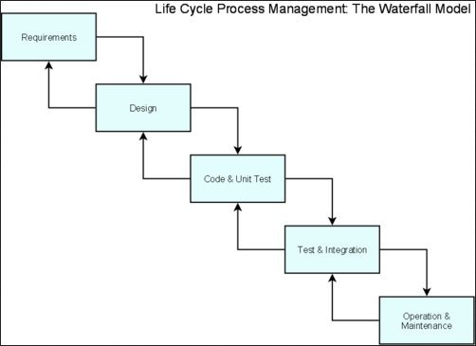

Figure 1 - Waterfall model

- Stages of Waterfall Model explained:
  - Requirement Analysis and Definition: All possible requirements of the system to be developed are captured in this phase. The requirements are gathered from the end user at the start of the software development phase. These requirements are analyzed for their validity, and the possibility of incorporating the requirements in the system to be developed is also studied. Finally, a requirement specification document is created which serves the purpose of guideline for the next phase of the model.
  - System and Software Design: The requirement specifications from the first phase are studied in this phase and a system design is prepared. System design helps in specifying hardware and system requirements and also helps in defining the overall system architecture. The system design specifications serve as an input for the next phase of the model.
  - Implementation and Unit Testing: On receiving system design documents, the work is divided in modules/units and actual coding is started. Each unit is developed and tested for its functionality; this is referred to as unit testing. Unit testing mainly verifies if the modules/units meet their specifications.
  - Integration and System Testing: Units from above phrase are integrated into a complete system during integration phase and tested to check if all modules/units coordinate with each other and the system as a whole behaves as per the specifications. After successfully testing the software, it is delivered to the customer.
  - Operations & Maintenance: Generally, problems with the system developed (which are not found during the development life cycle) come up after its practical use starts, so the issues related to the system are solved after deployment of the system. Not all the problems come into picture directly but they arise from time to time and need to be solved; hence this process is referred to as maintenance.

Roles and Responsibility
Name | Role | Responsibilities
Mr. Nguyen Trong Tai | Project Manager | - Supervise, give project guidance, and clear up team’s queries.  - Review and approve project documents
Vo Phuong Viet Khoi | Team Leader | - Manage team by set up plan.  - Support team members with technical problems.  - Solve problems in communicating among team member.  - Build up team member morale
Doan Gia Huy | Team Member | Developing, testing, customer support flowing project plan given by team leader
Nguyen Huu Thuan | Team Member | Developing, testing, customer support flowing project plan given by team leader
Pham Anh Tu | Team Member | Developing, testing, customer support flowing project plan given by team leader
Figure 2 – Member of Project

Tools and Techniques
- Tool: Visual Studio 2010, SQL Server 2008, JetBrain ReSharper 6, IIS 7, Notepad++
- Front-end technology: ASP.NET 4.0, jQuery, AJAX.
- Programing language: C#, Javacript.
- Architecture: 3-tier MVC3 model
- Object relational mapper: Fluent NHibernate.

Project Management Plan

Tasks
2.3.1.1 Researching:
Description | Do many kind of researching. Include:  - Traditional system research and user’s need research: have many discussions with management board and chairman of all clubs at FPT University; also make survey from other university at HCMC and other provinces via face to face discussion, phone calls and email.  - Technology research: research some technologies will use in this project, such as MVC3, NHibernate, Crystal report…
Deliverables | Project Introduction Report
Resources Needed | 22 man-day
Dependencies and Constrains | Depend on:  - Information from traditional system research.  - User’s need research.  - Project Introduction report template.
Risks | - Some users may not agree to spend time for making survey.  - Strange requirement form users.  - Lack of technologies or chosen technologies are not feasible.
2.3.1.2 Planning:
Description | Divide modules, create work breakdown structure prepare the project plan with task list (duration, predecessors, resources, etc.)
Deliverables | Software Project Management Plan report
Resources Needed | 27 man-day
Dependencies and Constrains | - Depend on the Project Introduction report.  - Project Management Plan report template.  - The result of researching.  - Task schedule must be in 15 weeks.
Risks | - Dividing modules and planning tasks maybe unbalance, and unreasonable.  - In fact, workflow of system may change when implementation.  - Maybe need to update functions list that lead to change schedule.  - Knowledge about technologies and working in group of team is not enough which may lead to fail in keeping schedule.
2.3.1.3 Create Software Requirement Specification:
Description | - Gather requirement from customer.  - Analyze requirements carefully.  - Create all the documents that necessary to describe the system.
Deliverables | Software Requirement Specification (SRS) document.
Resources Needed | 22 man-day
Dependencies and Constrains | - Planning process has to be finished.  - Customer requirements  - Follow the Software Requirement Specification template.
Risks | - All requirements come from team members, so conflicts may happen regularly.  - Misunderstand between user requirements and receiving information from designer may make designing and developing phrases be failed.  - Some customers just describe their requirement in simple way.
2.3.1.4 Designing the Database:
Description | - Create 3 steps in database design:  - Conceptual.  - Logical.  - Physical.
Deliverables | - Database design.  - Database script.  - This part is delivered with Software Design Description (SDD).
Resources Needed | 3 man-day
Dependencies and Constrains | Finish the requirement and specification phrase.
Risks | SRS is not good. It does not describe sufficient all business rules. Therefore, database design:  - Is not appropriate  - Maybe changed much in the future.
2.3.1.5 Designing User Interface:
Description | - Design layouts for each page in the system.  - Design style for each page in the system.  - Design connection between all pages in the system.  - Define some basic Javascript for each file.
Deliverables | Prototype which includes:  - HTML pages.  - CSS files.  - Javascript files.
Resources Needed | 6 man-day
Dependencies and Constrains | - Finish the requirement specification task.  - User Interface must be friendly, easy to see and suitable with all functions in the system and the topic of this project.
Risks | User interface may not completely satisfy all dependencies and constrains above.
2.3.1.6 Creating Software Design Description:
Description | Do architecture design and detailed design.
Deliverables | Software Design Description report
Resources Needed | 8 man-day
Dependencies and Constrains | - Finish Software Requirement Specification report.  - Follow Software Design Description (SDD) report template.
Risks | - SRS may not be detailed enough in other to capture business logic.  - Designing work is not good which lead to occur problem when implement, such as spending much effort for coding, maintaining hard…
2.3.1.7 Create Coding Framework:
Description | - Mapping the architecture design into source code.  - Create project solution files with:  - Common classes  - Common functions
Deliverables | ASP.NET MVC3 project and solution files.
Resources Needed | 6 man-day
Dependencies and Constrains | - Finish Software Design Description (SDD) report.  - Follow coding convention.
Risks | - Having bugs when coding framework.  - Team members do not understand thoroughly framework.  - Problem about coding skill which is not follow coding convention.  - Actual time may be more than estimated time.
2.3.1.8 Website design (Decoration):
Description | Coding GUI for website as User Prototype which done before.
Deliverables | GUI for website
Resources Needed | 6 man-day
Dependencies and Constrains | - Finish Software Design Description (SDD) report.  - Follow coding convention.
Risks | - Having bugs when coding GUI.  - Problem about coding skill which is not follow coding convention.  - Actual time may be more than estimated time.
2.3.1.9 Implementation:
Description | Implement the website based on all requirements and designs.
Deliverables | The whole website of Student Club Management System project.
Resources Needed | 96 man-day
Dependencies and Constrains | - Depend on the completion of SRS, SDD and Database design.  - Follow coding convention.
Risks | - Team members do not understand thoroughly framework.  - Problem about coding skill which is not follow coding convention.  - Behind schedule.  - Unit test completion depend on team member’s skill may require more effort in later testing phrase.
2.3.1.9 Performing System Test:
Description | Do systems test, include:  - Function test  - Performance test
Deliverables | Software Test Documentation (STD) report.
Resources Needed | 12 man-day
Dependencies and Constrains | - Finish coding development.  - Follow Software Test Documentation (STD) report template.
Risks | Team members are both developer and tester could lead to compromise and leak.
2.3.1.10 Deployment and Input Initial Data:
Description | - Deploy the system  - Input initial data for the system
Deliverables | Complete Student Club Management System project source code, up-to-date all documentations.
Resources Needed | 8 man-day
Dependencies and Constrains | Finish System testing.
Risks | - Update all documentations may need more time than schedule.  - Team members may not familiar with input consistent data for all tables in database.  - The program is not running properly in real environment.  - Cannot release before the deadline.
2.3.1.11 Creating Software User’s Manual:
Description | Create User’s manual.
Deliverables | Software User’s Manual (SUM) report.
Resources Needed | 16 man-day
Dependencies and Constrains | - Finish Deployment process.  - Follow Software User’s Manual (SUM) report template.
Risks | - User’s manual may be not easy to understand with the customer.  - Team members may be not familiar with crating user’s manual which leads to behind schedule.
Figure 3 – Main Tasks of Project

Task Sheet: Assignments and Timetables
Task Name | Duration | Star Date | End Date | Resource
Researching | 5.5 days | Tue 11/09/2012 | Tue 18/09/2012 | KhoiVPV, HuyDG, ThuanNH, TuPA
Planning | 6.75 days | Tue 18/09/2012 | Thu 27/09/2012 | KhoiVPV
Software Requirement Specification | 5.5 days | Thu 27/09/2012 | Thu 4/10/2012 | KhoiVPV, HuyDG, ThuanNH, TuPA
Designing the Database | 1.5 days | Tue 09/10/2012 | Thu 11/10/2012 | KhoiVPV, ThuanNH
Design User Interface | 3 days | Tue 09/10/2012 | Fri 12/10/2012 | HuyDG, TuPA
Creating Software Design Description | 3 days | Thu 11/10/2012 | Tue 16/10/2012 | KhoiVPV, HuyDG, ThuanNH, TuPA
Create coding framework | 3 days | Fri 19/10/2012 | Wed 24/10/2012 | KhoiVPV, ThuanNH
Website design (Decoration) | 3 days | Fri 19/10/2012 | Wed 24/10/2012 | HuyDG, TuPA
Implementation | 29 days | Wed 24/10/2012 | Tue 04/12/2012 | KhoiVPV, HuyDG, ThuanNH, TuPA
Performing system test | 3 days | Tue 04/12/2012 | Fri 07/12/2012 | KhoiVPV, HuyDG, ThuanNH, TuPA
Deployment and input initial data | 2 days | Fri 07/12/2012 | Tue 11/12/2012 | KhoiVPV, HuyDG, ThuanNH, TuPA
Creating Software User’s Manual | 4 days | Tue 27/09/2012 | Mon 11/12/2012 | KhoiVPV, HuyDG, ThuanNH, TuPA
Figure 4 – Task Sheet

Coding Convention
- Reference coding convention statement at:
  - http://csharpguidelines.codeplex.com/
  - http://msdn.microsoft.com/en-us/library/vstudio/ff926074.aspx

Report No.3: Software Requirements Specifications (SRS)

User Requirement Specification
- Student Club Management System facilitates student club management’s process by dividing management role and access role into seven parts for seven types of user in the system.
- Guests can register to become User in the system. Guests also can do search function.
- Users can login into the system to edit their profile, search club, search event, comment for events. Moreover, they can send requests for joining into clubs which they want. Besides, Users also can retrieve their password when they forget it.
- When Users becomes club’s members, they can manage articles for each event in their club.
- If club’s member is upgraded into club’s chairman, of course will have more authorization in the system. Chairman of clubs can approve or reject request for joining into their clubs from Users. They also can eliminate club’s members out of their clubs. Besides, they are authorized to manage event, finance in their clubs. In addition, the system also supports club’s chairman to view and export some reports about trend of finance and member in their clubs.
- The Members of the Management Board are inherited authorization form the club’s chairman with additional functions such as sending request for create new club.
- The President is delegated powers to manage list of the members of the management board. He or she also can approve or reject request for create new club which sent from the members of the management board.
- Admin of the system is inherited authorization from Users with additional functions such as import student list or delete account out of the system.

System Requirement Specification

External Interface Requirement

User Interfaces
- User can interact with the system and other users through the user interface. Below are screens available for users:

Screen Name | Function
Register Screen | Allow actor (Guest) to register
Home Screen | Allow all actors view Home Screen
Forget Password Screen | Allow actors (except Guest) to get password
Edit Profile Screen | Allow actors (except Guest) to edit profile
Manage Send Request Join Club Screen | Allow actor (User) to request join club
Manage Send Request Create Club Screen | Allow actor (MMB) to request new club
Manage Request Join Club Screen | Allow actor (CC) to manage request join club
Manage Request Create Club Screen | Allow actor (President) to manage request create club
View Club Screen | Allow all actors to view club
Manage Club Screen | Allow actor (President) to manage club
Manage Member Of CC Screen | Allow actor (CC) to manage member
Manage Member Of MMB Screen | Allow actor (MMB) to manage member
Manage MMB Screen | Allow actor (President) to manage MMB
Manage President Screen | Allow actor (Admin) to manage President
Manage Account Screen | Allow actor (Admin) to manage account
Search Screen | Allow all actors to view search result
View Event Screen | Allow all actors to view event
Create Event Screen | Allow actor (CC) to create event
Edit Event Screen | Allow actor (CC) to edit event
View Article Screen | Allow all actors to view article
Create Article Screen | Allow actors (CC, CM) to create article
Edit Article Screen | Allow actors (CC, CM) to edit article
Approve Article Screen | Allow actor (CC) to approve article
Income Screen | Allow actor (CC) to manage finance
Month Fees Screen | Allow actor (CC) to manage finance
Other Fees Screen | Allow actor (CC) to manage finance
Estimated Expend Screen | Allow actor (CC) to manage finance
Actual Expend Screen | Allow actor (CC) to manage finance
View Total Income & Expend Report Screen | Allow actors (CM, CC, MMB, President) to view report
View Income In Club Report Screen | Allow actors (CM, CC, MMB) to view report
View Event Report Screen | Allow actors (User, CM, CC, MMB, President) to view report
View Member Report Screen | Allow actors (User, CM, CC, MMB, President) to view report
Figure 5 – User Interfaces

Hardware Interfaces
- Network cable, network interface card

Hardware Interfaces
- N/A

Hardware Interfaces
- N/A

System Features
- This section includes all features which Student Club Management System will support for users to interact and manage student clubs system more efficient. There are seven kinds of users who will interact directly with the system

Actor | Description
Guest | The person who does not login into the system.
User | The person who registered and is logging into the system.
Club’s Member (CM) | The person who has joined a particular club.
Club’s Chairman (CC) | The person who leads a club.
Member of the Management Board (MMB) | The person who is a representative of the President and responsibility for managing one or more clubs in the university.
President | The person who is in charge of managing all members of the management board.
Admin | The person who is responsibility for managing the whole system.
Figure 6 – Actor Description
- The overall use case model of Student Club Management application:

- The whole system functions will be divided into four main group functions. Those are:
  - User Management.
  - Activity Management.
  - Finance Management.
  - Supporting Tools for User.
- Details of each group functions will be presented in succession below.

User Management

Use Case 001 - Register

USE CASE-001 SPECIFICATION

Use-case No. | <UC001> | Use-case Version |  | <1.0>
Use-case Name | Register
Author | KhoiVPV
Date | 19/09/2012 | Priority | Normal
Actor: Guest
Summary: This use case is about allowing Guest to create an account in the system.
Goal: Help Guest can have an account in the system.
Triggers: Guest needs an account to login in to the system in other to have more authorization in the system.
Preconditions: Guest clicks on “Đăng Kí” link.
PostConditions: A new account is crated in the system. This account is User account type.
Main Success Scenario:
Actors action  - Guest clicks on “Đăng Kí” link | System Response
 | - Display “Register” screen with text box for Guest to type all necessary info for creating new account.
- Guest inputs all required fields.
 | - Validate all input data. Send invalid message (if have).
- Correct all invalid fields (if have)
- Guest clicks on “Đồng Ý” button
- System creates new account for Guest.
- Redirect to Login page.
Alternative Scenario: N/A
Exceptions:
- When database connection has problem, the system will ask user for trying again.
Relationships: N/A
Business Rules:
- Guest must enter all required fields before submitting.
- Each registering, Guest can create one account in the system.
- Each account in the system is distinguished by email address which assumes as username.
- When Email fields of the new account are as same as the existing ones, the system will show invalid message.

Use Case 002 - Login

USE CASE-002 SPECIFICATION

Use-case No. | <UC002> | Use-case Version |  | <1.0>
Use-case Name | Login
Author | KhoiVPV
Date | 19/09/2012 | Priority | Normal
Actor: User, CM, CC, MMB, President, Admin
Summary: This use case is about allowing all people who have an account can login into the system.
Goal: Allow user can login into the system.
Triggers: Each types of account are authorized for do some functions. Therefore, user needs to login into the system with their role for doing delegated functions.
Preconditions: User must have an account in the system.
PostConditions: User can login into the system with power suitable for their account’s types.
Main Success Scenario:
Actors action | System Response
- User clicks on “Đăng nhập” link and types email and password and then click on “Đăng Nhập” button.
- Validate all input data.
- System show invalid email or password message. (if have)
- User retypes correct email and password and clicks on “Đăng Nhập” button. (if have)
- Validate all input data.
- Login successfully and link user to “Home” page.
Alternative Scenario: N/A
Exceptions:
- When database connection has problem, the system will ask user for trying again.
Relationships: N/A
Business Rules:
- User must type correct email and password for login successfully.

Use Case 003 – Forget Password

USE CASE-003 SPECIFICATION

Use-case No. | <UC003> | Use-case Version |  | <1.0>
Use-case Name | Forget Password
Author | KhoiVPV
Date | 19/09/2012 | Priority | Normal
Actor: User, CM, CC, MMB, President, Admin
Summary: This use case is about generating new password for person who has account in the system.
Goal: User can get new password in his or her email.
Triggers: User maybe forget password because of many reasons, such as setting complex password, having so much accounts and so on.
Preconditions: User has account in the system.
PostConditions: New password is sent to user’s email which user used to register account.
Main Success Scenario:
Actors action  - User click on “Quên Mật Khẩu” link  - User input his or her email. | System Response  - Display “Forget Password” screen with text box for user to type his or her email which resisted when create account.  - Validate all input data.  - Show incorrect message for each invalid value (if have).
- User corrects all invalid value (if have).
- User clicks on “Gửi Mật Khẩu Qua Email” button
 | - System generates new password for user in database and send it to user‘s email.
Alternative Scenario: N/A
Exceptions:
- When database connection has problem, the system will ask user for trying again.
Relationships: N/A
Business Rules:
- User must register an account before doing this function.
- User must enter email to field and solve input errors before submitting.

Use Case 004 – Edit Profile

USE CASE-004 SPECIFICATION

Use-case No. | <UC004> | Use-case Version |  | <1.0>
Use-case Name | Edit Profile
Author | KhoiVPV
Date | 19/09/2012 | Priority | Normal
Actor: User, CM, CC, MMB, President, Admin
Summary: This use case is about allowing user to edit his or her profile.
Goal: User can edit his or her profile.
Triggers: User wants to change some his or her profile’s information, such as phone number, address...
Preconditions: User logon with his or her role.
PostConditions: New profile of user is updated.
Main Success Scenario:
Actors action  - User logon to the system with his or her role. | System Response
- User clicks “Thông Tin Cá Nhân” link
 | - Show “Edit Profile” screen.
- User changes value at allowed fields
- Validate all input data.
- Show incorrect messages for each invalid value (if have).
- User correct all invalid value (if have).
- User clicks on “Lưu” button
 | - New profile of user is updated in database.
 | - Redirect to Home page.
Alternative Scenario: N/A
Exceptions:
- When database connection has problem, the system will ask user for trying again.
Relationships: N/A
Business Rules:
- User must login into the system for doing this function.
- User only can edit profile of himself or herself.
- User must enter valid value for every field which user wants to change before submitting.

Use Case 005 – Send Request Join Club

USE CASE-005 SPECIFICATION

Use-case No. | <UC005> | Use-case Version |  | <1.0>
Use-case Name | Send request join club.
Author | KhoiVPV
Date | 19/09/2012 | Priority | Normal
Actor: User
Summary: This use case is about allowing User to send request for joining into club.
Goal: Send request for joining into club.
Triggers: Want to become member of a club.
Preconditions: User logon with “User” role. User send request for joining into club to CC.
PostConditions:
- Request for joining into club is created and sent to CC.
- The sending request has Pending status.
Main Success Scenario:
Actors action  - User logon to the system with “User” role. | System Response
- User click on “Gửi Yêu Cầu Gia Nhập CLB” on menu.
 | - Show “Manage Send Request Join Club” screen.
- User searches club that wants to join and clicks on “Gửi” button.
- System will create new request with status Pending and send it to CC of that club.
- Show that request with it status on that page.
Alternative Scenario: N/A
Exceptions:
- When database connection has problem, the system will ask user for trying again.
Relationships: N/A
Business Rules:
- Once User sent request but CC has not approved or rejected, then User can delete that request.
- User account in this case including:
  - MMB in the system.
  - CC of other club.
  - CM of other club.
  - User

Use Case 006 – Delete Request Join Club

USE CASE-006 SPECIFICATION

Use-case No. | <UC006> | Use-case Version |  | <1.0>
Use-case Name | Delete request join club.
Author | KhoiVPV
Date | 19/09/2012 | Priority | Normal
Actor: User
Summary: This use case is about allowing User to delete request for joining into club.
Goal: Delete request for joining into club.
Triggers: Do not want to become member of a club.
Preconditions: User logon with “User” role. User send request for joining into club to CC. However, CC has not approved or rejected this request.
PostConditions:
- Request for joining into club is deleted and CC cannot see this request any more.
- The deleted request has Cancelled status.
Main Success Scenario:
Actors action  - User logon to the system with “User” role. | System Response
- User clicks on “Gửi Yêu Cầu Gia Nhập CLB” on menu.
 | - Show “Manage Send Request Join Club” screen.
- User clicks on “Xóa” button next to request which User has sent.
- User clicks “Đồng Ý” button on confirm delete message.
- System will update status of this request into Canceled.
- Show new status of request on that page.
Alternative Scenario: N/A
Exceptions:
- When database connection has problem, the system will ask user for trying again.
Relationships: N/A
Business Rules:
- Once User sent request but CC has not approved or rejected, then User can delete request for joining into that club. However, when User decides to delete this request, User cannot resubmit it again.
- User account in this case including:
  - MMB in the system.
  - CC of other club.
  - CM of other club.
  - User

Use Case 007 – Update Request Join Club – Approve Member

USE CASE-007 SPECIFICATION

Use-case No. | <UC007> | Use-case Version |  | <1.0>
Use-case Name | Approve Member
Author | KhoiVPV
Date | 19/09/2012 | Priority | Normal
Actor: CC
Summary: This use case is about allowing CC to approve request for joining into club.
Goal: Approve request for joining into club.
Triggers: Need to have more clubs’ members.
Preconditions:
- CC logon with “CC” role.
- User sent request for joining into club to CC.
- The sending request has Pending status.
PostConditions:
- The User becomes member of that club.
- The sending request has Approved status.
Main Success Scenario:
Actors action  - CC logon to the system with “CC” role. | System Response
- CC clicks on “Quản Lý Yêu Cầu Gia Nhập Câu Lạc Bộ” on menu.
 | - Show “Manage Request Join Club” screen.
- CC clicks on “Duyệt” button next to request which CC want to approve.
- System will insert that User into this club as new member of that club. Request status is changed to Approved.
- Request status is updated on table for CC to manage.
Alternative Scenario: N/A
Exceptions:
- When database connection has problem, the system will ask user for trying again.
Relationships: N/A
Business Rules: Once CC approves that request, he or she cannot change request status to Rejected.

Use Case 008 – Update Request Join Club – Reject Member

USE CASE-008 SPECIFICATION

Use-case No. | <UC008> | Use-case Version |  | <1.0>
Use-case Name | Reject Member
Author | KhoiVPV
Date | 19/09/2012 | Priority | Normal
Actor: CC
Summary: This use case is about allowing CC to reject request for joining into club.
Goal: Reject request for joining into club.
Triggers: Do not want that User become club’s member.
Preconditions:
- CC logon with “CC” role.
- User sent request for joining into club to CC.
- The sending request has Pending status.
PostConditions:
- The User does not become member of that club.
- The sending request has Rejected status.
Main Success Scenario:
Actors action  - CC logon to the system with “CC” role. | System Response
- CC click on “Quản Lý Yêu Cầu Gia Nhập CLB” on menu.
 | - Show “Manage Request Join Club” screen.
- CC clicks on “Từ chối” button next to request which CC does not want to approve.
- CC clicks on “Đồng ý” on confirm reject message.
- System will not insert that User into club as new member of that club. Request status is changed to Rejected.
- Update request status on table for CC to manage.
Alternative Scenario: N/A
Exceptions:
- When database connection has problem, the system will ask user for trying again.
Relationships: N/A
Business Rules: Once CC rejects that request, he or she cannot change request status to Reapproved.

Use Case 009 – Manage Member Function for CC

USE CASE-009 SPECIFICATION

Use-case No. | <UC009> | Use-case Version |  | <1.0>
Use-case Name | Manage member function for CC
Author | KhoiVPV
Date | 19/09/2012 | Priority | Normal
Actor: CC
Summary: This use case is about allowing CC to fire a club’s member out of his or her club.
Goal: Dismissing a club’s member.
Triggers: Need to fire a club’s member because of many reasons, such as breaking club regulations or not have time to participate in this group anymore….
Preconditions: CC logon with “CC” role.
PostConditions: That member does not belong to this club anymore.
Main Success Scenario:
Actors action  - CC logon to the system with “CC” role. | System Response
- CC clicks on “Quản Lý Thành Viên CLB” on menu.
 | - Show “Manage Member Of CC” screen.
- CC search CM account and clicks on “Loại Bỏ” button next to email/name of the CM who CC wants to dismiss.
- System will update in the database to make that member not belong to this club anymore.
- Do not show that CM account on this page.
Alternative Scenario: N/A
Exceptions:
- When database connection has problem, the system will ask user for trying again.
Relationships: N/A
Business Rules:
- If the CM who is dismissed does not play any other role in other club, he or she will become User Actor.
- When CC fired a CM successfully, CC cannot undo that action.
- If the fired member wants to participate in that club again, the fired one need to send request for joining into club and wait for approval from CC.

Use Case 010 – Manage Member Function for MMB

USE CASE-010 SPECIFICATION

Use-case No. | <UC010> | Use-case Version |  | <1.0>
Use-case Name | Manage member function for MMB
Author | KhoiVPV
Date | 19/09/2012 | Priority | Normal
Actor: MMB
Summary: This use case is about allowing MMB to find new CC for a club. Including:
- Edit current CC into CM.
- Edit CM into new CC.
Goal: Allow MMB changes two positions above in a club which belongs to MMB’s management.
Triggers: Some time CC positions in are need to be changed.
Preconditions: MMB logon with “MMB” role.
PostConditions:
- CC becomes CM in that club.
- CM becomes new CC in that club.
Main Success Scenario:
Actors action  - MMB logon to the system with “MMB” role. | System Response
- MMB click on “Quản Lý Chủ Nhiệm CLB” on menu.
 | - Show “Mange Member Of MMB” screen.
- MMB searches club that wants to change CC.
- MMB searches account that wants to become new CC in that club.
- MMB clicks on “Nâng quyền” button.
- System will update the database to make
  - Current CC becomes CM
  - CM becomes new CC.
 | - Show info of new CC on that club for MMB to manage.

Alternative Scenario: N/A
Exceptions:
- When database connection has problem, the system will ask user for trying again.
Relationships: N/A
Business Rules:
- If CC does not want to play as CC or CM of that club, MMB will use this function to change position of CC into CM of that club. After that, MMB will upgrade one CM into CC. Then, the new CC will use “Manage Member Function for CC” to dismiss the old CC out of that club.
- When MMB search account for new CC position, the system will show all CC account in other club, CM account in other club, account in that club and User account in the system for MMB to choose.
  - If MMB chooses CM account in that club, that CM will become CC of that club and the old CC will become CM of that club.
  - If MMB chooses CC of other club or CM of other club or User, the system will make those CC or CM or User become CM of this club and approver is MMB account. Finally, the system will upgrade the new CM become the new CC and change old CC become CM of this club.
  - If MMB chooses a User account that sent request for joining this club, but has not been approved, the system will approve this request to makes that account become CM of this club automatically and the approver is MMB account. Finally, the system will upgrade the new CM become the new CC and the old CC become CM of this club.

Use Case 011 – Send Request Create Club

USE CASE-011 SPECIFICATION

Use-case No. | <UC011> | Use-case Version |  | <1.0>
Use-case Name | Send request create club.
Author | KhoiVPV
Date | 19/09/2012 | Priority | Normal
Actor: MMB
Summary: This use case is about allowing MMB to send request for creating new club.
Goal: Send request for creating new club.
Triggers: Need to create new club.
Preconditions:
- MMB logon with “MMB” role. MMB send request for creating new club to President. The request includes some required information about:
  - MMB of club (also the person who send this request).
  - CC (An existing User account or a CC/CM of an existing club. Not include account that is both MMB and CM).
  - Club name
  - Description.
  - Rules
PostConditions:
- Request for create new club is created and sent to President.
- The sending request has Pending status.
- A new club is created with Pending status.
Main Success Scenario:
Actors action  - MMB logon to the system with “MMB” role. | System Response
- MMB clicks on “Gửi Yêu Cầu Tạo CLB” on menu.
 | - Show “Manage Send Request Create Club” screen.
- MMB fills required fields.
- Validate all fields.
- Send incorrect messages for each invalid field (if have).
- MMB corrects all invalid fields (if have).
- MMB clicks on “Gửi” button.
- System will create new request with status Pending and send it to President.
- A new club is created with Pending status.
- Show successful message to MMB.
Alternative Scenario: N/A
Exceptions:
- When database connection has problem, the system will ask user for trying again.
Relationships: N/A
Business Rules:
- Once MMB sent request but the President has not approved or rejected, then MMB can delete that request.
- Club name is not as same as any existing club name in database.

Use Case 012 – Delete Request Create Club

USE CASE-012 SPECIFICATION

Use-case No. | <UC012> | Use-case Version |  | <1.0>
Use-case Name | Delete request create club.
Author | KhoiVPV
Date | 19/09/2012 | Priority | Normal
Actor: MMB
Summary: This use case is about allowing MMB to delete request for creating new club.
Goal: Delete request for create new club.
Triggers: Need to delete request for creating new club.
Preconditions:
- MMB logon with “MMB” role. MMB sent request for creating new club to President. The request includes some required information about:
  - MMB of club (also the person who send this request).
  - CC (An existing User account or a CC/CM of an existing club. Not include account that is both MMB and CM).
  - Club name
  - Description.
  - Rules
- When the President has not approved or rejected that request, MMB can delete it.
PostConditions:
- Request for creating new club is deleted out of the system and does not show for the President to view.
- The sending request has Cancelled status.
- Status of club which was created when MMB sent request will be changed into Inactive status.
Main Success Scenario:
Actors action  - MMB logon to the system with “MMB” role. | System Response
- MMB clicks on “Hủy Yêu Cầu Tạo CLB” on menu.
 | - Show “Manage Send Request Create Club” screen.
- MMB clicks on “Hủy” button next to the request which MMB wants to delete.
- MMB clicks “Đồng Ý” button on confirm delete message.
- System will delete that request and do not show it to the President any more. That request will have Cancelled status on the database.
- The club which was created when MMB sent request will have Inactive status.
- Show successful message to MMB.
Alternative Scenario: N/A
Exceptions:
- When database connection has problem, the system will ask user for trying again.
Relationships: N/A
Business Rules: Once MMB sent request but the President has not approved or rejected, then MMB can delete request for create new club. However, when MMB decides to delete that request, it will have Cancelled status and MMB cannot resubmit it again.

Use Case 013 – Update Request Create Club – Approve Club

USE CASE-013 SPECIFICATION

Use-case No. | <UC013> | Use-case Version |  | <1.0>
Use-case Name | Approve club.
Author | KhoiVPV
Date | 19/09/2012 | Priority | Normal
Actor: President
Summary: This use case is about allowing President to approve request for creating the new club.
Goal: Approve request for creating the new club.
Triggers: Need to create a new club.
Preconditions:
- President logon with “President” role. MMB sent request for creating the new club to President. The request includes some required information about:
  - MMB of club (also the person who send this request).
  - CC (An existing User account or a CC/CM of an existing club. Not include account that is both MMB and CM).
  - Club name
  - Description.
  - Rules
- The sending request has Pending status.
PostConditions:
- The club which was created when MMB sent request will have Active status.
- The new club has MMB and CC that listed in the request and attached information.
- The sending request has Approved status.
Main Success Scenario:
Actors action  - President logon to the system with “President” role. | System Response
- President clicks on “Quản Lý Yêu Cầu Tạo CLB” on menu.
 | - Show “Manage Request Create Club” screen.
- President clicks on “Duyệt” button next to request which pPresident want to approve.
- Status of club will be changed into Active.
- Request status is changed to Approved.
- Status of that request is updated in table for President to manage.
Alternative Scenario: N/A
Exceptions:
- When database connection has problem, the system will ask user for trying again.
Relationships: N/A
Business Rules: Once President approves club, he or she cannot change request status to Rejected.

Use Case 014 – Update Request Create Club – Reject Club

USE CASE-014 SPECIFICATION

Use-case No. | <UC014> | Use-case Version |  | <1.0>
Use-case Name | Reject club.
Author | KhoiVPV
Date | 19/09/2012 | Priority | Normal
Actor: President
Summary: This use case is about allowing President to reject request for creating the new club.
Goal: Reject request for creating the new club.
Triggers: Need to reject creating the new club.
Preconditions:
- President logon with “President” role. MMB sent request for creating the new club to President. The request includes some required information about:
  - MMB of club (also the person who send this request).
  - CC (An existing User account or a CC/CM of an existing club. Not include account that is both MMB and CM).
  - Club name
  - Description.
  - Rules
- The sending request has Pending status
PostConditions:
- The club which was created when MMB sent request will have Inactive status. So, MMB and CC account attached when create request will not become MMB and CC of that club.
- Request status is changed to Rejected.
Main Success Scenario:
Actors action  - President logon to the system with “President” role. | System Response
- President clicks on “Quản Lý Yêu Cầu Tạo Câu Lạc Bộ” on menu.
 | - Show “Manage Request Create Club” screen.
- President clicks on “Từ Chối” button next to request which President wants to reject.
- President clicks on “Đồng Ý” on confirm reject message.
- Club’s status is updated into Inactive status.
- The request status is updated to Rejected status.
- Status of request is updated in table for President to manage.
Alternative Scenario: N/A
Exceptions:
- When database connection has problem, the system will ask user for trying again.
Relationships: N/A
Business Rules: Once President decides to reject request, he or she cannot reapprove that request.

Use Case 015 – Manage List of MMB – Create MMB

USE CASE-015 SPECIFICATION

Use-case No. | <UC015> | Use-case Version |  | <1.0>
Use-case Name | Create MMB.
Author | KhoiVPV
Date | 19/09/2012 | Priority | Normal
Actor: President
Summary: This use case is about allowing President to create the new MMB in the system.
Goal: President can create MMB account type for the system.
Triggers: Need to have the new MMB.
Preconditions: President logon with “President” role.
PostConditions: The system has the new MMB who not to manage any club.
Main Success Scenario:
Actors action  - President logon to the system with “President” role. | System Response
- President clicks on “Tạo TV Ban Quản Trị” screen.
 | - Show “Create MMB” screen.
- President clicks on “Tìm Kiếm” button.
 | - Show pop-up for President to search suitable account.
- President ticks on an account that President wants it to become the new MMB.
- President clicks on “Chọn Tài Khoản” button on pop-up.
- President clicks on “Nâng Quyền” button.
 | - The existing account is upgraded into MMB account in the database.
Alternative Scenario: N/A
Exceptions:
- When database connection has problem, the system will ask user for trying again.
Relationships: N/A
Business Rules:
- Accounts that are shown on Search pop-up include:
  - User account who has registered and has not upgraded into CM/CC/MMB/President/Admin.
  - If that User account has sent request for joining in a club and that request has Pending status, that User will not be shown on pop up.
- President should assign the new MMB to manage one or some clubs.

Use Case 016 – Manage List of MMB – Delete MMB

USE CASE-016 SPECIFICATION

Use-case No. | <UC016> | Use-case Version |  | <1.0>
Use-case Name | Delete MMB.
Author | KhoiVPV
Date | 19/09/2012 | Priority | Normal
Actor: President
Summary: This use case is about allowing President to dismiss MMB out of his or her position.
Goal: Dismiss MMB out of its position.
Triggers: Need for dismiss MMB out of its position.
Preconditions: President logon with “President” role.
PostConditions:
- The old MMB is dismissed out of the management board.
- The clubs which belong to that MMB will have other MMBs.
- All requests for creating new club which sent by this MMB will be rejected.
Main Success Scenario:
Actors action  - President logon to the system with “President” role. | System Response
- President clicks on “Loại Bỏ TV Ban Quản Trị” on menu.
 | - Show “Delete MMB” screen.
- President searches MMB account that wants to delete.
 | - Show the MMB that President searched.
- President clicks “Xóa” button next to that account.
- President clicks on “Đồng ý” button on confirm delete message.
- System will update in the database.
  - The old MMB will become User.
  - All requests for creating new clubs which sent by this MMB will be deleted.
 | - Do not show that MMB on table in this page.
Alternative Scenario: N/A
Exceptions:
- When database connection has problem, the system will ask user for trying again.
Relationships: N/A
Business Rules:
- To sure every clubs in the system will have a MMB every time, when President wants to dismiss a MMB out of his or her position, the system will show pop-up for President to choose other existing MMB in the system for each club which belongs to the dismissed MMB. President must change MMB for those entire clubs until that MMB does not manage any club in order to dismiss that MMB.
- If President wants to assign those clubs which belongs to the dismissed MMB to an account that has not been upgraded to MMB, President will create the new MMB after do this function and then update new MMB for each club in Edit Club function.

Use Case 017 – Manage Club – Edit Club

USE CASE-017 SPECIFICATION

Use-case No. | <UC017> | Use-case Version |  | <1.0>
Use-case Name | Edit club.
Author | KhoiVPV
Date | 19/09/2012 | Priority | Normal
Actor: President
Summary: This use case is about allowing President to Edit important information of a club, include:
- Basic information of club:
  - Club’s name.
  - Description.
  - Rules.
- MMB of that club.
Goal: Allow President change two types of information about a club as above.
Triggers: Some time basic information of club is need to be changed. MMB of club also need to be changed.
Preconditions: President logon with “President” role.
PostConditions:
- Basic information of club is updated.
- Club has new MMB.
Main Success Scenario:
Actors action  - President logon to the system with “President” role. | System Response
- President clicks on “Quản Lý CLB” on menu.
 | - Show “Manage Club” screen.
- President clicks on “Sửa” button next to club’s name.
 | - Show “Edit Club”screen.
 | - Show all fields about that club for President to edit.
- President fills all fields which want to change.
- Validate all input data format.
- Show incorrect messages for each invalid field (if have).
- President corrects all invalid fields (if have)
- President clicks on “Lưu Thay Đổi” button.
  - All basic information of club will be updated in the database.
  - MMB of club will be updated.
 | - Redirect to “Quản Lý CLB” screen with data is updated.
Alternative Scenario: N/A
Exceptions:
- When database connection has problem, the system will ask user for trying again.
Relationships: N/A
Business Rules:
- User must enter valid value for every filed before submitting.

Use Case 018 – Manage Club – Delete Club

USE CASE-018 SPECIFICATION

Use-case No. | <UC018> | Use-case Version |  | <1.0>
Use-case Name | Delete club.
Author | KhoiVPV
Date | 19/09/2012 | Priority | Normal
Actor: President
Summary: This use case is about allowing President to delete a club out of the system.
Goal: Delete a club out of the system.
Triggers: Need to delete a club out of the system.
Preconditions: President logon with “President” role.
PostConditions: When a club is deleted out of the system, then the following information will not belong to that club:
- MMB.
- CC.
- All CMs.
- All Pending requests for joining into this club.
Main Success Scenario:
Actors action  - President logon to the system with “President” role. | System Response
- President clicks on “Quản Lý CLB” on menu.
 | - Show “Manage Club” screen.
- President searches club that wants to delete.
 | - Show the club that President searched.
- President clicks button “Loại Bỏ” next to that club.
- President click on “Đồng ý” button on confirm delete pop up.
- System will update in the database.
  - That club has Inactive status.
  - Current MMB does not belong to that club.
  - Current CC does not belong to that club.
  - Current CMs do not belong to that club.
  - All Pending requests for joining into that club has Rejected status.
 | - Update data of table in that page.
Alternative Scenario: N/A
Exceptions:
- When database connection has problem, the system will ask user for trying again.
Relationships: N/A
Business Rules:
- When CC or CM is participating only in deleted club:
  - CC will become User.
  - CM will become User.
- MMB is managing only in deleted club: he or she is still at his or her current position and wait for managing other club.
- All Pending requests which sent for asking to join this club will have Rejected status.

Use Case 019 – Manage President – Create President

USE CASE-019 SPECIFICATION

Use-case No. | <UC019> | Use-case Version |  | <1.0>
Use-case Name | Create President.
Author | KhoiVPV
Date | 19/09/2012 | Priority | Normal
Actor: Admin.
Summary: This use case is about allowing Admin to create the new President in the system.
Goal: Admin can create President account type for the system.
Triggers: Need to have the new President.
Preconditions:
- Admin logon with “Admin” role.
- There is an existing User account type or MMB account type for Admin to choose.
PostConditions:
- The system has the new President.
- The old President is dismissed out of his or her position.
Main Success Scenario:
Actors action  - Admin logon to the system with “Admin” role. | System Response
- Admin go to “Quản Lý Chủ Tịch” screen.
 | - Show “Manage President” screen.
- Admin click on “Tìm kiếm” button.
 | - Show pop-up of all user account type and MMB account type for Admin to choose.
- Admin choose an account that he or she want to become the new President and clicks on “Chọn Tài Khoản” button on pop-up.
- Admin clicks on “Bổ Nhiệm” button.
- The existing account is upgraded into President account type in the database.
- The old President is dismissed out of his or her position.
Alternative Scenario: N/A
Exceptions:
- When database connection has problem, the system will ask user for trying again.
Relationships: N/A
Business Rules:
- Upgrading an account into President is done by upgrading two kinds of below accounts:
  - User account who has not become CM/CC/Admin and does not have any request join club with status Pending.
  - MMB account that has not managed any club currently and has not played as CM in any club.

Use Case 020 – Manage President – Delete President

USE CASE-020 SPECIFICATION

Use-case No. | <UC020> | Use-case Version |  | <1.0>
Use-case Name | Delete President.
Author | KhoiVPV
Date | 19/09/2012 | Priority | Normal
Actor: Admin
Summary: This use case is about allowing Admin to dismiss President out of his or her position.
Goal: Dismiss President out of its position.
Triggers: Need for dismiss President out of its position.
Preconditions: Admin logon with “Admin” role.
PostConditions:
- The old President is dismissed out of his or her position and becomes User account.
- The new President is created in the system.
Main Success Scenario:
Actors action  - Admin logon to the system with “Admin” role. | System Response
- Admin go to “Quản Lý Chủ Tịch” screen.
 | - Show “Manage President” screen.
- Admin clicks “Tìm kiếm” button.
 | - System show pop-up with suitable account for President position.
- Admin choose account and clicks “Chọn Tài Khoản” on pop-up
- Admin clicks on “Bổ nhiệm” button.
- System will update in the database.
  - The old President will become User.
  - The system has the new President.
Alternative Scenario: N/A
Exceptions:
- When database connection has problem, the system will ask user for trying again.
Relationships: N/A
Business Rules:
- The old President after dismissed will become User in the system.
- The search result shown for Admin includes
  - User account who has not become CM/CC/Admin and does not have any request join club with status Pending.
  - MMB account that has not managed any club currently and has not played as CM in any club.

Use Case 021 – Delete Account

USE CASE-021 SPECIFICATION

Use-case No. | <UC021> | Use-case Version |  | <1.0>
Use-case Name | Delete account.
Author | KhoiVPV
Date | 19/09/2012 | Priority | Normal
Actor: Admin
Summary: This use case is about allowing Admin to delete User account who
- Does not keep any role in club such as CC/CM.
- Does not keep any role in The Manage Board such as MMB/President.
Goal: Delete those accounts out of the system.
Triggers: Need for delete those accounts out of the system.
Preconditions: Admin logon with “Admin” role.
PostConditions: That User account is deleted out of the system.
Main Success Scenario:
Actors action  - Admin logon to the system with “Admin” role. | System Response
- Admin clicks on “Quản Lý Tài Khoản” on menu.
 | - Show “Manage Account” screen.
- Admin searches account that wants to delete.
 | - Show the account that Admin searched.
- Admin click button “Loại Bỏ” next to that account.
- Admin click on “Đồng Ý” button on the comfirm delete message.
 | - System will update in the database for deleting that User account out of the system.
 | - Data in table of that page is updated.
Alternative Scenario: N/A
Exceptions:
- When database connection has problem, the system will ask user for trying again.
Relationships: N/A
Business Rules: When Admin delete an account that has requests join club with Pending status, those requests will be updated into Rejected status.

Use Case 022 – Edit Account

USE CASE-022 SPECIFICATION

Use-case No. | <UC022> | Use-case Version |  | <1.0>
Use-case Name | Edit account.
Author | KhoiVPV
Date | 19/09/2012 | Priority | Normal
Actor: Admin
Summary: This use case is about allowing Admin to edit five types of account in the system. Those are:
- President account.
- MMB account.
- CC account.
- CM account.
- User account.
Goal: Edit email of account.
Triggers: Need for edit email of account.
Preconditions: Admin logon with “Admin” role.
PostConditions:
- Email of account is updated.
- New password is generated and sent to new account email. Then, it is encrypted and updated in database.
Main Success Scenario:
Actors action  - Admin logon to the system with “Admin” role. | System Response
- Admin clicks on “Quản Lý Tài Khoản” on menu.
 | - Show “Manage Account” screen.
- Admin searches account that wants to update.
 | - Show the account that Admin searched.
- Admin click button “Sửa” next to that account.
 | - Show all fields about that account for Admin to edit.
- Admin edit email of account.
- System validates all input data.
- System show incorrect message (if have).
- Admin correct invalid data (if have).
- Admin click on “Lưu Thay Đổi” button.
- System updates in the database:
  - New email of account.
  - New password is encrypted.
- New password (without encrypted) is sent to new email.
- Redirect to “Quản Lý Tài Khoản” screen.
Alternative Scenario: N/A
Exceptions:
- When database connection has problem, the system will ask user for trying again.
Relationships: N/A
Business Rules: This function does not allow updating position of account in the system.

Activity Management

Use Case 023 – Create Event

USE CASE-023 SPECIFICATION

Use-case No. | <UC023> | Use-case Version |  | <1.0>
Use-case Name | Create Event
Author | HuyDG
Date | 19/09/2012 | Priority | <Normal>
Actor: CC.
Summary: Create new event in Club.
Goal: Create new event in Club.
Triggers: Want to create new event.
Preconditions: Go to Club’s page.
Post Conditions: Event has been created.
Main Success Scenario:
Actors action  - Login with account CC. | System Response
- Enter Club’s page.
- Click on “Tạo sự kiện” button.
 | - Display text box for fill in.
- Fill in information.
 | - Validate all input data.
- Click on “Đăng” button.
 | - Reload Club’s page.

Alternative Scenario: N/A
Exceptions: N/A
Relationships: N/A
Business Rules: N/A

Use Case 024 – Edit Event

USE CASE-024 SPECIFICATION

Use-case No. | <UC024> | Use-case Version |  | <1.0>
Use-case Name | Edit Event
Author | HuyDG
Date | 19/09/2012 | Priority | <Normal>
Actor: CC.
Summary: Edit event in Club.
Goal: Edit event in Club.
Triggers: Want to edit event.
Preconditions: Need to enter Event’s page.
Post Conditions: Event has change information.
Main Success Scenario:
Actors action  - Login with account CC. | System Response
- Enter Event’s page.
- Click on “Sửa” button.
 | - Display text box for edit.
- Edit information.
 | - Validate all input data.
- Click on “Lưu” button.
 | - Reload Club’s page.

Alternative Scenario: N/A
Exceptions: N/A
Relationships: N/A
Business Rules: N/A

Use Case 025 – Delete Event

USE CASE-025 SPECIFICATION

Use-case No. | <UC025> | Use-case Version |  | <1.0>
Use-case Name | Delete Event
Author | HuyDG
Date | 19/09/2012 | Priority | <Normal>
Actor: CC.
Summary: Delete event in Club.
Goal: Delete event in Club.
Triggers: Want to delete event.
Preconditions: Need to enter Event’s page.
Post Conditions: Event has been deleted.
Main Success Scenario:
Actors action  - Login with account CC. | System Response
- Enter Event’s page.
- Click on “Xóa” button.
 | - Display message to confirm.
- Click on “Đồng Ý” button.
 | - Reload Club’s page.

Alternative Scenario: N/A
Exceptions: N/A
Relationships: N/A
Business Rules: N/A

Use Case 026 – Create Article

USE CASE-026 SPECIFICATION

Use-case No. | <UC026> | Use-case Version |  | <1.0>
Use-case Name | Create Article
Author | HuyDG
Date | 19/09/2012 | Priority | <Normal>
Actor: CM, CC.
Summary: Create article into event.
Goal: Create article.
Triggers: Wants to create article.
Preconditions: Need to enter Event’s page.
Post Conditions: Article has been created.
Main Success Scenario:
Actors action  - Login with account CM, CC. | System Response
- Enter Event’s page.
- Click on “Tạo bài viết” button.
 | - Display text box for fill in.
- Fill in information.
 | - Validation all input data.
- Click on “Đăng” button.
 | - Reload Event’s page.

Alternative Scenario: N/A
Exceptions: N/A
Relationships: N/A
Business Rules: N/A

Use Case 027 – Edit Article

USE CASE-027 SPECIFICATION

Use-case No. | <UC027> | Use-case Version |  | <1.0>
Use-case Name | Edit Article
Author | HuyDG
Date | 19/09/2012 | Priority | <Normal>
Actor: CM, CC.
Summary: Edit article.
Goal: Edit article.
Triggers: Want to edit article.
Preconditions: Need to enter Article’s page.
Post Conditions: Article has change information.
Main Success Scenario:
Actors action  - Login with account CM, CC. | System Response
- Enter Article’s page.
- Click on “Sửa” button.
 | - Display text box for edit.
- Edit information.
 | - Validation all input data.
- Click on “Lưu” button.
 | - Reload Event’s page.

Alternative Scenario: N/A
Exceptions: N/A
Relationships: N/A
Business Rules: N/A

Use Case 028 – Delete Article

USE CASE-028 SPECIFICATION

Use-case No. | <UC028> | Use-case Version |  | <1.0>
Use-case Name | Delete Article
Author | HuyDG
Date | 19/09/2012 | Priority | <Normal>
Actor: CC.
Summary: Delete article.
Goal: Delete article.
Triggers: Want to delete article.
Preconditions: Need to enter Article’s page.
Post Conditions: Article has been deleted.
Main Success Scenario:
Actors action  - Login with account CC. | System Response
- Enter Article’s page.
- Click on “Xóa” button.
 | - Display confirm message.
- Click on “Đồng Ý” button.
 | - Reload Event’s page.

Alternative Scenario: N/A
Exceptions: N/A
Relationships: N/A
Business Rules: N/A

Use Case 029 – Approve/Reject Article

USE CASE-029 SPECIFICATION

Use-case No. | <UC029> | Use-case Version |  | <1.0>
Use-case Name | Approve/Reject Article
Author | HuyDG
Date | 19/09/2012 | Priority | <Normal>
Actor: CC.
Summary: Approve/Reject article.
Goal: Approve/Reject article.
Triggers: Create new article.
Preconditions: Need to enter Article’s page.
Post Conditions: Article has been approved/rejected.
Main Success Scenario:
Actors action  - Login with account CC. | System Response
- Enter Article’s page.
- Click on “Duyệt”/“Từ Chối” button.
 | - Reload Event’s page.

Alternative Scenario: N/A
Exceptions: N/A
Relationships: N/A
Business Rules: N/A

Use Case 030 – Comment

USE CASE-030 SPECIFICATION

Use-case No. | <UC030> | Use-case Version |  | <1.0>
Use-case Name | Comment
Author | HuyDG
Date | 19/09/2012 | Priority | <Normal>
Actor: All actors except for Guest.
Summary: Comment in article.
Goal: Comment in article.
Triggers: Wants to comment article.
Preconditions: Need to enter Article’s page.
Post Conditions: Comment has been post.
Main Success Scenario:
Actors action  - Login with all account except Guest. | System Response
- Enter Article’s page.
- Write comment.
- Click on “Đăng” button.
 | - Reload Article’s page.

Alternative Scenario: N/A
Exceptions: N/A
Relationships: N/A
Business Rules: N/A

Use Case 031 – Edit Comment

USE CASE-031 SPECIFICATION

Use-case No. | <UC031> | Use-case Version |  | <1.0>
Use-case Name | Edit Comment
Author | HuyDG
Date | 19/09/2012 | Priority | <Normal>
Actor: All actors except for Guest.
Summary: Edit comment in article.
Goal: Edit comment in article.
Triggers: Wants to edit comment in article.
Preconditions: Need to enter Article’s page.
Post Conditions: Comment has been edited.
Main Success Scenario:
Actors action  - Login with all account except Guest. | System Response
- Enter Article’s page.
- Click on “Sửa” button on comment.
 | - Display text box for edit comment.
- Edit comment.
- Click on “Lưu” button.
 | - Reload Article’s page.

Alternative Scenario: N/A
Exceptions: N/A
Relationships: N/A
Business Rules: N/A

Use Case 032 – Delete Comment

USE CASE-032 SPECIFICATION

Use-case No. | <UC032> | Use-case Version |  | <1.0>
Use-case Name | Delete Comment
Author | HuyDG
Date | 19/09/2012 | Priority | <Normal>
Actor: CC.
Summary: Delete comment in article.
Goal: Delete comment in article.
Triggers: Wants to delete comment in article.
Preconditions: Need to enter Article’s page.
Post Conditions: Comment has been deleted.
Main Success Scenario:
Actors action  - Login with account CC. | System Response
- Enters Article’s page.
- Clicks on “Xóa” button on comment.
 | - Display confirm message.
- Clicks on “Đồng Ý” button.
 | - Reload Article’s page.

Alternative Scenario: N/A
Exceptions: N/A
Relationships: N/A
Business Rules: N/A

Finance Management

Use Case 033 – Create Income

USE CASE-033 SPECIFICATION

Use-case No. | <UC033> | Use-case Version |  | <1.0>
Use-case Name | Create Income
Author | ThuanNH
Date | 24/09/2012 | Priority | <Normal>
Actor: CC.
Summary: This use case is about inputting the monthly income (school funding, others funding, others)
Goal :CC can manage the current financial situation of his or her group by calculate income
Triggers:
Preconditions: User must log in with role “CC”
Post Conditions: Create new income.
Main Success Scenario:
Actors action  - User login with role “CC” and choose “Chi phí khác” on menu. User clicks “Tạo mới” button.  - CC inputs data | System Response  - Display “CreateIncome” screens with input fields for basic information of income.  - Validate all input data.
- CC checks for error input and click “Tạo” button (when no error)
- System insert new issue to database
- Display result to user
Alternative Scenario: N/A
Exceptions:
- When database connection has problem, the system will ask user for trying again.
Relationships: N/A
Business Rules:
User must enter data to all important field and solve input errors before submitting

Use Case 034 – Edit Income

USE CASE-034 SPECIFICATION

Use-case No. | <UC034> | Use-case Version |  | <1.0>
Use-case Name | Edit Income
Author | ThuanNH
Date | 24/09/2012 | Priority | <Normal>
Actor: CC.
Summary: This use case is about allowing CC to edit income of his or her club.
Goal: CC can edit income of his or her club.
Triggers: CC wants to change some filed in his or her income of club.
Preconditions: User must log in with role “CC”.
Post Conditions: Income has change information.
Actors action  - User login with role “CC” and choose “Chi phí khác” on menu. User clicks “Sửa” button.  - CC changes value at allowed fields | System Response  - Display “EditIncome” screens with available information of income.  - Validate all input data.
- CC checks for error input and click ”Lưu” button (when no error)
- System insert new issue to database
- Display result to user
Alternative Scenario: N/A
Exceptions:
- When database connection has problem, the system will ask user for trying again.
Relationships: N/A
Business Rules:
User must enter data to all important field and solve input errors before submitting

Use Case 035– Create Fee

USE CASE-035 SPECIFICATION

Use-case No. | <UC035> | Use-case Version |  | <1.0>
Use-case Name | Create Fee
Author | ThuanNH
Date | 24/09/2012 | Priority | <Normal>
Summary: This use case is about inputting the monthly income (membership fees)
Goal: CC can manage the membership fees his or her group.
Triggers:
Preconditions: User must log in with role “CC”
Post Conditions: Create new fee.
Main Success Scenario:
Actors action  - User login with role “CC” and choose “Chi phí tháng” on menu. User clicks “Tạo mới” button.  - CC inputs data | System Response  - Display “CreateFee” screens with input fields for basic information of income.  - Validate all input data.
- CC checks for error input and click “Tạo” button (when no error)
- System insert new issue to database
- Display result to user
Alternative Scenario: N/A
Exceptions:
- When database connection has problem, the system will ask user for trying again.
Relationships: N/A
Business Rules:
User must enter data to all important field and solve input errors before submitting

Use Case 036– Edit Fee

USE CASE-036 SPECIFICATION

Use-case No. | <UC036> | Use-case Version |  | <1.0>
Use-case Name | Edit Fee
Author | ThuanNH
Date | 24/09/2012 | Priority | <Normal>
Actor: CC.
Summary: This use case is about allowing CC to edit membership fee of his or her club.
Goal: CC can edit membership fee of his or her club.
Triggers: CC wants to change some filed in his or her membership fee of club.
Preconditions: User must log in with role “CC”.
Post Conditions: Membership fee has change information.
Actors action  - User login with role “CC” and choose “Chi phí tháng” on menu. User clicks “Sửa” button  - CC changes value at allowed fields | System Response  - Display “EditFee” screens with available information of income.  - Validate all input data.
- CC checks for error input and click ”Lưu” button (when no error)
- System insert new issue to database
- Display result to user
Alternative Scenario: N/A
Exceptions:
- When database connection has problem, the system will ask user for trying again.
Relationships: N/A
Business Rules:
User must enter data to all important field and solve input errors before submitting

Use Case 037 – Create Actual

USE CASE-037 SPECIFICATION

Use-case No. | <UC037> | Use-case Version |  | <1.0>
Use-case Name | Create Actual
Author | ThuanNH
Date | 24/09/2012 | Priority | <Normal>
Actor: CC
Summary: This use case is about inputting the actual expenditure for each activity, event in group.
Goal: Chairman of club can manage the actual expenditure for each activity, event in group.
Triggers:
Preconditions: User must log in with role “CC”
Post Conditions: Create new actual expenditure.
Main Success Scenario:
Actors action  - User login with role “CC” and go to specific event. User clicks “Tạo thực chi” button  - CC inputs data | System Response  - Display “CreateActual” screens with input fields for basic information of income.  - Validate all input data.
- CC checks for error input and click “Tạo” button (when no error)
- System insert new issue to database
- Display result to user
Alternative Scenario: N/A
Exceptions:
- When database connection has problem, the system will ask user for trying again.
Relationships: N/A
Business Rules:
User must enter data to all important field and solve input errors before submitting

Use Case 038 – Edit Actual

USE CASE-038 SPECIFICATION

Use-case No. | <UC038> | Use-case Version |  | <1.0>
Use-case Name | Edit Actual
Author | ThuanNH
Date | 24/09/2012 | Priority | <Normal>
Actor: CC.
Summary: This use case is about allowing CC to edit actual expenditure for each activity, event in group.
Goal: CC can edit actual expenditure for each activity, event in group.
Triggers: CC wants to change some filed in actual expenditure for each activity, event in group.
Preconditions: User must log in with role “CC”.
Post Conditions: Actual expenditure has change information.
Actors action  - User login with role “CC” and go to specific event. User clicks “Sửa thực chi” button  - CC changes value at allowed fields | System Response  - Display “EditActual” screens with available information of income.  - Validate all input data.
- CC checks for error input and click ”Lưu” button (when no error)
- System insert new issue to database
- Display result to user
Alternative Scenario: N/A
Exceptions:
- When database connection has problem, the system will ask user for trying again.
Relationships: N/A
Business Rules:
User must enter data to all important field and solve input errors before submitting

Use Case 039 – Create Estimated

USE CASE-039 SPECIFICATION

Use-case No. | <UC039> | Use-case Version |  | <1.0>
Use-case Name | Create Estimated
Author | ThuanNH
Date | 24/09/2012 | Priority | <Normal>
Actor: CC
Summary: This use case is about inputting the estimated expenditure for each activity, event in group.
Goal: Chairman of club can manage the estimated expenditure for each activity, event in group.
Triggers:
Preconditions: User must log in with role “CC”
Post Conditions: Create new estimated expenditure.
Main Success Scenario:
Actors action  - User login with role “CC” and go to specific event. User clicks “Tạo Dự chi” button  - CC inputs data | System Response  - Display “Estimated Expend” screens with input fields for basic information of income.  - Validate all input data.
- CC checks for error input and click “Tạo” button (when no error)
- System insert new issue to database
- Display result to user
Alternative Scenario: N/A
Exceptions:
- When database connection has problem, the system will ask user for trying again.
Relationships: N/A
Business Rules:
User must enter data to all important field and solve input errors before submitting

Use Case 040 – Edit Estimated

USE CASE-040 SPECIFICATION

Use-case No. | <UC040> | Use-case Version |  | <1.0>
Use-case Name | Edit Estimated
Author | ThuanNH
Date | 24/09/2012 | Priority | <Normal>
Actor: CC.
Summary: This use case is about allowing CC to edit estimated expenditure for each activity, event in group.
Goal: CC can edit estimated expenditure for each activity, event in group.
Triggers: CC wants to change some filed in estimated expenditure for each activity, event in group.
Preconditions: User must log in with role “CC”.
Post Conditions: Estimated expenditure has change information.
Actors action  - User login with role “CC” and go to specific event. User clicks “Sửa Dự chi” button  - CC changes value at allowed fields | System Response  - Display “Estimated Expend” screens with available information of income.  - Validate all input data.
- CC checks for error input and click ”Lưu” button (when no error)
- System insert new issue to database
- Display result to user
Alternative Scenario: N/A
Exceptions:
- When database connection has problem, the system will ask user for trying again.
Relationships: N/A
Business Rules:
User must enter data to all important field and solve input errors before submitting

Suppporting Tools for User

Use Case 041 – View Total Income Expend Report

USE CASE-041 SPECIFICATION

Use-case No. | <UC0041> | Use-case Version |  | 1.0
Use-case Name | View Total Income Expend Report
Author | TuPA
Date | 22/09/2012 | Priority | Normal
Actor: President, MMB, CC,CM
Summary: This use case is about view total income expend report
Goal: Actor can view the total income expend report
Triggers: Actor's behavior
Preconditions: User must login into the system, and do actions to show the total income expend report
Post Conditions: User can view their needed information about total income expend of clubs in a month
Main Success Scenario:
Actors action  - Actor login into the system.  - Actor choose "Báo cáo về tài chính của CLB" in Menu.  - Actor enters time value. | System Response  - Display "Total Income Expend Report” screen with information about Income and Expenditure.

Alternative Scenario: N/A
Exceptions:
- When database connection has problem, the system will ask user for trying again.
Relationships: N/A
Business Rules: N/A

Use Case 042 – View Report about Event

USE CASE-042 SPECIFICATION

Use-case No. | <UC042> | Use-case Version |  | 1.0
Use-case Name | View Report About Event
Author | TuPA
Date | 22/09/2012 | Priority | Normal
Actor: President, MMB, CC, CM, User
Summary: This use case is about view report about event
Goal: Actor can view the report about club
Triggers: Actor's behavior
Preconditions: User must login into the system, and do actions to show the report about event
Post Conditions: User can view their needed information about number of event in each club in a month
Main Success Scenario:
Actors action  - Actor login into the system.  - Actor choose "Báo cáo về sự kiện của CLB" in Menu.  - Actor enters time value. | System Response  - Display "Report about Event" screen with detail about number of event in each club.

Alternative Scenario: N/A
Exceptions:
- When database connection has problem, the system will ask user for trying again.
Relationships: N/A
Business Rules: N/A

Use Case 043 – View Report about Member

USE CASE-043 SPECIFICATION

Use-case No. | <UC043> | Use-case Version |  | 1.0
Use-case Name | View Report About Member
Author | TuPA
Date | 22/09/2012 | Priority | Normal
Actor: President, MMB, CC, CM, User
Summary: This use case is about view report about member
Goal: Actor can view the report about member
Triggers: Actor's behavior
Preconditions: User must login into the system, and do actions to show the report about member
Post Conditions: User can view their needed information about member's rate of each club in a period
Main Success Scenario:
Actors action  - Actor login into the system.  - Actor choose "Báo cáo về thành viên của CLB" in Menu.  - Actor enters time value. | System Response  - Display "Report about Member" screen with information about member's rate of each club.

Alternative Scenario: N/A
Exceptions:
- When database connection has problem, the system will ask user for trying again.
Relationships: N/A
Business Rules: N/A

Use Case 044 – View Income in Club Report

USE CASE-044 SPECIFICATION

Use-case No. | <UC044> | Use-case Version |  | 1.0
Use-case Name | Search Club
Author | TuPA
Date | 22/09/2012 | Priority | Normal
Actor: User, CM, CC, MMB, President, Admin
Summary: This use case is about view income in club report
Goal: Actor can view the income in club report
Triggers: Actor's behavior
Preconditions: User must login into the system, and do actions to view the income in club report
Post Conditions: User can view their needed information about the incomes in club
Main Success Scenario:
Actors action  - Actor login into the system.  - Actor choose "Báo cáo về khoản thu của CLB" in Menu.  - Actor enters time value. | System Response  - Display "Income in Club Report" screen with information about the incomes in club.

Alternative Scenario: N/A
Exceptions:
- When database connection has problem, the system will ask user for trying again.
Relationships: N/A
Business Rules: N/A

Use Case 045 – Search All

USE CASE-045 SPECIFICATION

Use-case No. | <UC045> | Use-case Version |  | 1.0
Use-case Name | Search Event
Author | TuPA
Date | 22/09/2012 | Priority | Normal
Actor: President, MMB, CC, CM, User, Guest
Summary: This use case is about search all
Goal: Actor can find their needed information (club, event, article)
Triggers: Actor's behavior
Preconditions: User must login into the system, and do actions to search their needed information
Post Conditions: User can view the information that they need search
Main Success Scenario:
Actors action  - Actor login into the system. | System Response
- Actor chooses "Tìm kiếm" on right top of screen. | - Display "Search" screen with textbox to enter value and button to click.
- Actor enters search value. | - Display a table with data satisfied with the search value.

Alternative Scenario: N/A
Exceptions:
- When database connection has problem, the system will ask user for trying again.
Relationships: N/A
Business Rules: N/A

Software System Attributes

Reliability
- The system can be used like “always on” system.
- Mean Time Between Failures (MTBF): more than 6 months.
- Mean Time To Repair (MTTR): less than 24 hours.
- Accuracy: 100%
- Maximum Bugs and Defect Rate: 15 bugs per thousand lines of code (15 bugs/KLOC).
- Critical bugs:
  - Loss of data: not any
- Unable to use part of the system’s functionality: not any.

Availability
- The server shall be working 24/7.

Security
- Validate input data in SQL query before execute to avoid SQL Injection
- There are 7 types of users in the SCMS system:
  - Admin: the Administrator of the system, admin has the primitive privilege on the system features and database.
  - Guest: guest just view external system and has not account
  - User: user can do some basic functions but they are not join any club
  - Club's Member (CM): CM inherited from the user and can post the article
  - Club's Chairman (CC): CC can manage all activities in a club
  - Member of The Management Board (MMB): MMB manage all activities in some clubs and send request to create club
  - President: President manage list of MMB, all clubs and approve to create club.

Maintainability
- All code shall be fully documented. All program files shall include comments concerning authorship and date of last change.
- The code shall be modular to permit future modifications.

Protability
- The software shall be designed as cross-platform software.

Performace
- The software shall be met the need of a university
- Large tables and indexes must be partitioned data into smaller, more manageable sections by using partition in SQL Server 2008.

Entity Relationship Diargram

Entity Relationship Model

Figure 7 – Entity Relationship Model

Data Dictionary

Description of Entities
Entity Name | Description | Aliases | Occurrence
User | Description all attributes of a general user.
Account | Describe the account of a user.
Member | The person who is a member of a club.
Club | Represent for a club in a university.
CreateClub | Represent for a request of creating the new club.
JoinClub | Represent for a request of joining into a club.
Event | Description all attributes of an event.
Article | Description all attributes of an article.
Comment | Description all attributes of a comment for an article.
Income | Describe all information of an income.
Type | Classification by group for each income.
EstimatedExpend | Represent for estimated expenditure when creating an event.
ActualExpend | Represent for actual expenditure of an event.
Fee | Description for month fee of each member in a club.
Figure 8 – Description of Entities

Description of Relationship
Entity Name | Multiplicity | Relationship | Multiplicity | Entity Name
User | 1..1 | Own | 1..1 | Account
Account | 1..1 | Create | 0..* | Comment
Account | 1..1 | Create | 0..* | Article
Account | 1..1 | Approve | 1..* | Article
Account | 1..1 | Create | 1..* | Event
Account | 1..1 | Become | 1..* | Member
Account | 1..1 | Approve | 1..* | Member
Account | 1..1 | Create (User) | 1..* | JoinClub
Account | 1..1 | Approve (CC) | 1..* | JoinClub
Account | 1..1 | Belong (CC) | 1..* | CreateClub
Account | 1..1 | Create (MMB) | 1..* | CreateClub
Account | 1..1 | Create | 1..* | Income
Account | 1..1 | Is (MMB) | 1..* | Club
Account | 1..1 | Is (CC) | 1..* | Club
Club | 1..1 | Has | 1..* | Member
Club | 1..1 | Belong | 1..* | Event
Club | 1..1 | Has | 1..* | JoinClub
Club | 1..1 | Belong | 1..1 | CreateClub
Club | 1..1 | Has | 1..* | Income
Club | 1..1 | Has | 1..* | Fee
Event | 1..1 | Has | 1..* | Article
Event | 1..1 | Has | 1..* | EstimatedExpend
Event | 1..1 | Has | 1..* | ActualExpend
Article | 1..1 | Has | 0..* | Comment
Income | 1..* | Has | 1..1 | Type
Member | 1..1 | Has | 1..* | Fee
Figure 9 – Description of Relationship

Description of Attributes
Entity/Relationship  Name | Attributes | Description | Data Type & Length | Nulls | Multi-valued
User | UserID  FirstName  LastName  DOB  DOB  DOB  Phone  AddNumber  AddStreet  AddWard  AddDistrict  AddCity  Gender | ID of user  First name of user  Last name of user  User’s day of birth  User’s month of birth  User’s year of birth  Phone of user  Number in street of address of user  Street in address of user  Ward in address of user  District in address of user  City in address user  Gender of user | Integer  50 variable characters  50 variable characters  Integer  Integer  Integer  15 variable characters  50 variable characters  50 variable characters  50 variable characters  50 variable characters  50 variable characters  Boolean | No  No  No  No  No  No  Yes  Yes  Yes  Yes  Yes  Yes  No | No  No  No  No  No  No  No  No  No  No  No  No  No
Account | AccountID  Email  Password  Status  IsAdmin  IsPresident  IsMMB | ID of account  Email of user  Password of account  Status of account  Role (Admin)  Role (President)  Role (MMB) | Integer  50 variable characters  50 variable characters  11 variable characters  Boolean  Boolean  Boolean | No  No  No  No  No  No  No | No  No  No  No  No  No  No
CreateClub | CreateRequestID  RequestDate  ApproveDate  Status | ID of request create club  Date of request create club  Date of approve create club  Status of request create club | Integer  Datetime  Datetime  11 variable characters | No  No  Yes  No | No  No  No  No
JoinClub | JoinRequestID  RequestDate  ApproveDate  Status | ID of request join club  Date of request join club  Date of approve join club  Status of request join club | Integer  Datetime  Datetime  11 variable characters | No  No  Yes  No | No  No  No  No
Club | ClubID  ClubName  Status  MoneyOfClub  Description  Rules | ID of club  Name of club  Status of club  Money of club  Introduction of club  Rules of club | Integer  100 variable characters  11 variable characters  Float  ntext  ntext | No  No  No  Yes  No  No | No  No  No  No  No  No
Member | MemberID  Status | ID of member  Status of member | Integer  11 variable characters | No  No | No  No
Event | EventID  EventTitle  EventContent  CreatedDate  LastUpdatedDate  Status  StartTime  EndTime  Note | ID of event  Title of event  Content of event  Date of create event  Last updated date of event  Status of event  The start time of event  The end time of event  Summary of event | Integer  200 variable characters  ntext  Datetime  Datetime  11 variable characters  Datetime  Datetime  200 variable characters | No  No  No  No  Yes  No  No  No  No | No  No  No  No  No  No  No  No  No
Article | ArticleID  ArticleTitle  ArticleContent  CreatedDate  LastUpdatedDate  Status  ApproveDate  Note | ID of article  Title of article  Content of article  Date of create article  Last updated date of article  Status of article  Date of approve article  Summary of article | Integer  200 variable characters  ntext  Datetime  Datetime  11 variable characters  Datetime  200 variable characters | No  No  No  No  Yes  No  Yes  Yes | No  No  No  No  No  No  No  No
Comment | CommentID  CommentContent  CreatedDate  LastUpdatedDate  Status | ID of comment  Content of comment  Date of create comment  Last updated date of comment  Status of comment | Integer  ntext  Datetime  Datetime  11 variable characters | No  No  No  Yes  No | No  No  No  No  No
EstimatedExpend | EstimatedID  EstimatedName  CreatedDate  Money  LastUpdatedDate | ID of estimated expenditure  Name of estimated expenditure  Date of create estimated expenditure  Money of estimated expenditure  Date of update estimated expenditure | Integer  50 variable characters  Datetime  Float  Datetime | No  No  No  No  Yes | No  No  No  No  No
ActualExpend | ActualID  ActualName  CreatedDate  Money  LastUpdatedDate | ID of actual expenditure  Name of actual expenditure  Date of create actual expenditure  Money of actual expenditure  Date of update actual expenditure | Integer  50 variable characters  Datetime  Float  Datetime | No  No  No  No  Yes | No  No  No  No  No
Income | IncomeID  IncomeName  CreatedDate  Money  LastUpdatedDate | ID of income  Name of income  Date of create income  Money of income  Date of update income | Integer  50 variable characters  Datetime  Float  Datetime | No  No  No  No  Yes | No  No  No  No  No
Type | TypeID  TypeName  TypeDescription | ID of type  Name of type  Description of type | Integer  50 variable characters  100 variable characters | No  No  Yes | No  No  No
Fee | FeeID  Month  Year  Money  Status | ID of fee  Month of this fee  Year of this fee  Amount of fee’s money  Status of this fee | Integer  Integer  Integer  Float  11 variable characters | No  No  No  No  No | No  No  No  No  No
Figure 10 – Description of Attributes

Report No.4: Software Design Description (SDD)

Design Overview
This part describes the detailed design of the Student Club Management System website. It includes the system architectural design, component details and sequence diagrams. It also describes the graphical user interface and data structures of the system. This is to give the reader, a better understanding of the design process and procedure for this web application.
- The system architecture design describes the overview architecture of the system, the applied design pattern.
- Component diagram design describes the connection and integration of the system. It does not describe the functionality of the system but it describes the components used to make those functionalities.
- Detailed description of components describes static and dynamic structure for each component and function. It includes class diagrams and class diagram explanation.
- Sequence diagram describes the interactions between objects in the sequential order that those interactions occur. It depicts the objects and classes involved in the scenario and the messages exchanged between the objects needed to carry out the functionality of the scenario.
- User interface design demonstrates the layout of the system and graphical user interface in form of screen shots. It will also describe types of input, output element and the used action for each screen shot.
- The database design describes the relationship between entities and details of each entity in the physical model of system database. It uses notations of SQL Server 2008 R2 as it is the database server for developing the system.

System Architechure Design

Choice of System Architechure
The system will use Model – View – Controller architectural design pattern (which is typically a MVC pattern) as the main architecture.

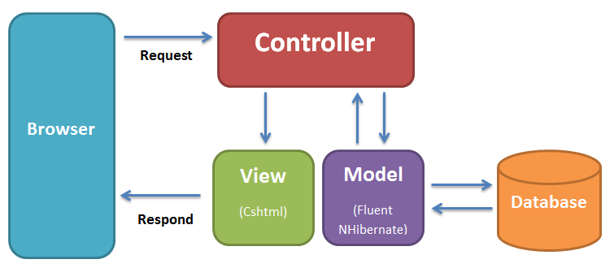

Figure 11 – MVC Architecture

The above diagram is explained as the following:
- Model: This interacts with objects in real world and is responsible for holding application state. It also represents the data manipulation which manipulated by the controller. In this system, we use Fluent NHibernate to manipulate with Microsoft SQL Server 2008 database.
- View: The view displays the data and also takes input form user. It renders the model data into a form, such as graphics, buttons, and tables, and so on to display to the user. In this system, we use cshtml page.
- Controller: The controller handles all requests coming from the view or user interface. The data flows to whole application are controlled by controller. It forwards the request to the appropriate handler. Only the controller is responsible for accessing model and rendering it into various user interfaces.

Discussion of Aternative Designs

MVP (Model-View-Presenter)
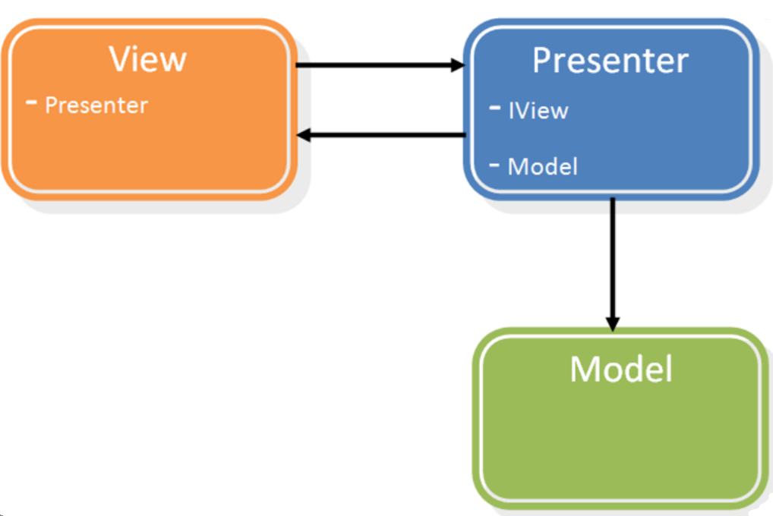
Figure 12 – MVP Model

  - Model–view–presenter (MVP) is a derivative of the model-view-controller (MVC) software pattern, also used mostly for building user interfaces.
  - In MVP the presenter assumes the functionality of the "middle-man" (played by the controller in MVC). In MVP, all presentation logic is pushed to the presenter. Eventually, the model becomes strictly a domain model.

MVVM (Model-View-View-Model)

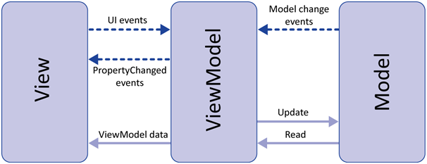
Figure 13 – MVVM Model
The Model-View-View-Model (MVVM) pattern is an application pattern that isolates the user interface from the underlying business logic. MVVM belongs to a class of patterns called Separated Presentation. These patterns provide a clean separation between the UI and the rest of the application. This improves the testability of the application and allows the application and its UI to evolve more easily and independently.

Description of System Interface
N/A

Component Diagram
The architecture of Student Club Management system is MVC architecture. Inside each layer, ther are some components that handle one or some spcific function.
- Presentation Layer’s Components:
This component has responsibility to deliver the front end to the users and accept their inputs. It will be developed by using cshtml page in .NET MVC3 combines with JavaScript, jQuery and CSS.
- Controller Layer’s Components:
This component handles requests from users. It is resonsible for rendering back a respone with the aid of both the Business Logic Layer and Presentation Layer. In more details, these components wait for petitions from clients, checks their validity accroding to authentication or authorization rules, delegates data fetching or processing to the Business Logic Layer, and select the correct type of presentational data that the client is accepting, to finally delegate this rendering process to the Presentation Layser.
- Business Logic Layer’s Components:
This component contains all business logic for the system. It includes business layer object classes, data transfer object classes… These components have responsibility to process importing data, validation, transferring data to presentation layer or data access layer.
- Data Access Layer’s Components:
This component contains all data access objects which is responsible for accessing data in database system component and exchange data information with database for the system. It includes data access classes.
- Data Source:
This component contains physical database in the system which is associated with data access classes in data asscess layer’s components.

Figure 14 – Component Diagram

Detail Description of Components

User Management

Class Diagram
Figure 15 – User Management Class Diagram

Class Diagram Explanation
UserBLO
Properties
Methods
public User[] GetUserByID(int userID) | Get all user’s information by ID of user
public User[] GetAllUser() | Get all users’ information in the Database
public void EditUserProfile(int userID) | Edit profile of user.
Getter methods | Get value of variables
Setter methods | Set value of variables

UserDAO
Properties
private Session session | Session of NHibernate
Methods
public UserDAO() | Constructor of UserDAO
public User[] GetUserByID(int userID) | Get all user’s information by ID of user
public User[] GetAllUser() | Get all users’ information in the Database
public void EditUserProfile(int userID) | Edit profile of user.

UserDTO
Properties
private int UserID | ID of user
private String FirstName | First name of user
private String LastName | Last name of user
private int DOB | User’s day of birth
private int MOB | User’s month of birth
private int YOB | User’s year of birth
private string Phone | Phone number of user
private int AddNumber | Number in street of address of user
private String AddStreet | Street in address of user
private String AddWard | Ward in address of user
private String District | District in address of user
private String AddCity | City in address of user
private boolean Gender | Gender of user
Methods
Constructor methods | Initialize class variables
Getter methods | Get value of variables
Setter methods | Set value of variables

AccountBLO
Properties
private User[] user | List of User’s type
Methods
public void CreateAccount(User user, String email, String password) | Create new account in the system.
public void EditAccount(int accID) | Edit primary information of account, such as username.
public void DeleteAccount (int accID) | Delete account out of the system.
public Account[] GetAllAccount() | Get information of all accounts in the system.
public Account[] GetAccountByID(int accID) | Get information of an account by its ID.
public String GetPasswordByEmail(String email) | Get forgot password of an account by its email.
public void CreatePresidentAccount(Account accID) | Create a new President for the system.
public void DeletePresident() | Delete the current President.
public void DeletePresident(int accountPresidentID) | Delete the current President out of his or her position.
public void CreateMMB(Account accID) | Create a new MMB for the system.
public void DeleteMMB(int accMMBID) | Delete the current MMB out of his or her position.
public void CheckDuplicateAccount(String email) | Check if email is duplicate or not
public void CheckExistingEmail(String email) | Check if email is as same as existing emails of not.
public void CheckLogin(String email, String password) | Check email and password for login.
Getter methods | Get value of variables
Setter methods | Set value of variables

AccountDAO
Properties
private Session session | Session of NHibernate
Methods
public AccoutDAO() | Constructor of AccountDAO
public void CreateAccount(User user, String accName, String accPass) | Create new account in the system.
public void EditAccount(int accID) | Edit primary information of account, such as username.
public void DeleteAccount (int accID) | Delete account out of the system.
public Account[] GetAllAccount() | Get information of all accounts in the system.
public Account[] GetAccountByID(int accID) | Get information of an account by its ID.
public String GetPasswordByEmail(String email, User user) | Get forgot password of an account by its email.
public void CreatePresidentAccount(Account accID) | Create a new President for the system.
public void DeletePresident() | Delete the current President.
public void DeletePresident(int accountPresidentID) | Delete the current President out of his or her position.
public void CreateMMB(Account accID) | Create a new MMB for the system.
public void DeleteMMB(int accMMBID) | Delete the current MMB out of his or her position.
public void CheckDuplicateAccount(String email) | Check if email is duplicate or not
public void CheckExistingEmail(String email) | Check if email is as same as existing emails of not.
public void CheckLogin(String email, String password) | Check email and password for login.
Getter methods | Get value of variables
Setter methods | Set value of variables

AccountDTO
Properties
private int AccountID | ID of account
private String Email | Email of account
private String Password | Password of account
private String Status | Status of account
private boolean IsAdmin | Check to know if account is Admin type or not
private boolean IsPresident | Check to know if account is President type or not.
private boolean IsMMB | Check to know if account is MMB type or not.
private int UserID | ID of user who owns this account.
Methods
Constructor methods | Initialize class variables
Getter methods | Get value of variables
Setter methods | Set value of variables

CreateClubBLO
Properties
private Account[] account | List of Account’s type
private Club[] club | List of Club’s type
Methods
public void SendRequestCreateClub(Account mmb, Account cc, Club newClub) | Create request for creating new club.
public void DeleteRequestCreateClub(Club newClub) | Delete request for creating new club.
public void ApproveClub(Club newClub) | Approve request for creating new club.
public void RejectClub(Club newClub) | Reject request for creating new club.
public String CheckRequestCreateClubStatus(int requestID) | Check the current status of request create club
public void ShowRequestCreateClubByStatus(String status) | Show request create club by status.
Getter methods | Get value of variables
Setter methods | Set value of variables

CreateClubDAO
Properties
private Session session | Session of NHibernate
Methods
public CreateClubDAO() | Constructor of CreateClubDAO
public void SendRequestCreateClub(Account mmb, Account cc, Club newClub) | Create request for creating new club.
public void DeleteRequestCreateClub(Club newClub) | Delete request for creating new club.
public void ApproveClub(Club newClub) | Approve request for creating new club.
public void RejectClub(Club newClub) | Reject request for creating new club.
public String CheckRequestCreateClubStatus(int requestID) | Check the current status of request create club
public void ShowRequestCreateClubByStatus(String status) | Show request create club by status.

CreateClubDTO
Properties
private int CreateRequestID | ID of request for creating new club.
private Date RequestDate | Date when creating request.
private Date ApproveDate | Date when approve request.
private String Status | Status of request
private int ClubID | ID of club which requestor request for creating.
private int MMBID | ID of requestor
private int CCID | ID of account who will become CC of the new club.
Methods
Constructor methods | Initialize class variables
Getter methods | Get value of variables
Setter methods | Set value of variables

JoinClubBLO
Properties
private Account[] account | List of Account’s type
private Club[] club | List of Club’s type
private Member[] member | List of Member’s type
Methods
public void SendRequestJoinClub(Account user, Club club) | Create request for joining into club.
public void DeleteReqeustJoinClub(Account user,Club club) | Delete request for joining into club.
public void ApproveMember(Account user, Member member, Club club) | Approve requestor into member of a club.
public void RejectMember(Account user, Club club) | Reject requestor for becoming member of a club.
public String CheckRequestJoinClubStatus(int requestID) | Check the current status of request join club
public void ShowRequestJoinClubByStatus(String status) | Show request join club by status.
Getter methods | Get value of variables
Setter methods | Set value of variables

JoinClubDAO
Properties
private Session session | Session of NHibernate
Methods
public JoinClubDAO() | Constructor of JoinClubDAO
public void SendRequestJoinClub(Account user, Club club) | Create request for joining into club.
public void DeleteReqeustJoinClub(Account user,Club club) | Delete request for joining into club.
public void ApproveMember(Account user, Member member, Club club) | Approve requestor into member of a club.
public void RejectMember(Account user, Club club) | Reject requestor for becoming member of a club.
public String CheckRequestJoinClubStatus(int requestID) | Check the current status of request join club
public void ShowRequestJoinClubByStatus(String status) | Show request join club by status.

JoinClubDTO
Properties
private int JoinRequestID | ID of request for joining into club.
private Date RequestDate | Date when creating request.
private Date ApproveDate | Date when approve request.
private String Status | Status of request.
private int ClubID | ID of club which requestor wants to join into.
private int CCID | ID of CC account that will approve or reject request.
private int RequestorID | ID of account who creates request.
Methods
Constructor methods | Initialize class variables
Getter methods | Get value of variables
Setter methods | Set value of variables

ClubBLO
Properties
private Account[] account | List of Account’s type
private CreateClub[] createClub | List of CreateClub’s type.
private JoinClub[] joinClub | List of JoinClub’s type.
private Member[] member | List of Member’s type
Methods
public void EditClub(int clubID) | Edit primary information of a club, such as club’s name, established date of club and MMB of club
public void DeleteClub(int clubID) | Delete a club out of the system.
public void GetAllClub() | Get all club
public void GetAllClubBelongToMMB(int mmbID) | Get all club belong to a specific MMB.
public void GetAllMMBAccount() | Get all MMB account.
Getter methods | Get value of variables
Setter methods | Set value of variables

ClubDAO
Properties
private Session session | Session of NHibernate
Methods
public ClubDAO() | Constructor of ClubDAO
public void EditClub(int clubID) | Edit primary information of a club, such as club’s name, established date of club and MMB of club.
public void DeleteClub(int clubID) | Delete a club out of the system.
public void GetAllClub() | Get all club
public void GetAllClubBelongToMMB(int mmbID) | Get all club belong to a specific MMB.
public void GetAllMMBAccount() | Get all MMB account.

ClubDTO
Properties
private int ClubID | ID of a club.
private String ClubName | Name of a club.
private String Status | Status of a club.
private int MMBID | ID of account which is a MMB of this club.
private int CCID | ID of account which is a CC of this club.
private float MoneyOfClub | Club’s money
Methods
Constructor methods | Initialize class variables
Getter methods | Get value of variables
Setter methods | Set value of variables

MemberBLO
Properties
private Account[] account | List of Account’s type
private Club[] club | List of Club’s type
Methods
public void DismissMember(int memberID, int clubID) | Dismiss a member out of a club.
public void ChangeCC(int accID, int memID, int clubID) | Change CC of a club.
Getter methods | Get value of variables
Setter methods | Set value of variables

MemberDAO
Properties
private Session session | Session of NHibernate
Methods
public MemberDAO() | Constructor of MemberDAO.
public void DismissMember(int memberID, int clubID) | Dismiss a member out of a club.
public void ChangeCC(int accID, int memID, int clubID) | Change CC of a club.

MemberDTO
Properties
private int MemberID | ID of member.
private String Status | Status of member.
private ApprovedByCCID | ID of the first CC who approved this member to become CM of club.
private int ClubID | ID of the club which member is joining into.
private int AccountID | ID of Member’s account.
Methods
Constructor methods | Initialize class variables
Getter methods | Get value of variables
Setter methods | Set value of variables

Activity Management

Class Diagram

Figure 16 – Activity Management Class Diagram

Class Diagram Explanation
EventDTO
Properties
private int EventID | ID of Event
private String EventTitle | Title of Event
private String Note | Summary of Event
private String EventContent | Content of Event
private DateTime StartTime | Time of Event to start
private DateTime EndTime | Time of Event to end
private DateTime CreatedDate | Date create Event
private DateTime LastUpdateDate | Last date update Event
private String Status | Status of Event
Methods
Constructor methods | Initialize class variables
Getter methods | Get value of variables
Setter methods | Set value of variables

EventBLO
Properties
private int ClubID | ID of Club
private int AccountID | ID of Account
Methods
public boolean CreateEvent(int EventID, int ClubID, int AccountID, String EventTitle, String Note, String EventContent, DateTime StartTime, DateTime EndTime) | Create new Event
public boolean UpdateEvent(int EventID, String EventTitle, String Note, String EventContent, DateTime StartTime, DateTime EndTime) | Update Event
public boolean DeleteEvent(int EventID) | Delete Event
Getter methods | Get value of variables
Setter methods | Set value of variables

EventDAO
Properties
private Session session | Session of NHibernate
Methods
public EventDAO() | Constructor
public boolean CreateEvent(int EventID, int ClubID, int AccountID, String EventTitle, String Note, String EventContent, DateTime StartTime, DateTime EndTime) | Create new Event
public boolean UpdateEvent(int EventID, String EventTitle, String Note, String EventContent, DateTime StartTime, DateTime EndTime) | Update Event
public boolean DeleteEvent(int EventID) | Delete Event

ArticleDTO
Properties
private int ArticleID | ID of Article
private String ArticleTitle | Title of Article
private String Note | Summary of Article
private String Content | Content of Article
private DateTime CreatedDate | Date create Article
private DateTime ApprovedDate | Date approve Article
private DateTime LastUpdatedDate | Last date update Article
private String Status | Status of Article
Methods
Constructor methods | Initialize class variables
Getter methods | Get value of variables
Setter methods | Set value of variables

ArticleBLO
Properties
private int EventID | ID of Event
private int AccountID | ID of Account
Methods
public boolean CreateArticle(int ArticleID, int EventID, int AccountID, String ArticleTitle, String Note, String ArticleContent) | Create Article
public boolean UpdateArticle(int ArticleID, String ArticleTitle, String Note, String ArticleContent, String Note) | Update Article
public boolean DeleteArticle(int ArticleID) | Delete Article
public boolean ApproveArticle(int ArticleID) | Approve Article
Getter methods | Get value of variables
Setter methods | Set value of variables

ArticleDAO
Properties
private Session session | Session of NHibernate
Methods
public ArticleDAO() | Constructor
public boolean CreateArticle(int ArticleID, int EventID, int AccountID, String ArticleTitle, String Note, String ArticleContent) | Create Article
public boolean UpdateArticle(int ArticleID, String ArticleTitle, String Note, String ArticleContent, String Note) | Update Article
public boolean DeleteArticle(int ArticleID) | Delete Article
public boolean ApproveArticle(int ArticleID) | Approve Article

CommentDTO
Properties
private int CommentID | ID of Comment
private String CommentContent | Content of Comment
private DateTime CreatedDate | Date create Comment
private DateTime LastUpdatedDate | Last date update Comment
private String Status | Status of Comment
Methods
Constructor methods | Initialize class variables
Getter methods | Get value of variables
Setter methods | Set value of variables

CommentBLO
Properties
private int ArticleID | ID of Article
private int AccountID | ID of Account
Methods
public boolean CreateComment(int CommentID, int ArticleID, int AccountID, String CommentContent) | Create Comment
public boolean UpdateComment(int CommentID, String CommentContent) | Update Comment
public boolean DeleteComment(int CommentID) | Delete Comment
Getter methods | Get value of variables
Setter methods | Set value of variables

CommentDAO
Properties
private Session session | Session of NHibernate
Methods
public CommentDAO() | Constructor
public boolean CreateComment(int CommentID, int ArticleID, int AccountID, String CommentContent) | Create Comment
public boolean UpdateComment(int CommentID, String CommentContent) | Update Comment
public boolean DeleteComment(int CommentID) | Delete Comment

Finance Management

Class Diagram
Figure 17 –Finance Management Class Diagram

Class Diagram Explanation
IncomeDTO
Properties
private int IncomeID | ID of income
private string IncomeName | Name of income
private int ClubID | ID of club
private string CreatedDate | Date input income
private int TypeID | ID of type
private int AccountID | ID of account
private float Money | Money income
private Date LastUpdatedDate | Date updated income
Methods
Constructor methods | Initialize class variables
Getter methods | Get value of variables
Setter methods | Set value of variables

IncomeBLO
Properties
private int AccountID | ID of account
private int TypeID | ID of type
Private int ClubID | ID of club
Methods
public boolean CreateIncome(int AccountID, int TypeID, string IncomeName, float Money, int ClubID) | Create new income
public boolean EditIncome(int IncomeID, String IncomeName, Float Money, String Note) | Edit income
public void ViewIncome(int IncomeID) | View income
Getter methods | Get value of variables
Setter methods | Set value of variables

IncomeDAO
Properties
private Session session | Session of NHibernate
Methods
public IncomeDAO() | Constructor
public boolean CreateIncome(int AccountID, int TypeID, String IncomeName, Float Money) | Create new income
public boolean EditIncome(int IncomeID, String IncomeName, float Money, int ClubID, int TypeID) | Edit income
public void ViewIncome(int IncomeID) | View income

ActualDTO
Properties
private int ActualID | ID of actual expend
private String ActualName | Name of actual expend
private Date CreatedDate | Date input actual expend
private int EventID | ID of event
private float Money | Money actual expend
private Date LastUpdatedDate | Date updated actual expend
Methods
Constructor methods | Initialize class variables
Getter methods | Get value of variables
Setter methods | Set value of variables

ActualBLO
Properties
private int EventID | ID of account
Methods
public boolean CreateActual(int EventID, String ActualName, Float Money) | Create new actual expend
public boolean EditActual(int ActualID, string ActualName, float Money) | Edit actual expend
public void ViewActual(int ActualID) | View actual expend
Getter methods | Get value of variables
Setter methods | Set value of variables

ActualDAO
Properties
private Session session | Session of NHibernate
Methods
public ActualDAO() | Constructor
public boolean CreateActual(int EventID, string ActualName, float Money) | Create new actual expend
public boolean EditActual(int ActualID, string ActualName, float Money) | Edit actual expend
public void ViewActual(int ActualID) | View actual expend

EstimatedDTO
Properties
private int EstimatedID | ID of estimated expend
private string EstimatedName | Name of estimated expend
private Date CreatedDate | Date input estimated expend
private int EventID | Id of event
private float Money | Money estimated expend
private Date LastUpdatedDate | Date updated estimated expend
Methods
Constructor methods | Initialize class variables
Getter methods | Get value of variables
Setter methods | Set value of variables

EstimatedBLO
Properties
private int EventID | ID of account
Methods
public boolean CreateEstimated(int EventID, String EstimatedName, Float Money) | Create new estimated expend
public boolean EditEstimated (int EstimatedID, string EstimatedName, float Money) | Edit estimated expend
public void ViewEstimated (int EstimatedID) | View estimated expend
Getter methods | Get value of variables
Setter methods | Set value of variables

EstimatedDAO
Properties
private Session session | Session of NHibernate
Methods
public EstimatedDAO() | Constructor
public boolean CreateEstimated(int EventID, String EstimatedName, Float Money) | Create new estimated expend
public boolean EditEstimated (int EstimatedID, string EstimatedName, float Money) | Edit estimated expend
public void ViewEstimated (int EstimatedID) | View estimated expend

FeeDTO
Properties
private int FeeID | ID of fee
private int Year | Year of inputting fee
private int Month | Month of inputting fee
private float Money | Money fee
private String Status | Status of fee
Methods
Constructor methods | Initialize class variables
Getter methods | Get value of variables
Setter methods | Set value of variables

FeeBLO
Properties
private int ClubID | ID of club
private int MemberID | ID of member
Methods
public boolean CreateFee(int ClubID, int Month , Float Money) | Create new fee
public boolean EditFee (int FeeID , float Money, String Status) | Edit fee
public void ViewFee (int FeeID) | View fee
Getter methods | Get value of variables
Setter methods | Set value of variables

FeeDAO
Properties
private Session session | Session of NHibernate
Methods
public FeeDAO() | Constructor
public boolean CreateFee(int ClubID, int Month, Float Money) | Create new fee
public boolean EditFee (int FeeID , Float Money, String Status) | Edit fee
public void ViewFee (int FeeID) | View fee

Supporting Tool for User

Class Diagram – Search Function
Figure 18 – Search Function Class Diagram

Class Diagram Explanation – Search Function
ClubBLO
Properties
Methods
public Club[] GetAllClub() | Get all club

ClubDAO
Properties
private Session session | Session of NHibernate
Methods
public ClubDAO() | Constructor
public Club[] GetAllClub() | Get all club

ClubDTO
Properties
private int ClubID | Identification of club
private String ClubName | Name of club
private String Status | Status of club
private int CC | CC of club
private int MMB | MMB manage club
private float Money | Money of club
Private String Description | Description about club
Private String Rules | Rules of club
Methods
Constructor methods | Initialize class variables
Getter methods | Get value of variables
Setter methods | Set value of variables

EventBLO
Properties
Methods
public Event[] GetAllEvent() | Get all event

EventDAO
Properties
private Session session | Session of NHibernate
Methods
public EventDAO() | Constructor
public Event[] GetAllEvent() | Get all event

EventDTO
Properties
private int EventID | Identification of event
private String EvenTitle | Title of event
private String EventContent | Content of event
private datetime CreateDate | Create date of event
private datetime LastUpdateDate | Last update date of event
private String Status | Status of event
private int ClubID | Identification of club
private int AccountID | Identification of account
private datetime StartTime | Start time of event
private datetime EndTime | End time of event
Methods
Constructor methods | Initialize class variables
Getter methods | Get value of variables
Setter methods | Set value of variables

AccountBLO
Properties
Methods
public Account[] GetAllAccount() | Get all account

AccountDAO
Properties
private Session session | Session of NHibernate
Methods
public AccountDAO() | Constructor
public Account[] GetAllAccount() | Get all account

AccountDTO
Properties
private int AccountID | Identification of account
private String Email | Email of account
private String AccPass | Password of account
private String Status | Status of account
private bit isAdmin | Check is admin
private bit isPresident | Check is president
private bit isMMB | Check is MMB
private int UserID | Identification of user
Methods
Constructor methods | Initialize class variables
Getter methods | Get value of variables
Setter methods | Set value of variables

ArticleBLO
Properties
Methods
public Article[] GetAllAccount() | Get all account

ArticleDAO
Properties
private Session session | Session of NHibernate
Methods
public ArticleDAO() | Constructor
public Article[] GetAllArticle() | Get all account

ArticleDTO
Properties
private int ArticleID | Identification of article
private String ArticleTitle | Title of article
private String ArticleContent | Content of article
private datetime CreatedDate | Create date of article
private datetime LastUpdateDate | Last update date of article
private String Status | Status of article
private int AccountID | Identification of account
private int EventID | Identification of event
private datetime ApproveDate | Approve date of article
private String Note | Note of article
private int CCApprove | CC who approve the article
Methods
Constructor methods | Initialize class variables
Getter methods | Get value of variables
Setter methods | Set value of variables

Class Diagram – Report Function

Figure 19 – Report Function Class Diagram

Class Diagram Explanation – Report Function
ClubBLO
Properties
Methods
public Club[] GetClub() | Get club
public Club[] GetAllClub() | Get all club

ClubDAO
Properties
private Session session | Session of NHibernate
Methods
public ClubDAO() | Constructor
public Club[] GetClub() | Get club
public Club[] GetAllClub() | Get all club

ClubDTO
Properties
private int ClubID | Identification of club
private String ClubName | Name of club
private String Status | Status of club
private int CC | CC of club
private int MMB | MMB manage club
private float MoneyOfClub | Money of club
private String Description | Description about club
private String Rules | Rules of club
Methods
Constructor methods | Initialize class variables
Getter methods | Get value of variables
Setter methods | Set value of variables

MemberBLO
Properties
Methods
public Member[] GetMember() | Get member
public Member[] GetAllMember() | Get all member

MemberDAO
Properties
private Session session | Session of NHibernate
Methods
public MemberDAO() | Constructor
public Member[] GetMember() | Get member
public Member[] GetAllMember() | Get all member

MemberDTO
Properties
private int MemberID | Identification of member
private String Status | Status of member
private int CCAprove | CC approve for member
private int ClubID | Identification of club
private int AccountID | Identification of account
Methods
Constructor methods | Initialize class variables
Getter methods | Get value of variables
Setter methods | Set value of variables

EventBLO
Properties
Methods
public Event[] GetEvent() | Get event
public Event[] GetAllEvent() | Get all event

EventDAO
Properties
private Session session | Session of NHibernate
Methods
public EventDAO() | Constructor
public Event[] Get Event () | Get event
public Event[] GetAllEvent () | Get all event

EventDTO
Properties
private int EventID | Identification of event
private String EventTitle | Title of event
private String EventContent | Content of event
private datetime CreatedDate | Created date of event
private datetime LastUpdateDate | Last update date of event
private String Status | Status of event
private int ClubID | Identification of club
private datetime StartTime | Start time of event
private datetime EndTime | End time of event
Methods
Constructor methods | Initialize class variables
Getter methods | Get value of variables
Setter methods | Set value of variables

ActualExpendBLO
Properties
Methods
public ActExpend[] GetActualExpend() | Get actual expenditure
public ActExpend[] GetAllActualExpend() | Get all actual expenditure

ActualExpendDAO
Properties
private Session session | Session of NHibernate
Methods
public ActualExpendDAO() | Constructor
public ActExpend[] GetActualExpend() | Get actual expenditure
public ActExpend[] GetAllActualExpend() | Get all actual expenditure

ActualExpendDTO
Properties
private int ActualID | Identification of actual expenditure
private String ActualName | Name of actual expenditure
private datetime CreateDate | Create date of actual expenditure
private String Note | Note of actual expenditure
private int EventID | Identification of event
private float Money | Money of actual expenditure
private datetime LastUpdateDate | Last update date of actual expenditure
Methods
Constructor methods | Initialize class variables
Getter methods | Get value of variables
Setter methods | Set value of variables

IncomeBLO
Properties
Methods
public Income[] GetIncome() | Get income
public Income[] GetAllIncom () | Get all income

IncomeDAO
Properties
private Session session | Session of NHibernate
Methods
public IncomeDAO() | Constructor
public Income[] GetIncome() | Get income
public Income[] GetAllIncome() | Get all income

IncomeDTO
Properties
private int IncomeID | Identification of income
private String IncomeName | Name of income
private datetime CreateDate | Create date of income
private String Note | Note of income
private int AccountID | Identification of account
private int TypeID | Identification of type
private float Money | Money of income
private datime LastUpdateDate | Last update date of income
private int ClubID | Identification of club
Methods
Constructor methods | Initialize class variables
Getter methods | Get value of variables
Setter methods | Set value of variables

JoinClubBLO
Properties
Methods
public JoinClub[] Get JoinClub() | Get joinclub
public JoinClub[] GetAll JoinClub() | Get all joinclub

JoinClubDAO
Properties
private Session session | Session of NHibernate
Methods
public JoinClubEventDAO() | Constructor
public JoinClub[] Get JoinClub() | Get joinclub
public JoinClub[] GetAllJoinClub() | Get all joinclub

JoinClubDTO
Properties
private int JoinRequestID | Identification of request
private datetime RequestDate | Request date of request
private datetime ApproveDate | Approve date of request
private String Status | Status of request
private int CC | CC approve the request join club
private int AccountID | Identification of account
private int ClubID | Identification of club
Methods
Constructor methods | Initialize class variables
Getter methods | Get value of variables
Setter methods | Set value of variables

Sequence Diagram

User Management

Register

    - This feature allows Guest to create an account in the system in other to have more authorization.
    - Validating input data format will be done in JavaScript based on restrictions of corresponding attributes in database.
    - The email which used to register must not be as same as exiting email in the database.

Figure 20 – Register Sequence Diagram

Login
    - This feature allows all people who have an account can login into the system.

Figure 21 – Login Sequence Diagram

Forget Password
    - This feature helps a person who has account in the system can reset his or her password.
    - Validating input email format will be done in JavaScript.
    - The email which used to get new password must be an existing email in the database.

Figure 22 – Forget Password Sequence Diagram

Edit Profile
    - This feature allows users to edit his or her profile.
    - Validating input data will be done in JavaScript based on restrictions of corresponding attributes in database.
Figure 23 – Edit Profile Sequence Diagram

Send Request Join Club
    - This feature helps User to send request for joining into club that he or she wants to participate in.
    - User can choose a club which they want to send request for joining into. Each time User can send request for only one club.
Figure 24 – Send Request Join Club Sequence Diagram

Delete Request Join Club
    - This feature is about allowing User to delete request for joining into club. User can delete request if request status is Pending.
Figure 25 – Delete Request Join Club Sequence Diagram

Update Request Join Club – Approve Member
    - This feature helps CC of each club can approve request for joining into his or her club which sent by User.
    - Only request which has Pending status is shown for CC to approve.

Figure 26 – Approve Member Sequence Diagram

Update Request Join Club – Reject Member
    - This feature helps CC to reject request for joining into his or her club.
    - Only request which has Pending status is shown for CC to reject.
Figure 27 – Reject Member Sequence Diagram

Manage Member Function for CC
    - This feature allows CC to fire a club’s member out of his or her club.
    - CC can click on “Loại Bỏ” button next to CM that CC wants to dismiss or CC can use Search CM account function to find specific account quickly and then clicks on “Loại Bỏ” button.

Figure 28 – Dismiss CM Sequence Diagram

Manage Member Function for MMB
    - This feature allows MMB to change CC of a club by find another suitable account for CC position and makes the old CC become CM of that club.

Figure 29 – Change CC Sequence Diagram

Send Request Create Club
    - This feature allows MMB to send request for creating new club in the system.
Figure 30 – Send Request Create Club Sequence Diagram

Delete Request Create Club
    - This feature allows MMB to delete request for creating new club which MMB sent. MMB can delete only sending request which has Pending status.
Figure 31 – Delete Request Create Club Sequence Diagram

Update Request Create Club – Approve Club
    - This feature allows President to approve request for creating new club which sent by MMB. Only request which has Pending status is shown for President to approve.
Figure 32 – Approve Club Sequence Diagram

Update Request Create Club – Reject Club
    - This feature allows President to reject request for creating new club which sent by MMB. Only request which has Pending status is shown for President to reject.

Figure 33 – Reject Club Sequence Diagram

Manage List of MMB – Create MMB
    - This feature helps President to create a new MMB in the system.

Figure 34 – Create MMB Sequence Diagram

Manage List of MMB – Delete MMB
    - This feature helps President to dismiss a MMB out of his or her position.
    - To finish this action, President must choose a new existing MMB for each club which belongs to the dismissed MMB.
Figure 35 – Delete MMB Sequence Diagram

Manage Club – Edit Club
    - This feature helps President can edit information of a club includes club’s name, Description, Rules and MMB of that club.
Figure 36 – Edit Club Sequence Diagram

Manage Club – Delete Club
    - This feature allows President to search and delete an existing club out of the system.
Figure 37 – Delete Club Sequence Diagram

Manage President – Create President
    - This feature helps Admin to choose a suitable account to create the new President for the system.
    - When Admin does creating the new President, the system will delete the existing one automatically and then start to upgrade a suitable account to President position.

Figure 38 – Create President Sequence Diagram

Manage President – Delete President
    - This feature Admin to delete current President out of his or her position.
    - Admin must choose another suitable account for the new President position to finish this delete function.
Figure 39 – Delete President Sequence Diagram

Delete Account
    - This feature helps Admin to delete allowed account out of the system.

Figure 40 – Delete Account Sequence Diagram

Edit Account
    - This feature helps Admin to edit email of all account in the system (President/MMB/CC/CM/User account).
    - This feature does not allow Admin to edit position of an account.

Figure 41 – Edit Account Sequence Diagram

Activity Management

Create Event
    - CC or MMB want to create new event for club.

Figure 42 – Create Event Sequence Diagram

Edit Event
    - CC or MMB want to edit an event existed.

Figure 43 – Edit Event Sequence Diagram

Delete Event
    - CC or MMB want to delete an event existed.

Figure 44 – Delete Event Sequence Diagram

Create Article
    - CM, CC or MMB want to create new article for event.
Figure 45 – Create Article Sequence Diagram

Edit Article
    - CM, CC or MMB want to edit an article existed.
Figure 46 – Edit Article Sequence Diagram

Delete Article
    - CM, CC or MMB want to delete an article existed.
Figure 47 – Delete Article Sequence Diagram

Approve Article
    - CC or MMB want to approve new article.
Figure 48 – Approve Article Sequence Diagram

Comment
    - All actors (except for Guest) want to comment.
Figure 49 – Create Comment Sequence Diagram

Edit Comment
    - All actors (except for Guest) want to edit a comment existed.
Figure 50 – Edit Comment Sequence Diagram

Delete Comment
    - CC or MMB want to delete a comment existed.
Figure 51 – Delete Comment Sequence Diagram

Finance Management

Create Income
    - CC wants to create a new income.
Figure 52 – Create Income Sequence Diagram

Edit Income
    - CC wants to edit an income.
Figure 53 – Edit Income Sequence Diagram

Create Fee
    - CC wants to create a new fee.
Figure 54 – Create Fee Sequence Diagram

Edit Fee
    - CC wants to edit a fee.
Figure 55 – Edit Fee Sequence Diagram

Create Actual
    - CC wants to create an actual expend for event.
Figure 56 – Create Actual Sequence Diagram

Edit Actual
    - CC wants to edit an actual expend for event.
Figure 57 – Edit Acual Sequence Diagram

Create Estimated
    - CC wants to create an estimated expend for event.
Figure 58 – Create Estimated Sequence Diagram

Edit Estimated
    - CC wants to edit an estimated expend for event.
Figure 59 – Edit Estimated Sequence Diagram

Supporting Tool for User

View Total Income Expend Report
    - This feature allows user can view their needed information about total income expend of clubs in a month.

Figure 60 – Total Income & Expend Report Sequence Diagram

View Report about Event
    - This feature allows user can view their needed information about number of event in each club in a month.

Figure 61 – View Report about Event Sequence Diagram

View Report about Member
    - This feature allows user can view their needed information about member's rate of each club in a period.

Figure 62 – View Report about Member Sequence Diagram

View Income in Club Report
    - This feature allows user can view their needed information about the incomes in club.
Figure 63 – View Income in Club Sequence Diagram

Search All
    - This feature allows user find their needed information (club, event, and article).
Figure 64 – Search All Sequence Diagram

User Interface Design

Figure 65 – Site Map

Reference in Report 6: Software User’s Manual.

Database Design

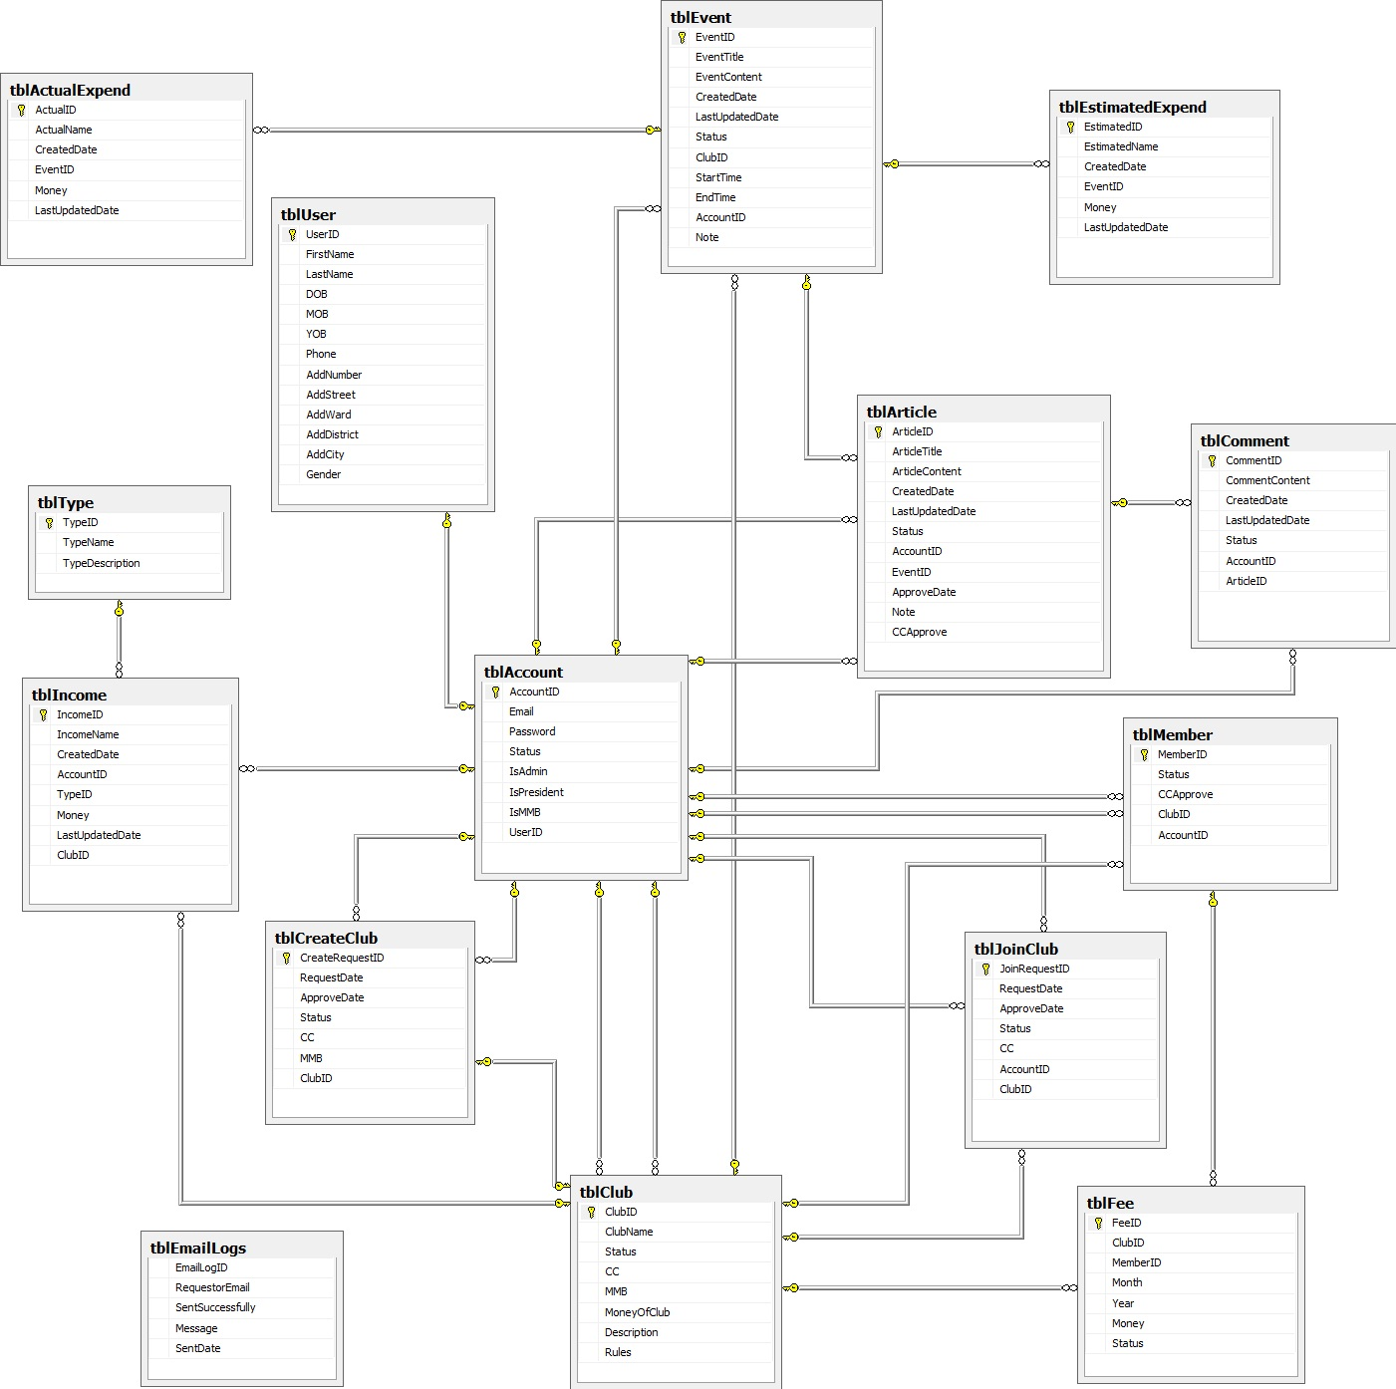

Figure 66 – Database Diagram

Report No.5: Software Test Documentation (STD)

Introduction

System Overview
This document provides all the features about test plans, test cases, test results, test environments, pass/fail criteria and risks estimation as well as checklist to cover all cases that can happen in Student Club Management system

Test Approach
- Test goal: To find all remain bugs in Student Club Management system.
- Test type: Black box testing.
- Test size: System Component.
- Test technique: Check list.

Test Plan
Test plan document is used to verify and ensure that Student Club Management system meets its design specifications and other user requirements. The following part will describe which features will be tested and which is not, test tools and test environment.

Features to be test

User Management

Send Request Join Club
Test if User can send request to join into a club.

Send Request Create Club
Test if MMB can send request to create a new club.

Manage Club – Edit Club
Test if President can edit basic information of club.

Edit Account
Test if User can send request to join into a club.

Activity Management

Create Event
Test if CC can create new event for his or her club.

Edit Event
Test if CC can edit an existing event of his or her club.

Create Article
Test if CC or CM can create new article for an existing event of his or her club.

Edit Article
Test is CC or CM can edit an existing article of his or her club.

Comment
Test if all account can post a comment for any article.

Edit Comment
Test if all account can edit a comment which was post by him or her.

Finance Management

Create Income
Test if CC can manage the current financial situation of his or her group by calculate income.

Edit Income
Test if CC can edit income of his or her club.

Create Fee
Test if CC can manage the membership fees of his or her group.

Edit Fee
Test if CC can edit membership fees of his or her group.

Create Actual
Test if CC can manage the actual expenditure for each activity, event in club.

Edit Actual
Test if CC can manage the actual expenditure for each activity, event in club.

Create Estimated
Test if CC can manage the estimated expenditure for each activity, event in club.

Edit Estimated
Test if CC can edit estimated expenditure for each activity, event in club.

Features not to be test

User Management

Register

Login

Forget Password

Edit Profile

Delete Request Join Club

Update Request Join Club – Approve Member

Update Request Join Club – Reject Member

Manage Member Function for CC

Manage Member Function for MMB

Delete Request Create Club

Update Request Create Club – Approve Club

Update Request Create Club – Reject Club

Manage List of MMB – Create MMB

Manage List of MMB – Delete MMB

Manage Club – Delete Club

Manage President – Create President

Manage President – Delete President

Delete Account

Activity Management

Delete Event

Delete Article

Approve/Reject Article

Delete Comment

Supporting Tools for User

View Total Income Expend Report

View Report about Event

View Report about Member

View Income in Club Report

Search All

Test Tool and Environment
- Test tool: There is no special testing tool used in testing this product.
- Test environment:
  - Hardware: Intel Core 2 Duo 2.00GHz or above, RAM at least 2GB, HDD free at least 1GB, Screen with 1024x768 or higher resolution.
  - Operating System: Microsoft Windows 7 Ultimate SP1.
  - Browser: Internet Explorer 9, Mozilla Firefox 13+, Google Chrome 20+.

Test Cases

User Management

Send Request Join Club
Purpose: Test whether user can send request to join into a club.
Inputs:
- Club name.
Results and pass/fail criteria:
- Pass: Show successful message pop up and data is updated in grid view.
- Fail:
- Successful message pop up is not shown.
- Data is not updated in database and grid view.
Test Procedure:
- Login with suitable account
- Go to “Quản Lý Gửi Yêu Cầu Gia Nhập CLB” screen.
- Choose club name.
- Press “Gửi” button.

Send Request Create Club
Purpose: Test whether MMB can send request to create new club.
Inputs:
- Club name
- Find CC for new club.
- Descriptions.
- Rules.
Results and pass/fail criteria:
- Pass:
- Show successful message pop up.
- Data is updated in database.
- New club with status Pending is shown in grid view.
- Request is sent to President.
- Fail:
- Successful message pop up is not shown.
- Data is not updated in database.
- New club with status Pending is not shown in grid view.
- Request is not sent to President.
Test Procedure:
- Login with suitable account.
- Go to “Quản Lý Gửi Yêu Cầu Tạo CLB” screen.
- Fill information for all fields.
- Click on “Gửi” button.

Manage Club – Edit Club
Purpose: Test whether President can edit basic information and MMB of a club.
Inputs:
- Club name.
- Descriptions.
- Rules.
- Choose a new MMB for club.
Results and pass/fail criteria:
- Pass:
- Show successful message pop up.
- Data is updated in database and grid view.
- Fail:
- Successful message pop up is not shown.
- Data is not updated in database or grid view.
Test Procedure:
- Login with suitable account.
- Go to “Quản Lý CLB” screen.
- Choose club that want to edit.
- Click on “Sửa” button.
- Fill and choose new information.
- Click on “Đồng ý” button.

Edit Account
Purpose: Test whether Admin can edit an existing account.
Inputs:
- New information of that account.
Results and pass/fail criteria:
- Pass:
- Show successful message pop up.
- Data is updated in database and grid view.
- Fail:
- Successful message pop up is not shown.
- Data is not updated in database and grid view.
Test Procedure:
- Login with suitable account.
- Go to “Quản Lý Tài Khoản” screen.
- Go to account that want to edit.
- Click on “Sửa” button.
- Fill new information on pop up.
- Click on “Đồng ý” button on pop up.

Activity Management

Create Event
Purpose: Test whether CC can create event.
Inputs:
- Start time
- End time
- Event title
- Event content
Results and pass/fail criteria:
- Pass: Navigate to “Câu Lạc Bộ” screen with suitable menu for its account type.
- Fail:
- Notification “Nhập vào ngày bắt đầu.” appears if start time is not filled.
- Notification “Nhập vào ngày kết thúc.” appears if end time is not filled.
- Notification “Nhập vào tên sự kiện.” appears if event title is not filled.
- Notification “Nhập vào nội dung sự kiện.” if event content is not filled.
Test Procedure:
- Input start time.
- Input end time.
- Input event title.
- Input event content.
- Press “Đăng” button.

Edit Event
Purpose: Test whether CC can edit event.
Inputs:
- Start time
- End time
- Event title
- Event content
Results and pass/fail criteria:
- Pass: Navigate to “Câu Lạc Bộ” screen with suitable menu for its account type.
- Fail:
- Notification “Nhập vào ngày bắt đầu.” appears if start time is not filled.
- Notification “Nhập vào ngày kết thúc.” appears if end time is not filled.
- Notification “Nhập vào tên sự kiện.” appears if event title is not filled.
- Notification “Nhập vào nội dung sự kiện.” if event content is not filled.
Test Procedure:
- Input start time.
- Input end time.
- Input event title.
- Input event content.
- Press “Lưu” button.

Create Article
Purpose: Test whether CC or CM can create article.
Inputs:
- Article title
- Article content
Results and pass/fail criteria:
- Pass: Navigate to “Sự Kiện” screen with suitable menu for its account type.
- Fail:
- Notification “Nhập vào tên bài báo.” appears if article title is not filled.
- Notification “Nhập vào nội dung bài báo.” if article content is not filled.
Test Procedure:
- Input event title.
- Input event content.
- Press “Đăng” button.

Edit Article
Purpose: Test whether CC or CM can edit article.
Inputs:
- Article title
- Article content
Results and pass/fail criteria:
- Pass: Navigate to “Sự Kiện” screen with suitable menu for its account type.
- Fail:
- Notification “Nhập vào tên bài báo.” appears if article title is not filled.
- Notification “Nhập vào nội dung bài báo.” if article content is not filled.
Test Procedure:
- Input event title.
- Input event content.
- Press “Lưu” button.

Comment
Purpose: Test whether all account except for Guest can comment.
Inputs:
- Comment content
Results and pass/fail criteria:
- Pass: Navigate to “Bài Báo” screen with suitable menu for its account type.
- Fail:
- Notification “Nhập vào nội dung bình luận.” appears if comment content is not filled.
Test Procedure:
- Input comment content.
- Press “Đăng” button.

Edit Comment
Purpose: Test whether all account except for Guest can edit comment.
Inputs:
- Comment content
Results and pass/fail criteria:
- Pass: Navigate to “Bài Báo” screen with suitable menu for its account type.
- Fail:
- Notification “Nhập vào nội dung bình luận.” appears if comment content is not filled.
Test Procedure:
- Input comment content.
- Press “Lưu” button.

Finance Management

Create Income
Purpose: Test whether CC can create income for a club.
Inputs:
- IncomeName
- ClubName
- TypeName
- Money
Results and pass/fail criteria:
- Pass: Navigate to Create Income screen (Dashboard screen)
- Data is updated in database
- Fail:
- Notification “Xin nhập tên phí !!” appears if incomeName is not filled.
- Notification “Xin nhập tên câu lạc bộ!!” appears if ClubName is not filled.
- Notification “Xin nhập loại!!” appears if typeName is not filled
- Notification “Xin nhập số tiền!!” appears if Money is not filled
- Data is not updated in database and grid view.

Test Procedure:
- Input IncomeName
- Input ClubName
- Input TypeName
- Input Money
- Press “Tạo mới”

Edit Income
Purpose: Test whether CC can edit income for a club.
Inputs:
- IncomeName
- ClubName
- TypeName
- Money
Results and pass/fail criteria:
- Pass: Navigate to Edit Income screen (Dashboard screen)
- Data is updated in database
- Fail:
- Notification “Xin nhập tên phi!!” appears if incomeName is not filled.
- Notification “Xin nhập tên câu lạc bộ!!” appears if ClubName is not filled.
- Notification “Xin nhập loại!!” appears if typeName is not filled
- Notification “Xin nhập số tiền!!” appears if Money is not filled
- Data is not updated in database and grid view.
- Edit pop up is not shown
Test Procedure:
- Input IncomeName
- Input ClubName
- Input TypeName
- Input Money
- Press “Sửa”

Create Fee
Purpose: Test whether CC can create fee for a club.
Inputs:
- Month
- Money
- Status
Results and pass/fail criteria:
- Pass: Navigate to Create Fee screen (Dashboard screen)
- Data is updated in database.
- Fail:
- Data is not updated in database and grid view.
Test Procedure:
- Input Money
- Input Month
- Input Status
- Press “Tạo mới phí tháng”

Edit Fee
Purpose: Test whether CC can create fee for a club.
Inputs:
- Status
Results and pass/fail criteria:
- Pass: Navigate to Fee screen (Dashboard screen)
- Status of request is updated in grid view.

- Fail:
- Data is not updated in database and grid view.
Test Procedure:
- Input Status
- Press “Lưu”

Create Actual
Purpose: Test whether CC can create actual expend for an event.
Inputs:
- ActualName
- EventTitle
- Money
Results and pass/fail criteria:
- Pass: Navigate to Create Actual screen (Dashboard screen)
- Create Actual pop up is shown
- Data is updated in database
- Fail:
- Notification “Xin nhập các khoản thực chi!!” appears if ActualName is not filled.
- Notification “Xin nhập tên sự kiện!!” appears if EventTitle is not filled.
- Notification “Xin nhập số tiền!!” appears if Money is not filled
- Data is not updated in database and grid view.

Test Procedure:
- Input ActualName
- Input EventTitle
- Input Money
- Press “Tạo mới”

Edit Actual
Purpose: Test whether CC can edit actual expend for an event.
Inputs:
- ActualName
- EventTitle
- Money
Results and pass/fail criteria:
- Pass: Navigate to Edit Actual screen (Dashboard screen)
- Edit Actual pop up is shown
- Data is updated in database
- Fail:
- Notification “Xin nhập các khoản thực chi!!” appears if ActualName is not filled.
- Notification “Xin nhập tên sự kiện!!” appears if EventTitle is not filled.
- Notification “Xin nhập số tiền!!” appears if Money is not filled
- Data is not updated in database and grid view.
Test Procedure:
- Input ActualName
- Input EventTitle
- Input Money
- Press “Lưu”

Create Estimated
Purpose: Test whether CC can create estimated expend for an event.
Inputs:
- EstimatedName
- EventTitle
- Money
Results and pass/fail criteria:
- Pass: Navigate to Create Estimated screen (Dashboard screen)
- Create Estimated pop up is shown
- Data is updated in database
- Fail:
- Notification “Xin nhập các khoản dự chi!!” appears if EstimatedName is not filled.
- Notification “Xin nhập tên sự kiện!!” appears if EventTitle is not filled.
- Notification “Xin nhập số tiền!!” appears if Money is not filled
- Data is not updated in database and grid view.

Test Procedure:
- Input EstimatedName
- Input EventTitle
- Input Money
- Press “Tạo mới”

Edit Estimated
Purpose: Test whether CC can edit estimated expend for an event.
Inputs:
- EstimatedName
- EventTitle
- Money
Results and pass/fail criteria:
- Pass: Navigate to Edit Estimated screen (Dashboard screen)
- Edit Estimated pop up is shown
- Data is updated in database
- Fail:
- Notification “Xin nhập các khoản thực chi!!” appears if EstimatedName is not filled.
- Notification “Xin nhập tên sự kiện!!” appears if EventTitle is not filled.
- Notification “Xin nhập số tiền!!” appears if Money is not filled
- Data is not updated in database and grid view.

Test Procedure:
- Input EstimatedName
- Input EventTitle
- Input Money
- Press “Lưu”

Checklists
Abbreviation:
- Result: [P]ass = [F]ail

User Management

Send Request Join Club
ID | Description | Test Case Procedure | Expected Output | Dependence | Result | Test date | Note
Steps
- Go to home page
- Login with suitable account
- Go to “Gửi Yêu Cầu Gia Nhập CLB” page.
 | Components
TC_SRJC_001 |  |  | Show page with its components. |  | P
TC_SRJC_002 |  | Choose club and click on “Gửi” button | - Show successful message pop up.  - Data is updated in database and table in that page. |  | P

Send Request Create Club
ID | Description | Test Case Procedure | Expected Output | Dependence | Result | Test date | Note
Steps
- Go to home page
- Login with MMB role
- Go to “Gửi Yêu Cầu Tạo CLB”
 | Components
TC_SRCC_001 |  |  | Show page with its component. |  | P
TC_SRCC_002 |  | Fill all required information and click on “Gửi” button | - Data is updated in database and in table in that page. |  | P
TC_SRCC_003 |  | Not fill all information and click on “Gửi” button | - Show invalid message with field miss information. |  | P

Manage Club – Edit Club
ID | Description | Test Case Procedure | Expected Output | Dependence | Result | Test date | Note
Steps
- Go to home page
- Login with President role.
- Go to “Quản Lý CLB” page.
 | Components
TC_EC_001 |  |  | Show page with its component. |  | P
TC_EC_002 |  | Choose club that want to edit and click on “Sửa” button. | - Show pop up for President to edit MMB and information of club.  - Data is updated in database and table in that page. |  | P
TC_EC_003 |  | - Choose club that want to edit and click on “Sửa” button.  - Delete information and click on “Lưu” button. | - Show pop up for President to edit MMB and information of club.  - When “Lưu” button is click then validate field and show invalid message in missing field. |  | P

Edit Account
ID | Description | Test Case Procedure | Expected Output | Dependence | Result | Test date | Note
Steps
- Go to home page
- Login with Admin role.
- Go to “Quản Lý Tài Khoản” page.
 | Components
TC_EA_001 |  |  | Show page with its components. |  | P
TC_EA_002 |  | Choose account that want to edit and click on “Sửa” button. | - Pop up with current account information is shown for editing.  - Data is updated in database and in table in that page. |  | P
TC_EA_003 |  | - Choose account that want to edit and click on “Sửa” button.  - Delete email and click on “Lưu” button. | - Pop up with current account information is shown for editing.  - When “Lưu” button is click then validate filed email and show invalid message. |  | P

Activity Management

Create Event
ID | Description | Test Case Procedure | Expected Output | Dependence | Result | Test date | Note
Steps
- Go to home page.
- Login with suitable account.
- Go to “Câu Lạc Bộ” page.
- Click on “Tạo Sự Kiện” button.
 | Components
TC_CE_001 |  |  | Show page with its components. |  | P
TC_CE_002 |  | Fill all required information and click on “Đăng” button. | - Data is update in database. |  | P
TC_CE_003 |  | Not fill all required information and click on “Đăng” button. | - Show invalid message in what field has missing information. |  | P
TC_CE_004 |  | Fill all required information, choose “Ngày bắt đầu” before “Ngày kết thúc” and click on “Đăng” button. | - Show invalid message in “Ngày bắt đầu” và “Ngày kết thúc” field. |  | P
TC_CE_005 |  | Fill all required information, choose “Ngày bắt đầu” same as “Ngày kết thúc” and click on “Đăng” button. | - Show invalid message in “Ngày bắt đầu” và “Ngày kết thúc” field. |  | P

Edit Event
ID | Description | Test Case Procedure | Expected Output | Dependence | Result | Test date | Note
Steps
- Go to home page.
- Login with suitable account.
- Go to “Câu Lạc Bộ” page.
- Go to “Sự Kiện” page.
- Click on “Sửa” button.
 | Components
TC_EE_001 |  |  | Show page with its components. |  | P
TC_EE_002 |  | Edit information and click on “Lưu” button | - Data is update in database. |  | P
TC_EE_003 |  | Not fill all required information and click on “Lưu” button. | - Show invalid message in what field has missing information. |  | P
TC_EE_004 |  | Edit “Ngày bắt đầu” before “Ngày kết thúc” and click on “Lưu” button. | - Show invalid message in “Ngày bắt đầu” và “Ngày kết thúc” field. |  | P
TC_EE_005 |  | Edit “Ngày bắt đầu” same as “Ngày kết thúc” and click on “Lưu” button. | - Show invalid message in “Ngày bắt đầu” và “Ngày kết thúc” field. |  | P

Create Article
ID | Description | Test Case Procedure | Expected Output | Dependence | Result | Test date | Note
Steps
- Go to home page.
- Login with suitable account.
- Go to “Câu Lạc Bộ” page.
- Go to “Sự Kiện” page.
- Click on “Tạo Bài Báo” button.
 | Components
TC_CA_001 |  |  | Show page with its components. |  | P
TC_CA_002 |  | Fill all required information and click on “Đăng” button. | - Data is update in database. |  | P
TC_CA_003 |  | Not fill all required information and click on “Đăng” button. | - Show invalid message in missing field. |  | P

Edit Article
ID | Description | Test Case Procedure | Expected Output | Dependence | Result | Test date | Note
Steps
- Go to home page.
- Login with suitable account.
- Go to “Câu Lạc Bộ” page.
- Go to “Sự Kiện” page.
- Go to “Bài Báo” page.
- Click on “Sửa” button.
 | Components
TC_EA_001 |  |  | Show page with its components. |  | P
TC_EA_002 |  | Edit information and click on “Lưu” button. | - Data is update in database. |  | P
TC_EA_003 |  | Delete some field required information and click on “Lưu” button. | - Show invalid message in field has missing information. |  | P

Comment
ID | Description | Test Case Procedure | Expected Output | Dependence | Result | Test date | Note
Steps
- Go to home page.
- Login with suitable account.
- Go to “Câu Lạc Bộ” page.
- Go to “Sự Kiện” page.
- Go to “Bài Báo” page.
 | Components
TC_C_001 |  |  | Show page with its components. |  | P
TC_C_002 |  | Write comment and click on “Đăng” button. | - Data is updated in database. |  | P
TC_C_003 |  | Not write comment and click on “Đăng” button. | - Show invalid message. |  | P

Edit Comment
ID | Description | Test Case Procedure | Expected Output | Dependence | Result | Test date | Note
Steps
- Go to home page.
- Login with suitable account.
- Go to “Câu Lạc Bộ” page.
- Go to “Sự Kiện” page.
- Go to “Bài Báo” page.
- Click on “Sửa” button.
 | Components
TC_EC_001 |  |  | Show page with its components. |  | P
TC_EC_002 |  | Edit information and click on “Lưu” button. | - Data is updated in database. |  | P
TC_EC_003 |  | Edit information and click on “Hủy” button. | - Data not change. |  | P

Finance Management

Create Income
ID | Description | Test Case Procedure | Expected Output | Dependence | Result | Test date | Note
Steps
- Go to “Trang chủ” page
- Login
- Go to “Chi Phí khác” page
 | Components
TC_CI_001 |  |  | Data is showed on table. |  | P
TC_CI_002 |  | Click on “Tạo mới” button, after popup show, fill data and click on “Tạo” button. | Validate and update in database and table in that page. |  | P

Edit Income
ID | Description | Test Case Procedure | Expected Output | Dependence | Result | Test date | Note
Steps
- Go to “Trang chủ” page
- Login
- Go to “Chi Phi khác” page
 | Components
TC_EI_001 |  | Click on “Sửa” button. | - Show page with its component.  - Current Income info is shown when page loads. |  | P
TC_EI_002 |  | Edit data and clicks on “Lưu” button | - Validate and update in database and table in that page. |  | P

Create Fee
ID | Description | Test Case Procedure | Expected Output | Dependence | Result | Test date | Note
Steps
- Go to “Trang chủ” page
- Login
- Go to “Chi Phi Tháng” page
 | Components
TC_CF_001 |  |  | Data is showed on table. |  | P
TC_CF_002 |  | Click on “Tạo mới” button, after popup show, fill data and click on “Tạo” button. | Validate and update in database and table in that page. |  | P

Edit Fee
ID | Description | Test Case Procedure | Expected Output | Dependence | Result | Test date | Note
Steps
- Go to “Trang chủ” page
- Login
- Go to “Chi Phi Tháng” page
 | Components
TC_EF_001 |  | Click on “Sửa” button. | - Show page with its component.  - Current Fee info is shown when page loads. |  | P
TC_ EF _002 |  | Edit data and clicks on “Lưu” button | - Validate and update in database and table in that page. |  | P

Create Actual
ID | Description | Test Case Procedure | Expected Output | Dependence | Result | Test date | Note
Steps
- Go to “Trang chủ” page
- Login
- Go to “Sự Kiện” page
 | Components
TC_CA_001 |  | Click on “Tạo thực chi” button, after popup show, fill data and click on “Tạo” button. | Validate and update in database and table in that page. |  | P

Edit Actual
ID | Description | Test Case Procedure | Expected Output | Dependence | Result | Test date | Note
Steps
- Go to “Trang chủ” page
- Login
- Go to “Sự Kiện” page
 | Components
TC_EA_001 |  | Click on “Sửa Thực Chi” button. | - Show page with its component.  - Current actual expend info is shown when page loads. |  | P
TC_ EA_ __002 |  | Edit data and clicks on “Lưu” button | - Validate and update in database and table in that page. |  | P

Create Estimated
ID | Description | Test Case Procedure | Expected Output | Dependence | Result | Test date | Note
Steps
- Go to “Trang chủ” page
- Login
- Go to “Sự Kiện” page
 | Components
TC_CE_001 |  | Click on “Tạo dự chi” button, after popup show, fill data and click on “Tạo” button. | Validate and update in database and table in that page. |  | P

Edit Estimated
ID | Description | Test Case Procedure | Expected Output | Dependence | Result | Test date | Note
Steps
- Go to “Trang chủ” page
- Login
- Go to “Sự Kiện” page
 | Components
TC_EE_001 |  | Click on “Sửa Dự Chi” button. | - Show page with its component.  - Current estimated expend info is shown when page loads. |  | P
TC_EE _002 |  | Edit data and clicks on “Lưu” button | - Validate and update in database and table in that page. |  | P

Report No.6: Software User’s Manual

Installation Guide

Server Side
- Server must support ASP.NET 4.0, and Microsoft SQL Server 2008 R2.
- Run file script scrip-1.0.0.sql in SQL Server.

Client Side
- Work best with the Mozilla Firefox and Chrome browser.

User Guide

Minimum System Requirements
- The server must meet the following minimum requirement:
  - Windows Server 2008.
  - 1.4GHz or higher.
  - 512 RAM or above.
  - 25GB HDD or above.
  - Have an internet connection.
- The client must meet the following minimum requirement:
  - Firefox 4.0 or higher, Chrome 11.0 or higher.
  - Have Internet connection

Introduction of Student Club Management System
- With Student Club Management System, we give users a new system that improves the current clubs’ activities process of the university by automating some functions of the traditional process.

Features and How to Use

Quản Lý Người Dùng

Đăng Kí
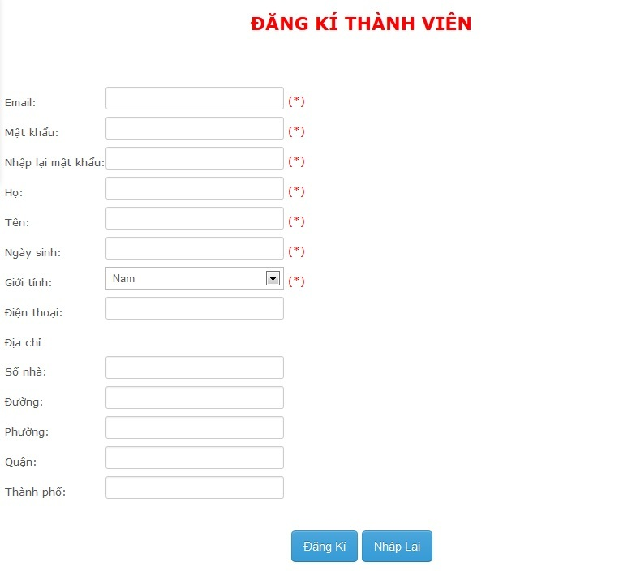
Figure 67 – GUI_”Đăng Kí”
- Đây là chức năng của khách.
- Để đăng kí tài khoản:
- Nhấn vào dòng chữ "Đăng kí" trên góc phải màn hình.
- Nhập vào những thông tin sau:
Email | Nhập email.  Đây là khung cần thiết.
Mật khẩu | Nhập mật khẩu.  Đây là khung cần thiết.
Nhập lại mật khẩu | Nhập lại mật khẩu giống hệt bên trên.  Đây là khung cần thiết.
Họ | Nhập họ.  Đây là khung cần thiết.
Tên | Nhập tên.  Đây là khung cần thiết.
Ngày sinh | Nhập ngày sinh.  Đây là khung cần thiết.
Giới tính | Nhập giới tính.  Đây là khung cần thiết.
Điện thoại | Nhập số điện thoại.
Số nhà | Nhập số nhà.
Đường | Nhập tên đường.
Phường | Nhập tên phường.
Quận | Nhập tên quận.
Thành phố | Nhập tên thành phố.
- Nhấn nút "Đăng kí".

Chỉnh Sửa Thông Tin Cá Nhân
- Đây là chức năng cho tất cả tài khoản.
- Để thay đổi thông tin cá nhân:
- Nhấn vào dòng chữ "Thông tin cá nhân" trên góc phải màn hình.
- Thay đổi những thông tin mà bạn muốn:
Email | Nhập email.  Đây là khung cần thiết.
Mật khẩu | Nhập mật khẩu.  Đây là khung cần thiết.
Nhập lại mật khẩu | Nhập lại mật khẩu giống hệt bên trên.  Đây là khung cần thiết.
Họ | Nhập họ.  Đây là khung cần thiết.
Tên | Nhập tên.  Đây là khung cần thiết.
Ngày sinh | Nhập ngày sinh.  Đây là khung cần thiết.
Giới tính | Nhập giới tính.  Đây là khung cần thiết.
Điện thoại | Nhập số điện thoại.
Số nhà | Nhập số nhà.
Đường | Nhập tên đường.
Phường | Nhập tên phường.
Quận | Nhập tên quận.
Thành phố | Nhập tên thành phố.
- Nhấn nút "Lưu thay đổi".

Đăng Nhập
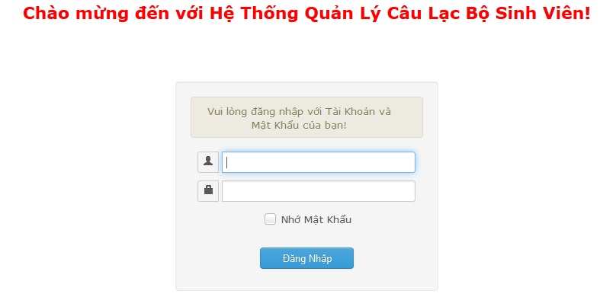
Figure 68 – GUI_”Đăng Nhập”
- Đây là chức năng cho tất cả tài khoản.
- Để đăng nhập tài khoản:
- Nhấn vào dòng chữ "Đăng nhập" trên góc phải màn hình.
- Nhập vào những thông tin sau:
Tài khoản | Nhập tài khoản cá nhân.  Đây là khung cần thiết.
Mật khẩu | Nhập mật khẩu cá nhân.  Đây là khung cần thiết.
- Nhấn nút "Đăng nhập".

Quên Mật Khẩu
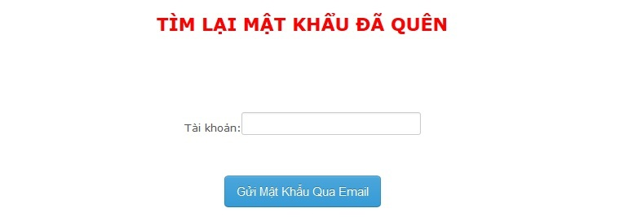
Figure 69 – GUI_”Quên Mật Khẩu”
- Đây là chức năng cho tất cả tài khoản.
- Để lấy lại mật khẩu:
- Nhấn vào dòng chữ "Quên mật khẩu" trên góc phải màn hình.
- Nhập vào những thông tin sau:
Tài khoản | Nhập tài khoản cá nhân.  Đây là khung cần thiết.
- Nhấn nút "Gửi mật khẩu qua email".

Gửi – Xóa Yêu Cầu Gia Nhập CLB
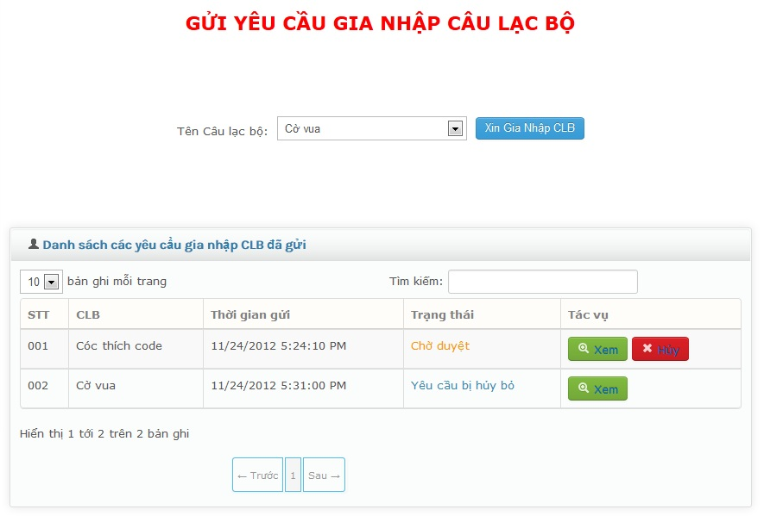
Figure 70 – GUI_”Gửi – Xóa Yêu Cầu Gia Nhập CLB”
- Chức năng này dành cho tài khoản chưa tham gia câu lạc bộ.
- Để gửi yêu cầu gia nhập câu lạc bộ:
- Nhấn "Gửi yêu cầu gia nhập câu lạc bộ" trên thanh Thực đơn.
- Nhập vào những thông tin sau:
Tên câu lạc bộ | Chọn câu lạc bộ cần tham gia.  Đây là khung cần thiết.
- Nhấn nút "Xin gia nhập CLB".
- Nhấn nút "Hủy" để tự xóa yêu cầu gia nhập câu lạc bộ.

Quản Lý Yêu Cầu Gia Nhập CLB
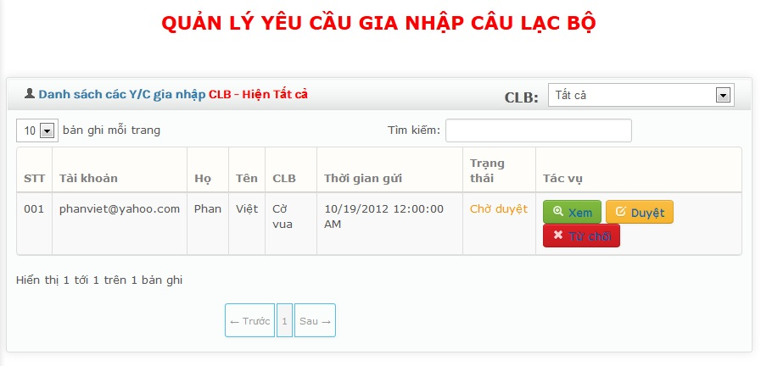
Figure 71 – GUI_”Quản Lý Yêu Cầu Gia Nhập CLB”
- Đây là chức năng của chủ nhiệm câu lạc bộ.
- Để quản lý yêu cầu gia nhập câu lạc bộ:
- Nhấn vào "Quản lý yêu cầu gia nhập câu lạc bộ" trên thanh Thực đơn.
- Nhấn nút "Xem" để xem thông tin chi tiết yêu câu.
- Nhấn nút "Duyệt" để chấp nhận yêu cầu gia nhập câu lạc bộ.
- Nhấn nút "Từ chối" để từ chối yêu cầu gia nhập câu lạc bộ.

Quản Lý Thành Viên CLB
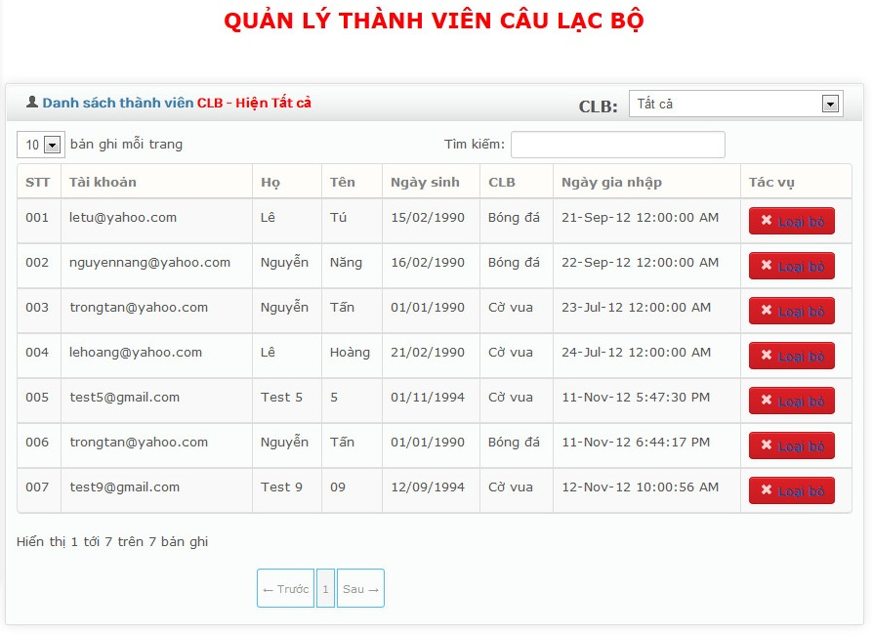
Figure 72 – GUI_”Quản Lý Thành Viên CLB”
- Đây là chức năng của chủ nhiệm câu lạc bộ.
- Để quản lý thành viên câu lạc bộ:
- Nhấn "Quản lý thành viên câu lạc bộ" trên thanh Thực đơn.
- Nhấn nút "Loại bỏ" để loại bỏ thành viên ra khỏi câu lạc bộ.

Quản Lý Chủ Nhiệm CLB
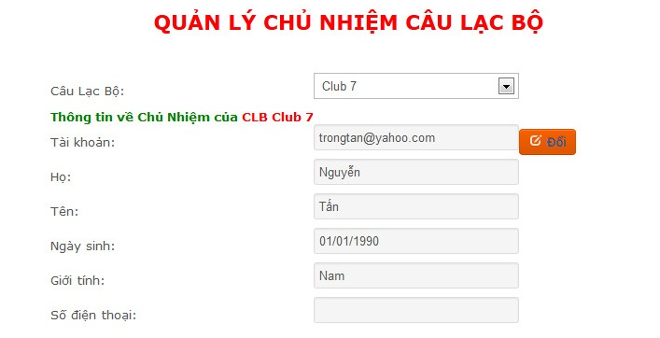
Figure 73 – GUI_”Quản Lý Chủ Nhiệm CLB”
- Đây là chức năng của thành viên bản quản trị.
- Để quản lý chủ nhiệm câu lạc bộ:
- Nhấn "Quản lý chủ nhiệm câu lạc bộ" trên thanh Thực đơn.
- Nhập vào những thông tin sau:
Câu lạc bộ | Nhập tên câu lạc bộ cần thay đổi.  Đây là khung cần thiết.
Tài khoản | Nhập vào tài khoản muốn cho làm chủ nhiệm mới.  Đây là khung cần thiết.
- Nhấn nút "Đổi".

Gửi Yêu Cầu Tạo CLB
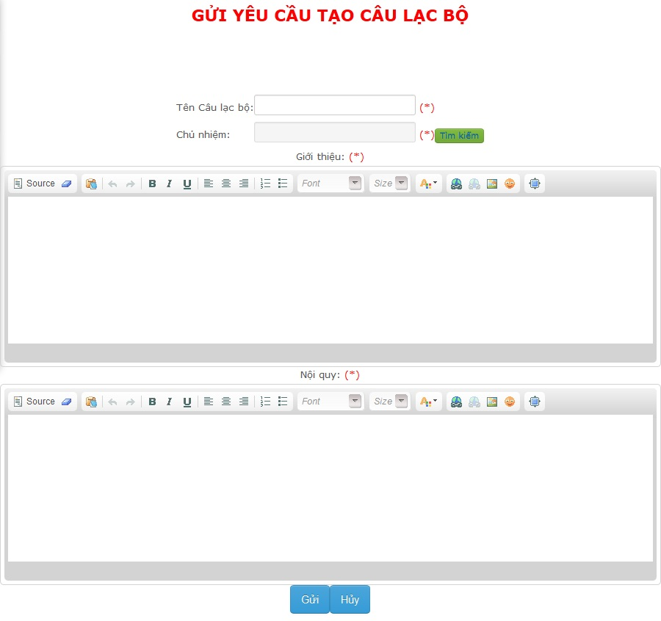
Figure 74 – GUI_”Gửi Yêu Cầu Tạo CLB”
- Đây là chức năng của thành viên ban quản trị.
- Để gửi yêu cầu tạo câu lạc bộ:
- Nhấn "Gửi yêu cầu tạo câu lạc bộ" trên thanh Thực đơn.
- Nhập những thông tin sau:
Tên câu lạc bộ | Nhập tên câu lạc bộ cần tạo.  Đây là khung cần thiết.
Chủ nhiệm | Nhập tên chủ nhiệm câu lạc bộ.  Đây là khung cần thiết.
Giới thiệu | Nhập thông tin giới thiệu về câu lạc bộ.  Đây là khung cần thiết.
Nội quy | Nhập nội quy của câu lạc bộ.  Đây là khung cần thiết.
- Nhấn nút "Gửi" để gửi yêu cầu.
- Nhấn nút "Hủy" để hủy yêu cầu.

Quản Lý Yêu Cầu Tạo CLB
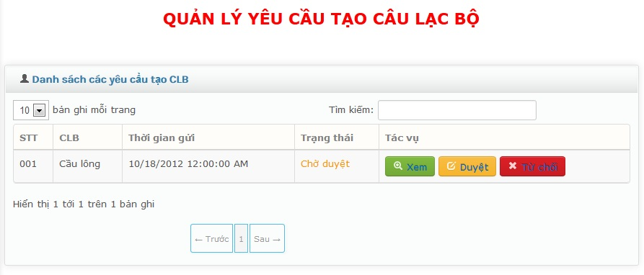
Figure 75 – GUI_”Quản Lý Yêu Cầu Tạo CLB”
- Đây là chức năng của chủ tịch.
- Để quản lý yêu cầu tạo câu lạc bộ:
- Nhấn "Quản lý yêu cầu tạo câu lạc bộ" trên thanh Thực đơn.
- Nhấn nút "Xem" để xem chi tiết yêu cầu.
- Nhấn nút "Duyệt" để chấp nhận yêu cầu.
- Nhấn nút "Từ chối" để từ chối yêu cầu.

Tạo Thành Viên Ban Quản Trị
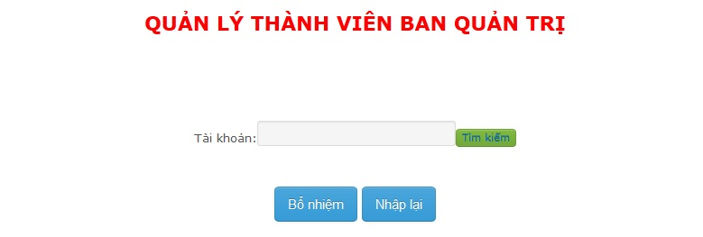
Figure 76 – GUI_”Tạo Thành Viên Ban Quản Trị”
- Đây là chức năng của chủ tịch.
- Để tạo thành viên ban quản trị:
- Nhấn "Tạo thành viên ban quản trị" trên thanh Thực đơn.
- Nhập vào những thông tin sau:
Tài khoản | Nhập tài khoản muốn bổ nhiệm làm thành viên ban quản trị.  Đây là khung cần thiết.
- Nhấn nút "Bổ nhiệm".

Sửa Thông Tin CLB
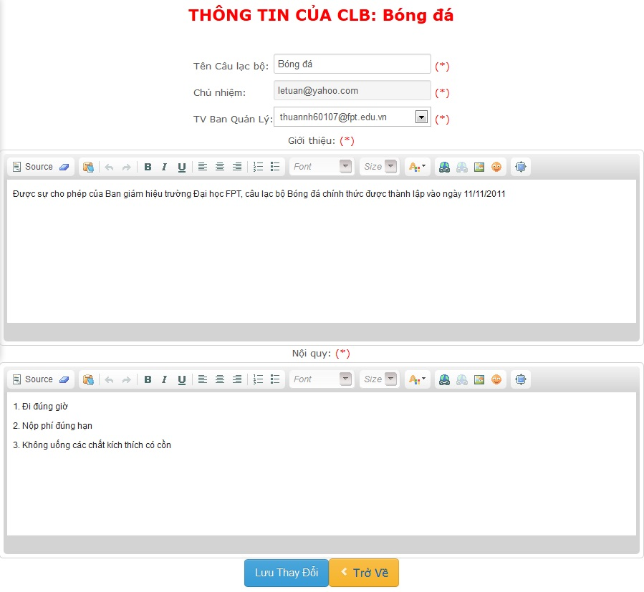
Figure 77 – GUI_”Sửa Thông Tin CLB”
- Đây là chức năng của chủ tịch.
- Để chỉnh sửa thông tin câu lạc bộ:
- Nhấn "Quản lý câu lạc bộ" trên thanh Thực đơn.
- Nhất nút "Sửa" trong trang Quản lý câu lạc bộ.
- Sửa những thông tin bạn muốn:
Tên câu lạc bộ | Nhập tên câu lạc bộ.  Đây là khung cần thiết.
Chủ nhiệm | Ko cho phép sửa.  Đây là khung cần thiết.
Thànhviên ban quản lý | Nhập tên thành viên ban quản lý.  Đây là khung cần thiết.
Giới thiệu | Nhập thông tin giới thiệu về câu lạc bộ.  Đây là khung cần thiết.
Nội quy | Nhập nội quy của câu lạc bộ.  Đây là khung cần thiết.
- Nhấn nút "Lưu thay đổi".

Quản Lý Chủ Tịch
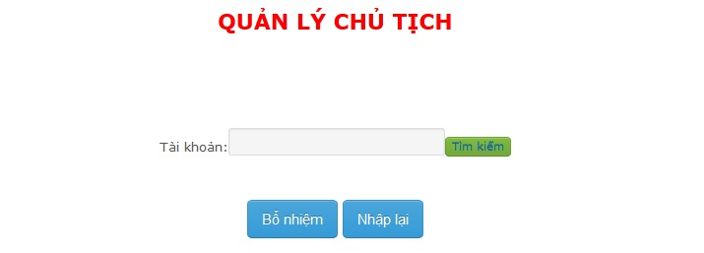
Figure 78 – GUI_”Quản Lý Chủ Tịch”
- Đây là chức năng của admin.
- Để quản lý chủ tịch:
- Nhấn vào "Quản lý chủ tịch" trên thanh Thực đơn.
- Nhập vào những thông tin sau:
Tài khoản | Nhập tài khoản muốn bổ nhiệm làm chủ tịch.  Đây là khung cần thiết.
- Nhấn nút "Bổ nhiệm".

Quản Lý Tài Khoản
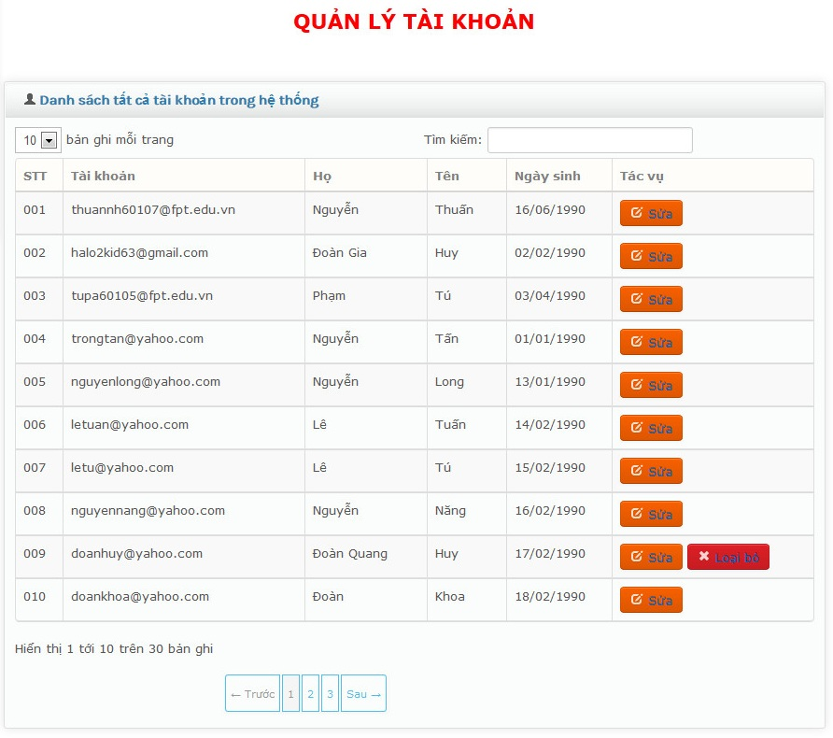
Figure 79 – GUI_”Quản Lý Tài Khoản”
- Đây là chức năng của admin.
- Để quản lý tài khoản:
- Nhấn "Quản lý tài khoản" trên thanh Thực đơn.
- Nhấn nút "Sửa" để thay đổi thông tin tài khoản.
- Nhấn nút "Loại bỏ" để xóa tài khoản.

Quản Lý Hoạt Động

Tạo Sự Kiện
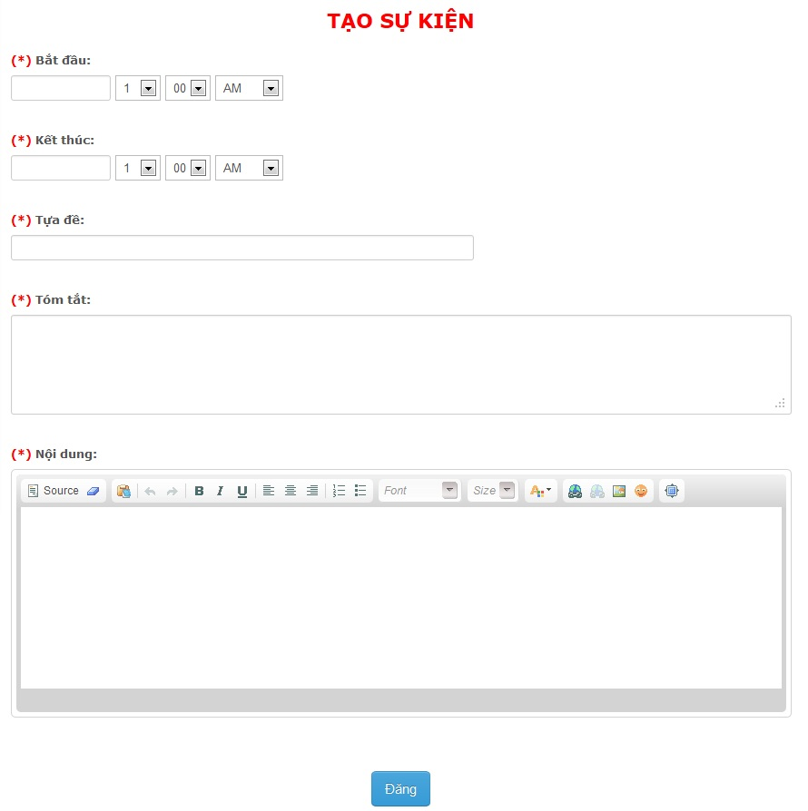
Figure 80 – GUI_”Tạo Sự Kiện”
- Đây là chức năng của chủ nhiệm câu lạc bộ.
- Để tạo sự kiện:
- Nhấn vào "Xem tất cả câu lạc bộ" trên thanh Thực đơn rồi chọn câu lạc bộ mình quản lý.
- Nhấn nút "Tạo sự kiện".
- Nhập vào những thông tin sau:
Bắt đầu | Nhập thời gian bắt đầu sự kiện.  Đây là khung cần thiết.
Kết thúc | Nhập thời gian kết thúc sự kiện.  Đây là khung cần thiết.
Tựa để | Nhập tên sự kiện.  Đây là khung cần thiết.
Tóm tắt | Nhập tóm tắt sơ lược sự kiện.  Đây là khung cần thiết.
Nội dung | Nhập nội dung của sự kiện.  Đây là khung cần thiết.
- Nhấn nút "Đăng".

Sửa Sự Kiện
- Đây là chức năng của chủ nhiệm câu lạc bộ.
- Để sửa sự kiện:
- Nhấn vào "Xem tất cả câu lạc bộ" trên thanh Thực đơn rồi chọn câu lạc bộ mình quản lý.
- Chọn sự kiện muốn sửa.
- Nhấn nút "Sửa".
- Sửa những thông tin bạn muốn:
Bắt đầu | Nhập thời gian bắt đầu sự kiện.  Đây là khung cần thiết.
Kết thúc | Nhập thời gian kết thúc sự kiện.  Đây là khung cần thiết.
Tựa để | Nhập tên sự kiện.  Đây là khung cần thiết.
Tóm tắt | Nhập tóm tắt sơ lược sự kiện.  Đây là khung cần thiết.
Nội dung | Nhập nội dung của sựa kiện.  Đây là khung cần thiết.
- Nhấn nút "Lưu".

Xóa Sự Kiện
- Đây là chức năng của chủ nhiệm câu lạc bộ.
- Để xóa sự kiện:
- Nhấn vào "Xem tất cả câu lạc bộ" trên thanh Thực đơn rồi chọn câu lạc bộ mình quản lý.
- Chọn sự kiện muốn xóa.
- Nhấn nút "Xóa".

Tạo Bài Báo
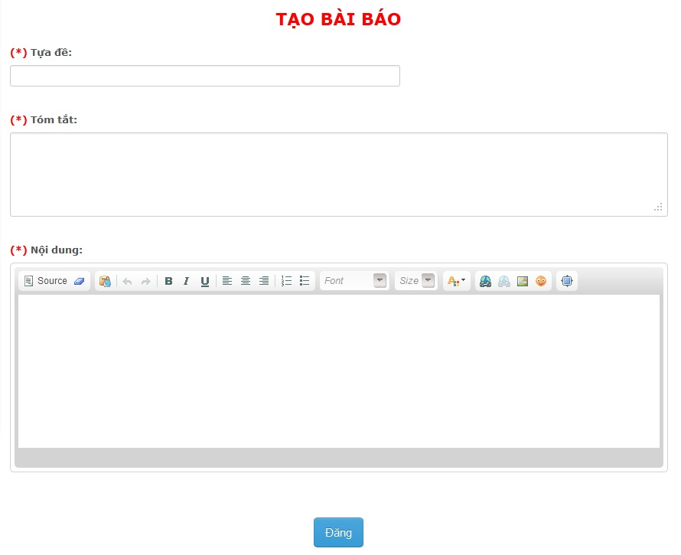
Figure 81 – GUI_”Tạo Bài Báo”
- Đây là chức năng của thành viên câu lạc bộ.
- Để tạo bài báo:
- Chọn sự kiện muốn tạo bài báo.
- Nhấn nút "Tạo bài báo".
- Nhập vào những thông tin sau:
Tựa đề | Nhập tựa đề bài báo.  Đây là khung cần thiết.
Tóm tắt | Nhập tóm tắt sơ lược.  Đây là khung cần thiết.
Nội dung | Nhập nội dung bài báo.  Đây là khung cần thiết.
- Nhấn nút "Đăng".

Sửa Bài Báo
- Đây là chức năng của thành viên câu lạc bộ.
- Để sửa bài báo:
- Chọn sự kiện có bài báo muốn sửa.
- Chọn bài báo cần sửa.
- Nhấn nút "Sửa".
- Sửa những thông tin bạn muốn:
Tựa đề | Nhập tựa đề bài báo.  Đây là khung cần thiết.
Tóm tắt | Nhập tóm tắt sơ lược.  Đây là khung cần thiết.
Nội dung | Nhập nội dung bài báo.  Đây là khung cần thiết.
- Nhấn nút "Lưu".

Xóa Bài Báo
- Đây là chức năng của chủ nhiệm câu lạc bộ.
- Để xóa bài báo:
- Chọn sự kiện có bài báo muốn xóa.
- Chọn bài báo cần xóa.
- Nhấn nút "Xóa".

Duyệt – Từ Chối Bài Báo
- Đây là chức năng của chủ nhiệm câu lạc bộ.
- Để duyệt – từ chối bài báo:
- Chọn sự kiện có bài báo cần duyệt.
- Chọn bài báo đang chờ duyệt.
- Nhấn nút "Duyệt" để duyệt bài báo.
- Nhấn nút “Từ Chối” để từ chối bài báo.

Tạo Bình Luận
- Đây là chức năng của mọi tài khoản trừ khách.
- Để tạo bình luận:
- Chọn bài báo muốn bình luận.
- Nhập vào khung "Bình luận".
- Nhấn nút "Đăng".

Sửa Bình Luận
- Đây là chức năng của mọi tài khoản trừ khách.
- Để sửa bình luận:
- Chọn bài báo có bình luận cần sửa.
- Nhấn nút "Sửa".
- Nhập lại vào khung "Bình luận".
- Nhấn nút "Lưu".

Xóa Bình Luận
- Đây là chức năng của chủ nhiệm câu lạc bộ.
- Để xóa bình luận:
- Chọn bài báo có bình luận cần xóa.
- Nhấn nút "Xóa" ở bình luận cần xóa.

Quản Lý Tài Chính

Tạo Khoản Thu
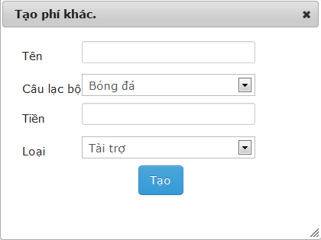
Figure 82 – GUI_”Tạo Khoản Thu”
- Đây là chức năng của chủ nhiệm câu lạc bộ.
- Để tạo thu nhập:
- Nhấn "Chi phí khác" trên thanh Thực đơn để chuyển đến trang Thu nhập.
- Nhấn nút "Tạo mới".
- Nhập vào những thông tin sau:
Loại | Nhập loại cho thu nhập.  Đây là khung cần thiết.
Tên câu lạc bộ | Nhập tên câu lạc bộ.  Đây là khung cần thiết.
Tên | Nhập tên của thu nhập.  Đây là khung cần thiết.
Số tiền | Nhập số tiền.  Đây là khung cần thiết.
- Nhấn nút "Tạo".

Sửa Khoản Thu
- Đây là chức năng của chủ nhiệm câu lạc bộ.
- Để sửa thu nhập:
- Nhấn "Chi phí khác" trên thanh Thực đơn để chuyển đến trang Thu nhập.
- Nhấn nút "Sửa".
- Sửa những thông tin mà bạn muốn:
Loại | Nhập loại cho thu nhập.  Đây là khung cần thiết.
Tên câu lạc bộ | Nhập tên câu lạc bộ.  Đây là khung cần thiết.
Tên | Nhập tên của thu nhập.  Đây là khung cần thiết.
Số tiền | Nhập số tiền.  Đây là khung cần thiết.
- Nhấn nút "Lưu".

Tạo Phí Tháng
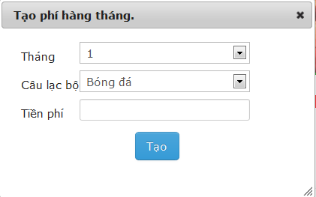
Figure 83 – GUI_”Tạo Phí Tháng”
- Đây là chức năng của chủ nhiệm câu lạc bộ.
- Để tạo phí tháng:
- Nhấn "Chi phí tháng" trên thanh Thực đơn để chuyển đến trang Phí tháng.
- Nhấn nút "Tạo mới".
- Nhập vào những thông tin sau:
Tháng | Nhập tháng.  Đây là khung cần thiết.
Số tiền | Nhập số tiền.  Đây là khung cần thiết.
Trạng thái | Nhập trạng thái đóng tiền hay chưa.  Đây là khung cần thiết.
- Nhấn nút "Tạo".

Sửa Phí Tháng
- Đây là chức năng của chủ nhiệm câu lạc bộ.
- Để sửa phí tháng:
- Nhấn "Chi phí tháng" trên thanh Thực đơn để chuyển đến trang Phí tháng.
- Nhấn nút "Sửa".
- Sửa những thông tin mà bạn muốn:
Tháng | Nhập tháng.  Đây là khung cần thiết.
Số tiền | Nhập số tiền.  Đây là khung cần thiết.
Trạng thái | Nhập trạng thái đóng tiền hay chưa.  Đây là khung cần thiết.
- Nhấn nút "Lưu".

Tạo Thực Chi
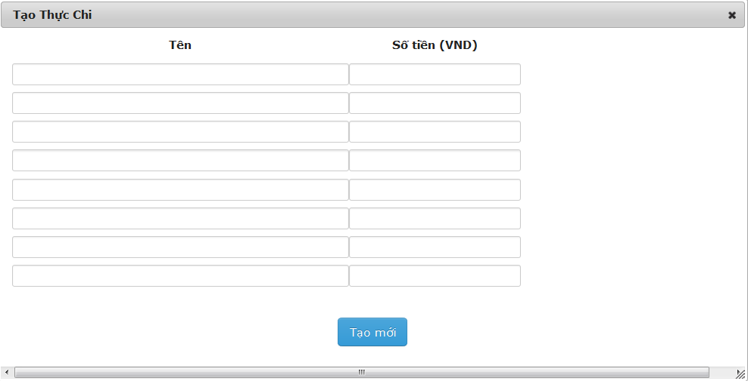
Figure 84 – GUI_”Tạo Thực Chi”
- Đây là chức năng của chủ nhiệm câu lạc bộ.
- Để tạo thực chi:
- Nhấn vào "Xem tất cả câu lạc bộ" trên thanh Thực đơn rồi chọn câu lạc bộ mình quản lý.
- Chọn sự kiện.
- Nhấn vào “Tạo thực chi”
- Nhập vào những thông tin sau:
Tên thực chi | Nhập tên thực chi.  Đây là khung cần thiết.
Số tiền | Nhập số tiền.  Đây là khung cần thiết.
- Nhấn nút "Tạo".

Sửa Thực Chi
- Đây là chức năng của chủ nhiệm câu lạc bộ.
- Để sửa thực chi:
- Nhấn vào "Xem tất cả câu lạc bộ" trên thanh Thực đơn rồi chọn câu lạc bộ mình quản lý.
- Chọn sự kiện.
- Nhấn vào “Sửa thực chi”.
- Sửa những thông tin mà bạn muốn:
Tên thực chi | Nhập tên thực chi.  Đây là khung cần thiết.
Số tiền | Nhập số tiền.  Đây là khung cần thiết.
- Nhấn nút "Lưu".

Tạo Dự Chi
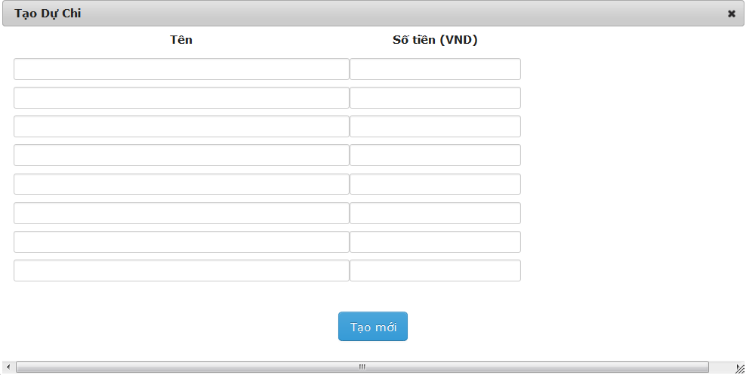
Figure 85 – GUI_”Tạo Dự Chi”
- Đây là chức năng của chủ nhiệm câu lạc bộ.
- Để tạo dự chi:
- Nhấn vào "Xem tất cả câu lạc bộ" trên thanh Thực đơn rồi chọn câu lạc bộ mình quản lý.
- Chọn sự kiện.
- Nhấn vào “Tạo dự chi”.
- Nhập vào những thông tin sau:
Tên dự chi | Nhập tên dự chi.  Đây là khung cần thiết.
Số tiền | Nhập số tiền.  Đây là khung cần thiết.
- Nhấn nút "Tạo".

Tạo Sự Kiện
- Đây là chức năng của chủ nhiệm câu lạc bộ.
- Để sửa dự chi:
- Nhấn vào "Xem tất cả câu lạc bộ" trên thanh Thực đơn rồi chọn câu lạc bộ mình quản lý.
- Chọn sự kiện.
- Nhấn vào “Sửa dự chi”.
- Nhập vào những thông tin sau:
Tên dự chi | Nhập tên dự chi.  Đây là khung cần thiết.
Số tiền | Nhập số tiền.  Đây là khung cần thiết.
- Nhấn nút "Lưu".

Hỗ Trợ Người Dùng

Báo Cáo Tài Chính
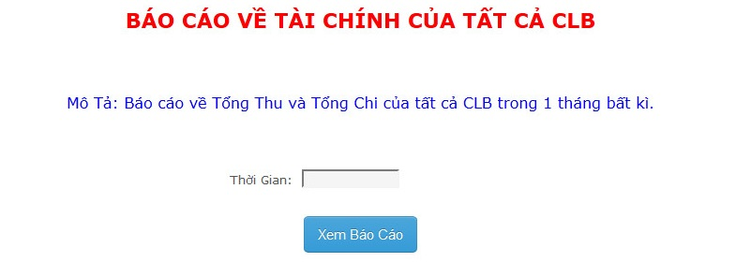
Figure 86 – GUI_”Báo Cáo Tài Chính”
- Đây là chức năng của chủ tịch, thành viên ban quản trị, chủ nhiệm và thành viên câu lạc bộ.
- Để xem báo cáo tài chính:
- Nhấn vào "Báo cáo tài chính" trên thanh Thực đơn.
- Nhập vào những thông tin sau:
Thời gian | Nhập thời gian, đơn vị tính là tháng.  Đây là khung cần thiết.
- Nhấn "Xem báo cáo" để xem báo cáo.
- Nhấn "Export" để chuyển báo cáo sang các dạng file khác.

Báo Cáo Về Sự Kiện
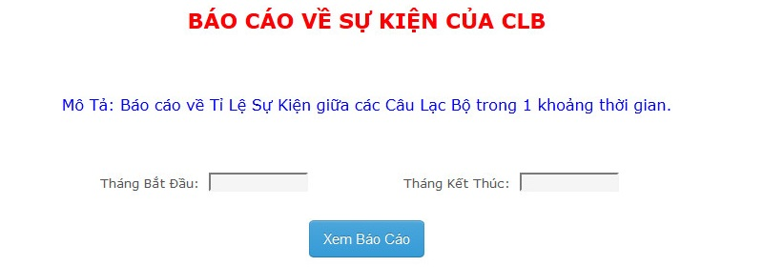
Figure 87 – GUI_”Báo Cáo Về Sự Kiện”
- Đây là chức năng của tất cả tài khoản ngoại trừ khách.
- Để xem báo cáo về sự kiện:
- Nhấn vào "Báo cáo về sự kiện" trên thanh Thực đơn.
- Nhập vào những thông tin sau:
Tháng bắt đầu | Nhập tháng bắt đầu.  Đây là khung cần thiết.
Tháng kết thúc | Nhập tháng kết thúc.  Đây là khung cần thiết.
- Nhấn "Xem báo cáo" để xem báo cáo.
- Nhấn "Export" để chuyển báo cáo sang các dạng file khác.

Báo Cáo Về Thành Viên
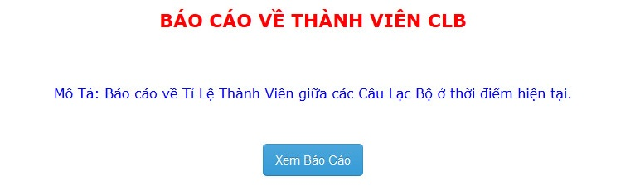
Figure 88 – GUI_”Báo Cáo Về Thành Viên”
- Đây là chức năng của tất cả tài khoản ngoại trừ khách.
- Để xem báo cáo về thành viên câu lạc bộ:
- Nhấn vào "Báo cáo về thành viên" trên thanh Thực đơn.
- Nhấn "Xem báo cáo" để xem báo cáo.
- Nhấn "Export" để chuyển báo cáo sang các dạng file khác.

Tìm Kiếm
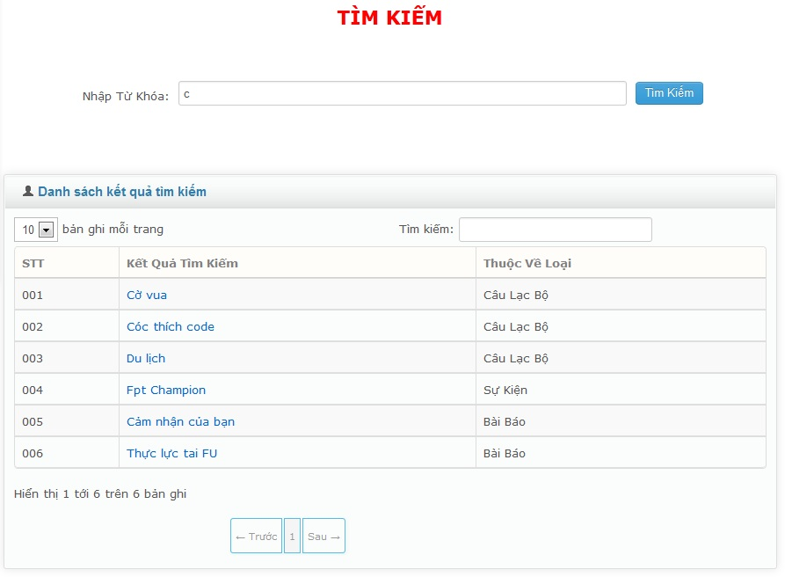
Figure 89 – GUI_”Tìm Kiếm”
- Chức năng này dành cho mọi tài khoản.
- Dùng để tìm kiếm tất cả câu lạc bộ, sự kiện, bài báo theo các kí tự :
- Nhấn vào "Tìm kiếm" trên thanh Thực đơn.
- Nhập kí tự cần tìm vào khung "Nhập từ khóa".
- Nhấn nút "Tìm kiếm" để hiển thị dữ liệu tìm kiếm.
- Nhấn vào mỗi kết quả tìm kiếm để xem thông tin chi tiết của nó.

Others
N/A

