

**AHSANULLAH UNIVERSITY OF SCIENCE AND TECHNOLOGY**

Department of Computer Science and Engineering

**Project Name**: DX-Ball

Group members: 1.Soumik Das (**11.02.04.003**)

2.Rauful Jamil (**11.02.04.025**)

3.Naimul Mukit (**11.02.04.009**)

Semester: 3.2

Section: A

Section group: A1

### FEATURES:



### NEW GAME

#### LOAD GAME

### SETTINGS

#### HELP

### ABOUT

#### EXIT

**New game**:  
 * Single player

**Load game**:

Start a previously saved game

**Settings**:  
*sound: sets the sound off or on

*music: a music that will be being played through the whole time

On

Off

*sfx: sound of Box hitting and Ball throughing etc.

On

Off

**Help**:

*instructions: how to play the game

*Levels: details about the levels after levels  
*History: The story on which the game is based on

**About**:

Info about the game developer

**Exit**:

Exit the game window

**Game Objects**

1.Bar: A rectangle shaped bar will be at the bottom of the game window with a constant colour.

Bar Size: Small and constant.

Bar movement: Bar will move by pressing the keyboard movement (left sticks). And that will move from left to the right.

Number of bar: one

2. Box: The boxes will be placed in a particular position. They will be rectangle in size. There number will be more than 10 or more.  
Size: Small/medium

Colour: Yellow, Red, green

Movement: Boxes won’t move.

3. Ball: A ball with a circle shape will be always moving when it touches the bar.

Size: Small  
Hitpoints: same for all boxes

Colour: Same for all levels .

4. Screen: Screen colour will change by the change of levels.

Size: Large

5. Levels: 2 levels

LEVEL: 01

**Objective:** Hitting all the Boxes in the window   
**Location**: Green Screen.

**Description**:

##### A constant sized ball will be moving and when it comes down it will touch the bar and will return to the top. If the player fails to touch the ball through bar then the ball will fall down , and the game will be over. Player will have to hit each and every boxes shown in the window to pass Level 1.

LEVEL:02

**Objective:** Hitting more Boxes than Level 1 within a particular time  
**Location**: Black Screen.  
**Description**:

##### In this Level Player will have to hit more boxes than level 1. That means the number of Boxes will increase. And there will be a particular time period. In this time period the player will have to finish his game. Otherwise the game will be Over. The rules of Level 2 will be as same as in Level 1.

**Language and tools**

* **C#**
* **Unity 3D**

**Internet Partners**

** **

What we did in our Project

##### We Used Unity game enginee for Developing our game. We needed to create multiple object to make the game. And there are some built in behavior for it, we used all of those. We used C# script to add the Behaviors. Such as the Behavior of the Paddle, Ball and Brick. And we used also other behaviors for making the game perfect. After completing gaming part we provided some extra features to it so that the game look good.

Some necessary images for our game

**  **

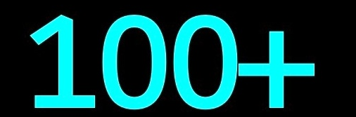  

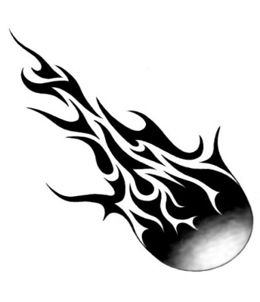 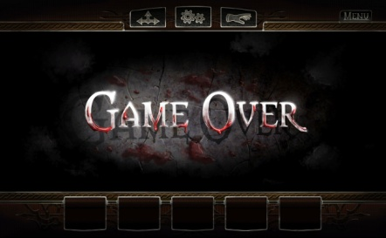

Some Game Screenshots while Coding

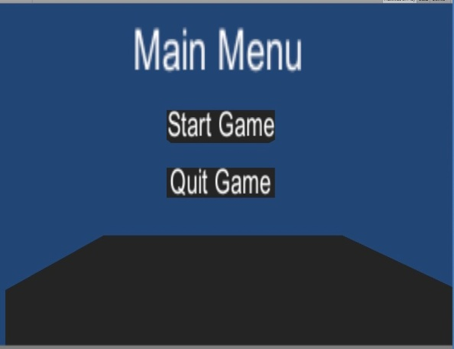 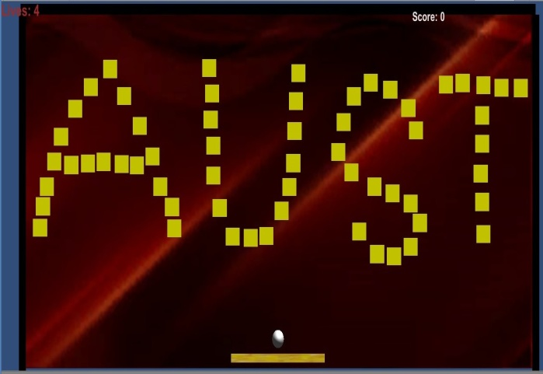

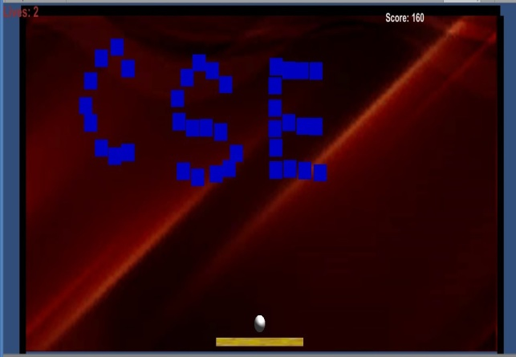

The C# scripts used in our game

* **Ball script**
* **Paddle script**
* **Brick script**
* **Death script**
* **life plus script**
* **life minus script**
* **Ball speed increase script**
* **Ball speed decrease script**
* **Double ball script**
* **100 plus script**
* **50 plus script**
* **50 minus script**
* **Game Over Script.**

##### All this scripts are added to the game. And all those contains the behaviors of the game objects.

Extra features

##### After completing the Basic parts we tried to add some extra features. we added sounds to the game for each object. And we downloaded good pictures from the Internet and put them on the Game.

Testing

##### We tested our game several times so that we make sure there are no error in it.

##### We tested each and every levels in the game.

Conclusion

##### As we are using Unity 3D game enginee we will try our best to make it a Nice Game. We will make it easy to play for everyone. At the end of the project if possible we will try to include more features.