## Front End Details

Home

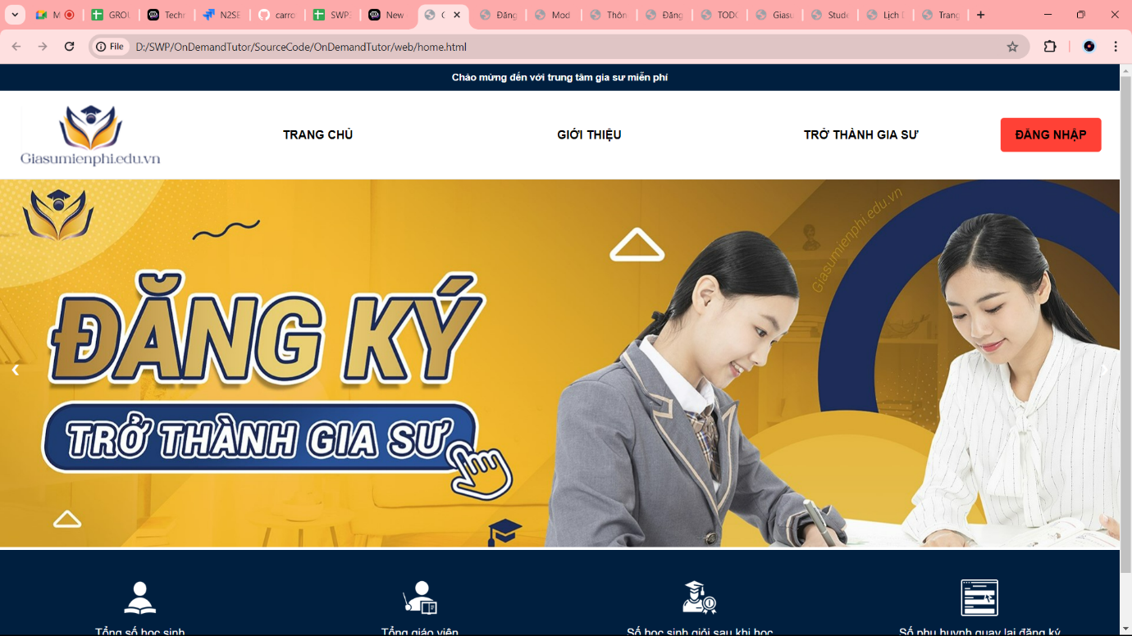

Login

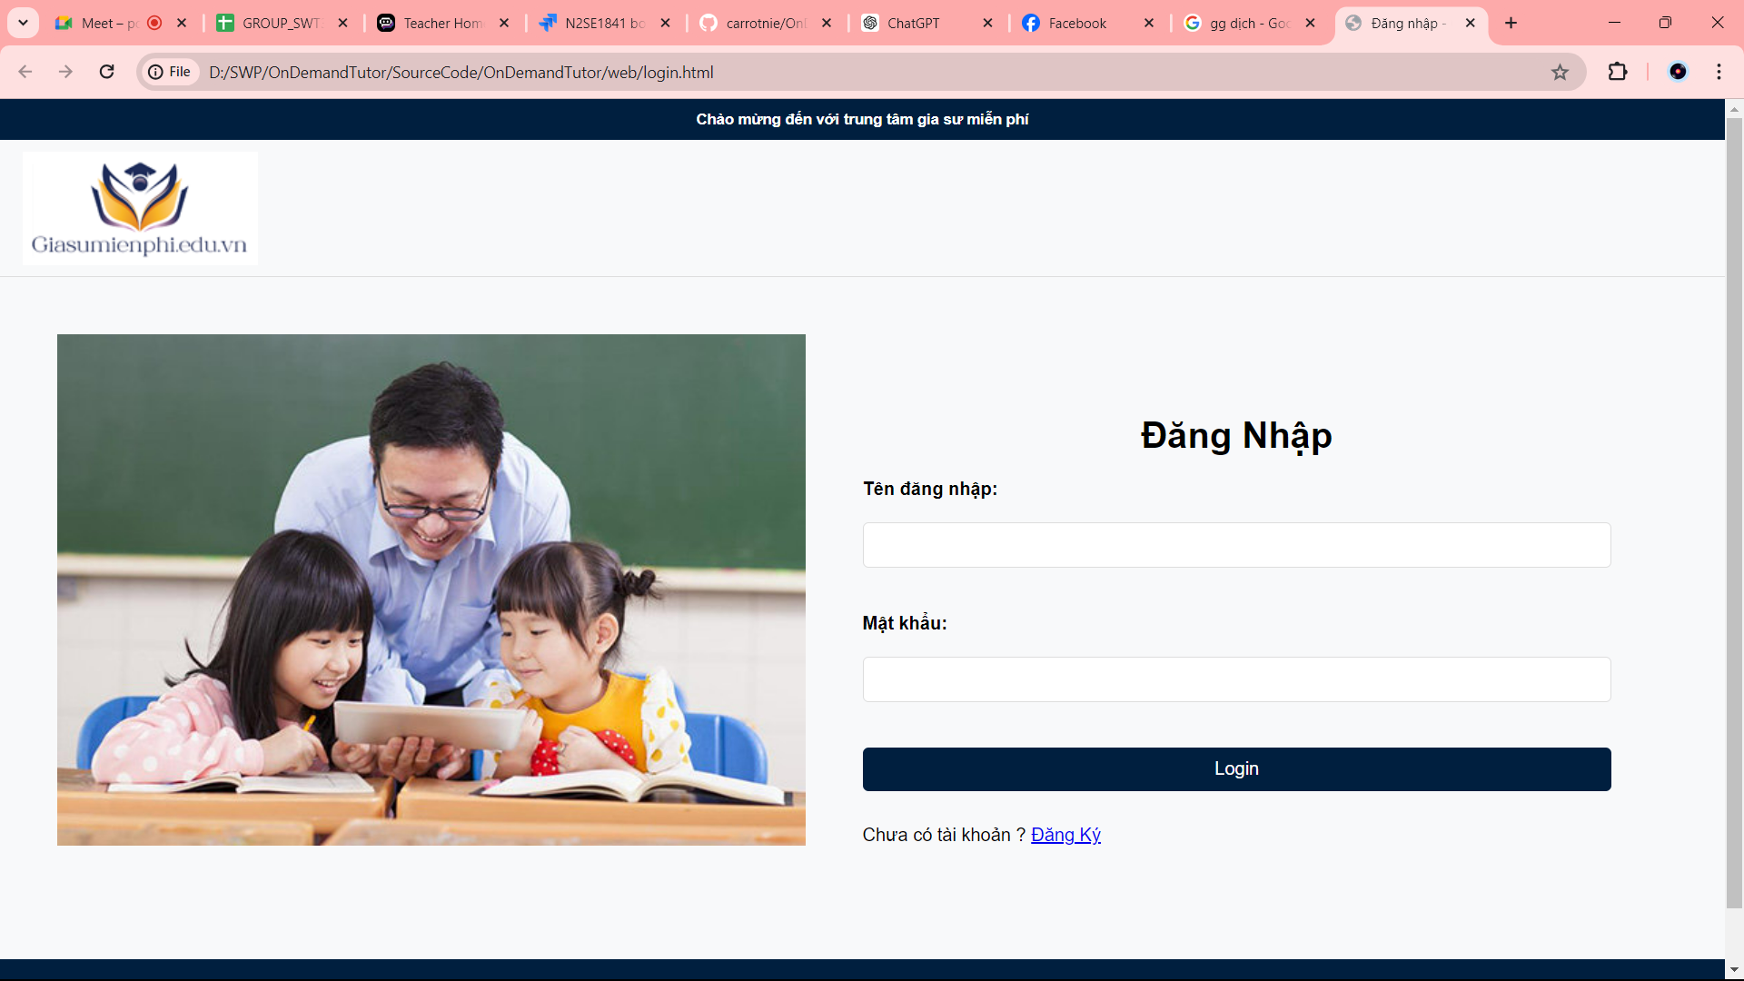

Register

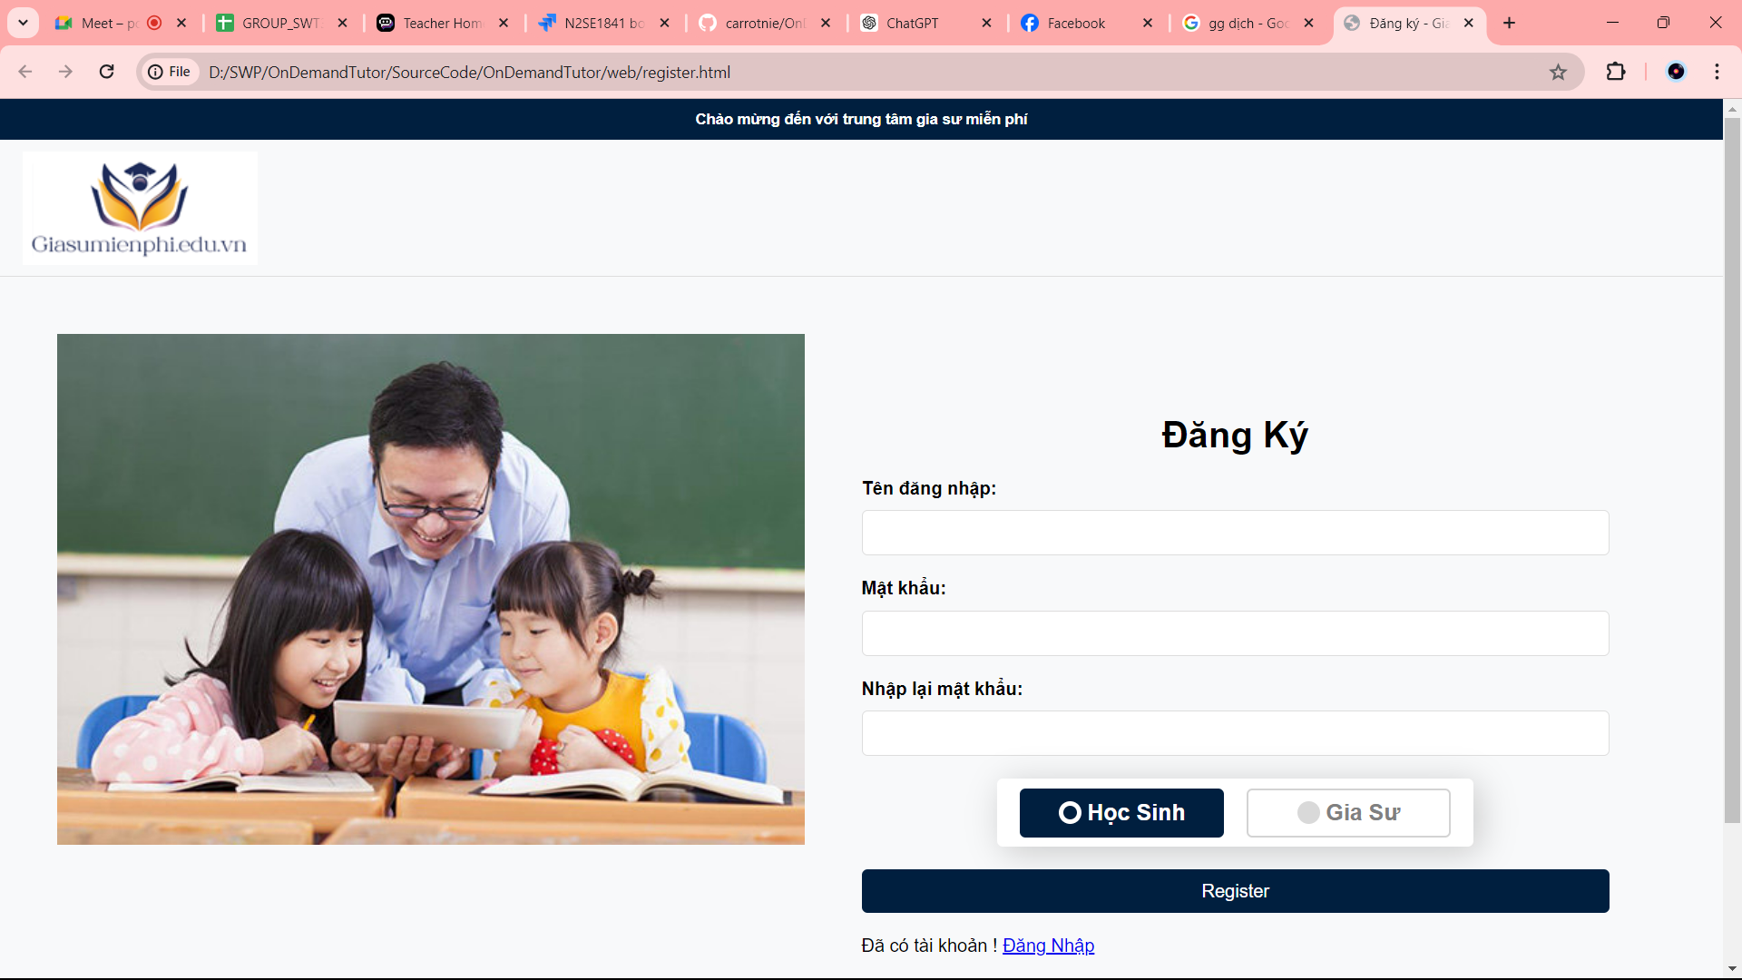

Student page

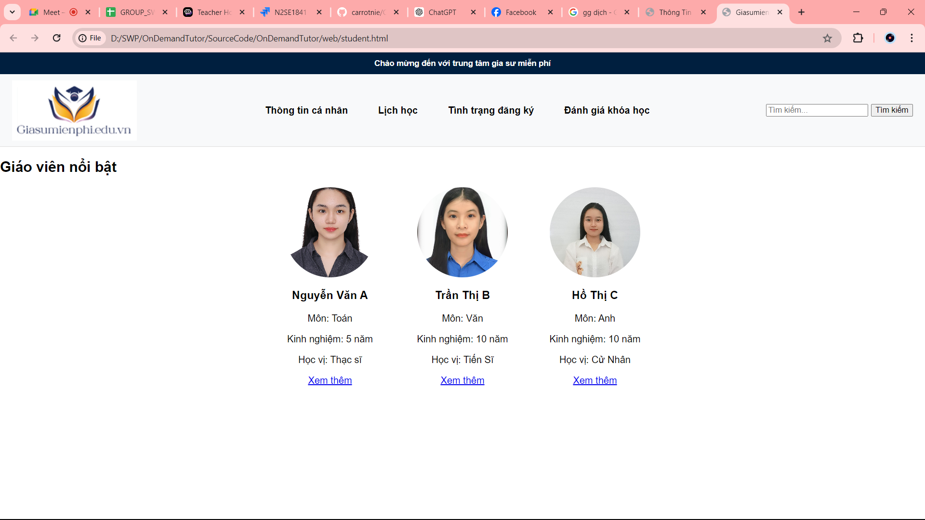

Tutor page

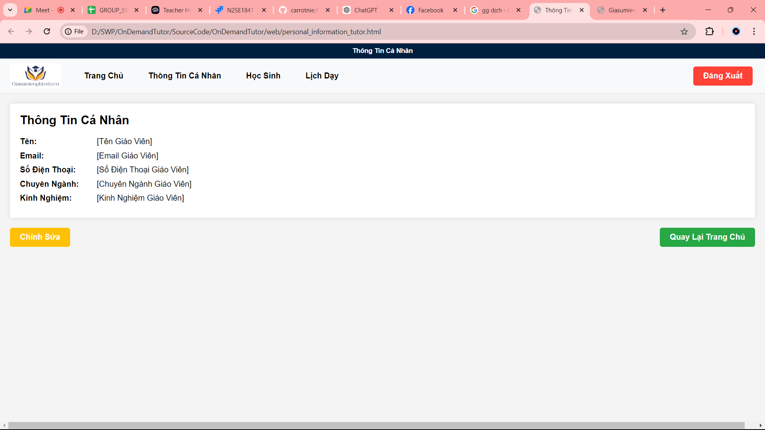

Information Tutor

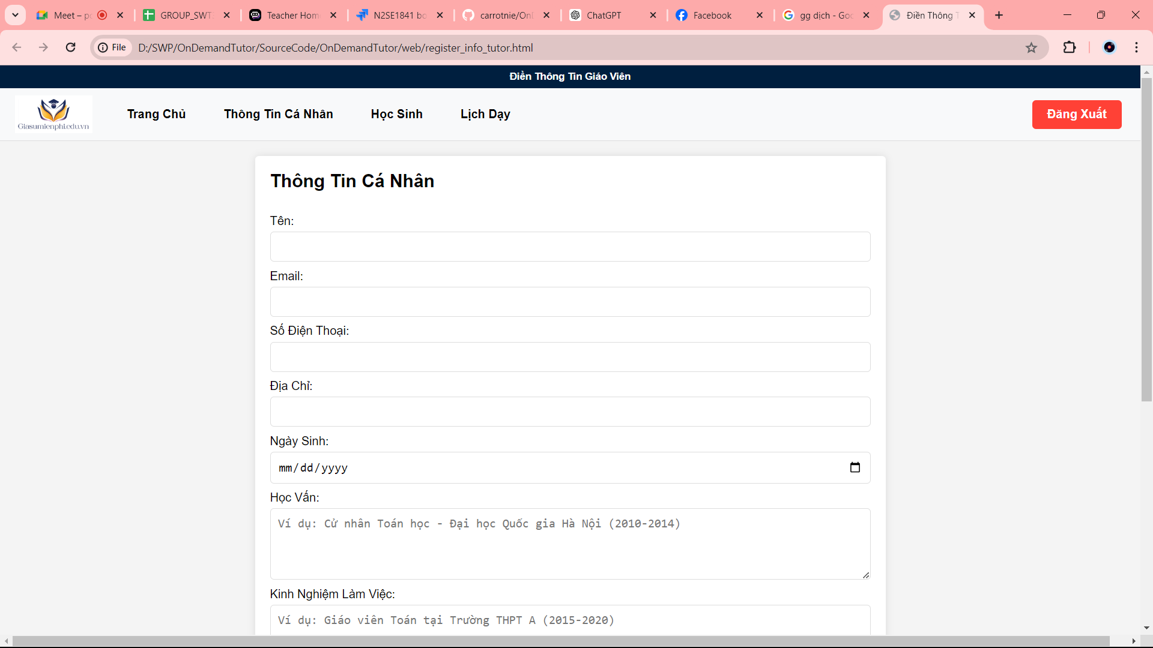

Information Student

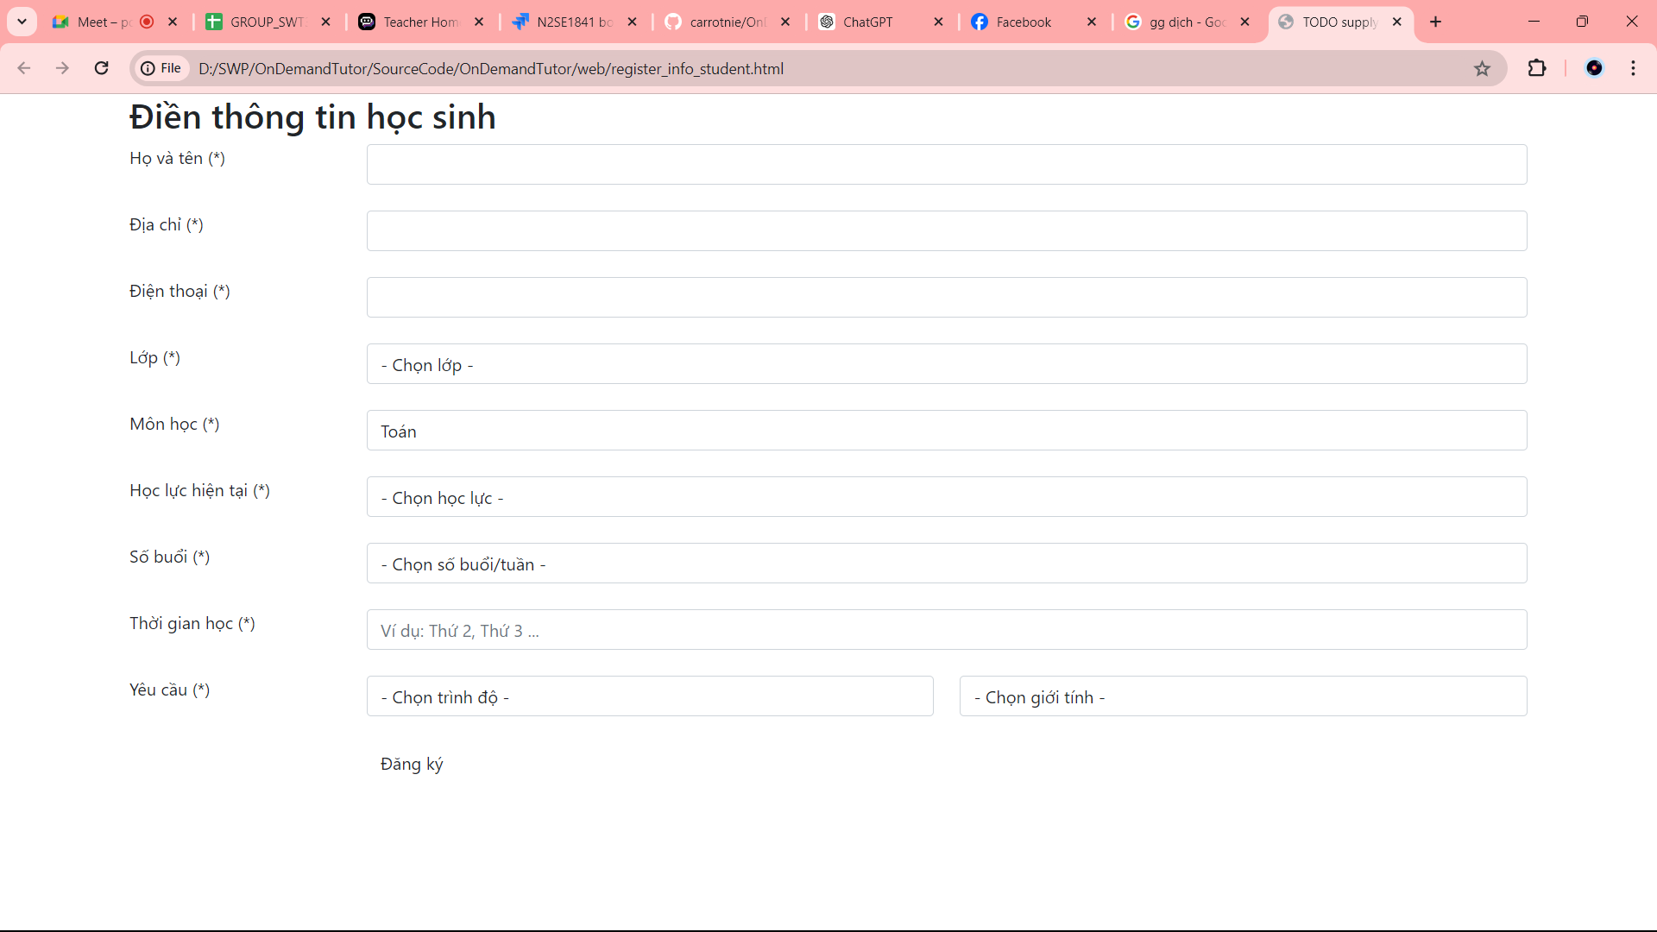

Student time table

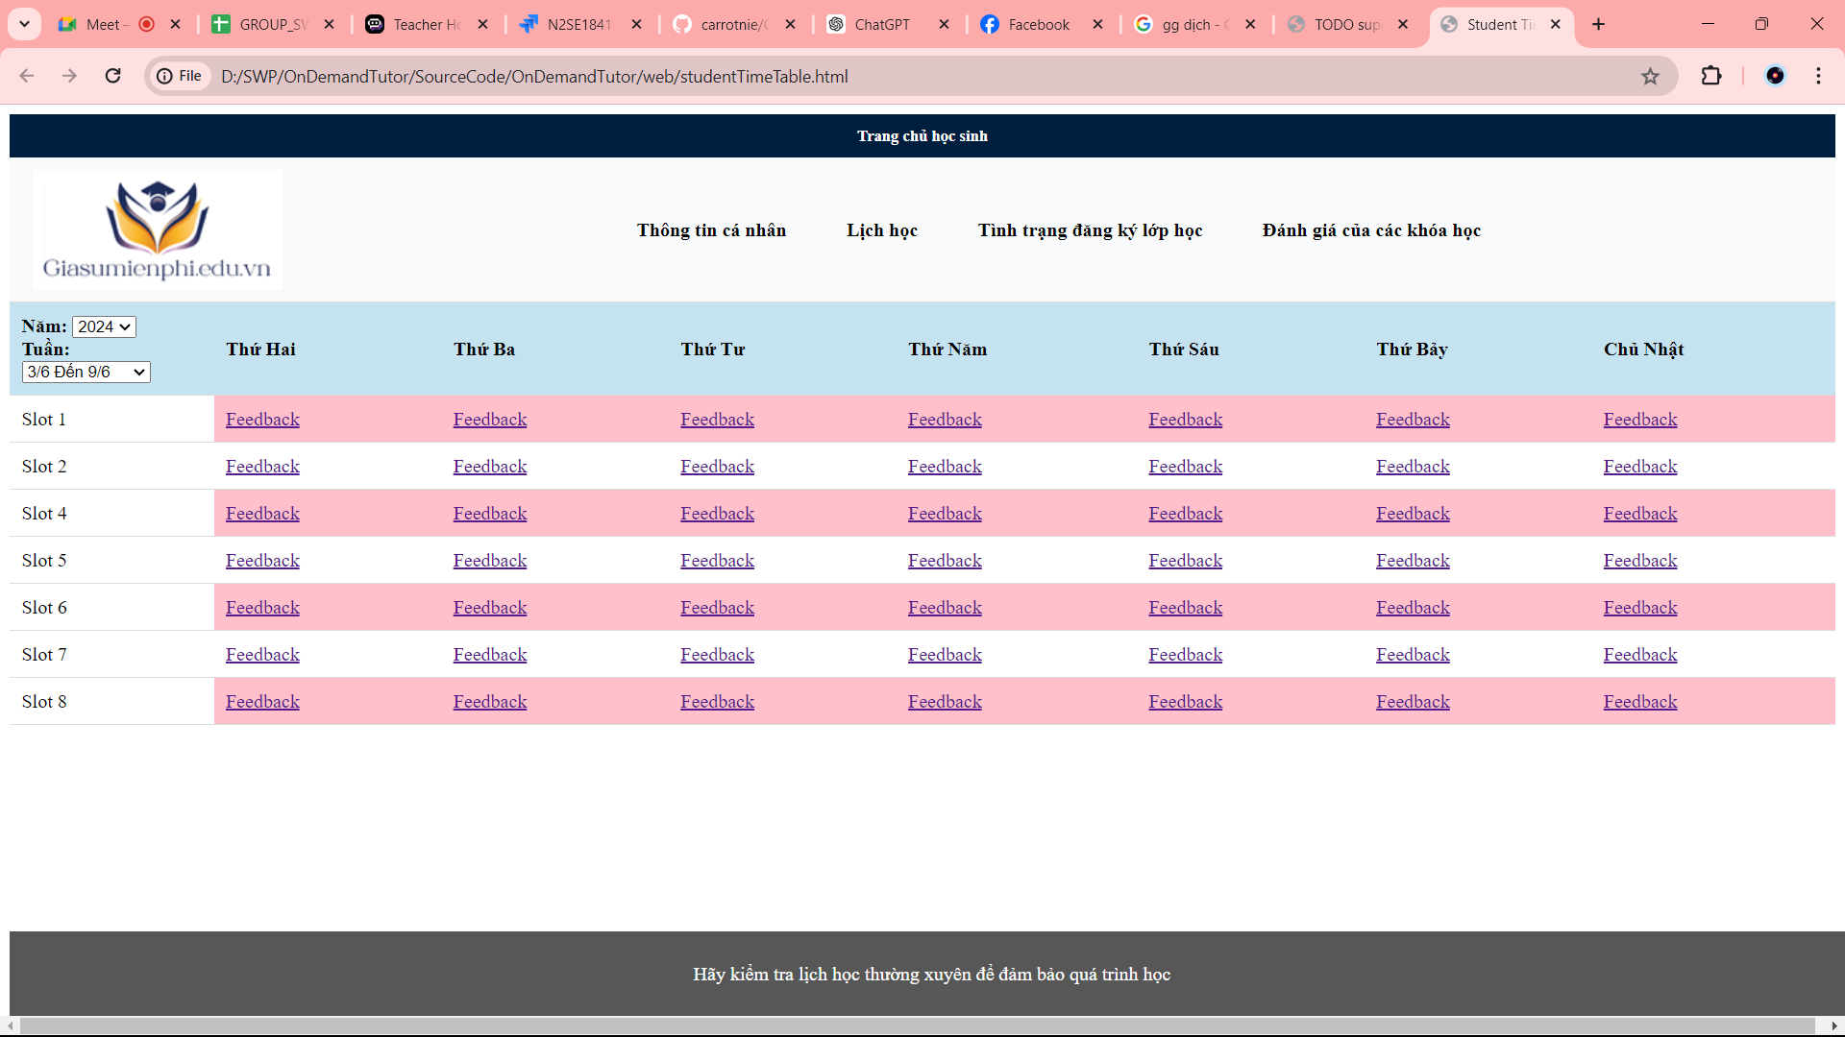

Tutor page

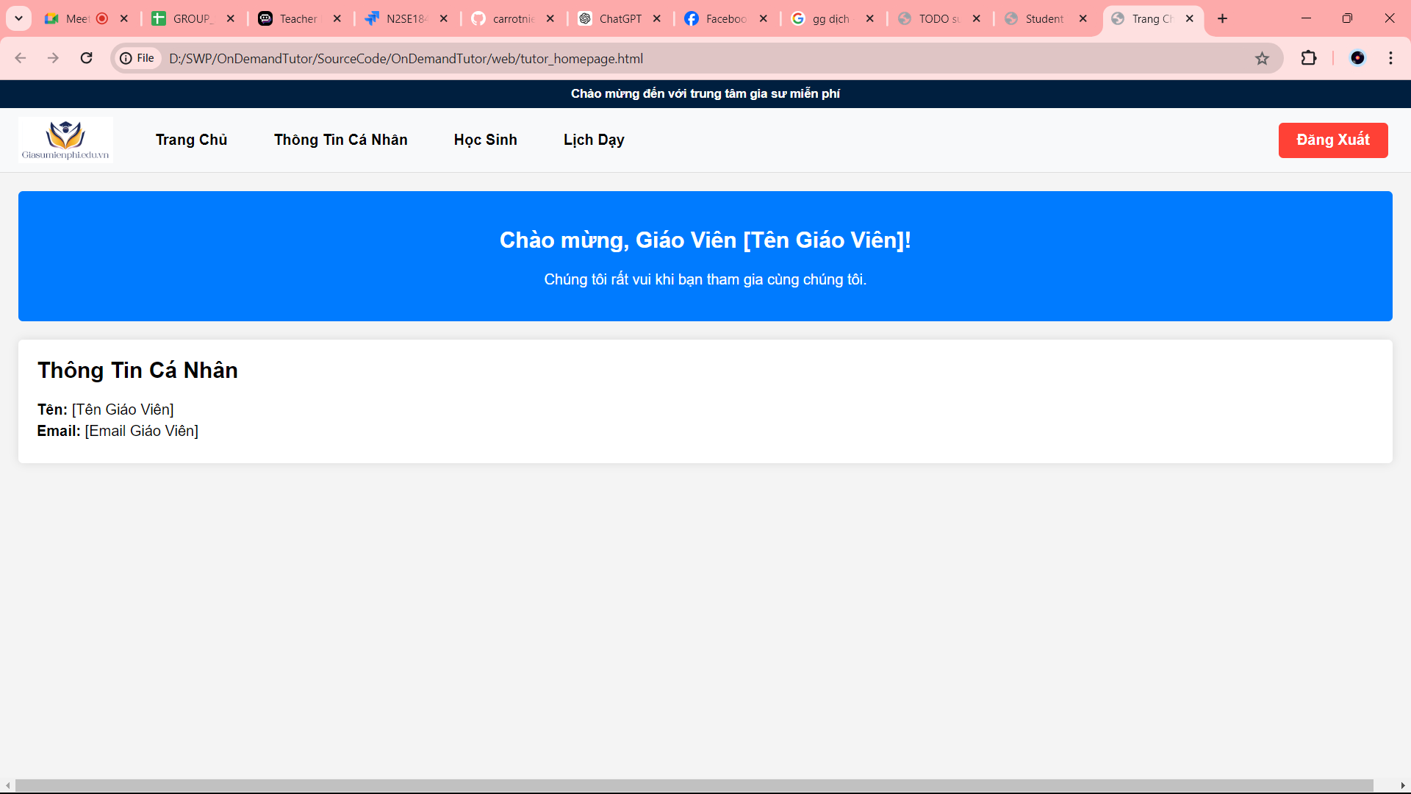

Tutor calander

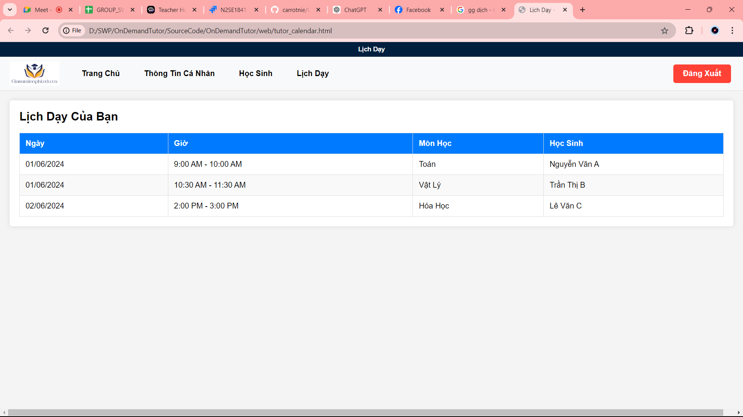

Admin

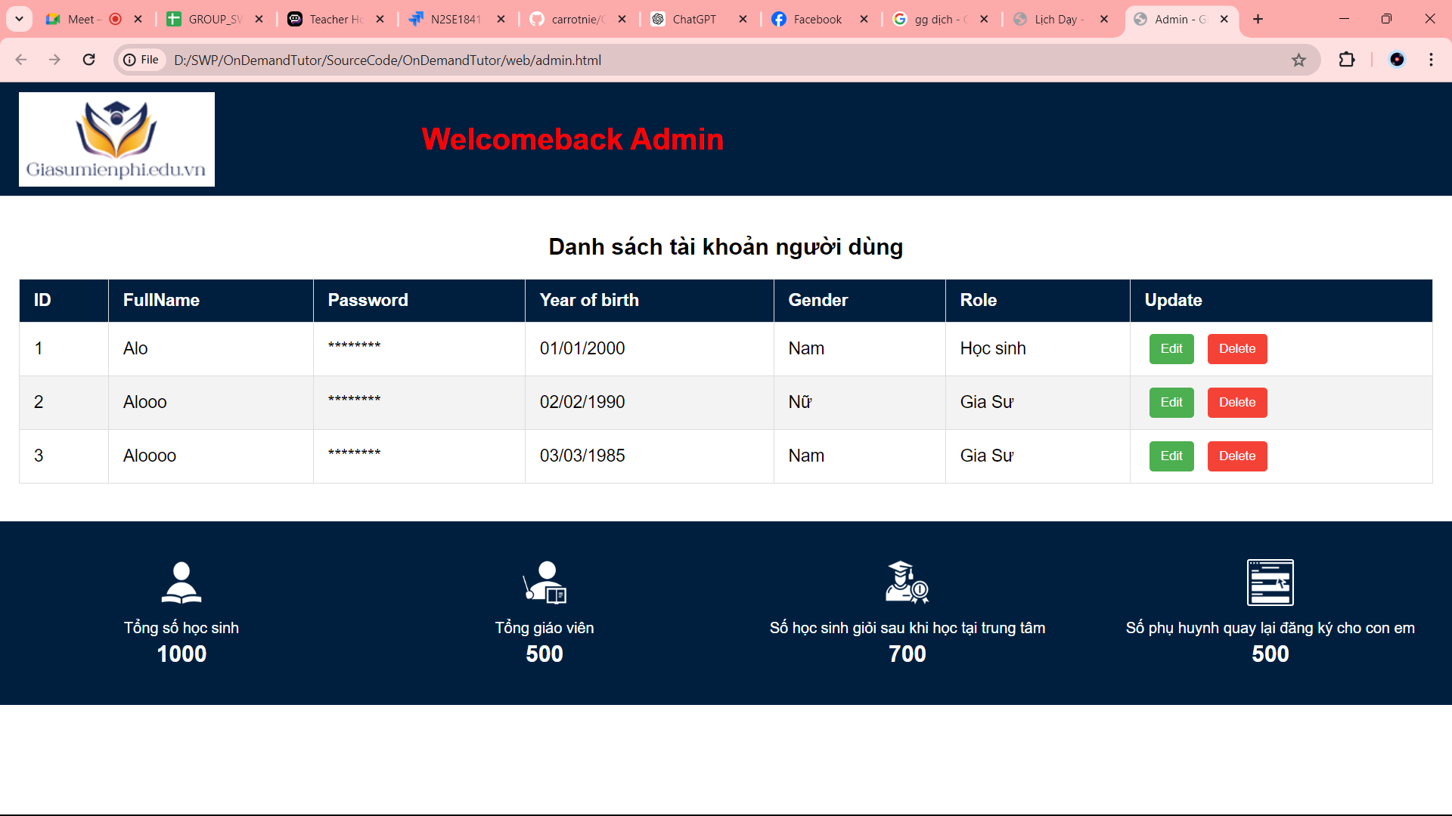

Moderator

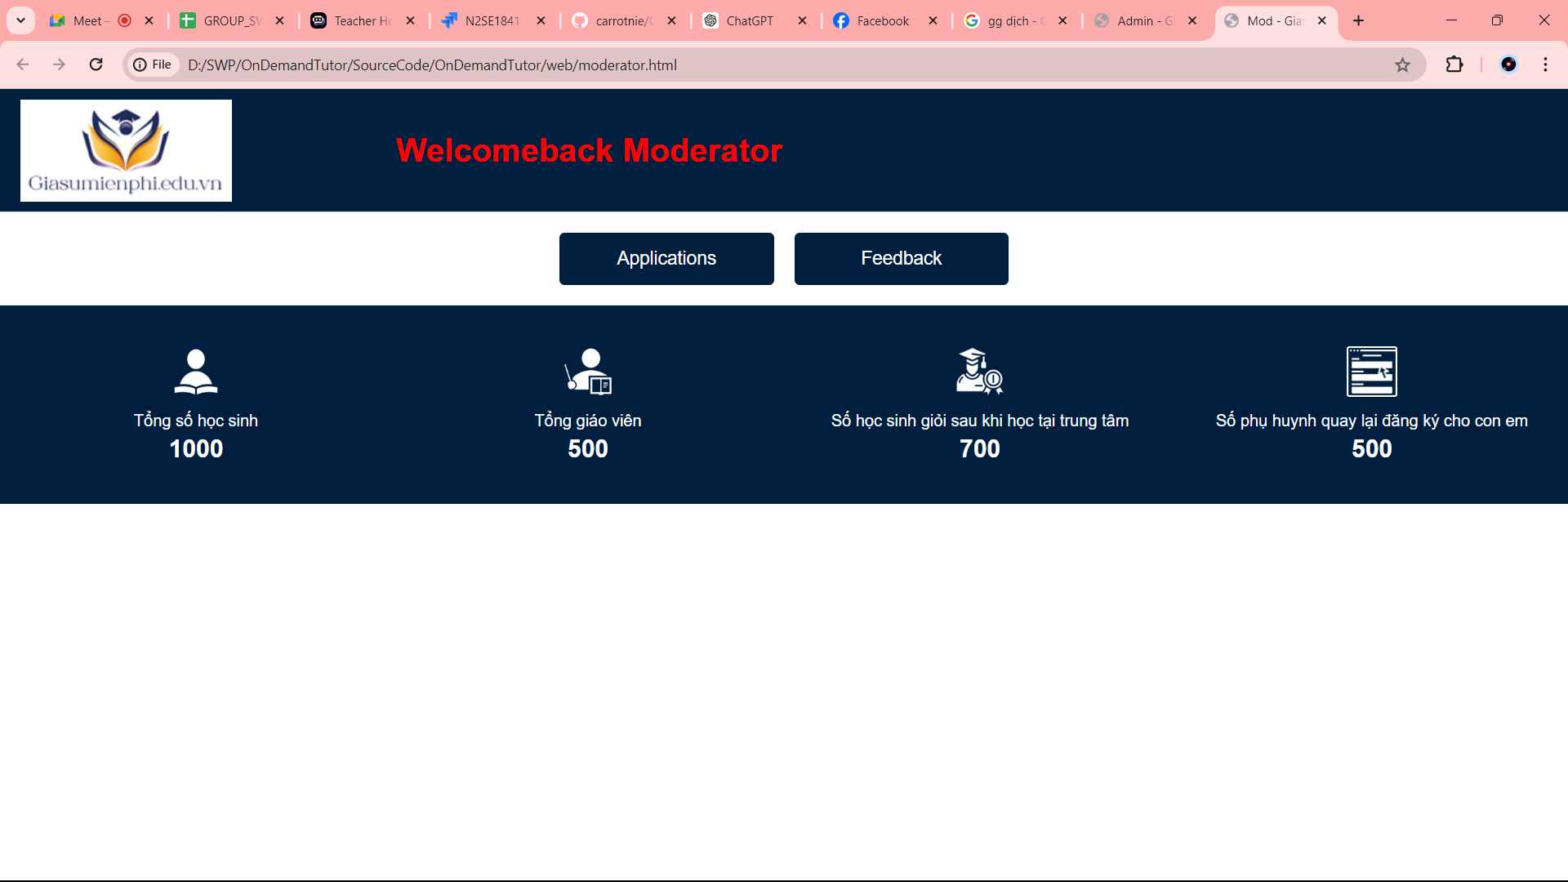

Feedback

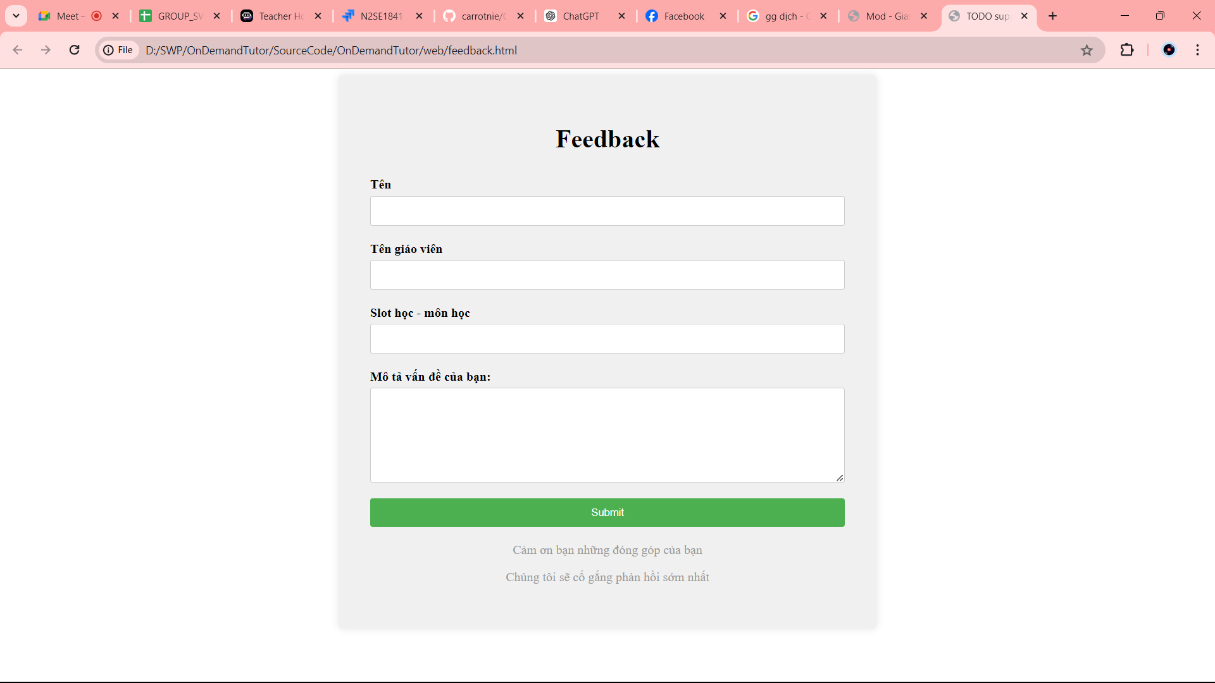

## Technical Requirements (TRD)

**Register**

**T1** UserName - UserName is required

**T2**  UserName - Special character are not allowed

**T3** UserName - Characters are not allowed

**T3.1** UserName - First character cannot have space

**T4** Password – Password is required

**T5** Password - First character cannot have space

**T6** Confirm Password - Confirm Password false

**T7** Confirm Password - Confirm Password is required

**T8** Confirm Password - Confirm Password true

**Login**

**T10** User-ID must not be blank

**T11** Password must not be blank

**New Student**

**T12** Student Name – Numbers are not allowed

**T13** Student Name – Special characters are not allowed

**T14** Student Name - Customer name must not be blank

**T15** Student Name - First character cannot have space

**T16** Address - Address Field must not be blank

**T17** Address - First character can not have space

**T18** Address - Special characters are not allowed

**T19** Telephone Number – Mobile no must not be blank

**T20** Telephone Number – Special character are not allowed

**T21** Telephone Number – Character are not allowed

**T22** Telephone Number - First character can not have space

**T23 Class – Class** must not be blank

T24 Subject – Subject must not be blank

T25 Current academic performance - Current academic performance must not be blank

T26 Number of slot – Number of slot must not be blank

T27 Time - Time must not be blank

T28 Level request – Level must not be blank

T29 Gender – Gender must not be blank

**New Tutor**

**T30** Tutor Name – Numbers are not allowed

**T31** Tutor Name – Special characters are not allowed

**T32** Tutor Name - Customer name must not be blank

**T33** Tutor Name - First character cannot have space

T34 Email – Email must not be blank

T35 Email – Email Invalid

T36 Email - First character cannot have space

**T37** Telephone Number – Mobile no must not be blank

**T38** Telephone Number – Special character are not allowed

**T39** Telephone Number – Character are not allowed

**T40** Telephone Number - First character can not have space

**T41** Address - Address Field must not be blank

**T42** Address - First character can not have space

**T43** Address - Special characters are not allowed

T44 Yob – Yob must not be blank

T45 Education – Education must not be blank

T46 Experience – Experience must not be blank

T47 Skill – Skill must not be blank

T48 Certificate – Certificate must not be blank

T49 Avatar – Avatar must not be blank

T50 Video – Video must not be blank

T51 Video – Video must file video

T52 Gender – Gender must not be blank

**Feedback**

**T53 Name – Name must not be blank**

**T54 Name Tutor – Name Tutor must not be blank**

**T55 Slot and Subject - Slot and Subject must not be blank**

**T56 Comment – Comment must not be blank**