# 1. Introduction

In this report, we will provide the meanings of ECG, smart home devices and deviecs concept. Besides, we will have some evaluations about smart devices in market that includes ECG. Thereby, we will create a smart medical device that allows users to measure electrocardiogram (ECG) through smartwatch and send analytical data information to smartphones. In the following part, we will focus on the design and requirements for 2 interaction modes. Finally, we show the conclusion to outline the success of the product and future developments.

# 2. Initial researches about smart home devices and ECG

Firstly, The electrocardiogram, also referred to as ECG, 12-lead ECG, or EKG, is a non-invasive diagnostic test that evaluates your heart's electrical system to assess for heart disease (Richard N. Fogoros, 2018). It is a test that can be used to measure rhythm and speed of one’s heart. Besides, it can also be used for electrical activity. The structure of ECG is an uninterrupted and non-straightforward path that often has the same cycle because ECG records the variation of electrical generated by the heart when performing contraction activity.

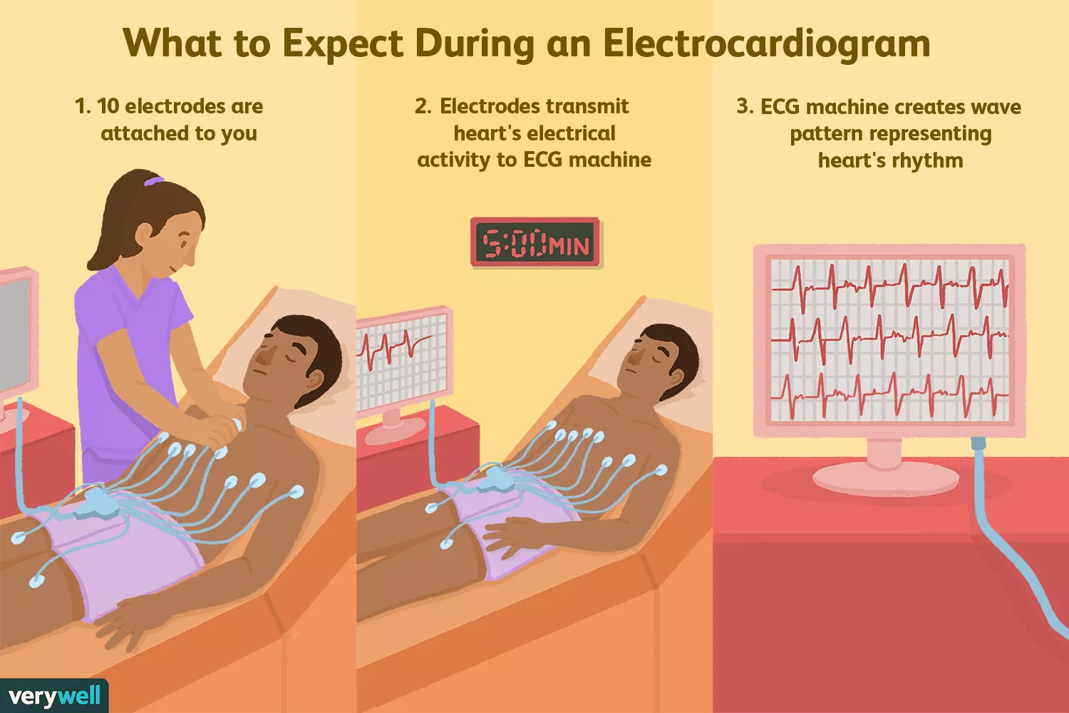

Figure 1: <https://www.verywellhealth.com/thmb/GqcgniiDv9Z1j-Ep1BtSOMr3CQE=/1500x0/filters:no_upscale():max_bytes(150000):strip_icc():format(webp)/1745304_color-5ba17840c9e77c00577efa25.png>

For the function, ECG is important evidence in diagnosing the current state of the heart, especially in dectecting the pathological state of atrial fibrillation. Draw lines of ECG represent the speed and rhythm of the heart, this is indirect evidence of blood flow to the heart. For this reason, ECG is considered as a routine test for people who have heart disease or who want to check their medical health.

Secondly, smart home objects are technology enabled objects often designed with the aim for people to change their traditional behaviour such as reduce the energy consumption or improve personal healthcare or even the purpose of controlling the house in an effective way. They will be controlled by a host system that can only be accessed by the owner of the house through sensors. Based on those sensors, the central controller or server will automatically analyze the situation, status and make decisions to control the sensors with appropriate activities to ensure the purposes: giving people the best living environment, the most comfortable, safest and the best way to save energy.

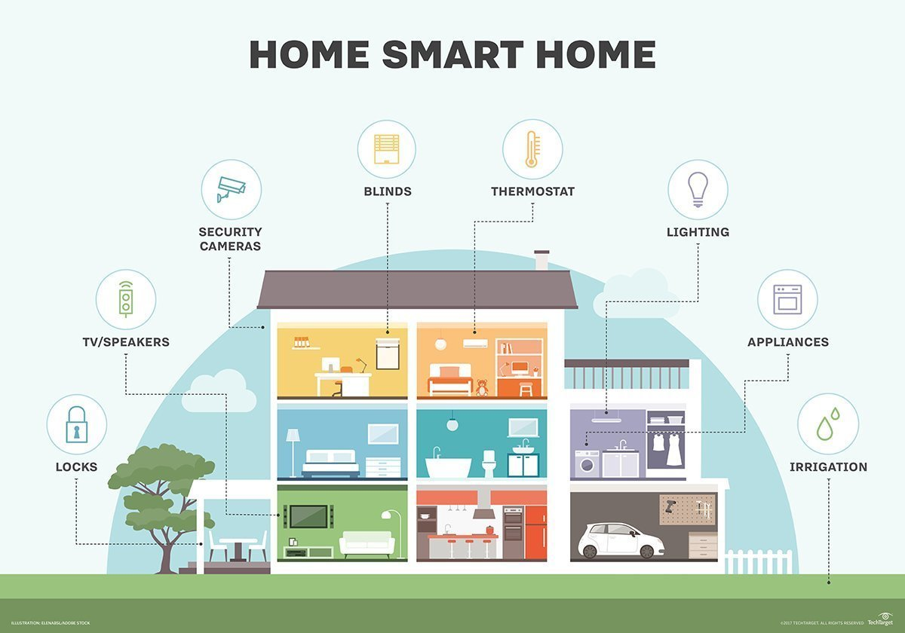

Figure 2: <https://cdn.ttgtmedia.com/rms/onlineImages/iota-smart_home.jpg>

An example of smart home object that people nowadays usually use is smart watch that included some advantages such as ECG or GPS. Moreover, it can be connected with smart phone so the owner can easily keep track of their health.

Here are some devices that have been integrated ECG to help users check their health care such as: Apple watch, The HeartCheck, ...

* Apple watch

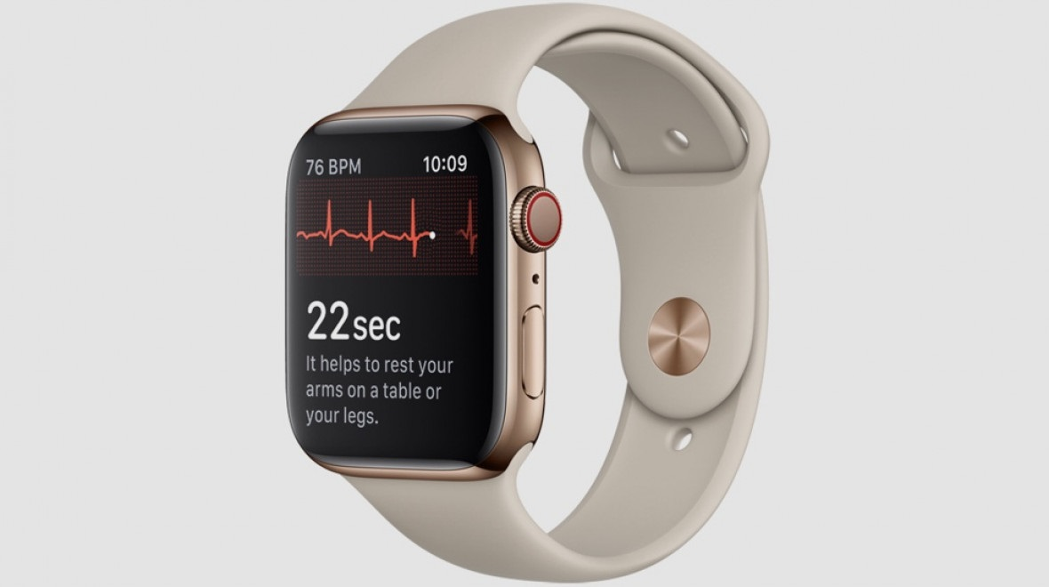

Figure 3: ECG in Apple watch

<https://techzones.vn/Data/Sites/1/News/1866/techzones-tinh-nang-ecg-tren-apple-watch-series-4.jpg>

*Device evaluation:*

- Apple watch series 4 is a medical device that have been integrated ECG technology.

- The device is equipped with an electrode on the back of the wrist and another electrode on the crown. When users need to measure the electrocardiogram, they just need to open the feature and then put their finger on the crown.

- The user only takes about 30 seconds to measure the heart rate. Apple watch software will analyze the data and send feedback to users.

- Data will be encrypted and saved as PDF file. The user can share with their doctor for a better health care.

- Apple watch can connect to other apple products such as Iphone, iPad ... and its price will range from $ 399 to $ 1500. (Apple, 2019)

* The HeartCheck

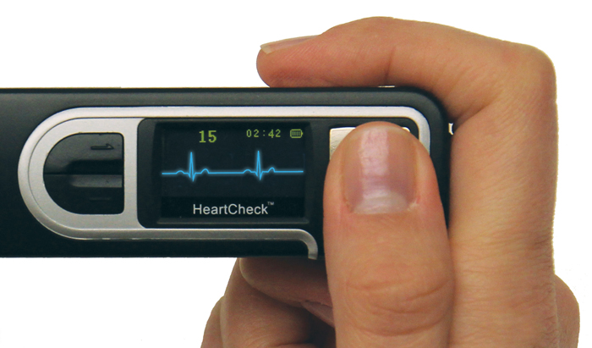

Figure 4: HeartCheck

<https://www.theheartcheck.com/images/pen-hand.jpg>

*Device evaluation:*

- The Heart Check PEN handheld device is integrated with ECG technology and is the only ECG device that be licensed by Health Canada for consumers.

- The Heart Check PEN is a compact design that can be pocketed. Users can monitor heart rate and symptoms that appear everywhere.

- Users only need to place their finger on the device's sensory face to measure the heart rate. And it will take 20-30 seconds to have ECG results.

- ECG data from The Heart Check PEN is encrypted and sent to the doctor via website. (HeartCheck™ ECG PEN, n.d.)

# 3. My Device Concept

In this project, we will create an ECG-integrated smart device. It is a wearable and active device that like a wearable that acts both as a skin contact electrode similar to the traditional devices. It is accessed and transferred information to the application on smartphone (via internet and Bluetooth).

This device helps us monitor heart rate. In addition, it has the ability to diagnose and identify cardiovascular disease symptoms, the device will tell users about their health status. Health data will be stored for monitoring and private information so users can access them whenever they need it. ECG smart medical device is suitable for those who do exercise, gym or jogging ... regularly. It will help them to know the strength of exercise intensity, thereby helping them adjust to fit. With the use of this device, users can limit cardiovascular risk.

# 4. Requirement

Main requirements

* Low power consumption
* Security and reliably
* Comfort and ergonomics
* App function
* view ECG received from the device
* record data
* analyzation Data
* medical suggestion from record

# 5. Design goal

After studying some devices in the market on the level of competition, the form of product and the group of users. We offer some of the goals and requirements for our equipment as following:

- Small and light: the device should be small enough to carry and use everywhere

- Device features: device should have a physical button and electrodes and can be connected with smartphones via a management application.

- Can use voice to interact with the device.

- Good ECG sensor with good material does not cause discomfort when operating.

## 3.1 User Centered Design (UCD)

UCD stands for User-Centered Design is a collection of processes which focus on putting users at the center of product design and development. (Ekaterina Novoseltseva, 2017). User Centered Design is a reiterative design process, designers focus on users and their needs in each stage of the design process. The process focuses on users through the design, planning and development.

The following are the general stages of the UCD process: (Usability, 2019)

* **Specify Context of Use:**Identify the need of people who will use the product, what they will use it for, and under what conditions or circumstances they will use the product.
* **Specify requirements: Determine** any business requirements or target users must meet in order for the product to be successful.
* **Create design solutions:**This part of the process can be done in stages, building from a preliminary concept to a final design.
* **Evaluate designs:** the stage that is tested with real users for a good software development.

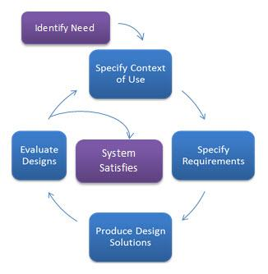

Figure 5: <https://www.usability.gov/sites/default/files/user-centered-design-chart-example.jpg>

In addition, the UCD process also has many other variants: waterfall combinations, agile, and other approaches depending on users’ needs. The UCD process is quite simple, but if the user changes the design too late, it will cost much more than when changing idea in any stages.

## 3.2 Goal Directed Design

Goal-Directed design is an interaction design methodology. Every feature in a Goal-Directed design can be tied to user research through personas and scenarios. (Lane Halley, 2008). During this process, Alan Cooper took the user at the center of the design process so it paid great attention to understanding the needs and goals of users. After that, it will turn that goal into tasks, activities and even final products.

According to Cooper, the process of Goal-Directed Design will include six phases: Research, modeling, requirements definition, framework definition, refinement, and support. (Greg Dalrymple , 2014)

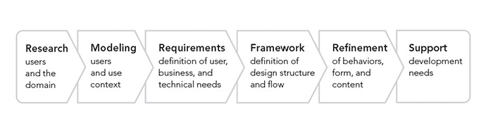

Figure 6:https://www.dtelepathy.com/wp-content/uploads/2014/11/cooper_goal-directed-design_process.png

The first step of Goal Directed Design is Research. It is the stage that happens between users and domain names. It will collect qualitative data about users through field studies and interviews. In this step, you should collect:

- Studying human beings

- Their opinions: What, How, Why?

- Attitudes, Motivations behind decisions taken

- Different from qualitative data

After that, designer should gather all the users’ requirement and after completion, they should leave them with a set of instructions describing how to use the product.

Next, Modeling is the second step. This step can be divided into two parts. Part one is to identify the domain model by building workflows from the research phase. Part two is to identify users through the use of personas or main prototypes representing groups of people. For example: Matter-of-fact user; the case of booking priority reservation ticket

The third step is Requirements. This is a very important step to provide a link between the user model and other models. During this stage, designer have to focus on contextual scenarios to identify a person's “a typical day” and explore different levels of interactions with respect goals and motivations of the persona.

Framework is considered as fourth step. This is the stage the designer creates the overall concept of the interactive product (behavior, visual design, physical form) and defines the basic framework of the product’s behavior. Then create the interaction design principles for example provide “user control”; design product which users can control.

Next, we move to Refinement. In this stage, the designer focuses on details and processes. In addition, they create a detailed document about design.

Last but not least, last step is Development Support. It is to maintain the conceptual integrity of the design when changing technological constraints to ensure the overall design quality is not compromised. Designer handover the designs for the development so they get developed within known technology constraints according to a re-specified timeline. Designers need to revisit in order to ensure that the form and behavior of the design stay consistent with the earlier stage.

So in this coursework, we choose to use Goal Directed Design. Goal Directed Design is a detailed process, it focuses on understanding the need and target of customers.

***your experience***

***the simplicity of the method***

**COGNITION**

Cognition is something that happens in our brain when we do activities in our daily life. It is the collection of mental processes and activities used in perceiving, learning, remembering, thinking, and understanding and the act of using those processes. There are varieties kinds of cognition but following Don Norman (1993), he discriminates two general type between experiential and reflective cognition. The first one relates to something that need to be professional while reflective cognition just shows people’s normal activities. That is why it have closed relationship with goal directed design because we can know exactly what we want the users to do.

Cognition also has specific kinds of processes including:

- attention

- perception and recognition

- memory

- learning

- reading, speaking, and listening

- problem solving, planning, reasoning, decision making

It is vital to remember that these processes are not related to each other, but some may be involved for a certain activity. For instance, when someone is trying to prepare a difficult subject for the end-term test, they have to give attention to the hand-down, perceive it, recognize it, think about it. So these processes mix with each other and then help the person. Consequently, cognition often presents a series of processes, very rarely occurs in isolation. Below we describe the different types in more detail.

First process is attention. It is the process of choosing things to focus on, at one time, from the range of possibilities available. Attention is related to our auditory or senses. An example of attention is waiting for the teacher to call our name so we can know it’s our time to give them your paper. Attention helps us to focus on information that is relevant to what we are doing.

Secondly, perception is process that people acquire things from environment through senses such as eyes, ears, fingers, … and transfer it into action like sounds, tastes, … It is a complex process, involving other cognitive processes such as memory, attention and language. Vision is the most important meaning for individuals to see, followed by hearing and touch. Besides, everyone has their own perception. An example to show this idea is when two person enter to a restaurant, both of them can smell a taste from the kitchen but maybe their own feeling is different. So move to the interactive design, it is important to present information in a way that is easily identifiable in the intended way and everyone can react to it in a same way. For instance, there are many ways to create emoji. It is vital to make them easily distinguishable from each other and to help simplify to recognize what they tend to represent.

Next, memory is responsible for processing and storage of information. Memory contains three components: executive function, visual spatial sketchpad, phonological loop. Memory allows us to remember everything. Without memory, we would not be able to function. There are three levels of memory through which information must travel to be truly learned. For example, for the first time that you hear the capital of the state Oregon is Salem. This information is now in your Sensory Register which holds everything you are exposed to for just a second or two. By the end of the sentence you may already forgotten the capital of Oregon. If you pay attention and re-read the sentence, that information will move from sensory register into into Short-term memory. This are of your memory will hold information anywhere from 20 seconds up to a minute. And if you rehearse the information, such as repeat it yourself, taking note or studying again and again, it has a chance of moving into the Long-term memory. This are will hold information indefinitely and has an unlimited capacity.

But there is a problem that happens with all of us, sometimes we can not remember everyday’ normal things such as people’s names, phone numbers…. if we try too much we can be overloaded. Therefor, we just need something to help us recall things. From that point, designer should create the apps that have a variety off way to help users remember where they stored them through color, emoji…

Thirdly, Learning is considered as the way users use a electronic-based to understand a topic that they do not understand. Learning acquiring knowledge through experience, study or being taught. Learning requires cognition and cognition involves learning. When you see something new, you do to a series of cognitive processes which are processes which result in learning.

We move to Reading, Speaking and Listening, three forms have similar thing is that the meaning of sentences is the same when users read, speak or hear it. However, there are still some mistakes depend on the person, background or context.

Finally, problem-solving, planning, reasoning and decision-making are all processes that include thinking about what to do, how to deal with things… it is the reason why we have some web searching that help us to find the answer if we do not know how to find it even thinking hardly.

# References

Anon., 2019. [Online]   
Available at: https://www.heart.org/en/health-topics/heart-attack/diagnosing-a-heart-attack/electrocardiogram-ecg-or-ekg

Anon., n.d. *User-Centered Design Basics.* [Online]   
Available at: https://www.usability.gov/what-and-why/user-centered-design.html  
[Accessed 26 February 2019].

Apple, 2019. *Apple Watch Series 4.* [Online]   
Available at: https://www.apple.com/apple-watch-series-4/health/  
[Accessed 25 2 2019].

Ekaterina Novoseltseva, 2017. *User-Centered Design.* [Online]   
Available at: https://usabilitygeek.com/user-centered-design-introduction/  
[Accessed 26 February 2019].

Greg Dalrymple , 2014. *Goal Directed Design.* [Online]   
Available at: https://gcdtech.com/blog/goal-directed-design/  
[Accessed 27 February 2019].

HeartCheck™ ECG PEN, n.d. *theheartcheck.* [Online]   
Available at: https://www.theheartcheck.com/warranty.html  
[Accessed 26 February 2019].

Lane Halley, 2008. *Six Sigma and goal-directed design.* [Online]   
Available at: https://www.cooper.com/journal/2008/5/six_sigma_and_goaldirected_des  
[Accessed 26 February 2019].

Richard N. Fogoros, M., 2018. *verywellhealth.* [Online]   
Available at: https://www.verywellhealth.com/the-electrocardiogram-ecg-1745304  
[Accessed 25 2 2019].