# 



COMP1649 Interaction Design



Coursework

51: Interaction Design - Term 2 - MAC



Student ID: GCH15253

Student name: DINH NGOC HUNG

Lecturer: Do Quoc Binh

**Contents**

**Introduction** 2

**1.** **Definitions** 3

**1.1 ECG** 3

**1.2 Smart home devices** 3

**1.3 Device cocepts** 3

**1.4 Functionalities** 3

**1.5 Some ECG devices** 3

4

**1.6 Use case of ECG** 5

**1.7 Design goal** 5

**2.** **research framework for design** 5

**2.1 User-centered design** 5

**2.2 Goal-Directed Design** 6

**2.3 The reason for using UCD** 8

**2.4 Conclusion** 8

**3.** **Cognition** 9

**3.1 What are mental or cognitive processes?** 9

**3.2 Attention** 9

**3.3 Perception** 9

**3.4 Memory** 9

**3.5 Learning** 9

**3.6 Reading, Speaking & Listening** 10

**3.7 Problem-solving, Planning, Reasoning, Decision-making** 10

**4.** **Design Process** 10

Conceptual Design 10

**Reference** 10

# **Introduction**

The purpose of this course is to design a prototype for smart medical devices connected to a phone that allows people to measure electrocardiography (ECG). This device will allow users to be able to take an ECG using sensors on either another device that can be connected with a smartphone. In order to complete the project, we need to solve the problemsThe interaction between the prototype and the user and the implementation of design and research activities need to be consistent with that choice.

# **Definitions**

## **1.1 ECG**

ECG is an English acronym for Electrocardiogram. ECG can measure the speed and rhythm of the heart. ECG is one of the most popular heart tests today. That's the only way to find out what happens to your heart. ECG can help you detect the danger of diseases such as angina, cardiac arrhythmia, etc. ECG is considered a routine test in hospitals of people with heart disease. ECG is a simple test and does not cause pain. The results of ECG bring much value in the monitoring and detection of cardiovascular disease.To measure electrical pulses from the heart, doctors use a specialized machine. The positive electrodes are inserted into the patient's wrist, leg and chest area. These positive electrodes will pick up the electric current from the heart and amplify them and record them on paper or machine.

## **1.2 Smart home devices**

Smart home devices are modern devices that allow you to control and connect to other devices, providing many features to help make life more comfortable, safer and contribute to the proper use of resources. Smart Home devices are connected to the Internet so users can manage and monitor remote devices and systems such as light and temperature or store the necessary information. It provides users with comfort, convenience and energy savings by allowing them to control smart devices with a smart application on the phone or other network-connected devices. Today, ECG functionality is also integrated on some devices such as Apple Watch, Kardia Mobile AFIB Detection. It can record heart rate for a while, alerting users when their heart rate rises and provides statistics about the heart's resting rhythm.

## **1.3 Device cocepts**

In general, a device is a machine designed for one purpose. In this project, the device that I will create have functions as an ECG device connected to a mobile phone. It helps users to know the health status and store the results and then send the results to the doctor. Thanks to this feature, users do not have to spend much time to the hospital to know their health status. however, it also has some limitations as the device cannot know if you have a heart attack. The device recommends that you go to the hospital if you feel unwell, the data from the device is for reference only.

## **1.4 Functionalities**

The device allows users to take electrocardiograms to monitor cardiovascular health. It will not have as much detailed information as ECG you get in the clinic or hospital. Here, it only provides valuable information for people who are basically about heart disease. After finishing the ECG measurement, the device will store information about your heart rate and send it to the doctor. If your heart beats with normal or irregular pace the device will notify you and give advice. If a problem is found, the device will ask you to contact the doctor for further testing. All ECG results measured by devices stored in the cloud make it easy to share with your doctor.

## **1.5 Some ECG devices**

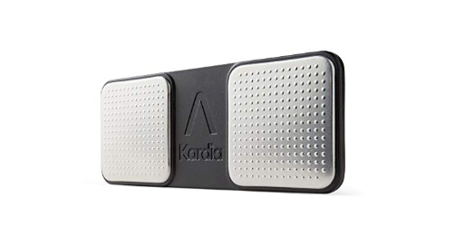

Figure 1: Alivecor® KardiaMobile EKG Monitor

The device can detect cardiovascular problems in 30 seconds. It is easy to use. You Just place your finger on the sensor. The device is capable of storing on the cloud unlimited of all your EKG records, monthly reports are sent via email. The device can connect to most smartphones and tablets.

## 

Figure 2 : EKG Monitor, Heart Monitor EKG for Smart Phone, Handheld Wireless Captures Heart Rhythm Without EKG Electrodes Required

The device has high accuracy in displaying and measuring cardiovascular condition. Provides an accurate Afib monitoring with the same accuracy as professional EKG in clinics and hospitals.The mobile heart rate monitor turns complex EKG data into easy-to-understand heart rate reports via Lifetime Free App (supports iOS 9.0 and above, Android 4.3 and above). This heart monitor allows unlimited storage of all your EKG records without any registration fees. In addition, the device is equipped with a built-in battery and makes the portable EKG screen perfect for carrying on work or on the trip, in case the cardio needs to be evaluated on the spot. Easy to use for the elderly.

## **1.6 Use case of ECG**

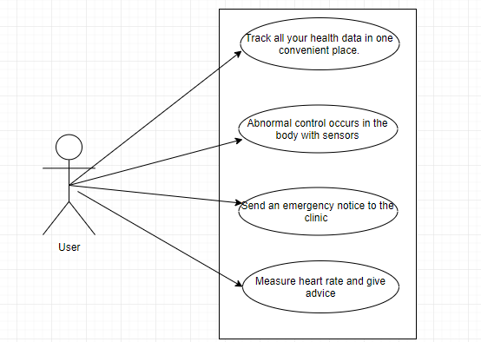

Figure 3: Use case

## **1.7 Design goal**

ECG device will be designed like a wristwatch. The device has a 0.96 inch screen, IPS and wristbands with different colors are very user friendly. The strap is made of high quality elastic material, which helps the skin to be irritated, soft, light and durable, comfortable to wear. When you want to measure your heart rate, you will put their hands on the sensor button on the screen.

# **research framework for design**

Using interaction design frameworks can help you complete your design process quickly and create better solutions to complex design problems. today there are some popular interactive design frameworks that are widely used by many people such as Goal-Directed Design and user-centered design (UCD) .

## **2.1 User-centered design**

User-centered design is a iterative design process, in which the designers focus on the needs and wants of users in each design phase. In order to design a product, UCD needs user collaboration throughout the design process through testing and research to create products that are suitable for users. In general, UCD focuses on the needs and desires of users in product design and development. UCD focuses on users in product design instead of making users adapt to the product .

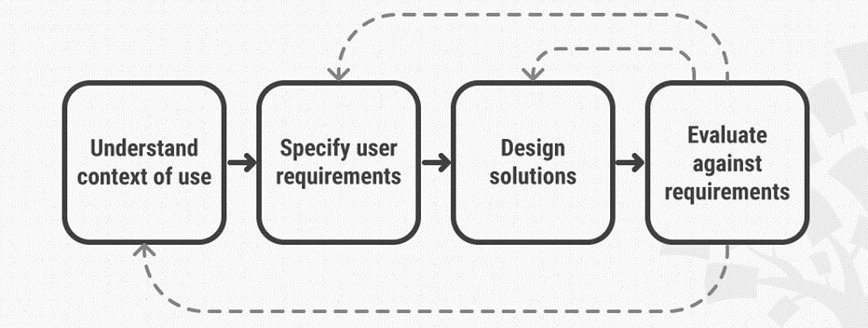

Figure 1: User-Centered Design is an iterative process that focuses on an understanding of the users and their context in all stages of design and development.

UCD method consists of four separate stages. First, designers will learn about the reasons users can use a system. Next they will determine the user's requirements and rely on it to implement the device's functional design, in which the design team develops solutions. Then the research team will conduct phase assessments and the results of the evaluation will be tested by the user and given an opinion before finalizing the product. In general, designers will try to create products through user requirements and expectations. The design team will perform repeated steps until the evaluation results are satisfactory.

## **2.2 Goal-Directed Design**

Goal-Directed Design is a user-centric approach developed by Alan Cooper to help designers focus on a method of designing in a way that seeks the relationship between the user and the object and the target use.It selects users as the center of the design process and focus on understanding and analyzing the needs and goals of those users, then transforming those goals into tasks and activities and finally into a more usable end product. It can be divided into six phases including research, modeling,Requirements Definition, definition of framework, Refinement and Development Support.

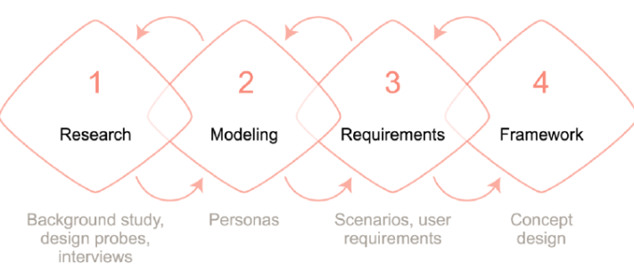

Figure 2 : In our design process, we implemented four phases of the goal-directed design process (Cooper et al., 2007)

**Research**

In this stage, we need to collect data about potential users through trials and research. Next we need to analyze competitors and collect requests from stakeholders. At the end of the process, we should leave a set of instructions and a description of how to use the product.

**Modelling**

The modeling stage can be divided into two parts including Workflow and Personas (archetypical user models). In part one, you define the Workflow by building workflow patterns from the research phase to answer questions about what individuals do, in what order? How does an individual relate to others through workflows? In part two, you define the user model through the use of personas or key archetypes which represent identifiable user groups.

**Requirements Definition**

This is an important stage in linking the user model and other models. In this phase, we must focus on context scenarios to help identify user requirements.

**Framework Definition**

In the frame definition phase, we must create an overall concept of the product and determine the shape and function of the product. You can also create prototypes during this period.

**Refinement**

During the refinement stage, you focus more on product details and refinement at the end of this phase you should create your design documentation.

**Development Support**

It is important that the designers are present to provide advice and ensure the overall design quality is not affected.

Goal-Directed Design describes the six-step process for connecting with users, analyzing their wishes to make decisions about whether different users can be satisfied with the same interface or They will require different interfaces.

## **2.3 The reason for using UCD**

To quickly implement my design process, I decided to use the User-centered Design framework. After studying both methods, the Design framework focuses on users that are effective and consistent with our requirements. The advantage of User-centered Design is clearly expressed in improving customer experience related to website, product or service. User-centred design could bring many advantages to your business. For example, it could:

* With close user involvement, products are more likely to meet users’ expectations and requirements. This leads to increased sales and lower costs incurred by customer services.
* Systems designers tailor products for people in specific contexts and with specific tasks, thereby reducing the chances of situations with a high risk of human error arising. UCD leads to safer products.
* Putting designers in close contact with users means a deeper sense of empathy emerges. This is essential in creating ethical designs that respect privacy and the quality of life.
* By focusing on all users of a product, designers can recognize the diversity of cultures and human values through UCD – a step in the right direction towards creating sustainable businesses.

## **2.4 Conclusion**

While UCD focuses on users (and looking at ongoing tasks and goals), GDD focus on a method of designing in a way that seeks the relationship between the user and the object and the target use. Where UCD determine user behavior and preferences for different aspects of a product and then use that information to decide product design , GDD will ask questions why users must perform those tasks or activities, to understand the value, purpose, or meaning of tasks or activities for users. Meanwhile , UCD considers who the user is and their level of understanding of the product ( How are they familiar with the application? What is the purpose of using their products?) ,their purpose (when will users use the product?)The reason for their use (why do they use it and how do they interact with it?) and their preferences (Do they like to use it?).

On the other hand, GDD selects the user at the center of the process and focuses on understanding the needs and goals of those users, then transforming those goals into tasks and relying on those tasks to create products.

# **Cognition**

## **3.1 What are mental or cognitive processes?**

Cognitive processes are a stage of acquiring knowledge and understanding through thought, experience and senses and are stored and processed by the brain. Thanks to these cognitive processes help us explore the world.

## **3.2 Attention**

Attention is the cognitive process that helps us possible to position ourselves towards relevant stimuli and consequently respond to it. Life with lots of stimuli happens at the same time, however, we have the ability to focus our attention on the stimuli we care about. For device design, it is important to create user attention to the device. Because users are mostly people with cardiovascular problems but they don't have time to medical examination , they will expect a compact device that suits them, neat and simple and They can use the device when they need it. Therefore, this device will have to meet user requirements. Different techniques such as graphics, logos, colors will have to be designed appropriately so that users are easily attracted. Since the application will be connected to a computer or phone via bluetooth we must consider the screen size. In the limited space of the screen, all user information will be displayed on the screen in order, arranging neat and eye-catching information.

## **3.3 Perception**

Awareness is how users will read, listen or perceive information from the application through the body senses (eyes, ears and fingers) and will convert into action. This process includes other cognitive processes such as memory, attention, and language helping users can accurately recognize the importance of information presented to them. Some equipment issues need to be considered:

* Illustrated images or icons must be reasonably designed so that users can understand their meaning.
* The displayed text will be easy to read and distinguish from the background.
* The abstract illustrations will have to be clearly annotated.

## **3.4 Memory**

Cognitive processes such as memory are important for life. Memory is a cognitive process includes encoding, storage, and retrieval. Memory can be distinguished into two type - recalling and recognizing .Some studies suggest that users are much better at recognizing things instead of remembering everything.

* Users will not have to perform complicated actions to get their desired content.
* Use easy-to-understand icons instead of new icons.

## **3.5 Learning**

Users tend to learn equipment through testing instead of reading instructions. so the interface of the application should be designed in a way that encourages users to explore functions, but also guides users on how to use the appropriate functionality. To achieve this, we need to design the interface of the application logically, have rules and provide instructions to help users easily use it.

## **3.6 Reading, Speaking & Listening**

Since the device will display information on the phone, the main problem will be related to the ability to read the text on the screen. When designing application, we will have to consider the issues of image quality, fonts. For example, the Application should have a text size editing function for users who have difficulty reading small text.

## **3.7 Problem-solving, Planning, Reasoning, Decision-making**

Problem solving, planning, reasoning and decision making are all cognitive processes related to reflective cognition . They include thinking about what to do, what choices are and what the possible consequences are when doing a certain action.

# **Design Process**

## Conceptual Design

# **Reference**

1. Aswini Kumar MD. [*"ECG- simplified"*](http://www.lifehugger.com/doc/120/ecg-100-steps). LifeHugger*. Retrieved 11 February 2010*.
2. ["Limb Leads – ECG Lead Placement – Normal Function of the Heart – Cardiology Teaching Package – Practice Learning – Division of Nursing – The University of Nottingham"](http://www.nottingham.ac.uk/nursing/practice/resources/cardiology/function/limb_leads.php). Nottingham.ac.uk. Retrieved 15 August 2009.
3. ["Lesson 1: The Standard 12 Lead ECG"](https://web.archive.org/web/20090322042804/http:/library.med.utah.edu/kw/ecg/ecg_outline/Lesson1/index.html). Library.med.utah.edu. Archived from [the original](http://library.med.utah.edu/kw/ecg/ecg_outline/Lesson1/index.html#orientation) on 22 March 2009. Retrieved 15 August 2009.
4. [*"Notes on User Centered Design Process (UCD)"*](https://www.w3.org/WAI/redesign/ucd)*. www.w3.org.*
5. [**^**](https://en.wikipedia.org/wiki/User-centered_design#cite_ref-3) *Rubin, Jeffrey; Chisnell, Dana.*[*Handbook of Usability Testing: How to Plan, Design, and Conduct Effective Tests*](https://books.google.com/books?id=l_e1MmVzMb0C&printsec=frontcover&dq=Jeffrey+Rubin,+Handbook+of+Usability+Testing:+How+to+Plan,+Design,+and+Conduct+Effective+Tests,&hl=en&sa=X&ved=0ahUKEwjBxcfY3YPTAhUJ7YMKHXMVBrAQ6AEIHDAA#v=onepage&q=Jeffrey%20Rubin%2C%20Handbook%20of%20Usability%20Testing%3A%20How%20to%20Plan%2C%20Design%2C%20and%20Conduct%20Effective%20Tests%2C&f=false)*. John Wiley & Sons.*[*ISBN*](https://en.wikipedia.org/wiki/International_Standard_Book_Number)[*978-1-118-08040-5*](https://en.wikipedia.org/wiki/Special:BookSources/978-1-118-08040-5)*.*
6. [**^**](https://en.wikipedia.org/wiki/User-centered_design#cite_ref-4) *Vredenburg, Karel; Mao, Ji-Ye; Smith, Paul; Carey, Tom (2002).*[*"A Survey of User-Centered Design Practice"*](http://www.cse.chalmers.se/research/group/idc/ituniv/kurser/09/hcd/literatures/Vredenburg%202002.pdf)*(PDF).*
7. [**^**](https://en.wikipedia.org/wiki/User-centered_design#cite_ref-5) Norman, D. A. (1986). User-Centered System Design: New Perspectives on Human-Computer Interaction.
8. [**^**](https://en.wikipedia.org/wiki/User-centered_design#cite_ref-6) [*"Don Norman (2003) Emotional Design, Prolog-- Three Teapots"*](http://www.jnd.org/dn.mss/CH00_Prolog.pdf)*(PDF). jnd.org.*
9. [**^**](https://en.wikipedia.org/wiki/User-centered_design#cite_ref-7) Greenbaum&Kyng (eds): Design At Work – Cooperative design of Computer Systems, Lawrence Erlbaum 1991
10. Cooper, Alan (2004). Inmates Are Running the Asylum, The: Why High-Tech Products Drive Us Crazy and How to Restore the Sanity. Sams Publishing. p. 288. [*ISBN*](https://en.wikipedia.org/wiki/International_Standard_Book_Number) [*0-672-32614-0*](https://en.wikipedia.org/wiki/Special:BookSources/0-672-32614-0).
11. [*Cooper, Alan*](https://en.wikipedia.org/wiki/Alan_Cooper); Reimann, Robert; Cronin, Dave (2007). [*About Face 3: The Essentials of Interaction Design*](https://books.google.com/books?id=0gdRAAAAMAAJ). [*Indianapolis, Indiana*](https://en.wikipedia.org/wiki/Indianapolis): [*Wiley*](https://en.wikipedia.org/wiki/John_Wiley_%26_Sons). p. 610. [*ISBN*](https://en.wikipedia.org/wiki/International_Standard_Book_Number) [*978-0-470-08411-3*](https://en.wikipedia.org/wiki/Special:BookSources/978-0-470-08411-3)*. Retrieved 18 July 2011*
12. [*"Notes on User Centered Design Process (UCD)"*](https://www.w3.org/WAI/redesign/ucd)*. www.w3.org.*
13. [**^**](https://en.wikipedia.org/wiki/User-centered_design#cite_ref-3) *Rubin, Jeffrey; Chisnell, Dana.*[*Handbook of Usability Testing: How to Plan, Design, and Conduct Effective Tests*](https://books.google.com/books?id=l_e1MmVzMb0C&printsec=frontcover&dq=Jeffrey+Rubin,+Handbook+of+Usability+Testing:+How+to+Plan,+Design,+and+Conduct+Effective+Tests,&hl=en&sa=X&ved=0ahUKEwjBxcfY3YPTAhUJ7YMKHXMVBrAQ6AEIHDAA#v=onepage&q=Jeffrey%20Rubin%2C%20Handbook%20of%20Usability%20Testing%3A%20How%20to%20Plan%2C%20Design%2C%20and%20Conduct%20Effective%20Tests%2C&f=false)*. John Wiley & Sons.*[*ISBN*](https://en.wikipedia.org/wiki/International_Standard_Book_Number)[*978-1-118-08040-5*](https://en.wikipedia.org/wiki/Special:BookSources/978-1-118-08040-5)*.*
14. [**^**](https://en.wikipedia.org/wiki/User-centered_design#cite_ref-4) *Vredenburg, Karel; Mao, Ji-Ye; Smith, Paul; Carey, Tom (2002).*[*"A Survey of User-Centered Design Practice"*](http://www.cse.chalmers.se/research/group/idc/ituniv/kurser/09/hcd/literatures/Vredenburg%202002.pdf)*(PDF).*
15. [**^**](https://en.wikipedia.org/wiki/User-centered_design#cite_ref-5) Norman, D. A. (1986). User-Centered System Design: New Perspectives on Human-Computer Interaction.
16. [**^**](https://en.wikipedia.org/wiki/User-centered_design#cite_ref-6) [*"Don Norman (2003) Emotional Design, Prolog-- Three Teapots"*](http://www.jnd.org/dn.mss/CH00_Prolog.pdf)*(PDF). jnd.org.*
17. [**^**](https://en.wikipedia.org/wiki/User-centered_design#cite_ref-7) Greenbaum&Kyng (eds): Design At Work – Cooperative design of Computer Systems, Lawrence Erlbaum 1991
18. Cooper, Alan (2004). Inmates Are Running the Asylum, The: Why High-Tech Products Drive Us Crazy and How to Restore the Sanity. Sams Publishing. p. 288. [*ISBN*](https://en.wikipedia.org/wiki/International_Standard_Book_Number) [*0-672-32614-0*](https://en.wikipedia.org/wiki/Special:BookSources/0-672-32614-0).
19. [*Cooper, Alan*](https://en.wikipedia.org/wiki/Alan_Cooper); Reimann, Robert; Cronin, Dave (2007). [*About Face 3: The Essentials of Interaction Design*](https://books.google.com/books?id=0gdRAAAAMAAJ). [*Indianapolis, Indiana*](https://en.wikipedia.org/wiki/Indianapolis): [*Wiley*](https://en.wikipedia.org/wiki/John_Wiley_%26_Sons). p. 610. [*ISBN*](https://en.wikipedia.org/wiki/International_Standard_Book_Number) [*978-0-470-08411-3*](https://en.wikipedia.org/wiki/Special:BookSources/978-0-470-08411-3)*. Retrieved 18 July 2011*.