How to get to the Auditorium

**We all knew it would happen, one day, they would come. Are you prepared, really prepared!!!**

There was something in the news this week about a man being attacked by a zombie!

It was just your average day in school until …. The zombies attacked our campus.

**What will you do?**

Run!

**How will you survive?**

By being prepared!

**Where will you go?**

According to [Cornell University researchers](http://arxiv.org/pdf/1503.01104v3.pdf) the best way to survive is to run for country areas, particularly sparsely populated mountain areas.

We are prepared. We will have buses to take you to a safe place. The Buses will be loaded outside the Clegg building. But first you will need to go to the Clegg Auditorium to be checked out medically and to get a boarding pass.

**The zombie apocalypse will be here soon, the only thing that can save you is good coding!**

Write **step by step directions** to get to the Clegg Auditorium so you will have them when you need them! Email them to me at [plong@northgatech.edu](mailto:plong@northgatech.edu) so that I can share them with others. Be sure to include the following information in the email header: Assignment one, CIST 1305 and whether you are in the M/W or T/R class.

Below is a map to help you find out where you need to go:

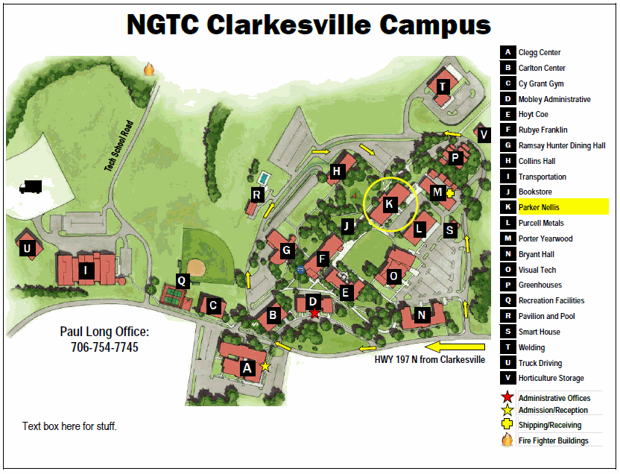

Links

[How to survive a zombie apocalypse: Stay far from the cities](http://mashable.com/2015/03/05/zombie-apocalypse-simulation/)

[The simulation, a must see](http://mattbierbaum.github.io/zombies-usa/)

[A DIY Survival Guide for the Zombie Apocalypse](http://mashable.com/2014/10/05/zombie-apocalypse-diy/)

[How To Survive The Zombie Apocalypse](http://www.makeuseof.com/tag/how-to-survive-zombie-apocalypse/)