**Flea Market’s User Manual**

# **Introduction**

For this website, I try to design the program like an online Market. I called it Flea Market. User can upload the item that they want to sell or search the thing that they want to buy. Also, it supposes that people log in by the account (username: longge password: 12345). In My profile, there are two functions, upload and review. For the upload function, user need to complete the information of the selling item. For the review function, user can review what the item does user upload.

# **Deployment**

**Support software client program software:** Chrome

**Hardware:** PHP, HTML, JavaScript, CSS

**Service:** Web Service, <http://199.17.161.60:3440/>

**Data Save:** Allitem.txt; All item information

myitem.txt; user’s item information

# **How to use the website**

## **2.1 Open the Home page**

Go to**:** [**http://199.17.161.60:3440/LonggeYuan/Final%20Project/**](http://199.17.161.60:3440/LonggeYuan/Final%20Project/)and click the **“Flea Market.php”**

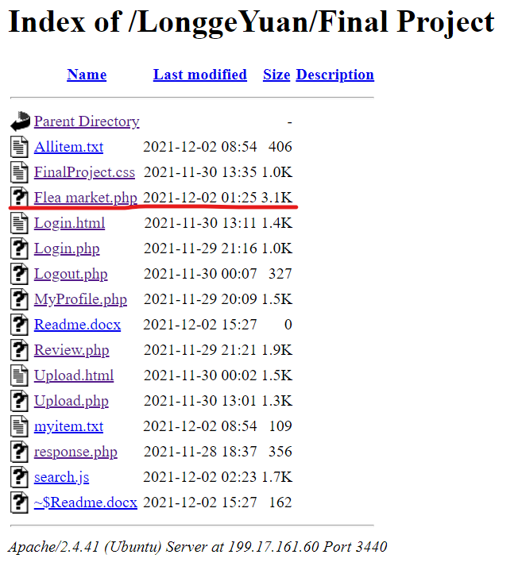

Figure 1. file menu

## **2.2 Go to Log in**

Please log in before you upload your project.

Figure 2. Home page

## **2.3 Enter the Account**

Enter the username and password (**username: longge password: 12345. Only this account can be access**)

Figure 3. Login Page

## **2.4 My profile function**

After you log in, you can upload or review you item.

Figure 4.My profile page

### **2.4.1 Upload**

For upload function, complete the item information please.

Figure 5. blanks of information

Please enter the name in the **“item”** blank

Figure 6. Item blank

Please enter the number in the **“price”** blank

Figure 7. Price blank

Please enter the number in the **“Account”** blank

Figure 8. Account blank

Please enter the phone number in the **“phone”** blank

Figure 9. Phone blank

After you finish upload or want to go back. Please click the **“go back”** button.

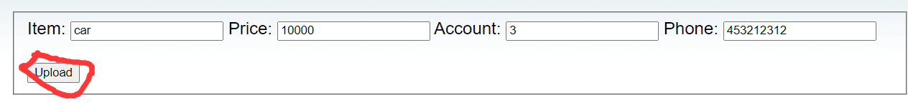

Figure 10. go back button

### **2.4.2 Review**

For review function, you can review the item that you have already added.

Figure 11. Example of Item list

Please click the “**go back**” to turn back the last page.

## **2.5 Log out**

After you upload or review, you can log out the account by click the “log out” button.

Figure 12. log out button

## **2.6 Check and Search**

Finally, you can find the items you added on the homepage. You can also search for the items you want to buy.

Figure 13. Example of search

# **Epilogue**

Thanks to Professor Li Shimin for providing the website. This project was completed independently.