**The files in this C:/LongGiaPha are used for the website render operation, maintained by the GitBash app.**

**To run on** [**www.render.com**](http://www.render.com) **with C:/LongGiaPha and maintained by github: type** “***longgiapha51.xyz”* on the browser URL bar.** This command will run index.html in which giaphabenngoai.pdf will be executed and show the main page of our family tree. Note that the absolute path is <https://longgiapha51.xyz>. In Word hyperlink this path must be specified for the pdf file to be linked to, say “*https://longgiapha51.xyz/giaphabasohai.pdf*”

To maintain the longgiapha files:

1. Edit the word file/s in E:/LongGiaPha Edit/Docx. If there is a hyperlink the linked pdf file path must have an absolute path <https://longgiapha51.xyz/> (eg [*https://longgiapha51.xyz/giaphabasohai.pdf*](https://longgiapha51.xyz/giaphabasohai.pdf)”). The word file is saved 2 times: one as word itself in E:/LongGiaPha Edit/Docx; the other is as a pdf file in in E:/LongGiaPha Edit. For hyperlink see “**Hyperlink to another in word.docx**” in E:/LogGiaPha.

2. Copy the edited pdf file/s and its hyperlink pdf file/s if any, to C:/LongGiaPha.

3. Run Git Bash from your PC:

1. In the Window box type Git Bash to run the app.

2. cd C:/longgiapha.

3. git status: show its status with red files.

4. git add . : add those modified file/s and new files if any (see comments on the screen). To ensure they have been added, run git status again. All files are now green (uptodate).

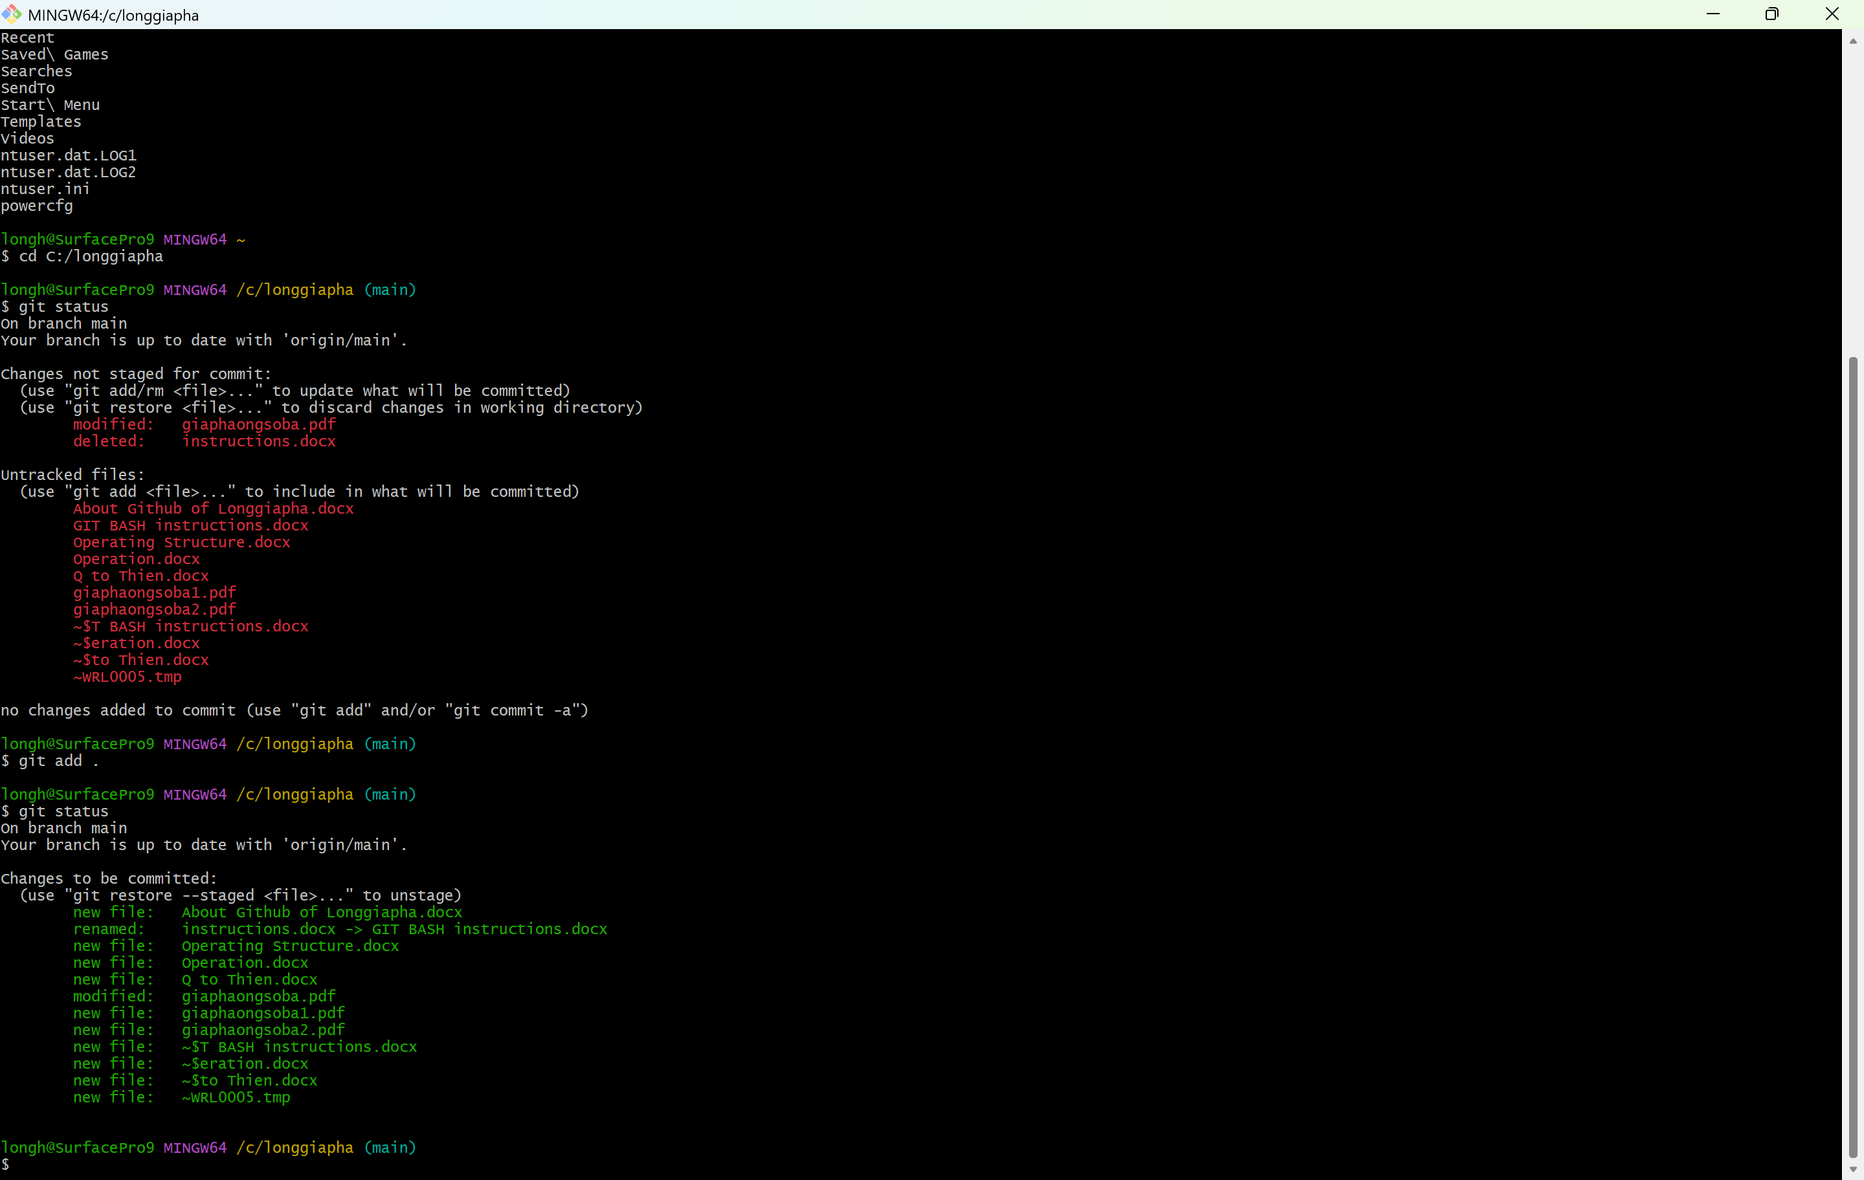

5. git commit -m “mod 121224” (mod 121224 as a note to be shown on git hub).

6. Finally run “git push -u origin main” to upload onto git hub.