Session 2.a

1. A Boolean value is either true or false
2. Expression:

* 1>2 (false)
* 1==5(false)
* 3<7(true)

1. Flow chart is a graphical representation of a computer program in relation to its sequence of functions

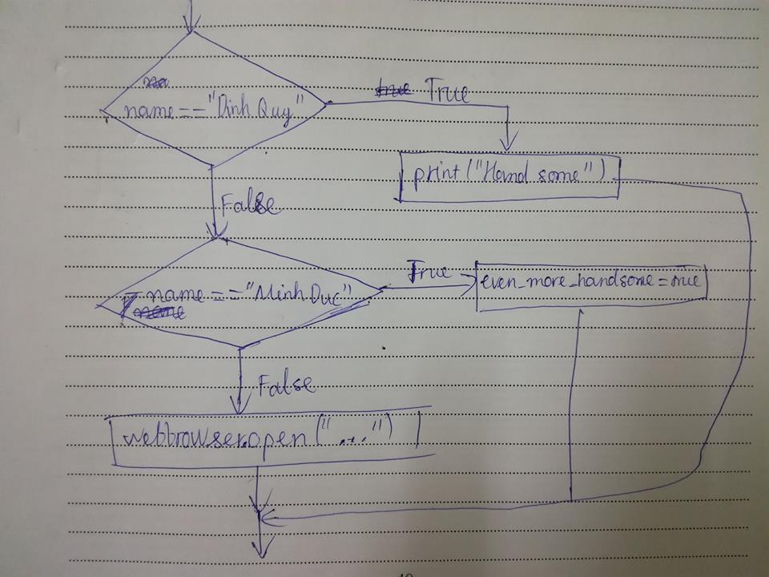

1. Nested conditional is a conditional that contains another conditional statements
2. Example

if x < y:

print("hihi")

else:

if x>y:

print(“hehe”)

else:

print("haha")

Session 2.b

1. A nested list is a list within another list
2. A list can store both integers and strings in it