Topic 1: Introduction to R
Longhai Li
2023-09-21

Basic R Objects and Operations
# create a vector
x <- 1:10
x <- seq (30,3, by = -2)
a <- c(66.32, 69.87, 70.12, 90.37, 50.08, 61.20, 65.00, 57.65)
d <- a [1]
a [1] <- 85.34
mean (a)
## [1] 68.70375
ma <- mean (a)
# read a vector of numbers from a file
x <- scan("numbers.txt")
# one can also read number withoug saving to a file
y <- scan(text = "7 8 9 10 11 12 13 13 14 17 17 45")
# create a matrix
A <- matrix (0, 4, 2)
A <- matrix (1:8, 4,2)
D <- matrix (a, 4, 2, byrow=T)
D <- matrix(1:8, 2, 4)
# create another matrix with all entry 0
B <- matrix (0, 100, 50)
# assign a number to B
B[1,4] <- 4.5
B[1,] <- 1:50
# create a list
E <- list (newa = a, newA = A)
# list the names of components
names (E)
## [1] "newa" "newA"
# to look at the component of E
E$newA
## [,1] [,2]
## [1,] 1 5
## [2,] 2 6
## [3,] 3 7
## [4,] 4 8
E$newa <- 10:17
# create a dataframe
scores <- c (30, 45, 50)
names <- c("Peter", "John", "Alice")
stat245_scores <- data.frame (names, scores)
stat245_scores$names
## [1] "Peter" "John" "Alice"
stat245_scores$scores [2] <- 17
stat245_scores$perc <- stat245_scores$score/50 * 100 + 10

Import a dataset into R environment and Simple Operation
# import myagpop.csv into an R data frame called 'myagpop'
agpop <- read.csv ("agpop.csv")
# Now, we can use the data:
# preview agpop
head (agpop)
## county state acres92 acres87 acres82 farms92 farms87 farms82
## 1 ALEUTIAN ISLANDS AREA AK 683533 726596 764514 26 27 28
## 2 ANCHORAGE AREA AK 47146 59297 256709 217 245 223
## 3 FAIRBANKS AREA AK 141338 154913 204568 168 175 170
## 4 JUNEAU AREA AK 210 214 127 8 8 12
## 5 KENAI PENINSULA AREA AK 50810 85712 98035 93 119 137
## 6 AUTAUGA COUNTY AL 107259 116050 145044 322 388 453
## largef92 largef87 largef82 smallf92 smallf87 smallf82 region
## 1 14 16 20 6 4 1 W
## 2 9 10 11 41 52 38 W
## 3 25 28 21 12 18 25 W
## 4 0 0 0 5 4 8 W
## 5 9 18 17 12 18 19 W
## 6 25 32 32 8 19 17 S
# look at the variable name
colnames (agpop)
## [1] "county" "state" "acres92" "acres87" "acres82" "farms92"
## [7] "farms87" "farms82" "largef92" "largef87" "largef82" "smallf92"
## [13] "smallf87" "smallf82" "region"
# find number of cols
ncol (agpop)
## [1] 15
# find number of rows
nrow (agpop)
## [1] 3078
# access a certain row
agpop [2, ]
## county state acres92 acres87 acres82 farms92 farms87 farms82 largef92
## 2 ANCHORAGE AREA AK 47146 59297 256709 217 245 223 9
## largef87 largef82 smallf92 smallf87 smallf82 region
## 2 10 11 41 52 38 W
# access a certain column
agpop [1:20, "acres92"] ## equivalent to
## [1] 683533 47146 141338 210 50810 107259 167832 177189 48022 137426
## [11] 144799 96427 73841 109555 121504 99466 67950 61426 68478 47200
agpop$acres92[1:20]
## [1] 683533 47146 141338 210 50810 107259 167832 177189 48022 137426
## [11] 144799 96427 73841 109555 121504 99466 67950 61426 68478 47200
agpop$largef92[1:20]
## [1] 14 9 25 0 9 25 24 40 6 9 29 18 4 22 24 8 9 13 4 5
# find mean of acres92
mean (agpop $acres92)
## [1] 306677
# find sd of acres92
sd (agpop $acres92)
## [1] 424686.7
agpop_AK <- agpop [agpop$state == "AK", ]
agpop_AK <- subset (agpop, state == "AK")
agpop_W <- subset (agpop, region == "W")
agpop_largefarm <- subset (agpop, largef92 > 10)
## simple analysis
summary (agpop)
## county state acres92 acres87
## Length:3078 Length:3078 Min. : -99 Min. : -99
## Class :character Class :character 1st Qu.: 80903 1st Qu.: 86236
## Mode :character Mode :character Median : 191648 Median : 199864
## Mean : 306677 Mean : 313016
## 3rd Qu.: 366886 3rd Qu.: 372224
## Max. :7229585 Max. :7687460
## acres82 farms92 farms87 farms82
## Min. : -99 Min. : 0.0 Min. : 0.0 Min. : 0.0
## 1st Qu.: 96397 1st Qu.: 295.0 1st Qu.: 318.5 1st Qu.: 345.0
## Median : 207292 Median : 521.0 Median : 572.0 Median : 616.0
## Mean : 320194 Mean : 625.5 Mean : 678.3 Mean : 728.1
## 3rd Qu.: 377065 3rd Qu.: 838.0 3rd Qu.: 921.0 3rd Qu.: 991.0
## Max. :7313958 Max. :7021.0 Max. :7590.0 Max. :7394.0
## largef92 largef87 largef82 smallf92
## Min. : 0.00 Min. : 0.00 Min. : 0.00 Min. : 0.00
## 1st Qu.: 8.00 1st Qu.: 8.00 1st Qu.: 8.00 1st Qu.: 13.00
## Median : 30.00 Median : 27.00 Median : 25.00 Median : 29.00
## Mean : 56.18 Mean : 54.86 Mean : 52.62 Mean : 54.09
## 3rd Qu.: 75.00 3rd Qu.: 70.00 3rd Qu.: 65.00 3rd Qu.: 59.00
## Max. :579.00 Max. :596.00 Max. :546.00 Max. :4298.00
## smallf87 smallf82 region
## Min. : 0.00 Min. : 0.00 Length:3078
## 1st Qu.: 17.00 1st Qu.: 16.00 Class :character
## Median : 35.00 Median : 34.00 Mode :character
## Mean : 59.54 Mean : 60.97
## 3rd Qu.: 67.00 3rd Qu.: 67.00
## Max. :3654.00 Max. :3522.00
hist (agpop$acres92)
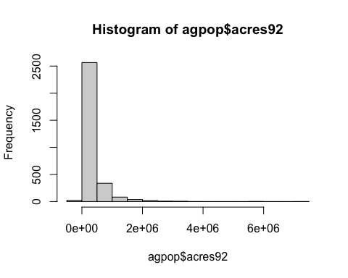
Produce Plots
#pdf ("hist_acres92.pdf") ## use this command and dev.off to save the output to a file
hist (agpop$acres92)

#dev.off()
#jpeg ("agpop_acres_87v92.jpg")
plot (agpop$acres87, agpop$acres92)
abline (a = 0, b = 1)
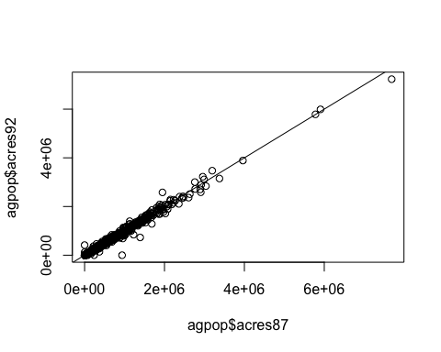
#dev.off()## this is used to close the jpeg file

Create your own function
## data is a matrix or data.frame
means_col <- function (data)
{
n <- ncol (data)
cmeans <- rep (NA, n)
for (j in 1:n)
{
cmeans[j] <- mean (data[,j])
}
cmeans
}
## apply function
means_col (agpop[, 3:13])
## [1] 306676.97141 313016.37817 320193.69298 625.50357 678.28428
## [6] 728.06238 56.17674 54.86160 52.62248 54.09227
## [11] 59.53769
## R built-in function
colMeans (agpop[, 3:13])
## acres92 acres87 acres82 farms92 farms87 farms82
## 306676.97141 313016.37817 320193.69298 625.50357 678.28428 728.06238
## largef92 largef87 largef82 smallf92 smallf87
## 56.17674 54.86160 52.62248 54.09227 59.53769

