Topic 1: Introduction to R

Longhai Li

2023-09-21

# Basic R Objects and Operations

# create a vector  
x <- 1:10  
x <- seq (30,3, by = -2)  
a <- c(66.32, 69.87, 70.12, 90.37, 50.08, 61.20, 65.00, 57.65)  
d <- a [1]  
a [1] <- 85.34  
  
mean (a)

## [1] 68.70375

ma <- mean (a)  
# read a vector of numbers from a file  
x <- scan("numbers.txt")  
  
# one can also read number withoug saving to a file  
y <- scan(text = "7 8 9 10 11 12 13 13 14 17 17 45")  
  
# create a matrix  
A <- matrix (0, 4, 2)  
  
A <- matrix (1:8, 4,2)  
  
D <- matrix (a, 4, 2, byrow=T)  
  
D <- matrix(1:8, 2, 4)  
  
# create another matrix with all entry 0  
B <- matrix (0, 100, 50)  
# assign a number to B  
B[1,4] <- 4.5  
B[1,] <- 1:50  
  
  
# create a list  
E <- list (newa = a, newA = A)  
# list the names of components  
names (E)

## [1] "newa" "newA"

# to look at the component of E  
E$newA

## [,1] [,2]  
## [1,] 1 5  
## [2,] 2 6  
## [3,] 3 7  
## [4,] 4 8

E$newa <- 10:17  
  
# create a dataframe  
scores <- c (30, 45, 50)  
names <- c("Peter", "John", "Alice")  
stat245_scores <- data.frame (names, scores)  
stat245_scores$names

## [1] "Peter" "John" "Alice"

stat245_scores$scores [2] <- 17  
stat245_scores$perc <- stat245_scores$score/50 * 100 + 10

# Import a dataset into R environment and Simple Operation

# import myagpop.csv into an R data frame called 'myagpop'  
agpop <- read.csv ("agpop.csv")  
  
# Now, we can use the data:  
  
# preview agpop  
head (agpop)

## county state acres92 acres87 acres82 farms92 farms87 farms82  
## 1 ALEUTIAN ISLANDS AREA AK 683533 726596 764514 26 27 28  
## 2 ANCHORAGE AREA AK 47146 59297 256709 217 245 223  
## 3 FAIRBANKS AREA AK 141338 154913 204568 168 175 170  
## 4 JUNEAU AREA AK 210 214 127 8 8 12  
## 5 KENAI PENINSULA AREA AK 50810 85712 98035 93 119 137  
## 6 AUTAUGA COUNTY AL 107259 116050 145044 322 388 453  
## largef92 largef87 largef82 smallf92 smallf87 smallf82 region  
## 1 14 16 20 6 4 1 W  
## 2 9 10 11 41 52 38 W  
## 3 25 28 21 12 18 25 W  
## 4 0 0 0 5 4 8 W  
## 5 9 18 17 12 18 19 W  
## 6 25 32 32 8 19 17 S

# look at the variable name  
colnames (agpop)

## [1] "county" "state" "acres92" "acres87" "acres82" "farms92"   
## [7] "farms87" "farms82" "largef92" "largef87" "largef82" "smallf92"  
## [13] "smallf87" "smallf82" "region"

# find number of cols  
ncol (agpop)

## [1] 15

# find number of rows  
nrow (agpop)

## [1] 3078

# access a certain row   
agpop [2, ]

## county state acres92 acres87 acres82 farms92 farms87 farms82 largef92  
## 2 ANCHORAGE AREA AK 47146 59297 256709 217 245 223 9  
## largef87 largef82 smallf92 smallf87 smallf82 region  
## 2 10 11 41 52 38 W

# access a certain column  
agpop [1:20, "acres92"] ## equivalent to

## [1] 683533 47146 141338 210 50810 107259 167832 177189 48022 137426  
## [11] 144799 96427 73841 109555 121504 99466 67950 61426 68478 47200

agpop$acres92[1:20]

## [1] 683533 47146 141338 210 50810 107259 167832 177189 48022 137426  
## [11] 144799 96427 73841 109555 121504 99466 67950 61426 68478 47200

agpop$largef92[1:20]

## [1] 14 9 25 0 9 25 24 40 6 9 29 18 4 22 24 8 9 13 4 5

# find mean of acres92  
mean (agpop $acres92)

## [1] 306677

# find sd of acres92  
sd (agpop $acres92)

## [1] 424686.7

agpop_AK <- agpop [agpop$state == "AK", ]  
  
agpop_AK <- subset (agpop, state == "AK")  
  
agpop_W <- subset (agpop, region == "W")  
  
agpop_largefarm <- subset (agpop, largef92 > 10)  
  
## simple analysis  
summary (agpop)

## county state acres92 acres87   
## Length:3078 Length:3078 Min. : -99 Min. : -99   
## Class :character Class :character 1st Qu.: 80903 1st Qu.: 86236   
## Mode :character Mode :character Median : 191648 Median : 199864   
## Mean : 306677 Mean : 313016   
## 3rd Qu.: 366886 3rd Qu.: 372224   
## Max. :7229585 Max. :7687460   
## acres82 farms92 farms87 farms82   
## Min. : -99 Min. : 0.0 Min. : 0.0 Min. : 0.0   
## 1st Qu.: 96397 1st Qu.: 295.0 1st Qu.: 318.5 1st Qu.: 345.0   
## Median : 207292 Median : 521.0 Median : 572.0 Median : 616.0   
## Mean : 320194 Mean : 625.5 Mean : 678.3 Mean : 728.1   
## 3rd Qu.: 377065 3rd Qu.: 838.0 3rd Qu.: 921.0 3rd Qu.: 991.0   
## Max. :7313958 Max. :7021.0 Max. :7590.0 Max. :7394.0   
## largef92 largef87 largef82 smallf92   
## Min. : 0.00 Min. : 0.00 Min. : 0.00 Min. : 0.00   
## 1st Qu.: 8.00 1st Qu.: 8.00 1st Qu.: 8.00 1st Qu.: 13.00   
## Median : 30.00 Median : 27.00 Median : 25.00 Median : 29.00   
## Mean : 56.18 Mean : 54.86 Mean : 52.62 Mean : 54.09   
## 3rd Qu.: 75.00 3rd Qu.: 70.00 3rd Qu.: 65.00 3rd Qu.: 59.00   
## Max. :579.00 Max. :596.00 Max. :546.00 Max. :4298.00   
## smallf87 smallf82 region   
## Min. : 0.00 Min. : 0.00 Length:3078   
## 1st Qu.: 17.00 1st Qu.: 16.00 Class :character   
## Median : 35.00 Median : 34.00 Mode :character   
## Mean : 59.54 Mean : 60.97   
## 3rd Qu.: 67.00 3rd Qu.: 67.00   
## Max. :3654.00 Max. :3522.00

hist (agpop$acres92)

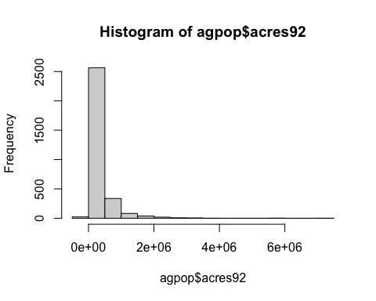

Produce Plots

#pdf ("hist_acres92.pdf") ## use this command and dev.off to save the output to a file  
hist (agpop$acres92)



#dev.off()  
  
#jpeg ("agpop_acres_87v92.jpg")  
  
plot (agpop$acres87, agpop$acres92)  
abline (a = 0, b = 1)

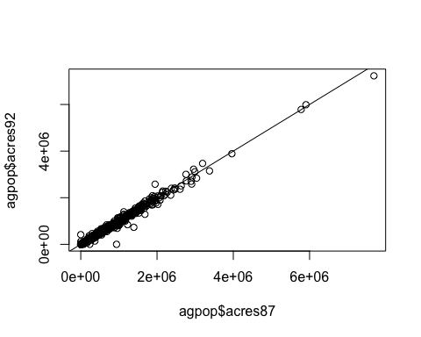

#dev.off()## this is used to close the jpeg file

# Create your own function

## data is a matrix or data.frame  
means_col <- function (data)  
{  
 n <- ncol (data)  
 cmeans <- rep (NA, n)  
 for (j in 1:n)  
 {  
 cmeans[j] <- mean (data[,j])  
   
 }  
 cmeans  
}  
  
## apply function  
means_col (agpop[, 3:13])

## [1] 306676.97141 313016.37817 320193.69298 625.50357 678.28428  
## [6] 728.06238 56.17674 54.86160 52.62248 54.09227  
## [11] 59.53769

## R built-in function  
colMeans (agpop[, 3:13])

## acres92 acres87 acres82 farms92 farms87 farms82   
## 306676.97141 313016.37817 320193.69298 625.50357 678.28428 728.06238   
## largef92 largef87 largef82 smallf92 smallf87   
## 56.17674 54.86160 52.62248 54.09227 59.53769