Simple Random Sampling
Longhai Li
Table of Contents

library(latex2exp)

A function for doing data analysis for srs sample
#
# sdata -- a vector of sampling survey data
# N -- population size
srs_mean_est <- function (sdata, N)
{
n <- length (sdata)
ybar <- mean (sdata)
se.ybar <- sqrt((1 - n / N)) * sd (sdata) / sqrt(n)
mem <- qt (0.975, df = n - 1) * se.ybar
c (ybar = ybar, se = se.ybar, ci.low = ybar - mem, ci.upp = ybar + mem)
}

Analysis of agsrs.csv Data

step by step calculation without using a function
## read survey data
agsrs <- read.csv ("data/agsrs.csv")
head(agsrs)
## county state acres92 acres87 acres82 farms92 farms87 farms82
## 1 COFFEE COUNTY AL 175209 179311 194509 760 842 944
## 2 COLBERT COUNTY AL 138135 145104 161360 488 563 686
## 3 LAMAR COUNTY AL 56102 59861 72334 299 362 447
## 4 MARENGO COUNTY AL 199117 220526 231207 434 471 622
## 5 MARION COUNTY AL 89228 105586 113618 566 658 748
## 6 TUSCALOOSA COUNTY AL 96194 120542 134616 436 521 650
## largef92 largef87 largef82 smallf92 smallf87 smallf82 region
## 1 29 28 21 57 47 66 S
## 2 37 41 42 12 44 47 S
## 3 4 4 3 16 20 30 S
## 4 48 66 62 14 11 28 S
## 5 7 9 9 11 23 27 S
## 6 20 17 23 18 32 29 S
## extract the variable of interest
sdata <- agsrs$acres92
N <- 3078
## do calculation
n <- length (sdata)
ybar <- mean (sdata)
se.ybar <- sqrt((1 - n / N)) * sd (sdata) / sqrt(n)
mem <- qt (0.975, df = n - 1) * se.ybar
## return estimate vector for pop mean
c (Est. = ybar, S.E. = se.ybar, ci.low = ybar - mem, ci.upp = ybar + mem)
## Est. S.E. ci.low ci.upp
## 297897.05 18898.43 260706.26 335087.84
## return estimate vector for pop total
c (Est. = ybar, S.E. = se.ybar, ci.low = ybar - mem, ci.upp = ybar + mem) * N
## Est. S.E. ci.low ci.upp
## 916927110 58169381 802453859 1031400361

Write a function for repeated use
## sdata --- a vector of original survey data
## N --- population size
## to find total, multiply N to the estimate returned by this function
srs_mean_est <- function (sdata, N = Inf)
{
n <- length (sdata)
ybar <- mean (sdata)
se.ybar <- sqrt((1 - n / N)) * sd (sdata) / sqrt(n)
mem <- qt (0.975, df = n - 1) * se.ybar
c (Est. = ybar, S.E. = se.ybar, ci.low = ybar - mem, ci.upp = ybar + mem)
}
agsrs <- read.csv ("data/agsrs.csv")
# inference for mean of variable acres92
srs_mean_est (agsrs[,"acres92"], N = 3078)
## Est. S.E. ci.low ci.upp
## 297897.05 18898.43 260706.26 335087.84
# inference for total of variable acres92
srs_mean_est (agsrs[,"acres92"], N = 3078) * 3078
## Est. S.E. ci.low ci.upp
## 916927110 58169381 802453859 1031400361

Estimate the proportion of counties with fewer than 200K acres for farming in 1992
acres92.is.fewer.200k <- as.numeric (agsrs[,"acres92"] < 200000)
srs_mean_est (acres92.is.fewer.200k, N = 3078)
## Est. S.E. ci.low ci.upp
## 0.51000000 0.02746498 0.45595084 0.56404916
# inference for total number of counties with fewer than 200K acres for farming in 1992
srs_mean_est (acres92.is.fewer.200k, N = 3078) * 3078
## Est. S.E. ci.low ci.upp
## 1569.78000 84.53722 1403.41670 1736.14330

Comparing with true value
agpop <- read.csv ("data/agpop.csv", na = "-99")
#true mean
mean (agpop[, "acres92"], na.rm = T)
## [1] 308582.4
# true total
sum (agpop[, "acres92"], na.rm = T)
## [1] 943953599
# true proportion of counties with less than 200K acres for farming
mean (agpop[, "acres92"] < 200000, na.rm = T)
## [1] 0.5145472
# true number of counties with less than 200K acres for farming
sum (agpop[, "acres92"] < 200000, na.rm = T)
## [1] 1574

A Simulation Demonstration of SRS Inference
# read population data
agpop <- read.csv ("data/agpop.csv")
## remove those counties with na
agpop <- subset( agpop, acres92 != -99)

Simulation
###################### working with variable 'acres92' ##################
# sample size
n <- 300
# population size
N <- nrow (agpop)
# true value of population mean
ybarU <- mean (agpop[,"acres92"]); ybarU
## [1] 308582.4
# true value of deviation of sample mean
true.se.ybar <- sqrt (1- n/N) * sd (agpop[,"acres92"]) / sqrt (n); true.se.ybar
## [1] 23320.29
## one srs sampling
# srs sampling
srs <- sample (1:N,n); srs
## [1] 2033 450 1815 342 2043 2440 196 2318 1664 786 934 1833 2443 1188 2499
## [16] 2435 987 2986 2640 2611 1082 1276 1039 2199 2592 562 1147 317 1107 40
## [31] 1950 2015 81 1873 810 1397 2579 2412 517 1742 2639 1929 2075 1963 1916
## [46] 1264 2521 1924 2514 1962 1567 1585 742 545 569 1116 1192 478 608 388
## [61] 1666 120 2607 2336 2493 908 1177 575 486 1904 1509 1075 2381 898 1681
## [76] 2084 935 1596 87 2421 373 2677 2471 737 2418 132 729 1170 11 97
## [91] 263 3032 194 1274 2959 257 713 2095 2253 83 1623 2462 2209 1547 414
## [106] 1388 2937 1159 1093 3041 697 275 1790 2338 3 698 2562 801 46 2002
## [121] 2243 400 351 1920 2274 2416 1760 1513 2010 93 2746 1325 2260 966 1689
## [136] 3015 3042 1446 363 1821 382 168 1251 612 322 924 1400 66 2975 80
## [151] 624 2137 1195 51 1356 1957 455 1905 1103 461 814 304 1005 2133 2549
## [166] 2388 1727 2469 1961 2628 1440 449 2070 1377 1442 1 65 2622 759 1098
## [181] 1396 1468 2192 425 2252 70 1770 1168 724 493 1740 1979 1734 1636 277
## [196] 892 1697 2423 312 2732 896 962 1189 2522 749 746 434 687 647 237
## [211] 1945 1113 2524 210 357 1154 622 1000 2982 2474 2712 1031 2473 1363 2065
## [226] 269 1071 2097 2480 315 430 1805 181 2770 1723 948 91 895 1602 184
## [241] 2442 377 1614 1467 1230 1327 1890 1702 1096 1610 1180 864 375 1025 1611
## [256] 1095 1981 1898 1826 1453 2978 2518 441 1551 2377 632 1432 2641 1234 922
## [271] 2384 2726 942 1518 152 32 2063 285 198 323 2806 691 1716 1407 348
## [286] 2118 1674 1369 609 2709 1150 2515 1629 439 799 1494 1144 530 1271 877
# get data of variable "acres92"
sdata <- agpop [srs, "acres92"]; sd (sdata)
## [1] 326901.8
# analysis
srs_mean_est (sdata, N)
## Est. S.E. ci.low ci.upp
## 298689.42 17924.32 263415.61 333963.22
## repeated srs sampling
nres <- 5000 # number of repeated sampling
simulation.results <- matrix (0, nres, 4) # matrix recording repeated results
colnames(simulation.results) <- c( "Est.", "S.E.", "ci.low", "ci.upp")
for (i in 1:nres)
{
srs <- sample (N, n)
sdata <- agpop [srs, "acres92"]
simulation.results [i,] <- srs_mean_est (sdata, N)
}
head(simulation.results)
## Est. S.E. ci.low ci.upp
## [1,] 319712.2 22355.02 275719.1 363705.3
## [2,] 296594.6 23847.78 249663.8 343525.3
## [3,] 279454.5 20363.84 239379.9 319529.1
## [4,] 292638.2 27075.43 239355.6 345920.7
## [5,] 299742.8 27145.96 246321.5 353164.2
## [6,] 329150.2 27225.44 275572.5 382728.0
# look at the distribution of sample mean
par (mfrow= c(1,4))
hist (agpop$acres92)
hist (simulation.results[,1])
abline (v = ybarU, col = "red")
qqnorm (simulation.results[,1]); qqline(simulation.results[,1])
boxplot (simulation.results[,1])
abline (h = ybarU, col = "red")
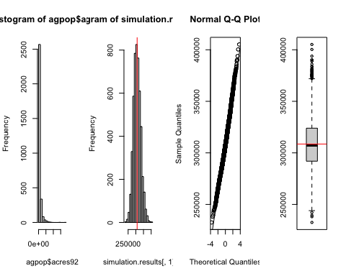
mean (simulation.results[,1])
## [1] 308512.8
ybarU
## [1] 308582.4
sd (simulation.results [,1])
## [1] 23593.81
true.se.ybar
## [1] 23320.29
# look at coverage rate through simulation
simulation.results <- cbind (simulation.results, (simulation.results[,3] < ybarU) * (ybarU < simulation.results[,4] ))
colnames(simulation.results)[5] <- "Covered?"
head(simulation.results)
## Est. S.E. ci.low ci.upp Covered?
## [1,] 319712.2 22355.02 275719.1 363705.3 1
## [2,] 296594.6 23847.78 249663.8 343525.3 1
## [3,] 279454.5 20363.84 239379.9 319529.1 1
## [4,] 292638.2 27075.43 239355.6 345920.7 1
## [5,] 299742.8 27145.96 246321.5 353164.2 1
## [6,] 329150.2 27225.44 275572.5 382728.0 1
library("plotrix")
par(mfrow=c(1,1))
plotCI(x=1:100,
y=simulation.results[1:100,1],
li = simulation.results[1:100,3],
ui = simulation.results[1:100,4],
col = 2-simulation.results[,5])
abline(h=ybarU, col = "blue")
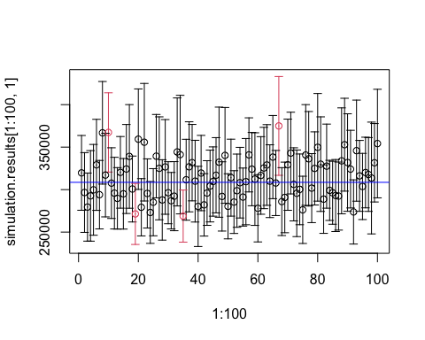
# actual coverage rate in the simulation
mean (simulation.results[,5])
## [1] 0.9338

