**Do Thanh Long – 2201040101 – Midterm PCO**

**Starbuck Company Website**

**Overview**

**Starbuck Company Website** is a straightforward website that focuses on creating a smooth, stylish, and user-friendly experience, making it easy for customers to access Starbucks products and services. The website is built using only HTML and CSS, with a touch of JavaScript for enhanced functionality. Its design is simple and responsive, ensuring a user-friendly experience.

**Keys features**

**Modern User Interface (UI) Design**:

* **Minimalist and Elegant Interface**: Uses Starbucks' signature colors (light green and white) combined with a minimalist yet sophisticated design.
* **High-Quality Images and Graphics**: Products are displayed with clear, high-resolution images, making it easy for users to recognize items.
* **Logical Layout and Easy Navigation**: Categories and functional buttons are arranged logically, allowing customers to quickly find products or services.

**Good User Experience (UX)**:

* **Fast Loading Speed**: Optimizes elements like images, videos, and source code for quick loading, ensuring users don't have to wait.
* **Mobile Compatibility**: The website is responsive, compatible with various devices (computers, phones, tablets), providing the best experience across all platforms.

**Responsive Design:** The website is responsive and adapts seamlessly to various screen sizes, including desktops, tablets, and smartphones

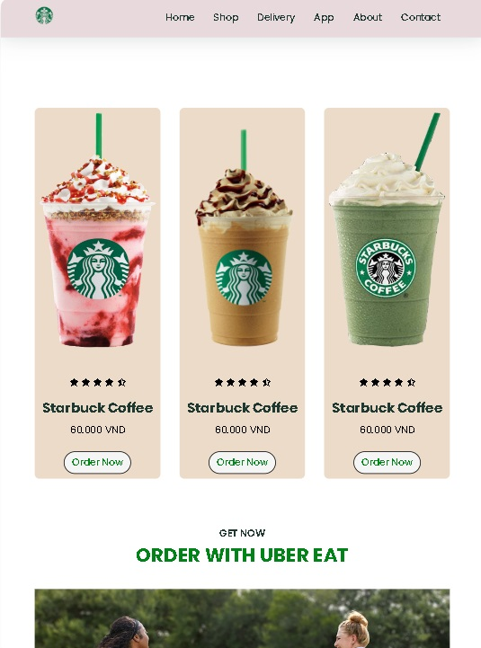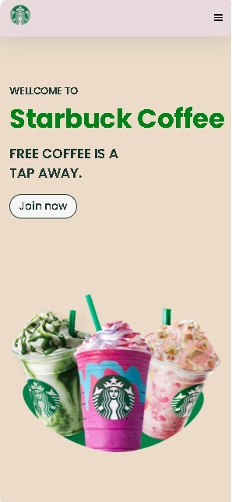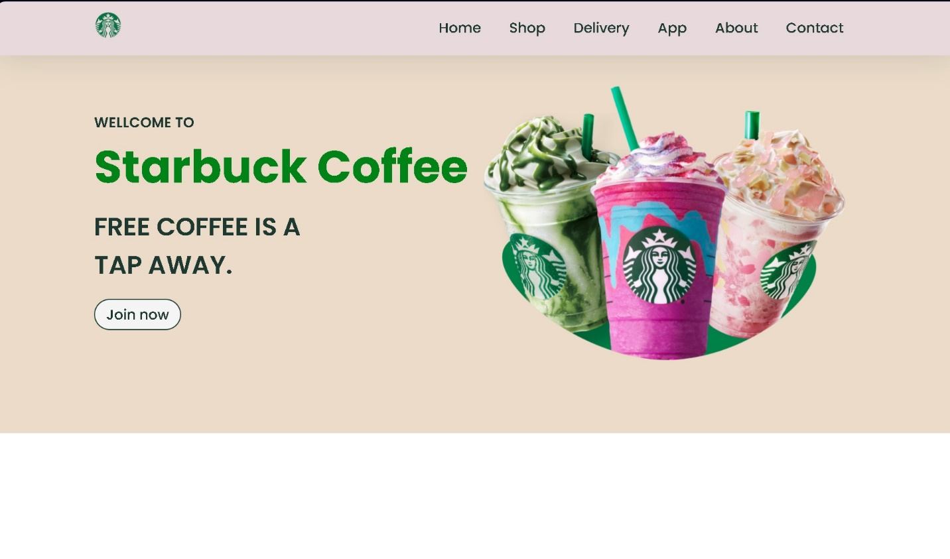

**Conclusion**

With this design, Starbucks provides a friendly experience, making exploration and shopping easier and more enjoyable for customers.