SDN302 – SERVER-SIDE DEVELOPMENT WITH NODEJS, EXPRESS AND MONGODB
LAB 02: APIs, THE HTTP MODULE AND THE FILE SYSTEM
Student Name: Nguyễn Long
Student Code: DE190039
Class: SE19c02

1. REQUIREMENT 1 – EXPLORE A PUBLIC REST API WITH POSTMAN
1.1 GET Request
Method: GET
URL: https://jsonplaceholder.typicode.com/posts/1
Request Body: None
Status Code: 200 OK
Response: The API returns information about post 1 in JSON format.
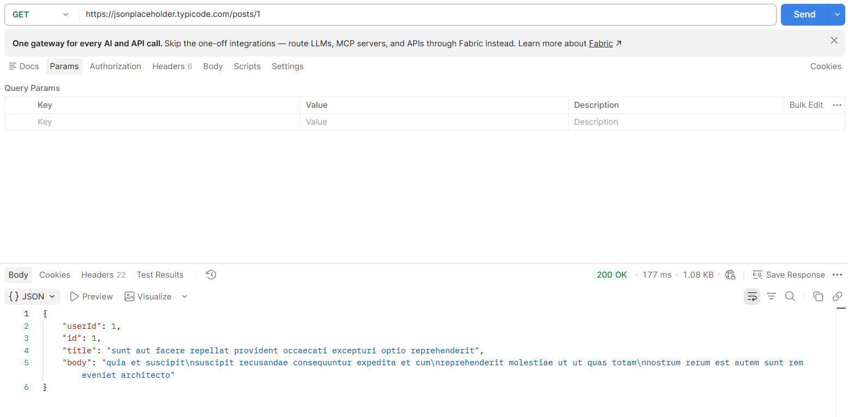
1.2 POST Request
Method: POST
URL: https://jsonplaceholder.typicode.com/posts
Request Body:
{
"title": "BookNest",
"body": "NodeJS Lab 02",
"userId": 1
}
Status Code: 201 Created
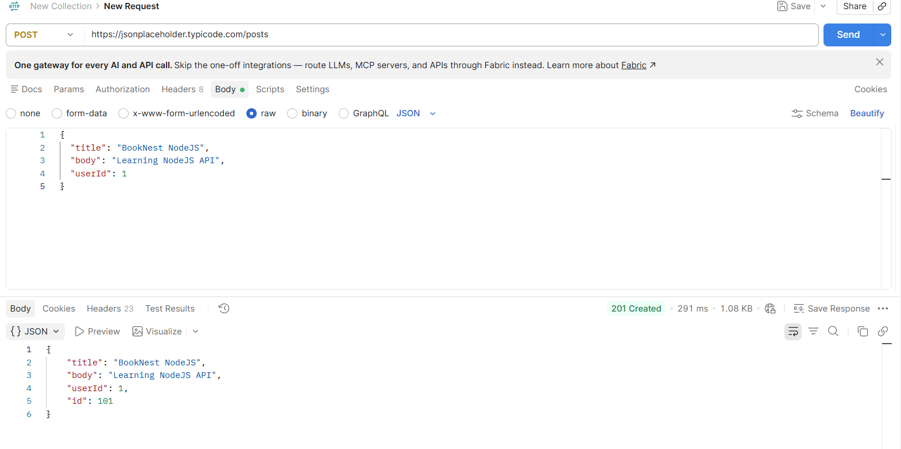
1.3 PUT Request
Method: PUT
URL: https://jsonplaceholder.typicode.com/posts/1
Request Body:
{
"id": 1,
"title": "Updated Book",
"body": "Updated content",
"userId": 1
}
Status Code: 200 OK
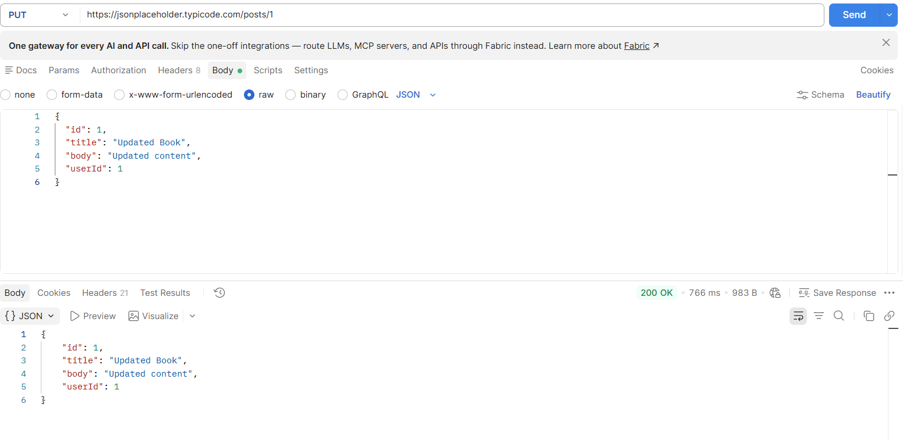
1.4 DELETE Request
Method: DELETE
URL: https://jsonplaceholder.typicode.com/posts/1
Request Body: None
Status Code: 200 OK
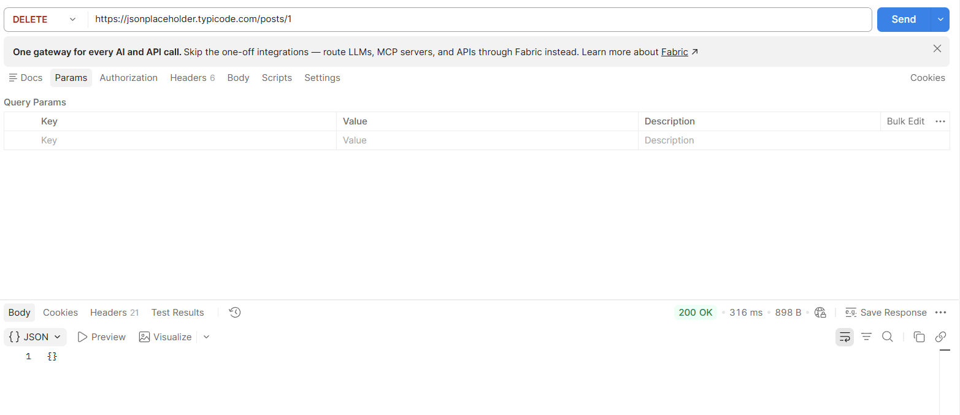
1.5 Summary of API Requests
Method | URL | Body | Status
GET | /posts/1 | None | 200 OK
POST | /posts | JSON | 201 Created
PUT | /posts/1 | JSON | 200 OK
DELETE | /posts/1 | None | 200 OK

1.6 JSON and XML
Example JSON:
{
"id": 1,
"title": "NodeJS Book"
}
Equivalent XML:
<book>
<id>1</id>
<title>NodeJS Book</title>
</book>
Advantages of JSON over XML
- JSON has a simpler and more compact syntax, so it is easier to read and write.
- JSON works naturally with JavaScript and Node.js and is commonly used in REST APIs.

1.7 SOAP and REST Comparison
Feature | SOAP | REST
Type | Protocol | Architectural style
Message format | Mainly XML | JSON, XML, text, etc.
State | Can support stateful communication | Usually stateless
Typical use | Enterprise systems, banking and systems requiring strict contracts | Web applications, mobile applications and CRUD APIs

2. REQUIREMENT 2 – BUILD A WEB SERVER WITH THE CORE HTTP MODULE
The server was created using Node.js built-in http module and listens on port 3000.
2.1 Home Page
URL: http://localhost:3000/
Status: 200 OK
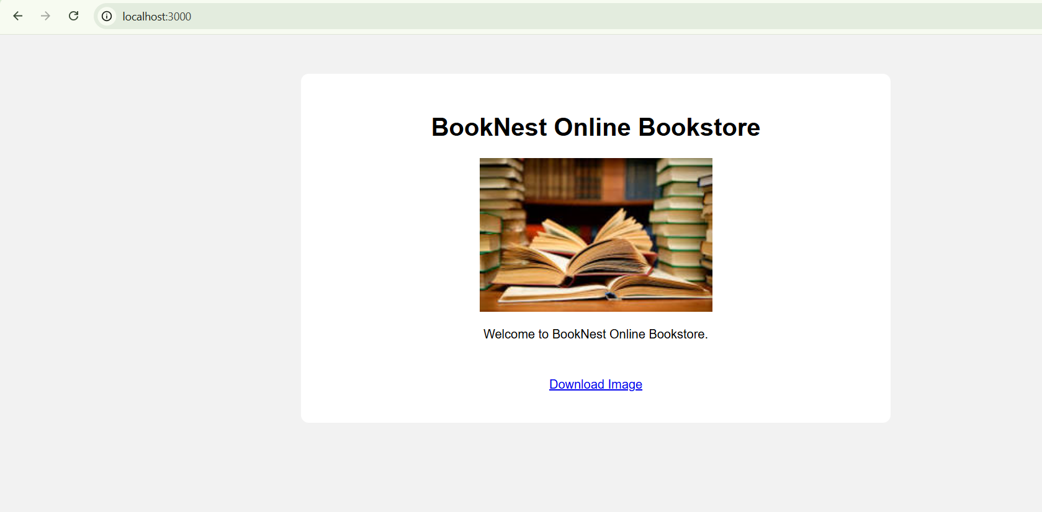
2.2 About Page
URL: http://localhost:3000/about
Status: 200 OK
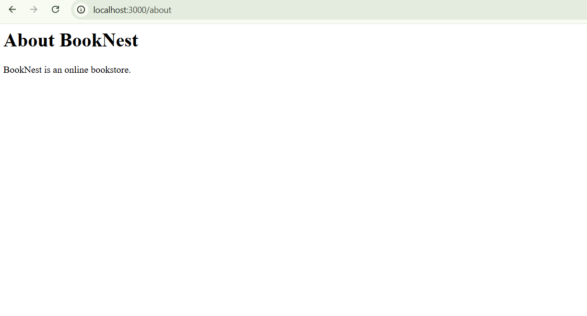
2.3 Books API
URL: http://localhost:3000/api/books
Method: GET
Status: 200 OK
The API returns an array containing at least five books in JSON format.
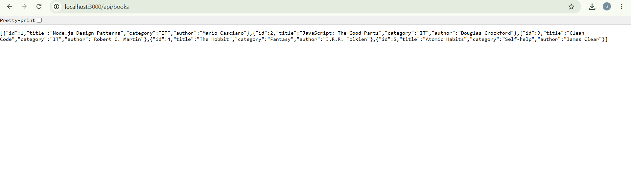
2.4 404 Page
An unknown route returns HTTP status code 404.
Example URL: http://localhost:3000/abc
Status: 404 Not Found
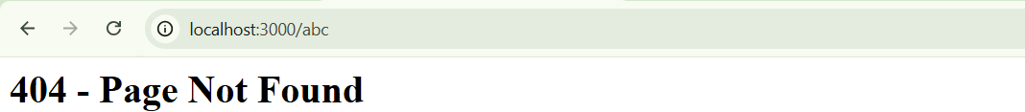
3. REQUIREMENT 3 – HTTP METHODS, QUERY STRINGS AND REQUEST BODIES
3.1 Filter Books
Request:
GET http://localhost:3000/api/books?category=IT&limit=2
The server filters books by category and limits the result to two books.
Status: 200 OK
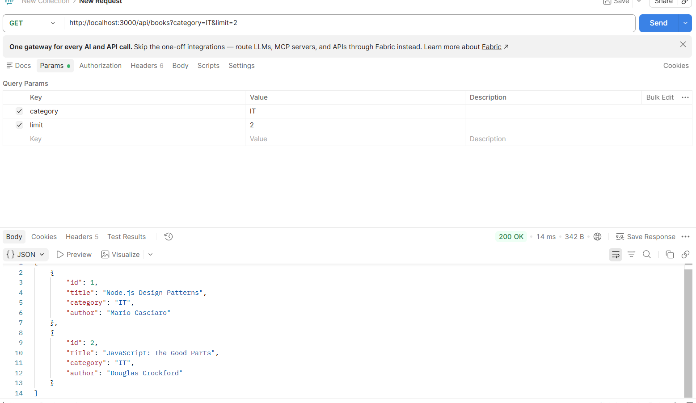
3.2 Create a New Book
Request:
POST http://localhost:3000/api/books
Request Body:
{
"title": "Learning Node.js",
"category": "IT",
"author": "John Doe"
}
Status: 201 Created
The new book is returned in the response.
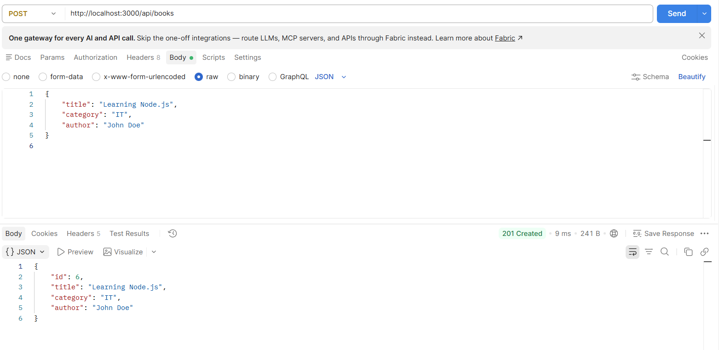
3.3 Unsupported HTTP Method
An unsupported HTTP method returns status code 405.
Example:
PUT http://localhost:3000/api/books
Status: 405 Method Not Allowed
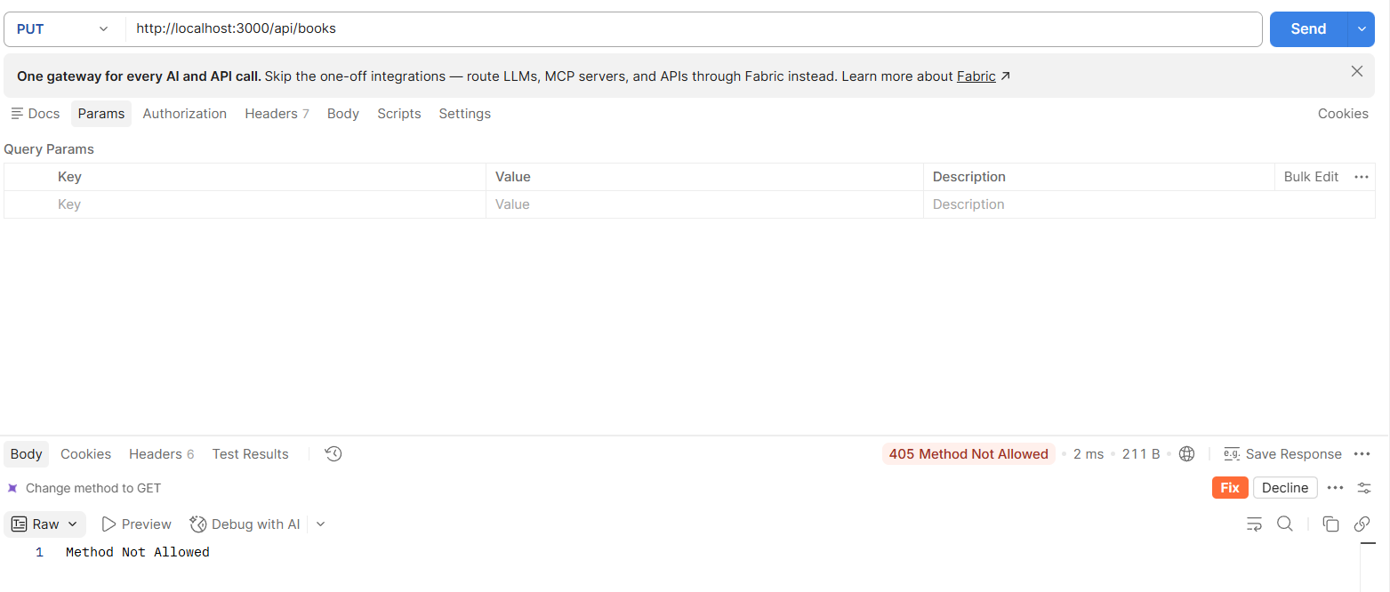
4. REQUIREMENT 4 – WORK WITH THE FILE SYSTEM
4.1 books.json
The application stores books in books.json.
After sending a POST request, the new book is saved permanently into the file.
Screenshot:
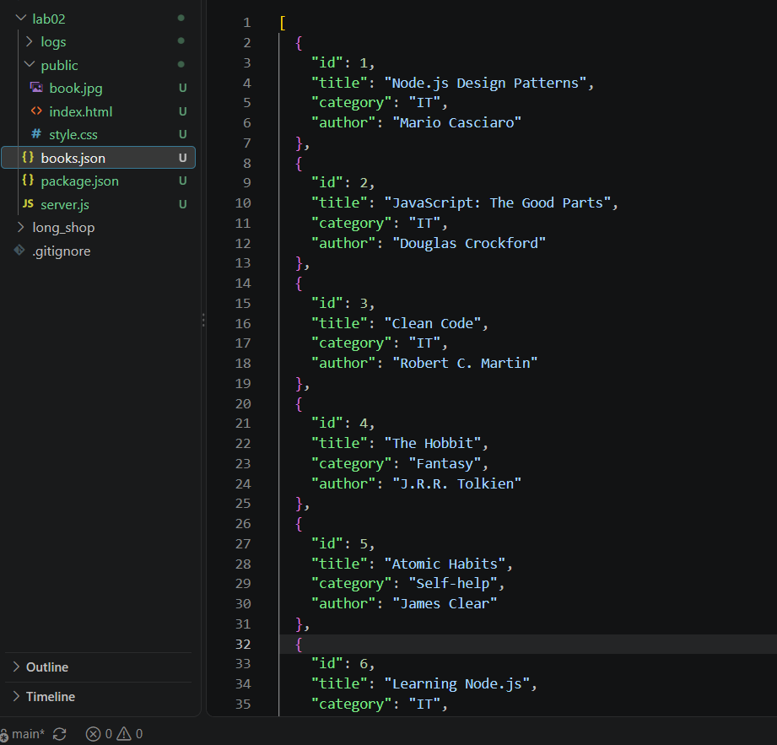
4.2 Access Log
The server creates the logs directory automatically if it does not exist.
Each request is recorded in logs/access.log with:
- Timestamp
- HTTP method
- Requested URL
Example:
2026-10-05T09:00:00.000Z GET /
2026-10-05T09:00:10.000Z GET /about
2026-10-05T09:00:20.000Z GET /api/books
2026-10-05T09:00:30.000Z GET /api/books?category=IT&limit=2
2026-10-05T09:00:40.000Z POST /api/books
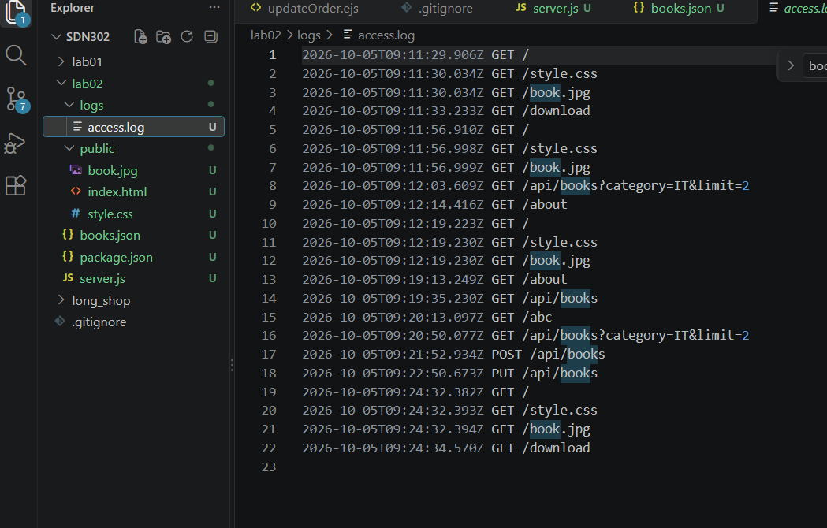
5. REQUIREMENT 5 – SERVE STATIC FILES
The application contains a public folder with HTML, CSS and image files.
public/
├── index.html
├── style.css
└── book.jpg
The server determines the MIME type based on the file extension.
5.1 Styled HTML Page
URL:
http://localhost:3000/
The page displays the BookNest title, CSS styling and a book image.
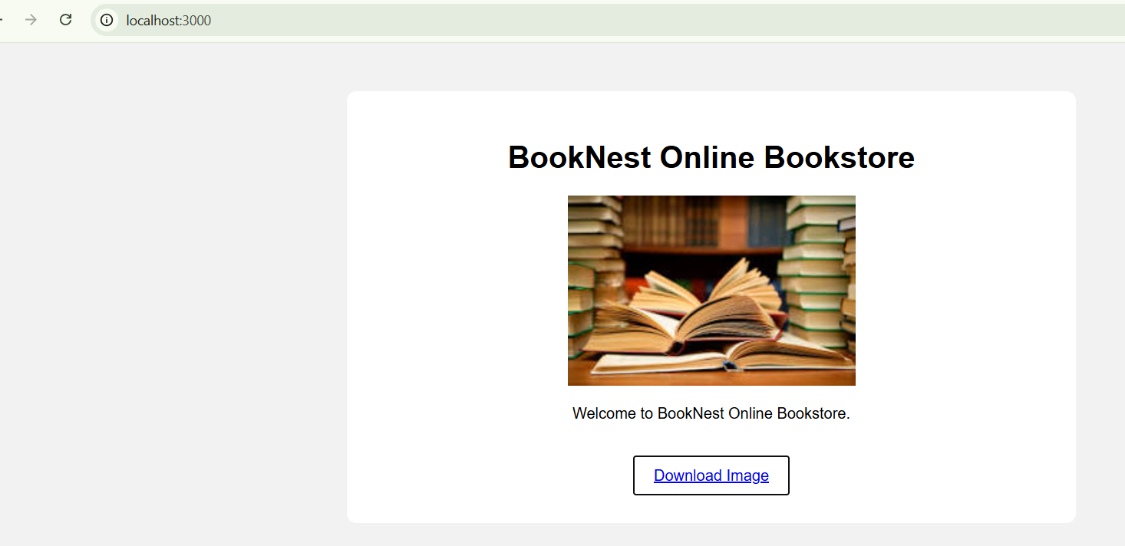
5.2 Download Route
URL:
http://localhost:3000/download
The route sends book.jpg to the client as an attachment.
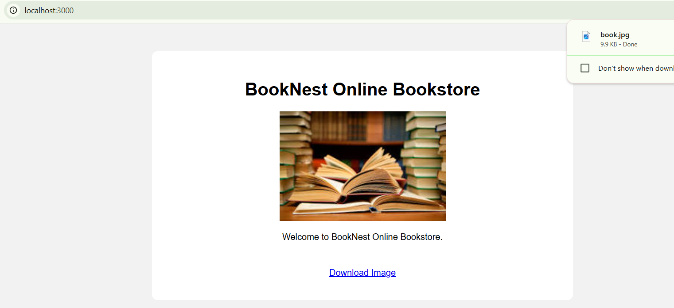
6. CONCLUSION
In this lab, I learned how clients and servers communicate through HTTP and how REST APIs work. I practiced using HTTP methods including GET, POST, PUT and DELETE with Postman.
I also implemented a web server using Node.js built-in http module, handled HTTP status codes, headers, query strings and request bodies.
In addition, I used the fs and path modules to read and write JSON files, save new books permanently, create access logs and serve static files. The lab helped me understand the basic components of a Node.js server before using Express.js.

