SDN302 - Lab 01 Report
Student Name: LONG NGUYEN
Student Code: DE190039
Course: SDN302 - Server-side Development with NodeJS, Express and MongoDB
Lab: Lab 01 - Back-end Development Fundamentals & Node.js Environment

1. Front-End, Back-End and Full-Stack Comparison
Aspect | Front-End | Back-End | Full-Stack
Responsibilities | Build the user interface and user interactions | Build APIs, business logic, authentication and database operations | Handle both front-end and back-end
Languages | HTML, CSS, JavaScript/TypeScript | JavaScript/TypeScript, Java, C#, Python, PHP, Go | Combination of front-end and back-end technologies
Frameworks | React, Vue, Angular | Node.js/Express, Spring Boot, ASP.NET, Django | React + Node.js/Express, Next.js, etc.
Typical tools | VS Code, Chrome DevTools, npm | VS Code, Postman, MongoDB, SQL Server | VS Code, Git, Postman, database tools

2. Five Essential Back-End Skills
1. Programming
A back-end developer needs strong programming skills to implement business logic, process data and build APIs.
2. Database
Database knowledge is important because back-end applications need to store, query and manage data efficiently.
3. API Development
Developers need to understand REST APIs and HTTP methods so that front-end applications and other services can communicate with the server.
4. Security
Authentication, authorization, password protection and input validation are important for protecting applications and user data.
5. Git and Version Control
Git allows developers to track changes, collaborate with other developers and recover previous versions of the source code.

3. Web Hosting
Web hosting is a service that provides servers and infrastructure for making a website or web application accessible over the Internet.
One popular hosting platform is Render.

4. CI/CD
CI/CD stands for Continuous Integration and Continuous Delivery/Deployment. It automates processes such as building, testing and deploying an application whenever developers push new code.
One popular CI/CD service is GitHub Actions.

5. CommonJS vs ES Modules
CommonJS
CommonJS uses require() to import modules and module.exports to export modules.
Example:
// bookUtils.js

function formatPrice(price) {
return `${price} VND`;
}

module.exports = {
formatPrice
};
The module can then be imported using:
const { formatPrice } = require("./bookUtils");
ES Modules
ES Modules use import and export.
Example:
// bookUtils.mjs

export function formatPrice(price) {
return `${price} VND`;
}
The function can then be imported using:
import { formatPrice } from "./bookUtils.mjs";
Node.js can recognize ES Modules by using the .mjs extension or by setting "type": "module" in package.json.
The main difference is that CommonJS uses require() and module.exports, while ES Modules use import and export.

6. Event Loop
Node.js uses a single JavaScript thread and an event-driven architecture. Synchronous CPU-intensive code can block the event loop and delay callbacks such as timers.
In the event loop demonstration, synchronous code executes first. process.nextTick() and resolved Promise callbacks are processed before the event loop continues with later phases. setTimeout() and setImmediate() are handled by the event loop, and their relative order can depend on the execution context.
The observed output was:
1. Start
6. End
4. process.nextTick
5. Promise
2. setTimeout
3. setImmediate
A blocking loop of 3 billion iterations prevented Node.js from processing the timer callback until the loop finished. The blocking version produced:
Start
Loop finished
Sum: 4499999997067114000
Total time: 3270 ms
Timer executed after: 3273 ms
This shows that the timer was delayed until the CPU-intensive synchronous operation completed.
In the non-blocking/chunked version, the calculation was divided into smaller tasks using setImmediate(). This allowed the event loop to process other callbacks while the calculation was still running.
The non-blocking version produced:
Start
Timer executed after: 105 ms
Loop finished
Sum: 4499999997067114000
Total time: 33628 ms
The timer therefore executed after approximately 105 ms instead of waiting for the entire calculation to finish. Although the total calculation took longer because of the overhead of processing smaller chunks, the event loop remained responsive.

7. Conclusion
This lab introduced the Node.js development environment, npm, CommonJS and ES Modules, built-in and third-party modules, and the event loop.
The lab also demonstrated why CPU-intensive synchronous operations can block a Node.js application and how asynchronous programming can improve responsiveness by allowing the event loop to process other callbacks.

8. Screenshots / Evidence
The following screenshots should be included as evidence for the corresponding requirements.
Requirement 1 - Development Environment
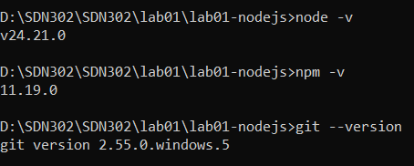
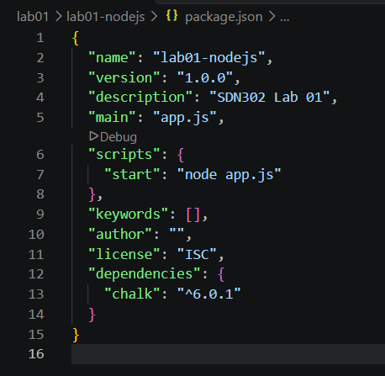
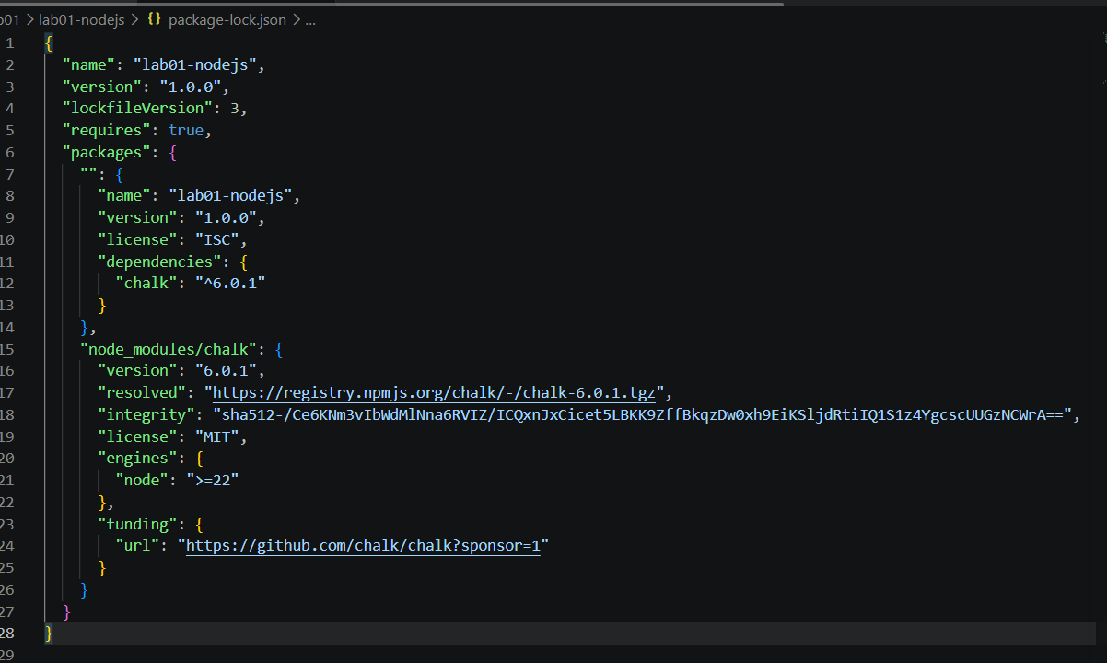
Requirement 2 - First Node.js Application
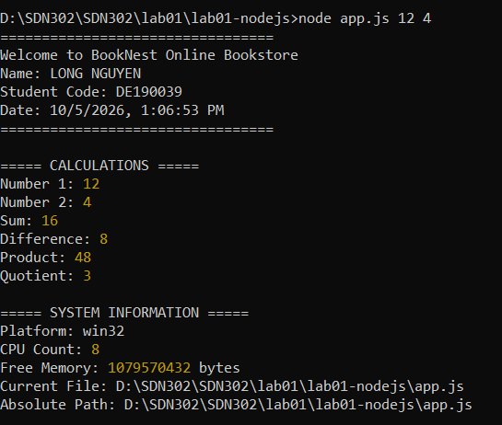
Requirement 3 - Modules
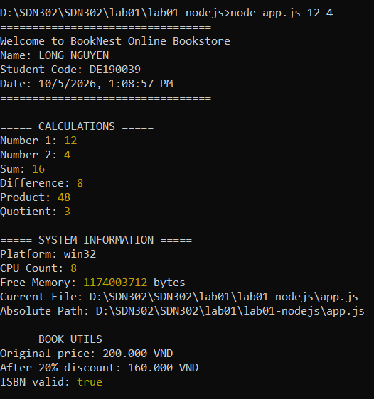
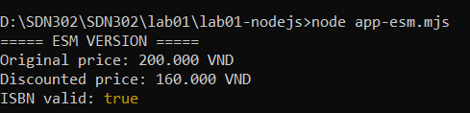
Requirement 4 - Event Loop and Non-blocking Behaviour
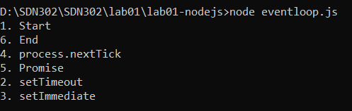
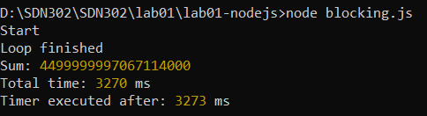
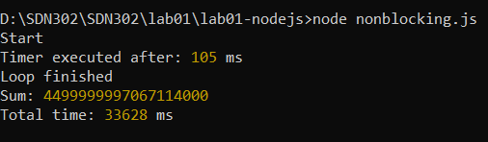
9. Lab Result
All five requirements were implemented and tested successfully:
Requirement | Status
1. Development Environment | Completed
2. First Node.js Application | Completed
3. CommonJS, Custom and Third-party Modules | Completed
4. Event Loop and Non-blocking Behaviour | Completed
5. Written Report | Completed

