STC8

Question 1:
Explain the following text primarily based on the surrounding page content: Pulse positive output of PWM3
Answer1:
The phrase “Pulse positive output of PWM3#” comes from the datasheet you’re viewing for the STC8H8K64U microcontroller. Let me break it down in the context of that document:
🔧 What it means
- PWM3#: This refers to the third Pulse Width Modulation (PWM) channel of the microcontroller. PWM channels are used to generate signals with variable duty cycles, often for controlling motors, LEDs, or other devices.
- Pulse positive output: This indicates the polarity of the signal being generated. A “positive output” means the PWM channel drives the pin high (logic 1) during the active portion of the duty cycle, and then returns to low (logic 0) during the inactive portion.
📘 Datasheet context
From the STC8H8K64U features document:
- The chip provides multiple PWM outputs (PWM1#, PWM2#, PWM3#, etc.).
- Each PWM channel can be configured for positive or negative polarity depending on how you want the waveform to behave.
- “Pulse positive output” specifically means that when the PWM duty cycle is active, the pin outputs a high-level pulse. Conversely, “pulse negative output” would mean the active duty cycle drives the pin low.
⚙️ Practical use
- If you’re driving a motor driver or LED circuit, a positive PWM output ensures that the connected device receives a high signal during the “on” portion of the cycle.
- Engineers often choose polarity depending on whether the external circuit expects an active-high or active-low signal.
✅ In short
The text is telling you that PWM3# produces an active-high pulse waveform — the pin goes high during the duty cycle’s “on” time and low otherwise. It’s essentially describing the signal behavior of that PWM channel.
Would you like me to also explain how to configure the STC8H8K64U registers to switch between positive and negative PWM outputs? That’s usually the next step when working with these datasheets.

Question 2:
Does Pulse negative output drive pin low (logic 0) during the active portion of the duty cycle, and then returns to high (logic 1) during the inactive portion?
Answer:
Yes — you’ve got it right.
For a pulse negative output configuration of a PWM channel:
- During the active portion of the duty cycle, the pin is driven low (logic 0).
- During the inactive portion, the pin returns to high (logic 1).
🔄 Contrast with pulse positive output
- Pulse positive output: Active duty cycle → pin goes high; inactive → pin goes low.
- Pulse negative output: Active duty cycle → pin goes low; inactive → pin goes high.
This polarity inversion is useful because some external circuits or drivers expect an active-low signal. Instead of adding extra inverters in hardware, you can configure the PWM channel to output the desired polarity directly.
On the page you’re viewing about PWM basics, this ties into the idea that PWM is essentially a square wave with a controllable duty cycle. Whether the “on” portion is represented by a high or a low level depends on the polarity setting of the PWM output .
👉 If you’re working with the STC8H8K64U (or similar MCUs), the datasheet usually provides a register bit to select between positive and negative pulse outputs for each PWM channel. Would you like me to walk you through how to set that bit in the registers for PWM3 specifically?

Question 3:
what is Active duty cycle? Can you draw it and explain it
Great question! Let’s break down active duty cycle in PWM and visualize it.

⚡ What is the Active Duty Cycle?
- Duty cycle: The percentage of one period in which a signal is active.
- Active duty cycle: Refers specifically to the portion of the PWM waveform where the output is in its “active” state (depending on polarity):
  - For pulse positive output → active = logic HIGH (1).
  - For pulse negative output → active = logic LOW (0).
So, the active duty cycle is essentially the “on-time” fraction of the PWM period.

📊 Formula

- (T_{ON}): Time the signal is active (high for positive, low for negative).
- (T_{PERIOD}): Total time of one PWM cycle.

📉 Visual Diagram
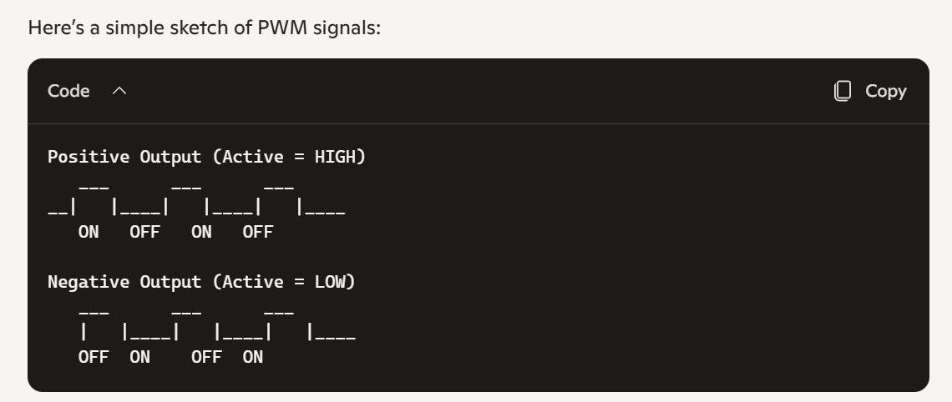
- In the positive case, the “ON” time is when the waveform is high.
- In the negative case, the “ON” time is when the waveform is low.

🔧 Example
- Suppose the PWM period is 10 ms.
- If the signal is active for 5 ms, then:
[ \text{Duty Cycle} = \frac{5}{10} \times 100 = 50% ]
That means the output is active half the time, inactive the other half.

✅ In short: The active duty cycle is the fraction of the PWM period where the signal is in its active state (high for positive polarity, low for negative polarity). It directly controls how much energy or average voltage is delivered to the load.
Would you like me to also show how varying the duty cycle (say 25%, 50%, 75%) changes the average voltage seen by a device like an LED or motor? That’s where PWM really becomes powerful.

Question 4:
In the negative case, the "ON" time is when the waveform is low. When the waveform is low, it means 0VDC (like 0% of 5VDC).
Otherwise, when the wavefomr is high, it means 5VDC (100%)?
Answer:
Exactly — you’re thinking about it correctly. Let’s make it crystal clear:
🔌 Voltage Levels in PWM
- Logic HIGH (1) → usually corresponds to the supply voltage (e.g., 5 VDC if the microcontroller runs at 5 V).
- Logic LOW (0) → corresponds to 0 VDC (ground).
So when we talk about “waveform high” or “waveform low,” we’re really talking about the pin being driven to those voltage levels.

📉 Negative Pulse Output Case
- Active duty cycle (ON time) → pin is LOW (0 VDC).
- Inactive duty cycle (OFF time) → pin is HIGH (≈5 VDC).
That means during the “on” portion of the PWM, the output is held at ground, and during the “off” portion it rises to the supply voltage.

📊 Visual Example (assuming 5 V supply)
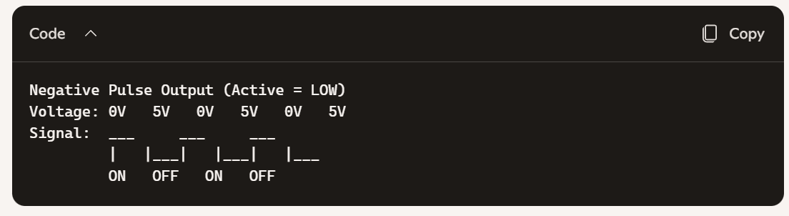
- When the signal is low (0 V) → that’s the “active” part of the duty cycle.
- When the signal is high (5 V) → that’s the “inactive” part.

⚙️ Why This Matters
Some circuits are designed to respond to active-low signals (for example, certain motor drivers, LEDs with common-anode configurations, or logic chips). Configuring PWM for negative polarity saves you from adding external inverters.

✅ In short: Yes — in the negative case, “ON” means 0 VDC, and “OFF” means 5 VDC (or whatever your MCU’s supply voltage is).
Would you like me to also show how this affects the average voltage delivered to a load (like an LED brightness or motor speed) when you vary the duty cycle? That’s where the practical difference between positive and negative polarity really shows up.

Question 5:
So if I use Negative Pulse Output to control LED 5V. The led will ON in Inactive duty cycle (OFF time) and the led will OFF in Active duty cycle (ON time)?
Answer:
Yes — that’s exactly what would happen if you connect an LED directly to a PWM pin configured for negative pulse output:
- Active duty cycle (ON time) → the pin is driven LOW (0 VDC).
→ In this phase, the LED would be OFF, because it’s not receiving voltage.
- Inactive duty cycle (OFF time) → the pin is driven HIGH (≈5 VDC).
→ In this phase, the LED would be ON, because it sees the full supply voltage.

🔦 Why the LED behaves this way
LEDs respond to the voltage across them:
- When the PWM pin is high (5 V), current flows through the LED (assuming proper resistor), and it lights up.
- When the PWM pin is low (0 V), no current flows, so the LED is off.
With negative polarity PWM, the “active” portion is low, so the LED actually lights up during the inactive portion of the duty cycle.

⚙️ Practical Note
If you want the LED to behave more intuitively (ON during the active duty cycle, OFF during inactive), you’d use positive pulse output.
But if your circuit or driver expects an active-low signal, then negative pulse output is the right choice.

✅ In short: With negative pulse output, your LED will glow during the inactive duty cycle (OFF time) and turn off during the active duty cycle (ON time).
Do you want me to sketch out how the LED brightness changes at different duty cycles (25%, 50%, 75%) for both positive and negative outputs? That comparison makes the polarity difference very clear.

Question 6:
Can the positive pulse output run as the same time/ paralelly with negative pulse output?
Answer:
Yes — the positive pulse output and negative pulse output can be generated in parallel, but it depends on how the microcontroller’s PWM hardware is designed and configured.
🔧 How it works in the STC8H8K64U
- Each PWM channel (PWM1#, PWM2#, PWM3#, etc.) has two complementary outputs:
  - Positive pulse output → active duty cycle drives the pin HIGH.
  - Negative pulse output → active duty cycle drives the pin LOW.
- These two signals are essentially inverted versions of each other.
- The datasheet shows that both outputs can be mapped to pins, so you can use them simultaneously.
⚙️ Why this is useful
- Running both outputs in parallel is common in motor control, half-bridge, or full-bridge driver circuits.
- Example:
  - Positive output goes to one transistor gate.
  - Negative output goes to the complementary transistor gate.
- This ensures that when one side is ON, the other is OFF — preventing short circuits and enabling efficient switching.
📊 Visual Concept
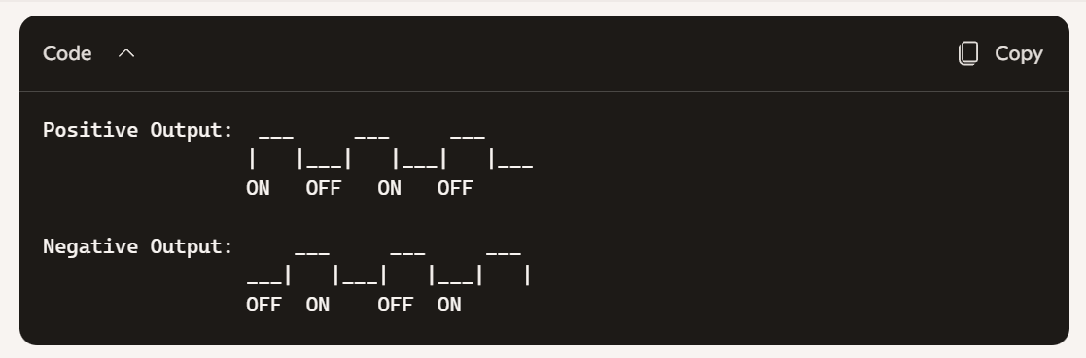
Both waveforms are synchronized but inverted. They can be routed to different pins and used together.

✅ In short: Yes, the positive and negative pulse outputs can run at the same time. They are complementary signals generated by the same PWM channel, and you can use them in parallel for applications like LED driving, motor control, or logic interfacing.
Would you like me to show you how to configure the PWM3 registers so that both positive and negative outputs are enabled simultaneously? That’s usually the next step when you want to actually wire them up in hardware.

