1. Open GeneByGene.sln in aspnetscore folder

Run **dotnet ef database update** in command line in GeneByGene.EfCore folder to migration database.

Set **GeneByGene.Host** ptoject as a start up project and run it. I integrated with Swagger for testing api on client side.

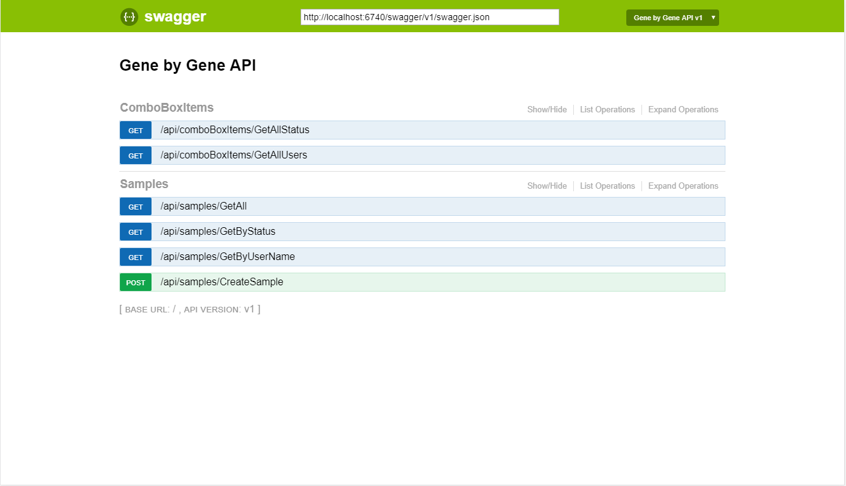

This project was not implemented Authorization and Authentication.

**2. Using Visual Code** to open angular project. This project was generated with [Angular CLI](https://github.com/angular/angular-cli).

Using compline in angular folder to run: **npm install**

The next step run: **npm install -g @angular/cli** if you did not install before.

Run **ng serve** for a dev server. Navigate to **http://localhost:4200***.* The app will automatically reload if you change any of the source files.

**3. About angular project.**

The service layer of this project was generated with NSwag. If you change anything which related with api. You have to run the bat file in \ftdna\angular\nswag folder.

You can filter, sorting and paging data on client on the list of samples.

4. Screenshots

