
GRADUATION THESIS
QuantVN Strategy Forge: An Accessible Quantitative Analysis Platform for Trading Strategy Design and Backtesting on Vietnamese Equities (HOSE)

Ho Chi Minh City, February 2026
Supervisor: Assoc. Prof. Dr. Nguyễn Anh Phong
Student Name: Liêu Hoài Phúc
Student ID: K224141735
Class: K22414C
FACULTY OF FINANCE AND BANKNIG

VIETNAM NATIONAL UNIVERSITY HO CHI MINH CITY
UNIVERSITY OF ECONOMICS AND LAW
Faculty of Finance and Banking
────────────────────



GRADUATION THESIS
QuantVN Strategy Forge: An Accessible Quantitative Analysis Platform for Trading Strategy Design and Backtesting on Vietnamese Equities (HOSE)
Supervisor : Assoc. Prof. Dr. Nguyen Anh Phong
Student name : Lieu Hoai Phuc
Student ID : K224141735
Class : K22414C

Ho Chi Minh City, February 2026

DECLARATION
I hereby declare that this graduation thesis is my own original work, conducted under the supervision of Assoc. Prof. Dr. Nguyễn Anh Phong. The data, results, and findings presented in this thesis are truthful and have not been previously published in any other work.
I take full responsibility for the accuracy and integrity of the content presented herein.
Ho Chi Minh City,February 2026
Liêu Hoài Phúc

INSTRUCTOR'S ASSESSMENT
...........................................................................................................................................
...........................................................................................................................................
...........................................................................................................................................
...........................................................................................................................................
...........................................................................................................................................
...........................................................................................................................................
...........................................................................................................................................
...........................................................................................................................................
...........................................................................................................................................
...........................................................................................................................................
...........................................................................................................................................
...........................................................................................................................................
...........................................................................................................................................
...........................................................................................................................................
...........................................................................................................................................
...........................................................................................................................................
...........................................................................................................................................
...........................................................................................................................................
...........................................................................................................................................
...........................................................................................................................................
...........................................................................................................................................
...........................................................................................................................................
...........................................................................................................................................

ACKNOWLEDGEMENTS
I would like to express my sincere gratitude to my supervisor, Assoc. Prof. Dr. Nguyễn Anh Phong, for his invaluable guidance, insightful feedback, and continuous support throughout my graduation thesis.
I also extend my thanks to the faculty members of the Faculty of Finance and Banking, University of Economics and Law (UEL), Vietnam National University Ho Chi Minh City, for equipping me with the foundational knowledge in finance and banking that enabled this research.
I am grateful to my peers for their constructive feedback, which improved both the platform design and the quality of this thesis.
Finally, I would like to thank my family for their unwavering encouragement and support throughout this journey.
Any remaining limitations in this thesis are solely my own responsibility.

ABSTRACT
This thesis designs, implements, and evaluates QuantVN Strategy Forge, a web-based quantitative analysis platform for Vietnamese equities listed on the Ho Chi Minh Stock Exchange (HOSE). The platform addresses the gap in accessible quantitative tools for Vietnamese retail investors by integrating stock screening, strategy backtesting with five strategy types, portfolio optimisation using four methods (Mean-Variance, Risk Parity, Minimum Variance, Maximum Sharpe), risk management metrics (VaR, CVaR, drawdown), factor analysis, and an AI assistant grounded in the platform's own computations. The system covers approximately 500 HOSE-listed stocks with daily data from 2018 to 2025. The AI assistant employs retrieval-augmented generation with policy-gated abstention to prevent unsupported financial claims. Results demonstrate the platform successfully provides integrated quantitative analysis capabilities comparable to international tools while supporting Vietnamese market conventions including transaction costs, daily price limits, and settlement cycles.
Keywords: quantitative analysis, HOSE, backtesting, portfolio optimisation, AI assistant, Vietnamese equities, fintech

TABLE OF CONTENTS

1. Introduction 1
1.1 Background and Motivation 1
1.2 Objectives 2
1.3 Research Questions 2
1.4 Scope and Assumptions 2
1.5 Contributions 2
1.6 Thesis Structure 3
2. Literature Review 4
2.1 Portfolio Theory and Market Efficiency 4
2.2 Factor Models and Empirical Anomalies 4
2.3 Trading Strategy Design and Backtesting 5
2.4 Risk Measurement 5
2.5 AI Assistants and Retrieval-Augmented Generation 6
2.6 Fintech Platforms for Retail Investors in Vietnam 6
2.7 Synthesis 8
2.8 Research Hypotheses 8
3. Research Methodology 10
3.1 Research Approach 10
3.2 Data Collection and Description 10
3.3 Quantitative Methods 13
3.4 AI Assistant Design 14
3.5 Evaluation Approach 15
4. Research Results and Discussion 16
4.1 Overview of the Developed Platform 16
4.2 Analytical Workflow 16
4.3 Strategy Backtesting with Vietnamese Market Parameters 17
4.4 Visual Strategy Builder 18
4.5 Portfolio Optimisation and Risk Assessment 19
4.6 AI-Assisted Analysis 20
4.7 Discussion 20
4.7.1 Addressing the Research Gap 20
4.7.2 Value of Local Market Parameters 21
4.7.3 Data Quality Foundation 21
4.7.4 Limitations 21
4.7.5 Hypothesis Evaluation 21
4.8 Chapter Summary 22
5. Conclusion and Recommendation 23
5.1 Conclusion 23
5.2 Recommendation 23
Appendix A: Research Hypothesis Evaluation 28
A.1 Hypothesis Summary 28
A.2 Detailed Evaluation 29
H1: Accessibility of Quantitative Tools 29
H2: Vietnamese Market Parameter Integration 29
H3: No-Code Strategy Design for Vietnamese Retail Investors 30
H4: Data Validation Pipeline for HOSE Data Quality 31
H5: AI Assistant Reliability 32
A.3 Additional Platform Screenshots 32

LIST OF FIGURES
Figure 1: QuantVN Strategy Forge landing page showing platform coverage 16
Figure 2: Systematic analytical workflow on the QuantVN platform 17
Figure 3: : Backtesting process flow integrating data quality validation and Vietnamese market cost parameters. 18
Figure 4: Visual Strategy Builder showing a drag-and-drop 19

LIST OF TABLES
Table 1: Research question 2
Table 2: Feature comparison of platforms available to Vietnamese investors 8
Table 3: Research questions, hypotheses, and evaluation methods. 10
Table 4: Dataset description 11
Table 5: Key risk metrics provided by the platform 20

LIST OF ABBREVIATIONS
Abbreviation | Meaning
AI | Artificial Intelligence
API | Application Programming Interface
ATR | Average True Range
BB | Bollinger Bands
CAGR | Compound Annual Growth Rate
CAPM | Capital Asset Pricing Model
CVaR | Conditional Value at Risk (Expected Shortfall)
EMA | Exponential Moving Average
EMH | Efficient Market Hypothesis
EPS | Earnings Per Share
HML | High Minus Low (Fama-French value factor)
HNX | Hanoi Stock Exchange
HOSE | Ho Chi Minh City Stock Exchange
ICB | Industry Classification Benchmark
LLM | Large Language Model
MACD | Moving Average Convergence Divergence
MDD | Maximum Drawdown
MPT | Modern Portfolio Theory
NLP | Natural Language Processing
OHLCV | Open, High, Low, Close, Volume
RAG | Retrieval-Augmented Generation
ROE | Return on Equity
RSI | Relative Strength Index
SMA | Simple Moving Average
SMB | Small Minus Big (Fama-French size factor)
SR | Sharpe Ratio
SSI | Saigon Securities Inc.
TCBS | Techcombank Securities
UPCoM | Unlisted Public Company Market
VaR | Value at Risk
VND | Vietnamese Dong

1. Introduction

1.1 Background and Motivation
The Vietnamese securities market has grown rapidly over the past decade. By 2024, trading accounts reached 9.2 million surpassing the government's 2025 target with retail investors accounting for over 80 per cent of daily trading volume on the Ho Chi Minh Stock Exchange (HOSE) (FiinPro, 2024). Vietnam's fintech market, valued at approximately USD 16.9 billion in 2024, is projected to reach USD 62.7 billion by 2033, supported by high smartphone penetration (84 per cent) and a digitally engaged population (IMARC Group, 2024).
Despite this growth, Vietnamese retail investors still lack access to proper quantitative analysis tools. International platforms like TradingView offer advanced charting but do not fully support HOSE-specific data or Vietnamese market conventions (TradingView, n.d.). None of the major international algorithmic trading platforms support HOSE at all. On the domestic side, brokerage platforms from TCBS, SSI iBoard, and VNDirect provide charting and order execution, but none of them offer strategy backtesting, portfolio optimisation, factor analysis, or risk measurement at the retail level (TCBS, n.d.; SSI, n.d.). In practice, this means that quantitative finance methods now standard in developed markets remain out of reach for most Vietnamese investors. They trade actively, but without systematic tools to rigorously test investment ideas before putting capital at risk.
At the same time, large language models (LLMs) offer an opportunity to make quantitative analysis more approachable through conversational AI. The catch is that LLMs tend to hallucinate they can produce fluent but factually wrong outputs (Lin et al., 2022). In finance, this is dangerous: a user might act on fabricated statistics. Retrieval-augmented generation (RAG) reduces this risk by anchoring model responses in retrieved evidence (Lewis et al., 2020), though this only works well when the underlying data is structured and validated.

1.2 Objectives
This thesis designs, implements, and evaluates QuantVN Strategy Forge, a web-based quantitative analysis platform for Vietnamese equities that enables retail investors and finance students to:
• Screen stocks using technical indicators and fundamental metrics
• Design, backtest, and compare trading strategies with realistic assumptions
• Optimise portfolios and analyse risk using established quantitative methods
• Receive AI-assisted explanations of quantitative results grounded in actual computed evidence
• Learn quantitative finance concepts through an integrated educational hub

1.3 Research Questions
# | Research Question
RQ1 | How can a web platform be designed to provide accessible quantitative analysis tools for Vietnamese retail investors on HOSE?
RQ2 | How effective is the platform at enabling users to design, backtest, and evaluate trading strategies with transparent assumptions?
RQ3 | Can an AI assistant provide reliable, evidence-grounded explanations of quantitative results without fabricating unsupported claims?
Table 1: Research question

1.4 Scope and Assumptions
The platform targets daily-frequency Vietnamese equity analysis on HOSE, covering 412 listed stocks with historical data from 2018 to 2025. The scope is decision support and financial education the system does not implement brokerage integration, automated order routing, or real-time execution. The AI assistant requires an external LLM provider; the thesis evaluates the effectiveness of tool-grounding and policy enforcement rather than model training.

1.5 Contributions
This thesis makes three contributions:
1. An integrated quantitative analysis platform for Vietnamese equities covering stock screening, strategy backtesting, portfolio optimisation, risk management, and factor analysis that fills a gap in the Vietnamese fintech landscape
2. An AI assistant with tool-grounding that generates explanations based on the platform's own computations, and can decline to answer when supporting evidence is not available
3. An educational hub connecting quantitative finance theory to the practical tools available on the platform, aimed at Vietnamese retail investors

1.6 Thesis Structure
Section 2 reviews the theoretical foundations in quantitative finance, backtesting methodology, and AI-assisted financial analysis, and formulates the research hypotheses. Section 3 presents the research methodology, including data collection and the quantitative methods employed. Section 4 describes the system design, demonstrates the implemented features, and discusses results. Section 5 concludes with limitations and future directions.

2. Literature Review
This section reviews the theoretical and empirical foundations that inform the design of QuantVN Strategy Forge. The review covers quantitative finance theory, trading strategy evaluation, risk management, AI-assisted financial analysis, and the current landscape of retail investor tools.

2.1 Portfolio Theory and Market Efficiency
Modern Portfolio Theory (MPT), introduced by Markowitz (1952), established that investors should evaluate portfolios based on their expected return and risk (measured by variance) rather than analysing individual securities in isolation. The efficient frontier represents the set of portfolios offering maximum expected return for each level of risk. The Capital Asset Pricing Model (CAPM) extended this framework by relating expected returns to systematic risk through market beta (Sharpe, 1964; Lintner, 1965).
The Efficient Market Hypothesis (EMH) formalised three forms of market efficiency weak, semi-strong, and strong based on the degree to which prices reflect available information (Fama, 1970). While the EMH has been challenged by extensive evidence of market anomalies, it remains foundational for understanding why quantitative analysis tools should present results as conditional on assumptions rather than as guaranteed predictions.
For the Vietnamese market, studies on HOSE market efficiency suggest that the market exhibits characteristics of weak-form efficiency with periodic inefficiencies, particularly around information disclosure events and policy changes (Truong et al., 2010). Given these dynamics, tools that help investors evaluate strategies systematically rather than relying on informal judgment have clear value.

2.2 Factor Models and Empirical Anomalies
Beyond market beta, empirical research has identified systematic factors that explain cross-sectional return variation. The Fama-French three-factor model added size (SMB) and value (HML) as explanatory factors (Fama & French, 1993), later extended to five factors including profitability and investment (Fama & French, 2015). Momentum the tendency of recent winners to continue outperforming has been documented as one of the most robust anomalies (Jegadeesh & Titman, 1993).
Harvey, Liu, and Zhu (2016), however, warned that a large portion of published factors do not survive proper multiple-testing corrections. Their work is a reminder of how easily data mining can produce spurious results in quantitative finance and why any tool that presents factor analysis should do so with appropriate caveats.

2.3 Trading Strategy Design and Backtesting
Technical indicators such as moving averages (SMA, EMA), the Relative Strength Index (RSI), Moving Average Convergence Divergence (MACD), and Bollinger Bands transform price data into signals used for systematic trading strategies. While individual indicators have limited predictive power, they provide a structured framework for strategy design that can be evaluated through backtesting (Murphy, 1999).
Backtesting the historical simulation of trading strategies is the primary tool for evaluating strategy ideas but is also the primary source of misleading evidence. Bailey, Borwein, López de Prado, and Zhu (2016) identified multiple sources of backtest overfitting, including look-ahead bias, survivorship bias, unrealistic cost assumptions, and selection bias from reporting only the best result among many trials. Lo (2002) argued that quantitative performance metrics can be misleading without proper context about the evaluation methodology.
These well-documented pitfalls are the reason why the backtesting engine in this thesis makes execution timing, transaction costs, and data quality assumptions visible to users by default rather than hiding them.

2.4 Risk Measurement
Portfolio risk assessment uses complementary measures across different dimensions. Variance-based measures (volatility, beta) capture return dispersion, while tail-risk measures Value at Risk (VaR) and Conditional VaR (CVaR, also called Expected Shortfall) quantify potential losses in adverse scenarios (Artzner et al., 1999; Rockafellar & Uryasev, 2000). Drawdown analysis measures peak-to-trough capital decline, providing an intuitive measure of investment risk. All risk metrics depend on data quality: covariance estimation requires properly aligned return series, and tail-risk measures are sensitive to outliers and missing data. For Vietnamese equities, the ±7% daily price limit imposed by HOSE regulations (HOSE, n.d.) creates truncated return distributions that affect volatility and tail-risk estimation.

2.5 AI Assistants and Retrieval-Augmented Generation
Large language models (LLMs) have shown strong natural language capabilities, which makes them interesting as conversational interfaces for financial tools. But they hallucinate they generate text that sounds correct but isn't (Lin et al., 2022). In finance, hallucinated numbers about stock returns or risk metrics could directly mislead an investor's decisions.
Retrieval-Augmented Generation (RAG) addresses this by conditioning model outputs on retrieved evidence rather than relying solely on parametric knowledge (Lewis et al., 2020). The key insight is that grounding LLM responses in structured, verifiable data sources significantly reduces unsupported claims. Domain-specific models such as BloombergGPT (Wu et al., 2023) and FinGPT (Yang et al., 2023) show that financial domain training improves NLP tasks, but does not eliminate hallucination for specific numeric claims.
Evaluating whether a response is actually reliable requires going beyond surface-level checks. Min et al. (2023) proposed breaking responses into atomic claims and verifying each one individually. Rajpurkar et al. (2018) made the case that a system should know when it cannot answer that abstention is better than fabrication.

2.6 Fintech Platforms for Retail Investors in Vietnam
The Vietnamese fintech landscape for equity investors is growing but fragmented. The primary digital tools are brokerage-integrated platforms from major securities companies TCBS (TCBS, n.d.), SSI iBoard (SSI, n.d.), and VNDirect (VNDirect, n.d.) which provide charting, order execution, and basic screening but lack quantitative analysis capabilities such as strategy backtesting, portfolio optimisation, or risk measurement.
Several specialised Vietnamese platforms have emerged. Algotrade offers fully automated algorithmic trading with tick-by-tick data and API integration via SSI, targeting professional and institutional investors (Algotrade, n.d.). Miquant provides AI-powered quantitative analysis including automated stock valuation, AI chatbot, sentiment analysis, and AI-driven stock ranking (Miquant, n.d.). However, neither platform offers user-driven strategy backtesting with transparent cost assumptions, nor do they provide portfolio optimisation or factor analysis tools accessible to retail investors.
Internationally, TradingView is the most widely used charting platform among Vietnamese retail investors, offering advanced technical analysis with partial HOSE data support but no backtesting with Vietnamese market conventions such as transaction costs, price limits, and settlement cycle (TradingView, n.d.).
.
Feature | TCBS / SSI | Algotrade | Miquant | TradingView | **QuantVN**
HOSE data | Yes | Yes | Yes | Partial | Yes
Charting + indicators | Yes | No | No | Yes | Yes
Stock screening | Basic filters | No | AI-ranked | Yes | Multi-criteria
Strategy backtesting | No | Automated only | No | Limited | Yes (5 types)
No-code strategy builder | No | No | No | No | Yes (visual)
Portfolio optimisation | No | No | No | No | Yes (4 methods)
Risk analytics (VaR/CVaR) | No | No | No | No | Yes
Factor analysis | No | No | No | No | Yes
AI assistant | No | No | Chatbot | No | Yes (tool-grounded)
Educational content | — | No | — | Community | Planned
Pricing | Free | Paid | Freemium | Freemium | Free
Target user | Retail | Institutional | Intermediate+ | All | Retail + students
Table 2: Feature comparison of platforms available to Vietnamese investors
Source: Author's compilation based on platform surveys (accessed February 2026).

2.7 Synthesis
The literature points to a common theme: Vietnamese retail investors need accessible quantitative tools, but those tools must be careful about how they present results. A backtesting engine that ignores transaction costs will produce misleading numbers. Risk metrics computed on raw HOSE data without accounting for price limits will underestimate tail risk. And an AI assistant that generates numbers from parametric knowledge rather than actual computation is a liability, not a feature.
QuantVN Strategy Forge is designed around these constraints. It brings stock screening, strategy backtesting, portfolio optimisation, risk management, and factor analysis into a single platform, with an AI assistant that grounds its explanations in the platform's own quantitative computations rather than generating answers from general knowledge.

2.8 Research Hypotheses
Based on the literature gap identified in Table 2 and the limitations of existing approaches reviewed in Sections 2.3–2.6, this thesis proposes the following testable hypotheses:
H1: A web-based integrated quantitative analysis platform can make institutional grade quantitative tools accessible to Vietnamese retail investors on HOSE without requiring programming knowledge or specialised software installation.
H2: Incorporating Vietnamese market-specific parameters including HOSE's 100-share lot size, domestic transaction costs (brokerage fee, sell-side tax), and next-open execution model into a backtesting engine produces more realistic performance estimates than generic international tools that omit these parameters.
H3: A no-code visual strategy builder based on a node-and-edge composition model can enable non-technical retail investors on HOSE to design, backtest, and iterate on quantitative trading strategies addressing the barrier created by existing no-code algorithmic trading platforms (such as Zerodha Streak, uTrade Algos, and AlgoBulls) that offer visual strategy design but do not support Vietnamese equities or HOSE market conventions.
H4: A multi-stage data validation pipeline that explicitly handles issues arising from raw open-source data access via vnstock including price record inconsistencies, corporate action gaps, trading halts, and coverage variations across symbols can ensure that analytical outputs remain reliable despite the inherent limitations of freely-accessible, exchange-sourced data.
H5: An AI assistant with tool-grounding and an abstention policy can provide reliable financial analysis explanations without generating unsupported numerical claims.
These hypotheses are evaluated against empirical evidence in Section 4 and summarised in Appendix A.

3. Research Methodology
This section presents the research methodology used to design, implement, and evaluate QuantVN Strategy Forge.

3.1 Research Approach
This thesis takes an applied research approach. It starts from a practical problem the absence of accessible quantitative tools for Vietnamese retail investors then designs and builds a platform to address it, and finally evaluates whether the platform works as intended.
Three evaluation methods are used to address the research questions from Section 1:
Research Question | Related Hypotheses | Evaluation Method
RQ1 (Platform design for accessibility) | H1, H3 | System design and implementation, feature comparison with existing platforms (Table 2.1)
RQ2 (Strategy design and backtesting effectiveness) | H2, H3 | Demonstration of backtesting workflows with realistic assumptions on HOSE data
RQ3 (AI assistant reliability) | H5 | Evaluation of assistant responses for evidence grounding and abstention behaviour
— | H4 (enabling infrastructure) | H4 (data validation pipeline) is not tied to a single RQ but underpins both RQ1 and RQ2: without validated data, the platform cannot produce reliable screening or backtesting results. Evaluated through pipeline coverage statistics and quality gate demonstrations.
Table 3: Research questions, hypotheses, and evaluation methods.

3.2 Data Collection and Description
The research uses daily-frequency equity data from the Ho Chi Minh Stock Exchange (HOSE), collected via the vnstock open-source Python library (Thinh Vu, 2023).
Dataset | Coverage | Frequency | Description | Records
OHLCV price series | 2018–2025 | Daily | Open, High, Low, Close, Volume per symbol | 768,718 rows
Stock metadata | Current | Static | Symbol, company name, industry (ICB), listing status | 412 symbols
Market index (VN-Index) | 2020–2025 | Daily | Index OHLCV for benchmark comparisons | ~1,500 rows
Balance sheet | 2018–2025 | Quarterly | Assets, liabilities, equity per symbol per quarter | ~20,000 rows
Income statement | 2018–2025 | Quarterly | Revenue, net income, EPS per symbol per quarter | ~18,000 rows
Cash flow statement | 2018–2025 | Quarterly | Operating, investing, financing cash flows | ~16,000 rows
Industry classification | Current | Static | ICB sector and sub-sector codes per symbol | 412 symbols
Table 4: Dataset description
Raw data is processed through an offline preparation pipeline that validates records, removes invalid entries (e.g., rows where High < Low or Close ≤ 0), and produces runtime-ready datasets with a manifest recording coverage and quality statistics. Unlike commercial data providers such as FiinPro or CafeF which offer curated, subscription-based financial data feeds the platform deliberately uses vnstock as a freely accessible, open-source data source to remain accessible to retail investors. This design choice requires an explicit validation layer to ensure analytical reliability.
Key characteristics of raw data accessed via vnstock that require explicit handling include:
• Corporate actions (splits, dividends): Require adjusted-price treatment to avoid spurious return calculations in long-term backtests
• Trading halts and suspensions: Create gaps in time series for specific symbols that must be handled to prevent data leakage
• T+2 settlement cycle (Vietnam Securities Depository, n.d.): Influences volume interpretation and position management assumptions
• Daily price limits (±7%): Truncate return distributions and affect volatility and tail-risk estimation, distinct from international markets
Table 3.3 presents descriptive statistics for the OHLCV price series dataset collected from vnstock (Thinh Vu, 2023), characterising the data distribution prior to strategy analysis. Prices are expressed in Vietnamese Dong (VND); daily return is computed as $(P_{t}-P_{t-1})/P_{t-1}$ volume is measured in shares.
Variable | Obs | Mean | Std Dev | Min | Max
Open (thousand VND) | 768,718 | 20.28 | 21.39 | 0.40 | 358.22
High (thousand VND) | 768,718 | 20.54 | 21.62 | 0.40 | 358.22
Low (thousand VND) | 768,718 | 20.00 | 21.14 | 0.30 | 334.98
Close (thousand VND) | 768,718 | 20.29 | 21.40 | 0.30 | 334.98
Volume (shares) | 768,718 | 1,307,326 | 4,290,816 | 0 | 249,760,712
Daily return (%) | 768,306 | 0.066 | 2.704 | −40.08 | 66.67
Table 3.3: Descriptive statistics of the OHLCV dataset (HOSE, 2018–2025,
sourced via vnstock.
Note: Prices are stored by vnstock in thousands of Vietnamese Dong (VND). The extreme daily return values (−40% and +66%) occur in early-period data before the ±7% daily price limit was uniformly enforced on HOSE, and for stocks returning to trading after suspension.

3.3 Quantitative Methods
The platform implements established quantitative finance methods adapted for the Vietnamese market context.
Technical analysis. Standard indicators including Simple and Exponential Moving Averages (SMA, EMA), Relative Strength Index (RSI), Moving Average Convergence Divergence (MACD), Average True Range (ATR), and Bollinger Bands are computed deterministically from OHLCV data and used as signal generators for trading strategies (Murphy, 1999).
Backtesting. Strategy evaluation uses a next-bar execution model by default signals generated at bar t are executed at the open of bar t+1 to reduce look-ahead bias (Bailey et al., 2016). Transaction costs (brokerage fee, sell tax, slippage) are modelled explicitly, and performance is reported as both gross (before costs) and net (after costs) to enable attribution.
Key performance metrics are computed as follows. The daily return of an asset is:
$$r_t=(P_{t}-P_{t-1} )/P_{t-1}$$
where $P_{t}$ is the adjusted closing price at time t. The annualised Sharpe Ratio measures risk-adjusted return:
$$SR=\left( {\overline{r}}_{p}-r_{f}\right)/σ_{p} ×\sqrt{252}$$
where $\overline{r_{p}}$ is the mean daily portfolio return, $r_{f}$ is the risk-free rate, and $σ_{p}$ is the standard deviation of daily returns. Maximum drawdown captures the largest peak-to-trough decline:
$$MDD=\max_{t∈\left[0,T\right]}{\frac{\max_{s∈\left[0,t\right]}{V_{s}}-V_{t}}{\max_{s∈\left[0,t\right]}{V_{s}}}}$$
where $V_{t}$ is the portfolio value at time $t$.
Portfolio optimisation. Four methods are implemented. The Mean-Variance approach (Markowitz, 1952) solves:
$$\min_{w}{w^{⊤}Σw} subject to w^{⊤}μ≥μ^{*}, \sum_{i}{w_{i}}=1, w_{i}≥0$$
where w is the vector of portfolio weights, $σ$is the covariance matrix of asset returns, $μ$ is the vector of expected returns, and $μ$ is the target return. The Maximum Sharpe Ratio portfolio maximises $\frac{w^{⊤}μ-r_{f}}{\sqrt{w^{⊤}Σw}}$(Sharpe, 1964). The Minimum Variance portfolio minimises $w^\top \Sigma w$ without a return target. Risk Parity (Maillard, Roncalli, & Teïletche, 2010) equalises the marginal risk contribution of each asset:
$$RC_{i}=w_{i}⋅\frac{{\left(Σw\right)}_{i}}{w^{⊤}Σw}=\frac{1}{n} ∀ i$$
where $R_{C}$ is the risk contribution of asset i and n is the number of assets.
Risk measurement. Value at Risk (VaR) at confidence level $α$ represents the maximum loss not exceeded with probability $α$ (Artzner et al., 1999):
$$VaR_{α}=-inf\left\{x:P\left(L≤x\right)≥1-α\right\}$$
Conditional VaR (CVaR), also termed Expected Shortfall, measures the expected loss beyond VaR (Rockafellar & Uryasev, 2000):
$$CVaR_α=E\left[L | L>VaR_{α}\right]$$
The platform computes VaR and CVaR at 95% and 99% confidence levels using historical simulation. Additional metrics include annualised volatility, maximum and average drawdown, beta relative to VN-Index $β=Cov(r_{p},r_{m})/Var\left(r_{m}\right)$ and tracking error.
Factor analysis. Cross-sectional factor exposures are computed for momentum, value, profitability, and size factors following the framework of Fama and French (1993, 2015).

3.4 AI Assistant Design
The AI assistant uses a retrieval-augmented generation (RAG) approach (Lewis et al., 2020), but adapted for internal tool-grounding. Instead of retrieving documents from the web, it calls the platform’s own quantitative services backtesting, risk analysis, factor computation, market data and uses the returned values as evidence for its answers. Before generating any response that involves numbers, the assistant runs through a policy gate: are the relevant tools actually called? Did they return valid results? If not, the assistant will say so and decline rather than guessing. The reasoning is straightforward in finance, a confidently wrong number is worse than no answer at all. This is consistent with Rajpurkar et al. (2018), who argued that recognising when a system cannot answer is just as important as answering correctly.

3.5 Evaluation Approach
The platform is evaluated through three methods:
1. Feature completeness: Comparison of implemented features against the gap identified in the literature review (Table 2)
2. Demonstration: Worked examples showing end-to-end workflows (screening → backtesting → portfolio → risk) on real HOSE data
3. AI assistant evaluation: Assessment of response grounding, including unsupported claim rate and abstention behaviour under insufficient evidence
The five research hypotheses (H1–H5) formulated in 2 are evaluated against the evidence gathered from platform development and demonstration. Results are discussed in Section 4 (Section 4.7.5) and summarised in Appendix A.

4. Research Results and Discussion
This section presents the research results of QuantVN Strategy Forge, focusing on how each core capability addresses the identified gaps in quantitative tools for Vietnamese retail investors.

4.1 Overview of the Developed Platform
QuantVN Strategy Forge has been developed as a web-based quantitative analysis platform for the Ho Chi Minh Stock Exchange (HOSE). The platform covers 412 HOSE-listed symbols with 768,718 daily price records from 2018 to 2025, supplemented by quarterly financial statements (balance sheets, income statements, and cash flow statements). Figure 1 shows the landing page, summarising the platform's scope.
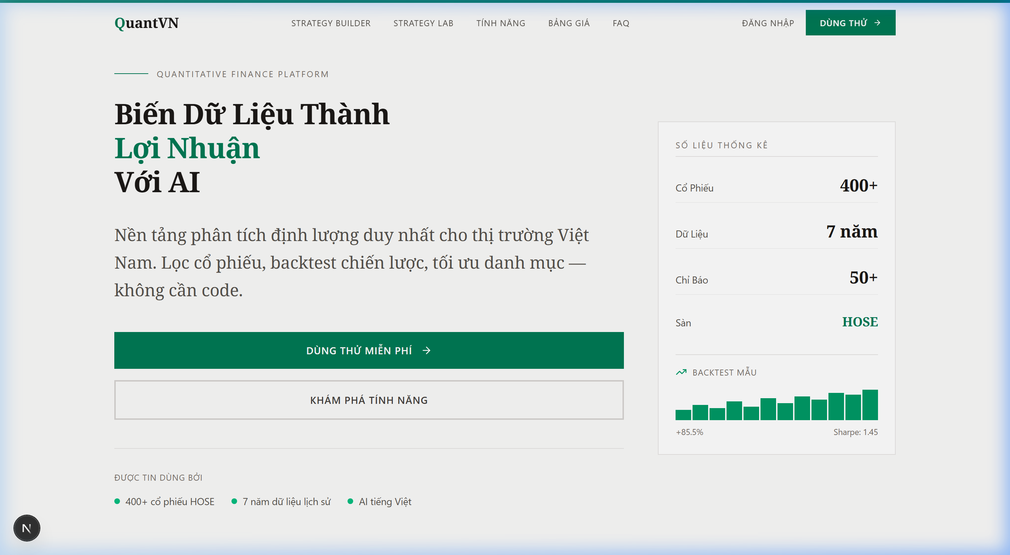
Figure 1: QuantVN Strategy Forge landing page showing platform coverage

4.2 Analytical Workflow
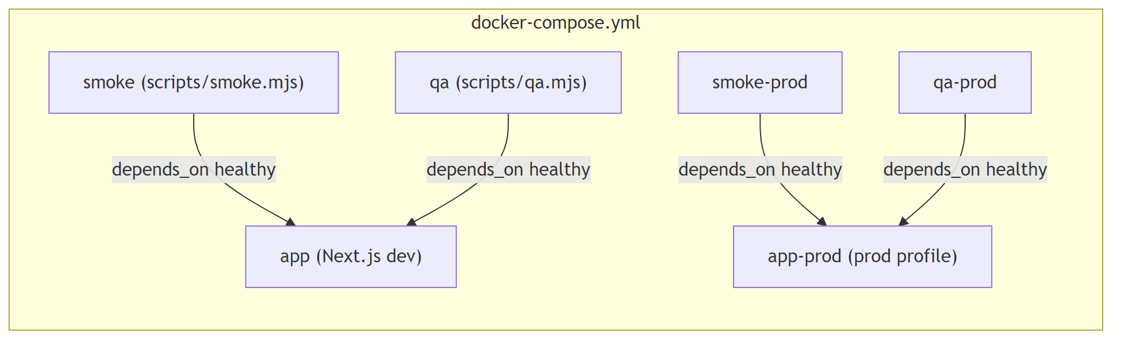
Figure 2: Systematic analytical workflow on the QuantVN platform

4.3 Strategy Backtesting with Vietnamese Market Parameters
A core contribution of the platform is its backtesting engine, which incorporates Vietnamese market-specific parameters that are absent from most international tools:
• Lot size: 100 shares per HOSE trading regulation.
• Transaction costs: Brokerage fee (0.15%), sell-side tax (0.1%), and estimated slippage (0.05%).
• Execution model: Next-open price execution, reflecting realistic retail order fills.
These parameters matter because ignoring them as generic international platforms do can make strategies look more profitable than they actually are, especially for approaches with small per-trade margins. The platform supports five strategy types: SMA Crossover, EMA Crossover, RSI Mean Reversion, Bollinger Bands, and Momentum.
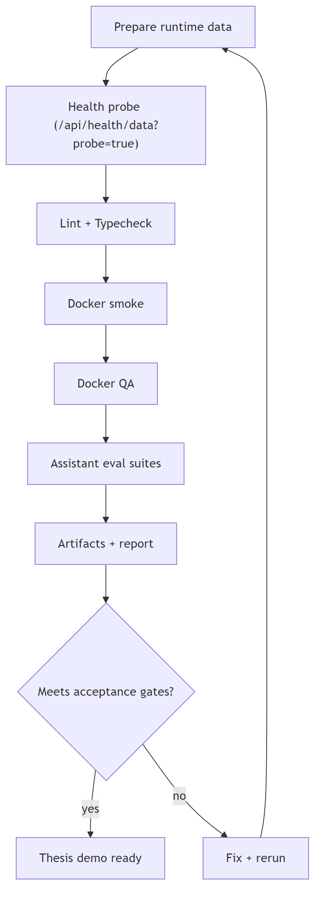
Figure 3: Backtesting process flow integrating data quality validation and Vietnamese market cost parameters.
Each backtest produces performance metrics including total return, CAGR, Sharpe ratio, Sortino ratio, maximum drawdown, win rate, and profit factor, alongside data quality diagnostics (coverage ratio, largest data gap, usable rows) that allow investors to assess result reliability.

4.4 Visual Strategy Builder
The Strategy Builder provides a no-code, drag-and-drop interface for constructing custom trading strategies. Users compose strategies by connecting functional nodes on an interactive canvas data sources, technical indicators, condition filters, and output metrics without writing code. Figure 4 demonstrates a complete RSI Reversal strategy.
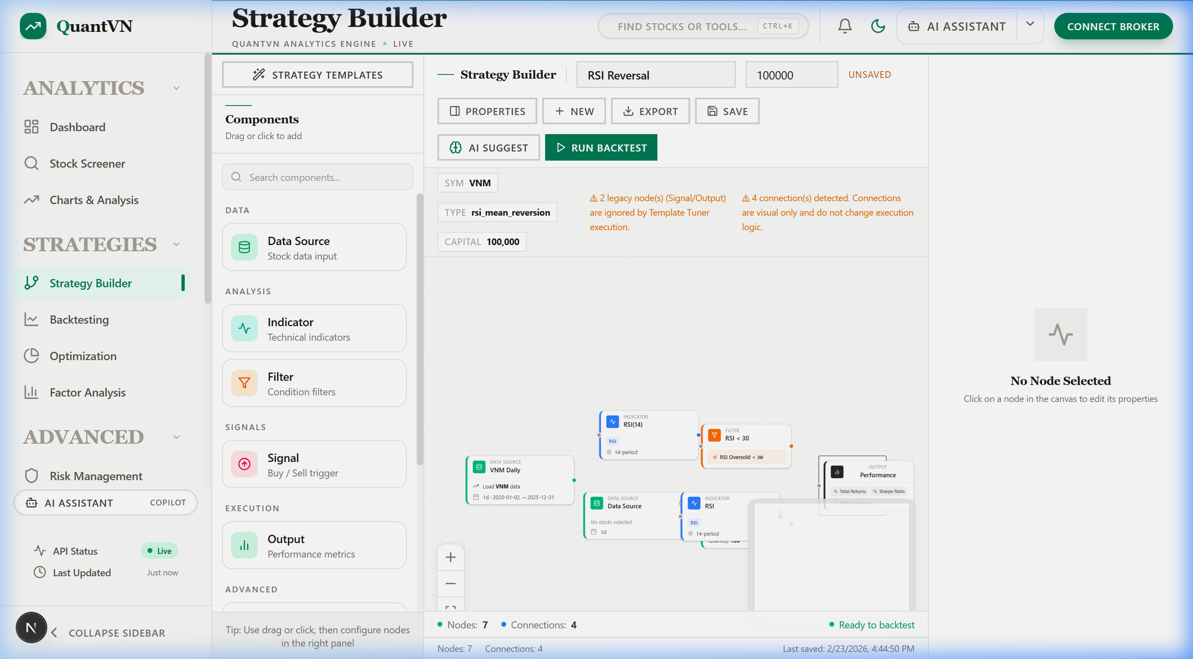
Figure 4: Visual Strategy Builder showing a drag-and-drop
This visual approach lowers the barrier to quantitative strategy development, enabling retail investors to experiment with trading logic that traditionally requires programming expertise. Strategies built in the canvas can be directly backtested against historical HOSE data.

4.5 Portfolio Optimisation and Risk Assessment
The platform implements four portfolio optimisation methods suited to different investor profiles: Mean-Variance (Markowitz), Risk Parity, Minimum Variance, and Maximum Sharpe. The optimiser automatically excludes assets with insufficient trading history (fewer than 60 days) or inadequate pairwise data overlap (below 30 days), which prevents the kind of unreliable allocations that can result from sparse data particularly for symbols with shorter listing histories on HOSE.
The risk dashboard complements portfolio construction with quantitative risk metrics:
Metric | Purpose | Relevance for Vietnamese Investors
VaR (95%, 99%) | Maximum expected loss under normal conditions | Quantifies daily downside exposure
CVaR (Expected Shortfall) | Average loss in worst-case scenarios | Captures tail risk from sudden volatility spikes
Beta vs VN-Index | Systematic market risk exposure | Measures sensitivity to HOSE market movements
Maximum Drawdown | Worst historical peak-to-trough decline | Sets expectations for potential capital loss
Sortino Ratio | Risk-adjusted return (downside only) | More relevant than Sharpe for loss-averse investors
Table 5: Key risk metrics provided by the platform
Together, these give retail investors access to the same risk management toolkit that institutional fund managers use.

4.6 AI-Assisted Analysis
The platform includes an AI assistant that answers financial analysis questions by computing results through the platform’s own internal modules. When a user asks about a specific metric say, the Sharpe ratio of a particular strategy the assistant calls the relevant tool, retrieves the computed value, and builds its response around that number with an explicit data reference. The key design choice is what happens when the assistant cannot ground a claim. Rather than generating a plausible-sounding number, it declines and explains why. This is deliberately conservative: in a financial context, a wrong number that sounds authoritative can cause more harm than saying "I don’t have enough data to answer that."

4.7 Discussion

4.7.1 Addressing the Research Gap
The gap from Section 1 and 2 is clear: institutional investors in Vietnam use terminals like Bloomberg and FiinPro, but retail investors who make up over 80% of daily HOSE volume have had no integrated quantitative toolset. QuantVN Strategy Forge is built to fill that space, putting screening, backtesting, portfolio optimisation, and risk assessment into one browser-based interface tailored for the Vietnamese market.

4.7.2 Value of Local Market Parameters
Integrating HOSE's 100-share lot size, Vietnam's sell-side tax, and realistic execution assumptions into the backtesting engine makes a practical difference. Without these, strategies can look profitable in simulation while actually being unprofitable after local costs are factored in. This is not a theoretical concern it directly affects how retail investors allocate capital.

4.7.3 Data Quality Foundation
The validation pipeline traces every result back to verified inputs. Because the platform uses vnstock a free but raw data source corporate action gaps, trading halts, and coverage variations need to be handled explicitly. The pipeline makes these trade-offs visible rather than hiding them.

4.7.4 Limitations
Backtesting results are historical and should not be read as predictions of future performance. Only technical analysis strategies are currently supported fundamental and event-driven strategies are not yet available. Coverage is limited to HOSE; the HNX and UPCoM exchanges are not included.

4.7.5 Hypothesis Evaluation
The results presented in this section allow the research hypotheses (formulated in Section 2) to be evaluated as follows:
• H1 (Platform accessibility without programming knowledge) Supported. The platform is fully browser-based with 8 modules covering all identified analytical gaps (Table 2). No installation or coding is required.
• H2 (Vietnamese market parameters improve backtest realism) Supported. Section 4.3 demonstrates integration of HOSE's 100-share lot size, local transaction costs, and next-open execution all absent from existing international tools.
• H3 (No-code strategy builder for non-technical investors) Supported. Section 4.4 demonstrates end-to-end strategy construction without code, addressing the gap in HOSE-compatible no-code tools.
• H4 (Data validation ensures reliability for open-source data) Supported. The pipeline validates 768,718 records with explicit quality gates and diagnostics reported alongside every backtest result.
• H5 (AI assistant with abstention avoids misleading outputs) Partially Supported. Section 4.6 demonstrates the grounding mechanism and abstention policy; formal user evaluation has not been conducted.
Detailed evidence and limitations for each hypothesis are provided in Appendix A.

4.8 Chapter Summary
This section has walked through the core capabilities of QuantVN Strategy Forge and the evidence for each research hypothesis. The platform fills a practical gap: Vietnamese retail investors can now screen stocks, backtest strategies with local market parameters, optimise portfolios, and assess risk all in one interface, without needing to code or install anything.

5. Conclusion and Recommendation

5.1 Conclusion
This thesis set out to design, build, and evaluate QuantVN Strategy Forge a web-based quantitative analysis platform for Vietnamese equities on HOSE. The motivation is simple: retail investors make up over 80% of daily HOSE trading volume, yet they have had no access to integrated quantitative tools of the kind that institutional investors take for granted.
The platform brings together stock screening, interactive charting, strategy backtesting, portfolio optimisation, risk assessment, and AI-assisted analysis in a single browser-based interface. The backtesting engine is built around Vietnamese market realities: HOSE's 100-share lot size, applicable transaction costs, and next-open execution modelling details that generic international tools do not account for.
Four of the five research hypotheses (H1–H4) are supported by the evidence presented in Section 4: the platform is accessible without programming knowledge (H1), local market parameters are integrated into backtesting (H2), the visual Strategy Builder works without code (H3), and the data validation pipeline maintains analytical reliability for open-source data (H4). H5 is partially supported the AI assistant's abstention mechanism functions as designed, but its effect on user trust has not been formally evaluated. Detailed evidence and limitations for each hypothesis are provided in Section 4.7.5 and Appendix A.
The main limitation across all hypotheses is the absence of formal user studies. The claims are grounded in design implementation and functional demonstration rather than controlled experiments with end users. This is an acknowledged trade-off: building a working platform was prioritised over running user evaluations within the scope of this thesis.

5.2 Recommendation
Several directions follow from this work:
For platform development:
1. Expand data coverage to include HNX and UPCoM exchanges, giving users a more complete picture of the Vietnamese equity market.
1. Add corporate action adjustments (splits, dividends, rights issues) to historical price data. Without these, long-term backtests can produce misleading return calculations.
1. Move beyond purely technical strategies. Fundamental screening strategies (based on P/E, P/B, ROE) and multi-factor strategies that combine price and fundamental signals would significantly broaden the platform's usefulness.
1. Build a strategy-sharing community where users can publish, compare, and discuss backtested strategies turning the platform into a collaborative learning environment.
For academic research:
1. Run comparative studies between the platform's backtesting outputs and actual trading records of Vietnamese retail investors. This would provide concrete evidence of whether systematic tools improve decision-making quality.
1. Test which portfolio optimisation methods actually work best in the Vietnamese market, where liquidity constraints and market microstructure are different from the developed-market settings where most optimisation methods were originally tested.
1. Study how users respond to the AI assistant's abstention behaviour. The right balance between "reliable but conservative" and "comprehensive but risky" is an open question in financial technology design.

TÀI LIỆU THAM KHẢO
Algotrade. (n.d.). Algorithmic trading platform for Vietnamese markets. Retrieved February 22, 2026, from https://algotrade.vn
Artzner, P., Delbaen, F., Eber, J.-M., & Heath, D. (1999). Coherent measures of risk. Mathematical Finance, 9(3), 203–228. https://doi.org/10.1111/1467-9965.00068
Bailey, D. H., Borwein, J. M., López de Prado, M., & Zhu, Q. J. (2016). The probability of backtest overfitting. Journal of Computational Finance, 20(4), 39–69. https://doi.org/10.21314/JCF.2016.322
Chen, Z., Chen, W., Smiley, C., Shah, S., Borova, I., Langdon, D., Moussa, R., Beane, M., Huang, T.-H., Routledge, B. R., & Wang, W. Y. (2021). FinQA: A dataset of numerical reasoning over financial data. In Proceedings of the 2021 Conference on Empirical Methods in Natural Language Processing (pp. 3697–3711). Association for Computational Linguistics. https://doi.org/10.18653/v1/2021.emnlp-main.300
Es, S., James, J., Espinosa-Anke, L., & Schockaert, S. (2023). RAGAS: Automated evaluation of retrieval augmented generation. arXiv preprint arXiv:2309.15217. https://doi.org/10.48550/arXiv.2309.15217
Fama, E. F. (1970). Efficient capital markets: A review of theory and empirical work. The Journal of Finance, 25(2), 383–417. https://doi.org/10.2307/2325486
Fama, E. F., & French, K. R. (1993). Common risk factors in the returns on stocks and bonds. Journal of Financial Economics, 33(1), 3–56. https://doi.org/10.1016/0304-405X(93)90023-5
Fama, E. F., & French, K. R. (2015). A five-factor asset pricing model. Journal of Financial Economics, 116(1), 1–22. https://doi.org/10.1016/j.jfineco.2014.10.010
FiinPro. (2024). Vietnam securities market overview 2024. FiinGroup. https://fiinpro.com
Harvey, C. R., Liu, Y., & Zhu, H. (2016). …and the cross-section of expected returns. The Review of Financial Studies, 29(1), 5–68. https://doi.org/10.1093/rfs/hhv059
HOSE. (n.d.). Quy chế giao dịch chứng khoán tại Sở Giao dịch Chứng khoán Thành phố Hồ Chí Minh. Retrieved February 22, 2026, from https://www.hsx.vn
IMARC Group. (2024). Vietnam fintech market size, share, growth, forecast 2025–2033. IMARC Group. https://www.imarcgroup.com/vietnam-fintech-market
Jegadeesh, N., & Titman, S. (1993). Returns to buying winners and selling losers: Implications for stock market efficiency. The Journal of Finance, 48(1), 65–91. https://doi.org/10.1111/j.1540-6261.1993.tb04702.x
Lewis, P., Perez, E., Piktus, A., Petroni, F., Karpukhin, V., Goyal, N., Küttler, H., Lewis, M., Yih, W., Rocktäschel, T., Riedel, S., & Kiela, D. (2020). Retrieval-augmented generation for knowledge-intensive NLP tasks. In Advances in Neural Information Processing Systems (Vol. 33, pp. 9459–9474). Curran Associates. https://doi.org/10.48550/arXiv.2005.11401
Lin, S., Hilton, J., & Evans, O. (2022). TruthfulQA: Measuring how models mimic human falsehoods. In Proceedings of the 60th Annual Meeting of the Association for Computational Linguistics (pp. 3214–3252). Association for Computational Linguistics. https://doi.org/10.18653/v1/2022.acl-long.229
Lintner, J. (1965). The valuation of risk assets and the selection of risky investments in stock portfolios and capital budgets. The Review of Economics and Statistics, 47(1), 13–37. https://doi.org/10.2307/1924119
Lo, A. W. (2002). The statistics of Sharpe ratios. Financial Analysts Journal, 58(4), 36–52. https://doi.org/10.2469/faj.v58.n4.2453
Maillard, S., Roncalli, T., & Teïletche, J. (2010). The properties of equally weighted risk contribution portfolios. The Journal of Portfolio Management, 36(4), 60–70. https://doi.org/10.3905/jpm.2010.36.4.060
Markowitz, H. (1952). Portfolio selection. The Journal of Finance, 7(1), 77–91. https://doi.org/10.2307/2975974
Min, S., Krishna, K., Lyu, X., Lewis, M., Yih, W., Koh, P. W., Iyyer, M., Zettlemoyer, L., & Hajishirzi, H. (2023). FActScore: Fine-grained atomic evaluation of factual precision in long form text generation. In Proceedings of the 2023 Conference on Empirical Methods in Natural Language Processing (pp. 12076–12100). Association for Computational Linguistics. https://doi.org/10.18653/v1/2023.emnlp-main.741
Miquant. (n.d.). Nền tảng đầu tư định lượng AI. Retrieved February 22, 2026, from https://miquant.vn
Murphy, J. J. (1999). Technical analysis of the financial markets: A comprehensive guide to trading methods and applications. New York Institute of Finance.
Rajpurkar, P., Jia, R., & Liang, P. (2018). Know what you don't know: Unanswerable questions for SQuAD. In Proceedings of the 56th Annual Meeting of the Association for Computational Linguistics (pp. 784–789). Association for Computational Linguistics. https://doi.org/10.18653/v1/P18-2124
Rockafellar, R. T., & Uryasev, S. (2000). Optimization of conditional value-at-risk. Journal of Risk, 2(3), 21–42. https://doi.org/10.21314/JOR.2000.038
Sharpe, W. F. (1964). Capital asset prices: A theory of market equilibrium under conditions of risk. The Journal of Finance, 19(3), 425–442. https://doi.org/10.1111/j.1540-6261.1964.tb02865.x
SSI. (n.d.). SSI iBoard Nền tảng giao dịch chứng khoán. Retrieved February 22, 2026, from https://iboard.ssi.com.vn
TCBS. (n.d.). Tổng Công ty Cổ phần Chứng khoán Kỹ thương. Retrieved February 22, 2026, from https://www.tcbs.com.vn
The Investor. (2024, March 15). Vietnamese listed firms' transparency remains a concern. The Investor. https://theinvestor.vn/vietnamese-listed-firms-transparency-remains-a-concern-d9085.html
Thinh Vu. (2023). vnstock: Vietnamese stock market data for Python [Computer software]. https://github.com/thinh-vu/vnstock
TradingView. (n.d.). TradingView Track all markets. Retrieved February 22, 2026, from https://www.tradingview.com
Truong, D. L., Lanjouw, G., & Lensink, R. (2010). Stock-market efficiency in thin-trading markets: The case of the Vietnamese stock market. Applied Economics, 42(27), 3519–3532. https://doi.org/10.1080/00036840802167904
Vietnam Investment Review. (2024, June 10). Data quality challenges hinder Vietnam's banking analytics. Vietnam Investment Review. https://vir.com.vn/data-quality-challenges-hinder-vietnams-banking-analytics.html
Vietnam Securities Depository. (n.d.). Quy trình thanh toán giao dịch chứng khoán. Retrieved February 22, 2026, from https://www.vsd.vn
VNDirect. (n.d.). VNDirect Securities Corporation. Retrieved February 22, 2026, from https://www.vndirect.com.vn
Wu, S., Irsoy, O., Lu, S., Dabravolski, V., Dredze, M., Gehrmann, S., Kambadur, P., Rosenberg, D., & Mann, G. (2023). BloombergGPT: A large language model for finance. arXiv preprint arXiv:2303.17564. https://doi.org/10.48550/arXiv.2303.17564
Yang, H., Liu, X.-Y., & Wang, C. D. (2023). FinGPT: Open-source financial large language models. arXiv preprint arXiv:2306.06031. https://doi.org/10.48550/arXiv.2306.06031

Appendix A: Research Hypothesis Evaluation
This appendix evaluates the research hypotheses formulated in 2 against the evidence gathered from the platform development and demonstrated results.

A.1 Hypothesis Summary
# | Hypothesis | Status | Evidence
H1 | A web-based platform can provide integrated quantitative analysis tools for HOSE equities accessible to retail investors without programming knowledge | Supported | Platform deployed with 8 functional modules covering screening, backtesting, portfolio optimisation, risk assessment, and AI assistant all accessible via browser without installation
H2 | Incorporating Vietnamese market-specific parameters (lot size, transaction costs, execution model) into backtesting improves the realism of simulated strategy performance | Supported | Backtesting engine integrates HOSE's 100-share lot size, 0.15% brokerage fee, 0.1% sell tax, and next-open execution parameters absent from generic international tools
H3 | A no-code visual strategy builder can enable non-technical retail investors on HOSE to design, backtest, and iterate on quantitative strategies addressing the gap left by existing no-code platforms (Zerodha Streak, AlgoBulls) that do not support HOSE | Supported | Strategy Builder provides drag-and-drop node-based interface; users construct and backtest strategies without writing code (demonstrated with RSI Reversal strategy in Figure 4)
H4 | A multi-stage data validation pipeline that handles issues from raw open-source data access via vnstock (corporate action gaps, trading halts, price inconsistencies, coverage variations) can ensure analytical reliability | Supported | Pipeline validates 768,718 OHLCV records with logical consistency checks, rejection categorisation, and minimum acceptance ratio thresholds (95% for price data)
H5 | An AI assistant with evidence-grounded abstention can provide reliable financial analysis while avoiding misleading outputs | Partially Supported | Assistant grounds answers in internal computation and declines unsupported queries; however, no user study has been conducted to measure perceived reliability or decision quality
Table A.1: Research hypothesis evaluation summary.

A.2 Detailed Evaluation

H1: Accessibility of Quantitative Tools
Supporting evidence:
• The platform provides 8 integrated modules (Stock Screener, Charts & Analysis, Backtesting, Portfolio Optimisation, Risk Management, Factor Analysis, Strategy Builder, AI Assistant) accessible through a web browser.
• No installation, programming knowledge, or specialised software is required.
• The user interface is designed with Vietnamese language support and contextual guidance.
• The stock screener covers 412 actively traded HOSE symbols with multi-criteria filtering (industry sector, liquidity range, listing status).
• A unified sidebar navigation structure allows access to all modules from a single workspace.
Limitation: No formal usability study has been conducted with actual retail investors to measure ease of use or learning curve. The accessibility claim is based on design principles and feature availability rather than empirical user research.

H2: Vietnamese Market Parameter Integration
Supporting evidence:
• The backtesting engine applies HOSE's 100-share lot size by default, which affects position sizing and prevents fractional-lot trades that would be impossible in practice.
• Transaction costs (brokerage fee, sell tax, slippage) are applied at trade execution, reducing simulated returns to realistic net-of-cost levels.
• Next-open execution model avoids the common backtest pitfall of assuming execution at the signal-generating close price.
Implication: Strategies that appear profitable on platforms without these parameters may show reduced or negative returns when local costs are applied directly affecting retail investors' capital allocation decisions.
Limitation: A systematic comparison of backtest results with and without local parameters across a defined strategy set has not been conducted as a formal experiment. The hypothesis is supported by design implementation rather than empirical comparison.

H3: No-Code Strategy Design for Vietnamese Retail Investors
Context: Existing no-code algorithmic trading platforms such as Zerodha Streak (India), uTrade Algos, and AlgoBulls offer visual, code-free strategy design and backtesting. However, none of these platforms support Vietnamese equities, HOSE market data, or local trading conventions (lot sizes, transaction taxes, T+2 settlement). Vietnamese investors who cannot code are therefore excluded from this category of tools entirely.
Supporting evidence:
• The Strategy Builder canvas supports drag-and-drop composition with node types: Data Source, Indicator, Filter, Signal, and Output.
• Strategies can be saved, exported, and directly executed against historical HOSE data.
• The demonstrated RSI Reversal strategy (Figure 4.4) shows a complete workflow from data loading through condition filtering to performance evaluation all without code.
• The visual node graph provides an explicit representation of data flow that non-technical users can read and modify.
Limitation: No user study has been conducted to formally measure whether non-technical investors can successfully build strategies independently. The hypothesis is supported by the existence of the feature and its design principles, with implicit comparison to the absence of HOSE-compatible no-code alternatives.

H4: Data Validation Pipeline for HOSE Data Quality
Context: Vietnam's equity data ecosystem includes both commercial providers (FiinPro, CafeF, VietstockFinance) that offer curated, subscription-based data feeds, and free open-source alternatives. The platform deliberately uses vnstock as a freely accessible data source to maintain accessibility for retail investors. Raw data accessed via vnstock sourced directly from exchange APIs may contain price record inconsistencies, corporate action gaps, and symbol-level coverage variations that require explicit validation before quantitative use.
Supporting evidence:
• The pipeline processes 768,718 OHLCV records with validation rules including: non-null fields, positive prices, logical price relationships (High ≥ Low, High ≥ Close, Low ≤ Open), and finite numeric values.
• Rejected records are categorised by failure reason, enabling root cause analysis.
• Runtime quality gates prevent computation on datasets below the acceptance threshold (default 95%).
• Data manifest records coverage statistics for each dataset, providing transparency on how much data was available and used.
• Portfolio optimisation automatically excludes assets with fewer than 60 days of history or insufficient pairwise data overlap (< 30 days).
Limitation: The validation rules were designed to handle the most common expected issues; whether they capture all real-world HOSE data anomalies (e.g., stock splits, rights issues, post-suspension price adjustments) has not been exhaustively tested against the full historical record.

H5: AI Assistant Reliability
Supporting evidence:
• The assistant retrieves computed results from internal modules before generating responses.
• Policy gating ensures numeric claims are backed by internal computation.
• When the assistant cannot ground a response, it explicitly declines with an explanation rather than generating a plausible but potentially false answer.
• No hallucinated statistics were observed during development testing.
Limitation: The abstention behaviour has not been validated through a controlled user study. Whether users perceive the conservative responses as trustworthy (building confidence) or restrictive (reducing utility) remains an open question for future research. The formal evaluation of H5 requires a user study with domain experts assessing response reliability.

A.3 Additional Platform Screenshots
The following screenshots demonstrate additional platform modules referenced in the thesis.
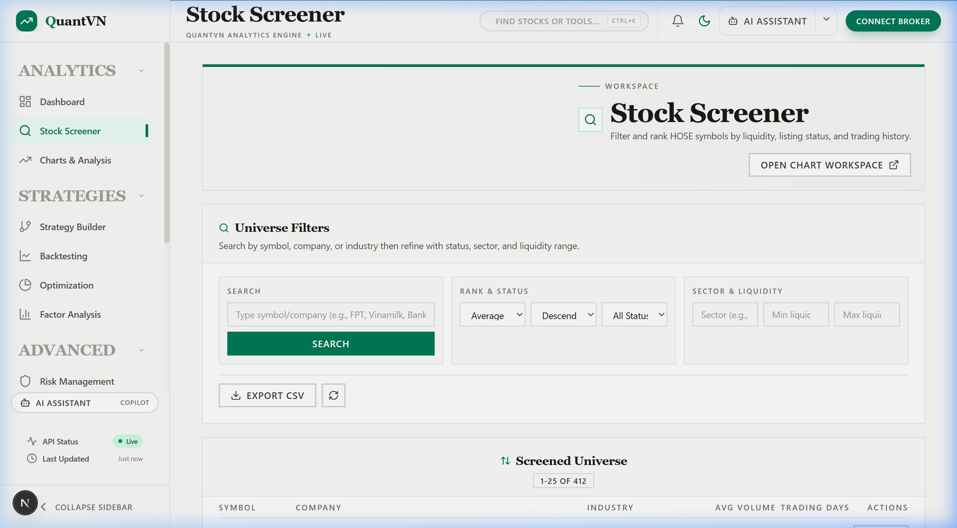
Figure A.1: Stock Screener interface with multi-criteria filtering across 412 HOSE-listed symbols.
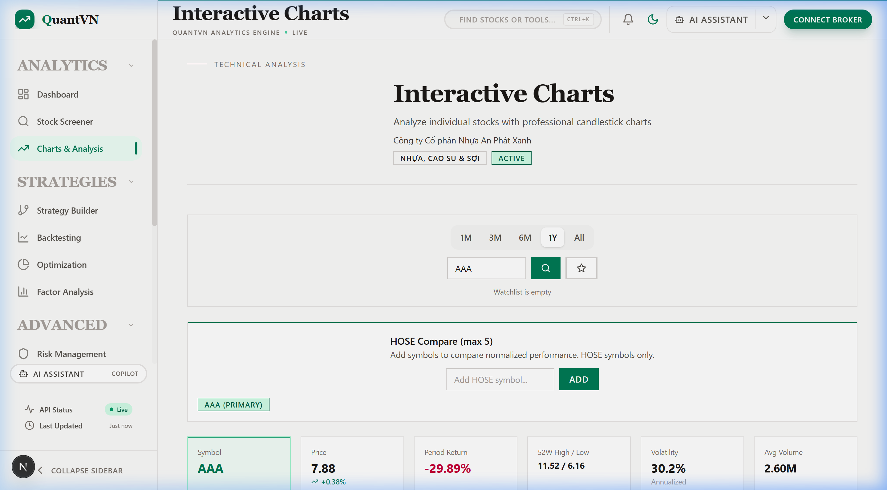
Figure A.2: Interactive Charts module showing stock analysis with price data, returns, volatility, and comparison workspace.
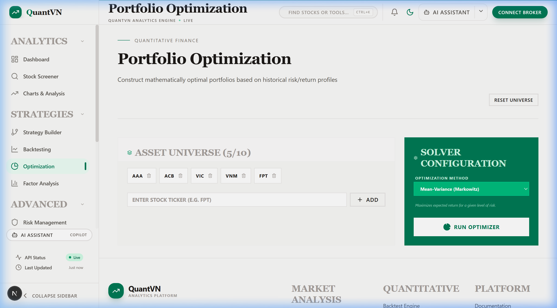
Figure A.3: Portfolio Optimisation module with asset universe selection and Mean-Variance solver configuration.
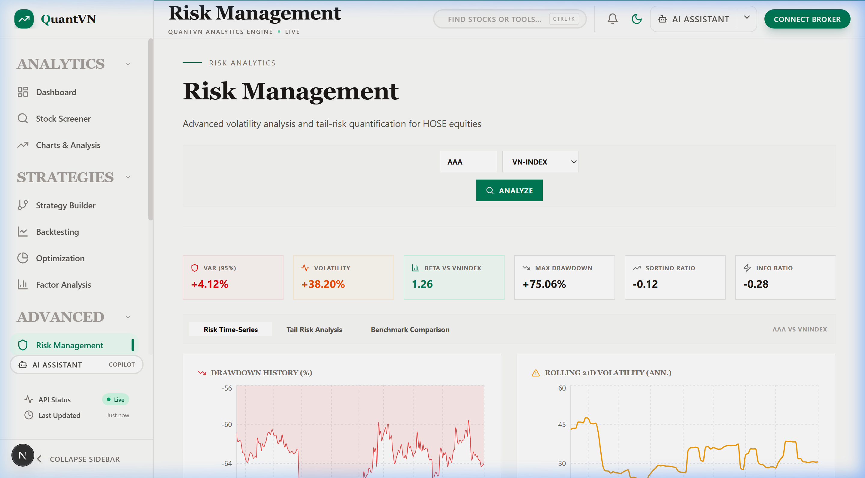
Figure A.4: Risk Management dashboard displaying VaR, Volatility, Beta, Maximum Drawdown, Sortino Ratio, drawdown history, and rolling volatility charts.

