* Guest house:
  + 790 on George Backpackers
  + 790 George Street, Haymarket, Central, Sydney, Australia 2000

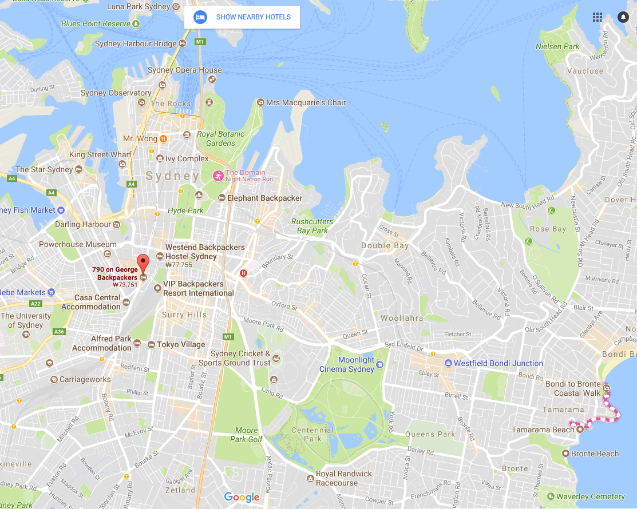

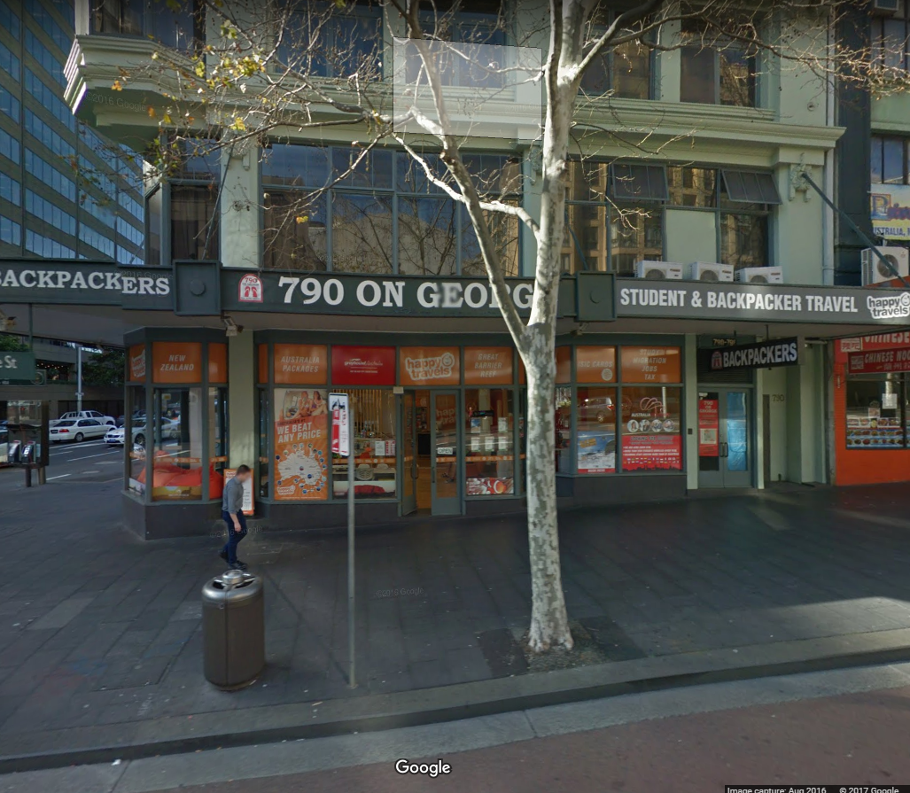

Opera House:

Bennelong Point, Sydney NSW 2000, Australia

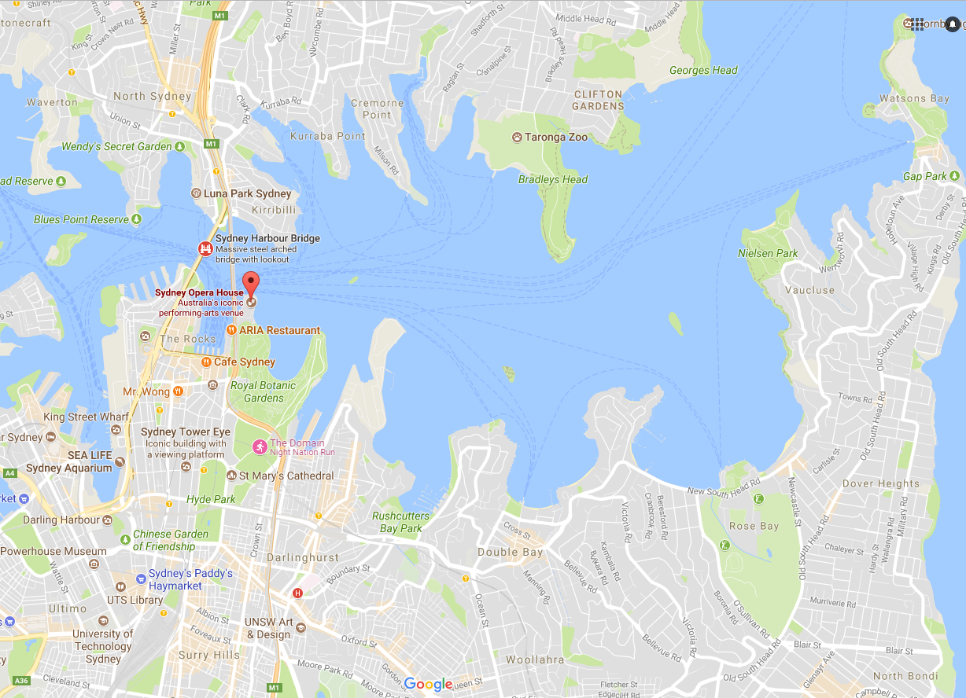

Sydney Convention and Exhibition Centre

14 Darling Dr, Sydney, NSW, AU

