# Result

**INDEX**

**Part I: SNP distribution features on miRNAs both conserved and non-conserved and their targets;**

**Part II: No obvious negative correlation between miRNA level and its target mRNA level;**

Part III: Combined Complementary Pattern Analysis found a family of miRNAs can recover their complementarity to some targets after double point mutations;

Part IV: Analysis of phenotypes of osa-miR156 and osa-miR172 along with their combined complementary patterns

**SNP distribution features on miRNAs both conserved and non-conserved and their targets**

Up till now, there are 592 pre-miRNAs with their 718 mature products deposited in *miRBase.org* (release 21, in June 2014), out of which 578 pre-miRNAs have been mapped to the rice genome (MSU 7.0). After BLAST to the rice genome, we finally obtained 585 pre-miRNAs and 703 MaMiRNAs with genomic coordination information. And as the conservation of miRNAs would bring differences in later miRNA studies, in that selection pressure imposed on deeply conserved miRNAs are comparatively higher than that on less conserved miRNAs and almost all deeply conserved miRNAs have identifiable targets and are also conserved among plant species, we did the classification of miRNAs by their conservation aided miRNA family classification provided by *miRBase.org* and finally 220 MaMiRNAs and 191 pre-miRNAs are classified as conserved miRNAs. Moreover, it’s unimaginable to study miRNA functions without knowing its targets, so we collected targets of conserved miRNAs from experimental data of previous studies and with the help of bioinformatics methods, and we got 823 target genes which can form 2,113 interaction pairs with miRNAs.

After searching against the SNP data derived from the 3,000 rice genomes project which now is deposited in *http://snp-seek.irri.org*, 7,193 SNPs were found in 578 pre-miRNAs, within which 1,270 SNPs fell unto MaMiRNAs, and 1,169 SNPs were found within the miRNA binding sites of target genes. Further analysis shows majority of pre-miRNAs, both conserved and non-conserved, fall in the SNP density range 0.01-0.06, and they both have peaks at 0.03-0.04 range. Moreover, conserved miRNAs gather at comparatively lower SNP density range than non-conserved miRNAs, e.g. more than 70% conserved miRNAs gather at 0-0.06 range while only less than 40% non-conserved miRNAs gather at this low SNP density region, and this implies that conserved miRNAs subject to higher selection pressure.

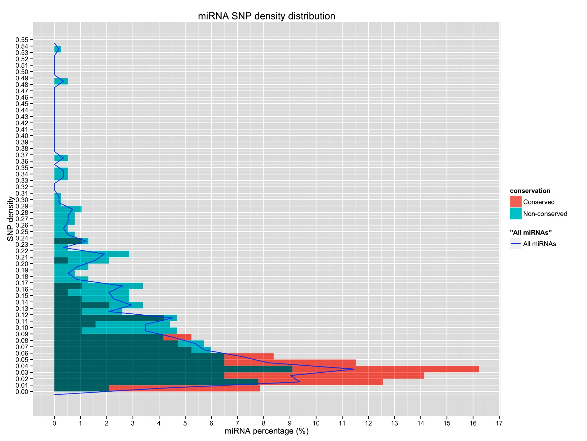

**Figure 1. SNP density distribution in pre-miRNAs**

miRNA percentage is the percentage of pre-miRNAs that fall in the given density range out of all pre-miRNAs.

Randomly choosing intergenic regions as control to compare with pre-miRNAs concerning SNP density, we have found there are many peaks in the figure of intergenic region and this phenomenon signifies the diversified selection pressures imposed on different parts of intergenic regions and pre-miRNAs tend to gather at lower SNP density ranges than intergenic fragments which may suggest pre-miRNAs subject to higher selection pressure owing to their regulation function.

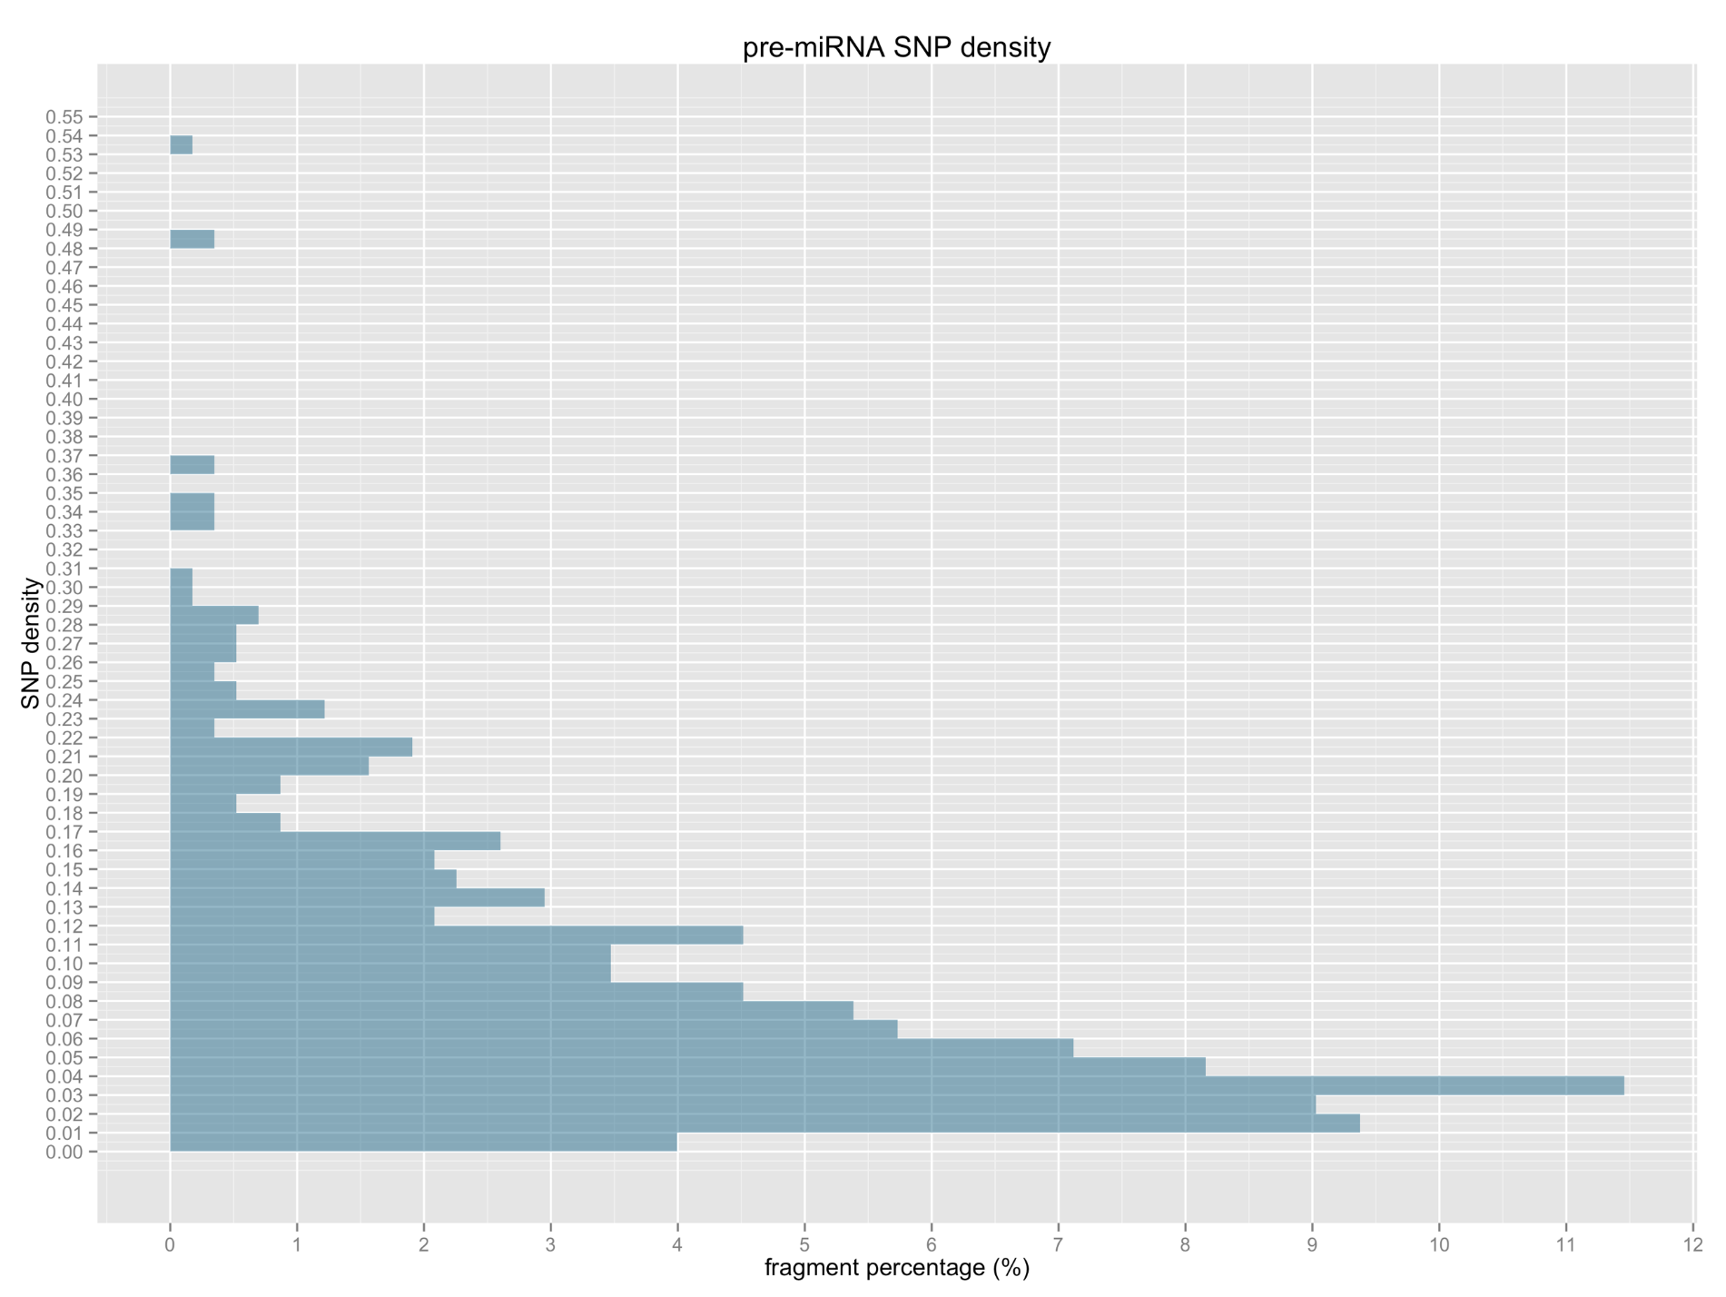

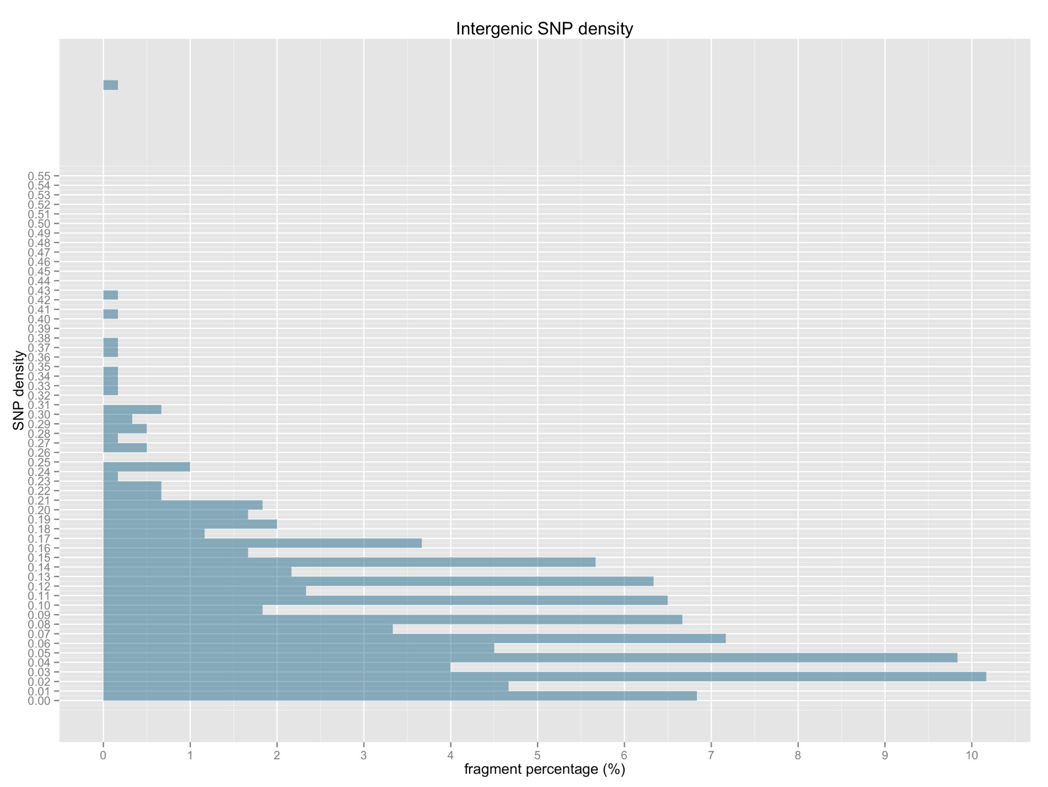

**Figure 2. SNP density distribution in pre-miRNAs(a), including both conserved and non-conserved miRNAs, and in intergenic regions(b).**

Mapping the 1,270 SNPs unto sites from 5’ end to 3’ end on mature miRNAs, the analysis of SNP distribution on MaMiRNAs with conserved and non-conserved MaMiRNA displayed separately for comparison, shows SNP density in conserved miRNAs is significantly lower than that of non-conserved miRNAs, implying that selective constraints on at least some non-conserved miRNAs are more relaxed. Mature miRNAs have their lowest SNP frequencies at sites 1, 11 and 18, while for conserved MaMiRNAs the lowest sites are 1, 9 and 12, which is not consistent with empirical parameters that cleavage site 10 and 11 must be complementary to target genes and are supposed be under higher selection pressure than other sites and the lowest SNP accumulation at site 1 may partly be explained by recognition and loading to AGO. By analyzing the SNP distribution on miRNA binding site of conserved miRNAs, we found site 1, 7 and 19 tend to accumulate the fewest SNPs and again is not consistent with the empirical claims about cleavage site 10 and 11.

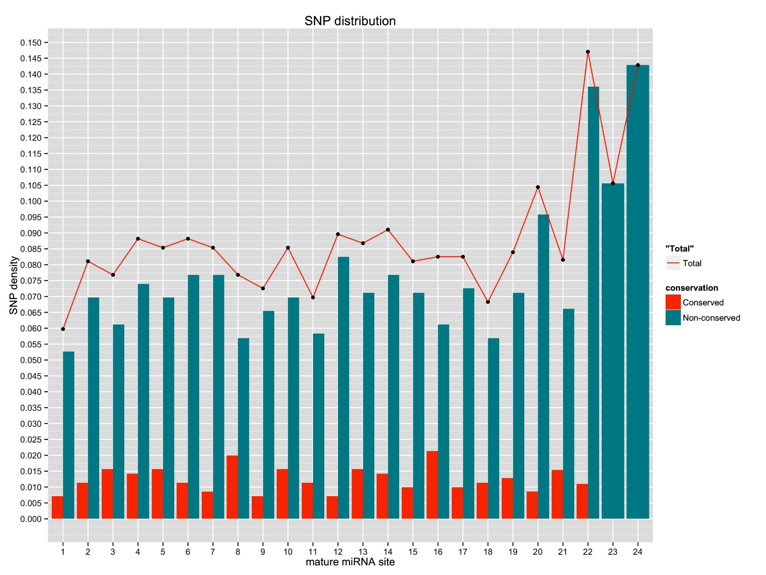

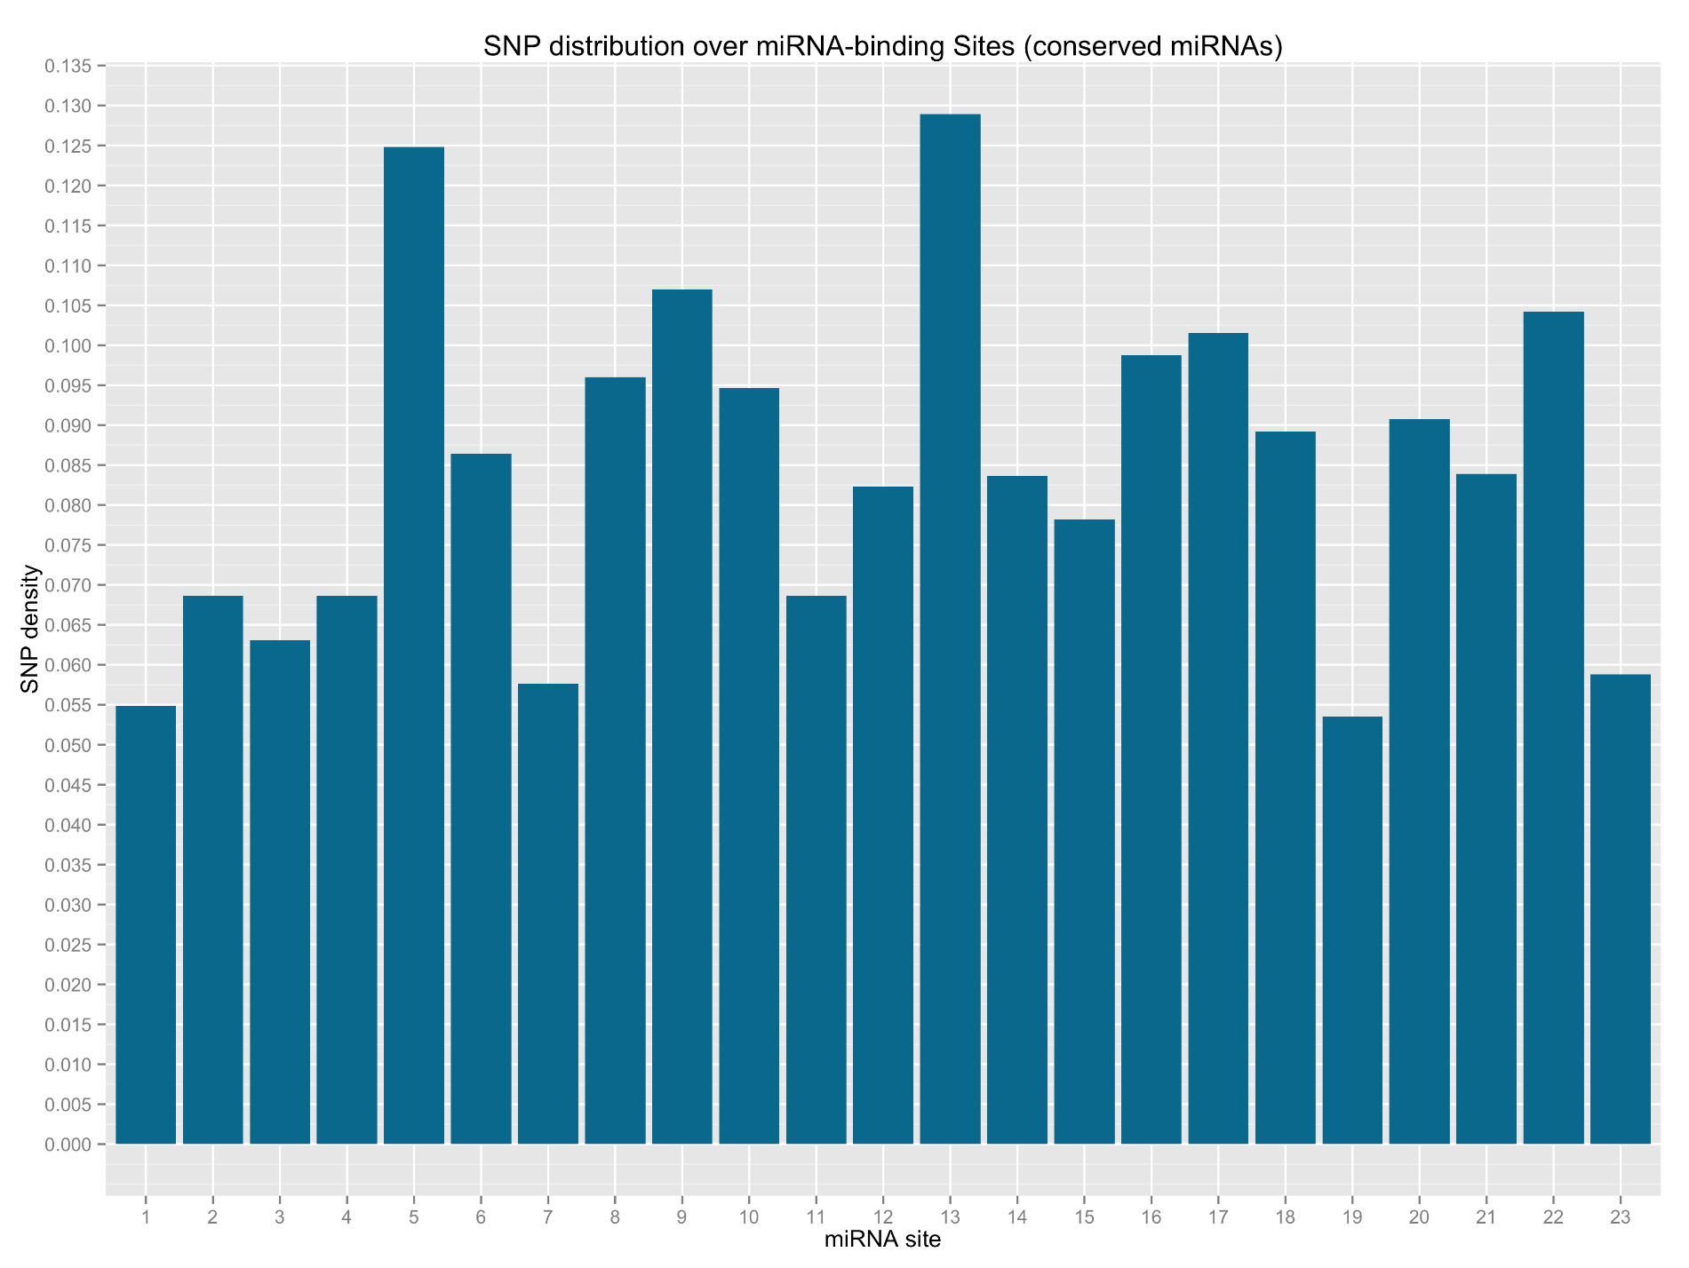

**Figure 3. SNP density for each site in rice mature miRNAs and miRNA binding sites of conserved miRNAs.** The order of sites in mature miRNAs is from 5’end to 3’ end, and in binding site, the order is the same and is from 5’ end to 3’end on mature miRNAs.

**No obvious negative correlation between miRNA level and its target mRNA level**

MiRNAs play the regulatory role of genes in plants mainly through transcript cleavage, though cases of translational repression have been reported. So the identification of the genes they regulate appears to be significantly important. Generally, plant miRNAs recognize their targets through high complementarity. Based on this, bioinformatics tools are easily and effectively to predict genes targeted by miRNAs. But such results cannot be regarded as bona fide targets, and further experimental validation methods are required, among which degradome sequencing is the choice of researchers to do global scale target authenticity validation. On the other hand, idea that expression of miRNAs and cognate target genes which are biologically relevant should be in negative correlation under the following premises, is held by most of the researchers:

* 1. Complementarity is the sole determinant of silencing;
  2. Plant miRNA-loaded RNA-induced silencing complex (miRISC) is able to act independently.

With the 703 genes predicted to be the targets of 220 conserved MaMiRNAs with mainstream web-based Plant Small RNA Target Analysis Server (*psRNATarget*), the question whether these targets are biologically regulated by their putative regulator miRNAs arises, which we call as biologically relevant targets. We tried to screen the biologically relevant targets of the prediction results with the expression data of both miRNAs and predicted targets. Before the screening, we applied the expression correlation method to the degradome validated 46 target genes which are regarded as bona fide targets. The results are surprising, only 31.96% of the total mature miRNA:target pairs are found negatively correlated and 37.06% of the total pre-miRNA:target pairs are found negatively correlated. Thus correlation between miRNA levels and target mRNA levels did not reveal a clear negative relationship between them.