ORCAL Component Library

Introduction

This library summarize the detailed steady-state component models, which are developed in EES. These models are general models. The objective of this library is to provide initial values, heat transfer coefficients, and pressure drops for the dynamic solution as well as its validation when run to steady-state. In addition, these models are also used for sizing and optimizing the system.

How to select Turbomachineray for your application

Turbomachinery finds many application in commercial, industrial, military, and aerospace application. These turbomachines include pumps, compressors, fans and blowers, and turbines for prime movers. Other applications include turbines for generating shaft power.

This following section describes a method of predicting turbomachinery performance using dimensionless parameter of specific speed and specific diameter.

Four parameters: specific speed, specific diameter, reynolds number and suction specific speed or Mach number are sufficient to describe completely the performance of geometrically similar turbomachines.

For a given ***volume flow rate*** and a given ***head change (pressure drop?)*** through a turbomachine, specific speed is a number indicative of the rotative speed of the machine and ***specific diameter*** is a number indicative of the rotor diameter or size of the machine. Reynolds number expresses the ratio of the inertia force to viscous force and reflects the properties of the fluid being pumped and the speed of the machine. Suction specific speed for machines such as pumps operating on non-compressible fluids will indicate whether or not cavitation exists. If cavitation does not exist, then pump performance will be as expected. If serious cavitation exists the pump performance cannot predicted from the similarity parameters. For machines operating on compressible fluids such as turbines and compressors Mach number $M_a^*$ is used as the fourth similarity parameter in place of suction specific speed

Chapter 1: Pump, compressor and expanders

1.1. Pump

1.1.1. Pump1 model

Pump model with a specified isentropic efficiency.

Syntax: Pump1(F$,p_in,p_out,h_in,m_dot_in,eta: h_out, m_dot_out,W_dot)

**Inputs:**

F$: fluid string identifier

p_in: inlet pressure (Pa)

p_out: outlet pressure (Pa)

m_dot_in: mass flow rate (kg/s)

eta: isentropic efficiency

**Outputs:**

h_out: outlet enthalpy

m_dot_out:

W_dot



**Note:** Available Net Positive Suction Head (NPSH) should be greater than 5 ft to avoid the cavitation



Where  is saturation pressure of working fluid at pump inlet temperature;  is the pump inlet pressure

1.1.2. MKIreland's pump model

A pump's global isentropic efficiency, , including both ***electromechanical*** and ***internal******losses,*** is defined by



Assuming the liquid behaves as an incompressible fluid, where the subscript  indicates pump; the variables  represents pressure; and  is electromechanical. Since the pump and motor are not integrated into the same shell like the expanders, the electromechanical and internal losses can be separated.

Basically, the pump isentropic efficiency is often given as a parameter. In the work of Melissa Kara Ireland (2014) and for a specific pump and specific working fluid, the isentropic efficiency is defined by



Which is derived from manufacturer data that is correlated as a function of ***normalized outlet pressure***. The nominal pressure, , is set to 30 bar. Volumetric efficiency is neglected in the manufacturer data.

The motor efficiency is also derived from manufacturer data and correlated with fraction of rated mechanical power:



Where the rated mechanical power, , for the working fluid pump is ***746 W*** and Table provides the coefficients, bk.

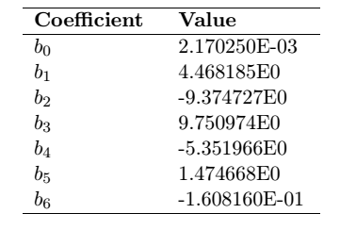

Table 1: Working fluid motor correlation coefficients for equation

http://www.asme-orc2015.be/online/proceedings/documents/91.pdf

according to the work of Schuller S. (2015) the pump is of centrifugal type. Because of high fluid pressure (above its critical pressure), the variation in density between the input and output of the pump is significant. The model considered therefore, for the pump power consumption calculation, a polytropic compression with efficiency depending on its variable speed, head and flow (Troskolanski, 1977). The power and the speed are assumed to be sufficient to reach all the requirements for all off-design points.

1.2. Expander/turbine

1.2.1. MKIreland expander-generator (positive deplacement machine)

Neglecting ambient heat losses, the expanders are characterized by their ***filling factor*** and isentropic efficiency. Filling factor, , is defined as:



Or the ratio of real to ideal mass flow rate, where  is the supply specific volume of the fluid;  is the ideal volume flow rate; *Vs* is the swept volume /*the volume of a cylinder swept by the piston while moving from one dead center to another*/ of the machine; and  is the rotational speed of the expander. Isentropic efficiency, , is the ratio of real to ideal power generated or



Where  is the electrical power generated;  is the isentropic power; and hsu and hex,s are the supply and isentropic exhaust specific enthalpies, respectively. The electrical power is used here as the asynchronous generator is integrated with the expander in a hermetic shell. The internal irreversibilities accounted for in the isentropic efficiency are thus a combination of both the fluidic and electrical losses.

In the work of Schuller S. (2015) the turbine is of radial inflow type (marcuccilli, 2007). The wheel diameter and the speed of rotation are determined to maximize isentropic efficiency (Balje, 1981). Pressure and temperature at turbine inlet are determined according to an optimization procedure (schuller et al. 2014). The turbine is equiped with variable inlet guide valves. The turbine inlet pressure is controlled by the position of these inlet guide valves whereas the inlet temperature is govened by the working fluid mass flow rate (i.e. controlled by the pump)

Chapter 2: Heat exchangers

Shell-and-tube heat exchanger

Shell-and-tube heat exchangers can be constructed with many different configurations. In the thesis of Daniel Walraven, it is chosen to investigate the TEMA E type. According to this author, this is only possible type for the ORC preheaters, the most basic type, with a single shell pass and with the inlet and outlet at the opposite ends of the shell. The working fluid always flows on the shell side, so models for the pressure drop and heat transfer coefficient in single-phase flow, evaporation and condensation in a TEMA E Shell are needed. The tube-side fluid (the heat source and heat sink) will always be single phase.

Air cooled condenser

The air cooled condenser is maybe a classical model similar to API661 models that are found in ORC facilities for **geothermal applications**

Thermosyphon-based evaporator off-design model

Heat transfer in the condenser [1]

The heat transfer in the condenser can be considered as the condensation heat transfer. By assuming that the condensate film flow was laminar and the film was thin with respect to the radius of curvature of the inside surface, the Nusselt’s film condensation theory for a vertical flat plate was applied in the condenser section and the average heat transfer coefficient was given by [2]



Heat transfer processes in the evaporator

Heat transfer in the liquid pool: the heat transfer process in the liquid pool is generally considered to be one of nucleate boiling. The boiling in the liquid pool differs somewhat from the well-known pool boiling because the boiling in the thermosyphon occurs in a closed cavity and the motion of the vapor bubbles in the liquid pool is having a large effects on the heat transfer process.



Heat transfer in the liquid film: very little is known about the heat transfer processes of the falling liquid film in the evaporator.

The following assumptions should be considered for two-phase closed thermosyphon modeling

1. The axial conduction through the tube wall is negligible (non we will involve this heat transfer mechanism)
2. The wall temperature of the condenser section is constant along its length
3. Heat is supplied uniformly to the evaporator section
4. The steady state operating condition is established and all the heat added at the evaporator section is removed at the condenser section
5. Change of liquid pool level in the evaporator due to the boiling action is negligible as compared to that with no power input

The thermosyphon-based evaporator off-design model is used to determine the performance of the device under changing boundary conditions. In the off-design model the heat transfer area and other geometric parameters are known. The design of the evaporator is fixed and the model calculates the mass flow rates and temperatures throughout the evaporator. The evaporator off-design model is able to determine the point where the working fluid starts evaporating??? The position of this point changes in off-design. If the fluid with minimum heat capacity rate suddenly becomes the fluid with maximum heat capacity rate, no problems are encountered because the P-NTU method is used.

Introduction

Two-phase closed thermosyphon which differs from heat pipe as the liquid returns from the condenser to the evaporator only by means of gravity. The thermosyphons are more suitable than heat pipes for most of the industrial applications, especially those involving large equipment as, in general sense, they are more efficient and cheaper to fabricate [3].

Design methodology

The following design methodology based on the experience of the Labtucal/UFSC and on procedures proposed in the literature is suggested for the thermosyphon operating in steady-state conditions

Basically, it consists of the determination of all thermal resistances of the thermal cirbuit as presented in the figure. The operation limits must also be determined. Based on this information, the total heat power is calculated. The heat transportation capacity of the thermosyphon is then compared with the operation limits. If the heat to be transferred is within the operational limits, optimization procedures, aiming the reduction of cost, improvement of heat transport capacity and geometry, can be applied.

* Step1: Design parameter specification: **lengths, tube diameters, inclination angle, evaporator and condenser external areas, external evaporator and condenser convection coefficients** (obtained from literature correlations and models), **source and sink temperatures, filling ratio and thermal conductivity of the casing metal.**
* Determine R1, R2, R8 and R9

Condenser resistance

Condensate is moving downward, from the end of the condenser region to the evaporator working fluid pool’s upper surface. In the condenser region, as heat is removed, the saturated vapor condensate and a film is formed over the internal wall surface. The thickness of the film increases as the liquid film moves down. When the condensate reaches the evaporator region, the film is in contact with the heated wall and evaporates. The thinner the liquid film, the more efficient is the evaporation. The remaining liquid accumulates in the evaporator region, forming a pool, and evaporation occurs in boiling region.

Wet cooling tower

On cooling option is to use a desuperheater and a condenser, coupled to a wet cooling tower:

Natural-draft cooling towers are not modeled in this work, because they are typically used for large cooling needs.

For lower cooling loads, mechanical-draft cooling towers are better suited.

Induced-draft and forced draft

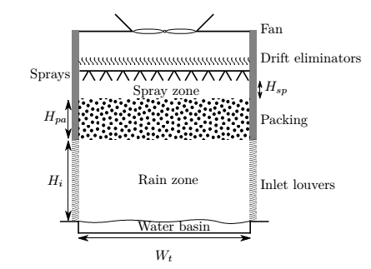

Geometry of an induced mechanical-draft wet cooling tower. Adapted from Kloppers

The warm cooling water enters the tower in the sprayers in which it is sprayed over the packing. The packing is used to increase the contact surface between droplets and air in order to enhance the heat and mass transfer. At the bottom, the cooled water is caught and it is sent back to cool the ORC condenser. The air flows in the opposite direction; it enters the tower from the sides at the bottom and flows through the inlet louvers. These louvers are used to prevent the inflow of unwanted elements, to prevent water splash and to decrease the amount of sunlight irradiation. When flowing upwards in the tower, the air is heated up and the humidity increases. The drift eliminators are used to decrease the amount of water droplets taken by the airflow. The height of the inlet Hi, the height of the packing Hfi, the height of the spray zone Hsp and the width of the tower Wt are show in the figure above.

Square tower with a film packing will be modeled.

For a given inlet temperature and required outlet temperature of the cooling water, the required Merkel number  is calculated. The Merkel number is a non-dimensional parameter describing the transfer characteristics in the cooling tower, defined as



 is the mass transfer coefficient

 is the area density of the packing

 is the mass velocity of the water

 is the wet-bulb temperature.

The heigh of the spray zone  is fixed at 0.5 m

The height of the packing  is a result of the cooling-tower model and is therefore not an optimization variable

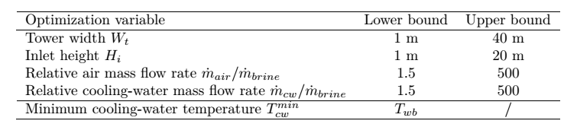

The govern equation used to calculate the heat and mass transfer in a wet cooling tower

The mass flow of water  falling down at a point in the cooling tower is given as



 is the amount of water at the sprays

ma is the mass flow of dry air

wo is the humidity ratio at the outlet of the air

w is the humidity ratio at the same point as 

Liquid gas ratio L\G: the amount of water entering the tower divided by the amount of air circulating through the system

Altitude (m): the height above sea level at which the tower is operating

Inlet air temperature: the temperature of the fresh air used for cooling purposes

Inlet air Relative humidity (RH): if you have a relative humidity of 80% you should enter 0.8

Hot water temperature: the temperature of the water being fed to the tower to be treated

Capacity: the amount of hot water at the inlet of the tower (m3/h)

Cold water temperature

Oulet air relative humidity (ratio)

Relative humidity (RH) is the ratio of the partial pressure of water vapor to the equilibrium vapor pressure of water at the same temperature



Relative humidity is normally expressed as a percentage; a higher percentage means that the air-water mixture is more humid

Vapor pressure or equilibrium vapor pressure is defined as the pressure exerted by a vapor in thermodynamic equilibrium with its condensed phased (solid or liquid) at a given temperature in a closed system

Humidity is the amount of water vapor in the air.

**Dry bulb temperature – **

The dry bulb temperature, usually referred to as air temperature, is the air property that is most common used. When people refer to the temperature of the air, they are normally referring to its dry bulb temperature

The dry bulb temperature refers basically to the ambient air temperature. It is called “dry bulb” because the air temperature is indicated by a thermometer not affected by the moisture of the air

Wet bulb temperature  is the adiabatic saturation temperature. Wet bulb temperature can be measured by using a thermometer with the bulb wrapped in wet muslin

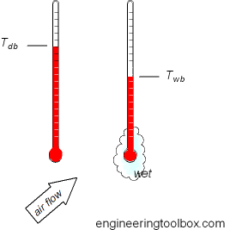



 is the enthalpy of air-water vapor mixture at bulk water temperature, btu/lb dry air

Merkel theory

The early investigators of cooling tower theory grappled with the problem presented by the dual transfer of heat and mass. The Merkel theory overcomes this by combining the two into a single process based on enthalpy potential. The theory considers the flow of mass and energy from the bulk water to an interface, and then from the interface to the surrounding air mass.

Merkel demonstrated that the total heat transfer is directly proportional to the difference between the enthalpy of saturated air at the water temperature and the enthalpy of air at the point contact with water



Where

Q: total heat transfer, btu/h (bristish thermal unit/hour) (or W)

K: overall enthalpy transfer coefficient, lb/hr.ft2

S: la surface de transfert de chaleur, ft2. S equals to  means an effective tower volume (ft3)

hw : enthalpy of air-water vapor mixture at the bulk water temperature, btu/lb dry air

ha: enthalpy of air-water vapor mixtures at the wet bulb temperature, btu/lb dry air

The water temperature and air enthalpy are being changed along the fill and Merkel relation can only be applied to a small element of heat transfer surface dS



The heat transfer rate from water side is



Where

Cw is specific heat of water (Cw = 1 or 4182 J/kg-K)

L is water flow rate lb/hr or kg/s

Therefore



Also the heat transfer rate from air side is



Where

G is air mass flow rate



Then the relation



Or



Are established



Or



By integration





Where

 is the value of (hw – ha) at a temperature of cooling water temperature + 0.1 Range

 is the value of (hw-ha) at a temperature of cooling water temperature + 0.4 Range

 is the value of (hw – ha) at a temperature of cooling water temperature + 0.6 Range

 is the value of (hw – ha) at a temperature of cooling water temperature + 0.9 Range

Heat balance

Water heat in+ air heat in = water heat out + air heat out



Water makeup : makeup requirements for a cooling tower consist of the summation of evaporation loss, and blowdow therefore

\[M_{wm} = M_{we}+M_{wd}+M_{bd}\]

Where

$M_{wm}$: makeup water

\[M_{we} = 0.00085M_{c}{\rm Range}\]

$M_{wc}$: circulating water flow, m3/h or gal/min at tower inlet

Range: inlet water temperature minus outlet water temperature in °F

Drift loss can be estimated

\[M_{wd} = 0.0002M_{wc}\]

Loading factor, specific water flow rate or water flow rate density is the recommended water flow rate per unit of tower cross-sectional area (base area, B). through experience with various types of fill, optimum loading factors have been determined as a function of design wet-bulb temperature, range and approach. For difficult cooling jobs (large range and/or close approach), a low loading factor is required and visa versa.

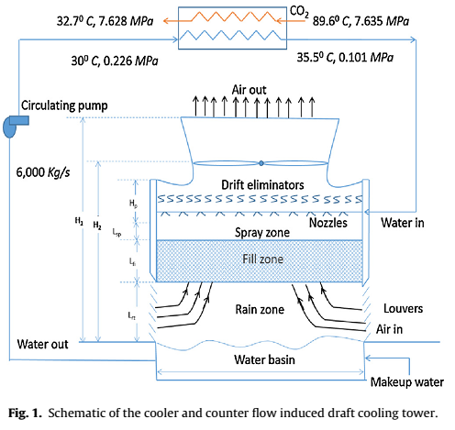

Heat and mass transfer in a cooling tower occurs in three zones namely

* Spray zone
* Fill zone
* Rain zone

However, more than 90% of the heat transfer occurs in the fill zone, and also a recent study suggested that the error in the prediction of tower volume due to exclusion of spray and rain zones in their model is about 6.5%. it was also shown that when the spray and rain zones are included their model, which directly solved the basic governing equation with anly assumptions, resulted in 2.65% error compared to the experimental data. Hence , the spray and rain zones are not explicitly modeled.

Assumptions:

* Air exiting the cooling tower is saturated (100% relative humidity)

**Estimation of floor area**

It is a common practice to use a certain number of small cells instead of a single large cell to reduce the total power consumption and to provide better temperature control. The cells are classified based on cell sizes and blower power consumption. Choosing different cells will result in different floor area and total power consumption. Using the smaller cell size will increase the required floor area of cooling tower but will reduce the power consumption and visa versa.

[1] Shiraishi M, Kikuchi K, Yamanishi T. Investigation of Heat Transfer Characteristics of a Two-Phase Closed Thermosyphon A2 - REAY, D.A. Advances in Heat Pipe Technology: Pergamon; 1982. p. 95-104.

[2] Krasnoshchekov EA, Protopopov VS, Van F, Kuraeva IV. Experimental investigation of heat transfer for carbon dioxide in the supercritical region In: C. Gazley, Jr., Ecker JPH, E RC editors. Conference Experimental investigation of heat transfer for carbon dioxide in the supercritical region, Minsk, Belarus vol. 1. p. 26-35.

[3] Marcia BHM. Thermosyphon Technology for Industrial Applications. Heat Pipes and Solid Sorption Transformations: CRC Press; 2013. p. 411-64.