Chapter 1: Pump, compressor and expander

1.1. Axial-flow turbine efficiency

Axial-flow turbine efficiency is predicted using the study of Macchi and Perdichizzi (1981)[1]. The turbine stage efficiency is found to be a function of three main parameters: the expansion ratio, defined as the specific volume variation across the turbine in an isentropic process; the dimensional parameter , which accounts for actual turbine dimensions, and the specific speed. ***The method is believed to be useful mainly for non conventional turbine stages, the efficiency of which cannot be anticipated on previous machines experience***

Method of solution: the design of a turbine stage can be looked at as an optimization problem, three main points should be made clear: (1) definition of the goal function; (2) independent variables; and (3) constraints which limit the range of the search.

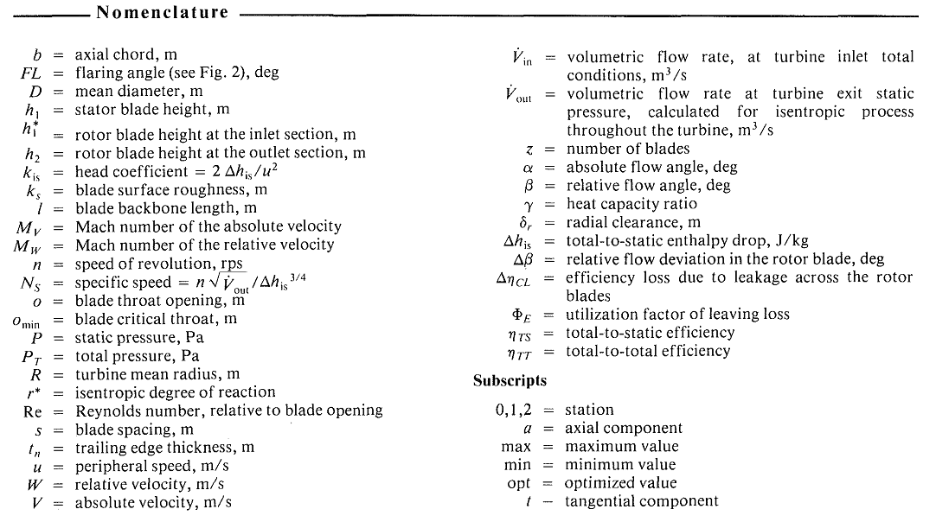

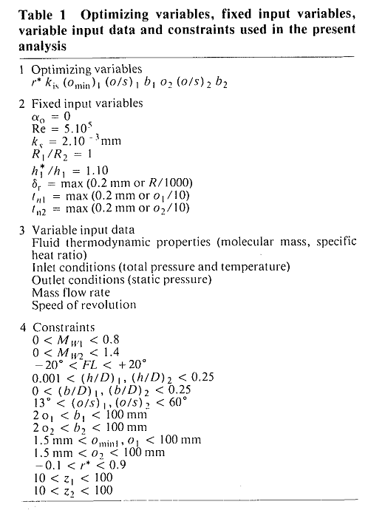

The results of turbine efficiency prediction in the work of Macchi and Perdichizzi was obtained from an optimization. The selected independent optimization variables, the variable and fixed input data, and the assumed constraints are summarized in Table 1. It can be seen that eight optimizing variables are sufficient to identify a turbine stage. The physical significance of the various constraints is in most cases self explanatory: some limits are due to practical limitations in blade machining, others are necessary to restrict the search of solutions in the validity range of the assumed correlations. The adopted procedure is a numerical optimization technique, fully automatized by and available computer program, which makes use of an iterative method, with tentative changes of the variables up to the attainement of the optimum value. The required number of iterations (each iteration performs a complete turbine stage calculation) varied within 3000-6000. Average CPU time on the Univac 1100 for the solution of one case was about 15 s..

**Discussion of results:**

Only cases with optimum specific diameters are considered. According to the similarity rules, results obtained for a particular turbine will hold for all other turbines having the same specificic speed, NS, provided that

- Reynolds number effects are neglected

The thermodynamic behavior is the same, i.e., either incompressible flows, or fluids with the same pressure ratio and the same heat capacity ratio are considered.

- the geometric similarity is preserved (including tip clearance, surface roughness, etc.)

The thermodynamic properties of the working fluid affect the turbine design and performance in two main ways: (1) loss coefficients are a function of Mach number; (2) the fluid volume variation during the expansion influences the geometry of the turbine. Therefore, two optimized turbines having the same specific speed and, say, the same pressure ratio will not have either the same geometry or the same efficiency, if they have working fluids with different heat capacity ratios. In fact, the same pressure ratio will cause different Mach numbers and different volume variation for the two fluids.

Results for optimum specific speed



Where n is speed of revolution, rps



Where D is rotor diameter

The specific speed, NS, can be also optimized: in this case, the results of fig. 5 and 6 are obtained. As seen in fig. 5, a strong influence on the efficiency achievable by a turbine stage is exerted both by the compressibility effects and by the turbine actual dimension. The two effects are combined, i.e. for small turbines with large volume variations, large efficiency penalties take place. It can be seen that optimum specific speeds increase for smaller turbine dimensions, owing to the increased importance of radial clearance effects. An idea of the actual turbine dimensions is given by the

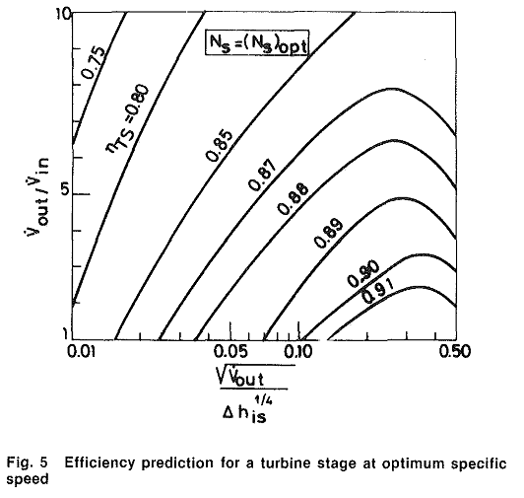

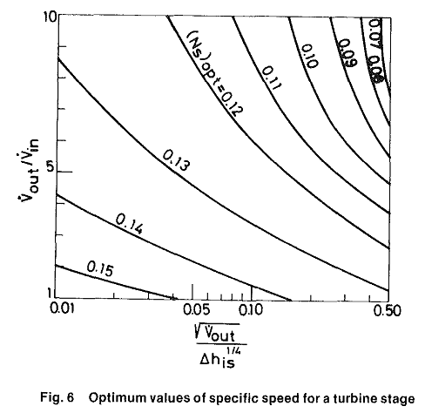

Results for various specific speeds: often the turbine stages cannot be designed for their optimum specific speed. For instance, in multi-stage turbines, the speed of revulution must be a compromise among the requirements of the various stages, which operate at different specific speeds. The efficiency dependence on specific speed is shown in fig. 11, where results obtained for various turbine dimension and expansion ratios are given. The efficiency dependence on the specific speed is quite marked, and the adoption of optimum or near optimum specific speed becomes mandatory.

Conclusions: it has been shown that the efficiency achievable by the turbine stage can be predicted by the curves of Fig. 5 and/or Fig. 11, as a function of three parameters, namely (a) the  ratio, which accounts for the compressibility effects, (b) the  parameter, which accounts for the actual turbine dimensions, and (c) the specific speed Ns, which can either be optimized, with values given in Fig. 6, or selected as an independent variable. The effects of compressibility become very important for turbine stages having large pressure ratios, and yield significant alterations of the optimized velocity triangles.

Model validation

In the work of Macchi et

Radiation of surfaces

All substances, regardless of shape and consistency, emit and absorb radiation energy when their temperature is above absolute zero temperature (T>0K). For non transparent opaque bodies, the absorption and emission processes are confined to their surface. Thermal radiation energy can be regarded as electromagnetic waves carrying energy and entropy in the wavelength range between 0.1 µm and about 1000 µm. Because of these emission and absorption processes in all substances around there will be a net transfer of energy between those bodies which face each other and whose surfaces have different temperatures. This net thermal radiation energy is a heat flux, from a thermodynamic view, as its only driving force is a temperature difference and as it carries entropy. In thermal equilibrium situations, the emission and absorption processes still exist, but the net radiation energy will be zero. The radiation fluxes typically appear in addition to convective heat fluxes and thus have to be worked out separately and added to give the overall heat flux.

The black body

The black body serves as a baseline for all calculations concerning thermal radiation, because only for this specific body an exact and simple physical description is known. A black body is a hypothetical radiating body, the surface of which absorbs all incoming radiation. No reflection or transmission occurs. Because of this the black body of a given temperature T will emit a maximum amount of radiation energy, no other body with the same temperature will emit more radiation in any wavelength interval.

Radiative properties

Emissivity

The emissivity of a surface represents the ratio of the radiation emitted by the surface at a given temperature to the radiation emitted by a blackbody at the same temperature. The emissivity of a surface is denoted by , and it varies between zero and one, , Emissivity is a measure of how closely a surface approximates a blackbody, for which .

The emissivity of a real surface is not a constant. Rather, it varies with the temperature of the surface as well as the wavelength and the direction of the emitted radiation.

Absorptivity, reflectivity, and transmissivity

Everything around us constantly emits radiation, and the emissivity represents the emission characteristics of those bodies. This mean that every body, including our own, is constantly bombarded by radiation coming from all direction over a range of wavelength and is denoted by G.

When radiation strikes a surface, part of it is absorbed, part of it is reflected, and the remaining part, if any is transmitted.

The fraction of irradiation absorbed by the surface is called the absorptivity , the fraction reflected by the surface is called the reflectivity , and the fraction transmitted is called the transmissivity .

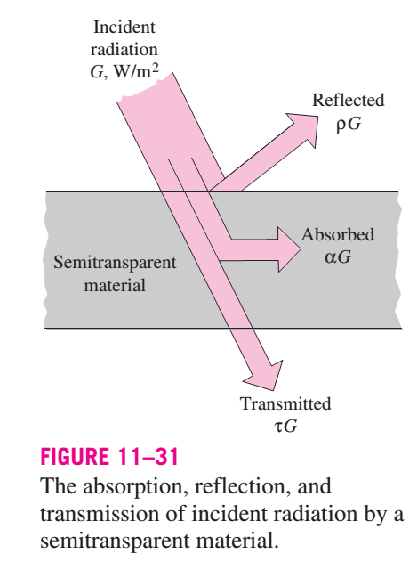

Kirchhoff's law

Consider a small body of surface area As, emissivity , and absorptivity  at temperature T contained in a large isothermal enclosure at the same temperature. Recall that a large isothermal enclosure forms a blackbody cavity regardless of the radiative properties of the enclosure surface, and the body in the enclosure is too small to interfere with the blackbody nature of the cavity. Therefore, the radiation incident on any part of the surface of the small body is equal to the radiation emitted by a blackbody at temperature T. That is, , and the radiation absorbed by the small body per unit of its surface area is



The radiation emitted by the small body is



Considering that the small body is in thermal equilibrium with the enclosure, the net rate of heat transfer to the body must be zero.

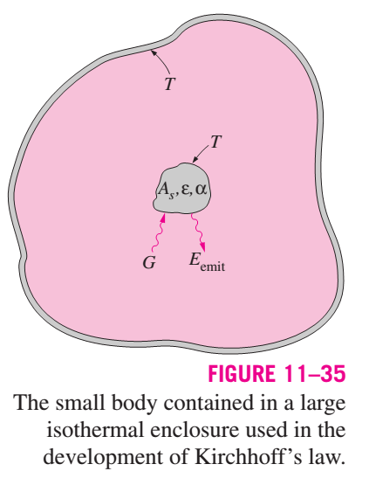

Radiation exchange with emitting and absorbing gases

So far we considered ratidation heat transfer between surfaces separated by a medium that does not emit, absorb, or scatter radiation - a nonparticipating medium that is completely transparent to the thermal radiation. A vacuum satisfies this condition perfectly, and air at ordinary temperatures and pressures comes very close. Gases that consist of monatomic molecules such as Ar and He and symmetric diatomic molecules such as N2 and O2 are essentially transparent to radiation, except at extremely high temperature at which ionization occurs. Therefore, atmospheric air can be considered to be a nonparticipating medium in radiation calculations.

Gases with asymmetric molecules such as H2O, CO2, CO, SO2, and hydrocarbon CmHn may participate in the radiation process by absorption at moderate temperatures, and by absorption and emission at high temperatures such as those encountered in combustion chambers. Therefore, air or any other medium that contains such gases with asymmetric molecules at sufficient concentrations must be treated as a participating medium in radiation calculation.

Radiation properties of a participating medium

 when .

When the total emissivity of a gas  at temperature  is known, the emissive power of the gas (radiation emitted by the gas per unit surface area) can be expressed . Then the rate of radiation energy emitted by a gas to a bounding surface of area  becomes



If the bounding surface is black at temperature , the surface will emit radiation to the gas at a rate  without reflecting any, and the gas will absorb this radiation at a rate of , where  is the absorptivity of the gas. Then the net rate of radiation heat transfer between the gas and a black surface surrounding it becomes

\[\dot{Q}_net=A_s\delta(\varepsilon_gT_g^4-\alpha_gT_s^4)\]

If the surface is not black, the analysis becomes more complicated because of the radiation reflected by the surface. But for surfaces that are nearly black with an emissivity , Hottel recommends this modification,



The emissivity of wall surfaces of furnaces and combustion chambers are typically greater than 0.7, and thus the relation above provides great convenience for preliminary radiation heat transfer calculations.

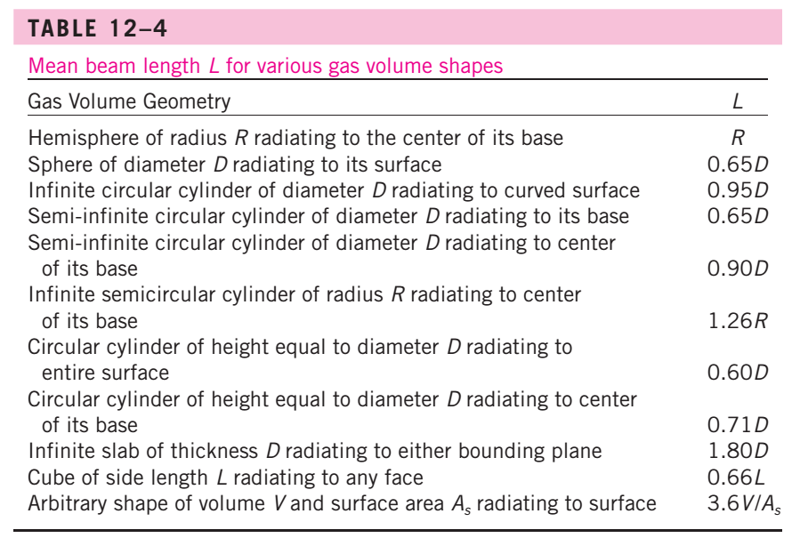

VDI atlas – K3: Gas radiation – Radiation from gas mixture

Gases emit thermal radiation, just as liquids and solids do, when they are at a T > 0 K. Radiation from gases is typically much less intense, as the volumetric density of the source of radiation, the molecules, is low. Dry air, elementary gases – e.g. O2, H2, N2, - and the nobles gases are practically diathermanous, i.e. transparent to thermal radiation.

Radiative exchange between gas and wall

The following equation applies for the net flow rate of thermal radiation energy between a volume of gas and the wall that encloses the gas space:



Where

Av is the geometry-dependent absorptance

A is the wall area around the gas body

boltzman constant

Equivalent layer thickness seq

An approximate value for the equivalent radius seq for geometries not included in the table can be obtained from the equation



It is valid only if the temperature, density, and concentration of the gas are constant in space, and its application requires knowledge of the gas emissivity and absorptance. The emissivity depends solely on the equivalent layer thickness seq and the state of the gas (Tg, total pressure p, and partial pressure pg of the gas components)



Gas mixtures





Example 1 :

Determine the net flow rate of radiant energy in a cube filled with gas under the following condtions:

|  |  |
| --- | --- |
| Length of side of cube | D = 1m |
| Wall temperature | Tw = 600 C |
| Gas temperature | Tg = 1400 C |
| Wall emissivity |  |

The gas contains 11% of water vapor and 10% of carbon dioxide (by volume). The rest is a non radiant component. The total pressure is 1 bar.

Solution

The equivalent length for a cube is





The following values for  and  can be read from the diagram

 (uncorrected) 

Applying the correction factor 



The total emissivity of the gas, as obtained from fig. 9c and equation 23a



Analytical calculation of the emissivities of H2O, CO2 and their mixtures

For computer-based calculations the total emissivities and absorptivities of real gases can be determined using the “gray-and clear gas approximation” (also called “weighted sum of gray gas model”

Radiation from gases and suspended particulate matter (perry handbook)

Flame radiation originates as a result of emission from water vapor and carbon dioxide in the hot gaseous combustion products and from the presence of particulate matter.

Gas emissivities radiant transfer in a gaseous medium is characterized by three quantities; the gas emissivity, gas absorptivity and gas transimivity. Gas emissivity refers to radiation originating within a gas volume wich is incident on some reference surface. Gas absorptivity and transmisisivity, however, refer to the absorption and transimission of radiation from some external surface radiation source characterized by some radiation temperature. The sum of the gas absorptivity and transimissivity must, by definition, be unity. The gas absortivity may be calculated from an appropriate gas emissivity. The gas emissivity is a function only of the gas temperature Tg while the absorptivity and transimissivity are functions of both Tg and T1

Mean beam lengths: it is always possible to represent the emissivity of an arbitrarily shaped volume of gray gas (and thus the corresponding direct gas-to-surface exchange area) with an equivalent sphere of radius R = L­M). In this context the hemisphere radius R = LM is referred to as the mean beam length of the arbitrary gas volume. Consider, e.g., an isothermal gas layer at the temperature Tg confined by two infinite parallel plate separated by distance L.

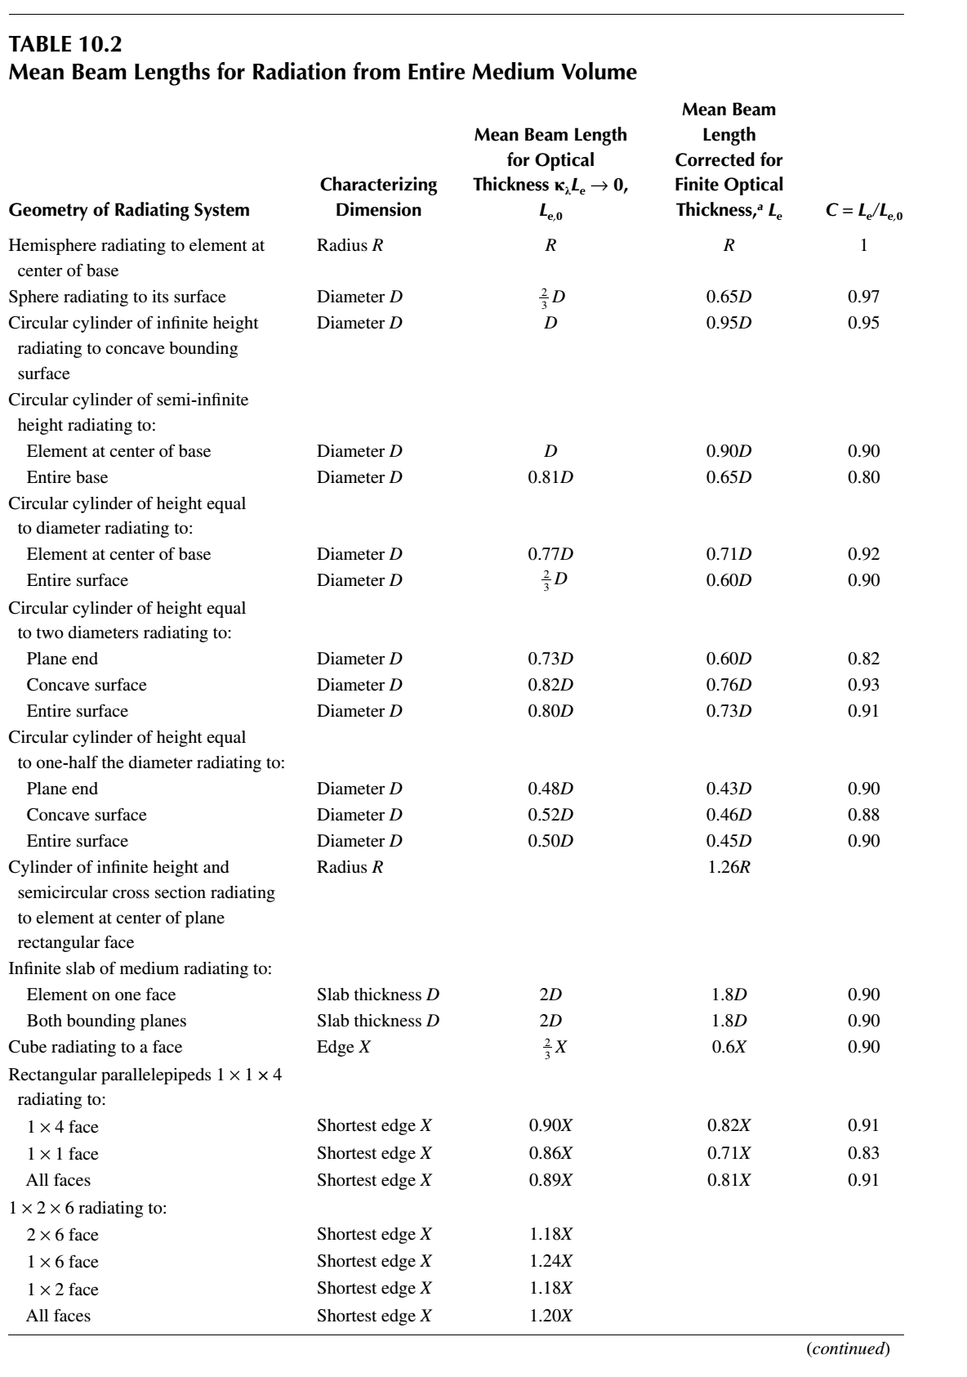

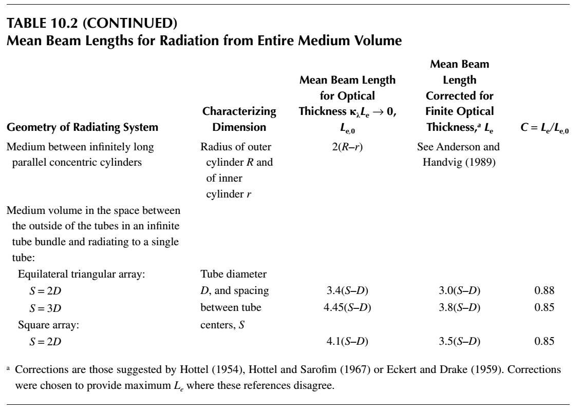

Condensation

Condensation outside horizontal tubes

1. Macchi E, Perdichizzi A. Efficiency Prediction for Axial-Flow Turbines Operating with Nonconventional Fluids. 1981. p. 718-24