Main Solution Window
Variables in Main
alpha_f=0.3244
alpha_m=48.1
A_fins=0.001979
A_fins_cond=0.5601
A_fpt=2.385
A_root_cond=0.08212
A_t=0.3487
A_t0_cond=0.0955
A_to=0.4059
A_tot=2.734
A_tot_cond=0.0955
A_tphex=225.6 [m^2]
A_tphex_a=16.12
A_tphex_c=42.98
A_tphex_e=182.7
beta_tphex=1.571
cp_target_f=1293
DELTAp_f=407.4 [Pa]
DELTAp_f1=146
DT_out_f=61.52
D_fins=0.052
D_i_tphex=0.033
D_o_tphex=0.038 [m]
eff_rec=0.1435
epsilon_f=0.1648
epsilon_rec=0.8 [-]
epsilon_s_pp=0.7 [-]
epsilon_s_tur=0.8246 [-]
eta_f=0.979
eta_gen=0.95
eta_motor=0.95
eta_ORC=0.2069
eta_s_tur=0.8246
eta_tur=0.8246
ExGasCMI$='heos::CO2[0.0854]&Water[0.1634]&Oxygen[0.0248]&Nitrogen[0.7264]'
f_free_spacing=0.002422
F_r_tphex=0.6
f_spacing=0.002822
h_c_o=54105
h_C_out=55481
h_e_o=126.5
h_e_o_conv=109.3 [W/m^2-K]
h_e_o_conv1=47.22
h_e_o_rad=17.11
h_fins=0.007 [m]
h_in_pp=-17706
h_in_tur=572357
h_out_pp=-12704
h_out_s_tur=436586
h_out_tur=460399
h_v_out_rec=392214
k_pipe=35.43
L_a=0.3 [m]
L_c=0.8 [m]
L_e=3.4 [m]
L_M=0.2736
L_tphex=1.448
m_dot_c_out=19.68
M_dot_f=50.22 [kg/s]
m_dot_out_pp=19.68
m_dot_out_tur=19.68
m_dot_v_out_rec=19.68
m_dot_wf=19.68
Nusselt_f=63.31
Nusselt_f1=27.64
N_col=15
N_col_ini=26
n_fins_cond=283
n_fpi=9
N_S_tur=0.09799
N_t=450
N_tpc=30
N_tpc_ini=35.79
ORCAL$='True'
ORCF$='cyclopentane'
PipeMat$='Carbon_Steel'
p_atm=101325 [Pa]
P_cd_wf=103829
P_crit_wf=4.571E+06
P_C_out=2.647E+06
P_ev_wf=2.647E+06
p_in_f=101325 [Pa]
P_v_out_rec=103829
Q_dot_ent_max=40250
Q_dot_ent_min=40102
Q_dot_ent_moy=40200
Q_dot_h=1.017E+07
Q_dot_max=26233
Q_dot_min=19283
Q_dot_moy=22607
Q_dot_rec=1.342E+06
Q_dot_target_f=6.234E+06
Q_dot_tphex=1.017E+07
Q_dot_tphex_ent=1.809E+07
q_flux_c=236711
q_flux_critical=366460
Rec$='True'
Re_f=6871
Re_f1=6314
rho_in_f=0.3237
rho_in_f1=0.3237
rho_N_f=1.242 [kg/m^3]
RPM_tur=14900
SC=10
SC$='True'
SH=0
SH$='False'
SL\D=2.541
SP=0.1454
SP_last=0.1454
stage_N#=1
ST\D=2.934
ST\Df=2.144
ST\SL=1.155
S_cross_tphex=11.56
s_in_tur=1344
S_L=0.09654 [m]
S_T=0.1115 [m]
TTF$='water'
TubeBank$='staggered'
T_b_wf=322.4
T_cd_wf=323.2
T_crit_wf=511.7
T_crit_wf_C=238.6
T_ev_wf=473.2 [K]
t_fins=0.0004 [m]
T_in_f=1048 [K]
T_in_pp=313.2 [K]
T_in_tur=473.2 [K]
T_out_f=890.6 [K]
T_out_f_C=617.5
T_out_pp=314.8
T_out_target_f=952.2
T_out_tur=371.4
t_pipe=0.0025 [m]
T_we_moy=530.3 [K]
V_dot_f=40.44 [m^3/s]
V_dot_in_tur=0.2564
V_dot_out_s_tur=7.789
V_r=30.38
W_dot_ORC=2.105E+06
W_dot_pp=98454
W_dot_spec=9330
W_dot_tur=2.204E+06
w_s=20.93
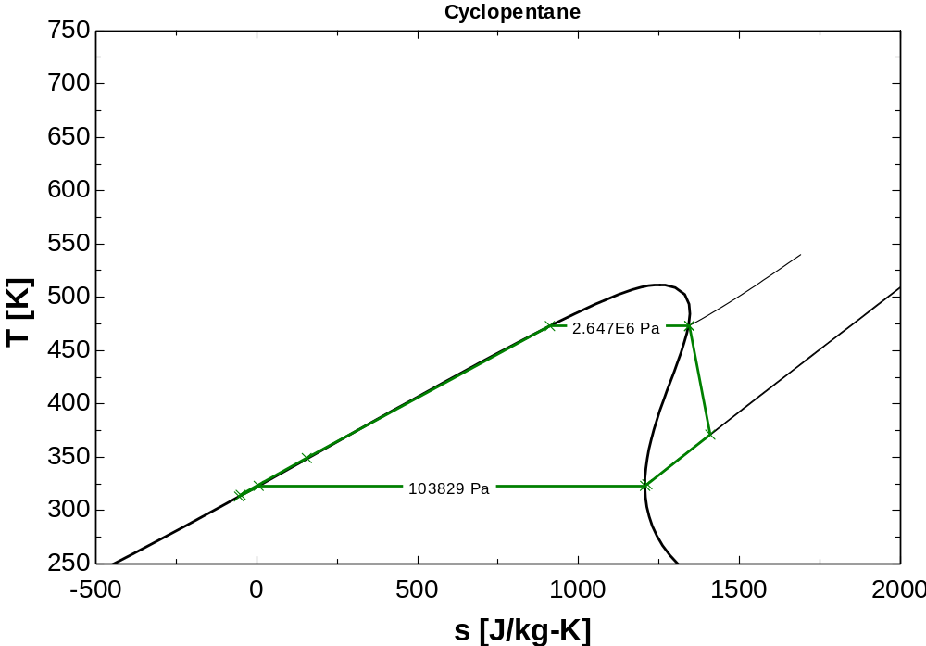
W_tphex=3.4 [m]

