西安交通大学

**计算机视觉与**

**模式识别**

计算机53班

龙思宇

2150500103

1. 补全SIFT1Scale的Line268-Line271

补全的代码如下：

odiff = repmat(ori(:),[1 num_bins]) - repmat(hist_orient(:)',[length(ori(:)),1]);

odiff = mod(odiff, 2*pi) - pi;

owght = 1 - abs(odiff) / hist_step;

owght(owght < 0) = 0;

1. 调通demo_sift_keypoint程序

想要调通demo_sift_keypoint需要补充gaussian_filter和display_keypoints函数，如下：

gaussian_filter

sample = 7.0/2.0;

n = 2*round(sample * sigma)+1;

x = 1:n;

x = x - ceil(n/2);

g = exp(-(x.^2)/(2*sigma^2))/(sigma*sqrt(2*pi));

display_keypoints

hold on;

alpha = 0.33;

beta = 0.33;

autoscale = 1.5;

plotarrows = 1;

sym = '';

filled = 0;

ls = '-';

ms = '';

col = '';

varin = nargin - 3;

while (varin > 0) & isstr(varargin{varin}),

vv = varargin{varin};

if ~isempty(vv) & strcmp(lower(vv(1)),'f')

filled = 1;

nin = nin-1;

else

[l,c,m,msg] = colstyle(vv);

if ~isempty(msg),

error(sprintf('Unknown option "%s".',vv));

end

if ~isempty(l), ls = l; end

if ~isempty(c), col = c; end

if ~isempty(m), ms = m; plotarrows = 0; end

if isequal(m,'.'), ms = ''; end % Don't plot '.'

varin = varin-1;

end

end

if varin > 0

autoscale = varargin{varin};

end

x = pos(:,1);

y = pos(:,2);

u = scale.*cos(orient);

v = scale.*sin(orient);

if prod(size(u))==1, u = u(ones(size(x))); end

if prod(size(v))==1, v = v(ones(size(u))); end

if autoscale,

u = u*autoscale; v = v*autoscale;

end

ax = newplot;

next = lower(get(ax,'NextPlot'));

hold_state = ishold;

x = x(:).'; y = y(:).';

u = u(:).'; v = v(:).';

uu = [x;x+u;repmat(NaN,size(u))];

vv = [y;y+v;repmat(NaN,size(u))];

h1 = plot(uu(:),vv(:),[col ls]);

if plotarrows,

hu = [x+u-alpha*(u+beta*(v+eps));x+u; ...

x+u-alpha*(u-beta*(v+eps));repmat(NaN,size(u))];

hv = [y+v-alpha*(v-beta*(u+eps));y+v; ...

y+v-alpha*(v+beta*(u+eps));repmat(NaN,size(v))];

hold on

h2 = plot(hu(:),hv(:),[col ls]);

else

h2 = [];

end

if ~isempty(ms),

hu = x; hv = y;

hold on

h3 = plot(hu(:),hv(:),[col ms]);

if filled, set(h3,'markerfacecolor',get(h1,'color')); end

else

h3 = [];

end

if ~hold_state, hold off, view(2); set(ax,'NextPlot',next); end

if nargout>0, hh = [h1;h2;h3]; end

1. 自己找两幅照片，进行调试，生成中间结果，包括特征点的生成，方向的搜索以及描述子的生成

原图

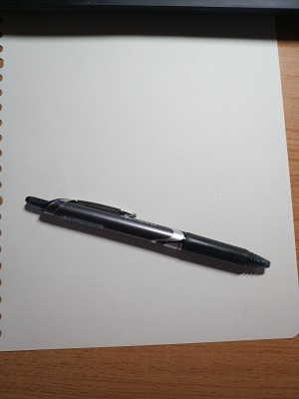

高斯金字塔

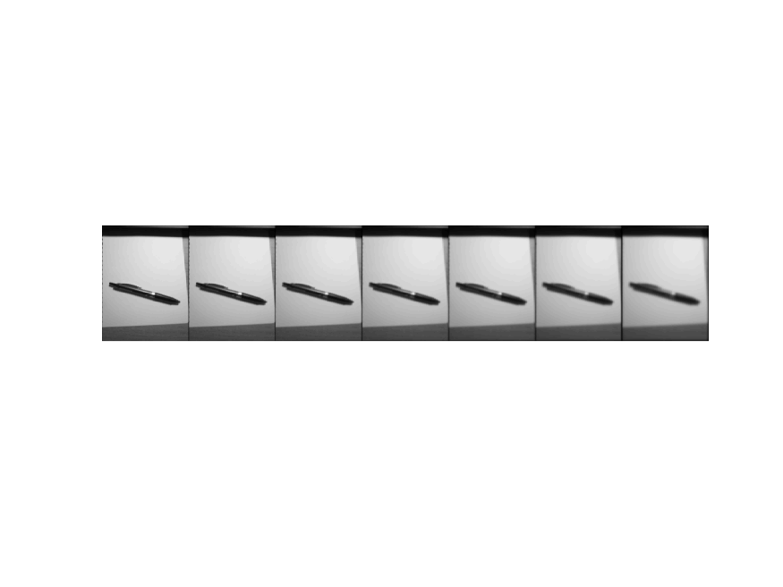

DOG

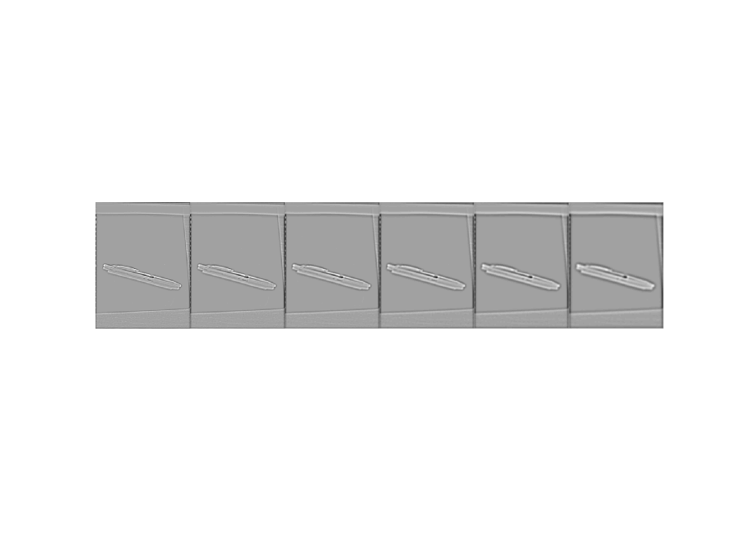

SIFT特征点

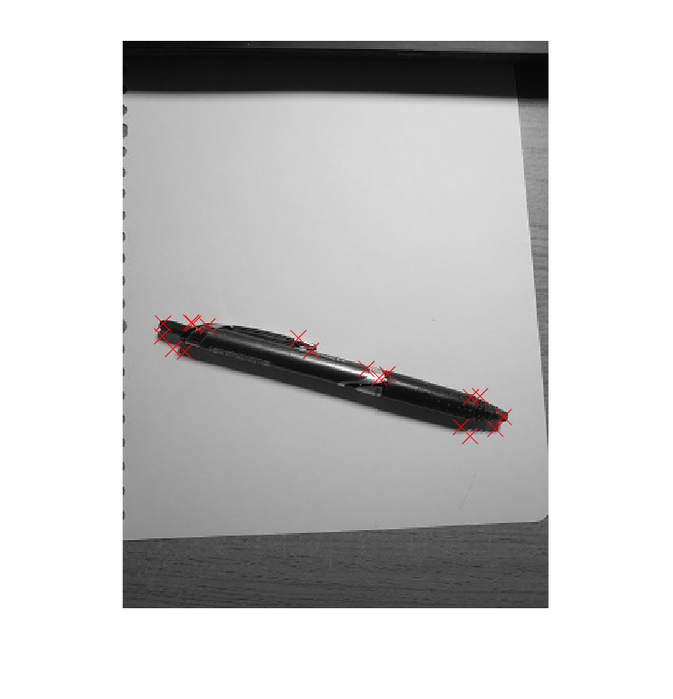

描述子

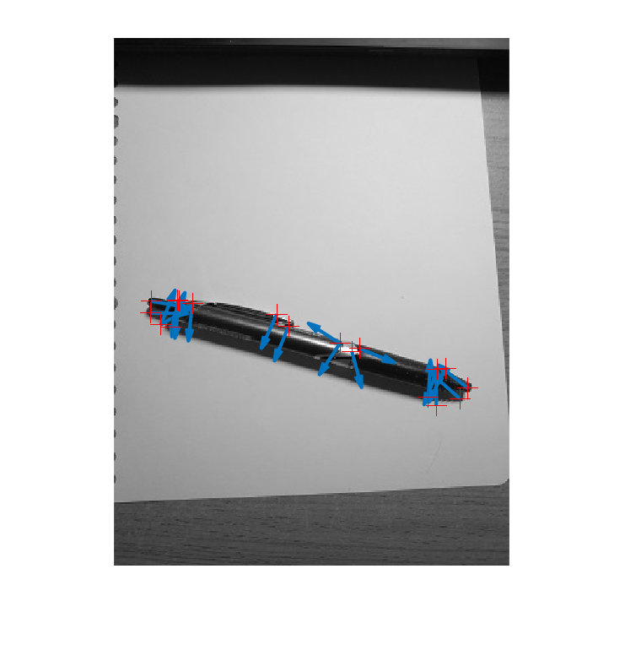

原图

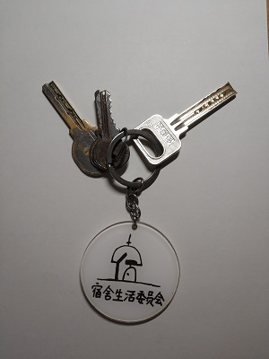

高斯金字塔

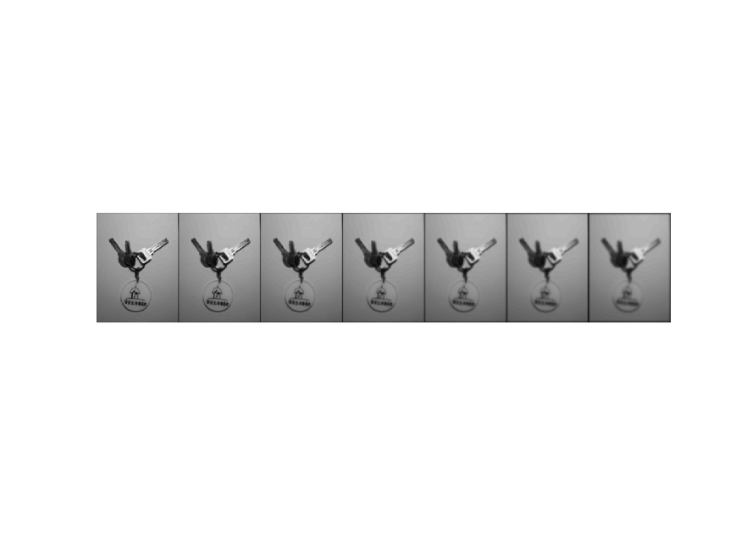

DOG

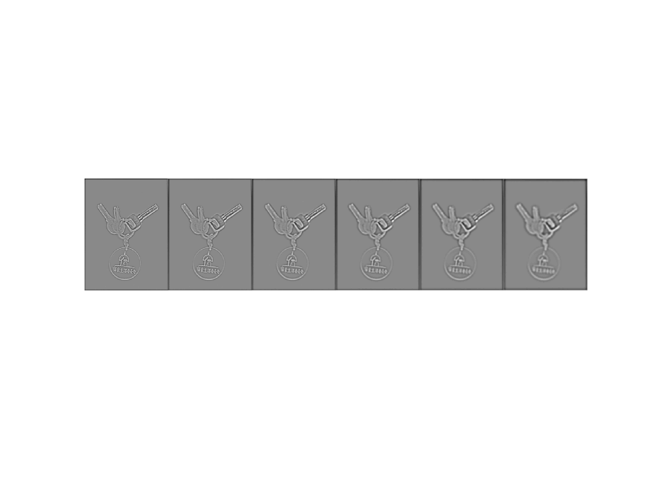

SIFT特征点

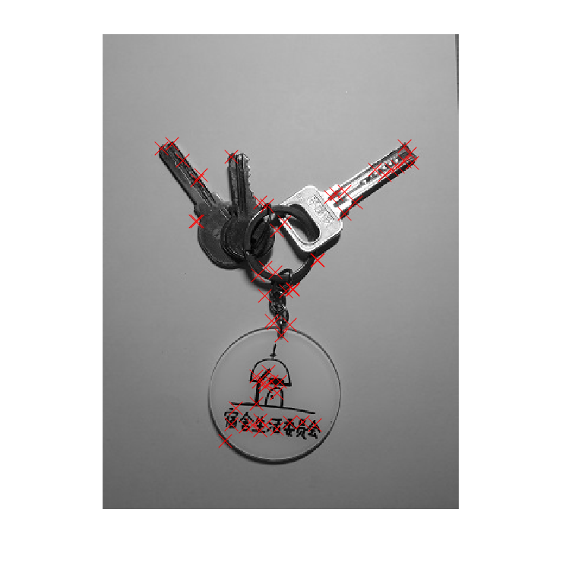

描述子

