西安交通大学

**计算机视觉与**

**模式识别**

计算机53班

龙思宇

2150500103

1. 实现genPyramids1中的expand和reduce函数，他们两个的输入都是图像+一个可分离的滤波器w，利用上课讲的expand和reduce实现这两个函数。

源代码

function after_expand = expand(origin,w)

[row,col,path] = size(origin);

expand_temp = zeros(row * 2,col,path);

for row_con = 1 : row

for col_con = 1 : col

for path_con = 1 : path

expand_temp(row_con * 2,col_con,path_con) = origin(row_con,col_con,path_con);

end

end

end

padding = zeros(1,col,path);

expand_temp_with_padding = [padding;padding;expand_temp;padding;padding];

for col_con = 1 : col

for row_con = 1 : row * 2

for path_con = 1:path

expand_temp(row_con,col_con,path_con) = 2 * sum(expand_temp_with_padding(row_con + 2 - 2:row_con + 2 + 2,col_con,path_con) .* w');

end

end

end

after_expand = zeros(row * 2,col * 2,path);

for row_con = 1:row * 2

for col_con = 1:col

for path_con = 1:path

after_expand(row_con,col_con * 2,path_con) = expand_temp(row_con,col_con,path_con);

end

end

end

padding = zeros(row * 2,1,path);

after_expand_with_padding = [padding padding after_expand padding padding];

for row_con = 1:row * 2

for col_con = 1:col * 2

for path_con = 1:path

after_expand(row_con,col_con,path_con) = 2 * sum(after_expand_with_padding(row_con,col_con + 2 - 2:col_con + 2 + 2,path_con) .* w);

end

end

end

end

function after_reduce = reduce(origin,w)

[row,col,path] = size(origin);

padding = zeros(row,1,path);

origin = [padding padding origin padding padding];

reduce_temp = zeros(row,floor(col / 2),path);

for row_con = 1:row

for col_con = 2:2:col

for path_con = 1:path

reduce_temp(row_con,floor(col_con / 2),path_con) = sum(origin(row_con,col_con + 2 - 2:col_con + 2 + 2,path_con) .* w);

end

end

end

[row,col,path] = size(reduce_temp);

after_reduce = zeros(floor(row / 2),col,path);

w = w';

padding = zeros(1,col,path);

reduce_temp = [padding;padding;reduce_temp;padding;padding];

for col_con = 1:col

for row_con = 2:2:row

for path_con = 1:path

after_reduce(floor(row_con / 2),col_con,path_con) = sum(reduce_temp(row_con + 2 - 2:row_con + 2 + 2,col_con,path_con) .* w);

end

end

end

end

实验结果

高斯金字塔

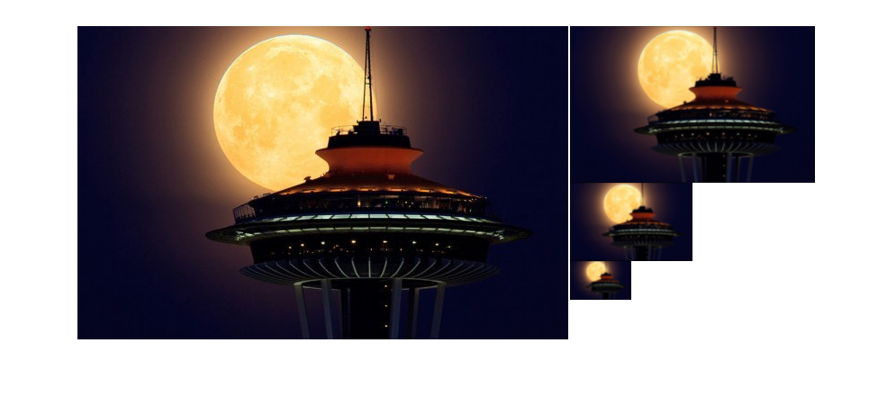

拉普拉斯金字塔

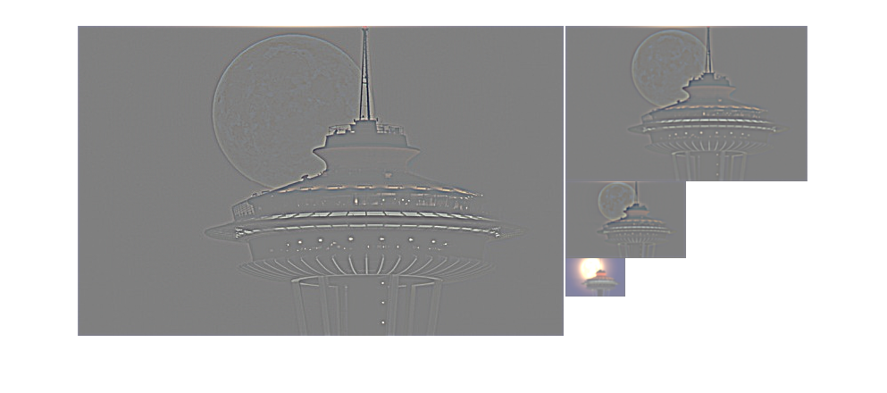

1. 利用拉普拉斯金字塔进行图像合成（补充recoverLaplacian函数）

源代码

function imBlend = recoverLaplacian(lapsBlend)

w = [1/8 1/4 1/4 1/4 1/8];

[row,~] = size(lapsBlend);

for laps_con = row:-1:2

after_expand = expand(lapsBlend{laps_con,1},w);

after_expand_size = size(after_expand);

laps_Blend_size = size(lapsBlend{laps_con - 1,1});

if(after_expand_size(1) < laps_Blend_size(1))

after_expand = vertcat(after_expand,after_expand(end,:,:));

end

if(after_expand_size(2) < laps_Blend_size(2))

after_expand = horzcat(after_expand,after_expand(:,end,:));

end

lapsBlend{laps_con - 1,1} = lapsBlend{laps_con - 1,1} + after_expand;

end

imBlend = lapsBlend{1,1};

end

实验结果

使用genMask.m生成Mask

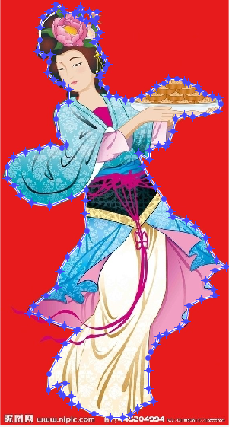

使用demo_laplacian_blend.m进行图像的合成

生成的Mask

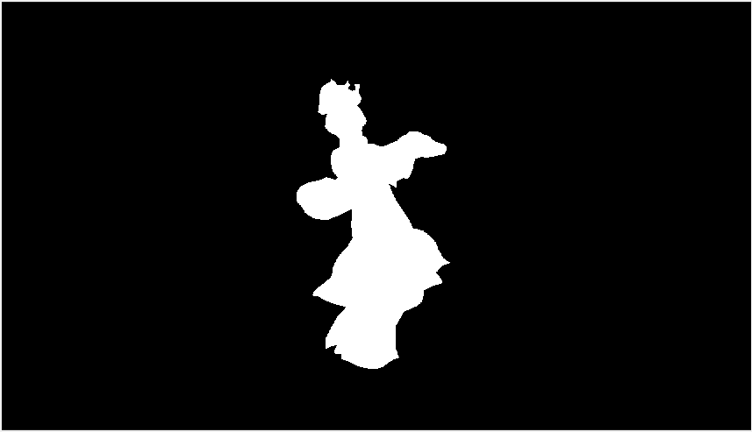

背景图片

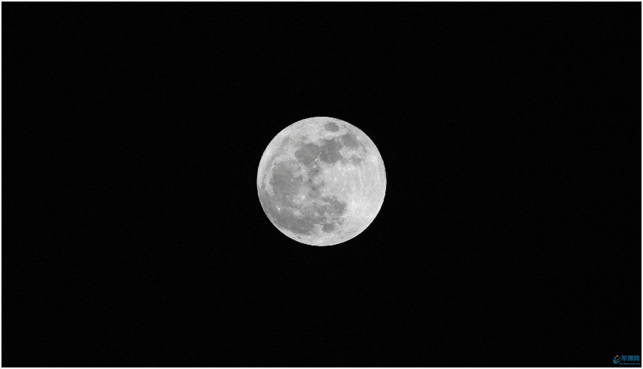

Blend后结果

