西安交通大学

**计算机视觉与**

**模式识别**

计算机53班

龙思宇

2150500103

1. 实现课上所讲诉的Gradient Blending的内容

源代码

%% 清空工作区和命令行窗口

clc;clear;

%% 读入两幅图像，一幅是background，另一幅是target图像，利用Matlab的roipoly函数标记target一个多边形的区域

background = imread('grass.jpg');

background_size = size(background);

target = imread('cat_2.jpg');

target_size = size(target);

%% 利用roipoly从target图片中选择感兴趣区域

figure(1);

[BW,xi,yi] = roipoly(target);

save('target.mat','BW','xi','yi');

close(figure(1));

target_Mask = load('target.mat','BW');

target_Mask = target_Mask.BW;

target_Mask = double(target_Mask);

%% padding操作

if(size(background,3) == 1),background_size(3) = 1;end

if(size(target,3) == 1),target_size(3) = 1;end

final_size = max([background_size(:) target_size(:)],[],2);

if(target_size(1) < final_size(1))

target_pad = vertcat(target,zeros(final_size(1) - target_size(1),target_size(2),target_size(3)));

target_Mask_pad = vertcat(target_Mask,zeros(final_size(1) - target_size(1),target_size(2)));

else

target_pad = target;

target_Mask_pad = target_Mask;

end

if(target_size(2) < final_size(2))

target_pad = horzcat(target_pad,zeros(size(target_pad,1),final_size(2) - target_size(2),target_size(3)));

target_Mask_pad = horzcat(target_Mask_pad,zeros(size(target_Mask_pad,1),final_size(2) - target_size(2)));

end

if(target_size(3) < final_size(3))

target_pad = repmat(target_pad,[1 1 3]);

end

if(background_size(1) < final_size(1))

background_pad = vercat(background,zeros(final_size(1) - background_size(1),background_size(2),background_size(3)));

else

background_pad = background;

end

if(background_size(2) < final_size(2))

background_pad = horzcat(background_pad,zeros(size(background_pad,1),final_size(2) - background_size(2),background_size(3)));

end

if(background_size(3) < final_size(3))

background_pad = repmat(background_pad,[1 1 3]);

end

%% 获得位置信息

figure(1);

imshow(background_pad);

[xshift,yshift] = ginput(1);

close(figure(1));

%% 获取原始图像中

maskPoints = load('target.mat','xi','yi');

xshift = (xshift - mean(maskPoints.xi));

yshift = (yshift - mean(maskPoints.yi));

%% 平移target以及它的mask

target_pad = imtranslate(target_pad,[xshift,yshift]);

target_Mask_pad = imtranslate(target_Mask_pad,[xshift,yshift]);

% figure(1);imshow(uint8(target_pad));

% figure(2);imshow(uint8(target_Mask_pad)*255);

%% 对target_pad做拉普拉斯算子卷积

laplacian_cal = [0 -1 0;-1 4 -1;0 -1 0];

target_pad_gradient = zeros(final_size(1),final_size(2),final_size(3));

for path_con = 1 : final_size(3)

target_pad_gradient(:,:,path_con) = target_Mask_pad .* conv2(target_pad(:,:,path_con),laplacian_cal,'same');

end

% figure(1);imshow(uint8(target_pad_gradient));

%% 给像素编号

target_label = zeros(final_size(1),final_size(2));

label = 1;

% for row_con = 1 : target_size(1)

% for col_con = 1 : target_size(2)

% if target_Mask_pad(row_con + round(yshift),col_con + round(xshift)) == 1

% target_label(row_con + round(yshift),col_con + round(xshift)) = label;

% label = label + 1;

% end

% end

% end

for row_con = 1 : final_size(1)

for col_con = 1 : final_size(2)

if target_Mask_pad(row_con ,col_con ) == 1

target_label(row_con ,col_con) = label;

label = label + 1;

end

end

end

% figure(1);imshow(uint8(target_label),[]);

%% 构造矩阵A和b

dim = label - 1;

nei = [-1 0;0 1;1 0;0 -1];

f = zeros(dim,1,3);

for path_con = 1 : final_size(3)

A = sparse(dim,dim);

b = zeros(dim,1);

cur = 0;

for row_con = 1 : final_size(1)

for col_con = 1 : final_size(2)

if target_Mask_pad(row_con ,col_con ) == 1

cur = cur + 1;

for nei_con = 1 : 4

if target_Mask_pad(row_con - nei(nei_con,1),col_con - nei(nei_con,2)) == 1

A(cur,target_label(row_con - nei(nei_con,1),col_con - nei(nei_con,2))) = -1;

else

b(cur,1) = b(cur,1) + background_pad(row_con - nei(nei_con,1),col_con - nei(nei_con,2),path_con);

end

end

b(cur,1) = b(cur,1) + target_pad_gradient(row_con,col_con,path_con);

A(cur,cur) = 4;

end

end

end

f(:,:,path_con) = A \ b;

end

%% 回填

target_res = zeros(final_size(1),final_size(2),final_size(3));

for row_con = 1 : final_size(1)

for col_con = 1 : final_size(2)

if target_Mask_pad(row_con ,col_con ) == 1

target_res(row_con,col_con,1) = f(target_label(row_con,col_con),1,1);

target_res(row_con,col_con,2) = f(target_label(row_con,col_con),1,2);

target_res(row_con,col_con,3) = f(target_label(row_con,col_con),1,3);

end

end

end

background_pad = double(background_pad);

verse_target_Mask_pad = (target_Mask_pad - 1) * (-1);

result = target_res + background_pad .* logical(verse_target_Mask_pad);

figure(1),imshow(uint8(result));

1. 找到自己感兴趣的4组照片，从中选择物体进行融合。

结果

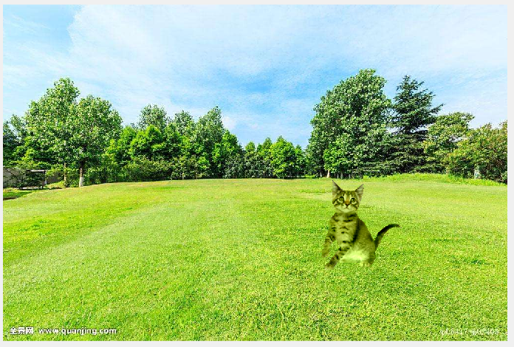

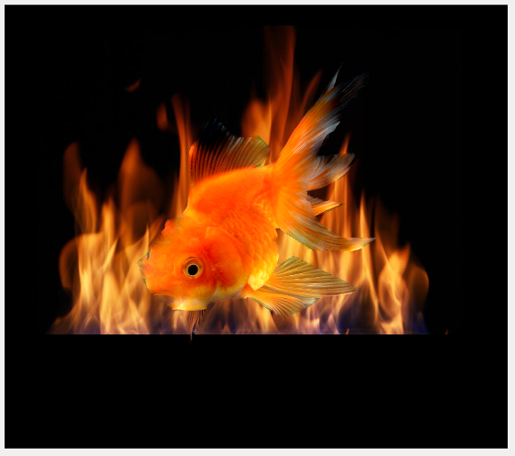

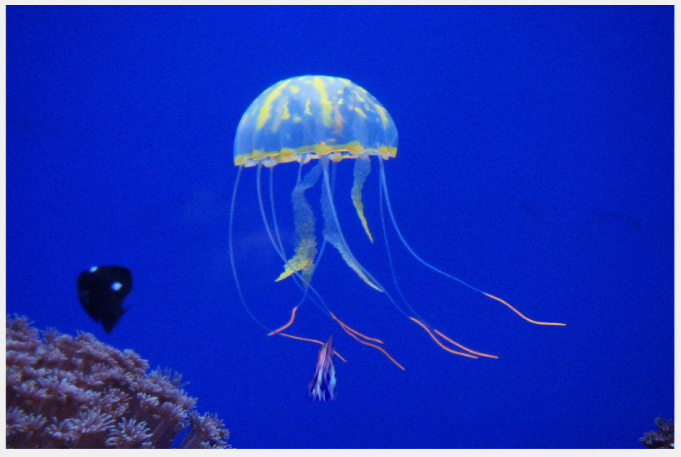

这是一团火

