- Framework 打开WiFi操作
public String setupInterfaceForClientMode(boolean lowPrioritySta,
@NonNull InterfaceCallback interfaceCallback) {
synchronized (mLock) {
if (!startHal()) {
Log.e(TAG, "Failed to start Hal");
mWifiMetrics.incrementNumSetupClientInterfaceFailureDueToHal();
return null;
}
if (!startSupplicant()) {
Log.e(TAG, "Failed to start supplicant");
mWifiMetrics.incrementNumSetupClientInterfaceFailureDueToSupplicant();
return null;
}
Iface iface = mIfaceMgr.allocateIface(Iface.IFACE_TYPE_STA);
if (iface == null) {
Log.e(TAG, "Failed to allocate new STA iface");
return null;
}
..............................................
}

- insmod 操作
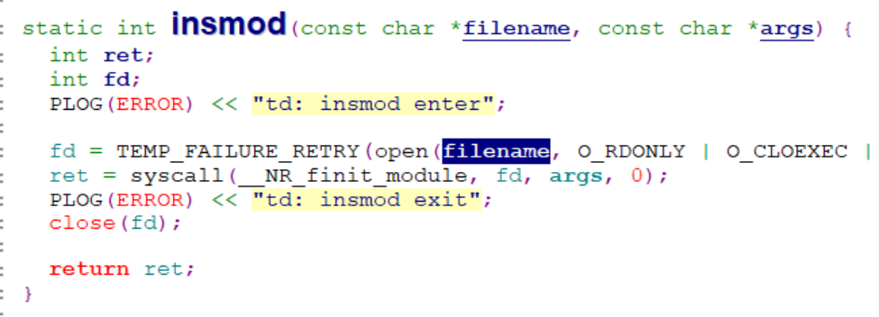

- Atbm_usb_module_init
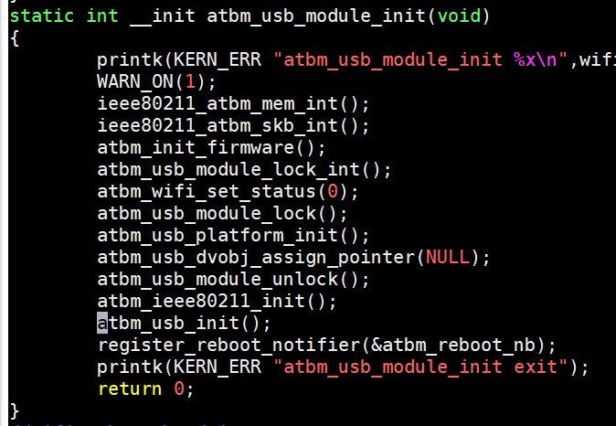

- 向kernel注册驱动
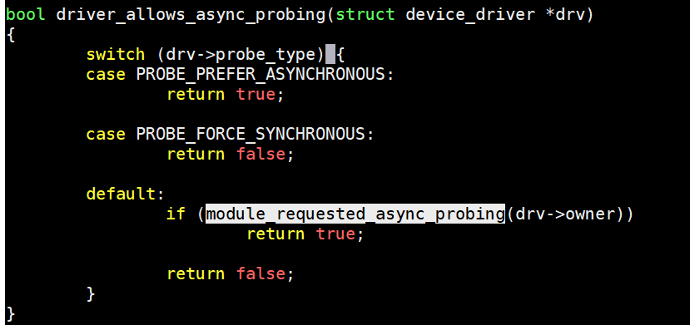

- 正常时序
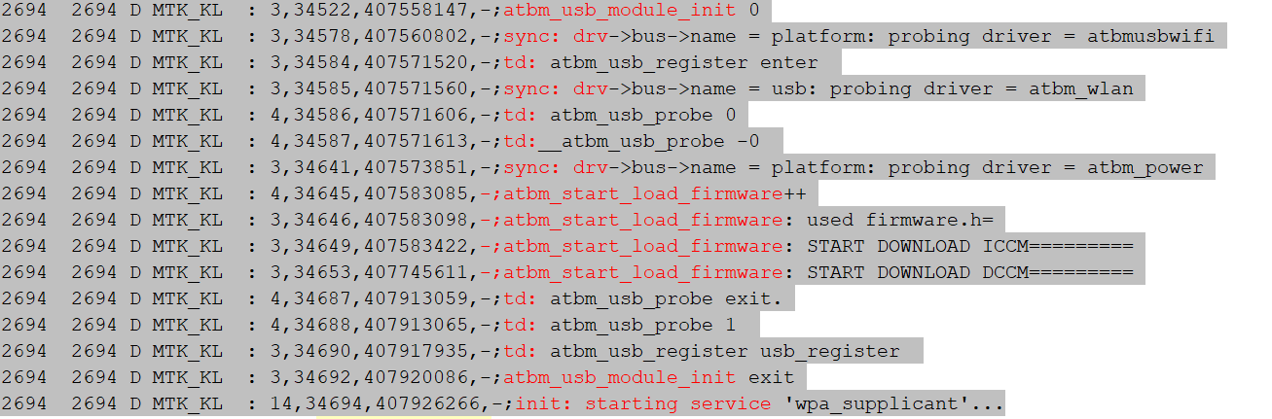

- 异常时序对比
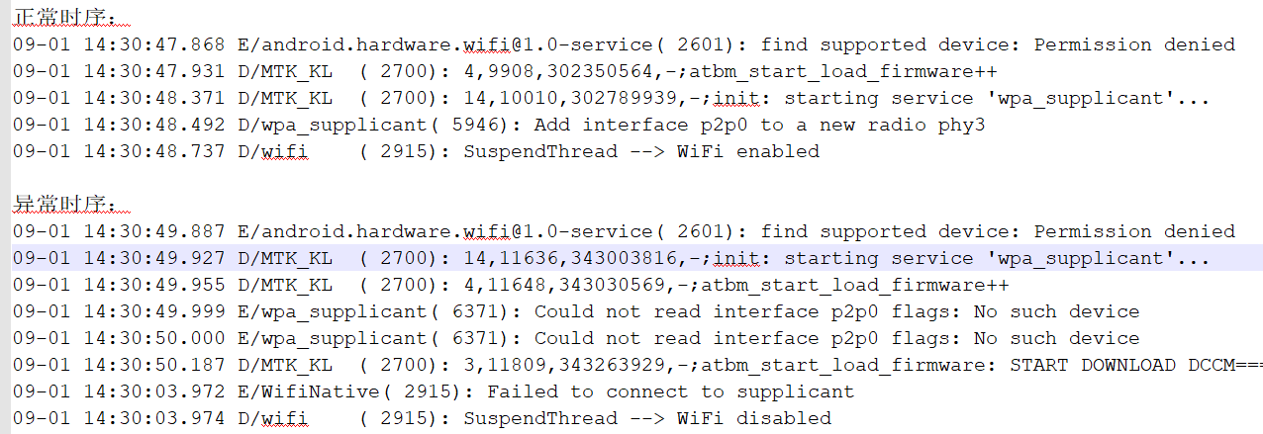

7、
(SyS_finit_module)
load_module
do_init_module
init_module
atbm_usb_module_init
atbm_usb_init
atbm_usb_register
usb_register
driver_register
bus_add_driver//drivers/base/bus.c +674
driver_attach
__driver_attach // return bus_for_each_dev(drv->bus, NULL, drv, __driver_attach);
driver_probe_device //drivers/base/dd.c +757
usb_probe_interface
atbm_usb_probe->__atbm_usb_probe-->atbm_wtd]usb:set wtd_probe = 1

Bus_add_driver
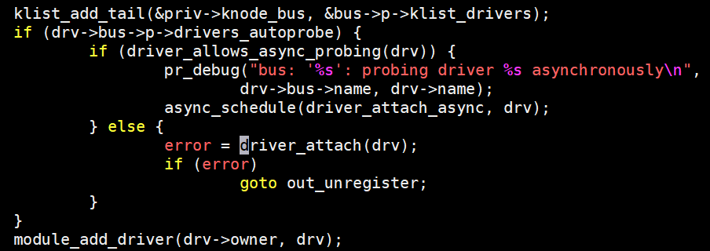
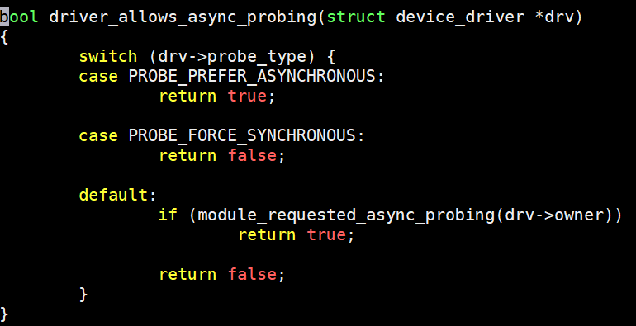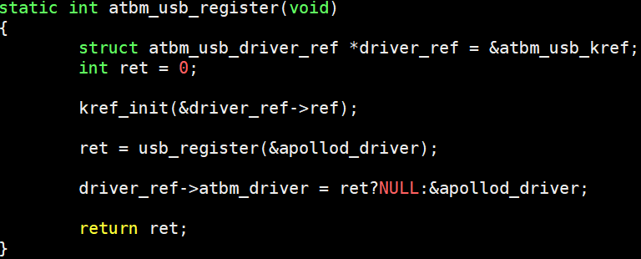

代码变更：
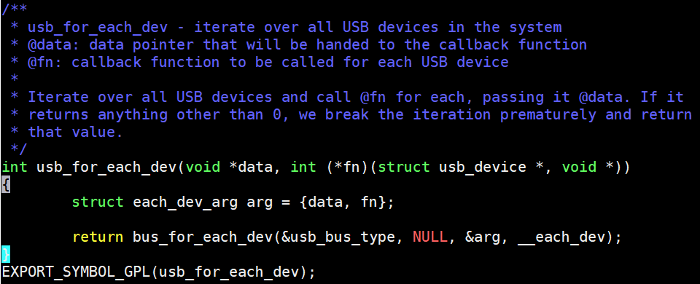
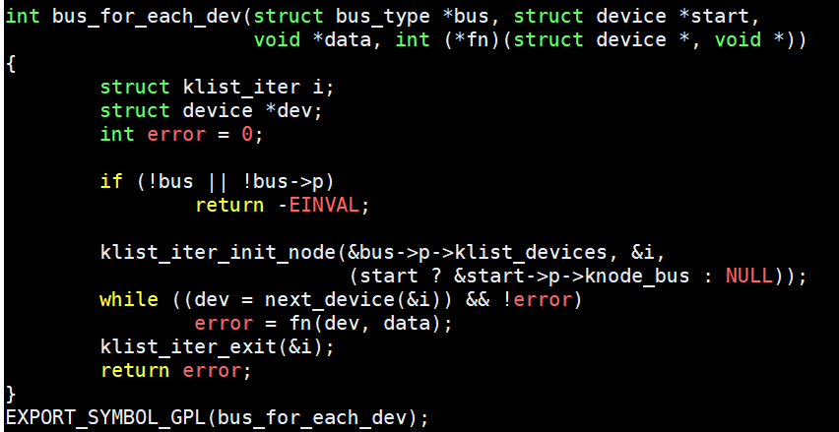
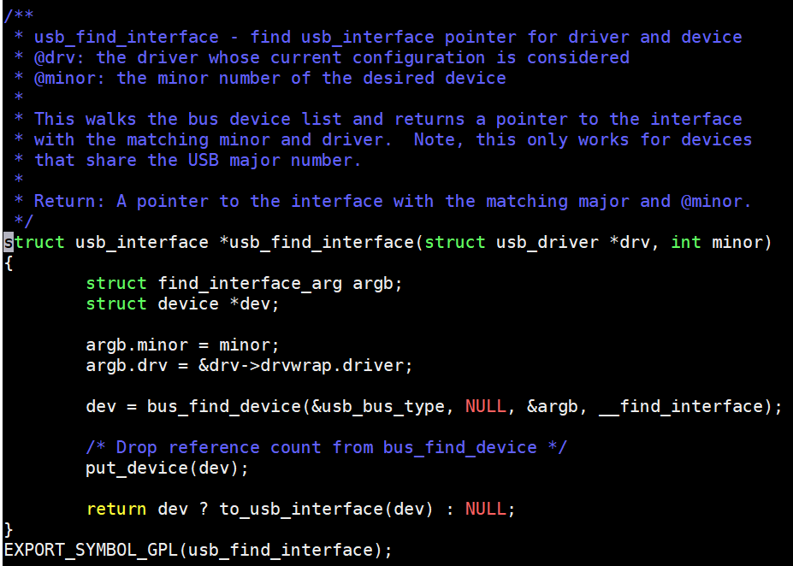
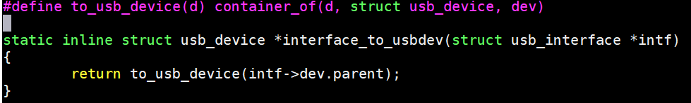
02-25 08:30:39.777 2698 2698 D MTK_KL : 3,8681,107133713,-;atbm_process_each_dev--usb_dev:product(EHCI Host Controller),manufacturer(Linux 4.9.118+ ehci_hcd),vendor(1d6b),product(2)
02-25 08:30:39.790 2698 2698 D MTK_KL : 3,8682,107146960,-;atbm_process_each_dev--usb_dev:product(EHCI Host Controller),manufacturer(Linux 4.9.118+ ehci_hcd),vendor(1d6b),product(2)
02-25 08:30:39.790 2698 2698 D MTK_KL : 3,8683,107160387,-;atbm_process_each_dev--usb_dev:product(AltoBeam_WIFI),manufacturer(AltoBeam inc.),vendor(7a),product(8888)
02-25 08:30:39.809 2698 2698 D MTK_KL : 3,8684,107172507,-;atbm_process_each_dev:found (wlan0) dev

hal_apollo/mac80211/ieee80211_i.h +861
#define seq_file_net &init_net; //存放net_device全局变量
include/linux/compat-2.6.25.h +83

